Agentic RAG
Knowledge Service
Design & Architecture Document

May 2026
Status: Draft

Table of Contents
1. Executive Summary
2. The Problem
3. Why Agentic RAG (Not Fine-Tuning)
4. System Architecture
5. Document Ingestion Pipeline
6. How the Agent Thinks: Query Flow
7. Security & Access Control
8. MCP Knowledge Service: Agent-to-Agent Integration
9. Technology Stack
10. Deployment Architecture
11. Implementation Phasing
12. Open Questions & Next Steps

1. Executive Summary
This document describes the design of an on-premises Agentic RAG (Retrieval-Augmented Generation) system that transforms enterprise documents into an intelligent, queryable knowledge service. The system ingests financial documents, procedure manuals, spreadsheets, meeting transcripts, and databases, then allows internal employees to ask natural language questions and receive accurate, cited answers.
Beyond serving as a chatbot, the system acts as an MCP (Model Context Protocol) server, enabling other AI agents across the organization to tap into the knowledge base as a tool. This positions the system as a foundational knowledge layer for the enterprise AI ecosystem.
Key design principles:
- All AI models are US-origin (Gemma 4 31B by Google, E5-large by Microsoft)
- Runs entirely on-premises on A100/H100 GPUs — no data leaves the network
- Document-level access control tied to Active Directory groups
- Agentic retrieval — the system reasons about how to find information, not just keyword matching
- Serves as an MCP knowledge service for other AI agents, not just a standalone chatbot

2. The Problem
Enterprise knowledge is scattered across hundreds of documents in multiple formats: financial reports in PDF, procedures in Word, data in spreadsheets, decisions captured in meeting transcripts, and live data in databases. Employees spend significant time searching for information, and institutional knowledge is often siloed by department.

What employees need
- Quick, accurate answers to questions about company policies and procedures
- The ability to trace answers back to source documents (citations)
- Cross-referencing across document types (e.g., 'Does our Q3 spending comply with policy 4.2?')
- Exhaustive searches across large document sets (e.g., 'What questions did Mike ask in all meetings this month?')

What the organization needs
- Access control — finance docs stay with finance, IT docs stay with IT
- On-premises deployment — sensitive financial data cannot leave the network
- An AI knowledge layer that other internal systems and agents can integrate with
- A system that grows organically as new documents and departments are added

3. Why Agentic RAG (Not Fine-Tuning)
An initial consideration was LoRA fine-tuning a small model on company documents. After analysis, this approach was ruled out in favor of agentic RAG for several critical reasons:

Why not LoRA fine-tuning?
Concern | Fine-Tuning (LoRA) | Agentic RAG
Factual accuracy | Learns patterns, not facts. Hallucinates specifics. | Retrieves actual document content. Grounded in source material.
Citations | Impossible. Generates from weights, not documents. | Built-in. Every answer traceable to source.
Document updates | Requires retraining on every change. | Just re-index. No retraining needed.
Cost of updates | GPU hours for each retrain cycle. | Minutes to re-embed changed documents.
Financial domain risk | Small models hallucinate financials confidently. | Only answers from retrieved, verified content.

Why agentic RAG specifically?
Basic RAG follows a simple pattern: embed a query, find similar chunks, generate an answer. This works for straightforward lookups but fails on complex queries that require:
- Searching across multiple document types with different retrieval strategies
- Exhaustive coverage (not just top-K results) for sweep queries
- Combining database queries with document searches
- Multi-step reasoning that follows cross-references between documents
An agentic approach adds a reasoning layer that classifies the query type, plans a retrieval strategy, executes multiple search strategies in parallel, evaluates whether it has enough context, and can re-retrieve if needed — all before synthesizing an answer.

4. System Architecture
The system is organized in layers: consumers at the top, a shared authentication gateway, multiple integration endpoints, a core agent orchestrator, and infrastructure services at the bottom. All endpoints share the same orchestrator core, auth layer, and audit infrastructure.
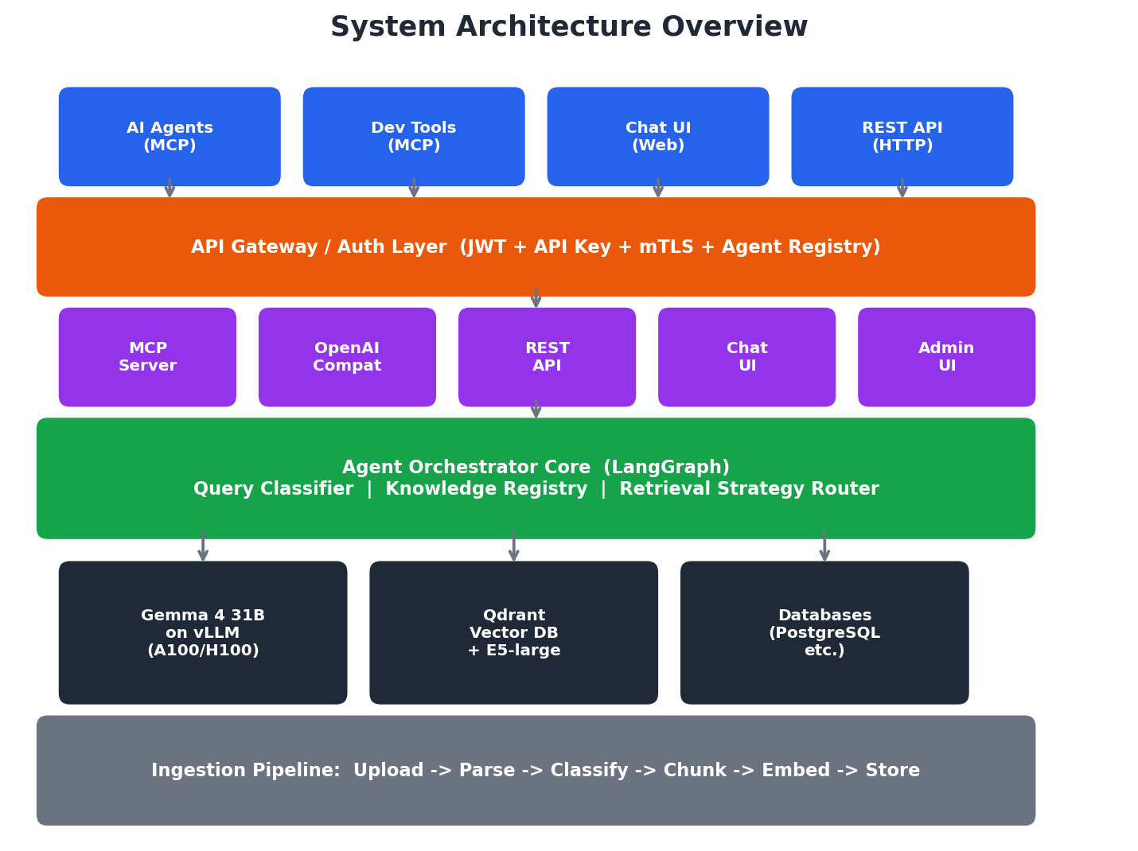

Key architectural decisions
- Single agent core shared by all endpoints — the MCP server, REST API, OpenAI-compatible API, and Chat UI all use the same orchestrator. No duplicated logic.
- Four integration points serve different consumers: Chat UI for end users, REST API for custom apps, OpenAI-compatible API for ecosystem tools, and MCP server for other AI agents.
- The Knowledge Registry is a metadata layer that catalogs all data sources, their types, retrieval strategies, and access control groups. It helps the agent make informed decisions about where to look.

5. Document Ingestion Pipeline
Documents enter the system through an upload UI or a watched folder. Each document passes through format-specific parsing, automatic classification, structure-aware chunking, and embedding before being stored in the vector database with rich metadata.
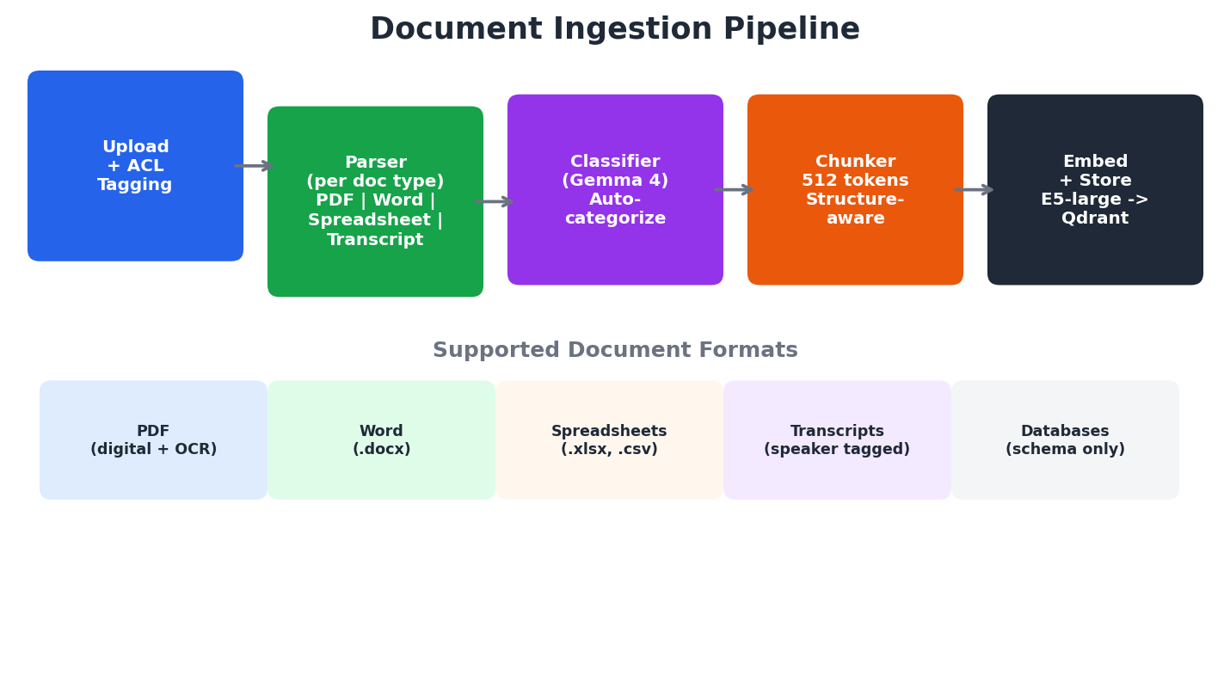

How each format is handled
Format | Parser | Special Handling
PDF (digital) | Unstructured.io | Direct text extraction, preserves page numbers
PDF (scanned) | Unstructured.io + Tesseract OCR | OCR converts images to text
Word (.docx) | python-docx via Unstructured.io | Preserves heading structure for section-aware chunks
Spreadsheets | Unstructured.io | Stored as text summaries AND queryable tabular data
Meeting transcripts | Custom parser | Speaker identification, utterance type tagging (question/statement/action item)
Databases | Schema registration only | Not ingested; queried live via text-to-SQL at runtime

Auto-categorization
When a new document is uploaded, the LLM (Gemma 4 31B) classifies it against existing categories. If it matches an existing category, it's assigned automatically. If a new category is detected, the system proposes the category with a name, description, suggested routing rules, and suggested ACL groups — then queues it for admin approval before going live.
Admin approval is required for new categories because each category carries access control implications and affects query routing for all users.

Meeting transcript enrichment
Meeting transcripts receive special processing. Each utterance is tagged with the speaker name and classified as a question, statement, or action item. This enables powerful metadata-based queries like 'What questions did Mike ask in all meetings the last 30 days?' — which would be nearly impossible with naive semantic search alone.

6. How the Agent Thinks: Query Flow
The agent orchestrator is the core reasoning engine. Unlike basic RAG which always does the same thing (embed query, find top-K chunks, generate), the agentic approach classifies the query type and selects the best retrieval strategy.
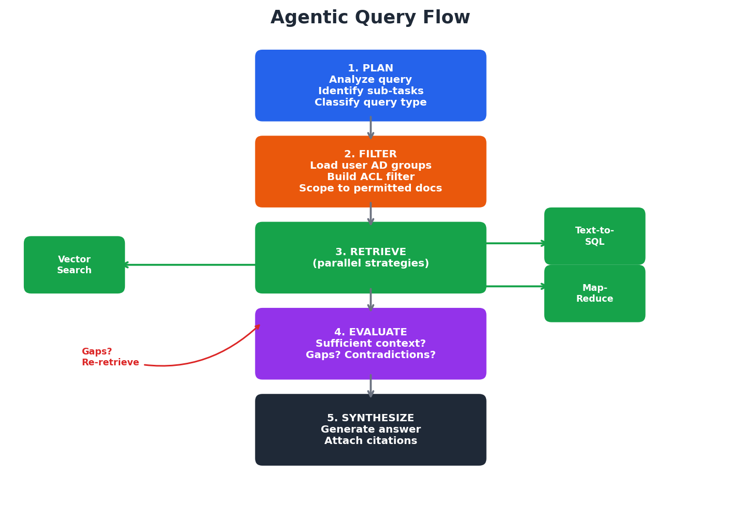

Five-step reasoning process
- PLAN — The agent analyzes the query and breaks it into sub-tasks. A complex question like 'What was our Q3 revenue and does it comply with policy 4.2?' becomes two sub-tasks: one for the database, one for procedure documents.
- FILTER — The user's Active Directory groups are loaded and used to build an ACL filter. All subsequent retrievals are scoped to only documents the user has permission to see.
- RETRIEVE — The agent executes the appropriate retrieval strategy for each sub-task, in parallel where possible. Different strategies are used for different query types.
- EVALUATE — The agent reviews the retrieved context. Is it sufficient to answer? Are there gaps? If so, it reformulates and re-retrieves. Are there contradictions? It flags them.
- SYNTHESIZE — The agent generates a final answer grounded in the retrieved context, with citations pointing back to specific documents, pages, and sections.

Query type classification
Not all queries are the same. The agent classifies each query and routes it to the optimal retrieval strategy:
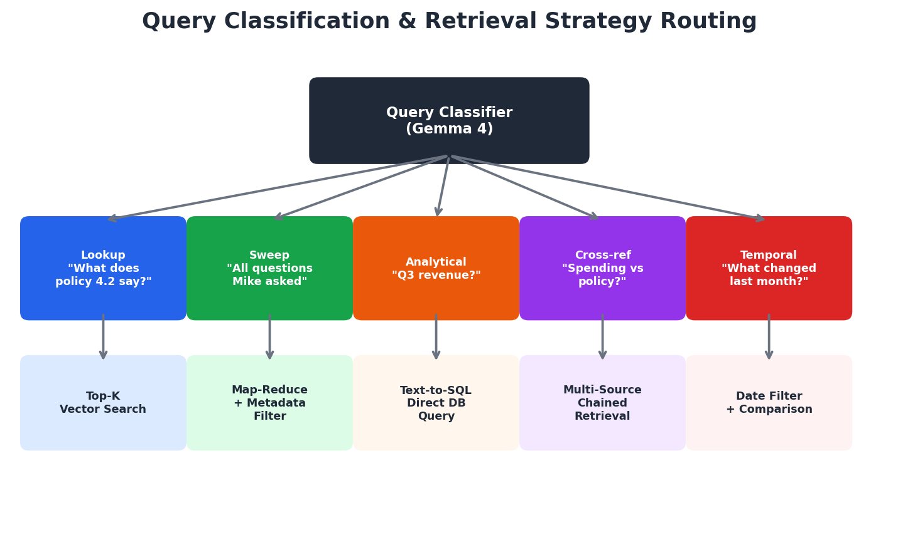

The sweep query challenge
Sweep queries like 'What questions did Mike ask in all meetings the last 30 days?' are the hardest type for traditional RAG. Standard top-K vector search returns the best 5-10 chunks but misses results scattered across dozens of documents.
The agentic approach handles this with a multi-strategy pattern:
- First, narrow the document set using metadata filters (doc_type=transcript, date >= 30 days ago)
- Run keyword search for speaker-tagged lines ('Mike:' followed by question patterns)
- Run semantic search with multiple reformulations ('questions raised by Mike', 'Mike asked about', 'Mike wanted to know')
- For remaining documents, use map-reduce: feed each transcript to the LLM and ask it to extract Mike's questions
- Merge, deduplicate, and sort results chronologically

7. Security & Access Control
With sensitive financial documents and cross-department data, the access control system must be robust. The design uses a three-layer authentication model that verifies both the calling application and the end user independently.
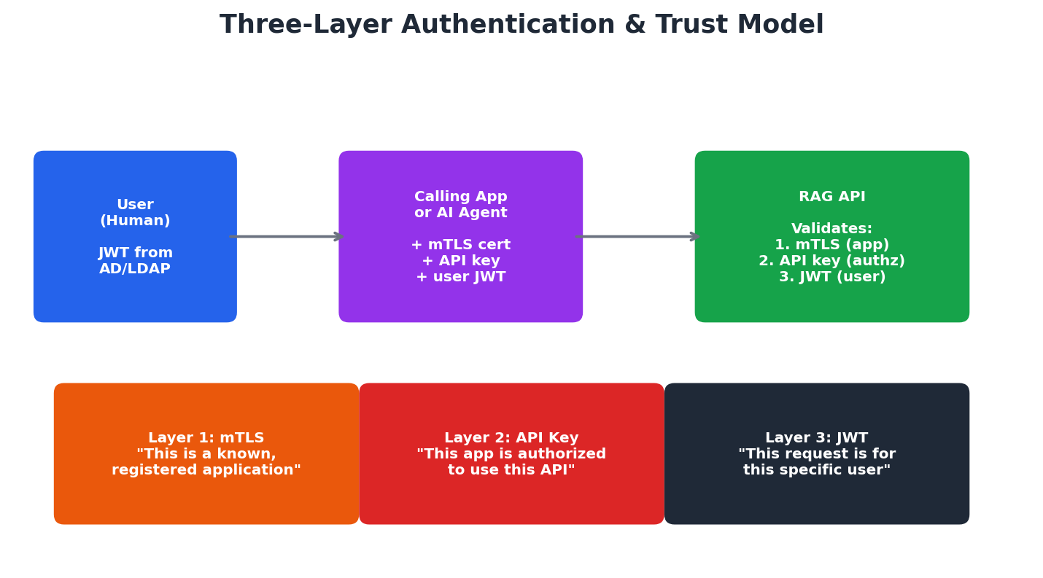

Three-layer trust model
Layer 1: mTLS (Mutual TLS)
Each registered application or AI agent receives a client certificate signed by the internal certificate authority. The RAG API only accepts connections with valid client certificates. This proves the connection is from a known, registered application.
Layer 2: API Key
Each application gets a unique API key that enables per-app rate limiting, auditing, and revocation. This proves the app is authorized to use the API.
Layer 3: JWT (JSON Web Token)
Users authenticate against LDAP/Active Directory and receive a signed JWT. This token is passed through with every API call — even when routed through another AI agent. The RAG API validates the JWT signature independently. It never trusts a bare user_id.

Document-level access control
Every document is tagged with permitted AD groups at ingestion time. At query time, the user's AD groups (extracted from their JWT) are used to filter all retrieval operations. If Mike is in the Finance AD group and Bob is in IT Support, they will get different results for the same query — Mike sees finance documents, Bob sees IT documents.

Double-gated access for AI agents
When other AI agents consume the MCP server, access is controlled by both the agent's permissions AND the user's AD groups. An IT support agent cannot access finance documents even if the underlying user could — because the agent's permissions restrict which sources it can query.

Audit trail
Every query is logged with:
- Which application or agent made the call
- Which user the request was on behalf of
- The full query text
- Which documents were retrieved and returned
- Which retrieval strategy was used
- Timestamp

8. MCP Knowledge Service: Agent-to-Agent Integration
The MCP (Model Context Protocol) server is what transforms this from a standalone chatbot into a foundational knowledge service. Any AI agent in the organization can use the MCP server to access enterprise knowledge as a tool — the HR agent, compliance agent, IT support agent, or any future agent can query the knowledge base.
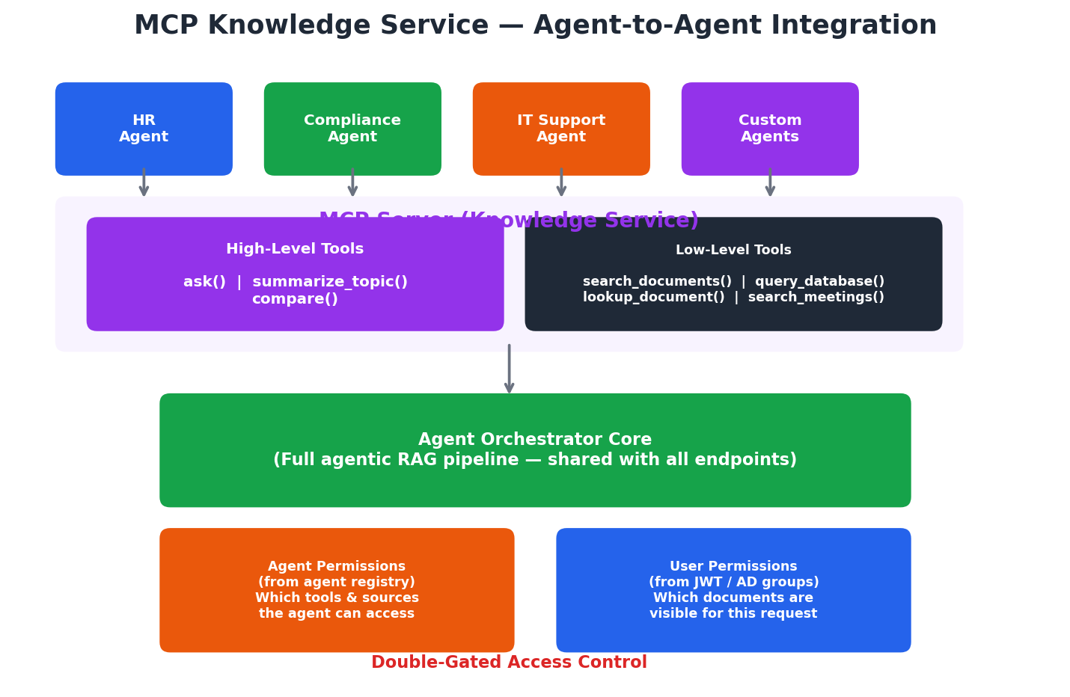

Two tiers of tools
High-level tools (agent-friendly):
These run the full agentic RAG pipeline and return complete, cited answers. A consuming agent just calls ask() with a question and gets back a synthesized result. The consuming agent doesn't need to understand retrieval strategies — the knowledge service handles everything.
- ask(question, context, depth) — Full Q&A with citations
- summarize_topic(topic, time_range, format) — Topic summaries from documents
- compare(item_a, item_b) — Compare two items across the knowledge base
Low-level tools (precise control):
For consuming agents that want to orchestrate their own retrieval logic or need specific data types.
- search_documents() — Vector similarity search with filters
- query_database() — Natural language to SQL
- lookup_document() — Fetch a specific document or section
- search_meetings() — Speaker and type-filtered transcript search
- list_sources() — Discover available knowledge sources

Context passing
Consuming agents can pass context about their workflow to improve retrieval quality. For example, an HR onboarding agent asking about PTO policy can include context like 'I am onboarding a new exempt employee in California' — this helps the knowledge service retrieve the most relevant policy sections.

Async support
Exhaustive sweep queries may take 30+ seconds. The MCP server supports asynchronous execution: the client receives a job_id immediately and polls for results. Jobs are stored server-side with a configurable TTL (default 1 hour).

Why this matters
Without the MCP server, every AI system in the organization would need its own copy of the document corpus, its own ingestion pipeline, and its own retrieval logic. The MCP knowledge service centralizes this: one source of truth, one set of access controls, one audit trail — consumed by any agent that needs organizational knowledge.

9. Technology Stack
All AI models are US-origin. All infrastructure is self-hostable on-premises.
Component | Technology | Rationale
LLM | Gemma 4 31B (Google) | US-origin, native tool use, 256K context, strong agentic benchmarks
LLM Serving | vLLM | Best NVIDIA throughput, continuous batching, OpenAI-compat API
Embeddings | E5-large (Microsoft) | US-origin, proven retrieval quality, self-hostable
Vector DB | Qdrant | Self-hosted, Rust-based (fast), metadata filtering for ACLs, MIT license
Agent Framework | LangGraph | Multi-step agentic flows, tool routing, map-reduce patterns
API Layer | FastAPI (Python) | Async, auto-generates OpenAPI docs
MCP Server | FastMCP (Python SDK) | Official MCP SDK, SSE transport
Chat UI | Open WebUI | Self-hosted, OpenAI-compatible
Doc Parsing | Unstructured.io | PDF, Word, spreadsheets, OCR; open source, US company
Auth | LDAP + JWT (PyJWT) | Integrates with existing AD infrastructure
Audit Logging | Elasticsearch or PostgreSQL | Queryable audit trail for compliance
Monitoring | Prometheus + Grafana | Standard, self-hosted
Orchestration | Docker Compose / K8s | Docker Compose to start; Kubernetes for production

10. Deployment Architecture
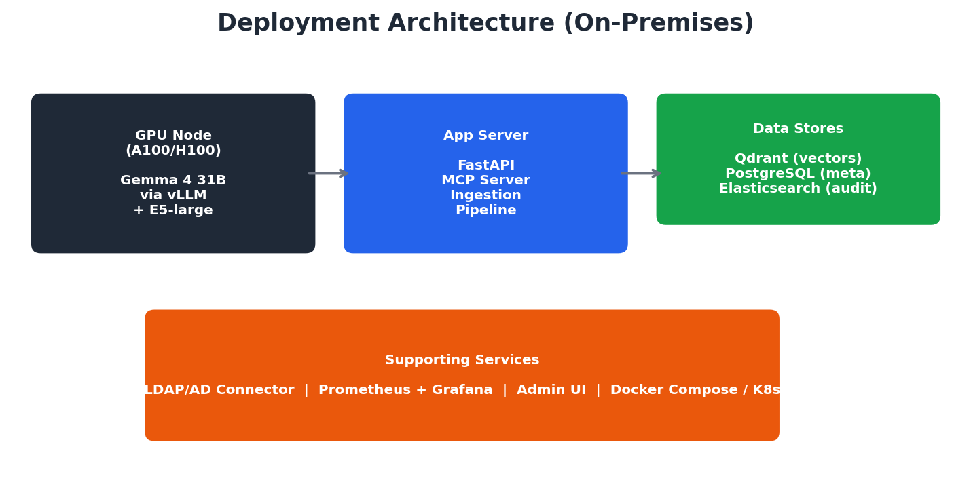

Minimal deployment (start here)
- 1x A100/H100 node — Gemma 4 31B + E5-large embeddings via vLLM
- 1x application server — Qdrant, FastAPI, ingestion pipeline, MCP server
- Docker Compose to manage all services
- Handles approximately 5-10 concurrent users

Production scale
- 2+ GPU nodes behind a load balancer for LLM redundancy
- Dedicated Qdrant cluster (3 nodes) for replication and availability
- Kubernetes for orchestration and auto-scaling
- Separate ingestion workers for bulk indexing during off-hours
- Dedicated Elasticsearch cluster for audit logs

GPU sizing
Workload | Requirement
Gemma 4 31B inference | 1x A100 80GB, ~10-15 tokens/sec per request
E5-large embeddings | Can share GPU or run on CPU
Concurrent conversations | 1x A100 handles ~5-10 via continuous batching
Bulk ingestion | Can share inference GPU or use separate GPU during off-hours

11. Implementation Phasing
The system is designed to be built incrementally, with each phase delivering standalone value. This reduces risk and allows the team to learn from real usage before adding complexity.
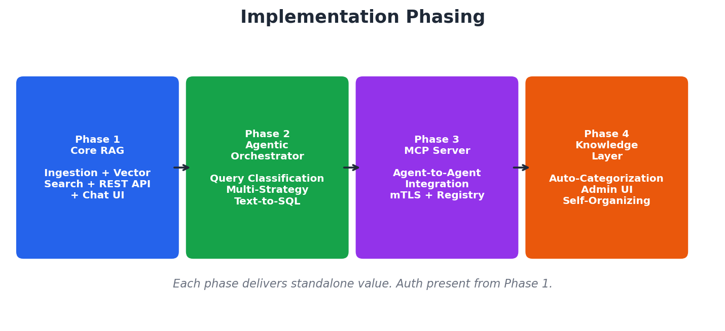
Phase | Scope | Delivers
Phase 1 | Core RAG: ingestion + vector search + REST API + Chat UI | Users can upload docs and ask questions with citations
Phase 2 | Agentic orchestrator: query classification, multi-strategy retrieval, text-to-SQL | Smarter answers, database integration, sweep queries
Phase 3 | MCP server + agent-to-agent integration | Other AI systems can use the knowledge base as a tool
Phase 4 | Knowledge layer auto-categorization + admin UI | Self-organizing corpus, category management

Authentication (JWT + API key) is present from Phase 1. mTLS and the agent registry are added in Phase 3 when external agents connect.

12. Open Questions & Next Steps
The following items need stakeholder input before implementation begins:
AD group structure: What existing AD groups map to document access? Needs input from IT/security team.
Database schemas: Which databases should be connected? What are their access patterns?
Meeting transcript format: What tool generates transcripts? Do they already have speaker tags?
Admin UI scope: Build custom or use an existing internal tools framework?
Backup & disaster recovery: Strategy for vector DB and metadata store.
Model update cadence: Process for evaluating and upgrading to newer model versions.

Next steps
- Review and approve this design document
- Resolve open questions with stakeholders
- Create detailed implementation plan for Phase 1
- Set up development environment with GPU access
- Begin Phase 1 implementation

