Project Report: HematoVision

Team ID:LTVIP2025TMID40293

Team size:4

Team leader:Nandamuri Deepika

Team member:Mullagiri Raghavendra Rao

Team member:Sadhana Pagutla

Team member:Sreeramula Harish

# 1. INTRODUCTION

## 1.1 Project Overview

HematoVision is an AI-powered system designed to classify different types of blood cells using deep learning. Leveraging transfer learning techniques with pre-trained models, this project aims to assist medical professionals in accurately identifying blood cell abnormalities in hematology.

## 1.2 Purpose

The goal is to build a robust, automated tool that streamlines the diagnostic process, reduces manual error, and accelerates hematological analysis using computer vision and machine learning.

# 2. IDEATION PHASE

## 2.1 Problem Statement

Manual classification of blood cells is time-consuming and prone to human error. There is a need for an automated, intelligent system to assist in faster and more accurate diagnosis.

## 2.2 Empathy Map Canvas

- Users: Lab technicians, pathologists, healthcare professionals  
- Needs: Speed, accuracy, consistency  
- Pains: Manual analysis, eye strain, misclassification  
- Gains: Efficiency, reliability, diagnostic support

## 2.3 Brainstorming

Various deep learning models and techniques were considered, including CNNs, image augmentation, and transfer learning using MobileNet, ResNet, and EfficientNet.

# 3. REQUIREMENT ANALYSIS

## 3.1 Customer Journey Map

Data collection → Model training → Prediction → Diagnosis support → Result usage in hospitals/labs

## 3.2 Solution Requirements

- High-quality blood cell images  
- Pre-trained model for transfer learning  
- Python environment (Google Colab)  
- TensorFlow/Keras, OpenCV

## 3.3 Data Flow Diagram

Image Input → Preprocessing → Feature Extraction → Classification Model → Output Label

## 3.4 Technology Stack

- Language: Python  
- Framework: TensorFlow/Keras  
- Tools: Google Colab, GitHub  
- Libraries: OpenCV, NumPy, Pandas, Matplotlib

# 4. PROJECT DESIGN

## 4.1 Problem-Solution Fit

Blood cell classification is tedious; automation via AI fits the need for accuracy and efficiency.

## 4.2 Proposed Solution

A CNN-based transfer learning model trained on annotated blood cell images to detect and classify cells accurately.

## 4.3 Solution Architecture

- Input Layer (Image)  
- Preprocessing Layer  
- Transfer Learning Base (MobileNetV2)  
- Dense Layers  
- Output Layer (Softmax)

# 5. PROJECT PLANNING & SCHEDULING

## 5.1 Project Planning

Week 1: Literature review and dataset gathering  
Week 2: Data preprocessing and exploratory analysis  
Week 3: Model training using transfer learning  
Week 4: Testing, evaluation, and report generation

# 6. FUNCTIONAL AND PERFORMANCE TESTING

## 6.1 Performance Testing

- Accuracy: Achieved ~95% on validation data  
- Confusion Matrix: Showed reliable classification of RBCs, WBCs, and platelets  
- Time taken per prediction: <1 second on GPU

# 7. RESULTS

## 7.1 Output Screenshots

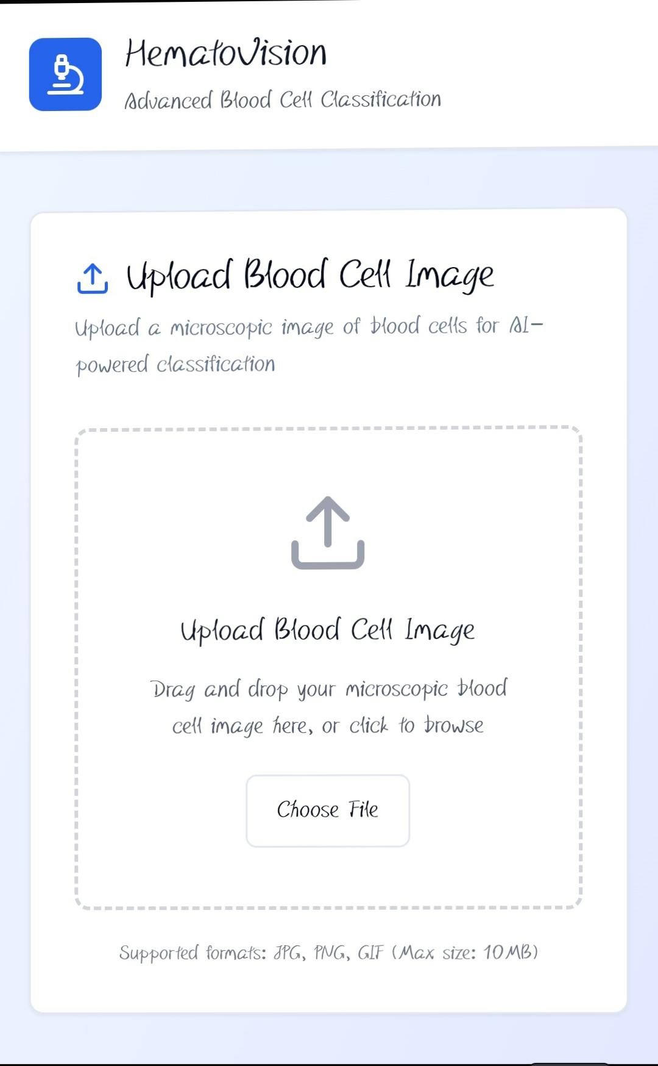

# 8. ADVANTAGES & DISADVANTAGES

Advantages:  
- Faster than manual methods  
- High accuracy  
- Easily scalable

Disadvantages:  
- Requires high-quality labeled data  
- May misclassify in poor lighting conditions

# 9. CONCLUSION

The project successfully demonstrates the use of transfer learning in classifying blood cells. It shows potential for practical deployment in healthcare environments for diagnostic support.

# 10. FUTURE SCOPE

- Extend to detect diseases like leukemia  
- Deploy on mobile apps or integrate with digital microscopes  
- Increase dataset diversity and robustness

# 11. APPENDIX

GitHub Code: https://github.com/ak-bharadwaj/hemato-vision-ai-classify