Laplacian Filter with CUDA
By Samaria Mulligan
The purpose of this experimen is to demonstrate various GPU implementations of the Laplacian filter using Nvidia’s CUDA interface. Since the Laplacian filter is highly parallelizable, and can apply to large image and filter sizes, the GPU is a well-suited tool to handle the application of Laplacian filters to an image.
All runs are done on the lab machines with a NVIDIA GeForce RTX 2070 GPU.

The algorithm
Given an image file I of size W×H and a Laplacian filter F of dimension D×D for an odd integer D, our goal is to derive the size W×H Laplacian filtered output, L. It can be noted L is a function of I, F. We chose the workqueue parallelization method with eight threads and a chunk size of 16×16 as the CPU implementation. This algorithm provided comparable performance to the row-sharding method, and provided highly consistent results.
We will now provide a GPU implementation of the same method. The GPU method consists of the following steps after obtaining the pgm image as a 1D matrix:
- Device memory phase: Device-side counterparts of I and F are allocated via the CudaMalloc(d, s) function. Call them d_I, d_F respectively.
- Transfer phase: Fill the device-side image and filter by their corresponding host-side counterparts via CudaMamcpy(d, h, s, cudaMemcpyHostToDevice).
- Filtering phase: Given input image d_I and filter d_F on the device, we run the corresponding kernel, to calculate the raw Laplacian filtered pixel values. This is called by kernel<<<B, T>>>(d_F, D, d_I, d_L, W, H) where:
  - B, T is the number of blocks and threads
  - d_L is the output
- Normalization phase: We perform normalization, using the same order of thread ordering. This is called by normalize<<<B, T>>>(d_L, W, H, p_{m}, p_{M}).
  - p_{m} and p_{M} are respectively min d_L, max d_L. They are already supplied on the CPU step.
- Return phase: Copy the device-side output back to the host-side output via CudaMamcpy(L, d_L, s, cudaMemcpyDeviceToHost).
- End phase: All hostside memory will be freed, and all device memory will be cudaFreed.
The phases will be timed via the cudaEvent calls between the relevant code. Let N = WH, the total number of elements in the image I and Laplace filtering L. The
runkernel(d_F, D, d_I, d_L, W, H, p_{m,} p_{M}) call performs the corresponding kernel and normalization step in one go.

Theory of Laplacian Filtering
The Laplacian filtering algorithm is effectively a double loop with N outer iterations across the pixels, each with D² inner iterations for each pixel, traversing through F. Viewing in respect to W, H, D, we basically have a quadruple loop.
The pixel at position row, col, is given by I[W*row + col]. Similarly, position ip, jp for F is given by F[D*ip + jp]. The corresponding offset to extract from I given the coordinates of I and F will be row_cur = row + ip – (D – 1)/2, col_cur = col + jp – (D – 1)/2.
Thus, L(I, F)[row][col] = ∑ F[ip][jp] I[row_cur][col_cur].
This suggests that the GPU algorithm is to perform a summation for each of the pixels. The workload is parallelized relative to the pixels.
The corresponding code, with pix = L[row][col] will be
for (int ip = 0; ip < dimension; ip++) {
for (int jp = 0; jp < dimension; jp++) {
int32_t row_cur = row + ip - (dimension - 1) / 2;
int32_t col_cur = col + jp - (dimension - 1) / 2;
if (row_cur >= 0 && row_cur < height && col_cur >= 0 && col_cur < width) {
pix += filter[dimension * ip + jp] * input[width * row_cur + col_cur];
}
}
}

Normalization
The normalization algorithm can also be done in parallel, with one thread per pixel, simply by performing a division sequence after inputting p_{m}, p_{M}. Without the CPU, we must provide an extra GPU step (this is now commented out).
The corresponding code, will be
image[idx] = ((image[idx] - smallest)*255) / (biggest - smallest);

Algorithm versions
There are five versions of the kernel, which differ by the access patterns based on thread number. The most important variables are:
- T: number of threads per block. This is limited to a hard constant, conventionally 512.
- B: number of blocks. Multiple blocks will be required if the image has size greater than 512. This can be calculated by (N + T – 1)/T so the quantity and quotient starts at one.
- idx: overall thread number. This is calculated via Tb + t where b is the current block number and t is the current thread number.
- Access order is the same for the filtering and normalization kernels.

Kernel 1: Column-major
The first few rows all reside on the first column. Thus, row = idx % H, col = idx / H.
Given thread with a given idx, the next thread accesses the element W indices forward.

Kernel 2: Row-major
This is the conventional ordering of a 2D matrix when collapsing to a 1D matrix. Here, row = idx / W, col = idx % W.
Given thread with a given idx, the next thread accesses the element 1 index forward.

Kernel 3: Sharded
This time, the number of threads will be reduced, and each thread will do the workload of an entire row. Thus, the idx is equivalent to the row and each thread performs its double loop using col as the outer loop and ip, jp as the inner loop counters.
We therefore have sharded access.

Kernel 4: 1 warp Strided
We are now given a single block, and the number of threads is now a single warp, T = 32. Given idx, the first index for that thread starts at index idx, and goes up by T per iteration.

Kernel 5: Termwise
Our optimization attempt attempts to maximize parallelization since we are performing a summation involving up to D² for each of the N pixels on the image. We will thus have a total thread count of D²WH.
Each thread, indexed by idx, will have its filter offset and pixel position information encoded. The filter offset is major, as the next thread calculates the corresponding term for the next pixel and the same offset, and if this thread represents the last pixel, the corresponding term corresponds to the first pixel and the next offset. The algorithm is row-major for both the filter and image matrices. We then have
int idx = blockIdx.x*blockDim.x + threadIdx.x; // thread index
int pixelindex = idx % (width*height);
int filterindex = idx / (width*height);

int row = pixelindex / width; // < height
int col = pixelindex % width; // < width
int ip = filterindex / dimension;
int jp = filterindex % dimension;
int row_cur = row + ip - (dimension-1)/2;
int col_cur = col + jp – (dimension-1)/2;

We perform all the summations at once. However, this may involve an if-condition to check that both the pixel index and filter position index are in bounds. We are basically computing L(I, F)[row][col] = ∑ F[ip][jp] I[row_cur][col_cur] in parallel as well. However, an atomic addition is required as the output is a critical section.
We basically achieved maximum granularity.
if (pixelindex < width * height && row_cur >= 0 &&
row_cur < height && col_cur >= 0 && col_cur < width)
{
atomicAdd(&(output[pixelindex]),
filter[dimension*ip + jp]*input[width*row_cur + col_cur]);
}

The normalization step for Kernel 5 is identical to 2 since there is only one operation per pixel for Kernel 5.

Running and testing the script
This C code takes in a filename as an input, performs the CPU and five different GPU implementations of the Laplace filter, prints out the timing data, and saves the file. The input files are in the ./samples folder, and all outputs should be placed to the ./outputs folder. You are required to provide the .pgm extension when typing the input file. The output file will add the .pgm extension for you noting the filename will be suffixed with a _G designator.
There is also a debug macro. Setting this to 1 causes the program to print out all of the wrong pixels. Setting debug mode to 2 also causes the program to print the pixel values of the input matrix, and setting debug mode to 3 allows printing the pixel values of the output matrix.
The CPU implementation updates p_{m} and p_{M} so no further GPU steps will be required. Otherwise, we still must reply on an extra GPU step which will cause some overhead and possibly dominate the runtime of the Laplacian filtering phase.
Therefore, I have modified all run_kernels so they must input p_{m} and p_{M}. This has effect on the testing code.

Sample files
We will test this code against various images, including small images (smaller than filter), medium images, large images, and images with the same N but differing aspect ratios.
./main -i ../samples/3,5.pgm -o "../outputs/s" # Small (N = 15)
./main -i ../samples/JENNYROM.pgm -o "../outputs/m" # Medium (N = 640k)
./main -i ../samples/LOG.pgm -o "../outputs/l" # Large (N = 5M)
./main -i ../samples/longcol.pgm -o "../outputs/c" # Column (W = 1)
./main -i ../samples/longrow.pgm -o "../outputs/r" # Row (H = 1)
./pgm_creator 1 1 "../samples/pixel.pgm" # Pixel (N = 1)
./pgm_creator 2048 2048 "../samples/square.pgm" # N = 4194304 with various aspect ratios
./pgm_creator 1048576 1 "../samples/wide.pgm" # H = 4
./pgm_creator 1048576 4194304 "../samples/tall.pgm" # W = 4

These files will be run 100 times each, and the output file will be parsed by a Python script, generate_graphs.py, which will then display a logarithmic graph of the filtering-then-normalization runtime.

Runtime Results
We have pitted our CPU and GPU implementations to Laplacian filter these images to find their average speedup. We are disappointed that Kernel 4 performed worse than the CPU, and Kernel 5 underperformed. It only performed comparable to the column major kernel.
A speedup factor less than 10⁰, indicate the the kernel even underperformed relative to the CPU, and thus is completely unsuitable for this type of image.

Legend
CPU | Kernel 1:  Column Major | Kernel 2:  Row Major | Kernel 3:  Row Sharded | Kernel 4:  Warp Strided | Kernel 5:  Optimization

Sample graphs

Large (2400×2400)
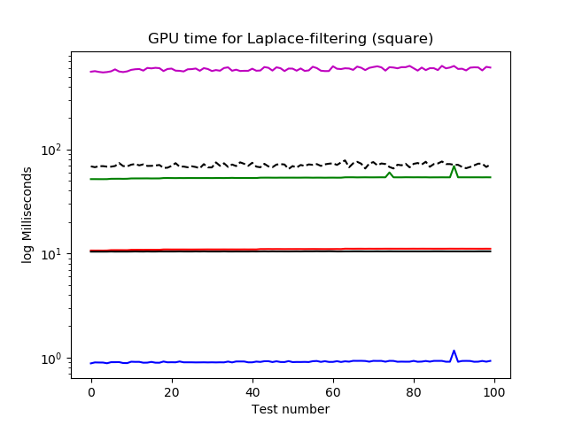 | 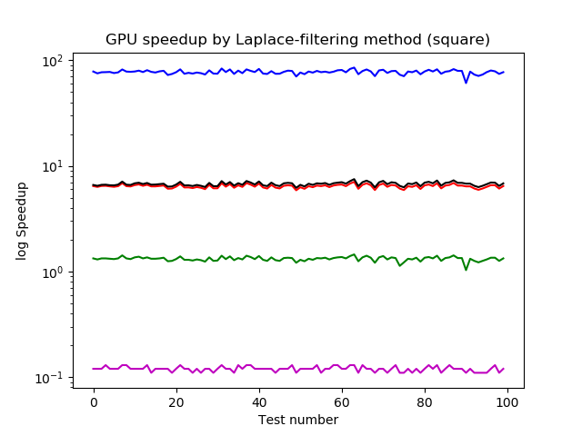
The optimized kernel only performed slightly better than the column-major kernel. The row-major kernel performed almost 100 times better.
The row-sharded kernel only performed slightly better than the CPU, and the warp-strided kernel performed very poorly.
Medium (800×800)
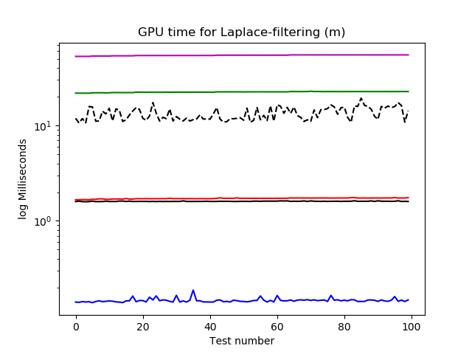 | 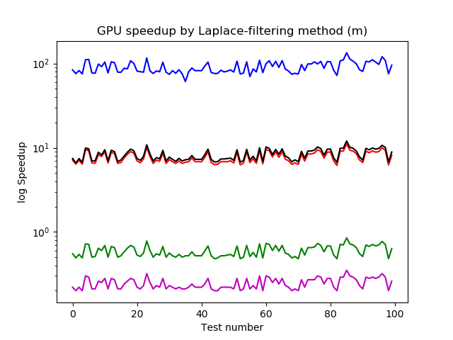
Again, the optimized kernel only performed slightly better than the column-major kernnel. This time, both Kernel 3 and 4 underperformed relative to the CPU.

Small (3×5)
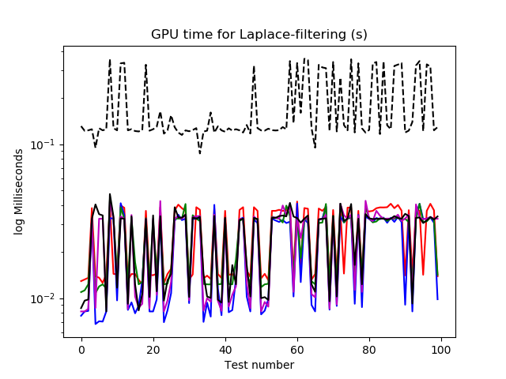 | 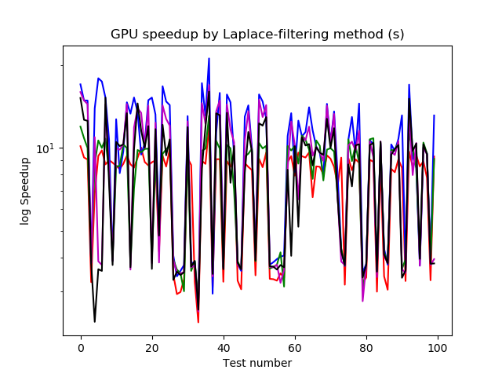
There is a performance benefit when using the GPU. However, the performance between various implementations are nonexistant for small images. The overall speedup, counting transfer overheads, is around 3.

Row (1914)
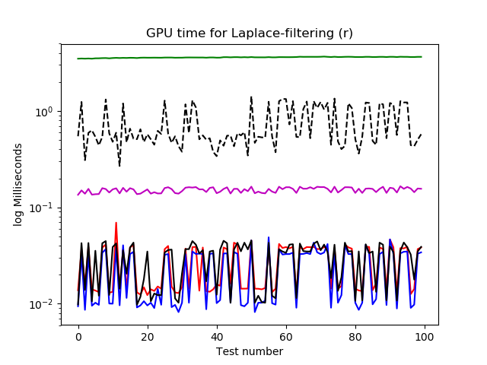 | 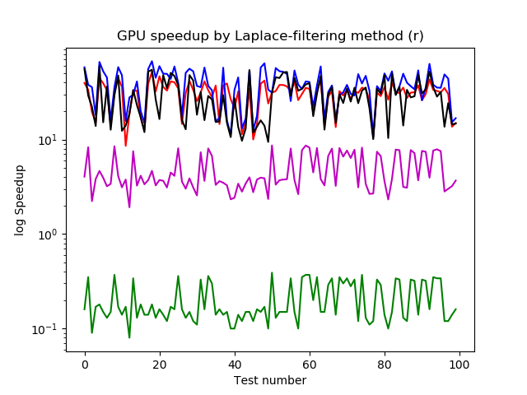
For a somewhat long one-row image, the performance is negligible between Kernels 1, 2, and 5, where each thread processes one pixel. Kernel 3 underperformed this time, because there is only one thread used for Kernel 3.
Column (1080)
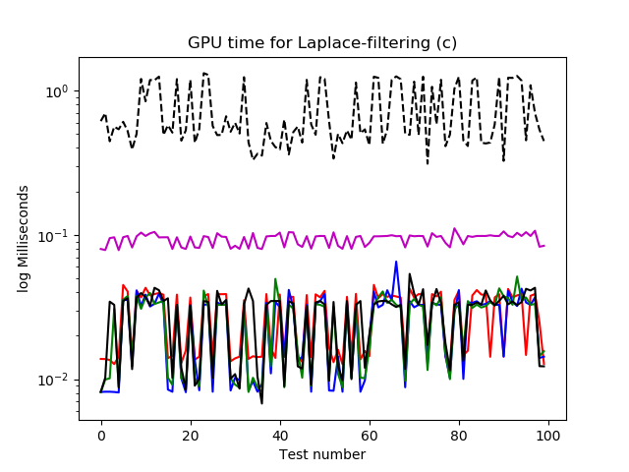 | 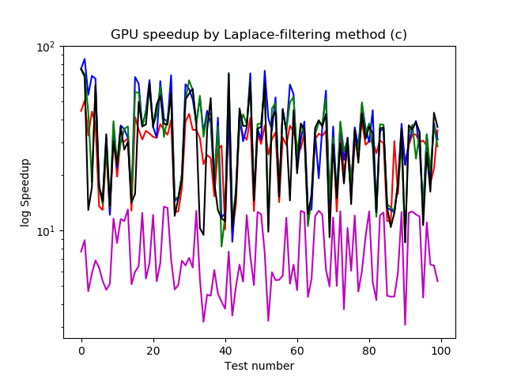
Again, negligible performance difference, except for Kernel 4 mainly due to the fewer number of threads (32 rather than 1080).
N=2048² (Square, Wide, Tall)
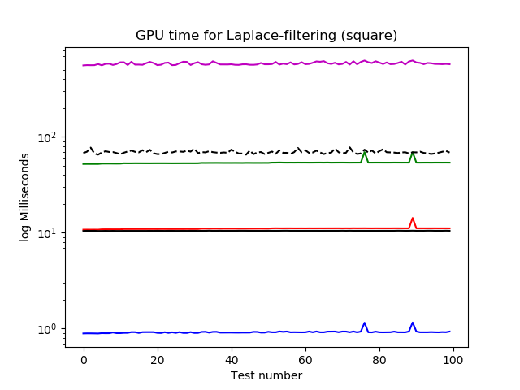 | 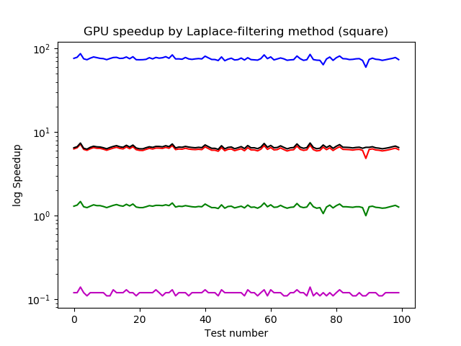
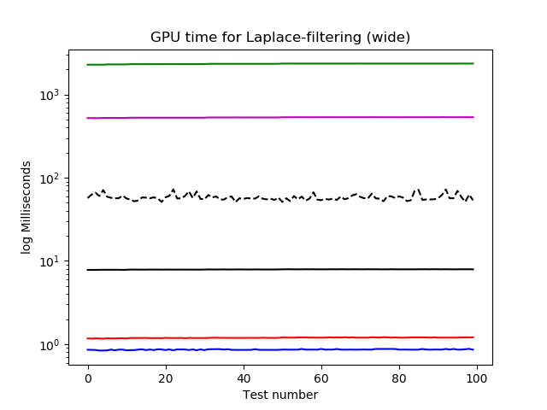 | 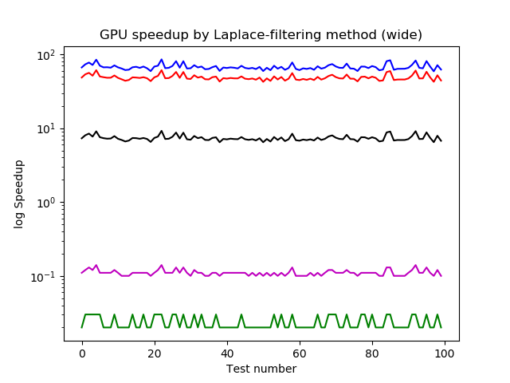
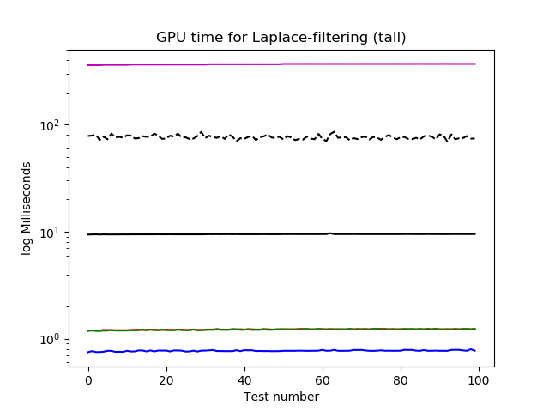 | 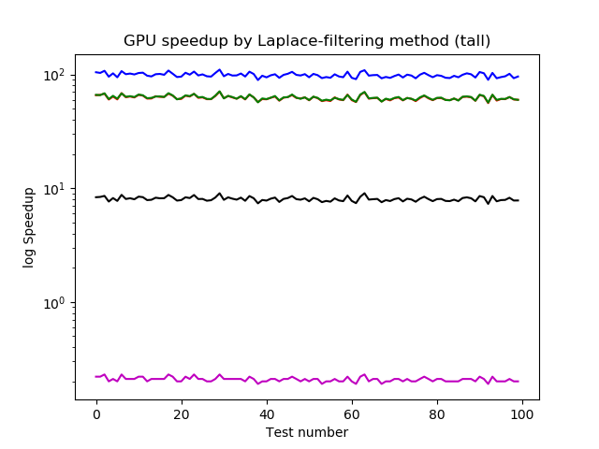
From these charts with the same N count, we noticed the attempted optimization underperformed, and not only that, it even underperformed Kernels 1 and 2 for long images. We must devise another way to perform this level of parallelization correctly and without causing delaying actions like branches and transfer overhead.

Discussion
The speedup is negligible for small images; both the CPU and GPU performed similarly on average. Kernels 3 and 4 always use less threads compared to Kernels 1 and 2, while Kernel 5 used the most amount of threads. We can also note that implementing GPU code with only a few threads compared to the CPU with the same number of threads is highly inefficient and can result in severe underperformance especiall with the row-sharded kernel agains a wide but not very tall image.
We are disappointed that Kernel 5 underperformed despite attempting to maximize parallelism by peerforming all of the summation per pixel at once. The motivation for Kernel 5 is to parallelize both the workload-per-pixel and the workload-per-term, as each term is associated with a particular offset encoded by ip, jp.

Performance of Kernels
All five kernels use only the global memory. Kernels 1 to 4 are MIMT models, while Kernel 5 uses the SIMT model. Kernel 2 performed better than Kernel 1 due to memory coalescing. Kernels 3 and 4 are suboptimal since GPU are not well-suited for handling serial code.
One reason for the Kernel 5 underperformance is that the code runs divergently, which occurs for threads corresponding to edge pixels. On edge pixels, certain offsets will result in the row_cur, col_cur to be out of bounds. An example is the thread corresponding to te topleftmost pixel and the topleftmost filter offset, where row = col = ip = jp = 0. The algorithm tells to refer to I[–(D – 1)/2][–(D – 1)/2], which is out of bounds.
Another reason is that Kernel 5 relies on synchronization, since adding
F[ip][jp] I[row_cur][col_cur] to each L(I, F)[row][col] may cause a race condition if the two threads have the same row and column number. Can we try running Kernel 5 via successive calls of Kernel 2 except with an extra offset flag?

Proposals to further improve the algorithm
Since Kernel 5 is based on Kernel 2, our extra step is to further parallelize Kernel 2 bby parallelizing the addition step. We can visualize L(I, F) as a sum of matrices, in which each term represents a particular filter offset ip,jp. Thus, each term, indexed by the filter offset, will be notated LF(I, F, ip,jp) and satisfies
LF(I, F, ip,jp)[row][col] = F[ip][jp] I[row_cur][col_cur] if row_cur, col_cur are in bounds
LF(I, F, ip,jp)[row][col] = 0 otherwise (implemented by an if loop)
L(I, F) = ∑ LF(I, F, ip,jp)
One can attempt to avoid divergent code by “padding” I with (D – 1)/2 zeroes to avoid divergent code. However, that would increase the array size which will affect all calls by offset number.
One can also attempt to make D² copies of I, and then calculate LF(I, F, ip,jp) for each ip,jp. This may cause transfer delays since transferring is fundamentally a CPU operation. Then, L(I, F) can be achieved using parallel summation.
One can also use shared memory, with each block representing a pixel. The threads correspond to filter offsets. One then use the threads to calculate the terms LF(I, F, ip,jp)[row][col], in which then we use parallel reduction to find L(I, F)[row][col].

Testing
The way the testing code is structured is not too suited without significant modifications, since all of the runkernels have their scripts modified (a p_{m} and p_{M} variable are added to accommodate normalization without repeating code), and there is confusion regarding using the hostside code and deviceside code between run_best_cpu and runkernel. Notably, runkernel used only deviceside arrays, while run_best_cpu used only hostside arrays, while the test files all used the hostside matrices.
I have added a customizable debug step, which is skipped if the macro DEBUGMODE is 0. The debug step outputs to stderr in the event of a mismatch between the correct CPU implementation and the erroneous GPU implementation.

