[**VISHNU MULLICK**](https://mullv10.github.io/home)

**Computer Science Major** |**Basketball Enthusiast**

[v.mullick@me.com](mailto:v.mullick@me.com) | [LinkedIn](https://www.linkedin.com/in/vishnu-mullick/) | South Setauket, NY | (631) 875-189

**EXPERIENCE**

**Tekscape** New York City

Field Tech InternJune 2019 - Present

* Support the IT team to maintain hardware, software and troubleshoot IT issues in multiple NY city schools and lend IT support in areas such as cybersecurity, programming, analytics and data center as needed.

**Hyatt Regency Long Island** Hauppauge, NY

Front Office SupervisorSeptember 2016 - Present

* Lead front desk operations to provide all guests with optimal customer services including efficient check-in procedures. managed guest payments using proprietary systems, adhering to safety policy at all times

**Days Inn Hotel and Conference Center** Meadville, PA

Front Desk AgentJune 2012 – June 2016

* Collaborated with a team of nine employees to administer front-desk duties, resulting in efficient operations and a positive work environment that promotes teamwork, recognition, mutual respect and employee satisfaction

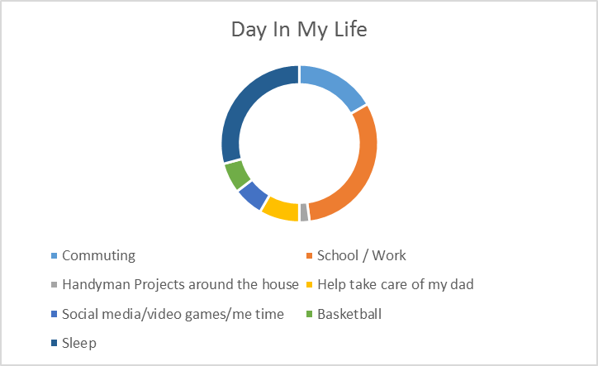**TYPICAL DAY OF MY LIFE**

**TECHNICAL SKILLS/ LANGUAGES**

**Programming Languages**: Java, Python, C++, HTML, SQL, JavaScript

**Software**: Eclipse, Git, VM sphere

**Operating Systems**: MacOS, iOS, Linux, Windows

**Database**: MySql

**Verbal:** English and Hindi

**RELEVANT COURSEWORK**

Data Structures and Algorithms | Fundamentals of UNIX and C Programming | Algorithms & Computing Theory | Web Design Programming Language / Implementation | Operating Sys/Architecture | Web Computing | Mobile Web Development | Software Engineering

**ACADEMIC PROJECTS**

**Parking Lot Application** April 2017

* Designed and coded a parking lot web application using lists in Java to increase operational efficiency

**Hotel Lodging**  October 2016

* Conducted studies for American Hotel and Lodging Association (AHLA) to determine best practices related to charging franchisees for proactive matching on guest reward programs, and consequently implement reward changes

**EDUCATION**

**Pace University, Seidenberg School of Computer Science and Information Systems New York, NY**

Bachelor of Science (BS) in Computer Science | **GPA**: 3.0 | Graduating in December 2019