Training & Certification Platform
Project Document

1. ERD and Database Design
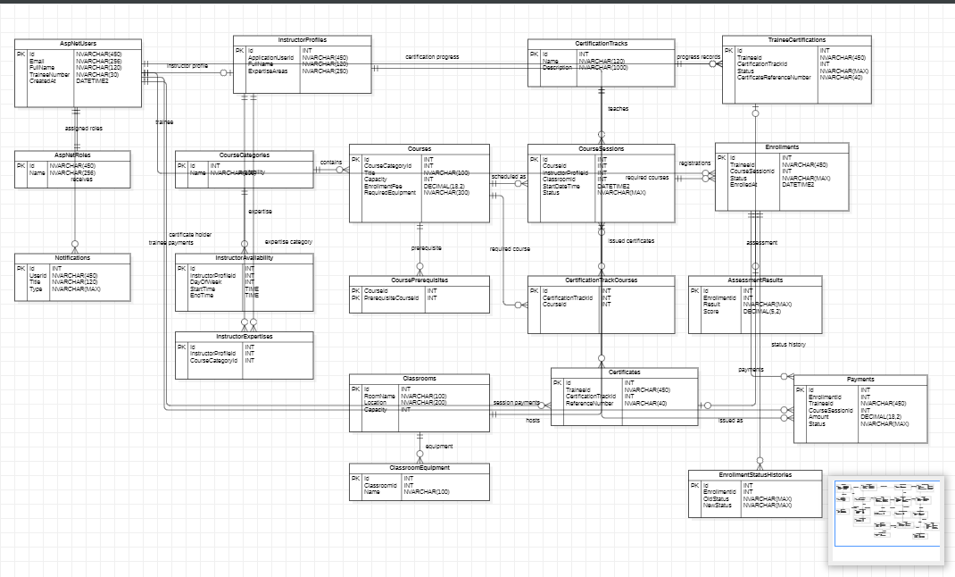

Figure 1: ERD for the Training & Certification Platform.
Explanation:
The diagram shows the main database flow for the training and certification system. User accounts are stored in AspNetUsers and are linked to roles through AspNetRoles. A user can optionally have one instructor profile, while trainee users can have many enrollments, payments, certification progress records, and certificates.
CourseCategories group Courses in a one-to-many relationship. A Course can be scheduled many times through CourseSessions. Each CourseSession belongs to one Course, one InstructorProfile, and one Classroom. This supports scheduling rules such as instructor assignment, room assignment, capacity, and status tracking.

Enrollments connect trainees to course sessions. One CourseSession can have many Enrollments, and one trainee can have many Enrollments. Each Enrollment can have zero or one AssessmentResult because an assessment is only recorded after completion. Each Enrollment can also have many Payments.
CertificationTracks define certification paths. CertificationTrackCourses links each track to its required courses. Certificates are issued to users for a certification track after the required courses are passed. The certificate reference is kept unique for public verification.
Supporting tables shown or described include CoursePrerequisites for prerequisite rules, Notifications for user messages, InstructorAvailability for instructor schedules, InstructorExpertises for category expertise, ClassroomEquipment for room resources, and EnrollmentStatusHistories for tracking status changes.
The database extends ASP.NET Core Identity with domain tables for training operations. Users are assigned to Trainee, Instructor, and TrainingCoordinator roles. Instructors have profiles, availability, and category expertise. Courses belong to categories, can define prerequisite courses, and are scheduled as course sessions with an instructor and classroom. Trainees enroll into sessions, receive payment records, status history, and assessment results. Certification tracks define required courses; trainee certification status and issued certificates are tracked separately. Notifications support operational messages such as enrollment updates, schedule changes, assessment results, and certification eligibility.
Key design decisions and assumptions:
- ASP.NET Identity is kept as the authentication source of truth, while domain-specific fields such as FullName and TraineeNumber are added to ApplicationUser.
- Many-to-many relationships are modeled with explicit join entities where business rules or uniqueness constraints matter, such as CoursePrerequisites, CertificationTrackCourses, and InstructorExpertises.
- CourseSession stores instructor, classroom, date/time, capacity, and status so scheduling conflicts and capacity checks can be enforced independently of the course template.
- Enrollment status, payment status, assessment result, session status, notification type, and trainee certification status are stored as strings for readability and safer reporting.
- NoAction/Restrict delete behavior is used around enrollments, payments, and course prerequisites to avoid accidental cascade deletion of historical training records.
- Unique indexes prevent duplicate trainee enrollments per session, duplicate instructor expertise entries, duplicate certification-track course requirements, and duplicate certificate references.
Entity / Table Group | Description
ApplicationUser / Identity tables | Stores users, credentials, roles, claims, full names, and trainee numbers.
CourseCategory, Course | Defines the course catalogue, category grouping, duration, capacity, fee, and equipment needs.
CoursePrerequisite | Defines prerequisite course relationships before enrollment.
InstructorProfile, InstructorAvailability, InstructorExpertise | Captures instructor identity, skills, timetable availability, and category specialisms.
Classroom, ClassroomEquipment | Stores rooms, capacities, locations, and available equipment for scheduling validation.
CourseSession | Represents a scheduled delivery of a course with instructor, room, time range, status, and capacity.
Enrollment, EnrollmentStatusHistory | Tracks trainee registrations, lifecycle changes, and audit notes.
AssessmentResult | Records pass/fail assessment outcome, score, timestamp, and instructor notes.
Payment | Records enrollment/session/trainee payments, amount, method, status, and notes.
CertificationTrack, CertificationTrackCourse | Defines certification paths and required courses.
TraineeCertification, Certificate | Tracks certification progress, eligibility, issue date, and verifiable reference numbers.
Notification | Stores user notifications for enrollment, payment, schedule, assessment, and certification events.

2. Demo Credentials
Local URLs: API http://localhost:5001, MVC http://localhost:5002, Reporting http://localhost:5003. Deployment URLs are not stored in this repository; the deployed version should use the same seeded accounts after migrations and DbInitializer run, unless production credentials are intentionally changed.
Role | Version | Username | Password
TrainingCoordinator | Local MVC / Reporting | tcp.coordinator@gmail.com | Admin@12345
Instructor | Local MVC | tcp.instructor@outlook.com | Admin@12345
Instructor | Local MVC | tcp.instructor2@outlook.com | Admin@12345
Trainee | Local MVC | tcp.trainee@gmail.com | Admin@12345
Trainee | Local MVC | tcp.trainee2@gmail.com | Admin@12345
TrainingCoordinator | Deployed MVC / Reporting | tcp.coordinator@gmail.com | Admin@12345
Instructor | Deployed MVC | tcp.instructor@outlook.com / tcp.instructor2@outlook.com | Admin@12345
Trainee | Deployed MVC | tcp.trainee@gmail.com / tcp.trainee2@gmail.com | Admin@12345

3. API Documentation
Route | Method | Purpose | Authentication
/api/auth/login | POST | Authenticate API/reporting client and return JWT. | Public
/api/auth/register | POST | Register a public trainee account. | Public
/api/courses | GET | List active courses with category, fee, prerequisites, and equipment. | JWT
/api/courses/{id} | GET | Return one course with upcoming session summaries. | JWT
/api/courses/{id}/sessions | GET | List available upcoming sessions for a course. | JWT
/api/sessions | GET | List scheduled sessions. | JWT
/api/sessions | POST | Create a validated session after instructor/classroom checks. | TrainingCoordinator JWT
/api/sessions/{id}/cancel | POST | Cancel a session and notify affected users. | TrainingCoordinator JWT
/api/enrollments | POST | Create enrollment after duplicate, prerequisite, and capacity checks. | JWT
/api/enrollments/my | GET | Return authenticated trainee enrollments. | Trainee JWT
/api/enrollments/session/{sessionId} | GET | Return trainee list for a session. | TrainingCoordinator or Instructor JWT
/api/enrollments/{id}/status | PUT | Update enrollment lifecycle status. | TrainingCoordinator or Instructor JWT
/api/enrollments/{id}/drop | POST | Drop an enrollment when rules allow it. | JWT
/api/enrollments/assessment-results | POST | Record assessment result and trigger certification eligibility check. | TrainingCoordinator or Instructor JWT
/api/enrollments/sessions/{sessionId}/remaining-seats | GET | Return remaining seat count for live UI updates. | Public
/api/public/certification | GET | Public certificate/certification lookup by trainee and reference. | Public
/api/certificates/verify | GET | Verify certificate reference and return completed courses. | Public
/api/certificates/generate | POST | Generate certificate when trainee is eligible. | TrainingCoordinator JWT
/api/reports/enrollment-stats | GET | Enrollment counts grouped by course/category with optional date filter. | TrainingCoordinator JWT
/api/reports/instructor-workload | GET | Instructor session, trainee, and completion workload. | TrainingCoordinator JWT
/api/reports/certification-completion | GET | Certification progress counts per track. | TrainingCoordinator JWT
/api/reports/revenue | GET | Revenue, outstanding balances, and overdue flags per session. | TrainingCoordinator JWT

4. NuGet Packages
Package | Project(s) | Purpose
AutoMapper.Extensions.Microsoft.DependencyInjection 12.0.1 | API | Registers AutoMapper profiles for object/DTO mapping support.
Microsoft.AspNetCore.Authentication.JwtBearer 8.0.11 | API | Enables JWT bearer authentication for API and reporting clients.
Microsoft.AspNetCore.Identity.EntityFrameworkCore 8.0.11 | API | Stores ASP.NET Core Identity users, roles, claims, logins, and tokens through EF Core.
Microsoft.AspNetCore.SignalR 1.2.0 | API | Supports real-time remaining-seat updates via EnrollmentHub.
Microsoft.EntityFrameworkCore.SqlServer 8.0.11 | API, MVC | SQL Server provider for EF Core persistence.
Microsoft.EntityFrameworkCore.Tools 8.0.11 | API | Migration and design-time tooling for database schema generation.
Swashbuckle.AspNetCore 6.9.0 | API | Generates Swagger/OpenAPI documentation in development.

5. System Walkthrough
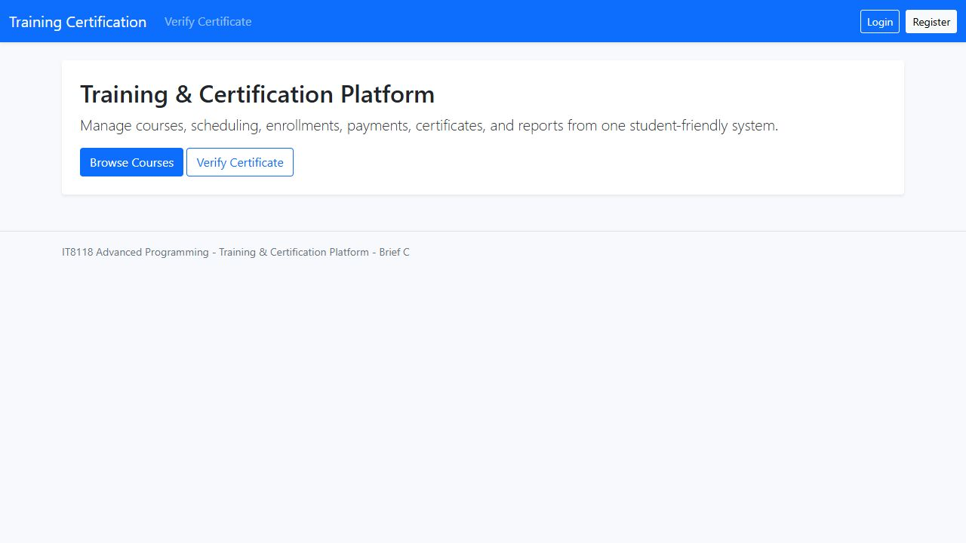
Public home page: entry point for course discovery, login, registration, and certificate verification.
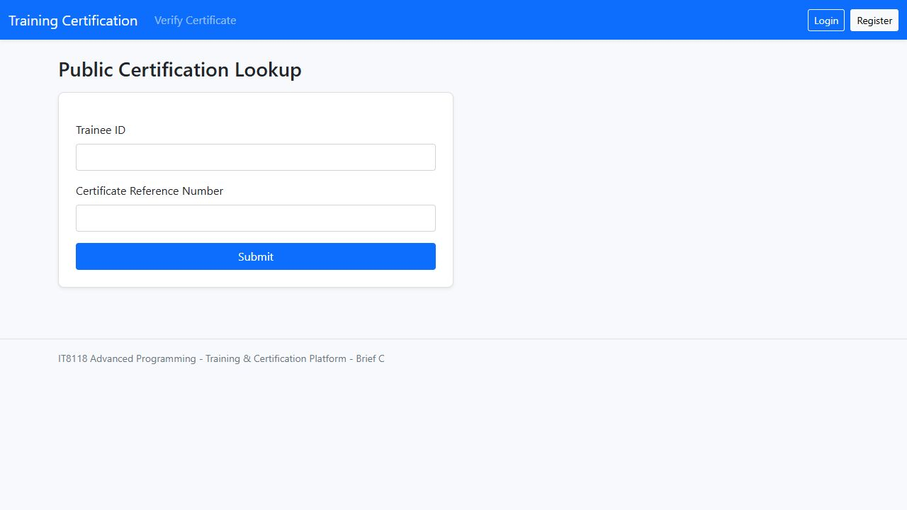
Public certificate lookup: verifies a trainee certification/reference without requiring login.
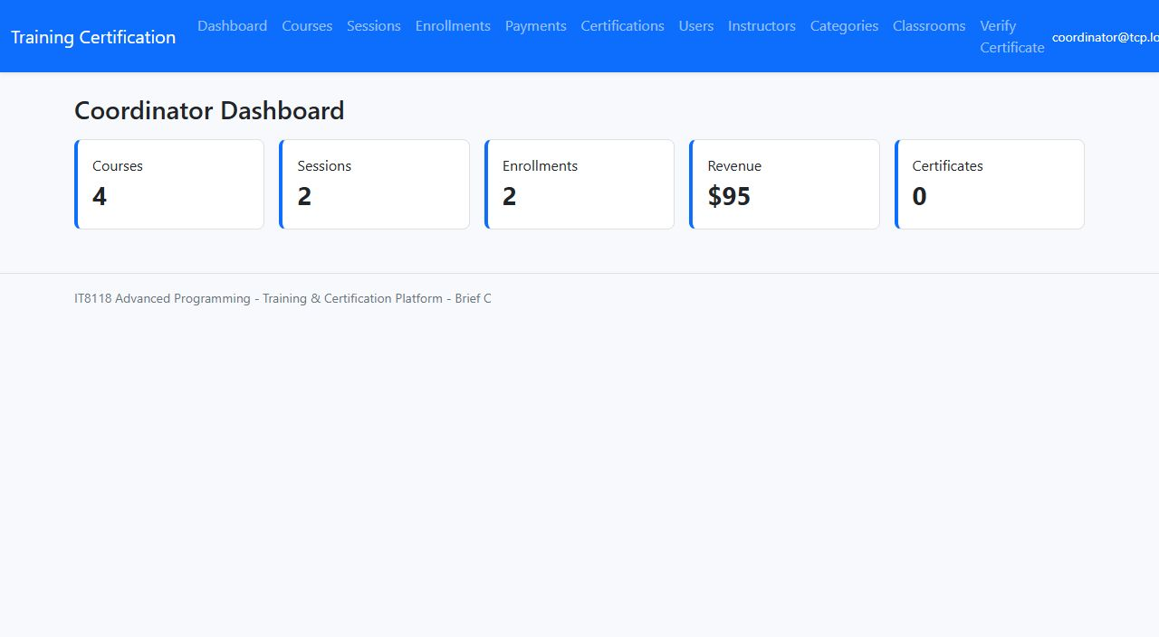
Training coordinator dashboard: operational summary of courses, sessions, enrollments, revenue, and certificates.
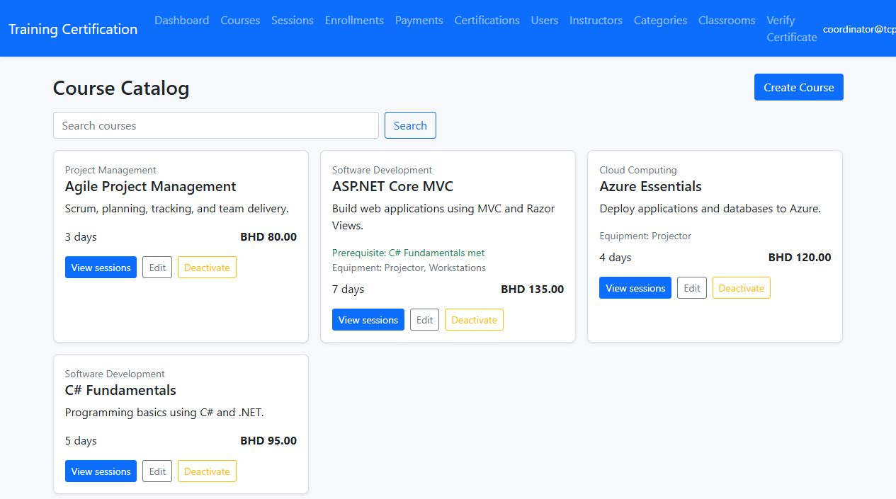
Coordinator course management: catalogue view with categories, capacity, fees, prerequisites, and equipment requirements.
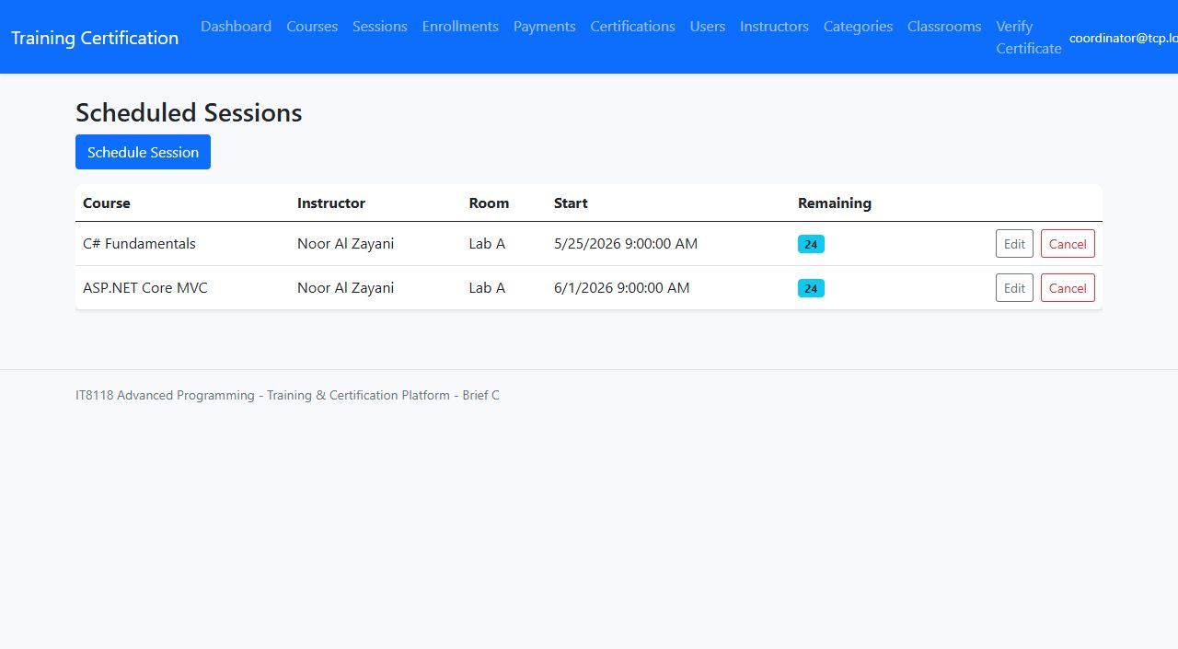
Coordinator session management: schedule view for instructor/classroom/date assignments.
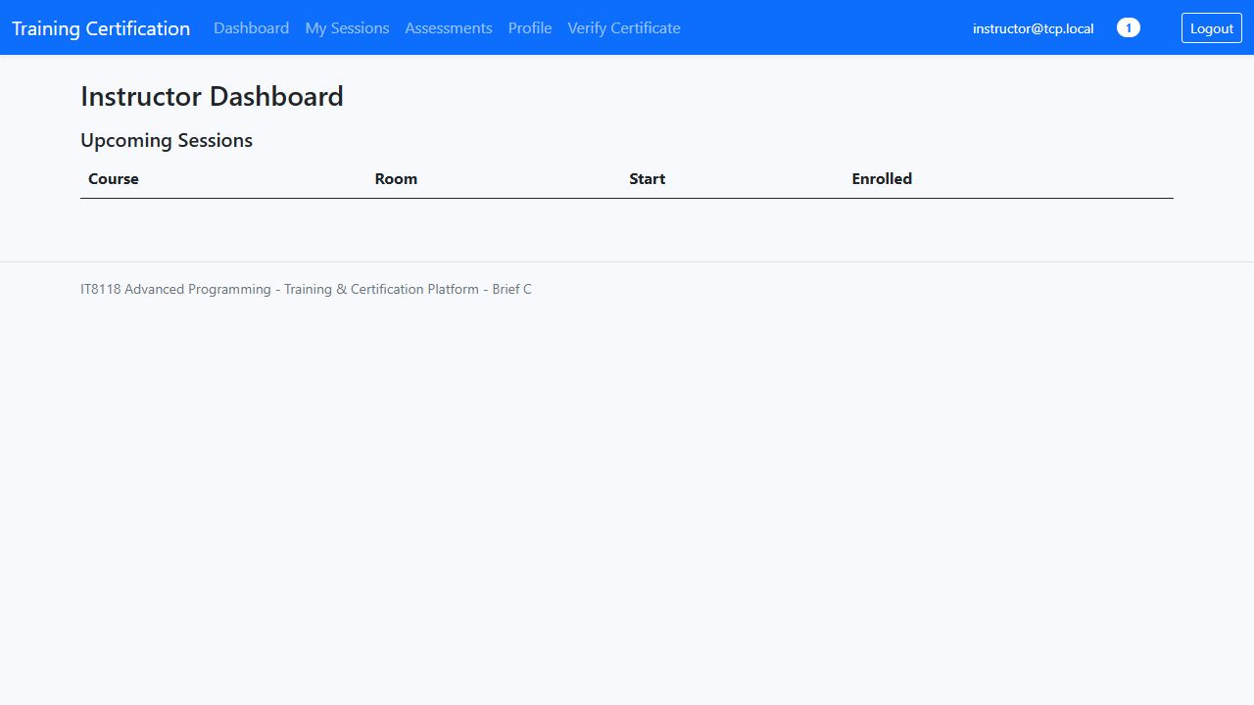
Instructor dashboard: assigned/upcoming sessions and access to assessment workflows.
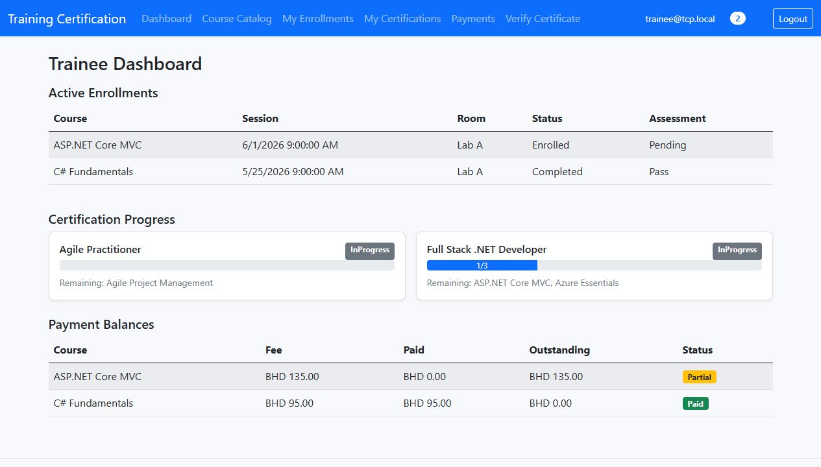
Trainee dashboard: active enrollments, certification progress, and payment balances.
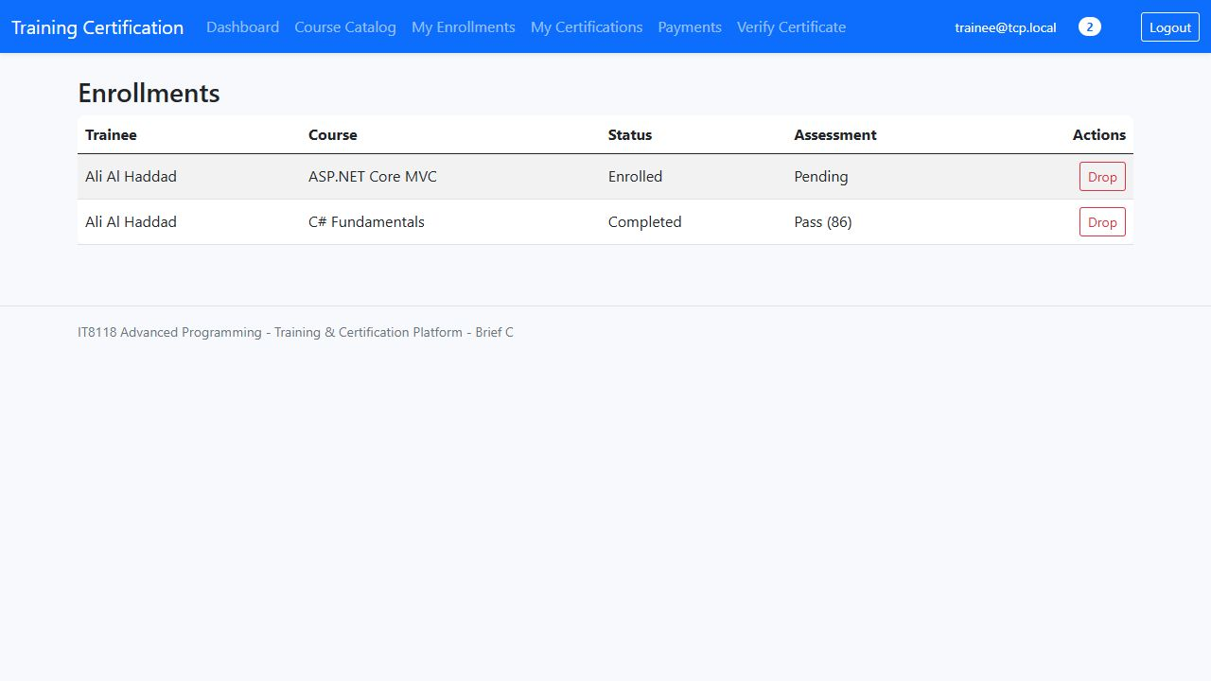
Trainee enrollment view: shows registered sessions and current statuses.
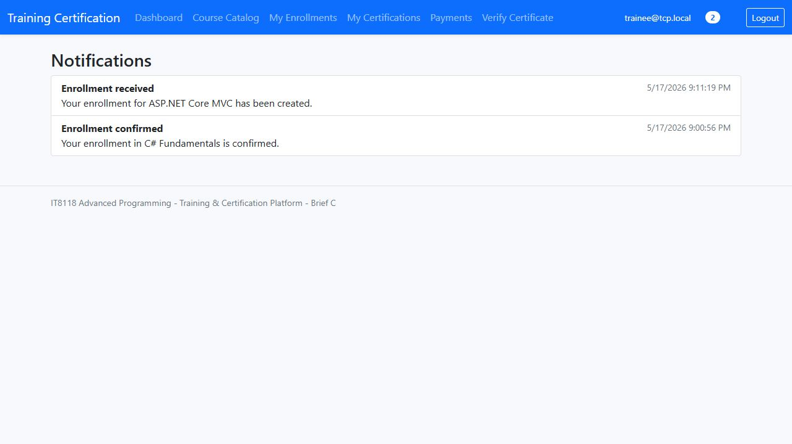
Notifications view: user-facing operational messages.
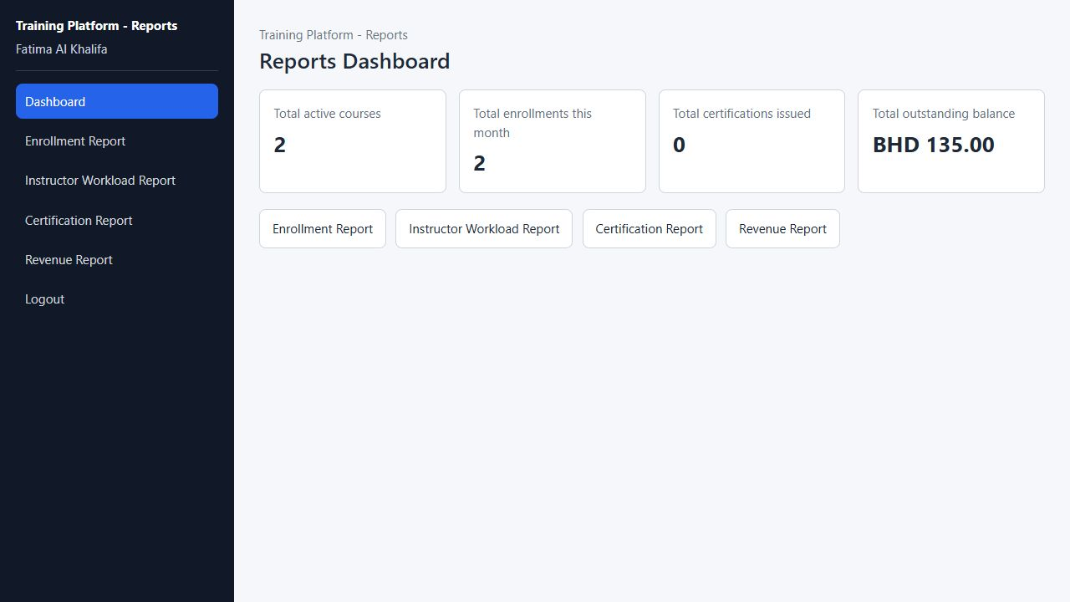
Reporting portal: coordinator-only reporting dashboard using JWT/API calls rather than direct DbContext access.

6. Enhancements

Real-time seat awareness
The API exposes a public remaining-seats endpoint and SignalR hub so course/session pages can show current availability without a full page refresh.

Enhancement screenshot: Real-time seat awareness.

Certification progress tracking
Trainees can see progress across certification tracks, remaining required courses, and issued/eligible status.

Enhancement screenshot: Certification progress tracking.

Payment balance handling
Payment records are tied to enrollment, trainee, and session, allowing paid/partial/outstanding balance views and revenue reporting.
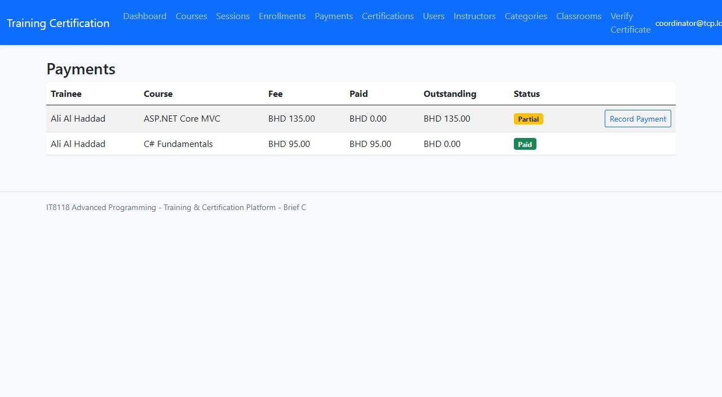
Enhancement screenshot: Payment balance handling.

Separate reporting portal
The Reporting project authenticates with JWT and consumes API endpoints only, demonstrating separation from direct database access.
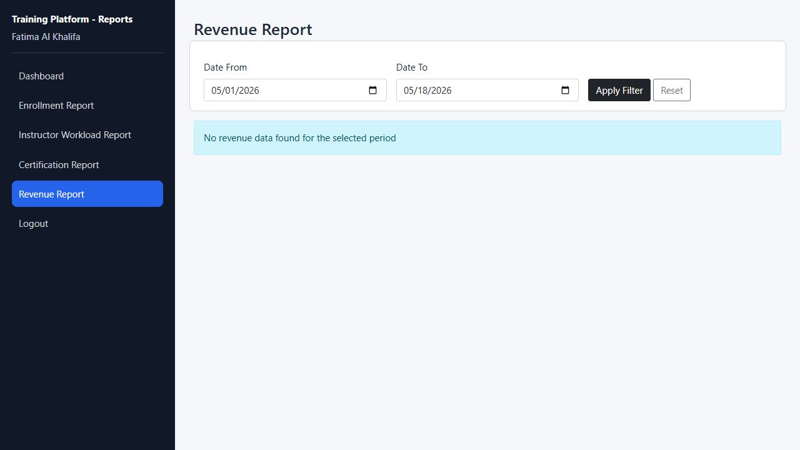
Enhancement screenshot: Separate reporting portal.

Public certificate verification
External users can verify a certification reference through public MVC/API lookup screens without needing an account.

Enhancement screenshot: Public certificate verification.

Scheduling and enrollment edge cases
Business services enforce instructor availability, room conflicts, classroom capacity, course prerequisites, duplicate enrollment prevention, 24-hour drop rules, and certificate eligibility after pass results.

Enhancement screenshot: Scheduling and enrollment edge cases.

