**Kyle Simpson – Author of You Don’t Know JS**

Imposter syndrome!

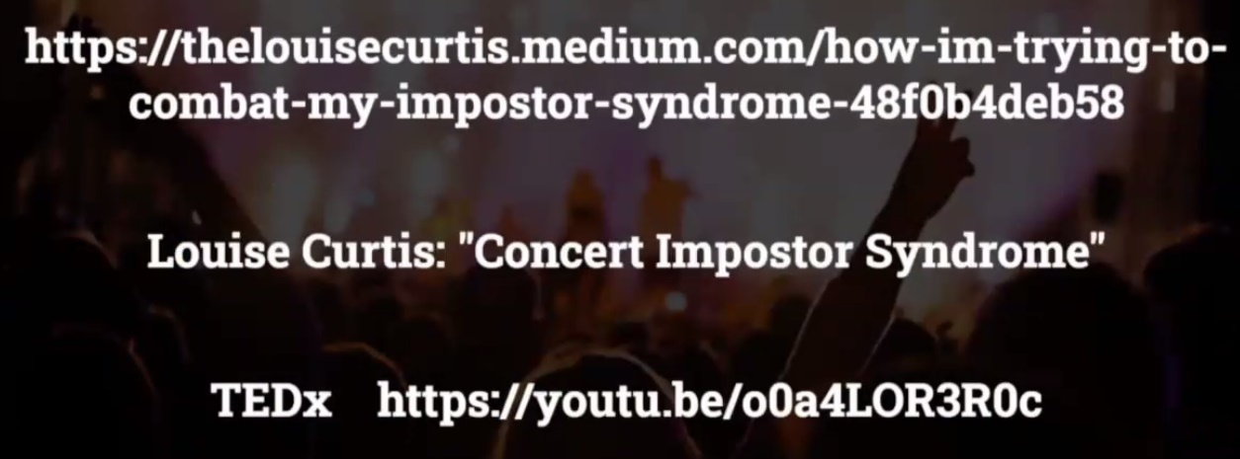

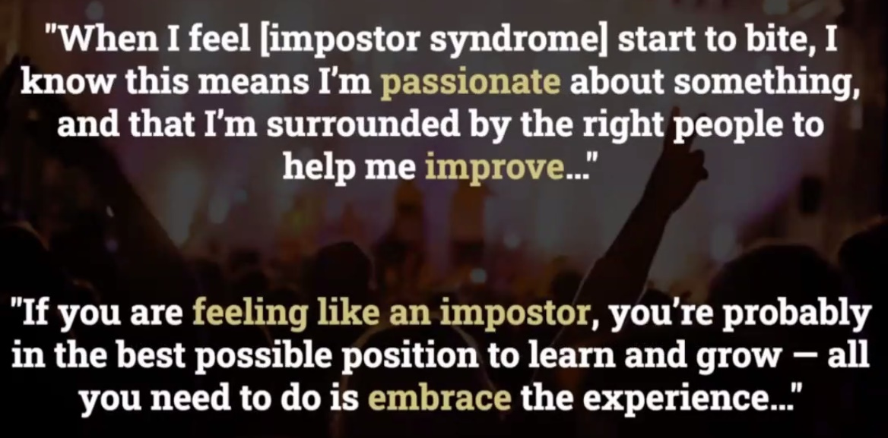

If you wait until you’re an “expert”, you waited too long. It’s the journey that matters most!

Strive to be this type of imposter:

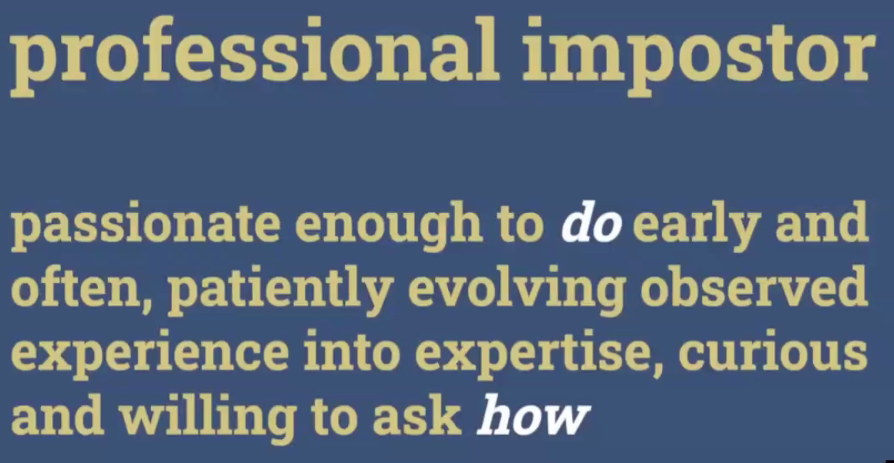

Doing something that is just good enough to get the job done is still good!

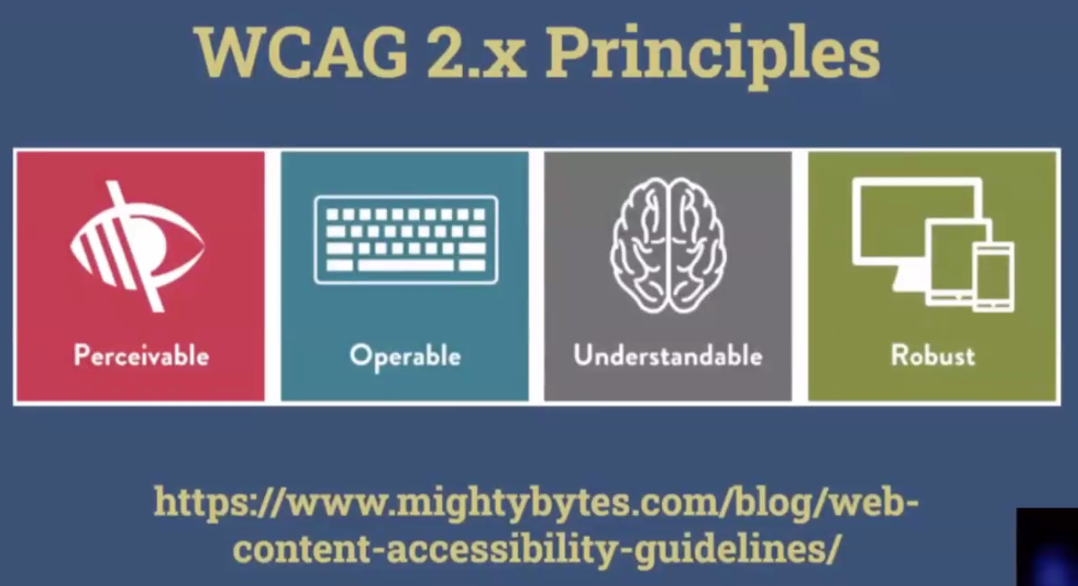



**A question to ask at Interview:**

**Tell me 6 months in and 12 months in, what you think I will have learned on the job?** (Or 1 year and 5 year)

Remember job postings should be a listing of what they expect you to be able to learn, rather than a list of qualifications you need to be able to do the job

Open-Source code – **good first issue**, when you’re a new contributor/maintainer, look for this label to see what you might be able to help with as a junior developer. Likewise if/when you become senior, leave the small issues for the juniors to fix so they can get better! Like a trail of breadcrumbs for the future generation!

Best advice – remember the people behind the pixels. Everything you are doing is about solving human problems, working with other humans etc. We just happen to use technology to communicate with other humans…We don’t serve machines, they serve us. “All I can do is what I can make the computer do” is NOT TRUE! As you can do more than a computer!