# Will Peachey – a Director of SOC

## Designing Data for Business Decision Making

The first rule of producing data for others is “Everyone else is an idiot!”

Top chart should be formatted like bottom chart as they are not comparable in the top chart (even though they appear to be)

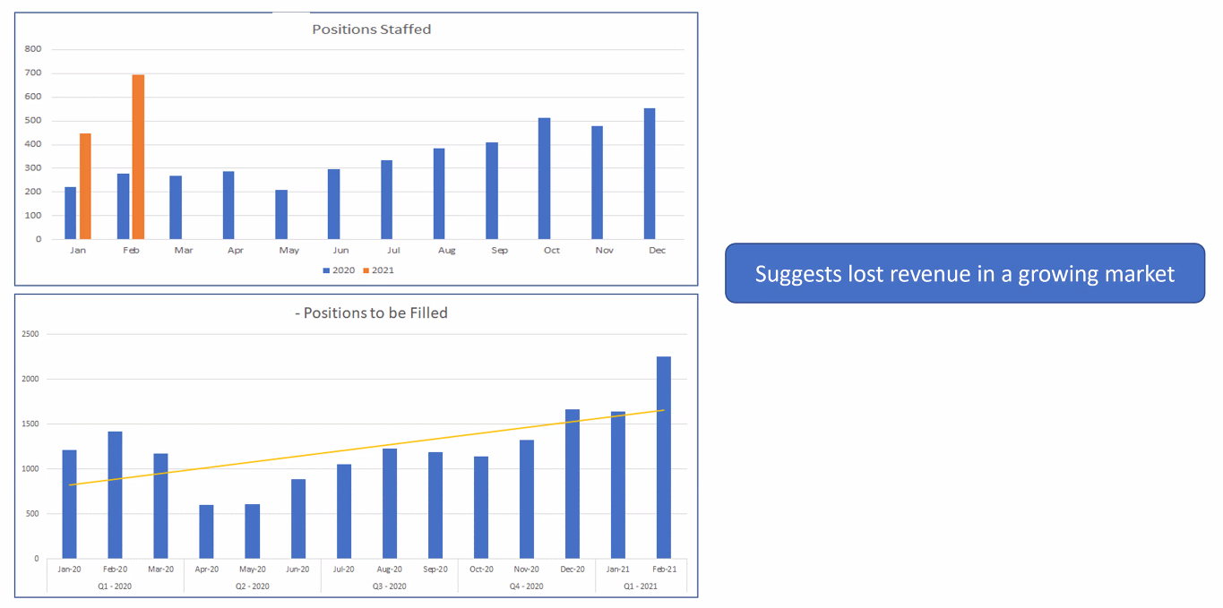

This data is difficult to understand by looking at but Will was able to explain it. His point is the data should be self-explanatory!

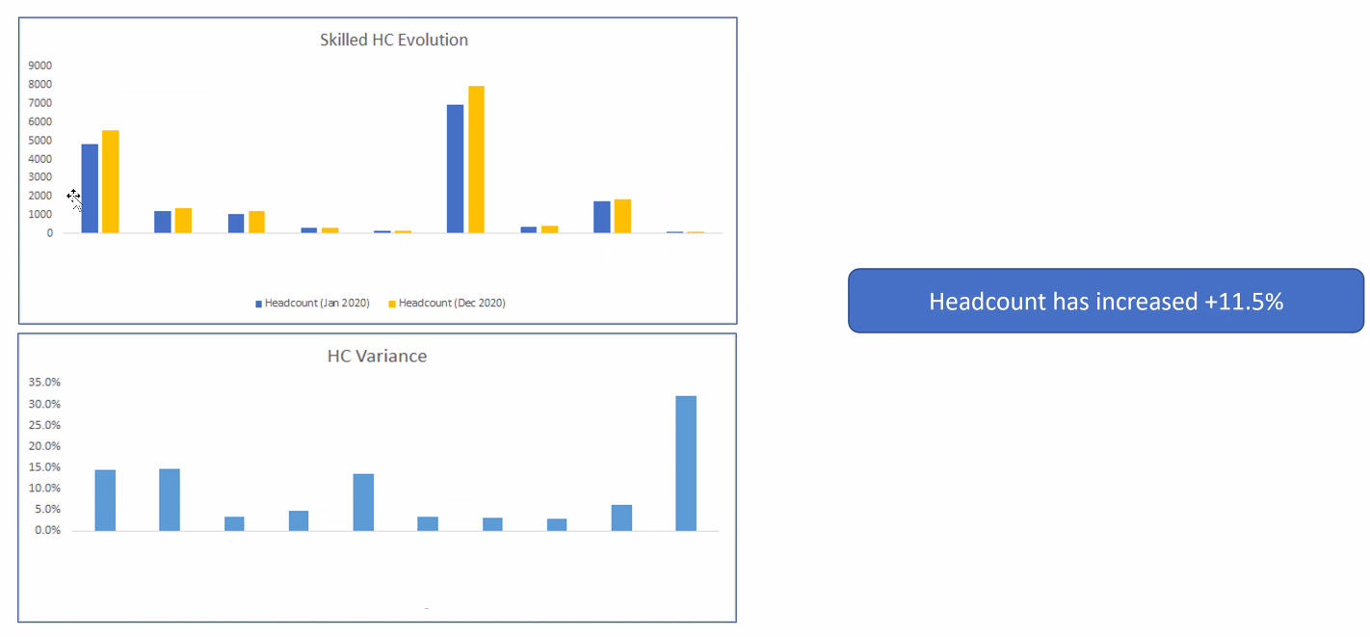

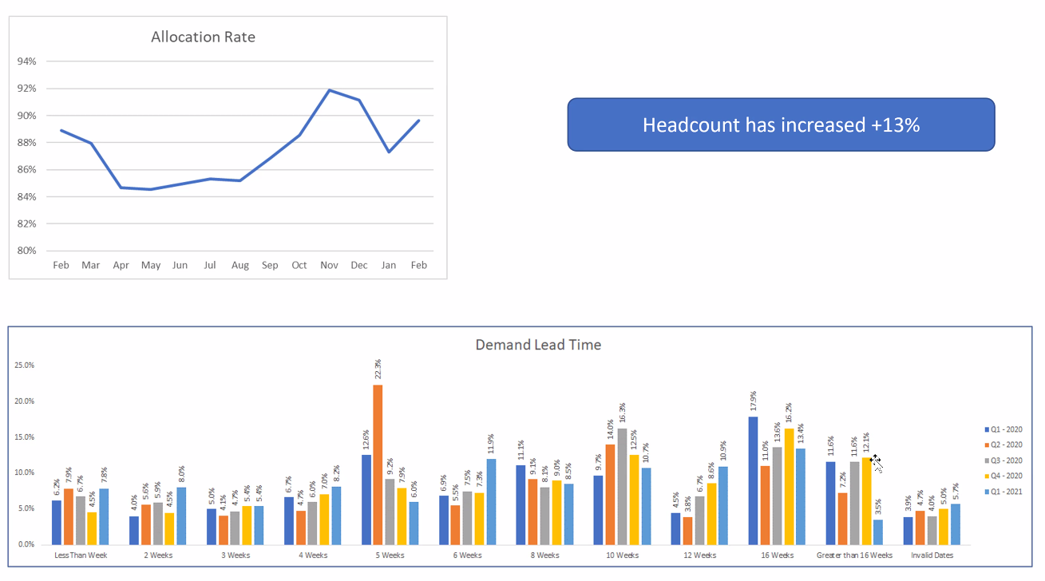

Try to look at your data as if it’s for the first time! Just because YOU can describe it, it doesn’t mean everyone can understand it.

3 steps:

1. Try to understand the real driver of the business and the process you’re thinking about

What makes a difference to this company?

How does it make money? How does it lose money?

1. Try and get the data, then play with it. E.g. put it in an excel, add sort and filter then use pivot table to draw out a logical conclusion
2. Try and be really critical about “finished” slides/concluding data to learn what the data really says.

Anonymise everything and don’t download it – remember GDPR!