**Nadeem Shabir from Talis**

**Software Testing**

**What is it?**

Find software errors and verify that an application or system is fit for use. It is the process of evaluating and verifying that a software product or application does what it is supposed to do. The benefits of testing include preventing bugs, reducing development costs and improving performance.

Software testing has been around for a very long time!:

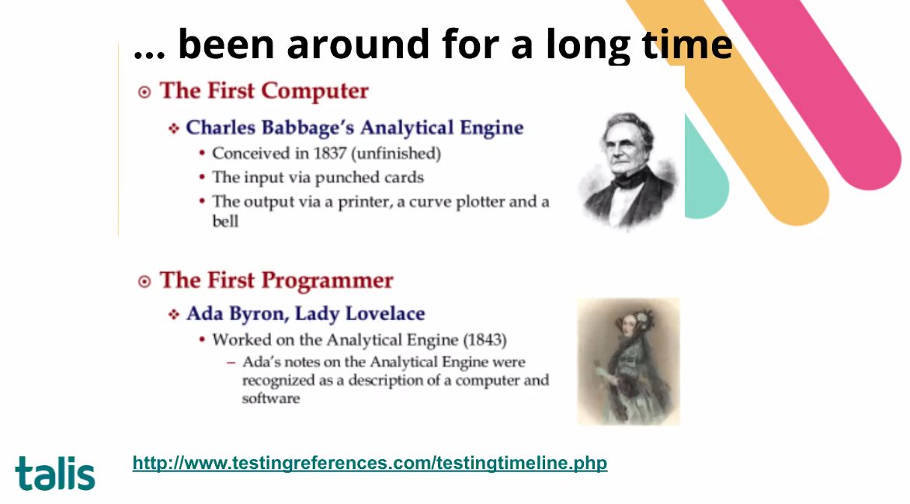

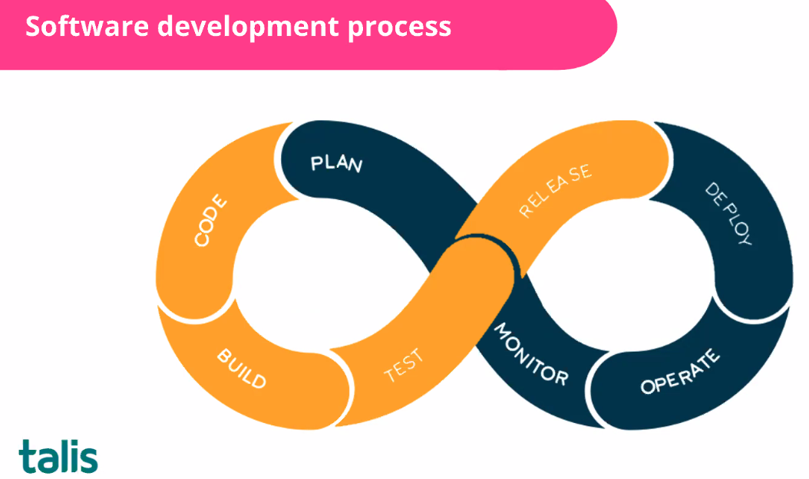

**Types of testing:**

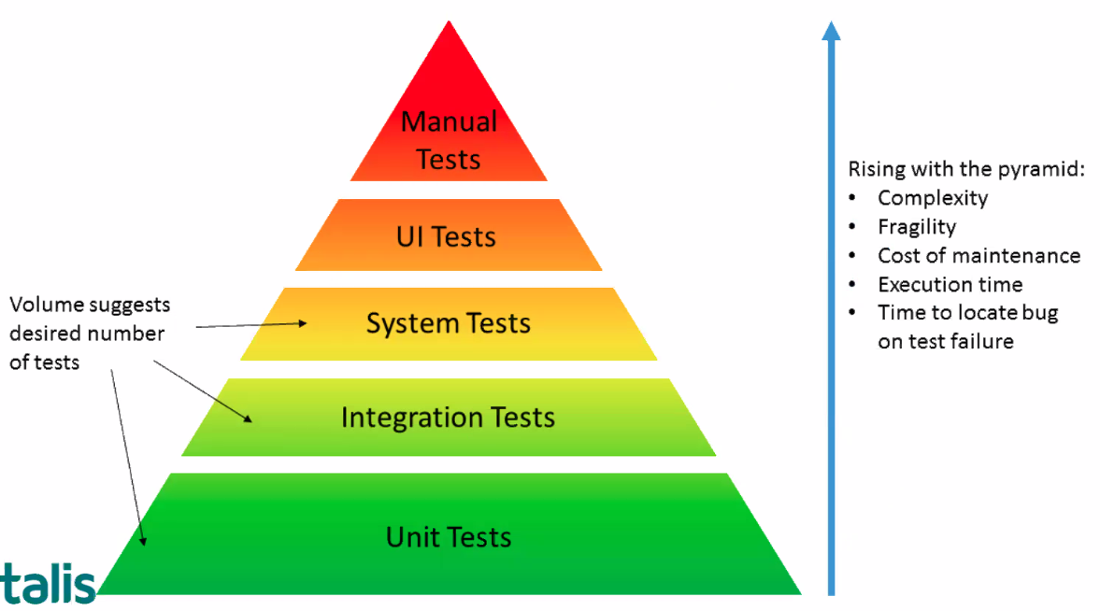

Code to test is probably 5 times longer than the actual code it is testing!! And that’s how it should be! So it will take more time to write test code than writing the original code, so bear that in mind!

Unit = single item (e.g. a single function)

Integration = how 2 things work together

System test are more broad etc.

So number of tests decrease as you go up the pyramid

**At Talis, here’s how they test:**

Smoke tests are common user workflows that are exercised every 15 minutes as a way to detect any issue or problem before users report them.

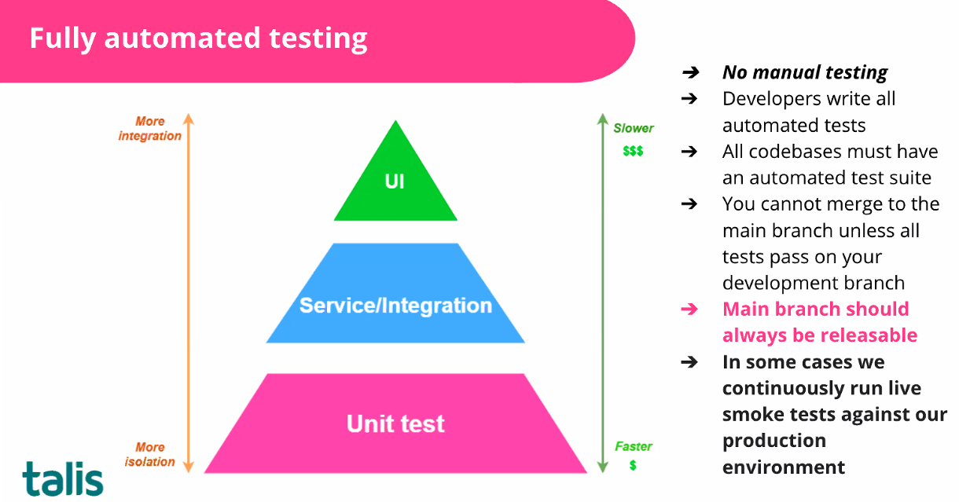

**Test driven development**

Theory is to write test before the actual code. Basically, ensuring that you’ve planned correctly what you want to do. Your test should definitely fail because it’s for something that doesn’t exist…(e.g. a function that adds 2 numbers), then you write JUST ENOUGH code to pass the test.

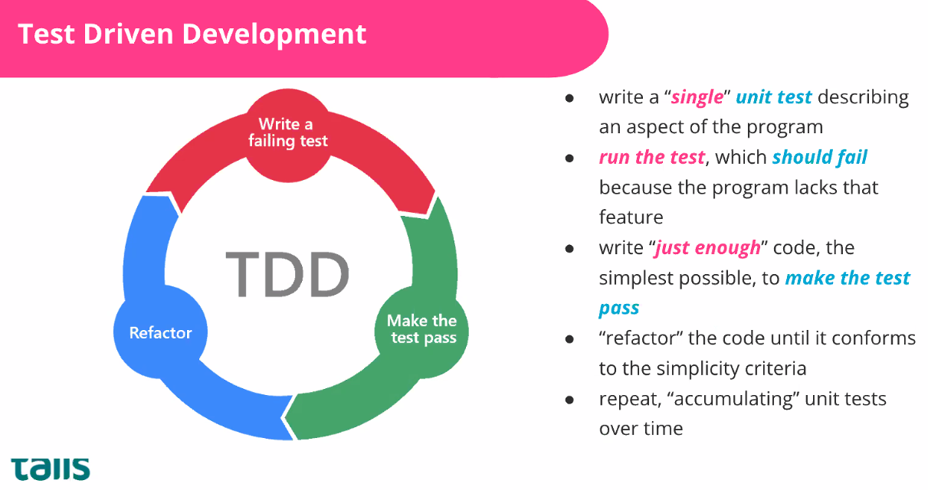

Great software developers are LAZY! Don’t become emotionally involved in the code you are writing!

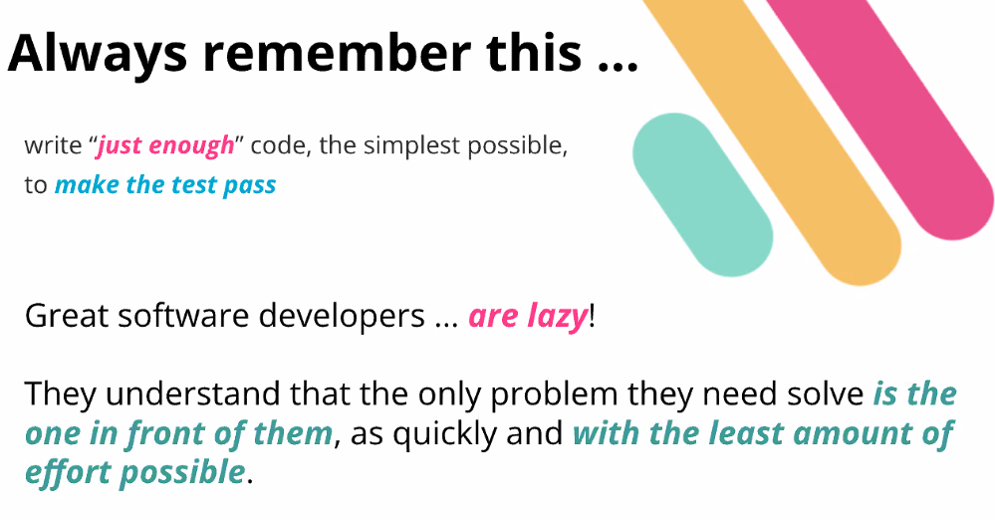

Book recommendation:

David Weinberger - Small pieces loosely joined

Not about code but breaking big problems down in to smaller problems

<https://www.amazon.co.uk/Small-Pieces-Loosely-Joined-Unified/dp/0738208507>

Pragmatic Programmer by David Thomas/Andrew Hunt

<https://www.amazon.co.uk/Pragmatic-Programmer-journey-mastery-Anniversary/dp/0135957052/ref=sr_1_1?adgrpid=52867291093&gclid=Cj0KCQjw1tGUBhDXARIsAIJx01nvPyD2zil8UdvqFA5yEw-3zlDUErAwCu-OUm2tjFWtZSz65cnpBWEaAgk6EALw_wcB&hvadid=259112479829&hvdev=c&hvlocphy=9046398&hvnetw=g&hvqmt=e&hvrand=14145205175354250470&hvtargid=kwd-298735734907&hydadcr=17607_1775410&keywords=pragmatic+programmer&qid=1653909046&sr=8-1>

The biggest mistake Junior Devs make is “they think they need to learn everything”. The only thing you need to do is learn what you need to do the job!

Code is small part of it…focus on communication and soft skills! The company you work for will teach you how to write code how they want…

Also be able to UNLEARN!

Exercism.org – great website with exercises for each language that comes with loads of unit testing

LEARN ABOUT WHAT YOUR BUSINESS IS DOING! It’s not just about writing code, you need to know who you are writing it for and why…

Apply for a job with a business where you care about what they’re doing!

Nadeem doesn’t care about quality of code – you can be taught that! Can you communicate, can you work in a team, how do you deal with conflict (e.g. people pushing back). Just sets a task on exercism.org that you turn up with and it’s all about talking that through!