**Piper Bates – Life after school of code (AKA my journey into tech)**

Was on bootcamp 4

* Dabbled in coding as a teenager
* Learnt HTML and CSS by playing Neopets and GaiaOnline
* Didn’t want a tech career, wanted to be an artist
* Worked retail after retail
* Eventually was able to be full time freelance illustrator, loved the illustration, hated the freelance
* Really struggled with back-end on the course and actually started in tech industry in front-end but now works on back-end!!!

Why the Tech industry needs you

* Saturated with people have done the “traditional” route of uni then into job
* Universities don’t teach soft skills and these are what make or break you as a programmer!
* Bootcampers are unique due to their extra experience in other things, different perspectives and solutions etc.

Things she thought about when applying for a job:

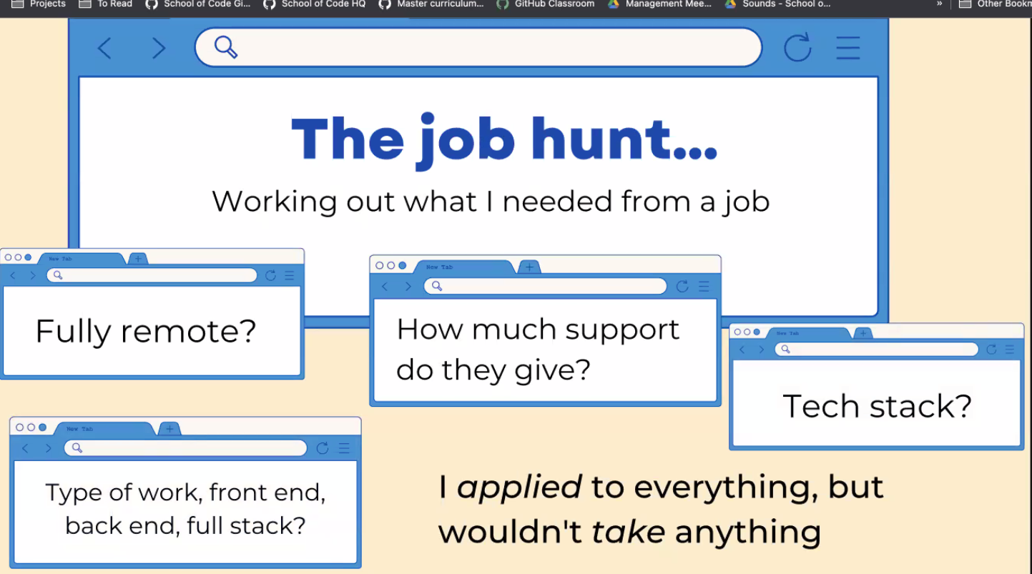

First job was ClickTravel

SOC REALLY prepared her for the job:

* Daily standups
* Fortnightly retrospectives
* Felt like she could contribute to these as did them on SOC every day!

First days at ClickTravel – was employed as a React Junior Dev as company were changing from Angular to React

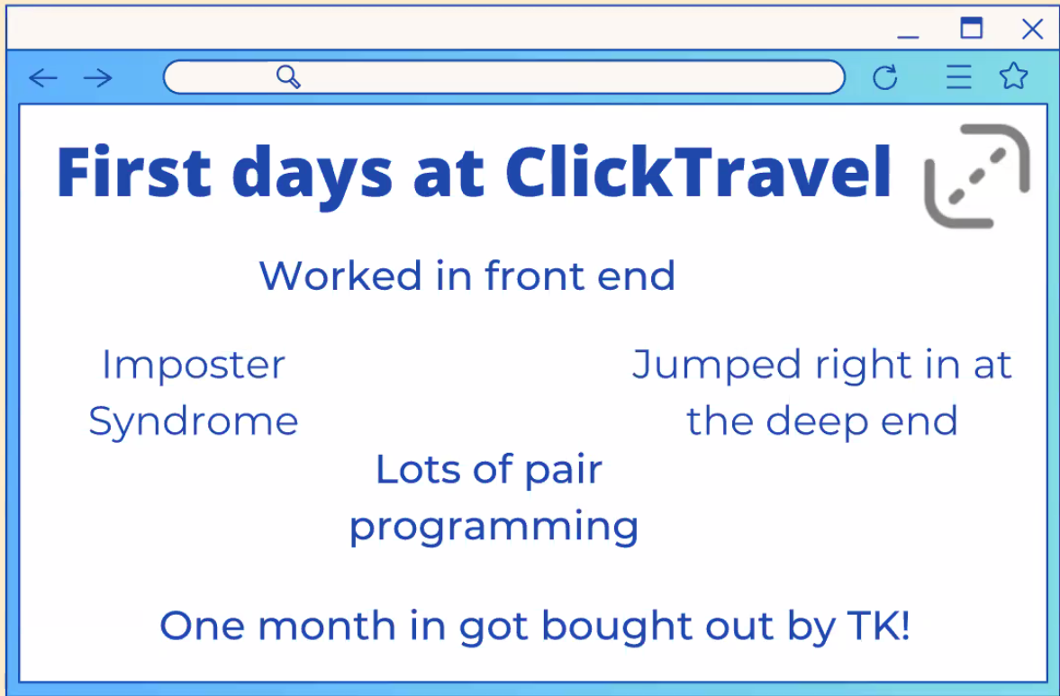

Got bought out by another company so that business aim changed and ended up working in the back end

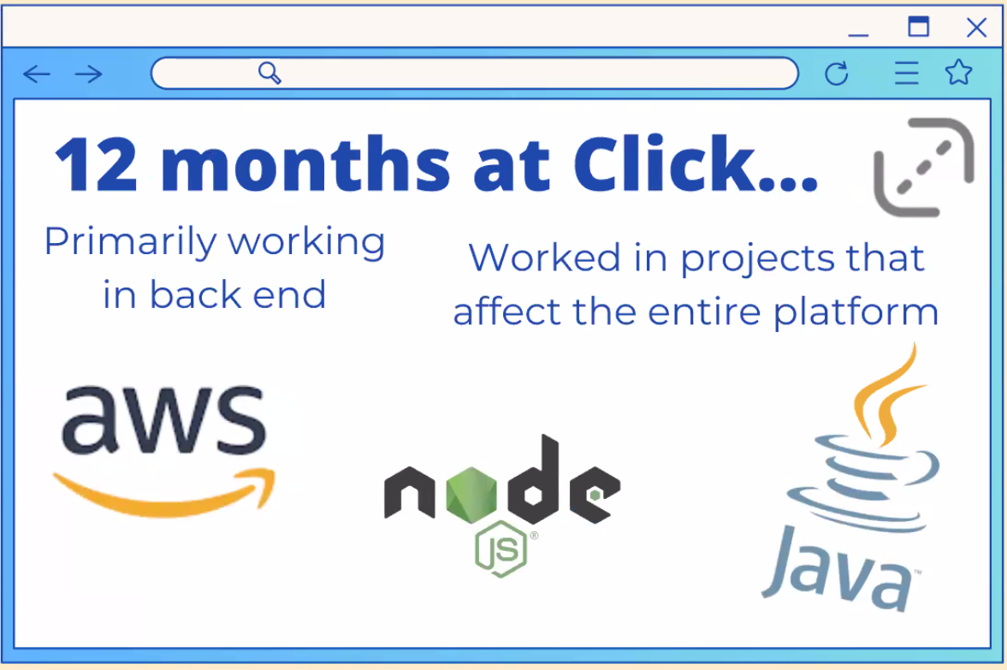

Left after a year at ClickTravel, missed the implementation-side of things and discussed it with line manager. But as ClickTravel were a big company (over 1000 employees total), less opportunities for progression, smaller cog in the machine etc. Wanted to make more of a difference at a smaller company: Bamboo has 14 employees total! (4 in tech team)

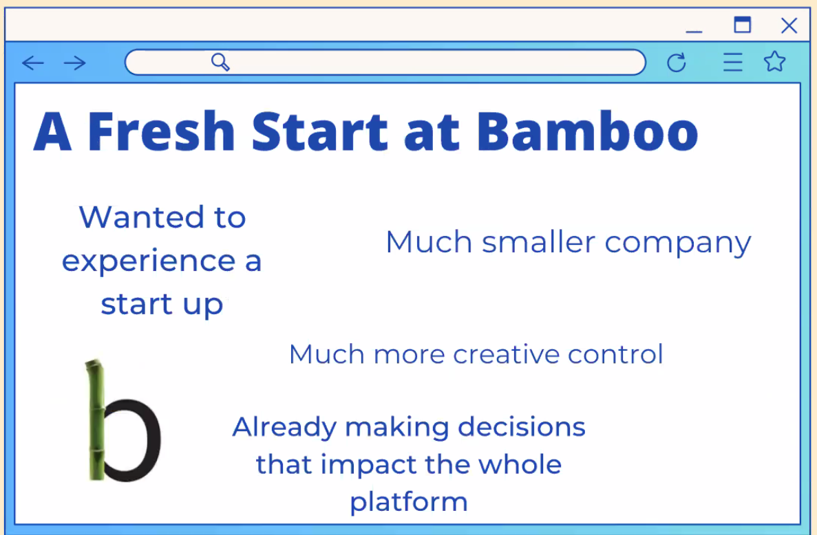

Only been at Bamboo for 3 weeks but really enjoying it – already found a big problem with Front End that needs sorting!

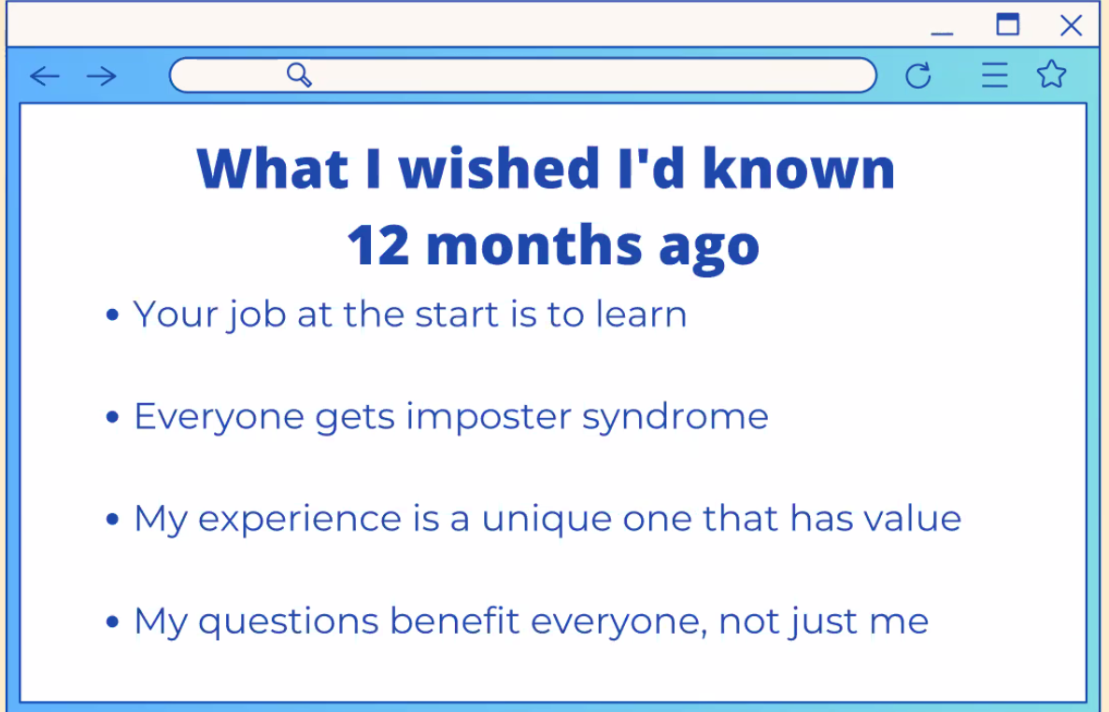

Tech companies constantly support you and want you to improve – even if that means you will eventually leave! As it benefits everyone, just like open source. The whole tech industry is only as strong as your weakest link.

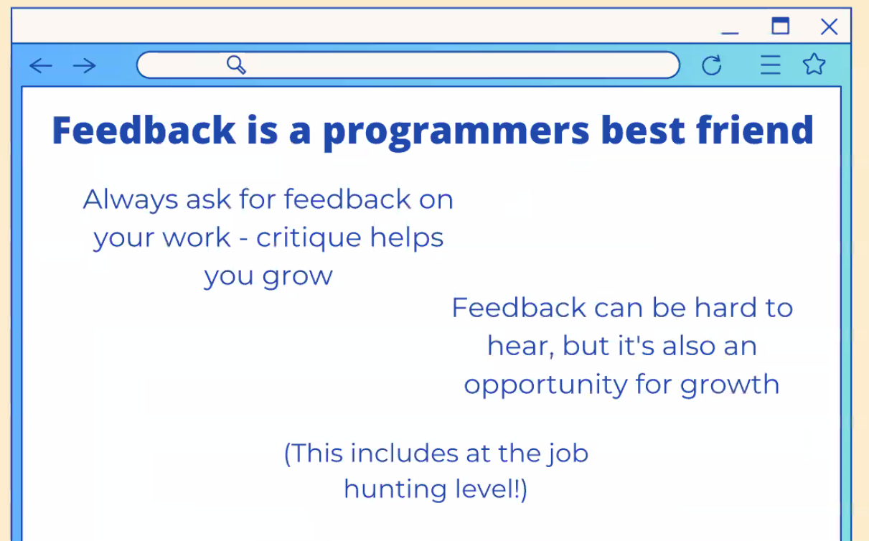

**Q&A**

How do we know what company is right?

The company will know if they can support you – Piper had a company come back to her 6 months after applying to ask her if she was still looking for a job! They were then in the right position to hire her.

SOC will weed out companies that are best for you!

Big vs. Small company = work out what you want/need and ask lots of questions to find out if it’s right for you!

Biggest transferrable soft skill = thinking on your feet! Actually then changed it and said it was ability to talk to people (of all ages, backgrounds, experience level etc.)

What typical support does a Junior Dev need? = Understanding the code base, time to practise things

Key piece of advice for interview/job hunting = job hunting is hard (as it’s your first job and don’t really know what you’re looking for), it’s a numbers game so keep on putting your CV out there. Don’t worry about competing with other bootcampers – we are all in this together and the industry is all about supporting others. Get as much feedback as you can!

Don’t worry about forgetting things – she’s met Senior Devs that have to google how to write a JS function as they’ve stopped using it for a while

Employers aren’t looking for the best developers necessarily – looking for a nice person, willing to learn, be adaptable. Fantastic developers who are terrible people will struggle to get a job!

What were you doing between bootcamp and first job? = Slept for a week!! Obsessed with coding after that and did too much! Then found a balance between working on personal projects, continuing learning and having time for yourself and rest! One example of a personal project was making a clone of GoodReads. SOC also set them up with some freelance one-off projects – no guarantees but this still happens if possible!

First interview? = Did tech test as ClickTravel, they used same one regardless of level of job being applied for. Was very honest about not knowing the answers and asked lots of questions to understand the code first – got the job! Showed a problem-solving mindset.

Try to build on your weak points by giving yourself mini-projects / problems to solve!

What should our approach be to continuing learning after the bootcamp ends? = If freelance projects and personal projects aren’t available/working for you…Get together with other bootcampers and have a go at something! The other bootcampers working with you may get jobs in this time but just keep going and then recruit other bootcampers if needed!

Link to blog post about “stupid questions”: <https://piperbates.medium.com/there-are-such-thing-as-stupid-questions-but-you-should-ask-them-anyway-434f61651b15>

Link to imposter syndrome post by Neil Gaiman(famous author) about conversation with Neil Armstrong: <https://journal.neilgaiman.com/2017/05/the-neil-story-with-additional-footnote.html>