**Nick Truby – Software Engineer Specialist (aka Front-end developer) at BT**

Last minute presentation!

Use React for his day job and is also a mentor for SOC – will be at Code club on Wednesday.

His background:

Career changer, just like us!

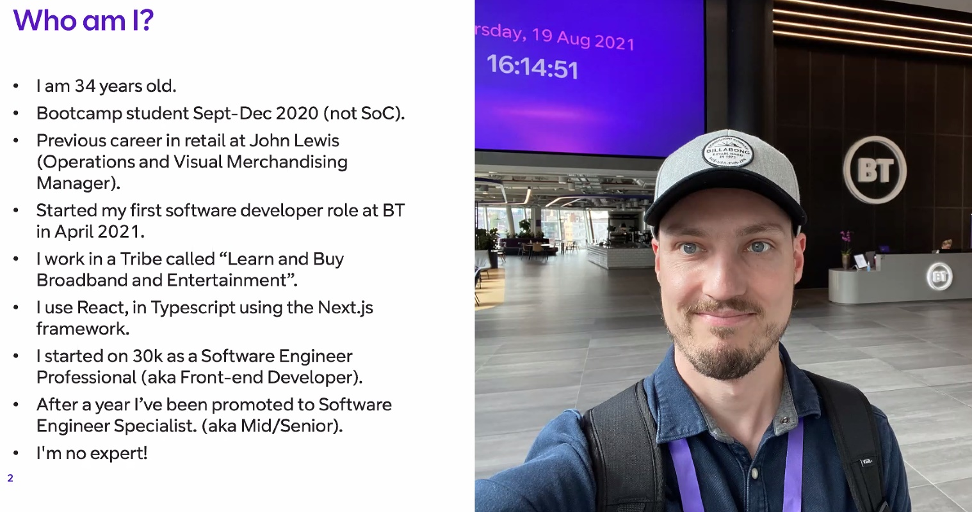

Typescript is like a more specific version of JavaScript – you can specify data types and it will make you use the correct data type. Next.js is a framework built on type of React – gives you server-side rendering (for SEO). Payband for “Specialist” starts at £37k.

**What is React?**

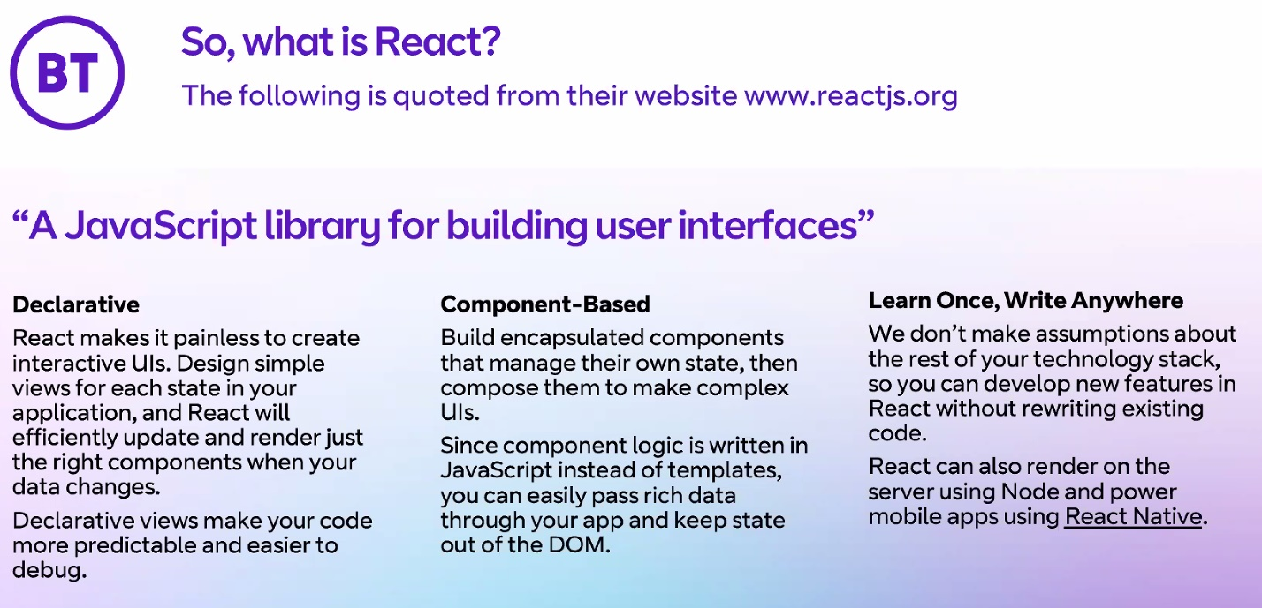

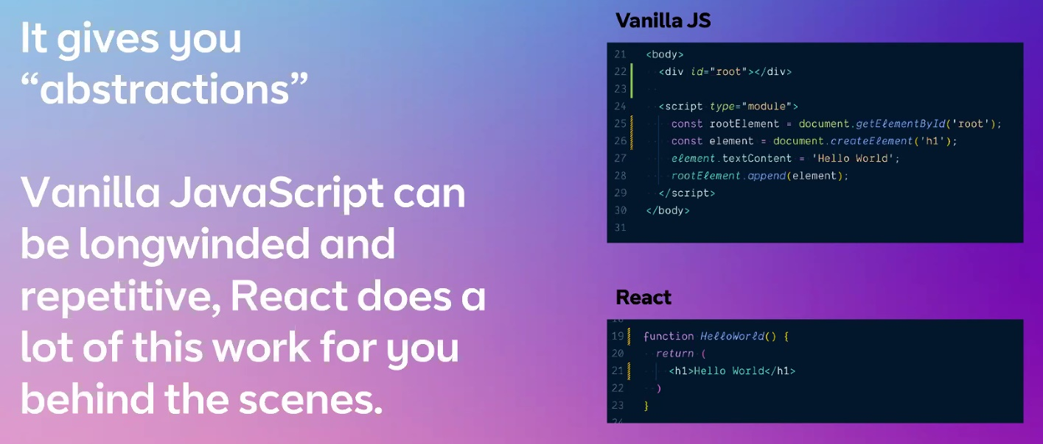

Box in blue is JSX – a combination of JS and HTML:

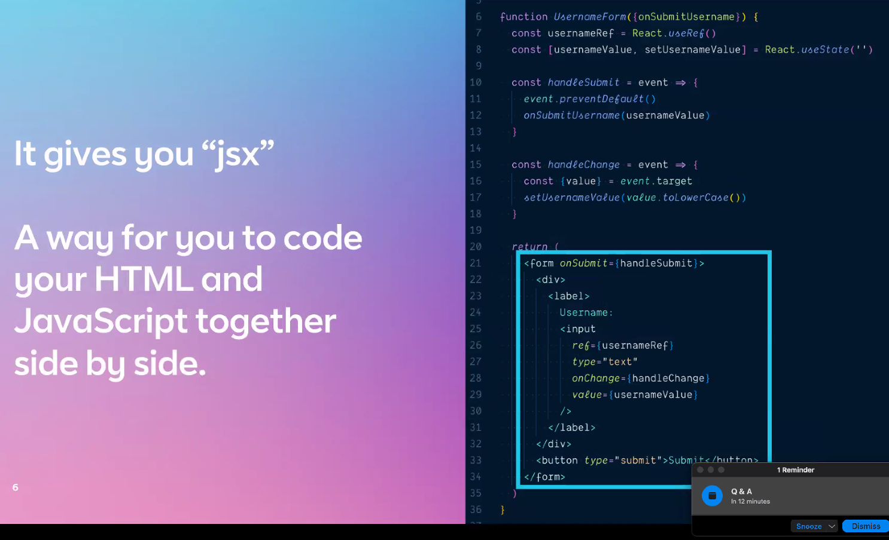

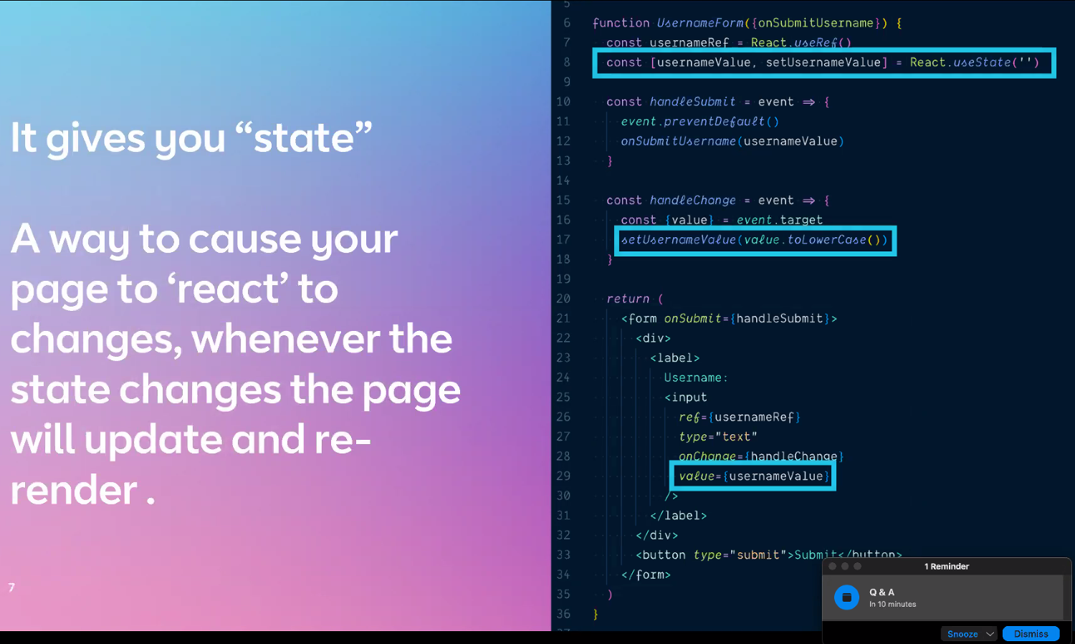

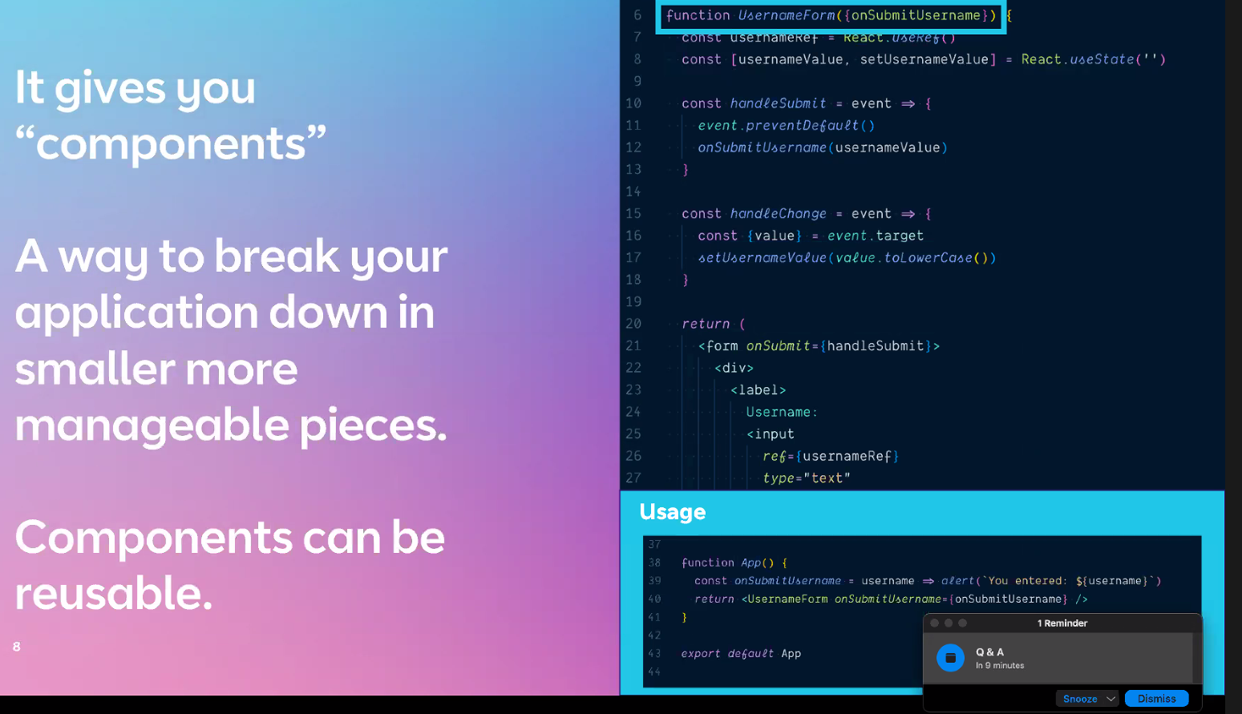

Starts with mobile first, then scales it up.

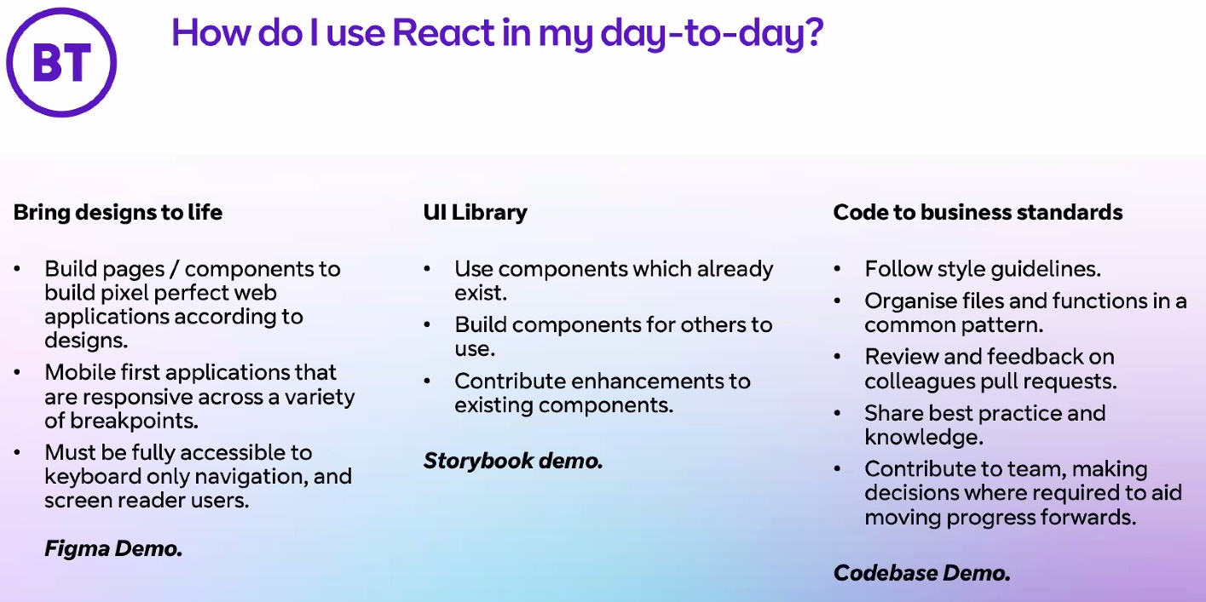

Showed us some proprietary designs from BT’s library so not screenshotted – these were Figma designs. He talked us through about breaking each wireframe down in to individual components so he can start creating the actual code for it – e.g. h1, a card for broadband with a price on it and list of features, a card for add-ons, various <p>, an accordion (something that expands out). His job is to build components (if not already existing in BT’s UI library) and make them work (async functions to fetch data etc).

Also showed us their folder layout (not screenshotted as above) - lots of similar folders to how we lay things out on SOC – particularly showed us a src folder that has subfolders: components, hooks, contexts, screens, pages etc so everything is separated out and imported where needed. Each component has its own folder – containing all files relevant to that component.

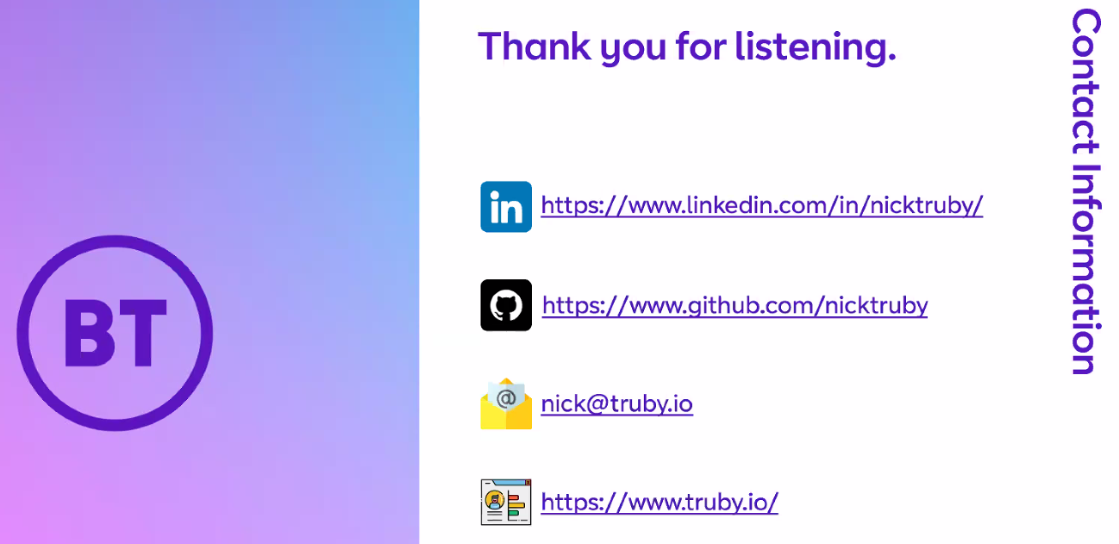

**Q & A**

Recruitment process/Interview process : Bootcamp he did was similar to SOC so had some recruitment part to it. He could apply for own things immediately as paid for his course. Applied for loads of things, got 4 interviews. 2 rejected, 3rd verbally accepted but never happened and then got BT job. BT was the job he actually wanted but each rejection was tough to take at the time. This is when imposter syndrome is at its highest – so keep an eye on mental health!

Interview process: Computer-based Tech Test – similar to codewars but a bit more technical. Then got interview and was asked to take away a task and then submit it. It was simple and needed to demo a typical day – create a News application, use an API that provides news article by search. Search box that sends API request and renders it to the page. Had to be responsive as was adding news articles each time. This got him to final interview – you don’t have to know everything on the job description, but be able to talk about each thing! E.g. research each part of the job description so you get an idea about it, basics of what it might be used for etc. Be honest about what you don’t know! Talk about “development areas”, not “weakenesses”.

Take home tasks were for about a week and he spent at least 2 or 3 days full time on it at least.