**Tom Lewis (Technical Engineer) and Dan Wildman (Product Engineer) from Adaptable**

(<https://weareadaptable.com/work/>)

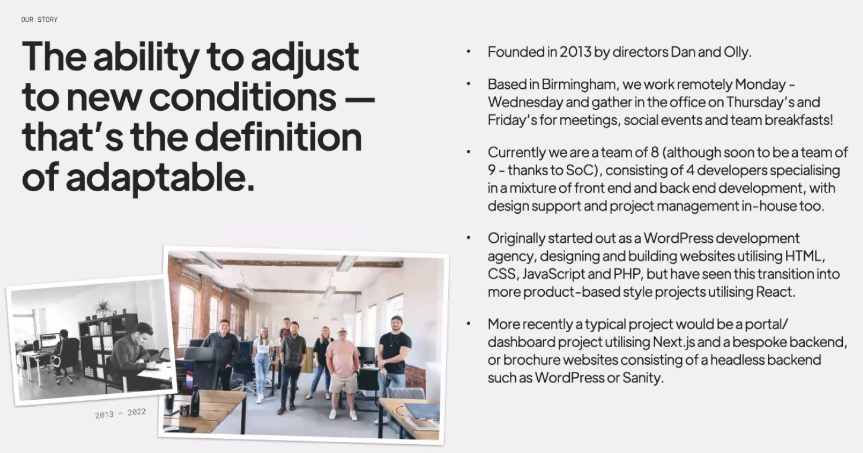

Review the tech stack at end of every project and add/remove as necessary, but core tools used:

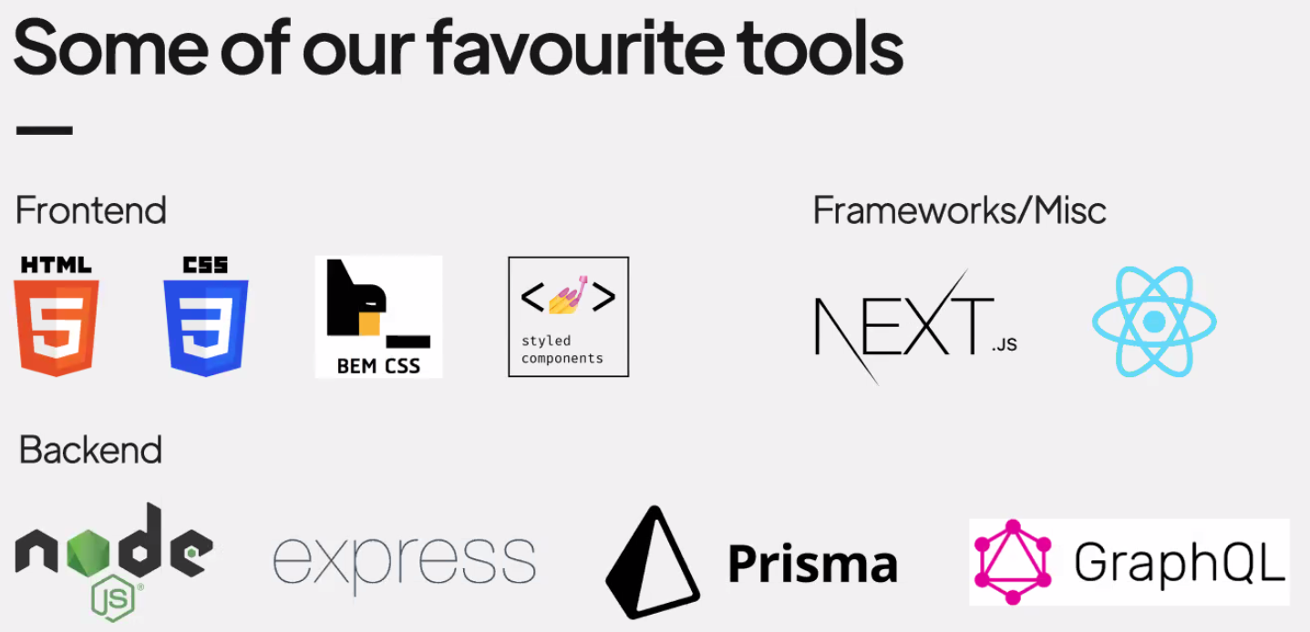

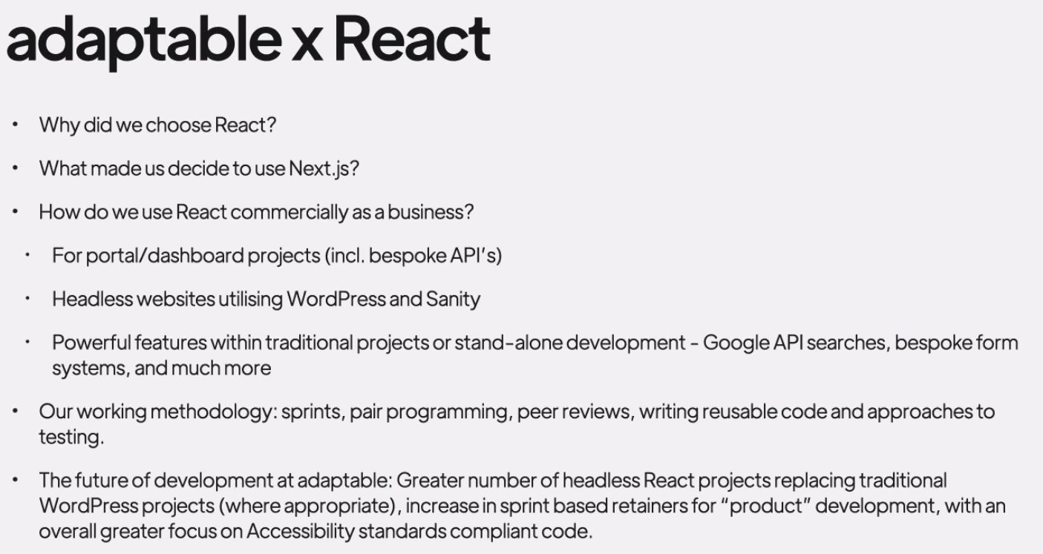

Chose React for its eco-system of supporting libraries

First time, just used React to build components like a small cinema listing

Then scaled up when building donation platforms, started to use Next.JS

Now majority of entire projects will be in React and Next.JS

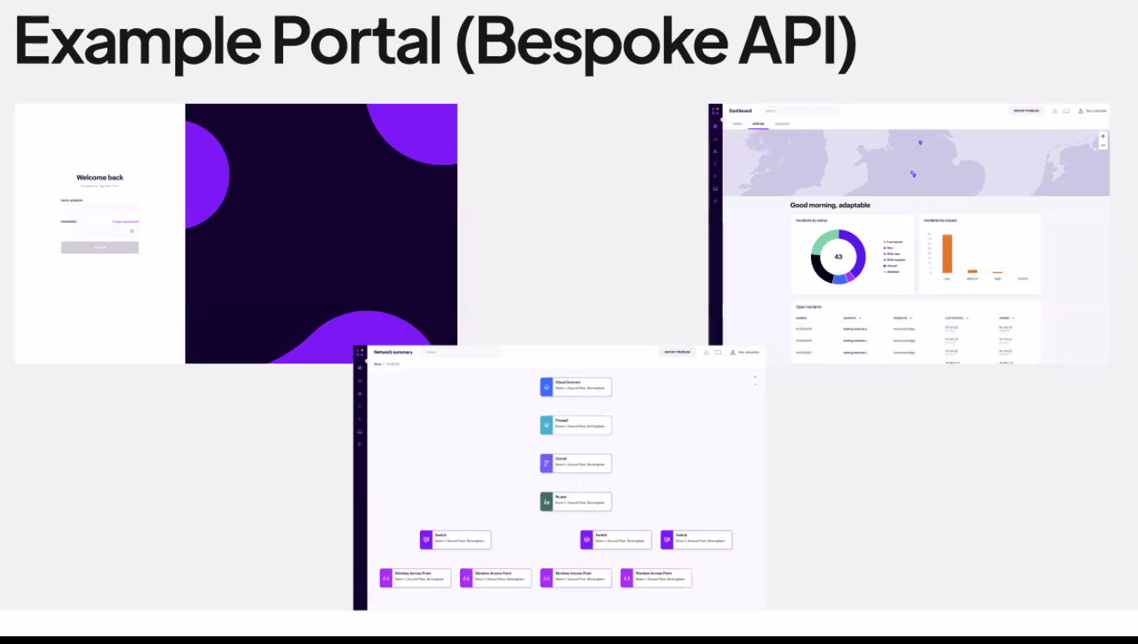

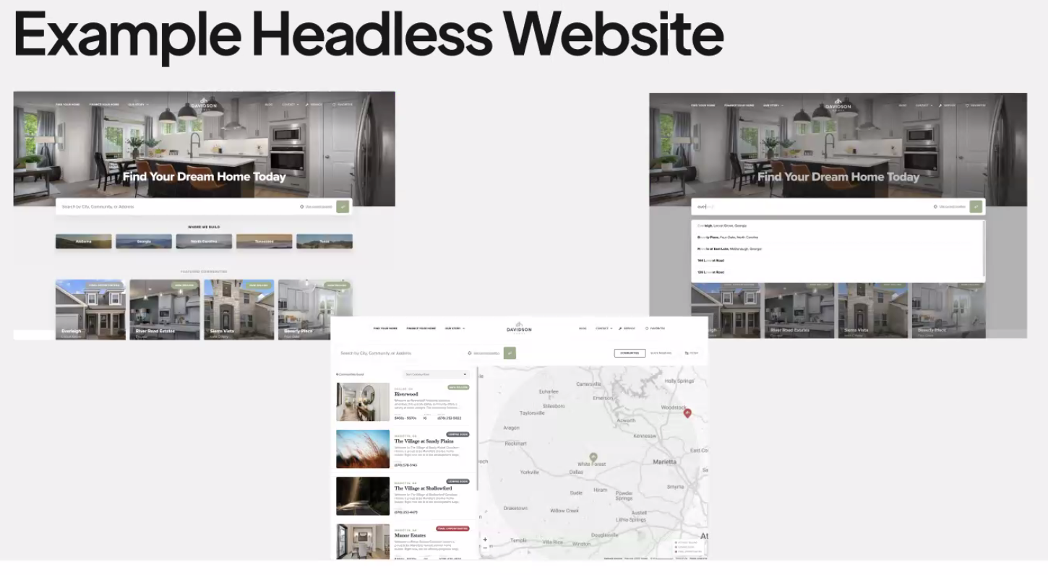

Headless = using a pre-existing backend like Wordpress and building your own Frontend with something else like React

**Q & A**

What do you look for when hiring? = Looking for how you are trying to solve problems, how have you solved problems in the past, a bit of experience with some of their tech stack

What is a product engineer? = 2 different types of product – “brochure websites” and “dashboards/platforms”. Dan’s job is about architecting and planning the products.

Headless = Traditional CMS like Wordpress deals with data and templating etc. Headless CMS deals with data and exposes that as an API, then you can use your choice of tool to access that. (I googled and found this - <https://www.contentful.com/r/knowledgebase/what-is-headless-cms/>)

How do you organise your time (and which time management app)? = Everyone works on anything needed in any capacity as they are a small company. Use tools like Tick and Slack.

Do you do one website at a time or lots concurrently? = A mix! Sometimes it will be 1 or 2 people seeing a brochure website through from start to finish, other times it would hopping on and off. They work in small fortnight sprints and only tend to have 1 developer working on a major project at any time.

