**Special Guest Mindset Session - Trenton Moss (Founder of Team Sterka)**

Golden Rule - Treating other people like you want to be treated – right?

He thinks that’s a terrible idea!

Platinum rule – Treat other people the way THEY want to be treated

Today we’re going to be focussing on different communication styles:

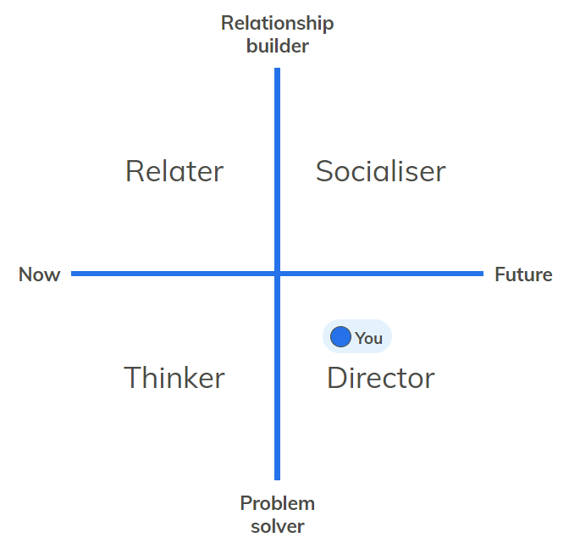

Problem solver means you are more task-based, relationship builder is more relationship-based (with other people)

Problem solver is more logical and can come across as uncaring. Relationship builder will tell more stories, be more empathetic.

Optimise the now – questions tend to start with “How”. E.g. How are we going to do this?

Focus on the future – tends to focus on the “Where”. E.g. Where are we going?

Optimise the now – could be accused of being slow/cautious

Future – fast-thinker, risk-taker.

The point is you need both optimisers and future-thinkers in a business!

4 communication styles – Relater, Socialiser, Thinker, Director

Can be different levels in each (so may take elements of others rather than being 100% of one type).

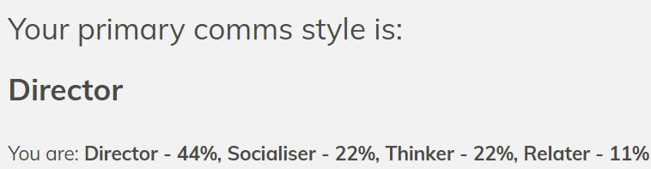

Thinker – Bit of a perfectionist, may never actually finish what you’re doing! Work slowly and methodically, structured and organised. Mortal enemy is context-switching! Want to deep dive. Opposite is Socialiser!

Socialiser – Warm, friendly, positive. Good at influencing people and building alliances. Thrive off other people’s energy. Thrives on recognition! Might do their thinking whilst they are talking.

Relater – think things through, can be slow to accept change. Loyal, builds deep relationships. Shares responsibility.

Director – DO YOU NOT HAVE EMOTIONS!? Are you a robot in a human body? Gets energy from achieving things, like to get on with things. Not interested in recognition. Incredibly logical, can be frustrated by others going slower. Up for massive challenges! Likes control/being in charge!

**Remember** these are just labels and indicators, not absolutes!

<https://sterka.team/comms-styles-intro>

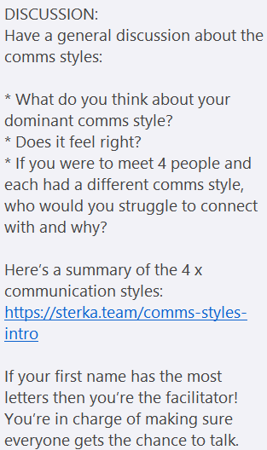

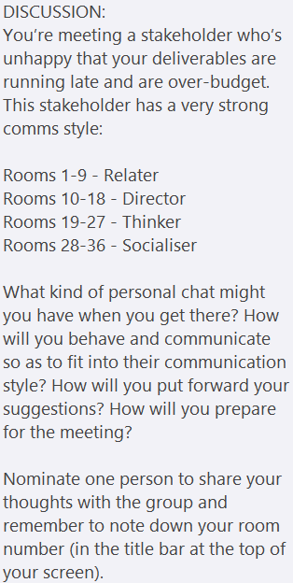

Our room got Thinker – Not much personal chat. Explain logically what the problem is, present a detailed and structured plan. All suggestions backed by evidence! Involve them in decision making on how to move forward. “We are trying to create perfection”! 😉

Trenton’s suggestions:

Meeting a relator – Be interested in them as a person and their emotions. Have a slow and reassuring manner. Check for misunderstandings and reassure around risks. Be non-threatening and truly sincere. Constantly show that you’re listening. Share personal opinions and feelings (don’t push facts/logic). Wouldn’t get a decision from them straight away – allow them time to solicit opinions from others (or send stuff over in advance so they can reflect before meeting).

Meeting a director – Be super-efficient and competent! Don’t waste their time (no need for personal chat). Use facts/data to backup your arguments (never feelings!). Let them take control – offer options, not solutions. Be very well prepared so you’re able to answer questions (they will ask specific questions about detail). Keep it high-level and straight-to-the-point. Recognise their ideas and ability to achieve results.

Meeting a thinker – Be thorough, well-prepared and patient. Don’t rush them into decision making (like relators). Gather lots of data to support your arguments. State pros and cons, with ways to overcome the cons. Provide clear evidence of your solutions (and confirm in writing). Don’t waste time with small talk. Compliment them on their brain power and efficiency (or the amazing things they are crafting).

Meeting a socialiser – Be very interested in them and give compliments. Recognise and get excited by their ideas. Don’t rush into getting down to business. Talk mostly about the big picture impact. Be very direct about your expectations of them in writing. Use storytelling to put forward your ideas. Help them to look good in front of others.

**So we’re all really weird, or all really normal!** Don’t think your way is right and others are wrong. We’re just all different. Need maximum cognitive diversity to get everything done as well as it can be! So try and meet in the middle e.g. You’re a details person and I’m more overview, can we use the best of both?

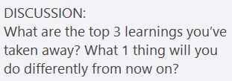

How you can spot someone’s style in 5 seconds (as long as they’re not too blended) – “How are you?”. Directors – “Fine, let’s crack on”. Socialiser – “Oh my god, so much has happened, let me tell you all about it”. Relator – “Oh thanks so much for asking, I’m fine, but what about you? How are you?”. Thinker – “Ngh” (You’ll be lucky to get a grunt!).