# Joseph Bonus Mindset Session 14/7/22

Personal Values

We all think differently, approach the world differently etc. But your values come from a deeper more subconscious place – very rarely have we consciously chosen our values.

We’re going to focus on these consciously so we can understand ourselves better – our values influence our thoughts, feelings, actions and mostly importantly – decisions!

We’re going to look at:

* Identify your top five values
* Expand their meaning
* Create a values hierarchy
* Explore the ‘dark side’
* The values of others

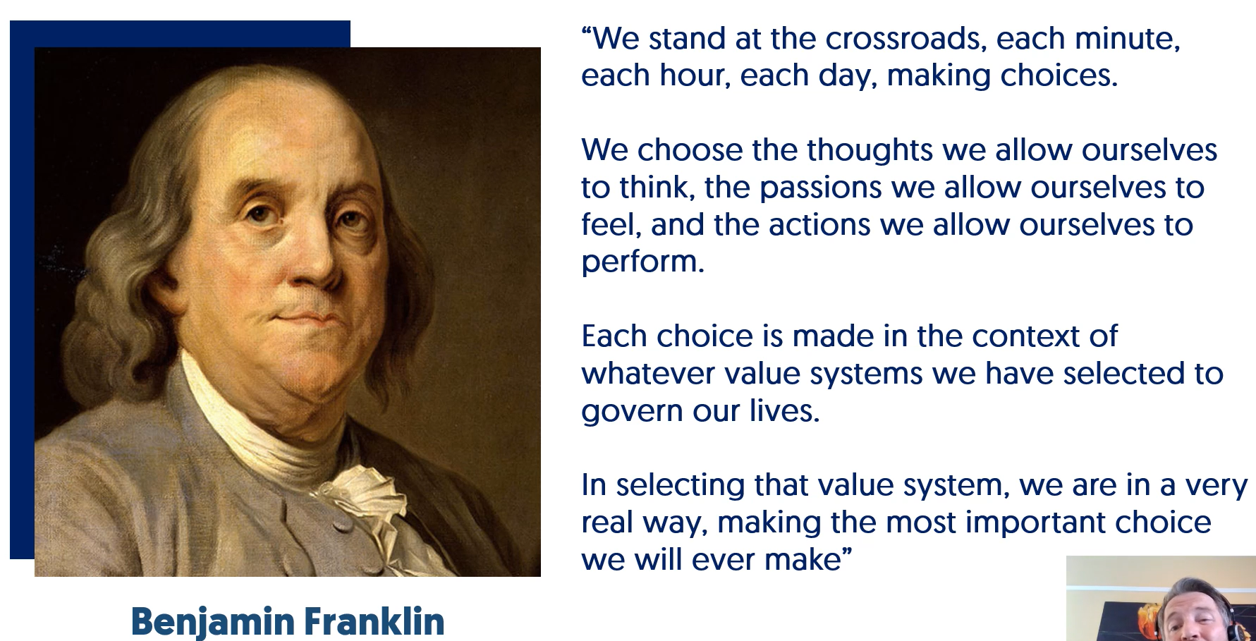

Choose your five top values. Joseph’s were:

* Progress
* Achievement
* Decisiveness
* Integrity
* Challenge

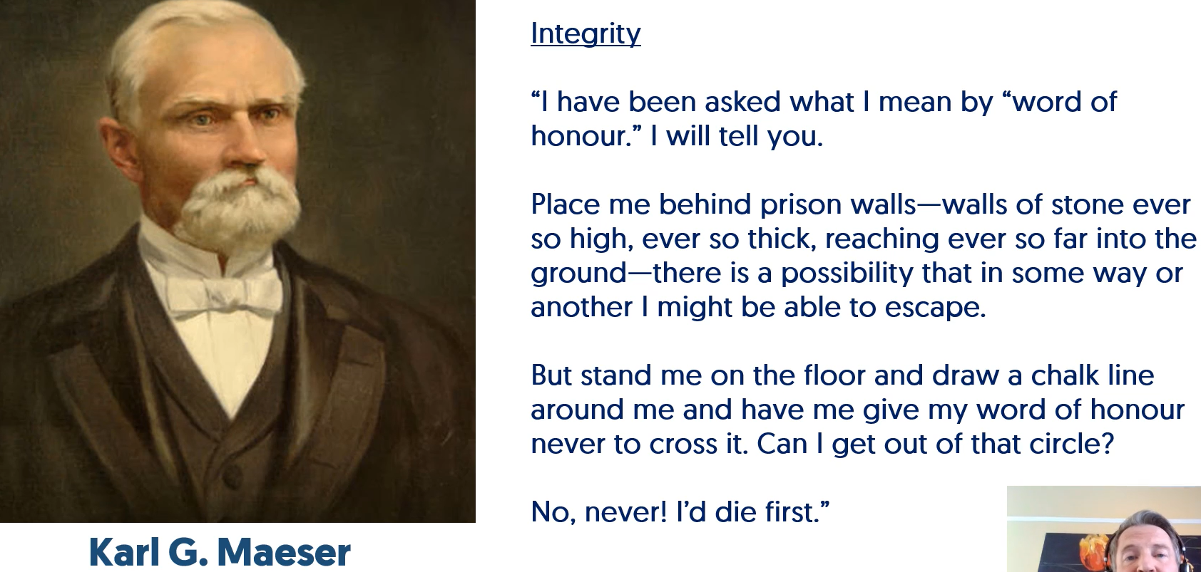

This is an extreme example but the next step is to flesh out each value with a short sentence or two, e.g.:

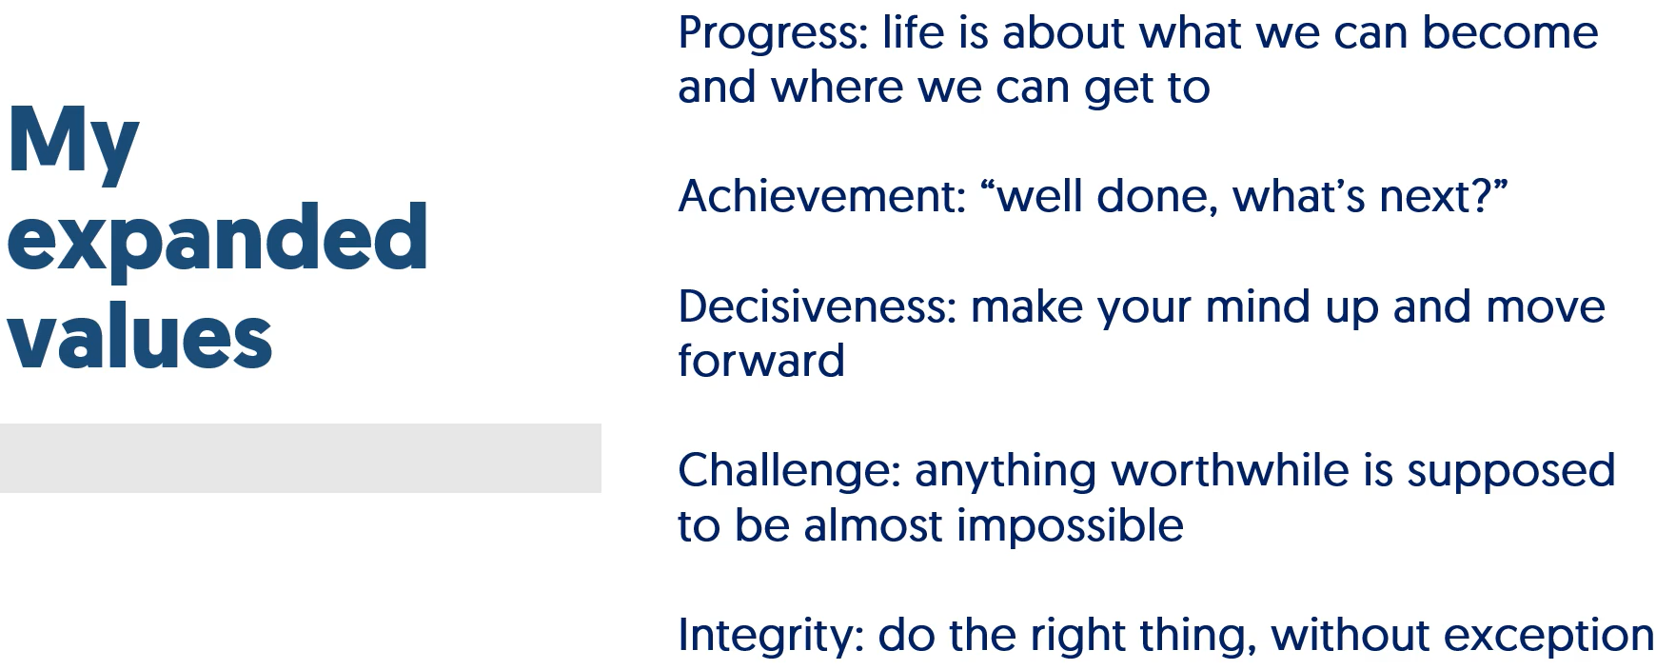

Even with 5 values, it can be hard to balance them out or weigh them against each other when making a decision. So, we are now going to consider what order our values rank in. Take the first value on your list and weigh it against the others on the list sequentially – taking the ‘winning’ value forward each time, then you’ll have them in order. Joseph’s ordered list:

1. Integrity
2. Progress
3. Challenge
4. Achievement
5. Decisiveness

His example for how this could influence your decision-making is – if he gets given a challenge that would breach his integrity, he knows he will refuse it due to the ranking of these values.

## The Dark Side

This is about where we overplay or misapply our values. When Joseph’s values are turned up too high and how he tempers them:

Integrity – do what I think is the right thing – don’t mistake the overall right thing for what you think it is

Progress – never stop, ever – you’ll never achieve anything great if you rush and don’t rest

Challenge – how can we make this even more challenging? – haven’t we got enough to do already!?

Achievement – excellent is the minimum, no need to celebrate – this can demotivate others who don’t have the same value

Decisiveness – force the decision – does this decision need to be rushed? Or can we take time to think about it

## Working with others

Joseph – Integrity, progress, challenge, achievement, decisiveness

Thomas – perseverance, humour, optimism, helpful, empathy

Jane – creativity, passion, humour, curiosity, spontaneity

Does Joseph’s decisiveness stifle Jane’s creativity? Does Joseph’s challenge/achievement take the fun out of the task? Is he turning off empathy when he’s all about progress?

Lean in to other people’s values if you know what they are! Don’t guess them though, you need to ask!

These all become strengths that will contribute to the team if applied in the right way – Joseph can help with decision-making when the group is struggling for example…

Pay attention to your values and write daily reflections on how they might be impacting your thoughts, actions, feelings and decisions - remember these can be both positive and negative ways.

Everything we are doing here is to raise your awareness so you can make authentic choices who you want to become.