TL;DR
The basic idea is to:
- Use pre-trained models that are publicly available for each modality of healthcare data - e.g. X-Ray, MRI, clinical notes, etc.
  - For actual Electronic Health Record (EHR) data (which is structured / tabular data) we can use my previous work - lemonpie if a better one is not publicly available.
- And put them together using one or more of the techniques detailed in this document to predict on data in the ‘Coherent Dataset’ (and a smaller summary here).

The risk / caveat is:
- The Coherent Dataset is very small or not big enough for meaningful training.
  - Meaning, the models have to perform pretty much entirely relying on their pre-trained weights.
- If they all perform well - it will be a good example of some type of Data-Centric AI - making models perform well on relatively small datasets and of course transfer learning.
- If they do not perform well, at a minimum - we end up creating a pipeline for multimodal healthcare models which are not available in the public / open source domains, so that will be a significant accomplishment.

Details are in the pages that follow (please scroll down)
- I created the original proposal for another project that did not take off.
  - Because access to the dataset (MIMIC IV) could not be secured on time for the project’s team members.
- This is the “scope-reduced version” of the original proposal on the publicly available Coherent Dataset.
  - Where scope is reduced, I have used strikethroughs to show the difference.

Problem
- Physicians (healthcare providers) use data from multiple sources (radiology images, patients’ longitudinal history from clinical narrative notes, prior visits, lab reports, etc.) to provide care for patients.
- Yet, the use of such multimodal data in machine learning and specifically deep learning applications in healthcare is not ubiquitous.

This project proposes to develop a multimodal deep learning model that surpasses state of the art (SOTA) performance of single-modality models on medical diagnosis tasks (i.e. predicting medical conditions) using Electronic Health Record (EHR) data and Medical Imaging data (e.g. chest X-rays).

Why
Opportunity
- A well regarded paper that reviewed the current state of AI in healthcare, listed models focused on EHR data and multi-modal data to be promising avenues in the near future for advancement of AI in healthcare.
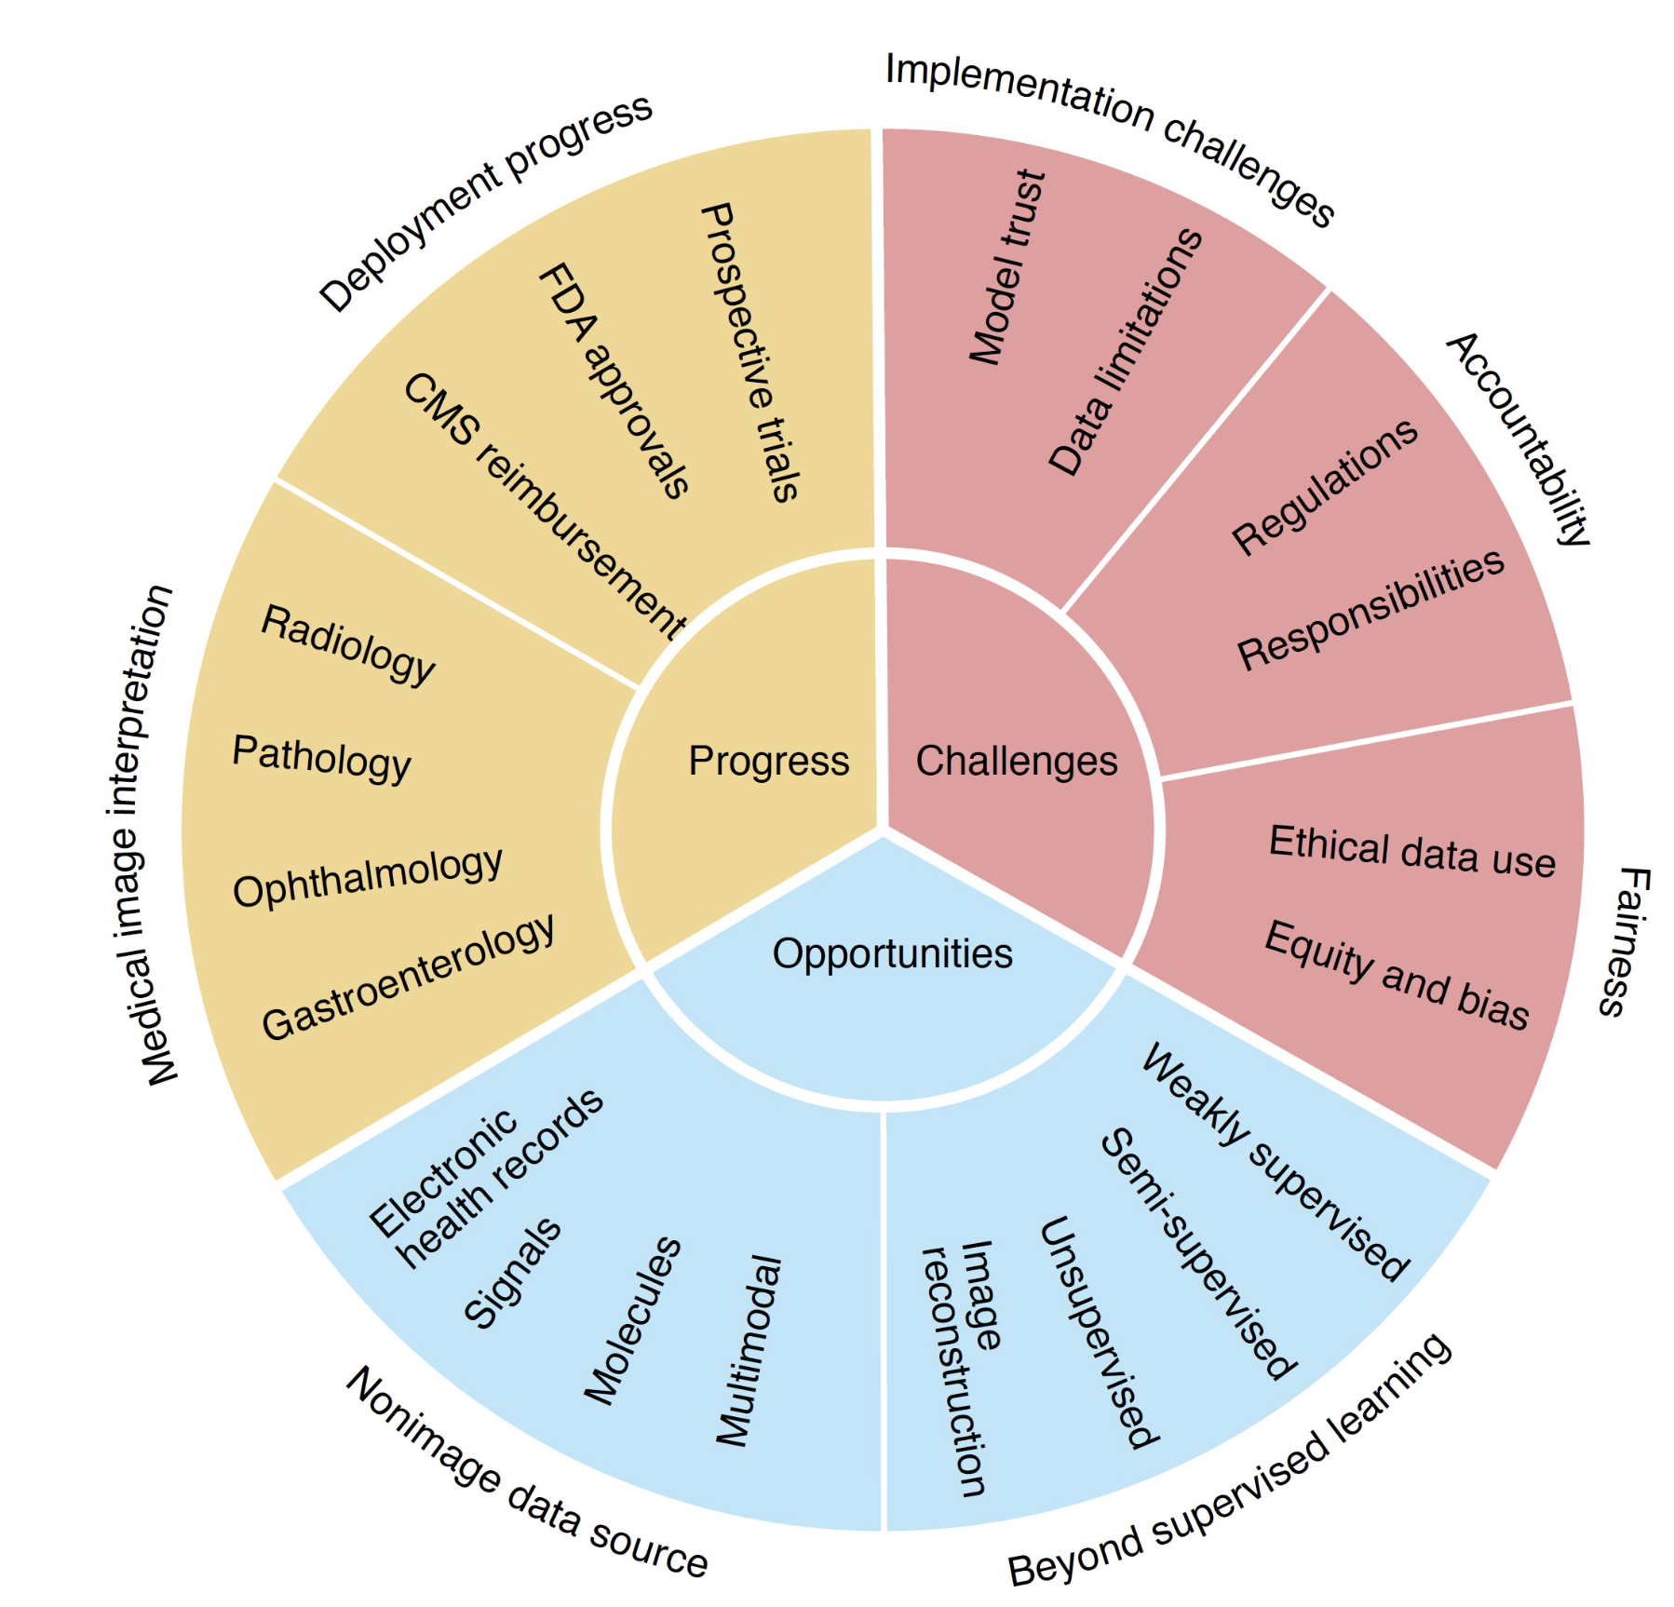
- EHR adoption has significantly improved in the last decade and has reached almost 100% coverage across the US. Yet, not many deep learning models are taking advantage of this rich data source.

Multimodal models - based on a recent review paper
- Current SOTA deep learning models in healthcare (e.g. radiology) are dominated by single-modality models.
- Meanwhile advances in other areas like autonomous driving, social media video classification, etc have proven the superior performance of models on multimodal data.
- This paper that did a systematic review of all multimodal efforts in healthcare concluded that:
  - Multimodal models always outperform models based on a single data modality.
  - Deep learning models combining EHR data and images is an area of opportunity (not yet well explored by the research community).

Value-Proposition
- An opportunity to establish a new SOTA for this type of data and model.
- Provide a pretrained model for industry and researchers in the field.
- Provide pre-trained embeddings.
- Provide an open source reusable ML pipeline for multimodal healthcare data.

Success
- Success = Surpassing SOTA performance of single-modality models on the same or similar dataset (proposed dataset = MIMIC-CXR + MIMIC-IV)
  - That is - surpassing the performance of deep learning models that rely solely on image data (chest X-rays) for medical predictions.
- Success = End to end pipeline for predicting using multiple modalities given multimodal healthcare data for a patient.

Audience
- Healthcare + AI researchers in academia and industry.
  - Value propositions = An open source and potentially new state-of-the-art model on an open source dataset that:
    - Demonstrates model development on multimodal data.
    - Can be easily benchmarked against and eventually surpassed.
- Health IT teams of hospitals.
  - Pain points = Lack of pre-trained models, embeddings and pipelines.

What
Model(s)
- A deep learning model or comparative models implementing one or all of the multimodal fusion techniques (early, joint and late fusion) described in the paper mentioned above².
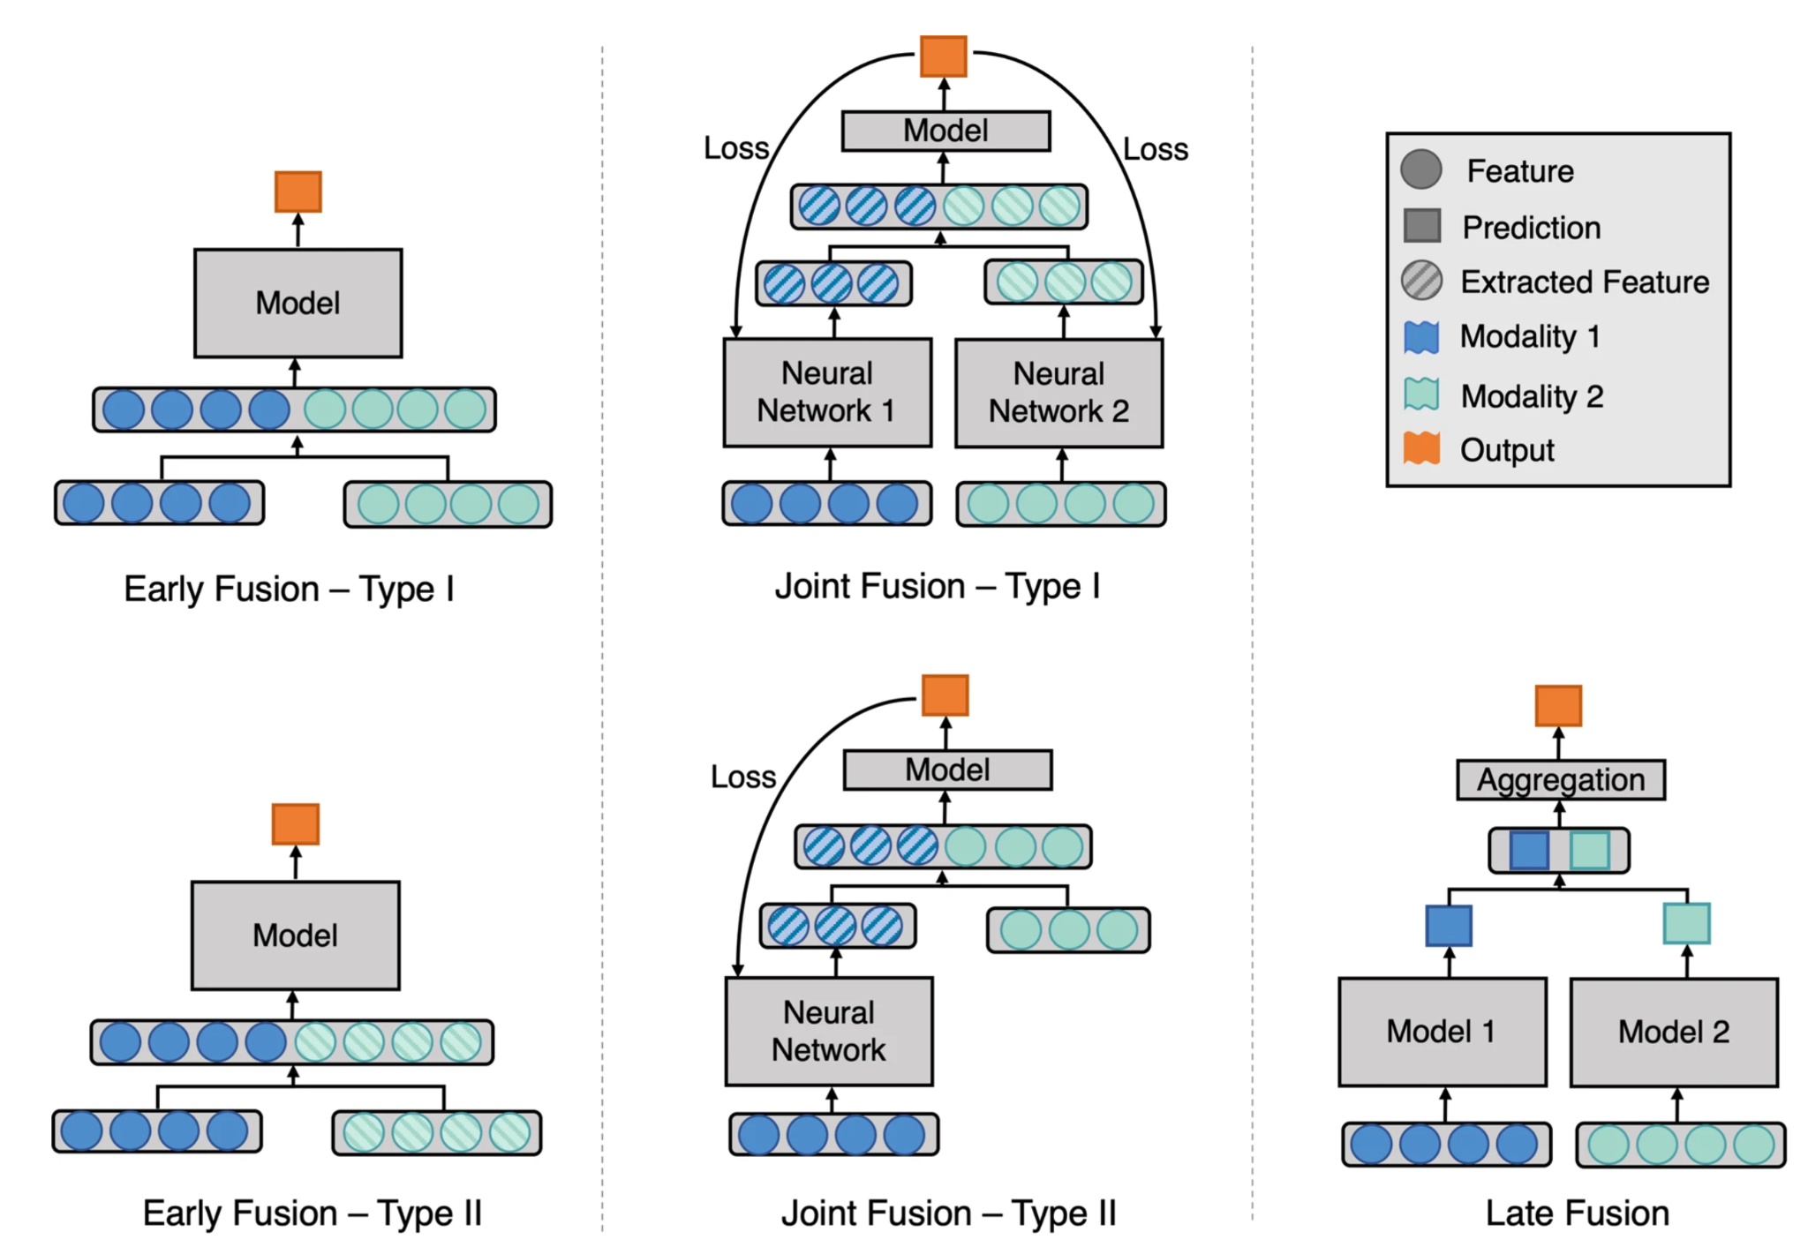

- Model for image data = CNN (some type of Resnet).
- EHR data (Structured + time series) = LSTM or potentially Graph NN.
- Potentially Clinical Notes = Transformer (BERT).
Dataset
- The relatively new MIMIC-IV and MIMIC-CXR datasets provide the only English-language data (available anywhere in the world) of actual EHR and related radiology images for de-identified patients.
- Risk: Timely access to MIMIC for all team members
- The Coherent Dataset.

Metrics
- AUROC - the most popular metric in healthcare applications of this type.
- All current papers and results are published and measured based on AUROC.

Rajpurkar, P., Chen, E., Banerjee, O. et al. AI in health and medicine. Nat Med 28, 31–38 (2022). https://doi.org/10.1038/s41591-021-01614-0
Huang, S. C., Pareek, A., Seyyedi, S., Banerjee, I., & Lungren, M. P. (2020). Fusion of medical imaging and electronic health records using deep learning: a systematic review and implementation guidelines. NPJ digital medicine, 3, 136. https://doi.org/10.1038/s41746-020-00341-z

