AIDE User’s guide

v1.1

**1. Installation Instructions for AIDE v1.1**

AIDE (Automatic IDentification of functional Events) is an algorithm developed to identify functional events directly from fNIRS data using the General Linear Model (GLM) approach. fNIRS data are fitted with all the possible combinations of event onsets and durations. The combination that gives the best fit, is marked as functional event. Please read [1] for further details and further information about the input parameters required to apply AIDE.

Download the AIDE code release.

AIDE v1.0 uses:

* *Matlab toolboxes*:

Image Processing Toolbox

Statistics Toolbox

Robust Control Toolbox

* *SPM8* (<http://www.fil.ion.ucl.ac.uk/spm/software/spm8/)>
* *Peak_finder.m* developed by N. C. Yoder (2016)   
  (https://it.mathworks.com/matlabcentral/fileexchange/25500-1001 peakfinder-x0--sel--thresh--extrema--includeendpoints--interpolate-)
* *Fdr_bh.m* (<https://uk.mathworks.com/matlabcentral/fileexchange/27418-fdr-bh)>

Type ‘AIDE_GUI’ in the Matlab command window to run AIDE or run the AIDE_GUI.m script.

**2. Data Format**

The input file is a Matlab file including the following fields:

* *HBO*: this variable is the oxyhemoglobin data. It is a matrix with dimensions [(number of time points) x (number of channels)]. Example: the element (i,j) represent the value of oxyhemoglobin for the time point i of channel j.
* *HHB*: this variable is the oxyhemoglobin data. It is a matrix with dimensions [(number of time points) x (number of channels)]. Example: the element (i,j) represent the value of deoxyhemoglobin for the time point i of channel j.
* *fs*: this is the sampling frequency of the fNIRS data. We advise to use 1 Hz to reduce computational time.

See SampleData.mat for an example of input data format.

**3. GUI Description**

The main panel of AIDE GUI is shown in Figure 1.

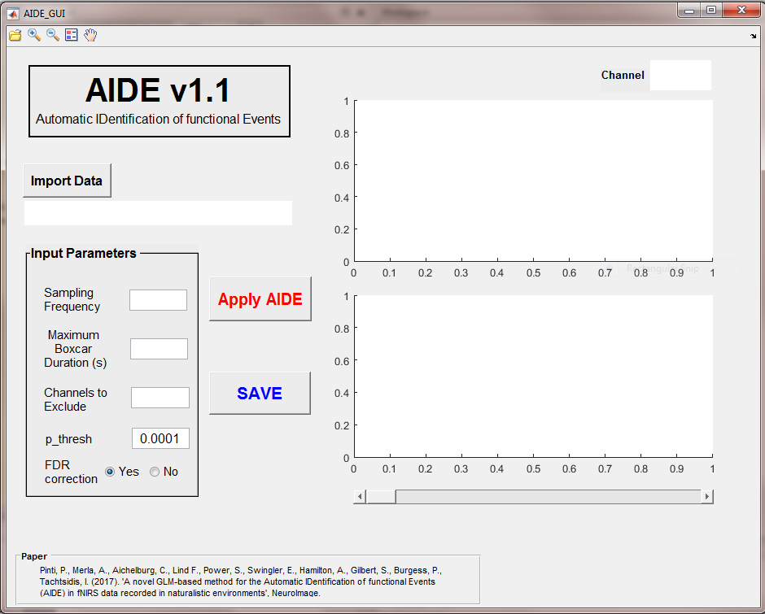

**Figure 1. AIDE main panel.**

* *Import Data button*: it allows to select and import the input data file (see Section 2 for the file format)
* *Input Parameters*: these are the parameters required to run AIDE:
  + *Maximum Boxcar Duration*: it refers to the maximum boxcar duration that will be tested by AIDE (in seconds). The minimum is set to 1. To test all the possible boxcar durations with a minimum duration of 1 s and a maximum duration equal to the signal length, leave it blank.
  + *Channels to Exclude*: if any channels have to be excluded by AIDE, type the corresponding channel number (e.g. 1 5 6). If no channels have to be excluded, leave it blank.
  + *p_thresh*: it is the p-value threshold that is applied to the t-values peaks (e.g. 0.0001 as determined with the simulations reported in [1])
  + *FDR correction*: Select yes to correct for multiple comparisons by means of False Discovery Rate (FDR); select no otherwise. The default is yes.
* Apply AIDE: it applies the AIDE algorithm to the NIRS data.
* Save: it saves AIDE results as a *.mat file. The output file includes:
  + *Activation_Points*: it is a cell variable with dimensions [6 x (number of analysed channels+1)]. Activation_Points{2, j+1} contains the onset of the event identified for channel j; Activation_Points{3, j+1} contains the duration of the event identified for channel j; Activation_Points{4, j+1} contains the t-value corresponding to the event identified for channel j; Activation_Points{5, j+1} contains the p-value corresponding to the event identified for channel j; Activation_Points{6, j+1} contains the β-value corresponding to the event identified for channel j.
  + *Results*: it is a struct containing the β-value (Beta), the t-values (t_stat), the variance (Var), the p-values (p_value), degrees of freedom (ndf), the t-values signal (t_signal), the channels included in the analysis (Channels2Include), the hemodynamic response function used for the fitting procedure (hrf), the input signal (Signal) and the sampling frequency of Signal (fs). Beta, t_stat, Var, p_value are cell variables with [2 x (number of tested boxcar durations)]. Example: Beta{2,1} contains the β-values computed for all the boxcars with duration=1 s; Beta{2,1} is [(number of boxcar onset shifts) x (number of analysed channels+1)]. Beta{2,1}(21,2) corresponds the β-value computed for Channel 1 using a boxcar with duration=1 s and onset 21 s. t_values and Signal are [(number of time points) x (number of analysed channels)]; ActivationModel is [(number of time points) x (number of analysed channels)] and represents the activation model resulting from the AIDE-detected functional events (i.e., the model that gives the best fit with the fNIRS activation signal).
* The two graphs on the right will show the t-values signal (top panel) computed by AIDE with the identified functional events and the corresponding model (Results.ActivationModel) that gives the best fit with fNIRS data. To show results for all the channels, use the scrolling bar.

**4. Example**

This section illustrates the use of the AIDE GUI on fNIRS sample data (Sampling Frequency=1 Hz), corresponding to 3 channels synthetic time-series simulating a block-design experiment:

1. Click ‘Import Data’ to select and load SampleData.mat
2. Specify the Sampling Frequency (Hz) = 1 (Figure 2)
3. Leave blank the Max Boxcar Duration box to test all the possible boxcar durations
4. Leave blank Channels to Exclude box to include all the 3 channels
5. Use p_thresh=0.0001 as established through the simulations [1]
6. Use the False Discovery Rate (FDR) correction to correct for multiple comparisons

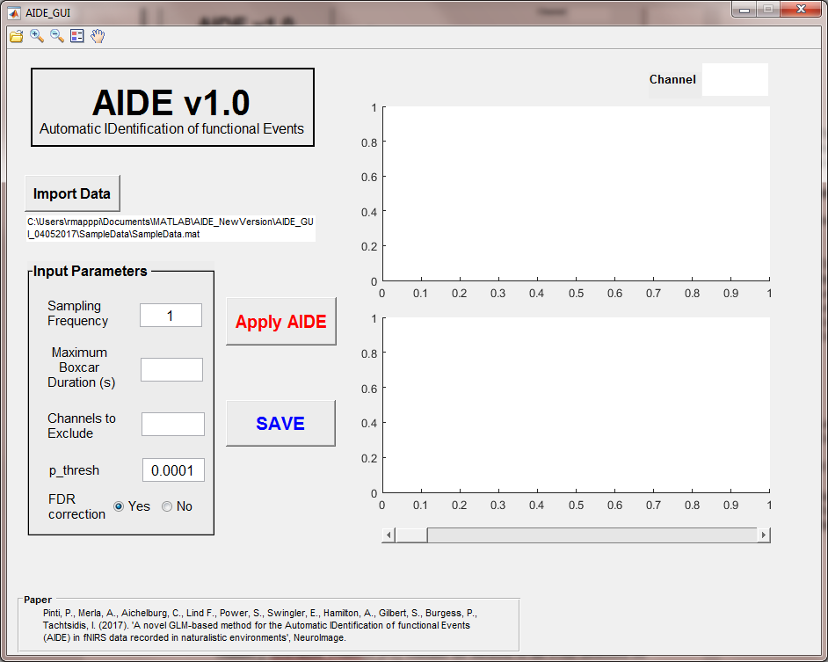

**Figure 2. AIDE Input Parameters.**

1. Launch AIDE by clicking on Apply AIDE
2. Use the scrollbar to see the results for all the 3 channels (Figure 3).

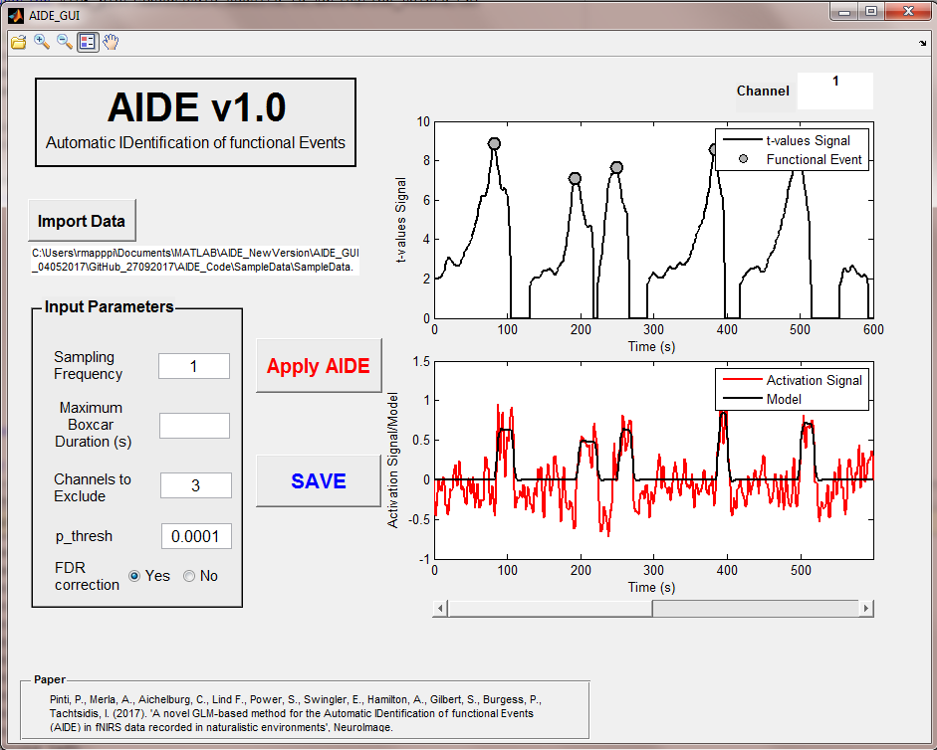 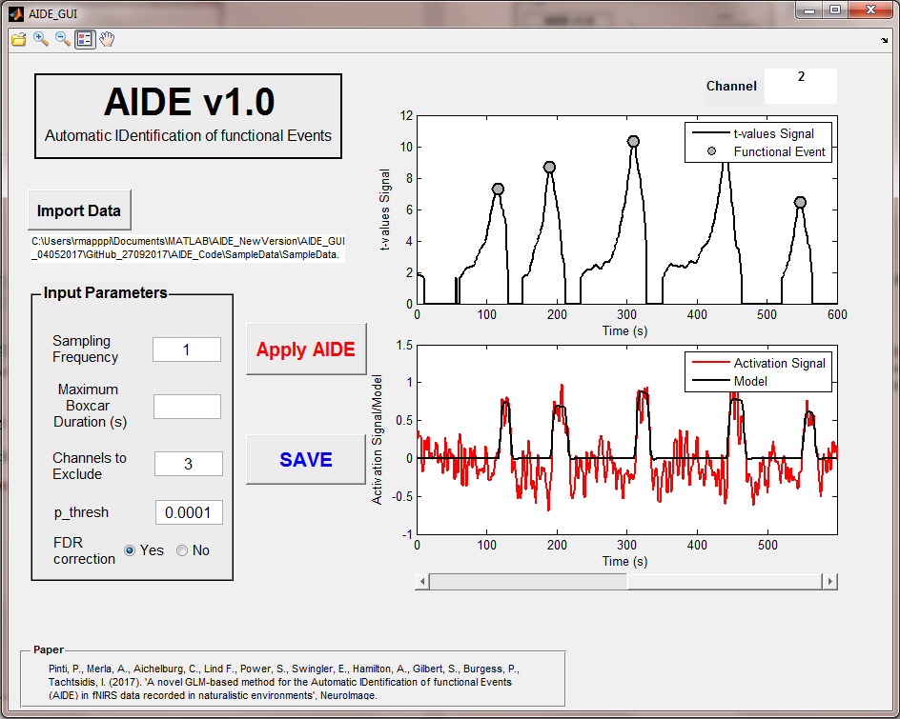

**Figure 3. AIDE Results per Channel.**

1. Save the results by clicking on Save.
2. To load previously saved results, click on the folder on the toolbar and select the results *.mat file (Figure 2, red circle).

**References:**

[1] Pinti, P., Merla, A., Aichelburg, C., Lind F., Power, S., Swingler, E., Hamilton, A., Gilbert, S., Burgess, P., Tachtsidis, I. (2017). 'A novel GLM-based method for the Automatic IDentification of functional Events (AIDE) in fNIRS data recorded in naturalistic environments', *NeuroImage*.