eRegQual analysis

Chris Rose, Norwegian Institute of Public Health ( 2 Jul 2020)

Generated using git revision: e7ada8f

# Introduction

This document presents the methods used to analyze the adverse pregnancy and process outcome data for the eRegQual trial and presents the results.

# Methods

Because health outcome data were missing for about a third of participants (see results), we used Little's tests (Little 1988) of the null hypotheses that missing values of the constituent outcomes were jointly missing completely at random (MCAR) and covariate-dependent missing (CDM). We then used multiple imputation via chained equations (van Buuren 2007) to create and analyze 10 multiply-imputed datasets. We imputed using the auxiliary variables trial arm, years of education, average monthly household income (transformed to the log scale due to the skewed distribution of income), body mass index, ultrasound availability, and the variables used as constraints in the randomization (cluster size, age, lab availability, and parity). We were not able to include auxiliary variables that indicated previous pregnancy with pre-eclampsia or previous history of GDM due to collinearity. We evaluated convergence of the imputation algorithm by inspecting trace plots and evaluated imputed data by inspecting kernel density and histograms comparing the distributions of imputed and complete case data.

An adverse pregnancy outcome was defined to have occurred if at least one of the constituent outcomes occurred, and not to have occurred if none of the constituent outcomes occurred. For each imputed data set and outcome, we estimated an odds ratio to compare treatment to control using logistic regression, accounting for the cluster-randomized design using random effects. We combined estimates for each outcome using Rubin's rules (Rubin 2004). For comparison, we also performed a complete case analysis under the MCAR assumption. We estimated the intraclass correlation coefficient (ICC) using the complete cases.

We used logistic regression to estimate the relative odds of each of the process outcomes under the treatment versus control conditions. For outcomes measured at multiple time points, we modelled clustering within each pregnancy using random-effects, and computed cluster-robust standard errors to account for the cluster-randomized design. For outcomes measured at only one time point within each pregnancy, we accounted for the cluster-randomized design using random effects. For each of the process outcomes, we plotted marginal predictive probabilities of attendance or successful screening and management with respect to cluster size, age, laboratory availability, and parity. Age was either incorrectly coded or missing for no more than 1.3% of women across the process outcomes. Because data were missing for less than 5% of women, we performed complete case analyses (Jakobsen 2017).

We adjusted for the stratification variable (CHMP 2015) as a fixed effect in all analyses except that for severe hypertension (due to chance, this relatively rare outcome could be predicted perfectly by that variable for a small proportion of the imputed data sets). We also adjusted for the variables used to constrain randomization (Li 2017) as fixed effects in all analyses, using individual- rather than cluster-level measurements where possible. We followed the intention-to-treat principle for all analyses: participants were analyzed in the arms to which they were randomized and — with the exception of the complete case analyses — all participants were included in the analyses. We computed 95% confidence intervals and used the significance criterion P<0.05 throughout. Statistical analyses were performed using Stata 16 (StataCorp LLC, College Station, Texas, USA). The statistician was not involved in data extraction and was blinded to treatment allocation during analysis. Protocol deviations are documented in Appendix 1.

# Results

## Adverse pregnancy outcomes

Outcome data were missing for between 11.8% and 35.5% of the constituent outcomes, and 33.8% of the composite outcome. We were unable to reject the MCAR and CDM hypotheses (P=0.15 and P=0.64, respectively). Distributions of the original and the first five imputed data sets are shown in Appendix 2. Table 1 shows the result of the adverse pregnancy outcome analysis. The odds ratio was estimated to be 0.99 (95% CI 0.88 to 1.12, P = 0.93). This compares to the complete case odds ratio of 0.98 (95% CI 0.86 to 1.12, P = 0.79). Tables 2–6 show results for the constituent outcomes. The ICC was estimated to be close to zero and no greater than 0.007 (upper bound of 95% CI).

|  |  |  |  |  |  |  |
| --- | --- | --- | --- | --- | --- | --- |
| Table 1. Adverse pregnancy outcome (multiply-imputed result) | | | | | | |
|  | Odds Ratio | Std. Err. | t | P>|t| | [95% Conf. Interval] | |
| arm |  |  |  |  |  |  |
| D | 0.99 | 0.06 | -0.09 | 0.93 | 0.88 | 1.12 |

|  |  |  |  |  |  |  |
| --- | --- | --- | --- | --- | --- | --- |
| Table 2. Anemia at birth (multiply-imputed result) | | | | | | |
|  | Odds Ratio | Std. Err. | t | P>|t| | [95% Conf. Interval] | |
| arm |  |  |  |  |  |  |
| D | 1.13 | 0.27 | 0.49 | 0.62 | 0.70 | 1.81 |

|  |  |  |  |  |  |  |
| --- | --- | --- | --- | --- | --- | --- |
| Table 3. Severe hypertension at birth (multiply-imputed result) | | | | | | |
|  | Odds Ratio | Std. Err. | t | P>|t| | [95% Conf. Interval] | |
| arm |  |  |  |  |  |  |
| D | 1.57 | 0.60 | 1.18 | 0.24 | 0.74 | 3.35 |

|  |  |  |  |  |  |  |
| --- | --- | --- | --- | --- | --- | --- |
| Table 4. SGA undetected at birth (multiply-imputed result) | | | | | | |
|  | Odds Ratio | Std. Err. | t | P>|t| | [95% Conf. Interval] | |
| arm |  |  |  |  |  |  |
| D | 0.99 | 0.11 | -0.05 | 0.96 | 0.80 | 1.23 |

|  |  |  |  |  |  |  |
| --- | --- | --- | --- | --- | --- | --- |
| Table 5. Malpresentation undetected at birth (multiply-imputed result) | | | | | | |
|  | Odds Ratio | Std. Err. | t | P>|t| | [95% Conf. Interval] | |
| arm |  |  |  |  |  |  |
| D | 1.06 | 0.17 | 0.37 | 0.71 | 0.77 | 1.47 |

|  |  |  |  |  |  |  |
| --- | --- | --- | --- | --- | --- | --- |
| Table 6. Large for gestational age (multiply-imputed result) | | | | | | |
|  | Odds Ratio | Std. Err. | t | P>|t| | [95% Conf. Interval] | |
| arm |  |  |  |  |  |  |
| D | 0.93 | 0.07 | -0.90 | 0.37 | 0.79 | 1.09 |

## Process outcomes — tables

The following tables show odds ratios comparing treatment to control for each process outcome. Full regression results are presented in Appendix 3.

|  |  |  |  |  |  |  |
| --- | --- | --- | --- | --- | --- | --- |
| Table 7. Successful attendance screening & management | | | | | | |
|  | Odds Ratio | Robust |  |  |  |  |
| y |  | Std. Err. | z | P>|z| | [95% Conf. Interval] | |
| arm |  |  |  |  |  |  |
| F | 1.18 | 0.13 | 1.47 | 0.14 | 0.95 | 1.47 |

|  |  |  |  |  |  |  |
| --- | --- | --- | --- | --- | --- | --- |
| Table 8. Successful hypertension screening & management | | | | | | |
|  | Odds Ratio | Robust |  |  |  |  |
| y |  | Std. Err. | z | P>|z| | [95% Conf. Interval] | |
| arm |  |  |  |  |  |  |
| J | 0.62 | 0.07 | -4.07 | 0.00 | 0.49 | 0.78 |

|  |  |  |  |  |  |  |
| --- | --- | --- | --- | --- | --- | --- |
| Table 9. Successful diabetes screening & management | | | | | | |
|  | Odds Ratio | Robust |  |  |  |  |
| y |  | Std. Err. | z | P>|z| | [95% Conf. Interval] | |
| arm |  |  |  |  |  |  |
| L | 1.45 | 0.17 | 3.08 | 0.00 | 1.14 | 1.83 |

|  |  |  |  |  |  |  |
| --- | --- | --- | --- | --- | --- | --- |
| Table 10. Successful malpresentation screening & management | | | | | | |
|  | Odds Ratio | Std. Err. | z | P>|z| | [95% Conf. Interval] | |
| arm |  |  |  |  |  |  |
| B | 1.42 | 0.31 | 1.57 | 0.12 | 0.92 | 2.19 |

|  |  |  |  |  |  |  |
| --- | --- | --- | --- | --- | --- | --- |
| Table 11. Successful anemia screening & management | | | | | | |
|  | Odds Ratio | Robust |  |  |  |  |
| y |  | Std. Err. | z | P>|z| | [95% Conf. Interval] | |
| arm |  |  |  |  |  |  |
| H | 1.88 | 0.20 | 5.89 | 0.00 | 1.52 | 2.32 |

|  |  |  |  |  |  |  |
| --- | --- | --- | --- | --- | --- | --- |
| Table 12. Successful fetalgrowth screening & management | | | | | | |
|  | Odds Ratio | Robust |  |  |  |  |
| y |  | Std. Err. | z | P>|z| | [95% Conf. Interval] | |
| arm |  |  |  |  |  |  |
| H | 0.72 | 0.18 | -1.31 | 0.19 | 0.45 | 1.17 |

## Process outcomes — figures

The following figures show marginal predictive probabilities for each process outcome.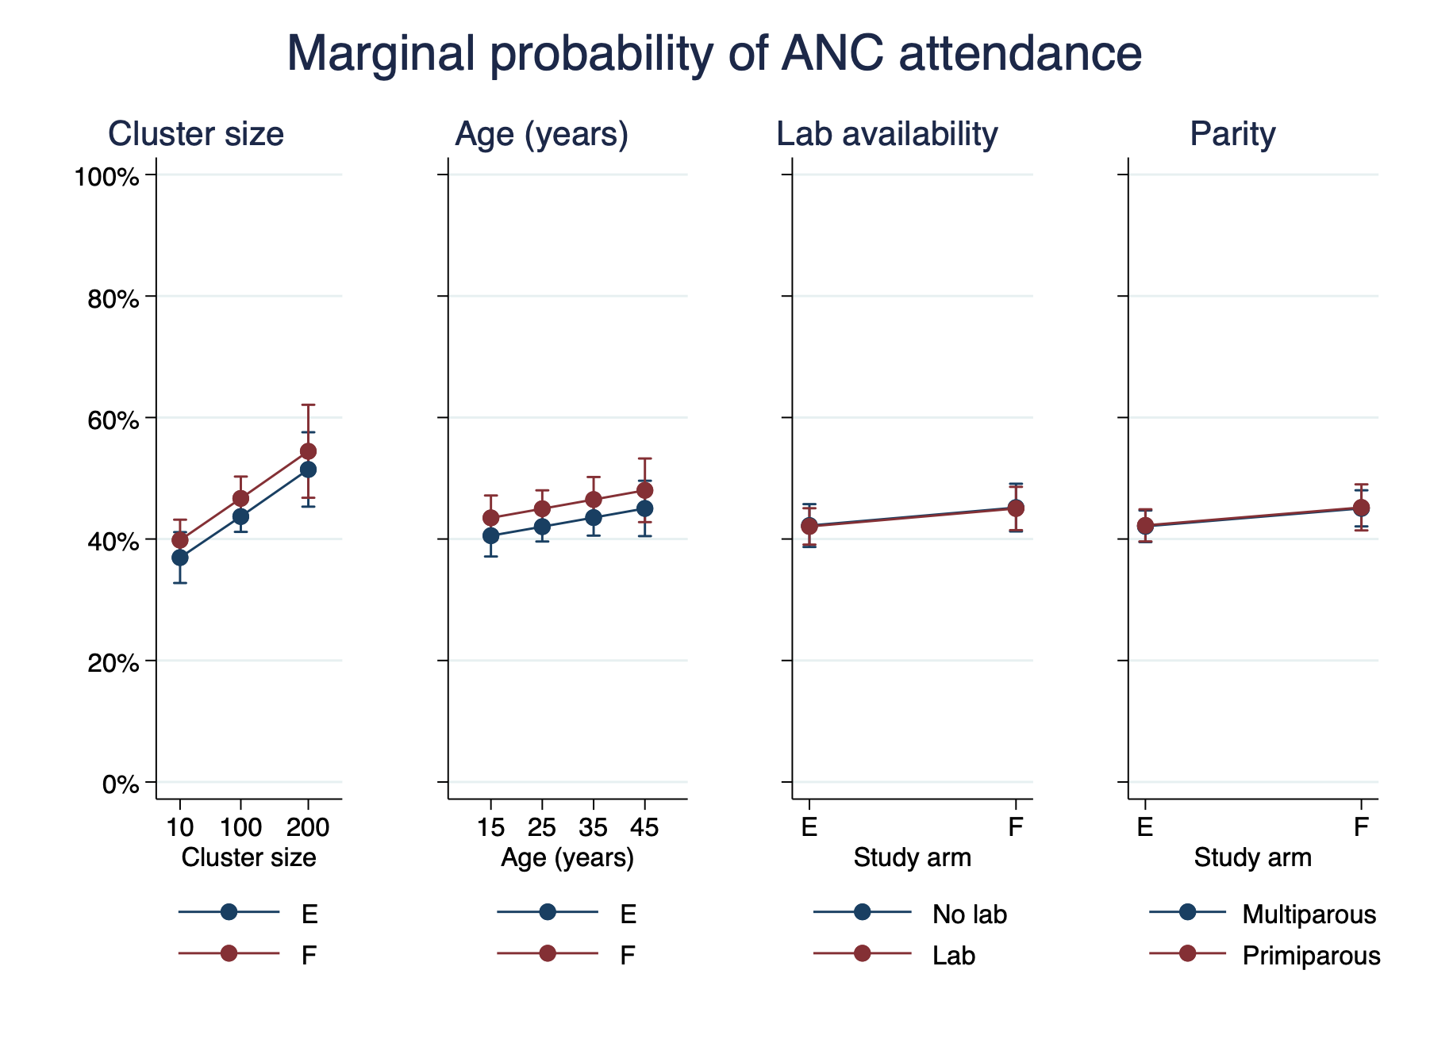  
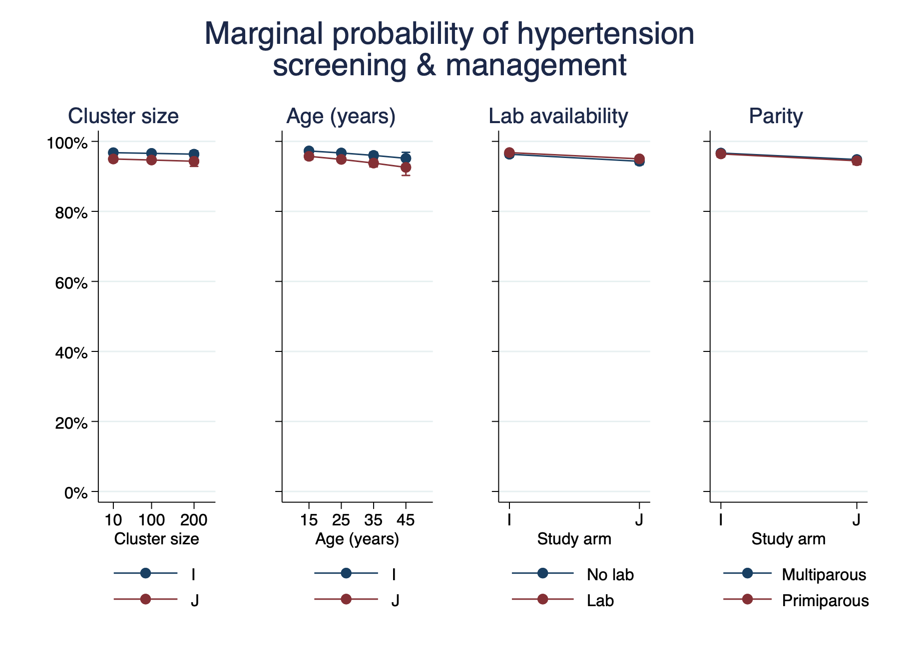  
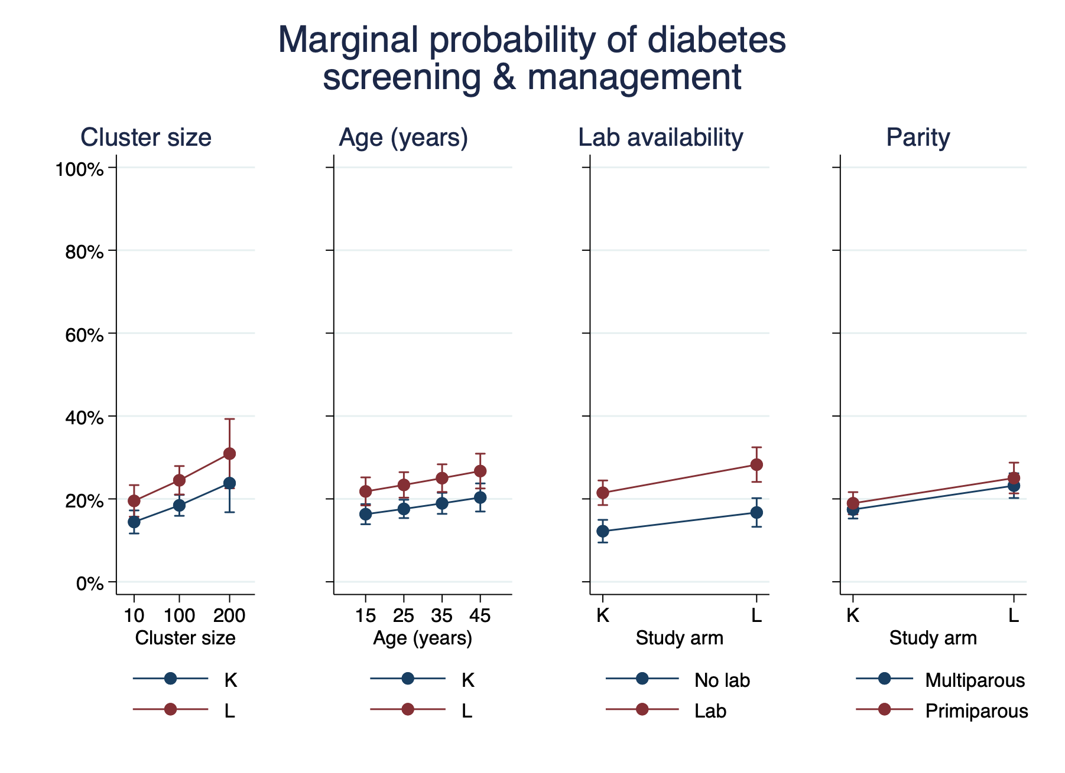  
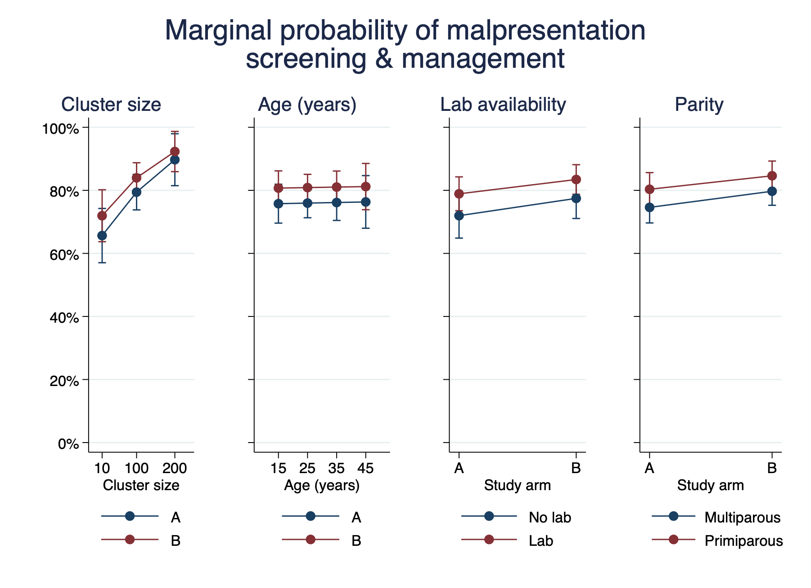  
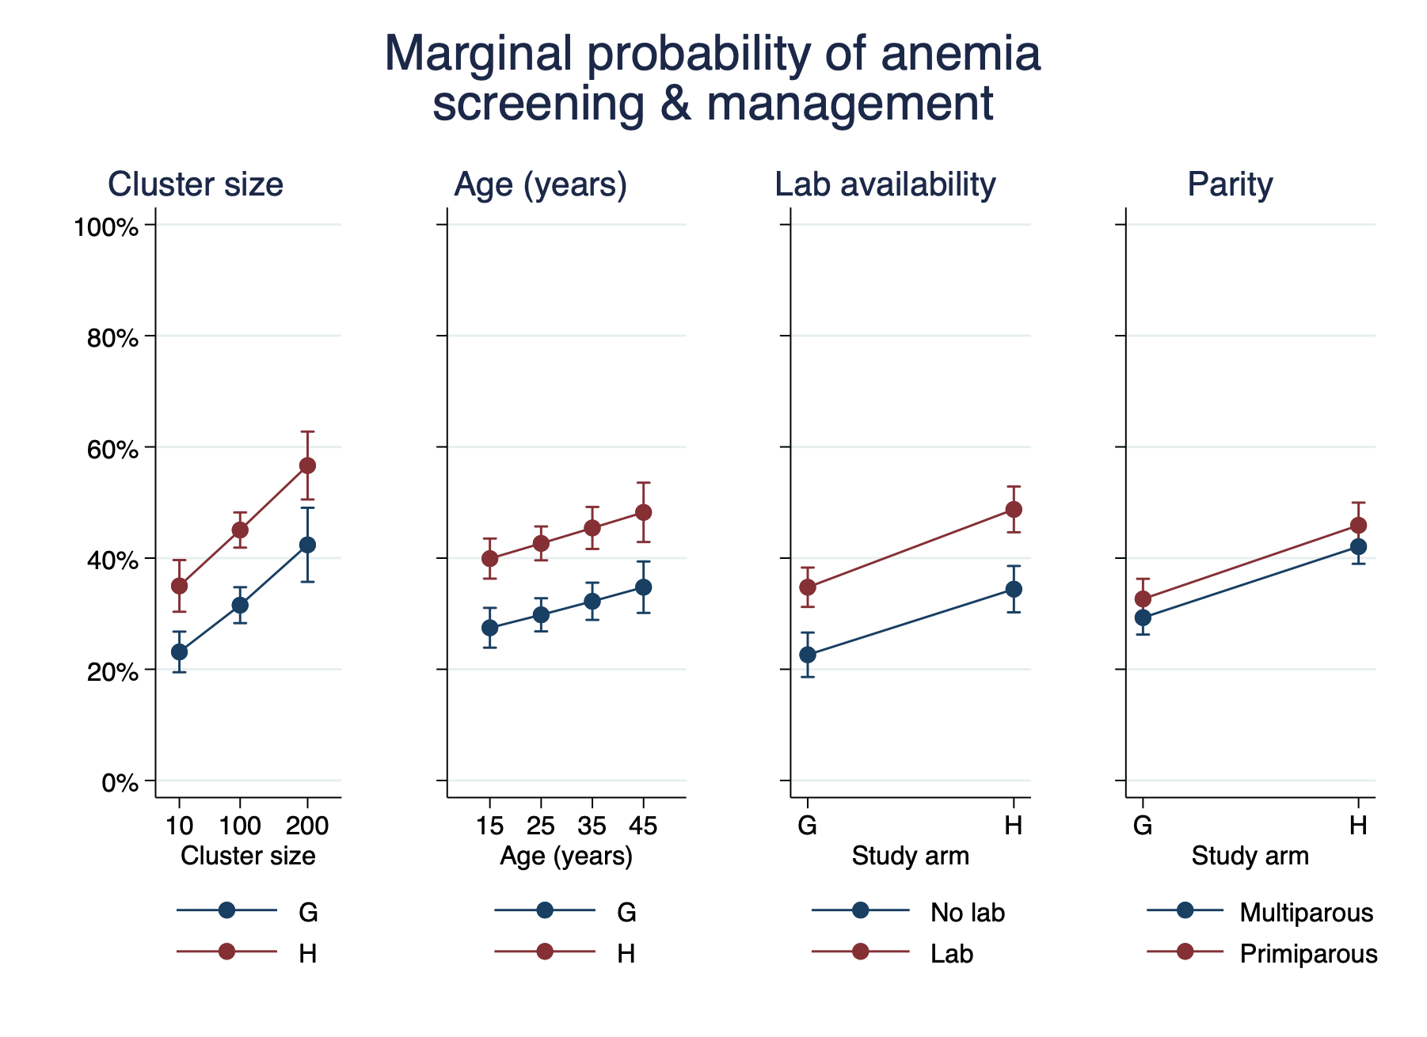  
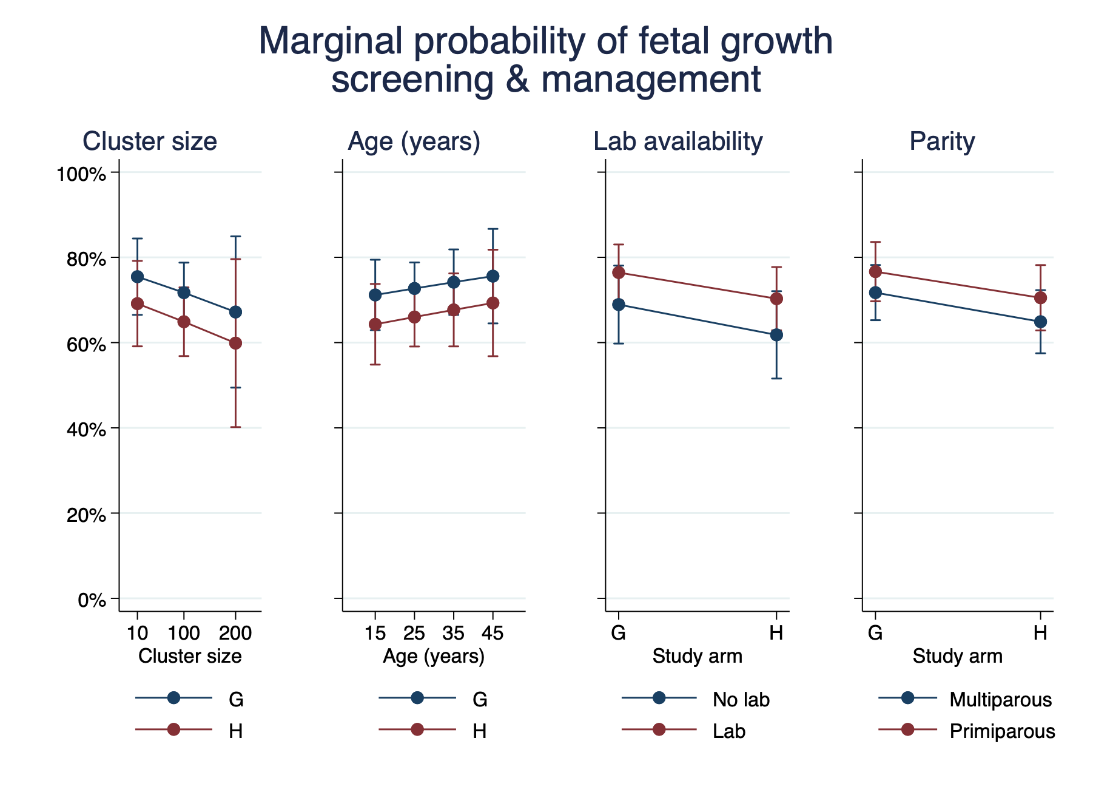

# References

Committee for Medicinal Products for Human Use (CHMP) (2015). Guideline on adjustment for baseline covariates in clinical trials. London: European Medicines Agency.

van Buuren, S. (2007). Multiple imputation of discrete and continuous data by fully conditional specification. Statistical methods in medical research, 16(3), 219-242.

Jakobsen, J. C., Gluud, C., Wetterslev, J., & Winkel, P. (2017). When and how should multiple imputation be used for handling missing data in randomised clinical trials–a practical guide with flowcharts. BMC medical research methodology, 17(1), 162.

Li, F., Turner, E. L., Heagerty, P. J., Murray, D. M., Vollmer, W. M., & DeLong, E. R. (2017). An evaluation of constrained randomization for the design and analysis of group‐randomized trials with binary outcomes. Statistics in medicine, 36(24), 3791-3806.

Little, R. J. (1988). A test of missing completely at random for multivariate data with missing values. Journal of the American statistical Association, 83(404), 1198-1202.

Rubin, D. B. (2004). Multiple imputation for nonresponse in surveys (Vol. 81). John Wiley & Sons.

# Appendix 1 — Protocol Deviations

We planned to use generalized estimating equations (GEEs) to account for the cluster-randomized design but used random-effect logistic regression because it was necessary to analyze the process outcome data in which outcomes are clustered within pregnancy (over time) and within clinic. Stata's XTGEE command can compute robust standard errors that account for clustering within pregnancy, but not additionally at the clinic level. We chose to use a common model for all analyses, rather than use GEEs for some outcomes and logistic regressions for others. We planned to report risk ratios, but report odds ratios as provided by logistic regression. We did not plan to adjust for the stratification variable or the variables used as constraints in the randomization, but have done so based on guidance from the European Medicines Agency and research that was not available when the protocol was being developed. We planned to visually explore differences in process outcomes between clusters using spider graphs but judged that plots of marginal predictive probabilities show the required information more clearly and provide confidence intervals.

# Appendix 2 — Imputation

The following figures show the distributions of the original and a selection of the imputed data.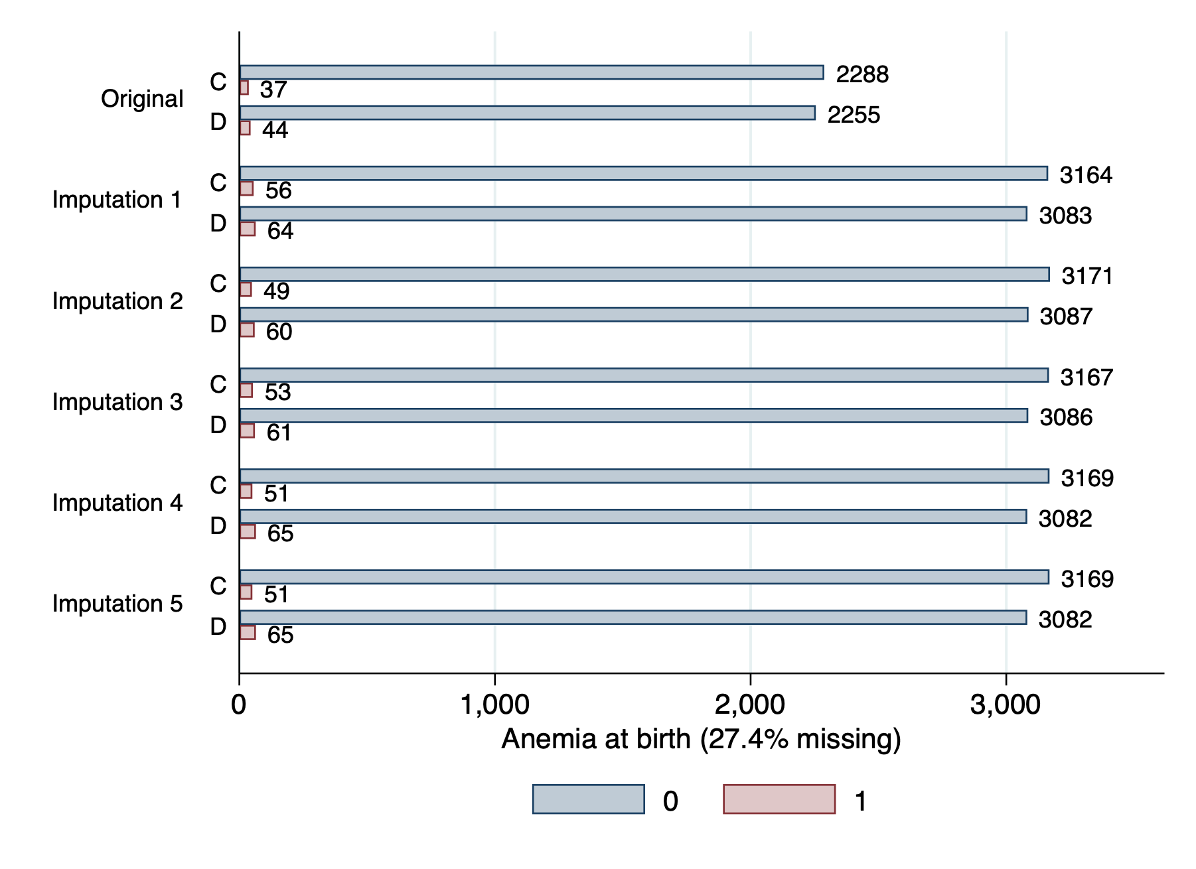  
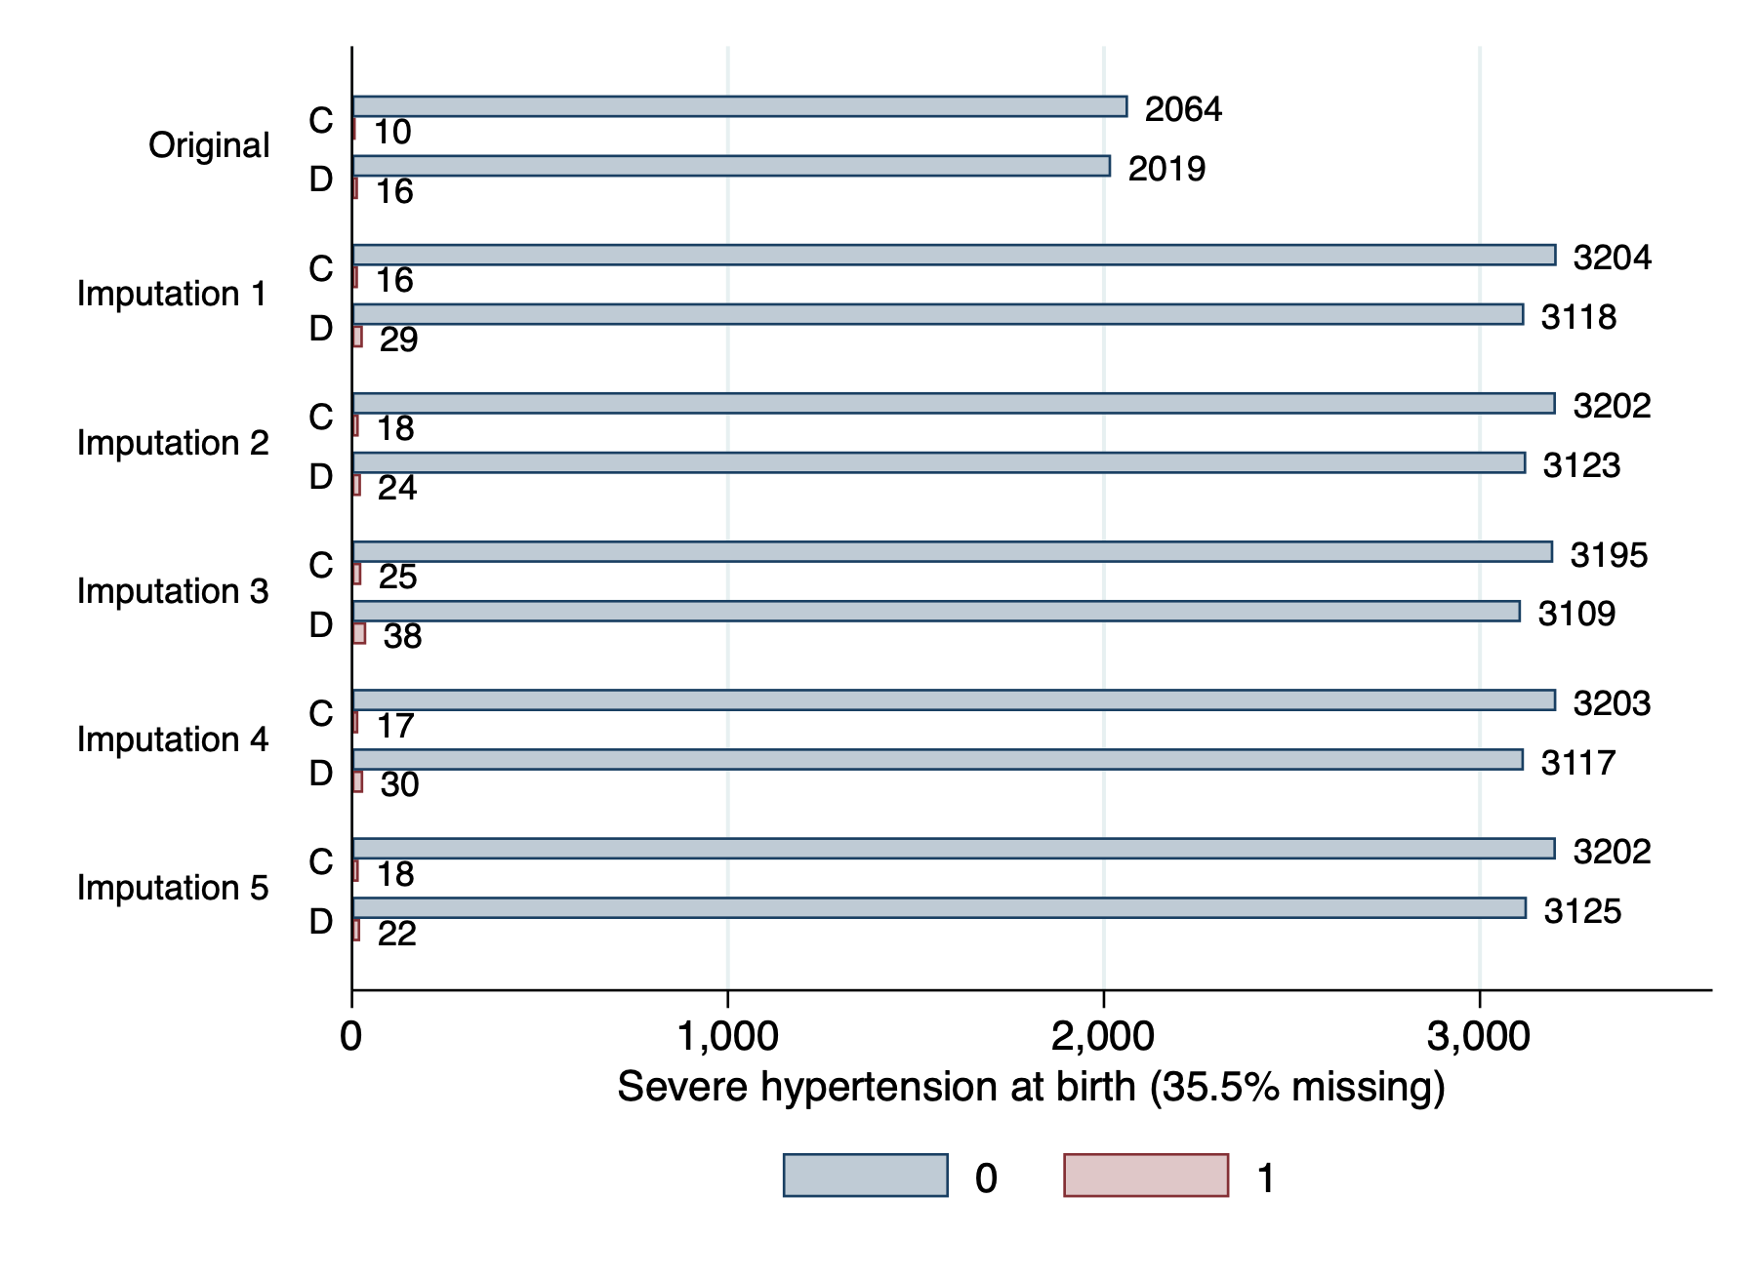  
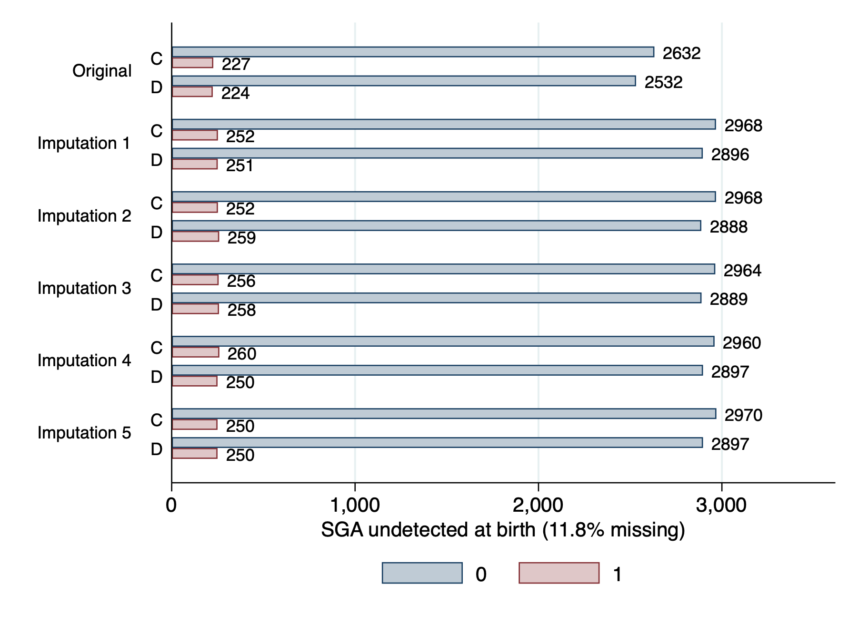  
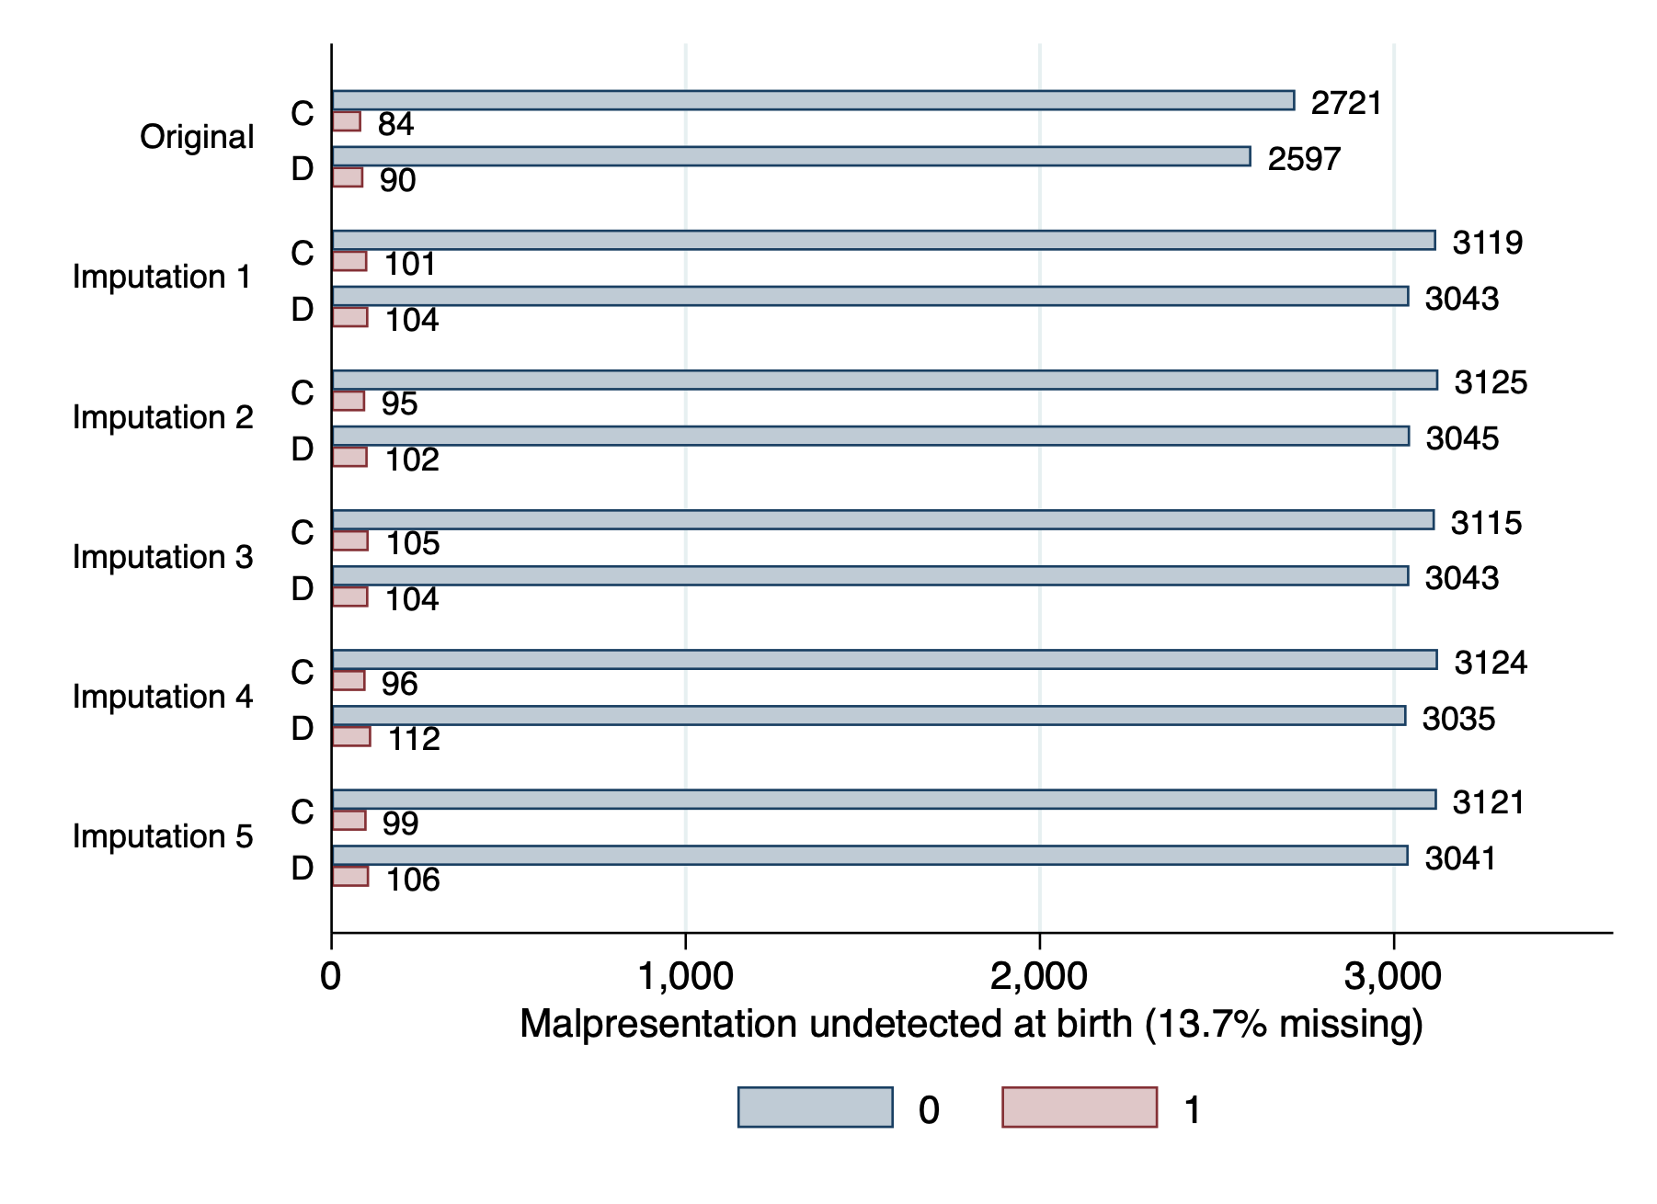  
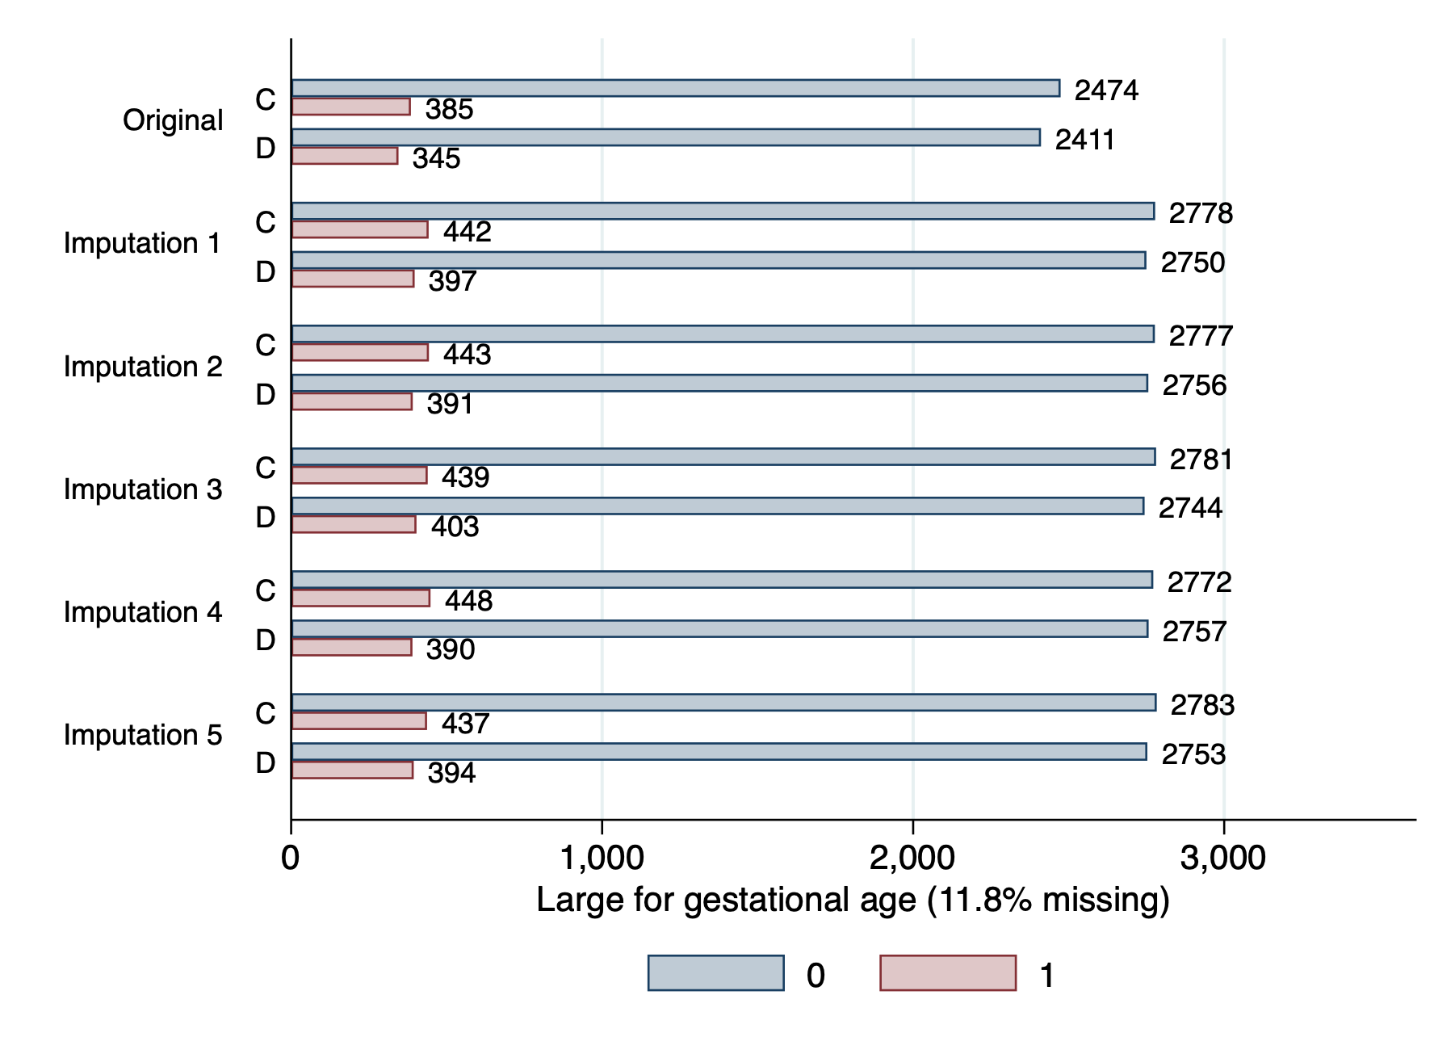  
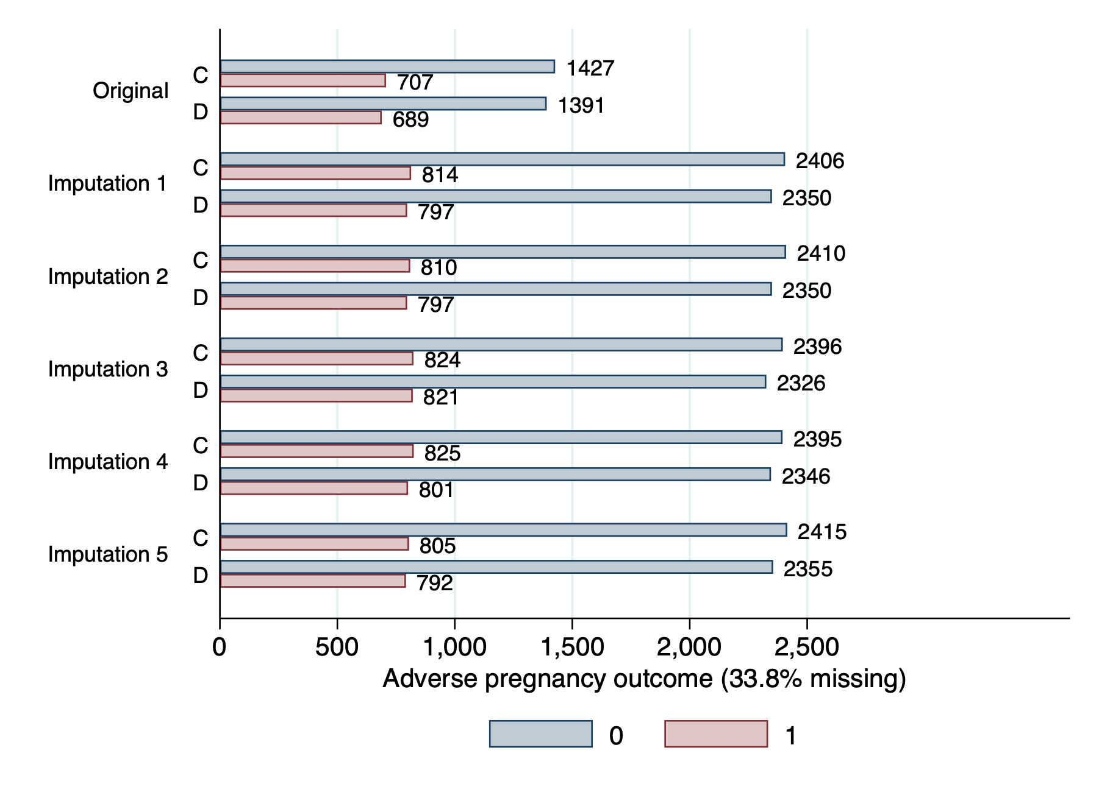  
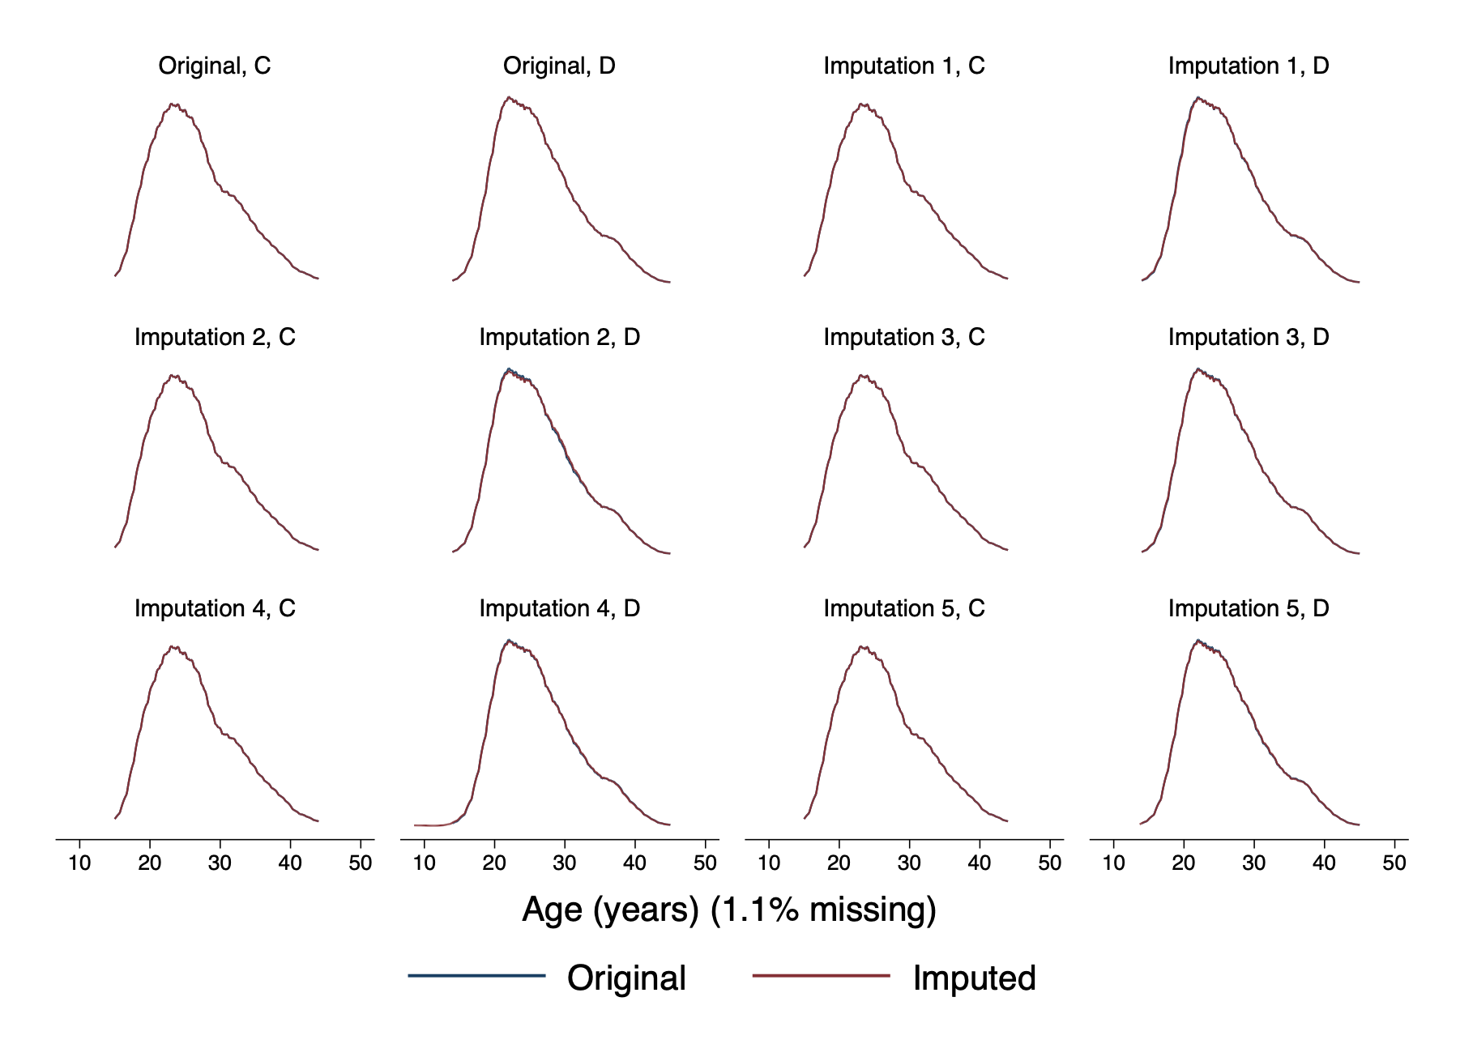  
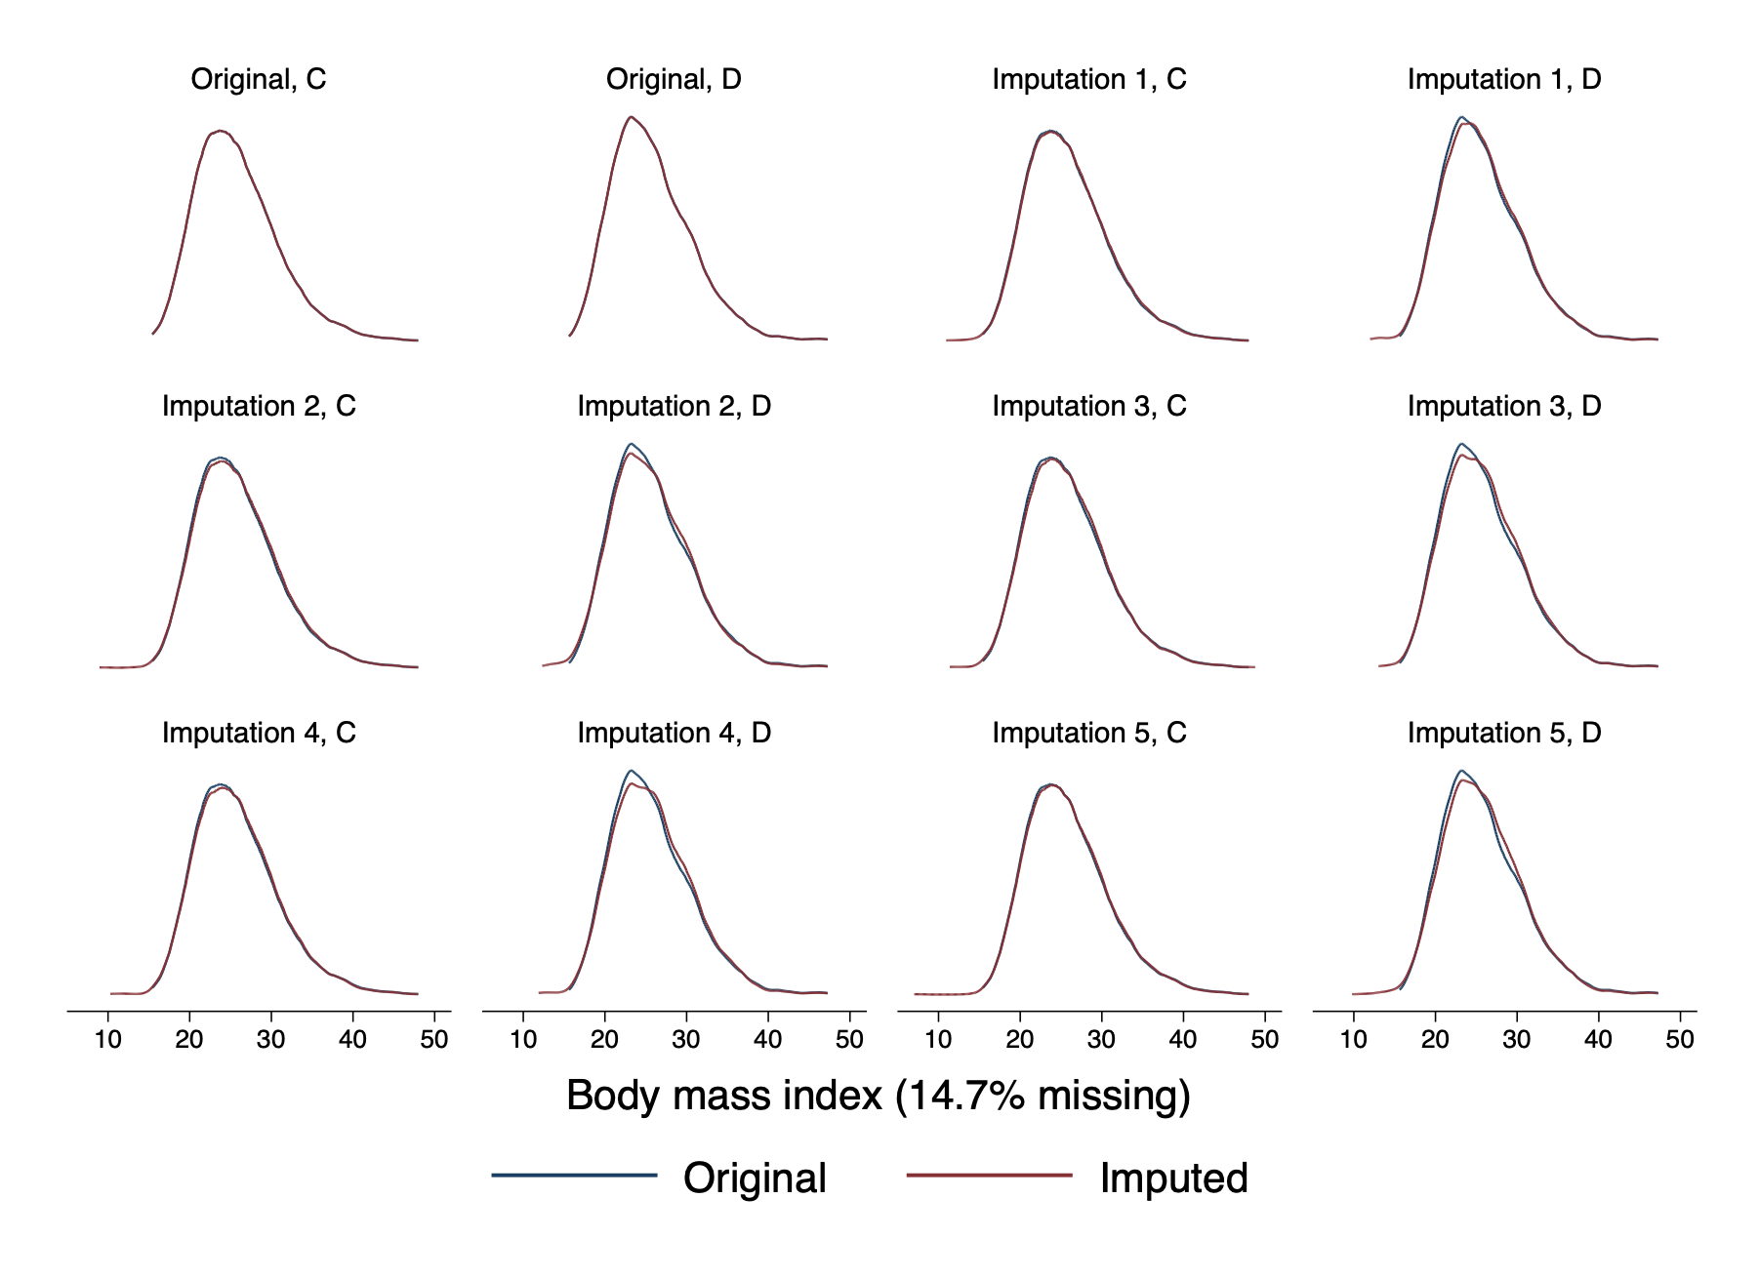  
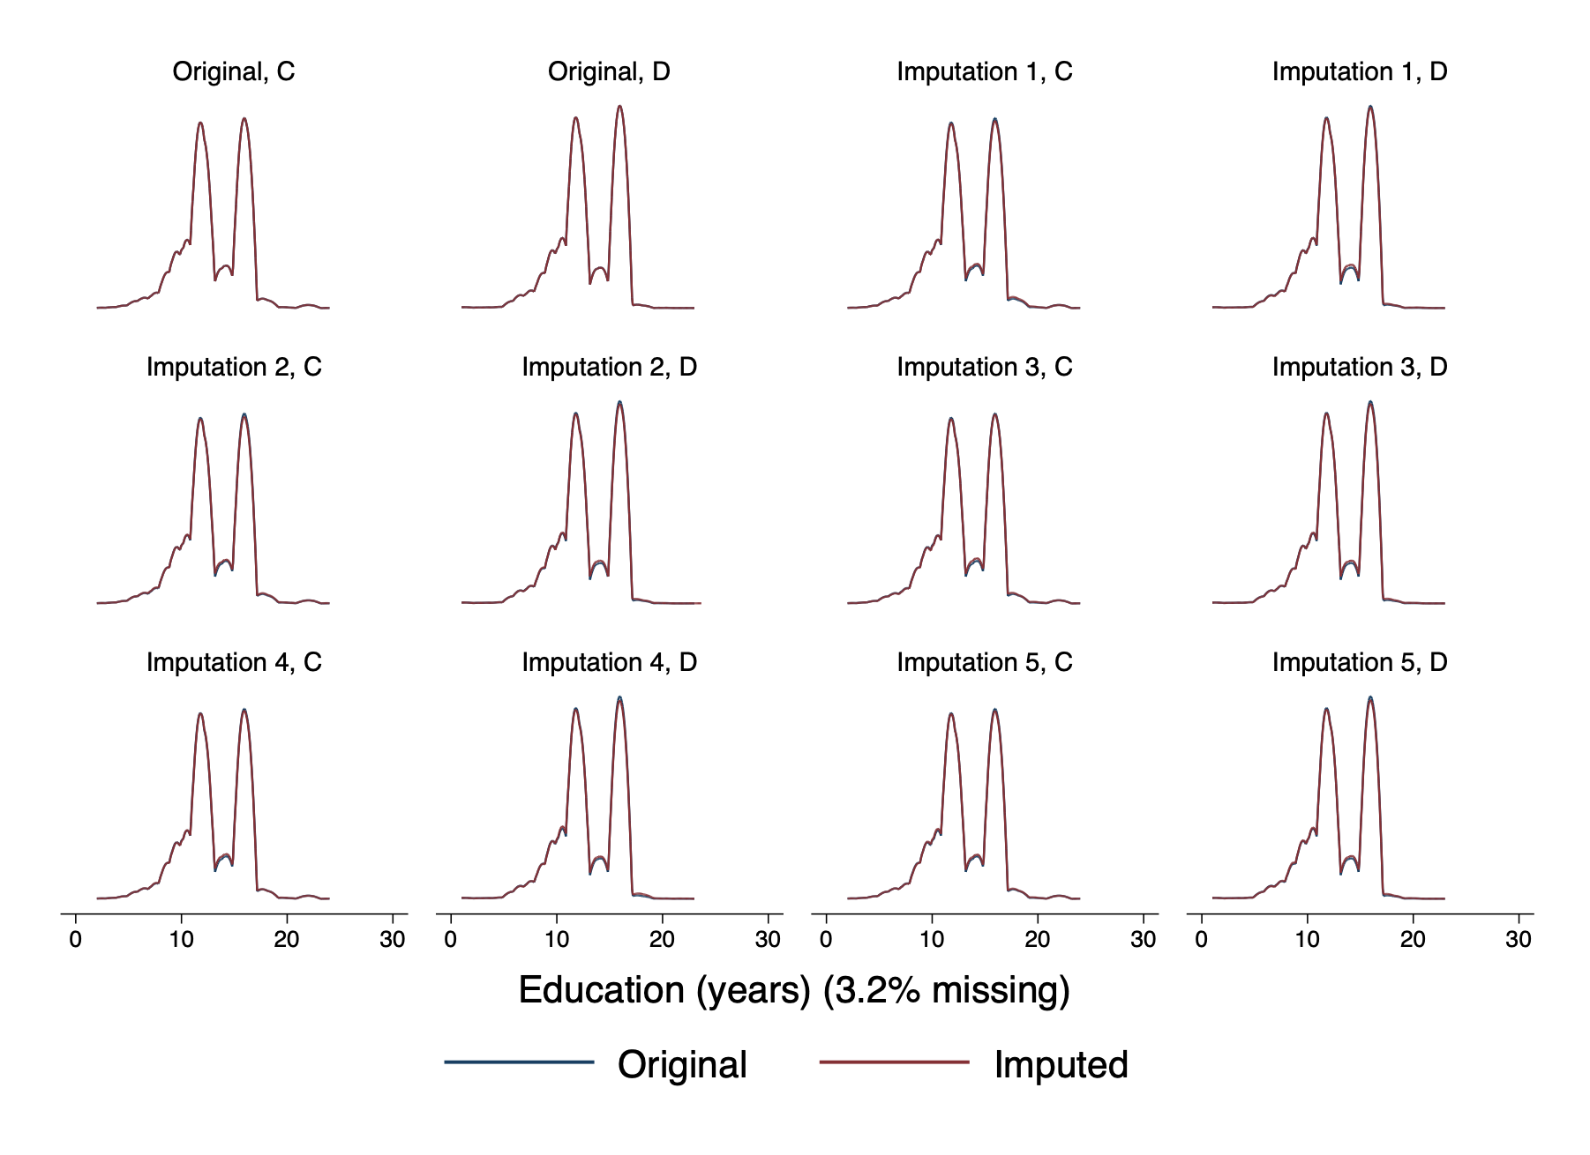  
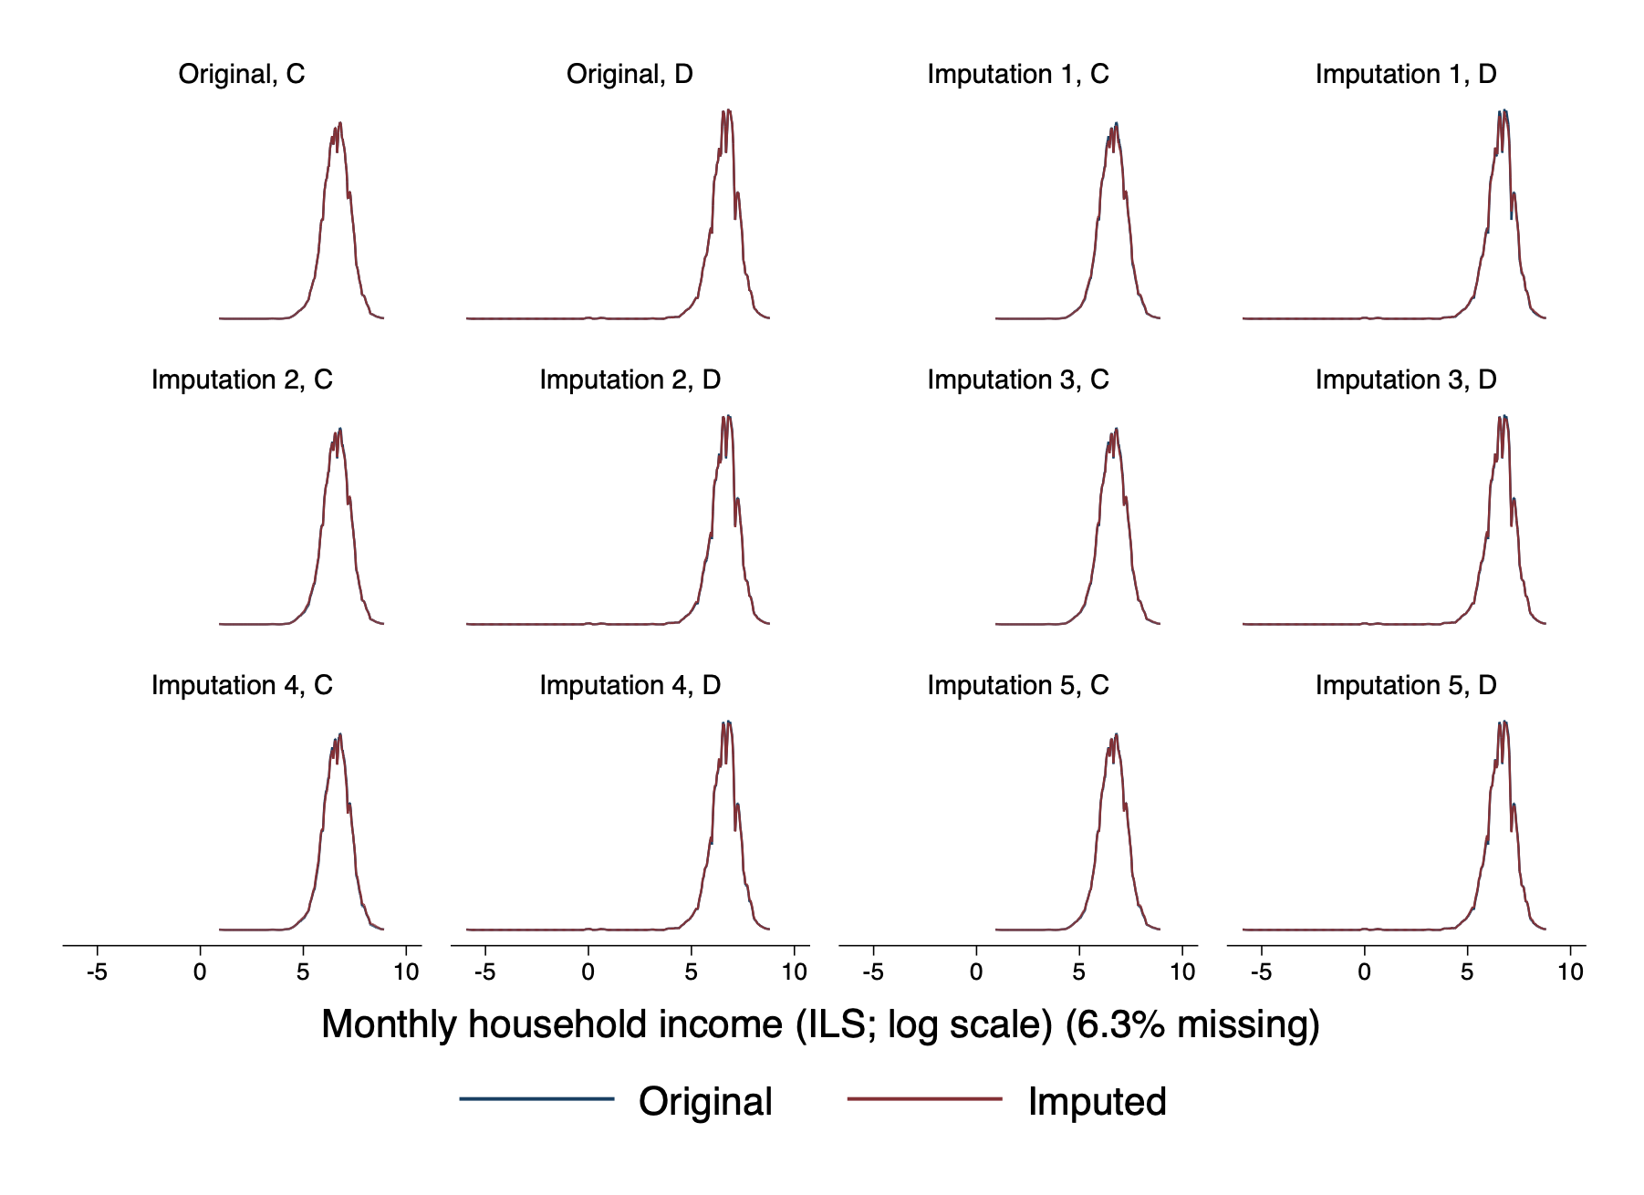  
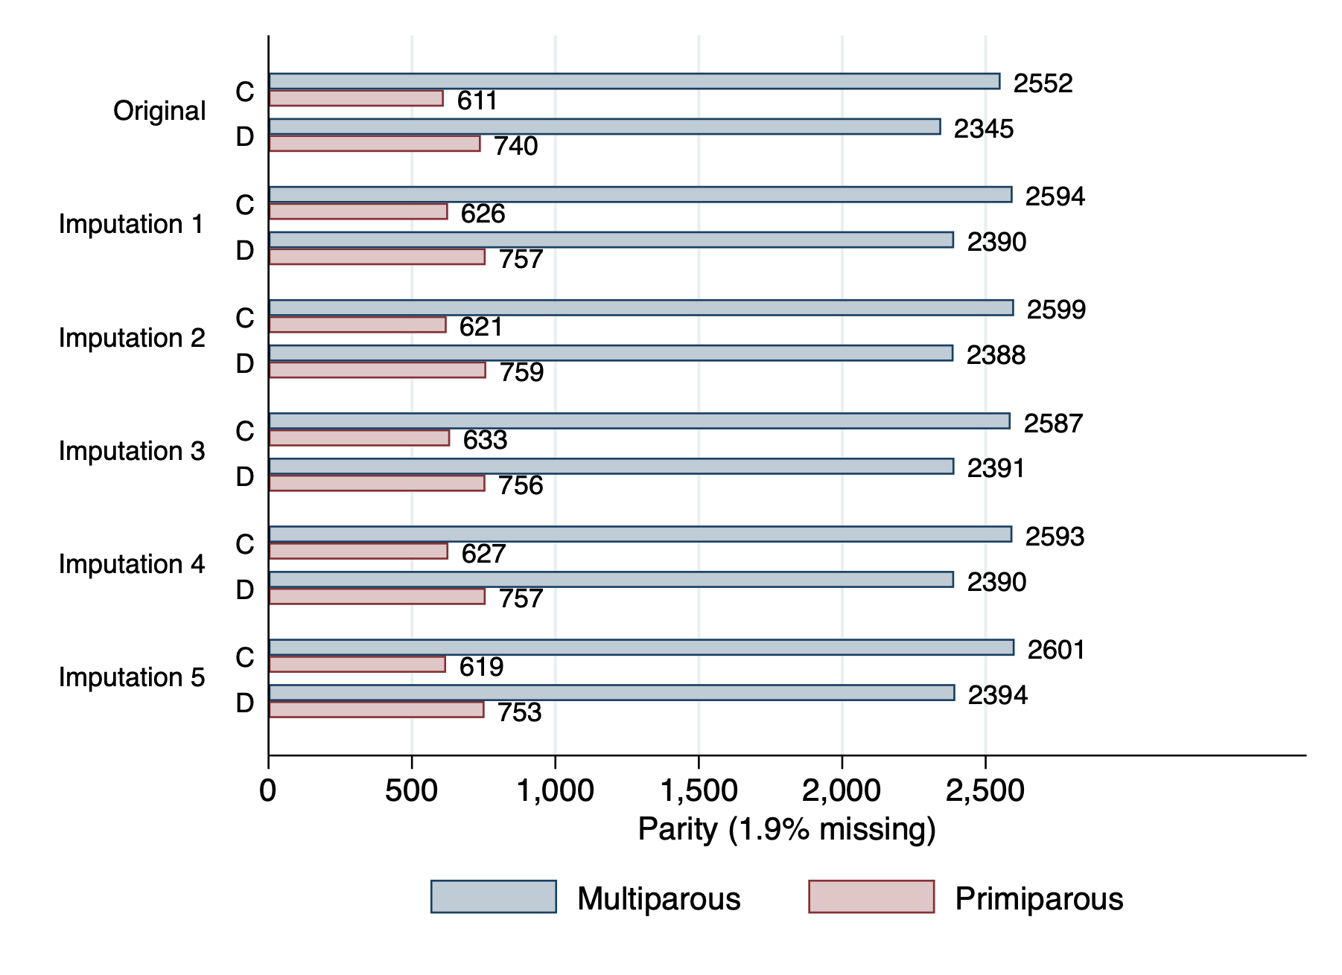

# Appendix 3 — Full Regression Results

## Health outcomes

The following tables show the full regression results for the health outcomes.

|  |  |  |  |  |  |  |
| --- | --- | --- | --- | --- | --- | --- |
| Table 13. Adverse pregnancy outcome (multiply-imputed result) | | | | | | |
| y | Odds Ratio | Std. Err. | t | P>|t| | [95% Conf. Interval] | |
| arm |  |  |  |  |  |  |
| D | 0.99 | 0.06 | -0.09 | 0.93 | 0.88 | 1.12 |
|  |  |  |  |  |  |  |
| strat_var |  |  |  |  |  |  |
| 8d9c30 | 1.19 | 0.13 | 1.54 | 0.12 | 0.95 | 1.47 |
| 9d5ed6 | 0.90 | 0.13 | -0.73 | 0.47 | 0.68 | 1.19 |
| e1e1d3 | 1.05 | 0.12 | 0.38 | 0.70 | 0.83 | 1.32 |
| ff4457 | 1.19 | 0.13 | 1.67 | 0.10 | 0.97 | 1.47 |
|  |  |  |  |  |  |  |
| cluster_size | 0.87 | 0.07 | -1.63 | 0.10 | 0.74 | 1.03 |
| age | 1.03 | 0.01 | 4.87 | 0.00 | 1.02 | 1.04 |
|  |  |  |  |  |  |  |
| lab_available |  |  |  |  |  |  |
| Lab | 1.12 | 0.08 | 1.56 | 0.12 | 0.97 | 1.29 |
|  |  |  |  |  |  |  |
| primiparous |  |  |  |  |  |  |
| Primiparous | 1.06 | 0.09 | 0.72 | 0.47 | 0.90 | 1.24 |
| _cons | 0.14 | 0.03 | -8.96 | 0.00 | 0.09 | 0.22 |
| /lnsig2u | -9.54 | 15.01 |  |  | -38.96 | 19.89 |
| sigma_u | 0.01 | 0.06 |  |  | 0.00 | 20806.64 |
| rho | 0.00 | 0.00 |  |  | 0.00 | 1.00 |

|  |  |  |  |  |  |  |
| --- | --- | --- | --- | --- | --- | --- |
| Table 14. Anemia at birth (multiply-imputed result) | | | | | | |
| y1 | Odds Ratio | Std. Err. | t | P>|t| | [95% Conf. Interval] | |
| arm |  |  |  |  |  |  |
| D | 1.13 | 0.27 | 0.49 | 0.62 | 0.70 | 1.81 |
|  |  |  |  |  |  |  |
| strat_var |  |  |  |  |  |  |
| 8d9c30 | 1.64 | 0.79 | 1.04 | 0.30 | 0.64 | 4.26 |
| 9d5ed6 | 1.17 | 0.66 | 0.27 | 0.79 | 0.38 | 3.56 |
| e1e1d3 | 1.61 | 0.74 | 1.04 | 0.30 | 0.64 | 4.04 |
| ff4457 | 1.74 | 0.79 | 1.22 | 0.22 | 0.71 | 4.30 |
|  |  |  |  |  |  |  |
| cluster_size | 0.63 | 0.20 | -1.50 | 0.14 | 0.34 | 1.16 |
| age | 0.96 | 0.02 | -1.49 | 0.14 | 0.92 | 1.01 |
|  |  |  |  |  |  |  |
| lab_available |  |  |  |  |  |  |
| Lab | 1.37 | 0.35 | 1.24 | 0.21 | 0.83 | 2.27 |
|  |  |  |  |  |  |  |
| primiparous |  |  |  |  |  |  |
| Primiparous | 0.52 | 0.17 | -1.97 | 0.05 | 0.27 | 1.00 |
| _cons | 0.04 | 0.03 | -3.82 | 0.00 | 0.01 | 0.21 |
| /lnsig2u | -4.29 | 12.20 |  |  | -28.22 | 19.65 |
| sigma_u | 0.12 | 0.72 |  |  | 0.00 | 18497.05 |
| rho | 0.00 | 0.05 |  |  | 0.00 | 1.00 |

|  |  |  |  |  |  |  |
| --- | --- | --- | --- | --- | --- | --- |
| Table 15. Severe hypertension at birth (multiply-imputed result) | | | | | | |
| y2 | Odds Ratio | Std. Err. | t | P>|t| | [95% Conf. Interval] | |
| arm |  |  |  |  |  |  |
| D | 1.57 | 0.60 | 1.18 | 0.24 | 0.74 | 3.35 |
| cluster_size | 0.79 | 0.36 | -0.52 | 0.60 | 0.32 | 1.95 |
| age | 1.20 | 0.04 | 5.82 | 0.00 | 1.13 | 1.28 |
|  |  |  |  |  |  |  |
| lab_available |  |  |  |  |  |  |
| Lab | 0.96 | 0.36 | -0.11 | 0.91 | 0.45 | 2.03 |
|  |  |  |  |  |  |  |
| primiparous |  |  |  |  |  |  |
| Primiparous | 4.76 | 2.59 | 2.87 | 0.01 | 1.57 | 14.40 |
| _cons | 0.00 | 0.00 | -9.38 | 0.00 | 0.00 | 0.00 |
| /lnsig2u | -5.17 | 15.33 |  |  | -35.27 | 24.94 |
| sigma_u | 0.08 | 0.58 |  |  | 0.00 | 260073.73 |
| rho | 0.00 | 0.03 |  |  | 0.00 | 1.00 |

|  |  |  |  |  |  |  |
| --- | --- | --- | --- | --- | --- | --- |
| Table 16. SGA undetected at birth (multiply-imputed result) | | | | | | |
| y3 | Odds Ratio | Std. Err. | t | P>|t| | [95% Conf. Interval] | |
| arm |  |  |  |  |  |  |
| D | 0.99 | 0.11 | -0.05 | 0.96 | 0.80 | 1.23 |
|  |  |  |  |  |  |  |
| strat_var |  |  |  |  |  |  |
| 8d9c30 | 0.92 | 0.17 | -0.42 | 0.67 | 0.64 | 1.33 |
| 9d5ed6 | 0.63 | 0.16 | -1.82 | 0.07 | 0.38 | 1.04 |
| e1e1d3 | 0.92 | 0.17 | -0.47 | 0.64 | 0.65 | 1.31 |
| ff4457 | 0.99 | 0.19 | -0.05 | 0.96 | 0.68 | 1.45 |
|  |  |  |  |  |  |  |
| cluster_size | 0.87 | 0.13 | -0.94 | 0.35 | 0.66 | 1.16 |
| age | 0.97 | 0.01 | -2.66 | 0.01 | 0.95 | 0.99 |
|  |  |  |  |  |  |  |
| lab_available |  |  |  |  |  |  |
| Lab | 1.27 | 0.16 | 1.85 | 0.06 | 0.99 | 1.63 |
|  |  |  |  |  |  |  |
| primiparous |  |  |  |  |  |  |
| Primiparous | 1.37 | 0.16 | 2.66 | 0.01 | 1.09 | 1.73 |
| _cons | 0.17 | 0.06 | -5.32 | 0.00 | 0.09 | 0.32 |
| /lnsig2u | -3.07 | 0.79 |  |  | -4.63 | -1.51 |
| sigma_u | 0.22 | 0.09 |  |  | 0.10 | 0.47 |
| rho | 0.01 | 0.01 |  |  | 0.00 | 0.06 |

|  |  |  |  |  |  |  |
| --- | --- | --- | --- | --- | --- | --- |
| Table 17. Malpresentation undetected at birth (multiply-imputed result) | | | | | | |
| y4 | Odds Ratio | Std. Err. | t | P>|t| | [95% Conf. Interval] | |
| arm |  |  |  |  |  |  |
| D | 1.06 | 0.17 | 0.37 | 0.71 | 0.77 | 1.47 |
|  |  |  |  |  |  |  |
| strat_var |  |  |  |  |  |  |
| 8d9c30 | 1.29 | 0.39 | 0.84 | 0.40 | 0.71 | 2.32 |
| 9d5ed6 | 0.83 | 0.37 | -0.42 | 0.68 | 0.34 | 2.00 |
| e1e1d3 | 1.75 | 0.51 | 1.93 | 0.05 | 0.99 | 3.09 |
| ff4457 | 1.51 | 0.43 | 1.44 | 0.15 | 0.86 | 2.63 |
|  |  |  |  |  |  |  |
| cluster_size | 0.66 | 0.15 | -1.82 | 0.07 | 0.43 | 1.03 |
| age | 1.05 | 0.02 | 3.08 | 0.00 | 1.02 | 1.08 |
|  |  |  |  |  |  |  |
| lab_available |  |  |  |  |  |  |
| Lab | 0.99 | 0.19 | -0.04 | 0.97 | 0.69 | 1.44 |
|  |  |  |  |  |  |  |
| primiparous |  |  |  |  |  |  |
| Primiparous | 1.95 | 0.40 | 3.23 | 0.00 | 1.30 | 2.93 |
| _cons | 0.01 | 0.00 | -8.80 | 0.00 | 0.00 | 0.02 |
| /lnsig2u | -6.30 | 15.98 |  |  | -37.65 | 25.04 |
| sigma_u | 0.04 | 0.34 |  |  | 0.00 | 273767.62 |
| rho | 0.00 | 0.01 |  |  | 0.00 | 1.00 |

|  |  |  |  |  |  |  |
| --- | --- | --- | --- | --- | --- | --- |
| Table 18. Large for gestational age (multiply-imputed result) | | | | | | |
| y5 | Odds Ratio | Std. Err. | t | P>|t| | [95% Conf. Interval] | |
| arm |  |  |  |  |  |  |
| D | 0.93 | 0.07 | -0.90 | 0.37 | 0.79 | 1.09 |
|  |  |  |  |  |  |  |
| strat_var |  |  |  |  |  |  |
| 8d9c30 | 1.20 | 0.17 | 1.24 | 0.21 | 0.90 | 1.59 |
| 9d5ed6 | 1.12 | 0.20 | 0.64 | 0.52 | 0.79 | 1.60 |
| e1e1d3 | 0.94 | 0.15 | -0.37 | 0.71 | 0.69 | 1.30 |
| ff4457 | 1.13 | 0.16 | 0.83 | 0.40 | 0.85 | 1.49 |
|  |  |  |  |  |  |  |
| cluster_size | 0.97 | 0.10 | -0.32 | 0.75 | 0.79 | 1.18 |
| age | 1.05 | 0.01 | 6.65 | 0.00 | 1.04 | 1.07 |
|  |  |  |  |  |  |  |
| lab_available |  |  |  |  |  |  |
| Lab | 1.02 | 0.10 | 0.19 | 0.85 | 0.84 | 1.24 |
|  |  |  |  |  |  |  |
| primiparous |  |  |  |  |  |  |
| Primiparous | 0.67 | 0.08 | -3.31 | 0.00 | 0.53 | 0.85 |
| _cons | 0.04 | 0.01 | -12.36 | 0.00 | 0.02 | 0.07 |
| /lnsig2u | -5.86 | 7.57 |  |  | -20.71 | 8.98 |
| sigma_u | 0.05 | 0.20 |  |  | 0.00 | 89.32 |
| rho | 0.00 | 0.01 |  |  | 0.00 | 1.00 |

## Process outcomes

The following tables show the full regression results for the process outcomes.

|  |  |  |  |  |  |  |
| --- | --- | --- | --- | --- | --- | --- |
| Table 19. Successful attendance screening & management | | | | | | |
|  | Odds Ratio | Robust |  |  |  |  |
| y |  | Std. Err. | z | P>|z| | [95% Conf. Interval] | |
| arm |  |  |  |  |  |  |
| F | 1.18 | 0.13 | 1.47 | 0.14 | 0.95 | 1.47 |
|  |  |  |  |  |  |  |
| strat_var |  |  |  |  |  |  |
| 8d9c30 | 0.58 | 0.11 | -2.98 | 0.00 | 0.40 | 0.83 |
| 9d5ed6 | 1.38 | 0.26 | 1.69 | 0.09 | 0.95 | 2.00 |
| e1e1d3 | 1.22 | 0.21 | 1.15 | 0.25 | 0.87 | 1.71 |
| ff4457 | 1.75 | 0.31 | 3.16 | 0.00 | 1.24 | 2.47 |
|  |  |  |  |  |  |  |
| cluster_size | 1.53 | 0.21 | 3.17 | 0.00 | 1.18 | 2.00 |
| age | 1.01 | 0.01 | 1.39 | 0.16 | 1.00 | 1.02 |
|  |  |  |  |  |  |  |
| lab_available |  |  |  |  |  |  |
| Lab | 0.99 | 0.12 | -0.07 | 0.95 | 0.78 | 1.27 |
|  |  |  |  |  |  |  |
| primiparous |  |  |  |  |  |  |
| Primiparous | 1.01 | 0.07 | 0.13 | 0.89 | 0.89 | 1.15 |
| _cons | 0.34 | 0.09 | -3.95 | 0.00 | 0.20 | 0.58 |
| /lnsig2u | 0.60 | 0.08 |  |  | 0.44 | 0.76 |
| sigma_u | 1.35 | 0.05 |  |  | 1.25 | 1.46 |
| rho | 0.36 | 0.02 |  |  | 0.32 | 0.39 |

|  |  |  |  |  |  |  |
| --- | --- | --- | --- | --- | --- | --- |
| Table 20. Successful hypertension screening & management | | | | | | |
|  | Odds Ratio | Robust |  |  |  |  |
| y |  | Std. Err. | z | P>|z| | [95% Conf. Interval] | |
| arm |  |  |  |  |  |  |
| J | 0.62 | 0.07 | -4.07 | 0.00 | 0.49 | 0.78 |
|  |  |  |  |  |  |  |
| strat_var |  |  |  |  |  |  |
| 8d9c30 | 1.18 | 0.24 | 0.83 | 0.41 | 0.79 | 1.77 |
| 9d5ed6 | 1.51 | 0.26 | 2.37 | 0.02 | 1.07 | 2.12 |
| e1e1d3 | 1.28 | 0.24 | 1.33 | 0.18 | 0.89 | 1.85 |
| ff4457 | 1.78 | 0.32 | 3.24 | 0.00 | 1.26 | 2.53 |
|  |  |  |  |  |  |  |
| cluster_size | 0.93 | 0.10 | -0.65 | 0.51 | 0.75 | 1.15 |
| age | 0.98 | 0.01 | -2.25 | 0.02 | 0.96 | 1.00 |
|  |  |  |  |  |  |  |
| lab_available |  |  |  |  |  |  |
| Lab | 1.16 | 0.15 | 1.14 | 0.25 | 0.90 | 1.49 |
|  |  |  |  |  |  |  |
| primiparous |  |  |  |  |  |  |
| Primiparous | 0.93 | 0.10 | -0.67 | 0.50 | 0.74 | 1.16 |
| _cons | 53.59 | 16.61 | 12.85 | 0.00 | 29.19 | 98.37 |
| /lnsig2u | -0.13 | 0.25 |  |  | -0.61 | 0.36 |
| sigma_u | 0.94 | 0.12 |  |  | 0.74 | 1.20 |
| rho | 0.21 | 0.04 |  |  | 0.14 | 0.30 |

|  |  |  |  |  |  |  |
| --- | --- | --- | --- | --- | --- | --- |
| Table 21. Successful diabetes screening & management | | | | | | |
|  | Odds Ratio | Robust |  |  |  |  |
| y |  | Std. Err. | z | P>|z| | [95% Conf. Interval] | |
| arm |  |  |  |  |  |  |
| L | 1.45 | 0.17 | 3.08 | 0.00 | 1.14 | 1.83 |
|  |  |  |  |  |  |  |
| strat_var |  |  |  |  |  |  |
| 8d9c30 | 0.68 | 0.12 | -2.10 | 0.04 | 0.48 | 0.97 |
| 9d5ed6 | 0.58 | 0.13 | -2.42 | 0.02 | 0.37 | 0.90 |
| e1e1d3 | 0.50 | 0.10 | -3.30 | 0.00 | 0.33 | 0.76 |
| ff4457 | 0.72 | 0.11 | -2.10 | 0.04 | 0.53 | 0.98 |
|  |  |  |  |  |  |  |
| cluster_size | 1.39 | 0.20 | 2.29 | 0.02 | 1.05 | 1.85 |
| age | 1.01 | 0.00 | 2.26 | 0.02 | 1.00 | 1.02 |
|  |  |  |  |  |  |  |
| lab_available |  |  |  |  |  |  |
| Lab | 1.98 | 0.29 | 4.60 | 0.00 | 1.48 | 2.65 |
|  |  |  |  |  |  |  |
| primiparous |  |  |  |  |  |  |
| Primiparous | 1.11 | 0.05 | 2.16 | 0.03 | 1.01 | 1.22 |
| _cons | 0.12 | 0.02 | -10.86 | 0.00 | 0.08 | 0.17 |
| /lnsig2u | -13.38 | . |  |  | . | . |
| sigma_u | 0.00 | . |  |  | . | . |
| rho | 0.00 | . |  |  | . | . |

|  |  |  |  |  |  |  |
| --- | --- | --- | --- | --- | --- | --- |
| Table 22. Successful malpresentation screening & management | | | | | | |
| y | Odds Ratio | Std. Err. | z | P>|z| | [95% Conf. Interval] | |
| arm |  |  |  |  |  |  |
| B | 1.42 | 0.31 | 1.57 | 0.12 | 0.92 | 2.19 |
|  |  |  |  |  |  |  |
| strat_var |  |  |  |  |  |  |
| 8d9c30 | 1.42 | 0.56 | 0.88 | 0.38 | 0.65 | 3.07 |
| 9d5ed6 | 3.55 | 1.86 | 2.43 | 0.02 | 1.28 | 9.89 |
| e1e1d3 | 1.27 | 0.46 | 0.67 | 0.51 | 0.63 | 2.60 |
| ff4457 | 1.74 | 0.65 | 1.49 | 0.14 | 0.84 | 3.61 |
|  |  |  |  |  |  |  |
| cluster_size | 2.50 | 0.85 | 2.70 | 0.01 | 1.28 | 4.86 |
| age | 1.00 | 0.01 | 0.10 | 0.92 | 0.98 | 1.03 |
|  |  |  |  |  |  |  |
| lab_available |  |  |  |  |  |  |
| Lab | 1.56 | 0.41 | 1.71 | 0.09 | 0.94 | 2.61 |
|  |  |  |  |  |  |  |
| primiparous |  |  |  |  |  |  |
| Primiparous | 1.48 | 0.25 | 2.38 | 0.02 | 1.07 | 2.05 |
| _cons | 0.85 | 0.44 | -0.31 | 0.76 | 0.31 | 2.33 |
| /lnsig2u | -0.24 | 0.24 |  |  | -0.71 | 0.23 |
| sigma_u | 0.89 | 0.11 |  |  | 0.70 | 1.12 |
| rho | 0.19 | 0.04 |  |  | 0.13 | 0.28 |

|  |  |  |  |  |  |  |
| --- | --- | --- | --- | --- | --- | --- |
| Table 23. Successful anemia screening & management | | | | | | |
|  | Odds Ratio | Robust |  |  |  |  |
| y |  | Std. Err. | z | P>|z| | [95% Conf. Interval] | |
| arm |  |  |  |  |  |  |
| H | 1.88 | 0.20 | 5.89 | 0.00 | 1.52 | 2.32 |
|  |  |  |  |  |  |  |
| strat_var |  |  |  |  |  |  |
| 8d9c30 | 0.61 | 0.12 | -2.63 | 0.01 | 0.42 | 0.88 |
| 9d5ed6 | 1.02 | 0.23 | 0.09 | 0.93 | 0.65 | 1.60 |
| e1e1d3 | 0.58 | 0.10 | -3.06 | 0.00 | 0.41 | 0.82 |
| ff4457 | 0.74 | 0.13 | -1.75 | 0.08 | 0.53 | 1.04 |
|  |  |  |  |  |  |  |
| cluster_size | 1.67 | 0.18 | 4.76 | 0.00 | 1.35 | 2.06 |
| age | 1.01 | 0.01 | 2.55 | 0.01 | 1.00 | 1.02 |
|  |  |  |  |  |  |  |
| lab_available |  |  |  |  |  |  |
| Lab | 1.91 | 0.24 | 5.10 | 0.00 | 1.49 | 2.45 |
|  |  |  |  |  |  |  |
| primiparous |  |  |  |  |  |  |
| Primiparous | 1.19 | 0.09 | 2.32 | 0.02 | 1.03 | 1.38 |
| _cons | 0.17 | 0.04 | -8.35 | 0.00 | 0.11 | 0.26 |
| /lnsig2u | -1.34 | 0.46 |  |  | -2.25 | -0.43 |
| sigma_u | 0.51 | 0.12 |  |  | 0.32 | 0.80 |
| rho | 0.07 | 0.03 |  |  | 0.03 | 0.16 |

|  |  |  |  |  |  |  |
| --- | --- | --- | --- | --- | --- | --- |
| Table 24. Successful fetalgrowth screening & management | | | | | | |
|  | Odds Ratio | Robust |  |  |  |  |
| y |  | Std. Err. | z | P>|z| | [95% Conf. Interval] | |
| arm |  |  |  |  |  |  |
| H | 0.72 | 0.18 | -1.31 | 0.19 | 0.45 | 1.17 |
|  |  |  |  |  |  |  |
| strat_var |  |  |  |  |  |  |
| 8d9c30 | 1.22 | 0.47 | 0.51 | 0.61 | 0.57 | 2.59 |
| 9d5ed6 | 0.41 | 0.25 | -1.48 | 0.14 | 0.12 | 1.34 |
| e1e1d3 | 1.02 | 0.40 | 0.05 | 0.96 | 0.47 | 2.21 |
| ff4457 | 1.67 | 0.75 | 1.15 | 0.25 | 0.70 | 4.03 |
|  |  |  |  |  |  |  |
| cluster_size | 0.80 | 0.24 | -0.72 | 0.47 | 0.44 | 1.46 |
| age | 1.01 | 0.01 | 0.57 | 0.57 | 0.98 | 1.04 |
|  |  |  |  |  |  |  |
| lab_available |  |  |  |  |  |  |
| Lab | 1.48 | 0.40 | 1.45 | 0.15 | 0.87 | 2.51 |
|  |  |  |  |  |  |  |
| primiparous |  |  |  |  |  |  |
| Primiparous | 1.30 | 0.22 | 1.53 | 0.13 | 0.93 | 1.82 |
| _cons | 1.76 | 0.97 | 1.03 | 0.30 | 0.60 | 5.17 |
| /lnsig2u | -8.57 | 4272.16 |  |  | -8381.85 | 8364.70 |
| sigma_u | 0.01 | 29.35 |  |  | 0.00 | . |
| rho | 0.00 | 0.25 |  |  | 0.00 | . |