eRegTime analysis - Time and motion study analysis

Chris Rose, Norwegian Institute of Public Health ( 8 Jan 2021)

Generated using git revision: 49caa39

# Introduction

This document presents analyses for the time and motion component of the eRegTime trial.

# Methods

TODO: Write this.

# Results

## Health information management and client care

The following table presents comparisons of time used on health information management and client care.

|  |  |  |  |  |  |  |  |
| --- | --- | --- | --- | --- | --- | --- | --- |
| Table 1. Analysis of total time use, and time use on health information management and client care. | | | | | | | |
|  | Sample means (mins)* | | Relative time (intervention / control) | | | | |
|  | Control | Intervention | Sample | Adjusted† | [95% CI]‡ | | P-value‡ |
| Total Time§ | | | | | | | |
| Any visit | 15.56 | 11.99 | 0.77 | 0.74 | [0.60 | 0.90] | 0.003 |
| Booking | 29.36 | 24.80 | 0.84 | 0.96 | [0.66 | 1.39] | 0.823 |
| Follow-up | 12.91 | 10.68 | 0.83 | 0.72 | [0.58 | 0.90] | 0.004 |
| Health Information Management | | | | | | | |
| Any visit | 9.84 | 6.64 | 0.67 | 0.70 | [0.59 | 0.82] | <0.001 |
| Booking | 18.91 | 15.26 | 0.81 | 0.96 | [0.61 | 1.50] | 0.851 |
| Follow-up | 8.10 | 5.72 | 0.71 | 0.69 | [0.60 | 0.79] | <0.001 |
| Client Care | | | | | | | |
| Any visit | 4.91 | 5.01 | 1.02 | 0.85 | [0.64 | 1.13] | 0.270 |
| Booking | 8.56 | 8.82 | 1.03 | 0.79 | [0.36 | 1.72] | 0.547 |
| Follow-up | 4.22 | 4.66 | 1.10 | 0.84 | [0.60 | 1.19] | 0.328 |
| *Sample means were not computed on the log scale. †Estimates of relative time use were adjusted for the stratification variable, cluster size, lab availability, and booking visit. ‡Confidence intervals and P-values were adjusted for possible cluster effects due to the cluster RCT design and observer. §Total time includes activities not accounted for in health information management and client care. | | | | | | | |

## Activities

The following table shows relative differences in time used on activities such as finding, reading, and writing in the treatment versus control conditions.

|  |  |  |  |  |  |  |  |
| --- | --- | --- | --- | --- | --- | --- | --- |
| Table 2. Analysis of time used finding, reading, and writing. | | | | | | | |
|  | Sample means (mins)* | | Relative time (intervention / control) | | | | |
|  | Control | Intervention | Sample | Adjusted† | [95% CI]‡ | | P-value‡ |
| Finding | | | | | | | |
| Any visit | 0.58 | 0.86 | 1.47 | 2.71 | [0.98 | 7.44] | 0.054 |
| Booking | 0.82 | 1.45 | 1.76 | 4.95 | [0.15 | 166.66] | 0.373 |
| Follow-up | 0.54 | 0.80 | 1.50 | 1.68 | [0.51 | 5.56] | 0.393 |
| Reading | | | | | | | |
| Any visit | 0.74 | 0.25 | 0.34 | 0.03 | [0.00 | 2.60] | 0.126 |
| Booking | 1.55 | 0.07 | 0.05 | 0.00 | [0.00 | 0.04] | 0.006 |
| Follow-up | 0.59 | 0.27 | 0.46 | 0.09 | [0.00 | 2.43] | 0.153 |
| Writing | | | | | | | |
| Any visit | 8.48 | 5.50 | 0.65 | 0.68 | [0.56 | 0.83] | <0.001 |
| Booking | 16.48 | 13.73 | 0.83 | 1.30 | [0.55 | 3.05] | 0.551 |
| Follow-up | 6.94 | 4.61 | 0.66 | 0.65 | [0.59 | 0.72] | <0.001 |
| *Sample means were not computed on the log scale. †Estimates of relative time use were adjusted for the stratification variable, cluster size, lab availability, and booking visit. ‡Confidence intervals and P-values were adjusted for possible cluster effects due to the cluster RCT design and observer. | | | | | | | |

# References

Committee for Medicinal Products for Human Use (CHMP) (2015). Guideline on adjustment for baseline covariates in clinical trials. London: European Medicines Agency.

Li, F., Lokhnygina, Y., Murray, D. M., Heagerty, P. J., & DeLong, E. R. (2016). An evaluation of constrained randomization for the design and analysis of group‐randomized trials. Statistics in Medicine, 35(10), 1565-1579.

# Appendix 1 — Protocol Deviations

We did not plan to model relative times via transformation to the log scale. Nor did we plan to adjust for observer but chose to do so as it is plausible that systematic differences may exist between observers. We did not plan in detail how time used finding, reading, or writing files would be analyzed.

# Appendix 2 — Plots of marginal mean times

The following plots show marginal mean times for a selection of the outcomes.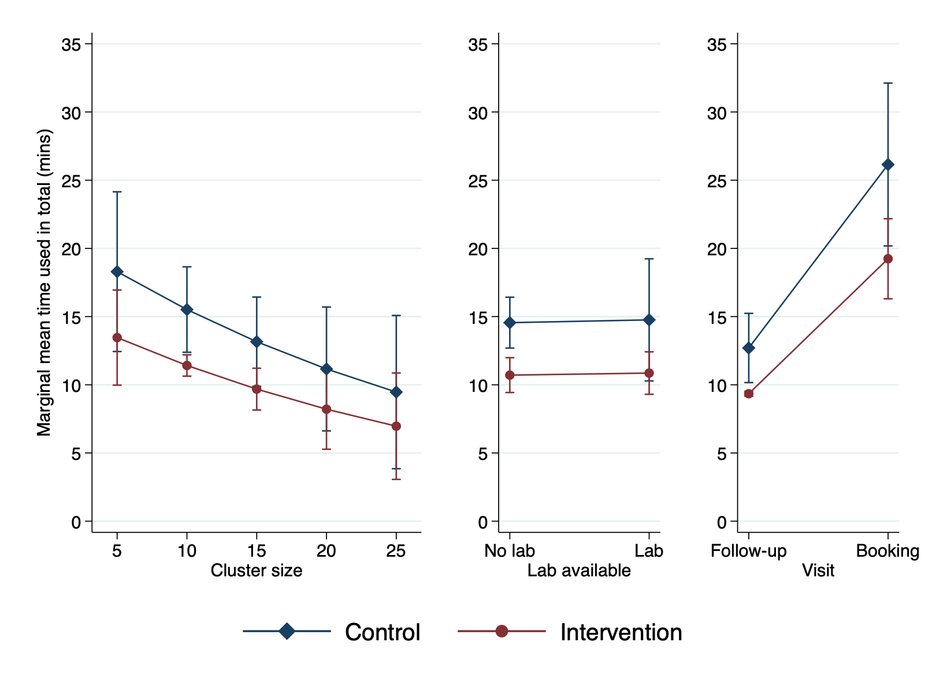  
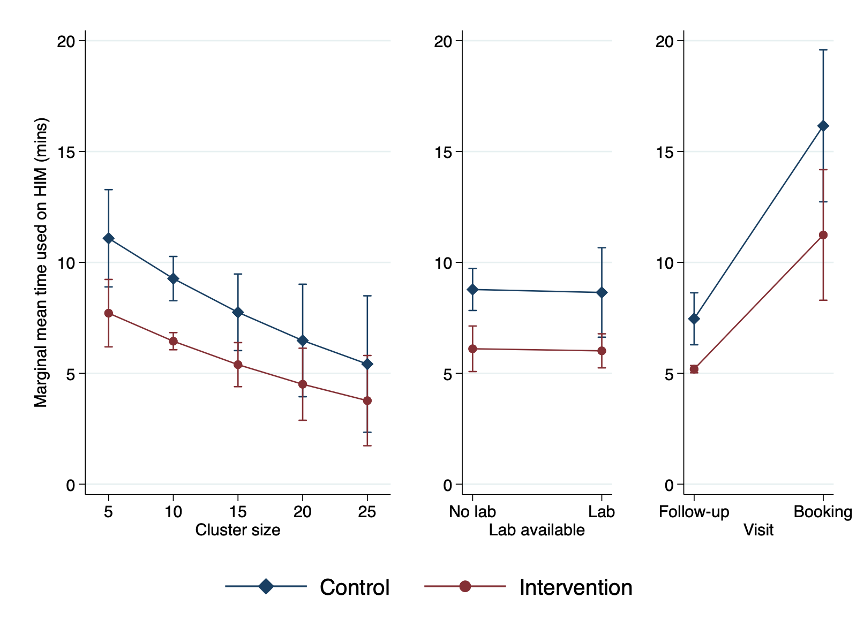  
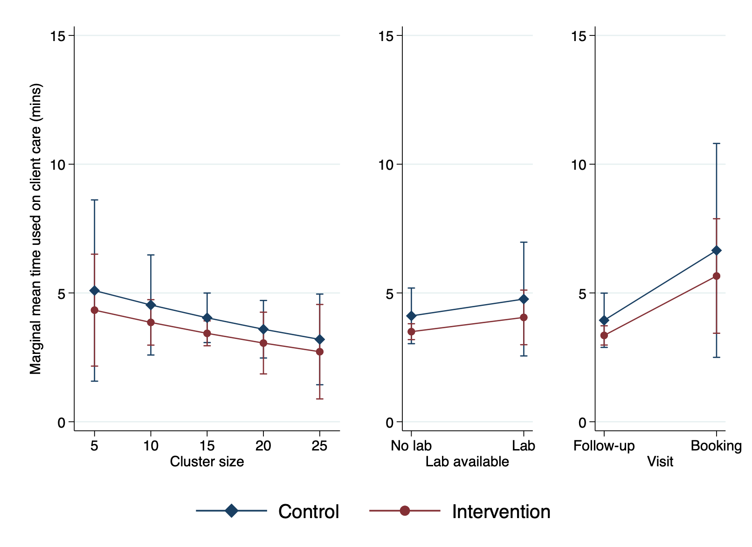  
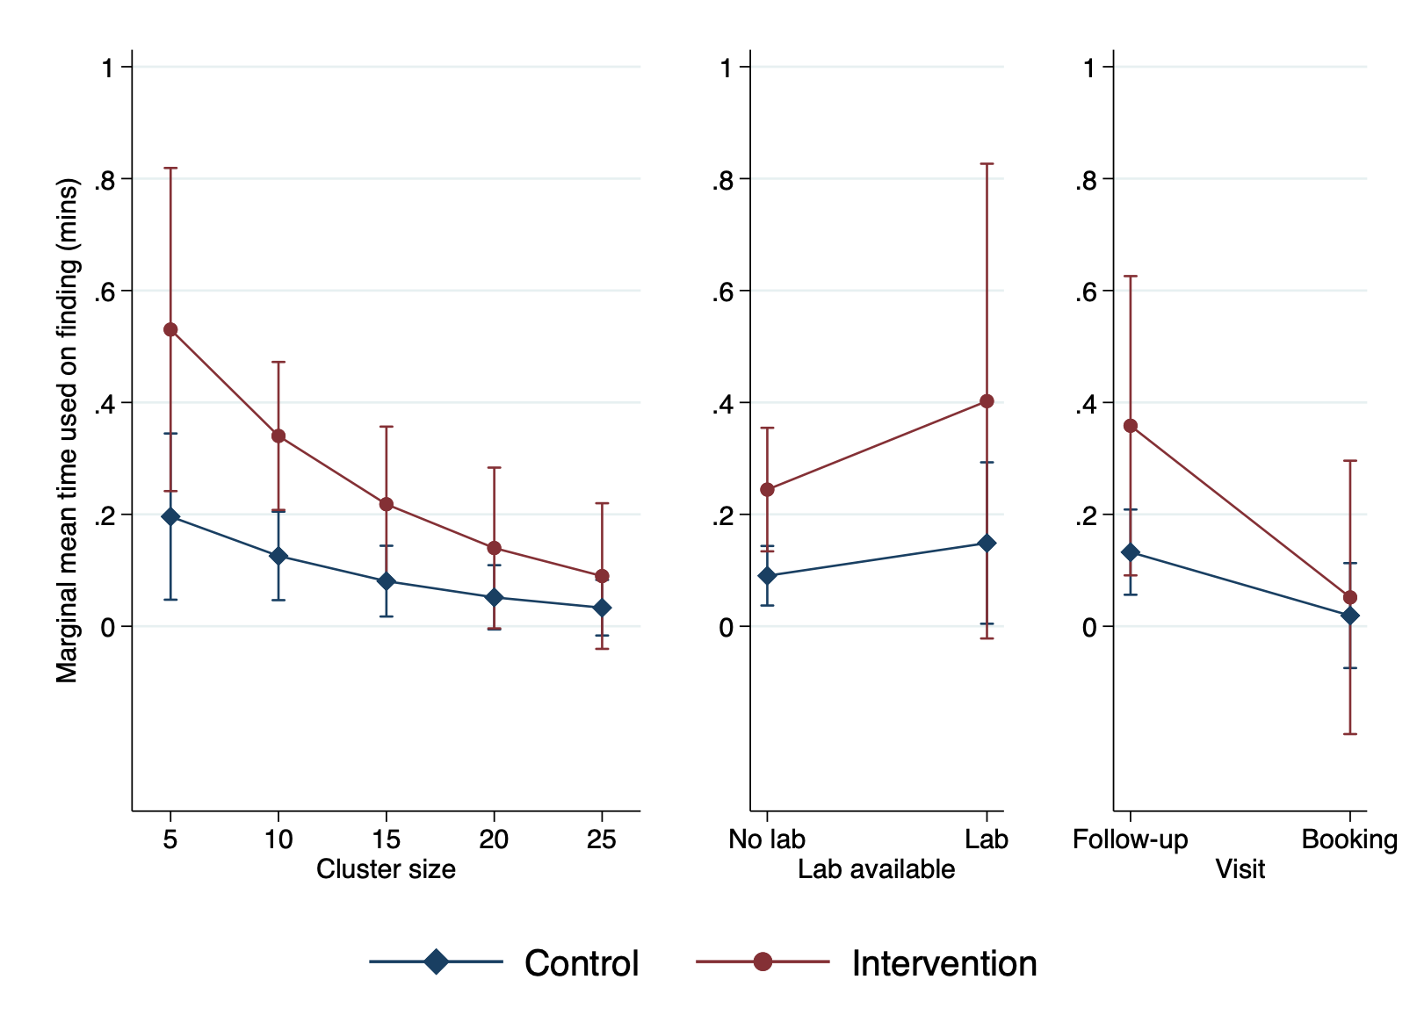  
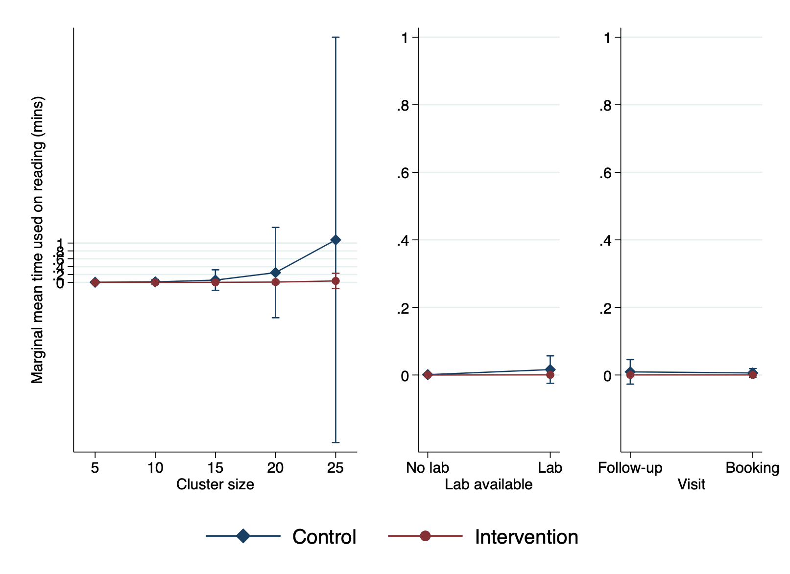  
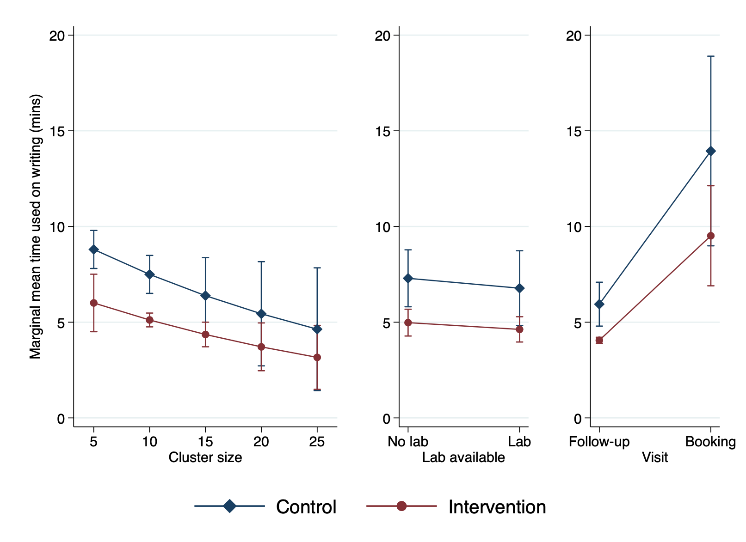

# Appendix 3 — Full Regression Results

## Comparisons of time used

The following tables show the full regression results. Note that time was modelled on the log scale and the full estimation results have not been exponentiated here.

|  |  |  |  |  |  |  |
| --- | --- | --- | --- | --- | --- | --- |
| Table 3. Total — full regression results | | | | | | |
|  |  | Robust |  |  |  |  |
| total_time | Coef. | Std. Err. | z | P>|z| | [95% Conf. Interval] | |
| arm |  |  |  |  |  |  |
| Intervention | -0.31 | 0.10 | -3.01 | 0.00 | -0.51 | -0.11 |
|  |  |  |  |  |  |  |
| strat_var |  |  |  |  |  |  |
| Ramallah | 0.19 | 0.63 | 0.30 | 0.76 | -1.04 | 1.42 |
| Nablus | -0.07 | 0.86 | -0.08 | 0.94 | -1.75 | 1.62 |
| Salfit | -0.07 | 0.60 | -0.11 | 0.91 | -1.24 | 1.11 |
| Jenin | -0.14 | 0.65 | -0.21 | 0.83 | -1.41 | 1.13 |
|  |  |  |  |  |  |  |
| cluster_size | -3.29 | 2.08 | -1.59 | 0.11 | -7.36 | 0.77 |
|  |  |  |  |  |  |  |
| lab_available |  |  |  |  |  |  |
| Lab | 0.01 | 0.12 | 0.11 | 0.91 | -0.23 | 0.26 |
|  |  |  |  |  |  |  |
| bookingvisit |  |  |  |  |  |  |
| Booking | 0.72 | 0.07 | 10.29 | 0.00 | 0.58 | 0.86 |
| _cons | 3.00 | 0.50 | 6.04 | 0.00 | 2.03 | 3.98 |
| Data were analyzed on the log scale. Estimates have not been exponentiated. | | | | | | |

|  |  |  |  |  |  |  |
| --- | --- | --- | --- | --- | --- | --- |
| Table 4. Total (booking visit) — full regression results | | | | | | |
|  |  | Robust |  |  |  |  |
| total_booking_time | Coef. | Std. Err. | z | P>|z| | [95% Conf. Interval] | |
| arm |  |  |  |  |  |  |
| Intervention | -0.04 | 0.19 | -0.22 | 0.82 | -0.41 | 0.33 |
|  |  |  |  |  |  |  |
| strat_var |  |  |  |  |  |  |
| Ramallah | 0.24 | 0.49 | 0.48 | 0.63 | -0.73 | 1.20 |
| Nablus | 1.49 | 0.72 | 2.08 | 0.04 | 0.09 | 2.89 |
| Salfit | 0.19 | 0.39 | 0.49 | 0.62 | -0.58 | 0.97 |
| Jenin | 0.35 | 0.42 | 0.82 | 0.41 | -0.48 | 1.18 |
|  |  |  |  |  |  |  |
| cluster_size | -11.46 | 3.60 | -3.18 | 0.00 | -18.53 | -4.40 |
|  |  |  |  |  |  |  |
| lab_available |  |  |  |  |  |  |
| Lab | 0.24 | 0.34 | 0.70 | 0.49 | -0.43 | 0.90 |
|  |  |  |  |  |  |  |
| bookingvisit |  |  |  |  |  |  |
| Booking | 0.00 | (omitted) |  |  |  |  |
| _cons | 4.00 | 0.21 | 19.16 | 0.00 | 3.59 | 4.41 |
| Data were analyzed on the log scale. Estimates have not been exponentiated. | | | | | | |

|  |  |  |  |  |  |  |
| --- | --- | --- | --- | --- | --- | --- |
| Table 5. Total (follow-up visit) — full regression results | | | | | | |
|  |  | Robust |  |  |  |  |
| total_fup_time | Coef. | Std. Err. | z | P>|z| | [95% Conf. Interval] | |
| arm |  |  |  |  |  |  |
| Intervention | -0.33 | 0.11 | -2.88 | 0.00 | -0.55 | -0.10 |
|  |  |  |  |  |  |  |
| strat_var |  |  |  |  |  |  |
| Ramallah | 0.31 | 0.69 | 0.45 | 0.65 | -1.04 | 1.66 |
| Nablus | -0.03 | 0.94 | -0.04 | 0.97 | -1.88 | 1.81 |
| Salfit | -0.05 | 0.69 | -0.07 | 0.94 | -1.40 | 1.30 |
| Jenin | -0.09 | 0.72 | -0.13 | 0.90 | -1.51 | 1.32 |
|  |  |  |  |  |  |  |
| cluster_size | -3.66 | 2.38 | -1.54 | 0.12 | -8.31 | 1.00 |
|  |  |  |  |  |  |  |
| lab_available |  |  |  |  |  |  |
| Lab | 0.01 | 0.12 | 0.07 | 0.95 | -0.23 | 0.25 |
|  |  |  |  |  |  |  |
| bookingvisit |  |  |  |  |  |  |
| Booking | 0.33 | 0.01 | 58.36 | 0.00 | 0.32 | 0.34 |
| _cons | 3.03 | 0.55 | 5.53 | 0.00 | 1.95 | 4.10 |
| Data were analyzed on the log scale. Estimates have not been exponentiated. | | | | | | |

|  |  |  |  |  |  |  |
| --- | --- | --- | --- | --- | --- | --- |
| Table 6. HIM — full regression results | | | | | | |
|  |  | Robust |  |  |  |  |
| him_time | Coef. | Std. Err. | z | P>|z| | [95% Conf. Interval] | |
| arm |  |  |  |  |  |  |
| Intervention | -0.36 | 0.09 | -4.27 | 0.00 | -0.53 | -0.20 |
|  |  |  |  |  |  |  |
| strat_var |  |  |  |  |  |  |
| Ramallah | -0.21 | 0.71 | -0.30 | 0.76 | -1.60 | 1.18 |
| Nablus | -0.31 | 0.86 | -0.36 | 0.72 | -1.99 | 1.37 |
| Salfit | -0.32 | 0.70 | -0.46 | 0.65 | -1.69 | 1.05 |
| Jenin | -0.45 | 0.72 | -0.62 | 0.53 | -1.87 | 0.97 |
|  |  |  |  |  |  |  |
| cluster_size | -3.58 | 1.85 | -1.94 | 0.05 | -7.20 | 0.04 |
|  |  |  |  |  |  |  |
| lab_available |  |  |  |  |  |  |
| Lab | -0.02 | 0.12 | -0.13 | 0.90 | -0.25 | 0.22 |
|  |  |  |  |  |  |  |
| bookingvisit |  |  |  |  |  |  |
| Booking | 0.77 | 0.12 | 6.35 | 0.00 | 0.53 | 1.01 |
| _cons | 2.78 | 0.62 | 4.48 | 0.00 | 1.57 | 4.00 |
| Data were analyzed on the log scale. Estimates have not been exponentiated. | | | | | | |

|  |  |  |  |  |  |  |
| --- | --- | --- | --- | --- | --- | --- |
| Table 7. HIM (booking visit) — full regression results | | | | | | |
|  |  | Robust |  |  |  |  |
| him_booking_time | Coef. | Std. Err. | z | P>|z| | [95% Conf. Interval] | |
| arm |  |  |  |  |  |  |
| Intervention | -0.04 | 0.23 | -0.19 | 0.85 | -0.49 | 0.40 |
|  |  |  |  |  |  |  |
| strat_var |  |  |  |  |  |  |
| Ramallah | 0.39 | 0.51 | 0.77 | 0.44 | -0.60 | 1.39 |
| Nablus | 2.59 | 0.80 | 3.24 | 0.00 | 1.02 | 4.16 |
| Salfit | 0.31 | 0.44 | 0.70 | 0.49 | -0.56 | 1.17 |
| Jenin | 0.91 | 0.39 | 2.33 | 0.02 | 0.14 | 1.67 |
|  |  |  |  |  |  |  |
| cluster_size | -20.87 | 4.83 | -4.32 | 0.00 | -30.33 | -11.40 |
|  |  |  |  |  |  |  |
| lab_available |  |  |  |  |  |  |
| Lab | 0.39 | 0.34 | 1.17 | 0.24 | -0.27 | 1.06 |
|  |  |  |  |  |  |  |
| bookingvisit |  |  |  |  |  |  |
| Booking | 0.00 | (omitted) |  |  |  |  |
| _cons | 4.02 | 0.35 | 11.41 | 0.00 | 3.33 | 4.71 |
| Data were analyzed on the log scale. Estimates have not been exponentiated. | | | | | | |

|  |  |  |  |  |  |  |
| --- | --- | --- | --- | --- | --- | --- |
| Table 8. HIM (follow-up visit) — full regression results | | | | | | |
|  |  | Robust |  |  |  |  |
| him_fup_time | Coef. | Std. Err. | z | P>|z| | [95% Conf. Interval] | |
| arm |  |  |  |  |  |  |
| Intervention | -0.37 | 0.07 | -5.39 | 0.00 | -0.51 | -0.24 |
|  |  |  |  |  |  |  |
| strat_var |  |  |  |  |  |  |
| Ramallah | -0.17 | 0.72 | -0.24 | 0.81 | -1.59 | 1.25 |
| Nablus | -0.35 | 0.91 | -0.38 | 0.70 | -2.12 | 1.43 |
| Salfit | -0.33 | 0.77 | -0.43 | 0.67 | -1.83 | 1.18 |
| Jenin | -0.50 | 0.76 | -0.65 | 0.51 | -1.98 | 0.99 |
|  |  |  |  |  |  |  |
| cluster_size | -3.71 | 2.22 | -1.67 | 0.09 | -8.05 | 0.64 |
|  |  |  |  |  |  |  |
| lab_available |  |  |  |  |  |  |
| Lab | -0.03 | 0.13 | -0.24 | 0.81 | -0.30 | 0.23 |
|  |  |  |  |  |  |  |
| bookingvisit |  |  |  |  |  |  |
| Booking | 0.86 | 0.01 | 89.86 | 0.00 | 0.85 | 0.88 |
| _cons | 2.84 | 0.63 | 4.48 | 0.00 | 1.60 | 4.09 |
| Data were analyzed on the log scale. Estimates have not been exponentiated. | | | | | | |

|  |  |  |  |  |  |  |
| --- | --- | --- | --- | --- | --- | --- |
| Table 9. Client care — full regression results | | | | | | |
|  |  | Robust |  |  |  |  |
| care_time | Coef. | Std. Err. | z | P>|z| | [95% Conf. Interval] | |
| arm |  |  |  |  |  |  |
| Intervention | -0.16 | 0.15 | -1.10 | 0.27 | -0.45 | 0.13 |
|  |  |  |  |  |  |  |
| strat_var |  |  |  |  |  |  |
| Ramallah | 1.73 | 0.21 | 8.19 | 0.00 | 1.32 | 2.15 |
| Nablus | 0.94 | 0.35 | 2.68 | 0.01 | 0.25 | 1.63 |
| Salfit | 0.88 | 0.17 | 5.14 | 0.00 | 0.55 | 1.22 |
| Jenin | 0.94 | 0.22 | 4.32 | 0.00 | 0.52 | 1.37 |
|  |  |  |  |  |  |  |
| cluster_size | -2.33 | 2.95 | -0.79 | 0.43 | -8.10 | 3.44 |
|  |  |  |  |  |  |  |
| lab_available |  |  |  |  |  |  |
| Lab | 0.15 | 0.11 | 1.30 | 0.20 | -0.08 | 0.37 |
|  |  |  |  |  |  |  |
| bookingvisit |  |  |  |  |  |  |
| Booking | 0.52 | 0.18 | 2.84 | 0.00 | 0.16 | 0.89 |
| _cons | 0.62 | 0.42 | 1.45 | 0.15 | -0.21 | 1.45 |
| Data were analyzed on the log scale. Estimates have not been exponentiated. | | | | | | |

|  |  |  |  |  |  |  |
| --- | --- | --- | --- | --- | --- | --- |
| Table 10. Client care (booking visit) — full regression results | | | | | | |
|  |  | Robust |  |  |  |  |
| care_booking_time | Coef. | Std. Err. | z | P>|z| | [95% Conf. Interval] | |
| arm |  |  |  |  |  |  |
| Intervention | -0.24 | 0.40 | -0.60 | 0.55 | -1.02 | 0.54 |
|  |  |  |  |  |  |  |
| strat_var |  |  |  |  |  |  |
| Ramallah | 1.04 | 1.19 | 0.88 | 0.38 | -1.29 | 3.37 |
| Nablus | -2.38 | 2.55 | -0.93 | 0.35 | -7.37 | 2.61 |
| Salfit | 0.75 | 0.95 | 0.79 | 0.43 | -1.12 | 2.61 |
| Jenin | -0.48 | 1.37 | -0.35 | 0.73 | -3.17 | 2.21 |
|  |  |  |  |  |  |  |
| cluster_size | 29.47 | 20.11 | 1.47 | 0.14 | -9.94 | 68.87 |
|  |  |  |  |  |  |  |
| lab_available |  |  |  |  |  |  |
| Lab | -0.39 | 0.42 | -0.92 | 0.36 | -1.22 | 0.44 |
|  |  |  |  |  |  |  |
| bookingvisit |  |  |  |  |  |  |
| Booking | 0.00 | (omitted) |  |  |  |  |
| _cons | -0.82 | 1.51 | -0.54 | 0.59 | -3.79 | 2.15 |
| Data were analyzed on the log scale. Estimates have not been exponentiated. | | | | | | |

|  |  |  |  |  |  |  |
| --- | --- | --- | --- | --- | --- | --- |
| Table 11. Client care (follow-up visit) — full regression results | | | | | | |
|  |  | Robust |  |  |  |  |
| care_fup_time | Coef. | Std. Err. | z | P>|z| | [95% Conf. Interval] | |
| arm |  |  |  |  |  |  |
| Intervention | -0.17 | 0.18 | -0.98 | 0.33 | -0.52 | 0.17 |
|  |  |  |  |  |  |  |
| strat_var |  |  |  |  |  |  |
| Ramallah | 1.70 | 0.24 | 7.01 | 0.00 | 1.23 | 2.18 |
| Nablus | 0.85 | 0.63 | 1.35 | 0.18 | -0.38 | 2.08 |
| Salfit | 0.59 | 0.22 | 2.69 | 0.01 | 0.16 | 1.02 |
| Jenin | 0.88 | 0.31 | 2.84 | 0.00 | 0.27 | 1.50 |
|  |  |  |  |  |  |  |
| cluster_size | -2.66 | 2.76 | -0.96 | 0.34 | -8.08 | 2.75 |
|  |  |  |  |  |  |  |
| lab_available |  |  |  |  |  |  |
| Lab | 0.20 | 0.14 | 1.42 | 0.16 | -0.07 | 0.47 |
|  |  |  |  |  |  |  |
| bookingvisit |  |  |  |  |  |  |
| Booking | -0.97 | 0.02 | -57.51 | 0.00 | -1.00 | -0.94 |
| _cons | 0.74 | 0.05 | 14.17 | 0.00 | 0.64 | 0.85 |
| Data were analyzed on the log scale. Estimates have not been exponentiated. | | | | | | |

|  |  |  |  |  |  |  |
| --- | --- | --- | --- | --- | --- | --- |
| Table 12. Finding — full regression results | | | | | | |
|  |  | Robust |  |  |  |  |
| find_time | Coef. | Std. Err. | z | P>|z| | [95% Conf. Interval] | |
| arm |  |  |  |  |  |  |
| Intervention | 1.00 | 0.52 | 1.93 | 0.05 | -0.02 | 2.01 |
|  |  |  |  |  |  |  |
| strat_var |  |  |  |  |  |  |
| Ramallah | 2.38 | 3.45 | 0.69 | 0.49 | -4.39 | 9.15 |
| Nablus | 1.03 | 3.66 | 0.28 | 0.78 | -6.14 | 8.21 |
| Salfit | 1.03 | 3.43 | 0.30 | 0.76 | -5.70 | 7.76 |
| Jenin | -0.27 | 3.55 | -0.08 | 0.94 | -7.22 | 6.68 |
|  |  |  |  |  |  |  |
| cluster_size | -8.88 | 4.55 | -1.95 | 0.05 | -17.80 | 0.04 |
|  |  |  |  |  |  |  |
| lab_available |  |  |  |  |  |  |
| Lab | 0.50 | 0.51 | 0.97 | 0.33 | -0.51 | 1.51 |
|  |  |  |  |  |  |  |
| bookingvisit |  |  |  |  |  |  |
| Booking | -1.94 | 2.63 | -0.74 | 0.46 | -7.08 | 3.21 |
| _cons | -2.15 | 2.88 | -0.75 | 0.46 | -7.79 | 3.50 |
| Data were analyzed on the log scale. Estimates have not been exponentiated. | | | | | | |

|  |  |  |  |  |  |  |
| --- | --- | --- | --- | --- | --- | --- |
| Table 13. Finding (booking visit) — full regression results | | | | | | |
|  |  | Robust |  |  |  |  |
| find_booking_time | Coef. | Std. Err. | z | P>|z| | [95% Conf. Interval] | |
| arm |  |  |  |  |  |  |
| Intervention | 1.60 | 1.79 | 0.89 | 0.37 | -1.92 | 5.12 |
|  |  |  |  |  |  |  |
| strat_var |  |  |  |  |  |  |
| Ramallah | -0.96 | 2.68 | -0.36 | 0.72 | -6.22 | 4.29 |
| Nablus | -16.29 | 3.96 | -4.11 | 0.00 | -24.05 | -8.53 |
| Salfit | -1.57 | 2.62 | -0.60 | 0.55 | -6.69 | 3.56 |
| Jenin | -6.65 | 3.65 | -1.82 | 0.07 | -13.81 | 0.50 |
|  |  |  |  |  |  |  |
| cluster_size | -8.06 | 21.79 | -0.37 | 0.71 | -50.77 | 34.66 |
|  |  |  |  |  |  |  |
| lab_available |  |  |  |  |  |  |
| Lab | -1.65 | 2.36 | -0.70 | 0.48 | -6.28 | 2.98 |
|  |  |  |  |  |  |  |
| bookingvisit |  |  |  |  |  |  |
| Booking | 0.00 | (omitted) |  |  |  |  |
| _cons | 1.71 | 1.90 | 0.90 | 0.37 | -2.00 | 5.43 |
| Data were analyzed on the log scale. Estimates have not been exponentiated. | | | | | | |

|  |  |  |  |  |  |  |
| --- | --- | --- | --- | --- | --- | --- |
| Table 14. Finding (follow-up visit) — full regression results | | | | | | |
|  |  | Robust |  |  |  |  |
| find_fup_time | Coef. | Std. Err. | z | P>|z| | [95% Conf. Interval] | |
| arm |  |  |  |  |  |  |
| Intervention | 0.52 | 0.61 | 0.85 | 0.39 | -0.67 | 1.72 |
|  |  |  |  |  |  |  |
| strat_var |  |  |  |  |  |  |
| Ramallah | 3.20 | 4.08 | 0.78 | 0.43 | -4.81 | 11.20 |
| Nablus | 3.24 | 4.61 | 0.70 | 0.48 | -5.80 | 12.28 |
| Salfit | 1.72 | 4.61 | 0.37 | 0.71 | -7.32 | 10.76 |
| Jenin | 1.97 | 4.23 | 0.46 | 0.64 | -6.33 | 10.27 |
|  |  |  |  |  |  |  |
| cluster_size | -8.97 | 5.48 | -1.64 | 0.10 | -19.71 | 1.76 |
|  |  |  |  |  |  |  |
| lab_available |  |  |  |  |  |  |
| Lab | 1.08 | 0.89 | 1.22 | 0.22 | -0.66 | 2.82 |
|  |  |  |  |  |  |  |
| bookingvisit |  |  |  |  |  |  |
| Booking | -13.67 | 0.40 | -34.35 | 0.00 | -14.45 | -12.89 |
| _cons | -3.95 | 3.52 | -1.12 | 0.26 | -10.85 | 2.94 |
| Data were analyzed on the log scale. Estimates have not been exponentiated. | | | | | | |

|  |  |  |  |  |  |  |
| --- | --- | --- | --- | --- | --- | --- |
| Table 15. Reading — full regression results | | | | | | |
|  |  | Robust |  |  |  |  |
| read_time | Coef. | Std. Err. | z | P>|z| | [95% Conf. Interval] | |
| arm |  |  |  |  |  |  |
| Intervention | -3.39 | 2.22 | -1.53 | 0.13 | -7.73 | 0.96 |
|  |  |  |  |  |  |  |
| strat_var |  |  |  |  |  |  |
| Ramallah | -0.69 | 2.50 | -0.28 | 0.78 | -5.60 | 4.22 |
| Nablus | -6.66 | 3.39 | -1.97 | 0.05 | -13.31 | -0.02 |
| Salfit | -2.27 | 2.41 | -0.94 | 0.35 | -7.00 | 2.46 |
| Jenin | -4.19 | 3.30 | -1.27 | 0.20 | -10.65 | 2.27 |
|  |  |  |  |  |  |  |
| cluster_size | 29.36 | 7.40 | 3.96 | 0.00 | 14.84 | 43.87 |
|  |  |  |  |  |  |  |
| lab_available |  |  |  |  |  |  |
| Lab | 2.68 | 0.79 | 3.40 | 0.00 | 1.13 | 4.22 |
|  |  |  |  |  |  |  |
| bookingvisit |  |  |  |  |  |  |
| Booking | -0.41 | 0.98 | -0.42 | 0.67 | -2.33 | 1.50 |
| _cons | -7.18 | 3.58 | -2.01 | 0.04 | -14.19 | -0.17 |
| Data were analyzed on the log scale. Estimates have not been exponentiated. | | | | | | |

|  |  |  |  |  |  |  |
| --- | --- | --- | --- | --- | --- | --- |
| Table 16. Reading (booking visit) — full regression results | | | | | | |
|  |  | Robust |  |  |  |  |
| read_booking_time | Coef. | Std. Err. | z | P>|z| | [95% Conf. Interval] | |
| arm |  |  |  |  |  |  |
| Intervention | -11.32 | 4.12 | -2.75 | 0.01 | -19.39 | -3.26 |
|  |  |  |  |  |  |  |
| strat_var |  |  |  |  |  |  |
| Ramallah | 0.29 | 4.35 | 0.07 | 0.95 | -8.24 | 8.82 |
| Nablus | -21.23 | 12.28 | -1.73 | 0.08 | -45.29 | 2.84 |
| Salfit | -1.37 | 4.03 | -0.34 | 0.73 | -9.27 | 6.53 |
| Jenin | -7.88 | 6.94 | -1.14 | 0.26 | -21.47 | 5.72 |
|  |  |  |  |  |  |  |
| cluster_size | 71.57 | 97.95 | 0.73 | 0.46 | -120.41 | 263.55 |
|  |  |  |  |  |  |  |
| lab_available |  |  |  |  |  |  |
| Lab | 2.21 | 2.83 | 0.78 | 0.43 | -3.33 | 7.75 |
|  |  |  |  |  |  |  |
| bookingvisit |  |  |  |  |  |  |
| Booking | 0.00 | (omitted) |  |  |  |  |
| _cons | -6.88 | 5.19 | -1.33 | 0.18 | -17.05 | 3.29 |
| Data were analyzed on the log scale. Estimates have not been exponentiated. | | | | | | |

|  |  |  |  |  |  |  |
| --- | --- | --- | --- | --- | --- | --- |
| Table 17. Reading (follow-up visit) — full regression results | | | | | | |
|  |  | Robust |  |  |  |  |
| read_fup_time | Coef. | Std. Err. | z | P>|z| | [95% Conf. Interval] | |
| arm |  |  |  |  |  |  |
| Intervention | -2.39 | 1.67 | -1.43 | 0.15 | -5.66 | 0.89 |
|  |  |  |  |  |  |  |
| strat_var |  |  |  |  |  |  |
| Ramallah | -2.22 | 3.81 | -0.58 | 0.56 | -9.70 | 5.25 |
| Nablus | -7.04 | 3.98 | -1.77 | 0.08 | -14.85 | 0.76 |
| Salfit | -1.84 | 3.00 | -0.61 | 0.54 | -7.73 | 4.05 |
| Jenin | -4.59 | 4.26 | -1.08 | 0.28 | -12.94 | 3.75 |
|  |  |  |  |  |  |  |
| cluster_size | 29.96 | 7.99 | 3.75 | 0.00 | 14.30 | 45.61 |
|  |  |  |  |  |  |  |
| lab_available |  |  |  |  |  |  |
| Lab | 1.81 | 0.81 | 2.24 | 0.02 | 0.23 | 3.40 |
|  |  |  |  |  |  |  |
| bookingvisit |  |  |  |  |  |  |
| Booking | -4.56 | 1.31 | -3.48 | 0.00 | -7.13 | -1.99 |
| _cons | -7.10 | 4.80 | -1.48 | 0.14 | -16.50 | 2.30 |
| Data were analyzed on the log scale. Estimates have not been exponentiated. | | | | | | |

|  |  |  |  |  |  |  |
| --- | --- | --- | --- | --- | --- | --- |
| Table 18. Writing — full regression results | | | | | | |
|  |  | Robust |  |  |  |  |
| write_time | Coef. | Std. Err. | z | P>|z| | [95% Conf. Interval] | |
| arm |  |  |  |  |  |  |
| Intervention | -0.38 | 0.10 | -3.79 | 0.00 | -0.58 | -0.18 |
|  |  |  |  |  |  |  |
| strat_var |  |  |  |  |  |  |
| Ramallah | -0.34 | 0.98 | -0.35 | 0.73 | -2.26 | 1.58 |
| Nablus | -0.17 | 1.15 | -0.15 | 0.88 | -2.41 | 2.08 |
| Salfit | -0.13 | 0.95 | -0.14 | 0.89 | -1.99 | 1.72 |
| Jenin | -0.30 | 0.99 | -0.30 | 0.76 | -2.24 | 1.65 |
|  |  |  |  |  |  |  |
| cluster_size | -3.21 | 1.97 | -1.63 | 0.10 | -7.07 | 0.65 |
|  |  |  |  |  |  |  |
| lab_available |  |  |  |  |  |  |
| Lab | -0.07 | 0.13 | -0.55 | 0.58 | -0.34 | 0.19 |
|  |  |  |  |  |  |  |
| bookingvisit |  |  |  |  |  |  |
| Booking | 0.85 | 0.16 | 5.46 | 0.00 | 0.55 | 1.16 |
| _cons | 2.41 | 0.92 | 2.62 | 0.01 | 0.61 | 4.22 |
| Data were analyzed on the log scale. Estimates have not been exponentiated. | | | | | | |

|  |  |  |  |  |  |  |
| --- | --- | --- | --- | --- | --- | --- |
| Table 19. Writing (booking visit) — full regression results | | | | | | |
|  |  | Robust |  |  |  |  |
| write_booking_time | Coef. | Std. Err. | z | P>|z| | [95% Conf. Interval] | |
| arm |  |  |  |  |  |  |
| Intervention | 0.26 | 0.44 | 0.60 | 0.55 | -0.59 | 1.11 |
|  |  |  |  |  |  |  |
| strat_var |  |  |  |  |  |  |
| Ramallah | 0.02 | 0.63 | 0.04 | 0.97 | -1.22 | 1.27 |
| Nablus | 3.15 | 1.22 | 2.57 | 0.01 | 0.75 | 5.55 |
| Salfit | 0.27 | 0.60 | 0.44 | 0.66 | -0.91 | 1.45 |
| Jenin | 1.09 | 0.57 | 1.92 | 0.06 | -0.02 | 2.21 |
|  |  |  |  |  |  |  |
| cluster_size | -23.10 | 8.08 | -2.86 | 0.00 | -38.94 | -7.26 |
|  |  |  |  |  |  |  |
| lab_available |  |  |  |  |  |  |
| Lab | 0.58 | 0.45 | 1.27 | 0.20 | -0.31 | 1.46 |
|  |  |  |  |  |  |  |
| bookingvisit |  |  |  |  |  |  |
| Booking | 0.00 | (omitted) |  |  |  |  |
| _cons | 3.84 | 0.54 | 7.08 | 0.00 | 2.77 | 4.90 |
| Data were analyzed on the log scale. Estimates have not been exponentiated. | | | | | | |

|  |  |  |  |  |  |  |
| --- | --- | --- | --- | --- | --- | --- |
| Table 20. Writing (follow-up visit) — full regression results | | | | | | |
|  |  | Robust |  |  |  |  |
| write_fup_time | Coef. | Std. Err. | z | P>|z| | [95% Conf. Interval] | |
| arm |  |  |  |  |  |  |
| Intervention | -0.43 | 0.05 | -8.48 | 0.00 | -0.53 | -0.33 |
|  |  |  |  |  |  |  |
| strat_var |  |  |  |  |  |  |
| Ramallah | -0.13 | 1.04 | -0.13 | 0.90 | -2.18 | 1.91 |
| Nablus | -0.09 | 1.28 | -0.07 | 0.94 | -2.61 | 2.42 |
| Salfit | -0.02 | 1.11 | -0.02 | 0.99 | -2.20 | 2.16 |
| Jenin | -0.26 | 1.09 | -0.24 | 0.81 | -2.39 | 1.87 |
|  |  |  |  |  |  |  |
| cluster_size | -3.83 | 2.73 | -1.41 | 0.16 | -9.18 | 1.51 |
|  |  |  |  |  |  |  |
| lab_available |  |  |  |  |  |  |
| Lab | -0.12 | 0.13 | -0.88 | 0.38 | -0.38 | 0.14 |
|  |  |  |  |  |  |  |
| bookingvisit |  |  |  |  |  |  |
| Booking | 1.17 | 0.01 | 88.55 | 0.00 | 1.14 | 1.19 |
| _cons | 2.47 | 0.94 | 2.62 | 0.01 | 0.62 | 4.32 |
| Data were analyzed on the log scale. Estimates have not been exponentiated. | | | | | | |