# DIAGRAMS FOR SYSTEM OF CONDITIONAL EVENTS AND AREAS

In fact they are 3D diagrams because of relations between macro and micro elements:

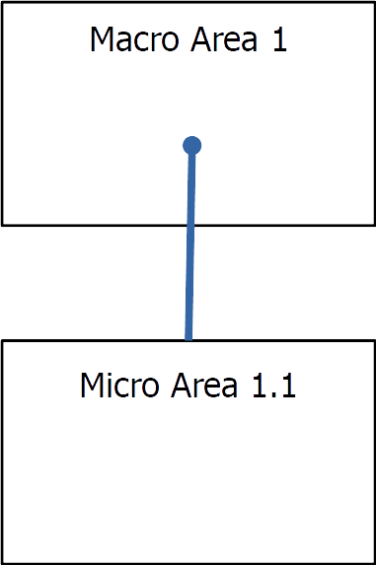

You can imagine the third axis added to common 2D diagrams as a measure of complexity of the system, with macrosystems on the top and microsystems near the origin of coordinates.

