Reusable Software Elements

Today, open source software packages that are part of many software applications can have a huge impact on the environment due to their significant consumption of computer resources. More efficient source code can reduce power consumpsion of computers running their compiled code. Open source projects that facilitate application development emphasize rapidness of writing source code and better expression of algorithms. They make it easier to implement ideas for developers. Many popular computer languages help developers in this endeavor. The question is, what if we can have common framework with macrolanguage and templates used for different kinds of software problems? An example of such framework for front-end is open source integrated development environment Multipage IDE available at www.multipage-software.org with a macrolanguage named Maclan. It does not use folders and source code files to build applications, such as a conventional IDE, but it uses areas and slots for source code providers. That areas act as templates. The resulting source code is created using a macro language implemented in preprocessor. Main purpose of this framework is to enable exchange of software elements. They can be loaded and embedded into required parts of the templates. The intent is, to further develop and complete a framework for AI, based on similar assumptions. Next chapter describes a system of conditional events.

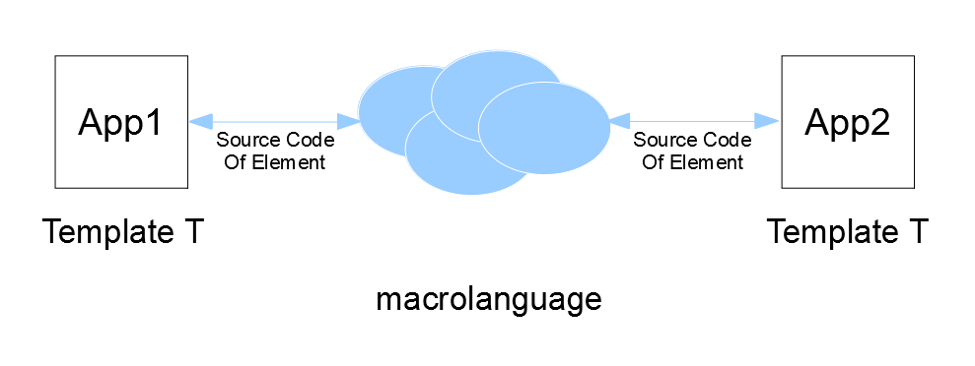

System of conditional events

Conventional and quantum computers can create and compute models of Earth systems and we can ask the computers if events that occur in the model are dynamically stable. That conditional events can be considered atomic parts of computer model.
A few following sentences describe AI add-in for the Multipage IDE. Top level hypothesis (H0) and hypotheses related to conditional events can have complex states written in qubits or in simple bits and the conditional events can be connected in directed graphs with “depth”, “spread” and “width” in their logic. The idea is that macrolevel event with related hypothesis (Hdepth,spred,width) can be a “macro event” in corresponding microlevel and that there also exist “callback” events in microlevel that affect macrolevel. Computers can use forward and backward chaining with balanced depth, spread and width evaluation priority when they examine the model with multiple processors. Temporal states of hypotheses for each processor can be combinations of complex or real values for “falsified”, “supported”, “not investigated”, “not testable”, “bad with errors” or other. In next image it is described a fractal space, which is also bounded in depth thanks to atomic conditional events.

