# Introduction

The objective of this technical document is to give general information about the development in the first phase of the UAVCAN project.

Objectives of project:

* Enable Cyphalcommunication.
* Cyphal communication between ESCs and FMU.
* Cyphal communication between GPS and FMU.
* Cyphal communication between BMS and FMU.
* Implementation of Cyphal publisher for IMU data.

The development is based on the PX4-Autopilot open source.

# Architecture

From the goal of project, we want to use the UAVCAN as the main communication protocol for the drone, including FMU, sensors, peripherals, and actuators based on the PX4 software stack.

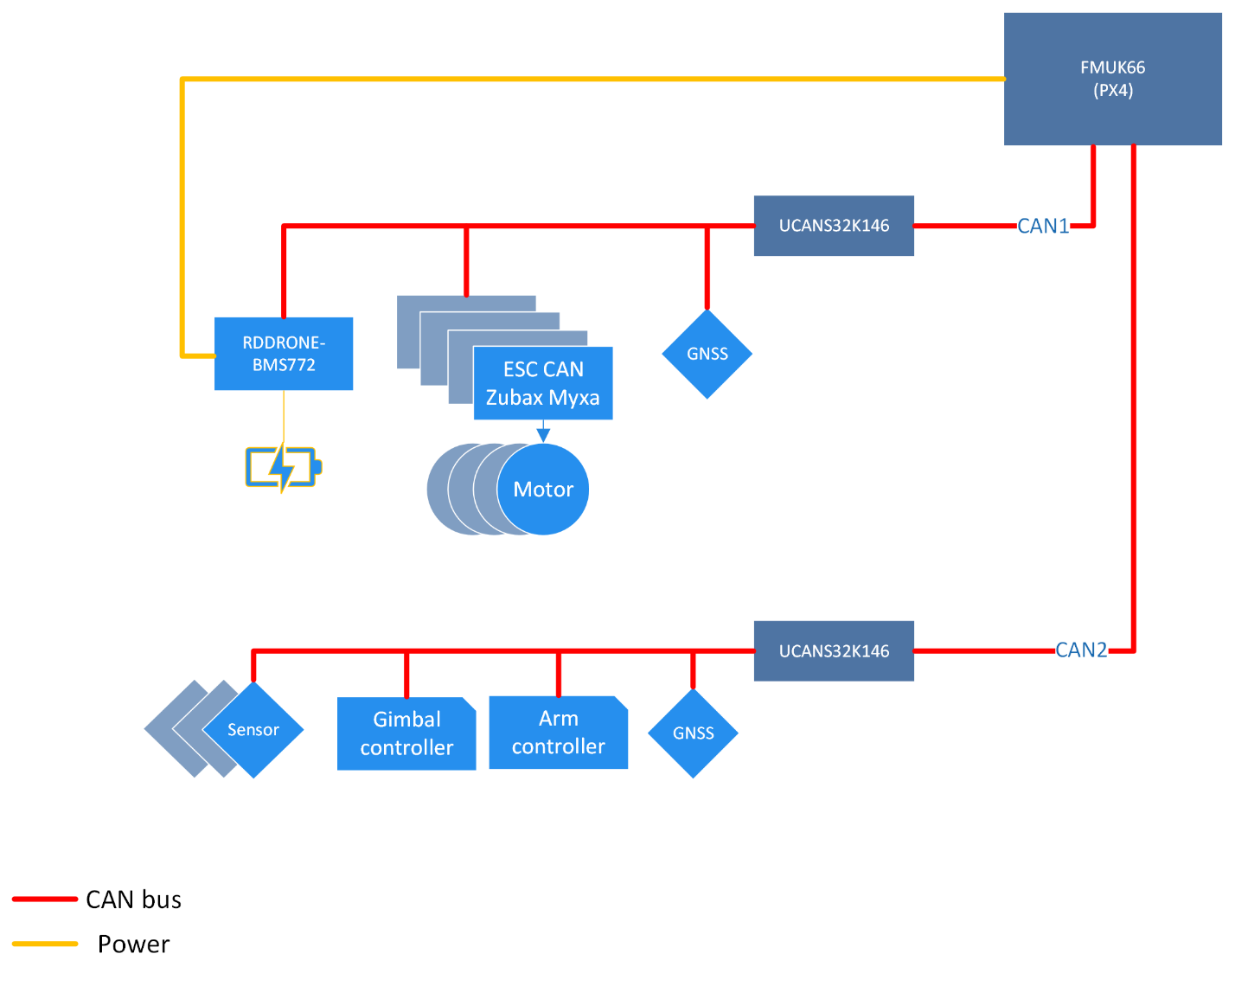

In this phase, we focused on the communication between the FMU and peripherals (ESC, GPS, BMS) with CanHub as an intermediate device. So, we have a general HW architecture as the diagram below.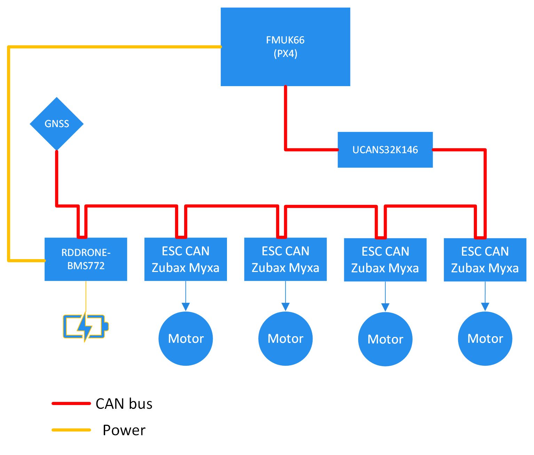

# Hardware setup

The picture shows all things connected.

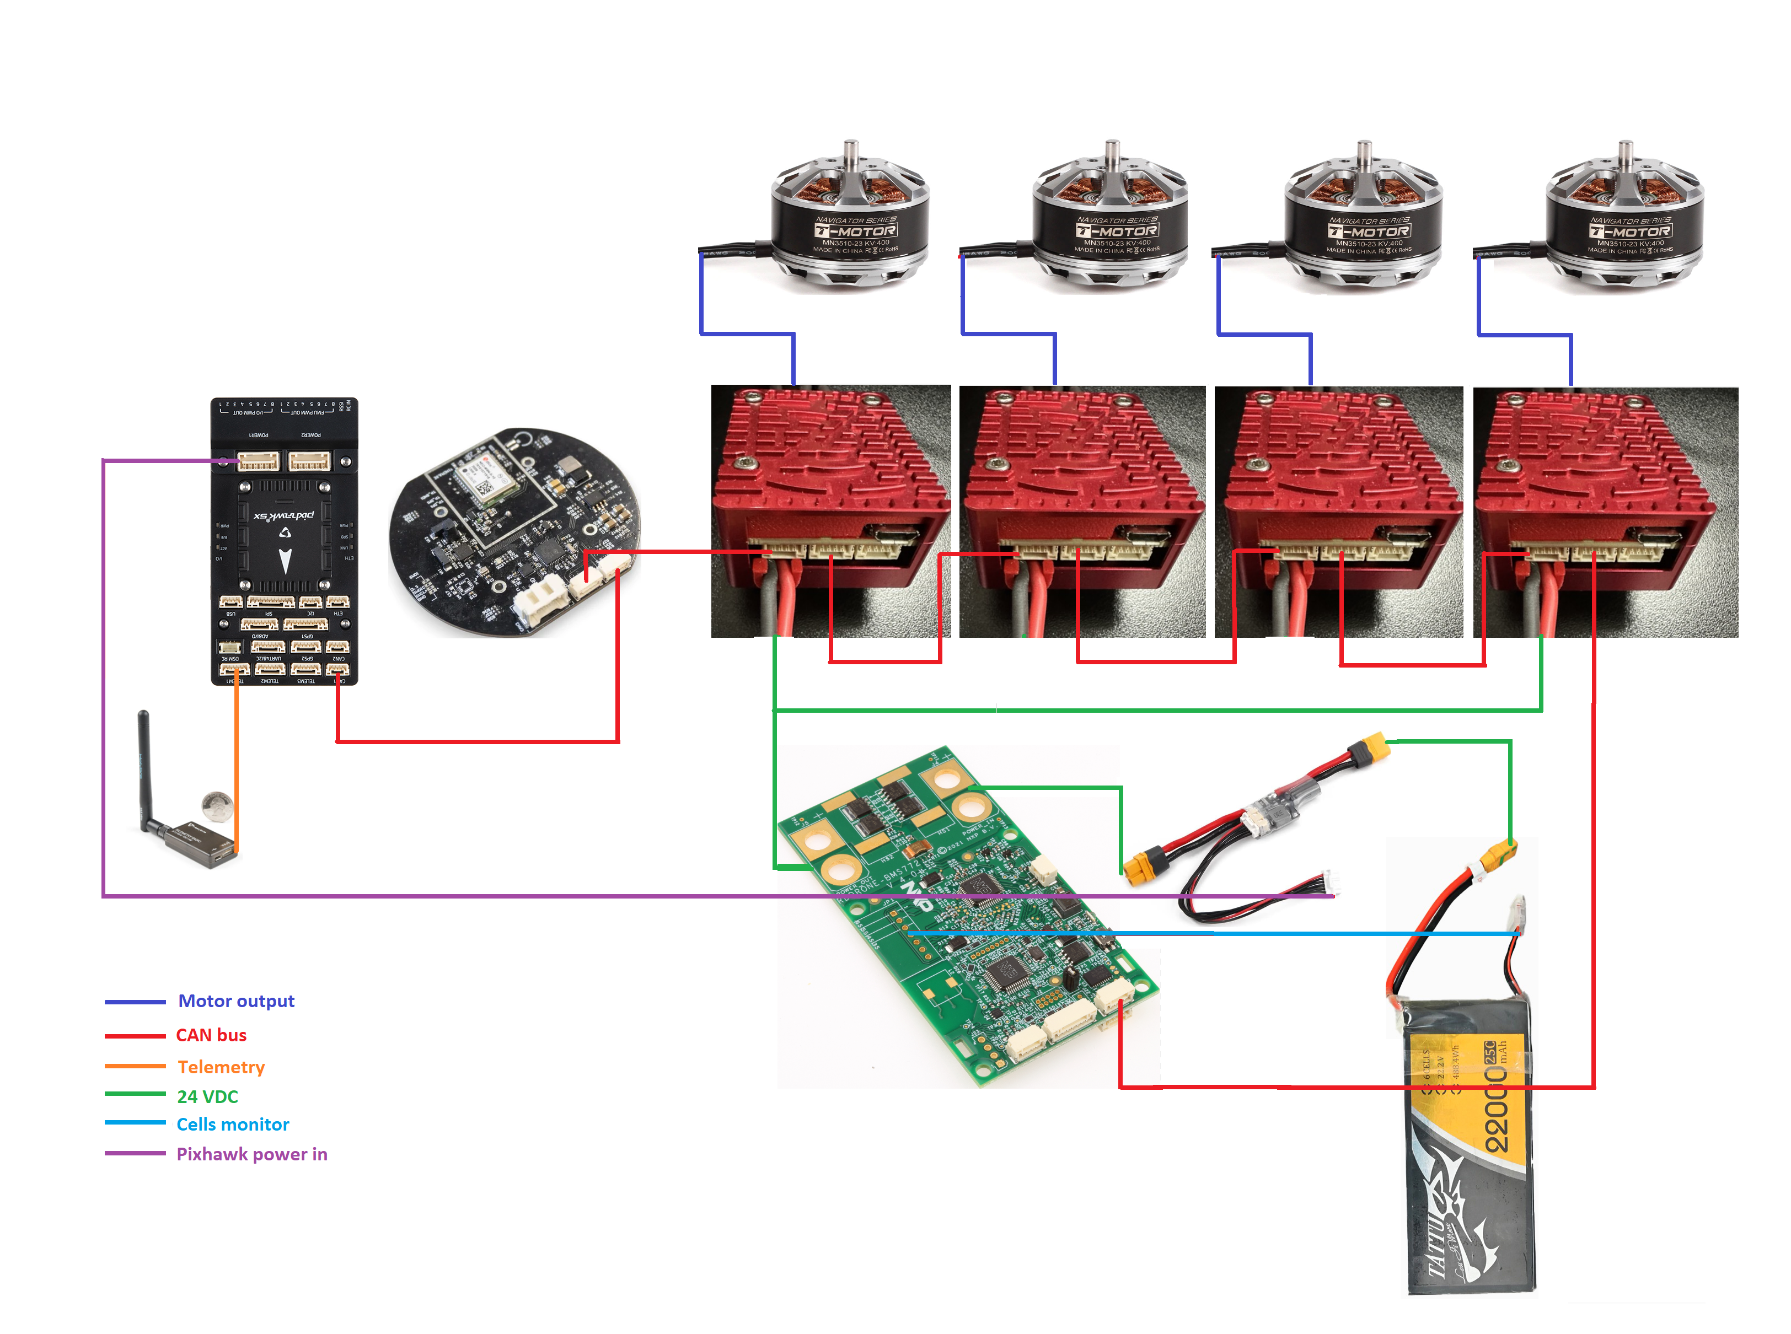

# Software setup

## Dev environment

We work mainly on PX4 project with the setup for Windows and WSL2-based. Then we can follow the instructions from PX4 for the development environment setting up [here](https://docs.px4.io/main/en/dev_setup/dev_env_windows_wsl.html).

# Board configuration

## Cyphal activation

To have Cyphal communication on the FMU, we need to make sure that Cyphal is activated in the FMU configuration file. The configuration files for all boards, including linker scripts and other required settings, are located under /boards in a vendor- and board-specific directory (i.e. boards/VENDOR/MODEL/).

The “*default.px4board”* is the one we need to work on. However, you can find sometimes the file named “*cyphal.px4board”*, that means Cyphal is already activated when you use the *cyphal* build option*.*

For example, with the Pixhawk FMU-v5X, you should find out the “*default.px4board”* without the activation for Cyphal. Then we have to modify some configuration:

CONFIG_DRIVERS_UAVCAN=n #UAVCANv0 must be disabled to enable Cyphal

CONFIG_DRIVERS_CYPHAL=y

Besides that, the CAN port of the board must be enabled in menuconfig of the NuttX OS configuration. Follow the instruction [here](https://docs.px4.io/main/en/hardware/porting_guide_nuttx.html#nuttx-menuconfig-setup) to know how to use the menuconfig as well as to verify the CAN port activation.

## Cyphal modules configuration

For every Cyphal node on the CANbus, we can enable or disable separately by the parameters in *\*.px4board* file. At the end of this phase, we are supporting the following Cyphal node:

CONFIG_CYPHAL_ESC_CONTROLLER # tested

CONFIG_CYPHAL_IMU_PUBLISHER # tested

CONFIG_CYPHAL_GNSS_PUBLISHER

CONFIG_CYPHAL_READINESS_PUBLISHER

CONFIG_CYPHAL_ESC_SUBSCRIBER

CONFIG_CYPHAL_GNSS_SUBSCRIBER_0

CONFIG_CYPHAL_GNSS_SUBSCRIBER_1

CONFIG_CYPHAL_BMS_SUBSCRIBER # tested

CONFIG_CYPHAL_UORB_SENSOR_GPS_SUBSCRIBER

# CANBus visualization

# Conclusion

At the end of the project, we had almost met all the requirements of the project. In details:

* Cyphal is enabled and works correctly on Pixhawk v5X board.
* Communication between GPS, ESCs, BMS and FMU via Cyphal is well established and can be visualized on the CANbus.

However, we can figure out some issues that need to be fixed:

* PX4 I2C-SMBus integration is not done yet. Need to continue working on PX4 code in Phase 2.
* BMS Fault modes need to be tested and improved more in Phase 2 because sometimes It happened but cannot be recovered by itself while battery is fine.
* HITL work is still in progress.