

DAP1_UAV

Configuration Management Plan

**Project Code: DAP1_UAV_FP**

**Document Code: DAP1_UAV_CM_Plan_v0.1**

Note:

* This template can be used at it is, or to complete and improve an already existing template.

Help:

* Don’t remove headlines level 1 and level 2 (Heading1 and Heading2)
* Reasons why a section is not applicable shall be documented under the respective headline

**RECORD OF CHANGE**

| No | Effective Date | Version | Change Description | Reason | Reviewer | Approver |
| --- | --- | --- | --- | --- | --- | --- |
| 1 | 27/10/2023 | 0.1 | Add new | Initial Version | DungLD | TrieuQU |
| 2 |  |  |  |  |  |  |
| 3 |  |  |  |  |  |  |
| 4 |  |  |  |  |  |  |
| 5 |  |  |  |  |  |  |
| 6 |  |  |  |  |  |  |
| 7 |  |  |  |  |  |  |
| 8 |  |  |  |  |  |  |
| 9 |  |  |  |  |  |  |
| 10 |  |  |  |  |  |  |

**TABLE OF CONTENTS**

1. Introduction 3

1.1 Purpose 4

1.2 Scope 4

1.3 Audience 4

1.4 Maintenance 4

1.5 Role & Responsibility 4

1.6 Definitions and Acronyms 5

1.7 Standards 5

2. configuration management Process 6

2.1 CI Identification rule 7

2.2 CI List and Naming convention 7

2.3 File naming and versioning rule 8

2.4 Project Infrastructure 9

2.5 Promotion Areas and Directory Structure 11

2.6 Access right control 13

2.7 CI Baseline Procedure 13

2.8 CI Interface management 14

2.9 Project Baseline Schedule 14

2.10 Backup strategy 14

2.11 Branch Management 14

2.12 Other CM rules 14

2.13 Related documents 15

# Introduction

* 1. **Purpose**

The purpose of this document is to identify and describe configuration management (CM) process implementing in the project DAP1_UAV

* 1. **Scope**

This document applies for DAP1_UAV in Business Unit Infotainment Solutions located in SUP.8 Configuration Management folder. It describes all Configuration Management activities.

* 1. **Audience**

The intended readers of this document are all Project Team members and all people external to the Project but involved with the Configuration Management.

* 1. **Maintenance**

The first version of this document shall be released before <*a draft version only is required with focus on the identification of test environment* > by above-mentioned person. It will be updated on major changes or (if necessary) at the end of each project process phase.

* 1. **Role & Responsibility**

|  |  |  |  |
| --- | --- | --- | --- |
| **No** | **Roles in projects** | **Full Name** | **FSOFT’s Accounts** |
| 1 | PM | Quach Ung Trieu | [TrieuQU@fpt.com](mailto:TrieuQU@fpt.com) |
| 2 | PTL | DungLD | [DungLD@fpt.com](mailto:DungLD@fpt.com) |
| 3 | CC | Quach Ung Trieu | [TrieuQU@fpt.com](mailto:TrieuQU@fpt.com) |
| 4 | DEV | Le Viet Tam Duc  Duong Nhat Zon  Tran Chi Nguyen | [DucLVT@fpt.com](mailto:DucLVT@fpt.com)  [ZonDN@fpt.com](mailto:ZonDN@fpt.com)  [NguyenTC9@fpt.com](mailto:NguyenTC9@fpt.com) |
| 5 | QA | Pham Thu Hang | [Hangpt3@fpt.com](mailto:Hangpt3@fpt.com) |
| 6 | SM | Mai Anh Thang | [ThangMA@fpt.com](mailto:ThangMA@fpt.com) |

|  |  |  |  |  |  |  |
| --- | --- | --- | --- | --- | --- | --- |
| **No** | **Roles** | **PM** | **PTL** | **BA** | **CC** | **Others** |
| 1 | CCB | x | x |  |  | SM |
| 2 | Responsibilities | x | x |  |  | SM |

| **No** | **Activities** | **CC** | **Replacement** |
| --- | --- | --- | --- |
| 1 | Develop CM Plan | x |  |
| 2 | Set up CM environment | x |  |
| 3 | Provide orientation in CM plan to project teams | x |  |
| 4 | Manage CI revision and Perform Project Baseline | x |  |
| 5 | Participate in Controlling Configuration Change | x |  |
| 6 | Control Access right | x |  |
| 7 | External Release | x |  |
| 8 | Track status of Changes to CIs in Change Control Report | x |  |
| 9 | Track status of Infrastructures | x |  |
| 10 | Release or handover equipments (if any) | x |  |

* 1. **Definitions and Acronyms**

| **No** | **Acronym** | **Definition** | **Note** |
| --- | --- | --- | --- |
| 1 | CC | Infrastructure Configuration Controller |  |
| 2 | CCB | Change Control Board |  |
| 3 | CI | Configuration Item |  |
| 4 | CM | Configuration Management |  |
| 5 | PM | Project Manager |  |
| 6 | PTL | Project Technical Leader |  |
| 7 | PIC | Person in Charge |  |
| 8 | QA | Quality Assurance Officer |  |
| 9 | Source | Source Code |  |
| 10 | WIP | Work in Progress |  |
| 11 | MSN | Module Short Name |  |

* 1. **Standards**

|  |  |  |  |  |
| --- | --- | --- | --- | --- |
| **No** | **Type** | **Name of Standard** | **refer links** | **Note** |
| 1 | Manage Process of Project | JIRA | <https://insight.fsoft.com.vn/jira9/projects/DAP1UAVFP/summary> |  |

# configuration management Process

* 1. **CI Identification rule**

CI/CD is not applicable for project at this phase.

* 1. **CI List and Naming convention**

|  |  |  |  |
| --- | --- | --- | --- |
| **Main category** | **CSCI** | **Configuration Items** | **Naming conventions** |
|
| **Information** | **Project Management** | Estimation | FPT-Dronomy-Proposal-v0.3-by_ThangMA_Aug28_yyyymmdd |
| Work Order | DAP1_UAV_Work Order_vx.y |
| Acceptance Note | DAP1_UAV_Acceptance Note_vx.y |
| Project Plan | DAP1_UAV_Project_Plan_vx.y |
| CM Plan | DAP1_UAV_CM_Plan.vx.y |
| Process Compliance Verification | [control in FI2.0: https://insight.fsoft.com.vn/jira9/secure/pcvCustomizeProject.jspa?projectKey=DAP1UAVFP&tab=ONE_PAGE_QA_MENU](https://insight.fsoft.com.vn/jira/secure/pcv_main.jspa?projectKey=MICROCHIPAU) |
| QA Service Agreement | DAP1_UAV_QAServiceAgreement_vx.y |
| Daily report | DAP1_UAV_daily report_yyyymmdd |
| Project Report | DAP1_UAV_WeeklyReport_vx.y |
| Meeting Minutes | Weekly_Meeting_Minutes_yyyymmdd |
| **Requirement & Design** | Software Requirement Specification | SRS_<FeatureName>_x.y |
| Architecture Design/Detail Design Document | SAD_<FeatureName>_x.y  SDD_<FeatureName>_x.y |
| **Build** | **Code** |  |
| SourceCode | <Msn>_<configuration time>.c  <Msn>_<configuration time>.h |
| **Test** |  |
| System Test Report | ST_<MSN>_Test_Report_vx.y |
| System Test Case | ST_<MSN>_Test_Specification_vx.y |
| **Process** | Guideline_CMMI | Document (\\10.16.34.99\Fsoft-QMS) |
| Design Standards/Procedures | Standard_Title of standard/procedures |
| Coding Convention/Standard | Standard_Title of standard/Convention |
| Template_Name of template | Template_Title of template |
| Rule_Name of rule | Standard_Title of standard/rule |
| **Data** | Technical Data | DAP1_UAV_Data package file name |
| Measurement Data | DAP1_UAV_Quality_Control_Report_vx.y |
| **Infrastructure** | **Hardware** | **For Development** |  |
| GIT Server | <https://git3.fsoft.com.vn/GROUP/DAP1UAVFP> |
| **For Test** |  |
| GIT Server | <https://git3.fsoft.com.vn/GROUP/DAP1UAVFP> |
| **For Deployment** |  |
| GIT Server | <https://git3.fsoft.com.vn/GROUP/DAP1UAVFP> |
| Build machine | PC with 32GB Ram + Open USB port. |
| **Software** | **For Development** |  |
| Development Tool | NXP S32 Studio |
| Sourcetree |  |
| WSL2 |  |
| QGroundcontrol |  |
| jMAVSim |  |
| Programming Language | C/Python |
| Software1 | Microsoft Office 2016 64 bit |
| Software1 |  |
| **For Test** |  |
| Test Tool | TBD |
| **For Deployment** |  |
| NA |  |
| **Communication equipments** |  |
| NA |  |
| **Equipments & Internet Connections** | **Technical equipments** |  |
| Testing equipment | EVB CAN FD |
| Drone Kit | KIT-HGDRONEK66 |
| Development board | Board i.MX 8 Plus Application + M20 GNSS board |
|  | **Others** |  |  |

Note:

* CICD won’t apply in this pilot phase.
* Internal documents: <Project name>_<Document name>_<Version>
  1. **File naming and versioning rule**

**Notes:**

The names of the objects managed are case sensitive.

There is no physical limitation for the length of the name but it is recommended not to exceed 32 characters.

The following characters cannot be used in object or project names include & ^ + @$ % * ( ) | \ / [ ] { } < > ? ; “ ‘ # - : !.

CM Plan version numbering rule is applicable for all items: Below is an example

Baseline version

1.0

2.0

1.1

1.1.1

x.0

1.1.2

1.3

1.2

1.2.1

0.x

0.1

Upgrading version

Draft version

* The initial version of document is 0.1, and it will be move to 0.x during the draft version.
* After the first baseline, the version is 1.0
* If there is any change, the version will become 1.x (like 1.1; 1.2) and event if there are much more detail changes, it could be 1.x.x (1.1.1; 1.1.2; 1.2.1)
* After the changes are done, the baseline version will be x.0 to be ready for using.

Remark: For source code, during a merge, the resulting object must be in the main stream and have a greater version number than the merged objects. If it is not the case automatically, the version must be modified manually.

* 1. **Project Infrastructure**

**Server:**

|  |  |  |  |  |  |
| --- | --- | --- | --- | --- | --- |
| **No** | **Server name** | **IP Address** | **Purpose** | **Person in charge** | **Expired date** |
| 1 | Project GitLab server | <https://git3.fsoft.com.vn/GROUP/DAP1UAVFP> | Source code of project | TrieuQU | 31/12/2023 |
| 2 | Project Sharepoint | <https://fptsoftware362.sharepoint.com/sites/dap1_uav_oneteam/Shared%20Documents/Forms/AllItems.aspx> | Store folder | TrieuQU | 31/12/2023 |

**Internet Connection:**

|  |  |  |  |  |  |
| --- | --- | --- | --- | --- | --- |
| **No** | **Internet Connection** | **IP Address** | **Purpose** | **Person in charge** | **Expired date** |
| 1 | Open access Internet | Youtube.com | Self learning and product investigation | TrieuQU | 31/12/2023 |

**PC:**

|  |  |  |  |  |
| --- | --- | --- | --- | --- |
| **No** | **PC** | **Purpose** | **Owner** | **Note** |
| 1 | Open USB Port for all project member PC | Connect to hardware via USB port to run, debug program on board | TrieuQU |  |
| 2 | Build Server | 1 PC with 32GB Ram + Open port USB | TrieuQU | Making build and deployment for the whole project |

**Equipment:**

|  |  |  |  |  |  |
| --- | --- | --- | --- | --- | --- |
| **No** | **Equipment** | **Location** | **Person in charge** | **Usage rule** | **No** |
| **1** | For more details, please see the HW list at Project Setup slide  [FPT-Dronomy-Proposal-v0.3-by_ThangMA_Aug28-Share.pptx](https://fptsoftware362.sharepoint.com/:p:/r/sites/dap1_uav_oneteam/Shared%20Documents/Reference/FPT-Dronomy-Proposal-v0.3-by_ThangMA_Aug28-Share.pptx?d=w8019c435c95649078665721e346988be&csf=1&web=1&e=qFOcW5) | s | DonBTM | DonBTM takes care key of locker for all Equipments, team will go to her table to borrow and return daily  Note:  They are tracked and controlled frequently at least at baseline point of project | **1** |

**Tool:**

|  |  |  |  |  |
| --- | --- | --- | --- | --- |
| **No** | **Tool** | **Purpose** | **Owner** | **Note** |
| 1 | NXP S32 Studio | IDE/Compiler | FPT | Freeware |

* 1. **Promotion Areas and Directory Structure** 
     1. Promotion Areas

| **No** | **Area** | **Purpose** |
| --- | --- | --- |
| 1 | Develop Area | Area for different users to store his/her owned items |
| 2 | Review Area | To store items that is ready for review.  Reviewer get to be-reviewed items from this area |
| 3 | Test Area | Just applicable for Source items.  To store items passed Unit Test and Code Review |
| 4 | Release Area | To store the items ready for release and all released versions of items  Users get the most recent items for their usage from this area |
| 5 | Archive Area | To archive all released versions of each CI  Archive area is a protected area for project baselines where all the CIs cannot be changed by any member |

* + 1. **Directory structure**

**Access right definition**

|  |  |  |  |  |
| --- | --- | --- | --- | --- |
| **No** | **Access Right** | **Project Folder** | **VSS** | **SVN** |
| 1 | Read | Read & Execute | Read (R) | read (r) |
| 2 | Modify | Modify | Check Out/Check In (C) Add/Rename/Delete (A) | read-write (rw) |
| 3 | Full | Full control | Destroy (D) | read-write (rw) |

| **Main Folder** | **Sub Folder** | **Purpose** | **Map to Area** | **Access right** |
| --- | --- | --- | --- | --- |
| Project Directory: <https://fptsoftware362.sharepoint.com/sites/dap1_uav_oneteam/Shared%20Documents/Forms/AllItems.aspx> | | | | |
| WIP | Project_Requirement | Store Customer’s requirements | Develop Area + Review | Modify: PM, PTL,  Read: All |
| Project_Management | Store the internal process management documents | Develop Area + Review | Modify: PM, PTL,  Read: All |
| Project_Preparation | Store the baseline documents | Develop Area + Review | Modify: PM, PTL,  Read: All |
| Project_Engineering | Contain all documents of Product Engineering | Develop Area + Review | Modify: PM, PTL, Developers  Read: All |
| Audit | Store Audit documents | Review | Modify: PM, PTL  Read: All |
| Release | Store deliverables for project | Release | Modify: PM, PTL, Developers  Read: All |
| Project_Supporting | Store other procecss documents that required for project operation | Release | Modify : CC  Read: All |
| References | Customer_Supplied | Store documents and other materials/data supplied by customer or those support software development and production operation in the project… | Review | Modify: PM, CC,PIC  Read: All |
| OpenSource | Store Guidelines/Open source software specified for the project usage | Review | Modify: PM, CC,PIC  Read: All |
| Archive | Baseline Name | To be released versions at baselines | Archive | Modify: PM, CC  Read: All |

* 1. **Access right control**

**Refer GIT Access Right DAP1_UAV:**

| **No.** | **Branch** | **Access Right** | **PIC** |
| --- | --- | --- | --- |
| Project Directory: <https://git3.fsoft.com.vn/GROUP/DAP1UAVFP> | | | |
| 1 | master | Push, Merge, Rebase | PM, PTL |
| 2 | master | Pull | All |
| 3 | Develop | Push, Merge, Rebase | PM, PTL |
| 4 | Develop | Pull | All |
| 5 | Feature branches | Pull, Push, Merge, Rebase | All |

* 1. **CI Baseline Procedure**

CI/CD is not applicable for the project at this phase.

Development Folder structure:

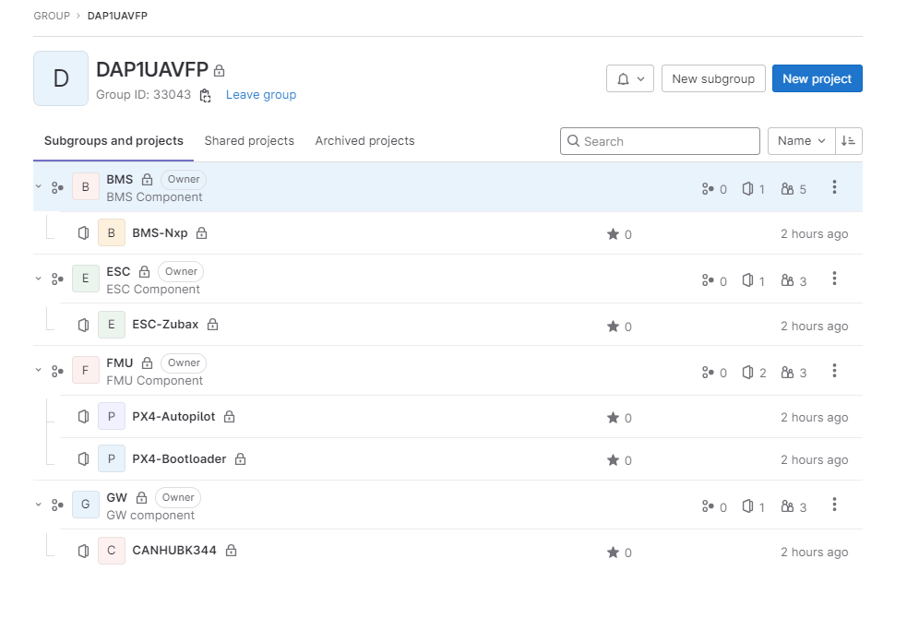

+ <Module>

++) Generic /* contains Autosar APIs, Error handling. It’s same for all platforms */

+++) include

+++) src

++) specific /* contains specific for platforms. This layer selects what IPs shall be used */

+++) <platform_name>

++++) config

++++) doc

++++) generate

++++) include

++++) resource

++++) src

++++) <Module>.mak

++) IP /* Contains source files to access hardware */

+++) IPV_NameOfIP

++++) include

++++) src

Note: Any exception is to be documented and approved in the Project Management Plan.

* 1. **CI Interface management**

| **No.** | **CI** | **Exchanging Type** | **Record Type** | **Communication Channel** | **Record Format** | **Frequency** | **Notification Type** | **PIC** |
| --- | --- | --- | --- | --- | --- | --- | --- | --- |
| 1 | All | Input/Output | Mail, Word, Excel, | Email Attachment, GIT | Formal, | Event-based | Email, Meeting Minute | CC |

* 1. **Project Baseline Schedule**

| **No.** | **Baseline Name** | **Baseline Criteria** | **PIC** |
| --- | --- | --- | --- |
| 1 | Wrap-up | Within 5 working days after the final release is sent to customer. It is mandatory requirement that version of all CI at Wrap-up baseline to be archived in separate folders in Archive area | CC |

* 1. **Backup strategy**

| **Storage Area to be Backed up** | **Items to be Backed up** | **Backup To** | **Backup Type** | **Backup Frequency** | **PIC** |
| --- | --- | --- | --- | --- | --- |
| Sharepoint | Sharepoint folders | Backup on server by RAID technology | Follow IT backup rule | Follow IT backup rule | CC |
| GIT repository | GIT repository | Backup on server by RAID technology | Follow IT backup rule | Follow IT backup rule | CC |

* 1. **Branch Management**

- Project do not create branching for code in any situation. In case Project need to branch source code (e.g customer request), we will revise CM plan – Brach Management Strategy follow FGA QMS procedure.

* 1. **Other CM rules**

When sending mail, members have to:

-       To: PIC

-       CC: Group Mail Project

Prefix Subject mail: [DAP1_UAV]

* 1. **Related documents**

|  |  |  |  |
| --- | --- | --- | --- |
| **No** | **Document Code** | **Document Name** | **Source** |
|  |  |  |  |