The new tools created to integrate VE-Suite will be described in this document. The assumptions are that users have access to Aspen and that they are familiar with general VE-Suite operations.

To begin, the user launches VE-Suite through the normal modes that can be found in the VE-Suite documentation. The user then launches the VE-AspenUnit executable via VE-Launcher.

Open VE Suite Launcher.
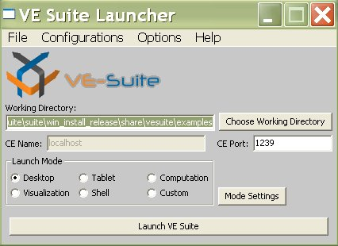

Choose “Open” from the File menu
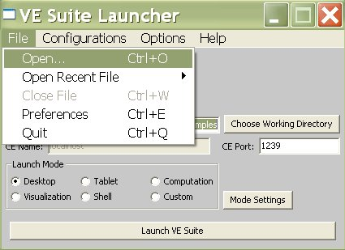
Using the file open dialog select the “Executable Files”
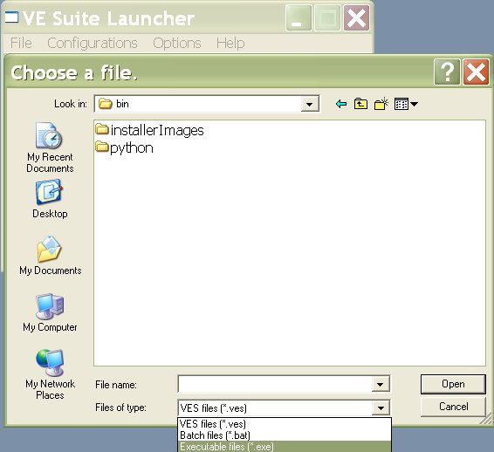

Select “AspenUnit.exe” and Choose “Launch VE Suite”
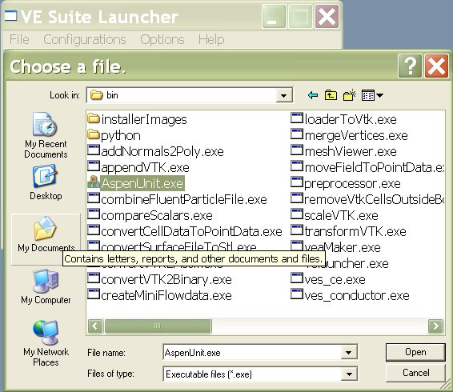

Once the VE-AspenUnit is launched:

Choose “…” to browse for working directory.
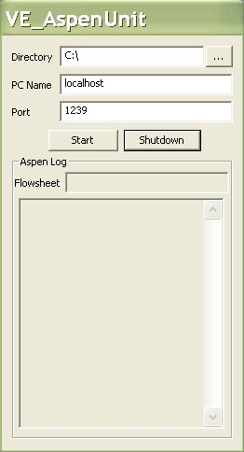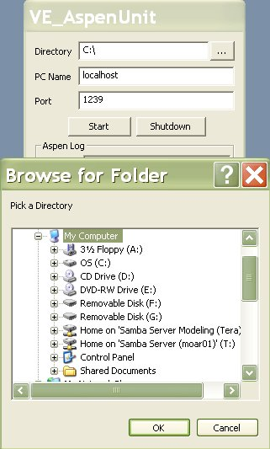

Once working directory choose “Start” - VE-Conductor will show “Successfully registered ASPENUNIT” if everything performed correctly.
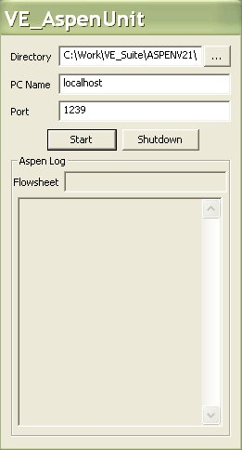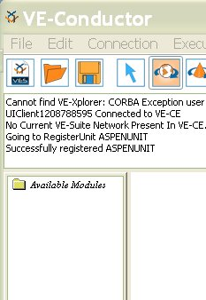

VE-Conductor: Choose Connection→Aspen→Open Simulation to run the Aspen Simulation:

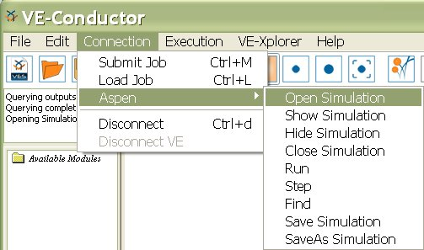

Note: As shown above, various other operations are also available in VE-Suite. The resulting actions can be intuited from the menu names.

Enter the Aspen .bkp/.apw file to be used:
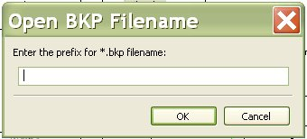
Note: Before doing this step be sure both the APW & bkp files have been created.

Once the .bkp/.apw file is chosen, the user will then see a network diagram of the Aspen flowsheet similar to what is seen in Aspen:

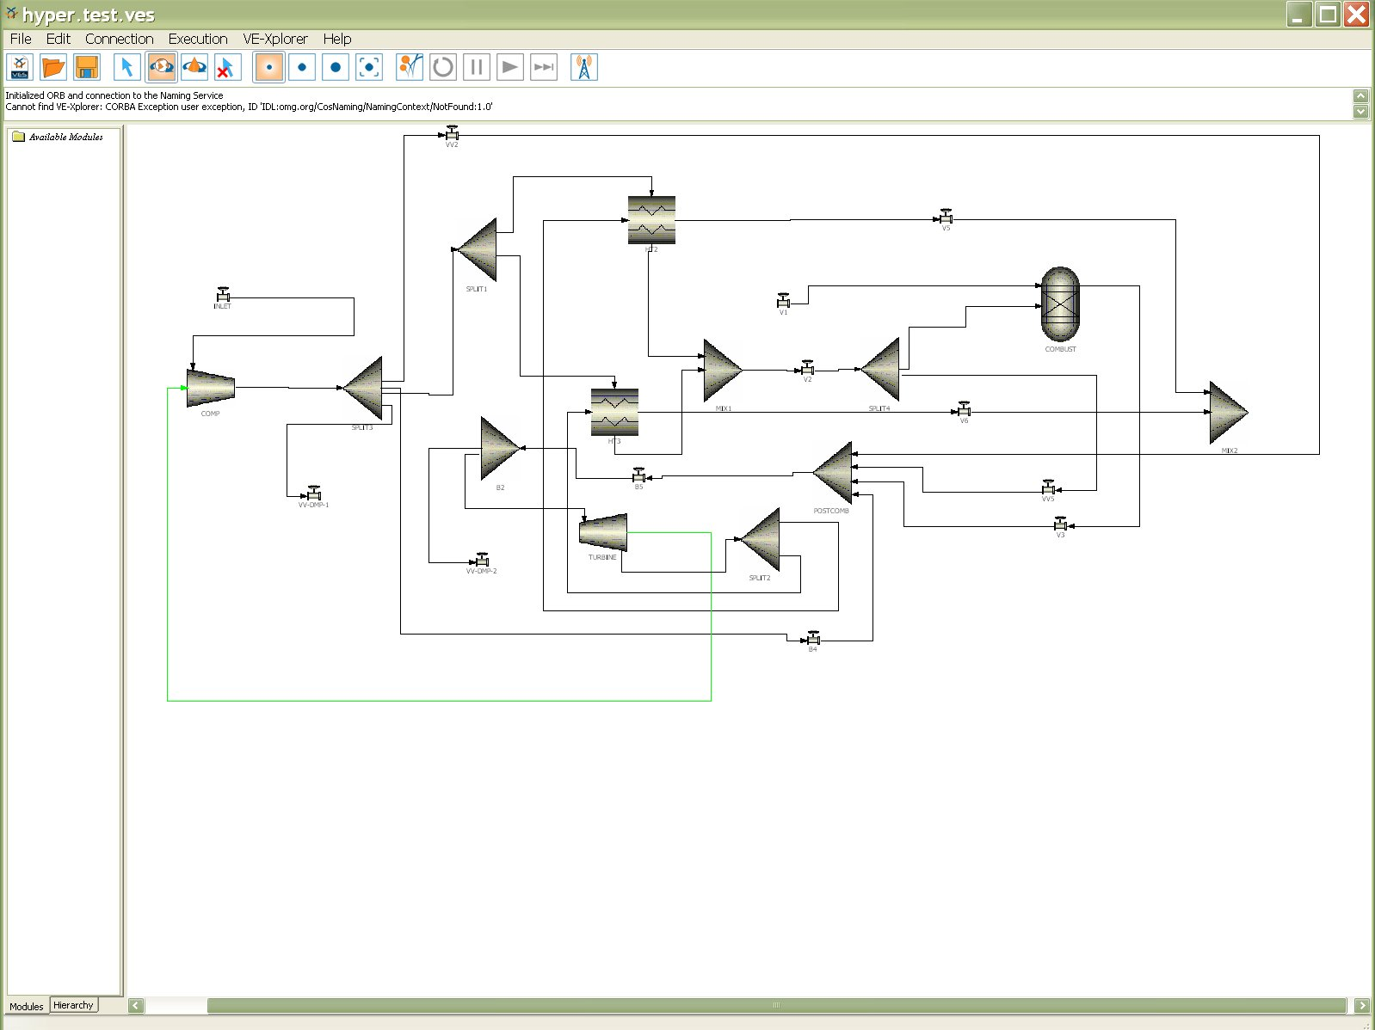
The Aspen flow sheet will also be displayed and available
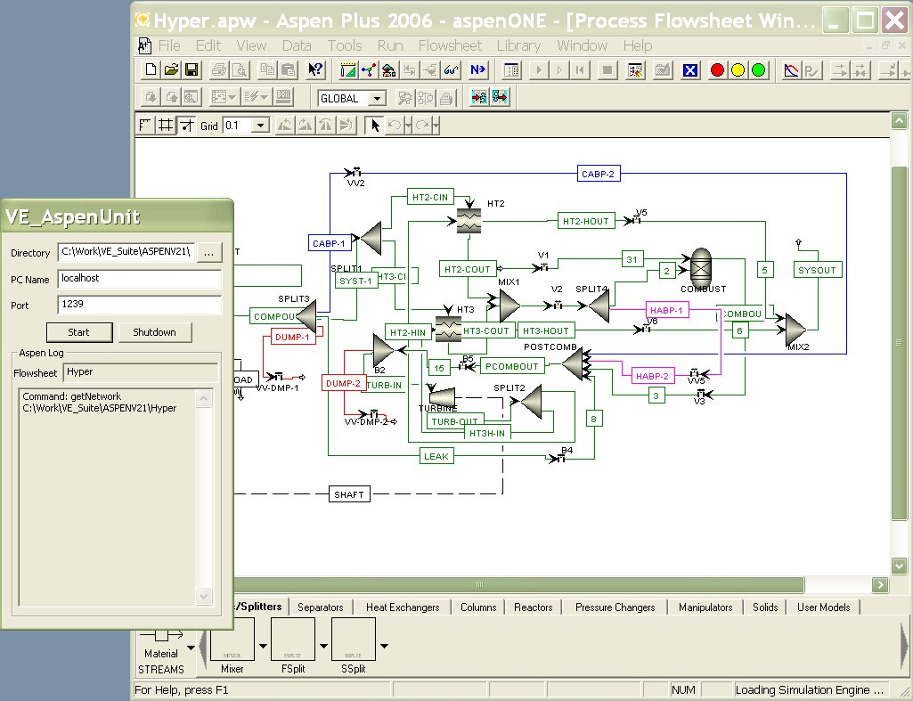

Once the Aspen flowsheet is loaded, it is possible to work with Aspen through the VE-Suite right-click menus:

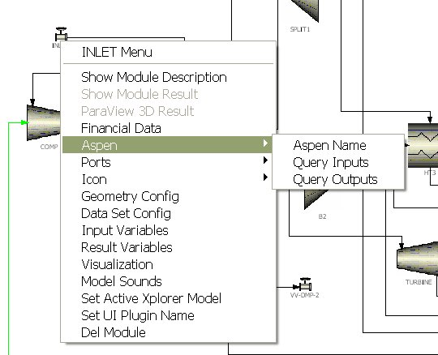

The Aspen unit operation name is shown below:
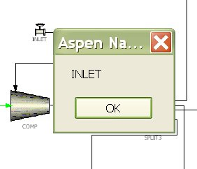

When the user chooses to investigate input variables, the parameters dialog allows any variable to be viewed for a specific unit operation and modified. This is also true for the results, except that the user is unable to change results.

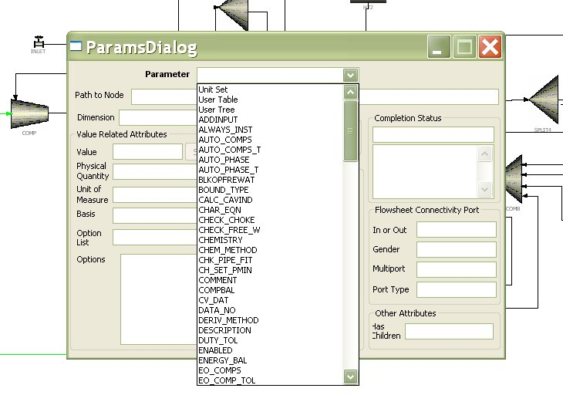

Inputs:
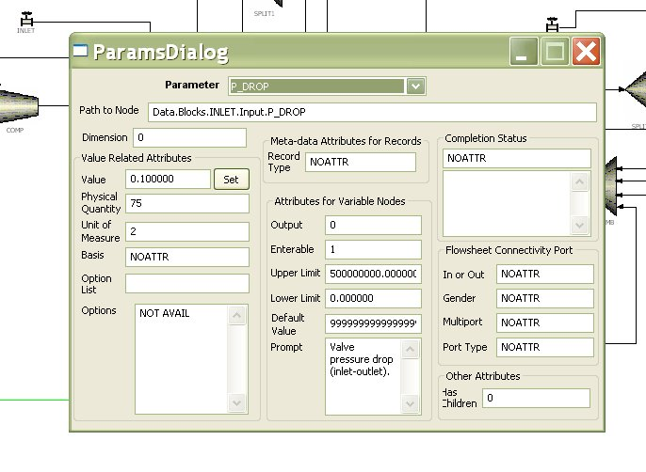

Results:

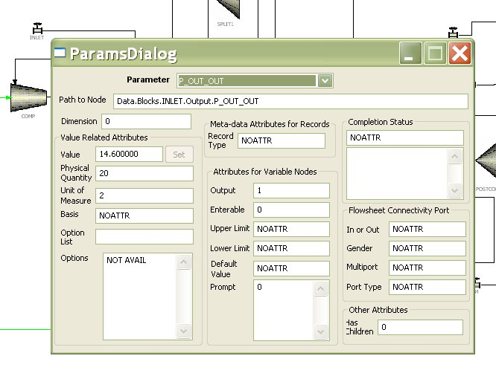
Once the user changes an input, the flowsheet can be run in Aspen by selecting Connection→Aspen→Run Simulation:

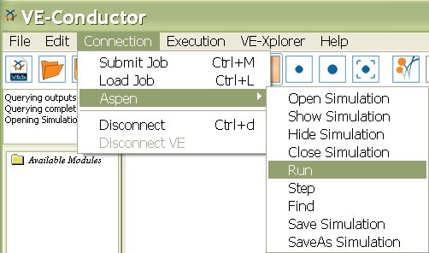
Note: In addition to being able to run the Aspen flowsheet in traditional modes, there is also a 3D mode that can be viewed by selecting VE-Xplorer → Graphical View → Network:

