Contents

• Tools configuration (Java, Git, Maven) 1

• Systems Configuration (Gitlab, JFrog, Notifications) 3

• Jenkins Job Configuration, Job Build History and Sample Console Output 3

• Git / Gitlab History 6

• JFrog Deployment History / Copy 7

• Application output – Execution of Application Home Page from Browser 7

## 

## Tools configuration (Java, Git, Maven)

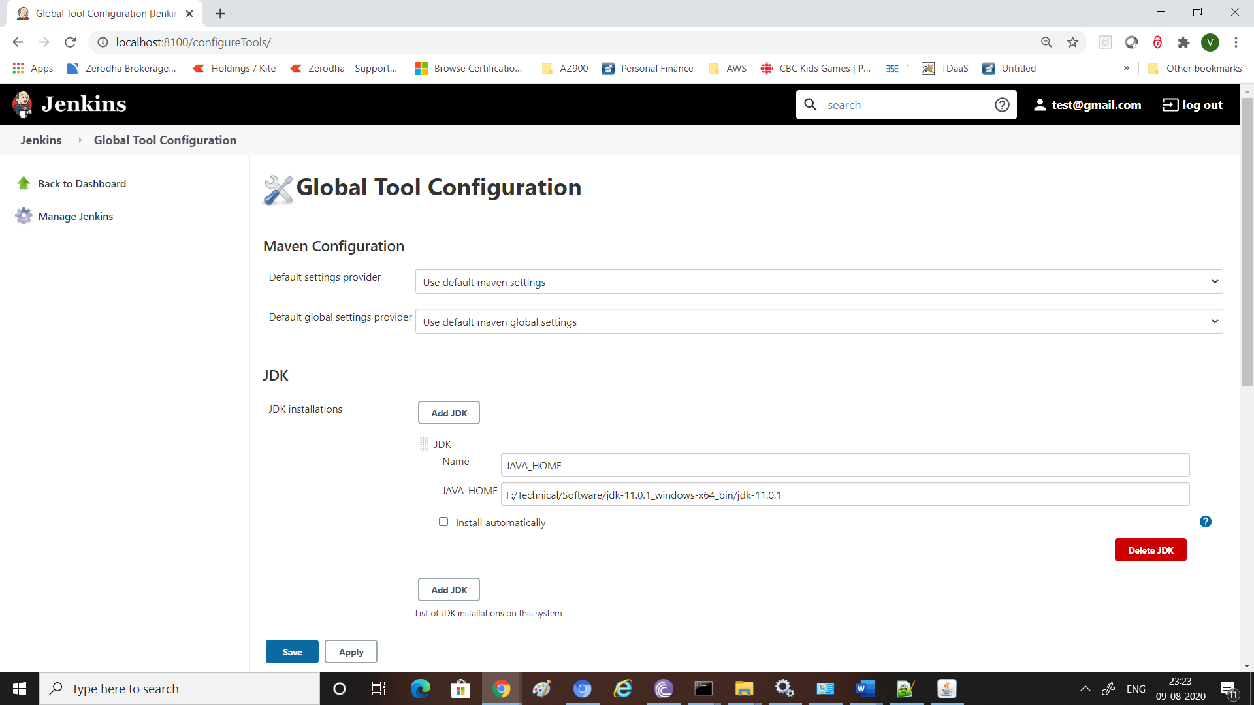

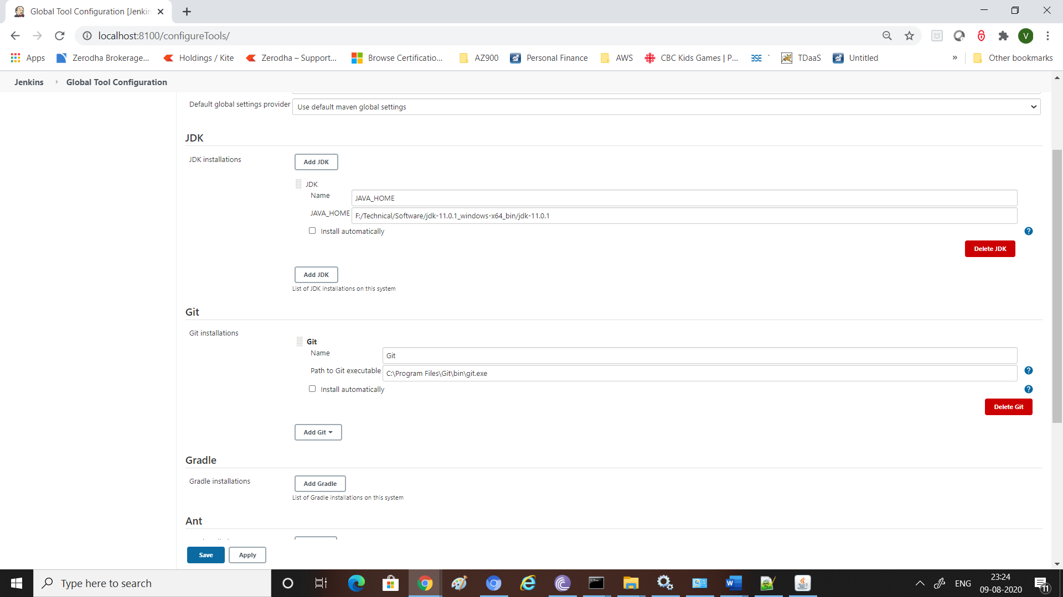

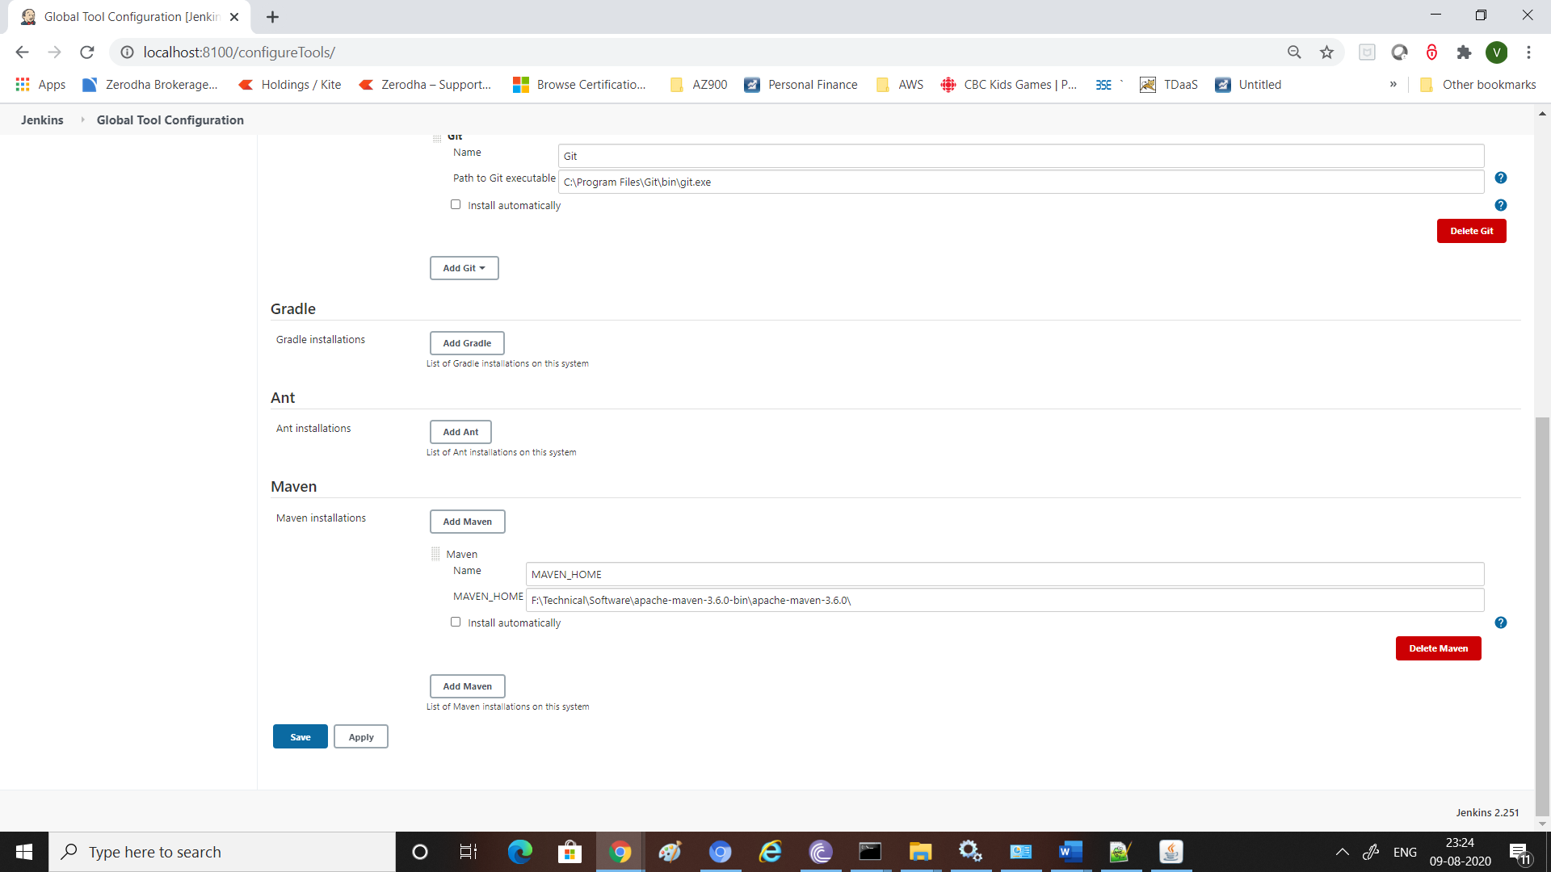

## Systems Configuration (Gitlab, JFrog, Notifications)

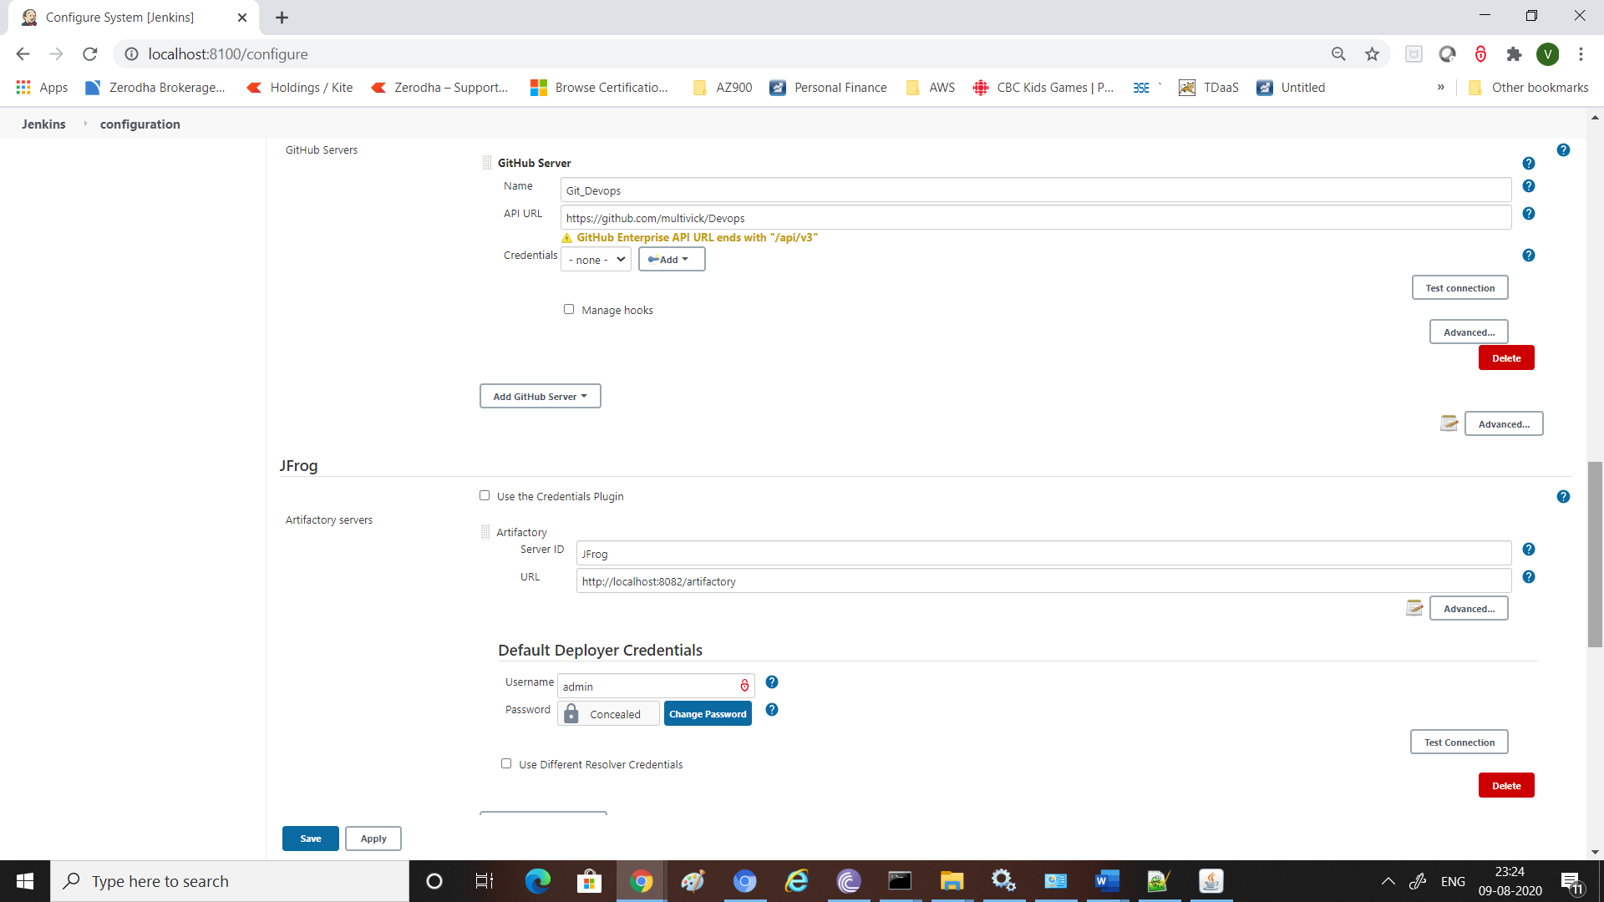

## Jenkins Job Configuration, Job Build History and Sample Console Output

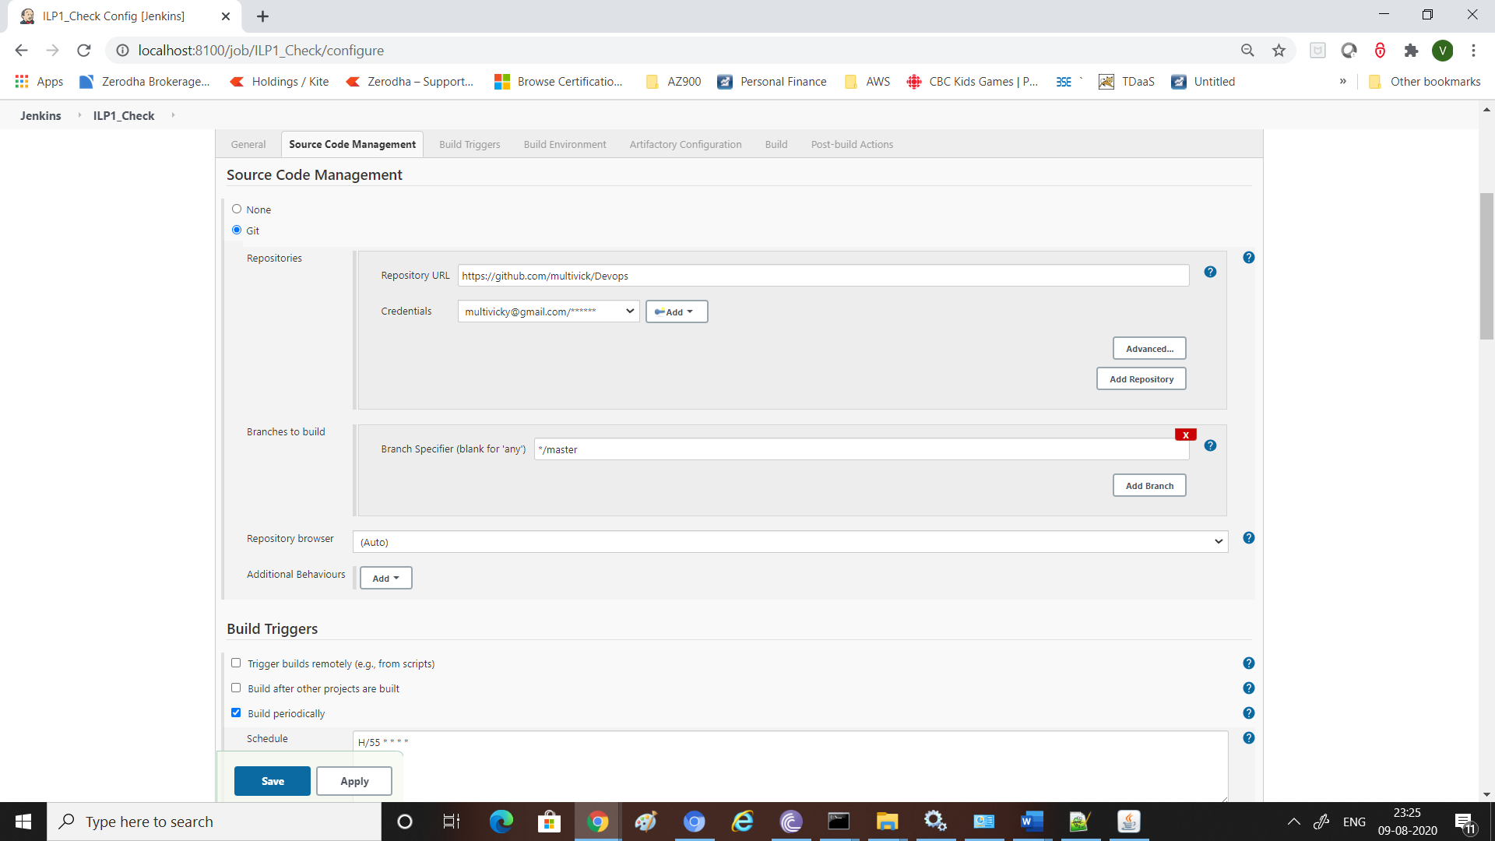

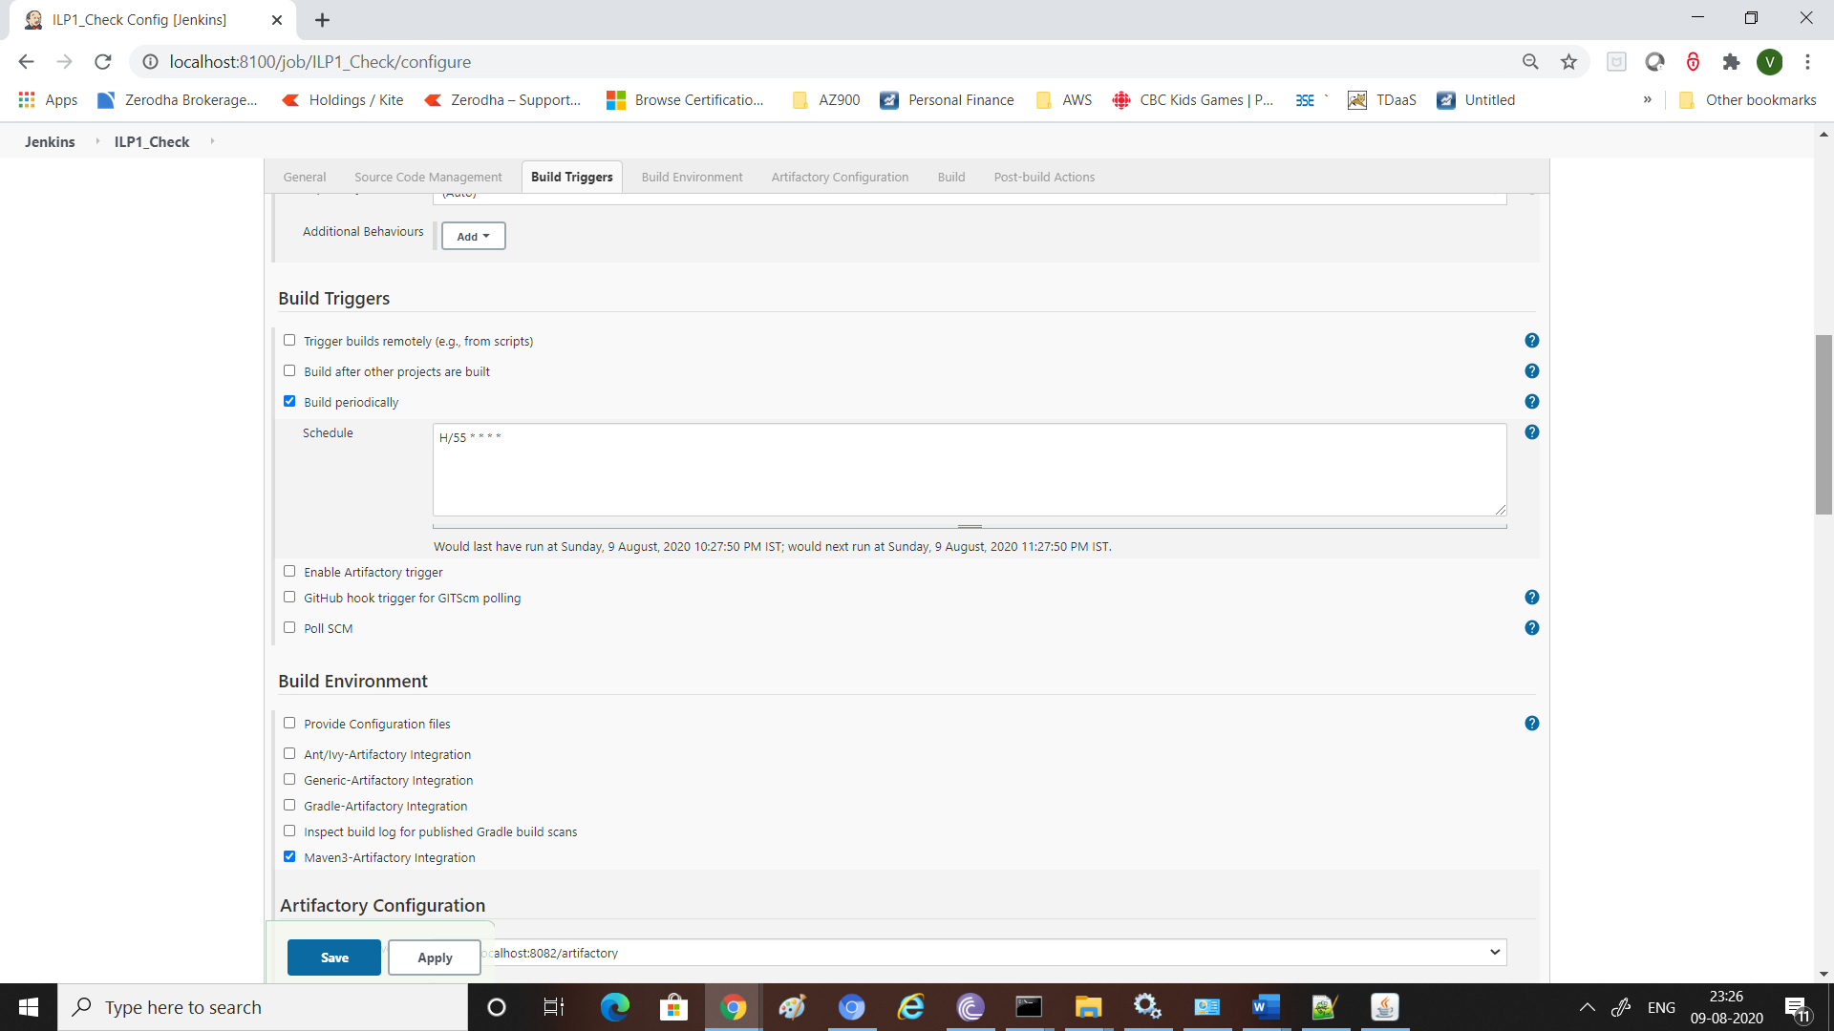



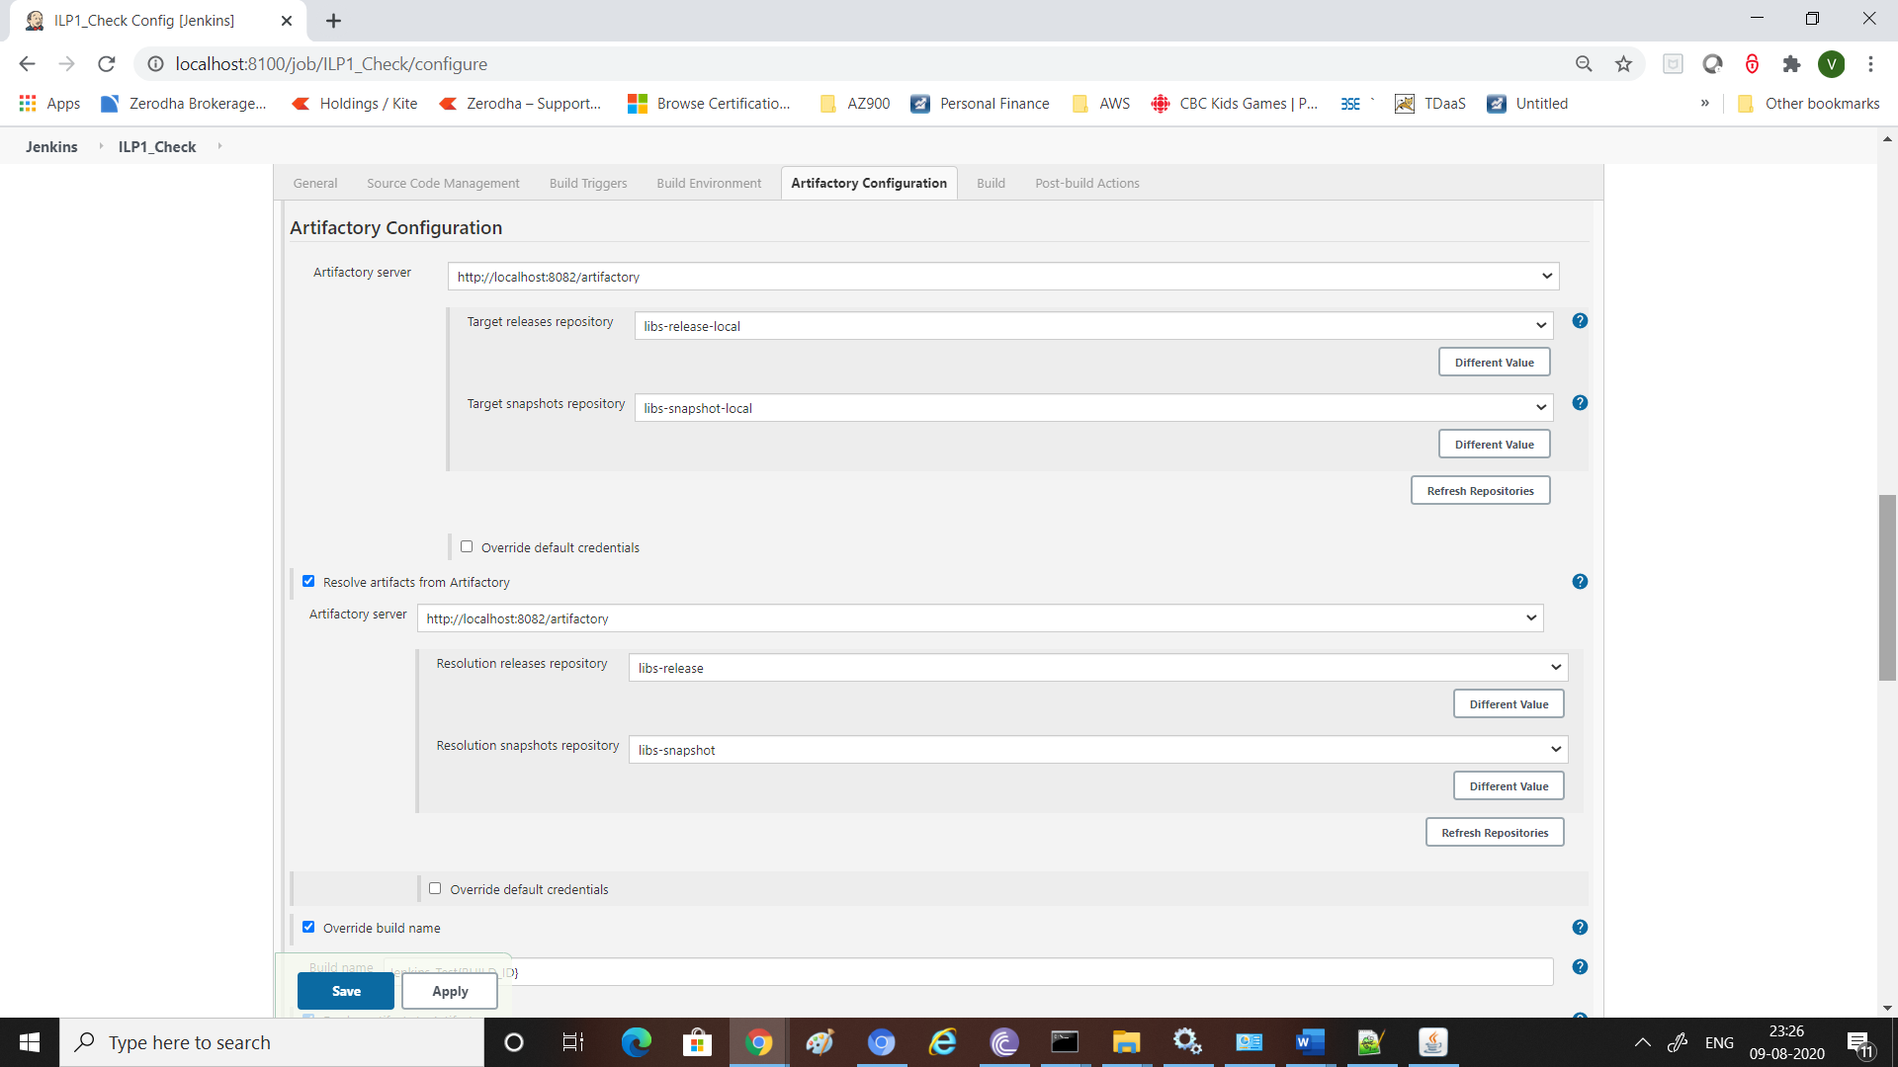

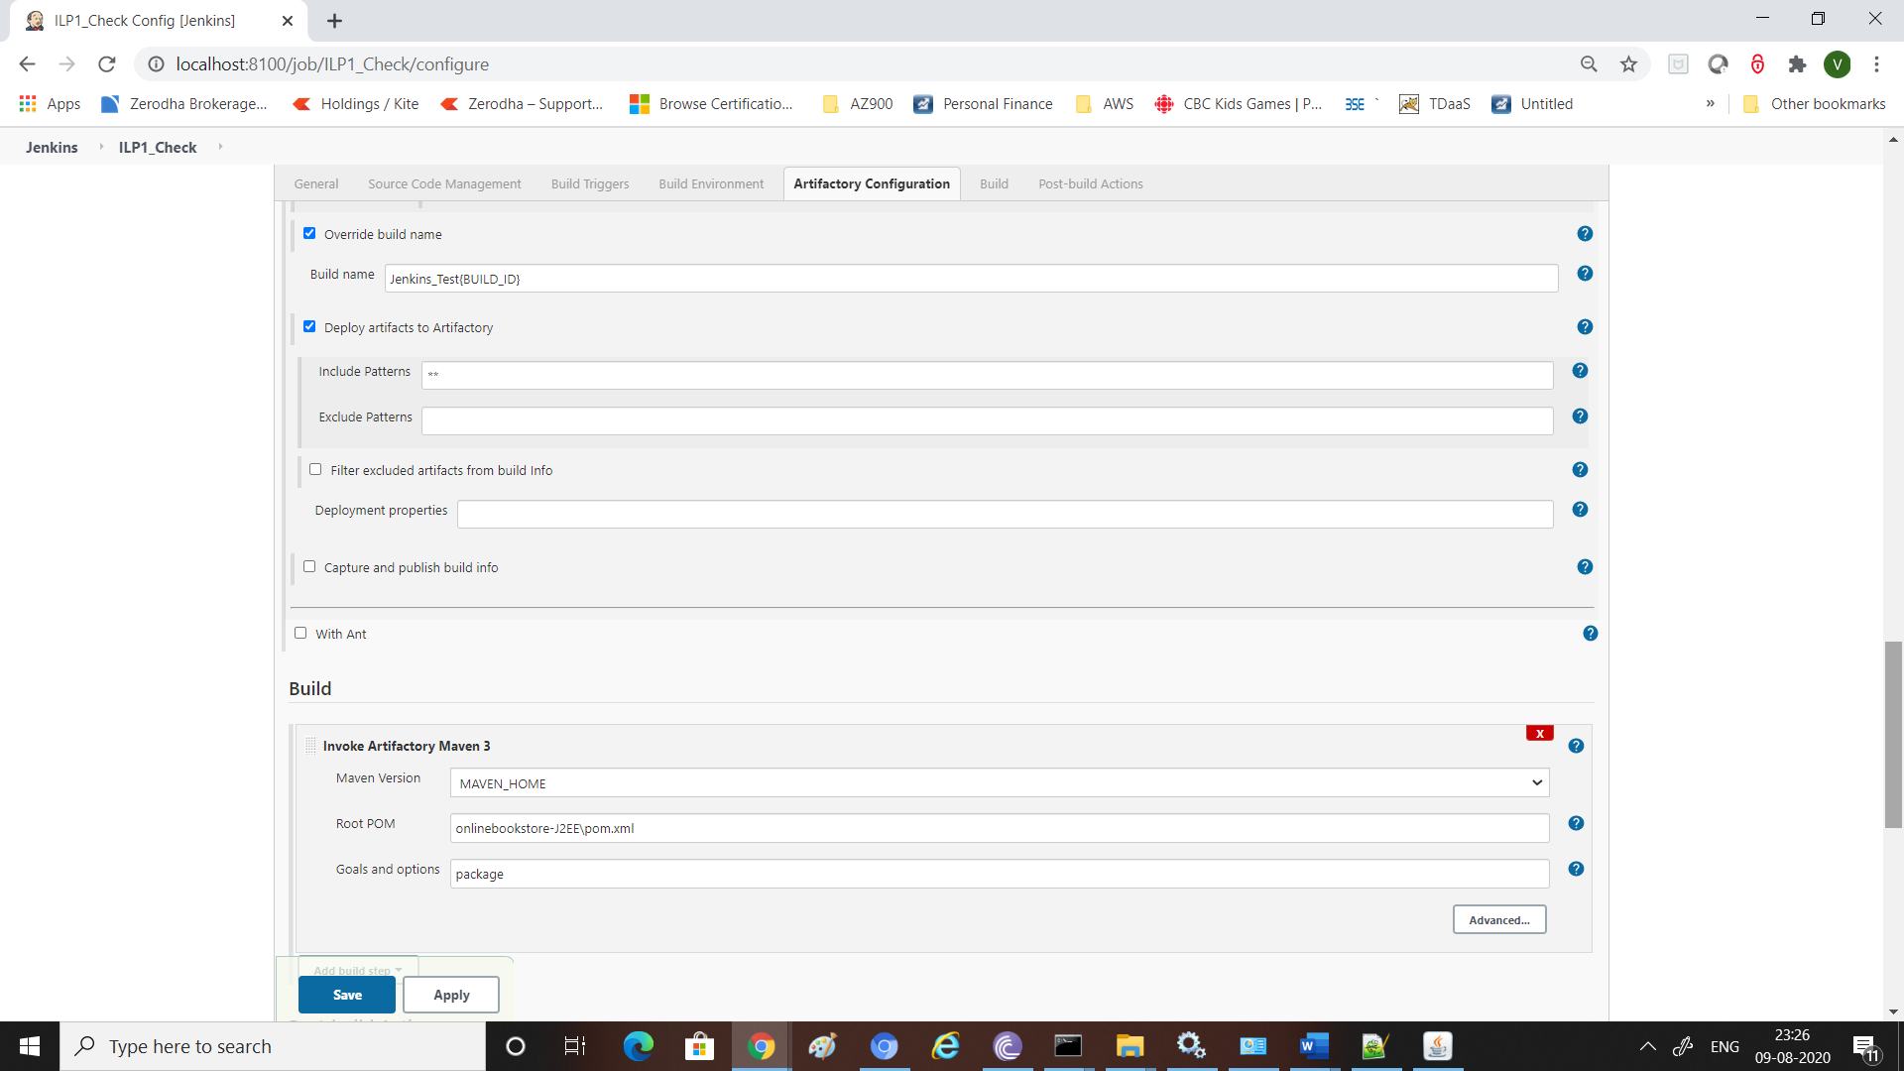

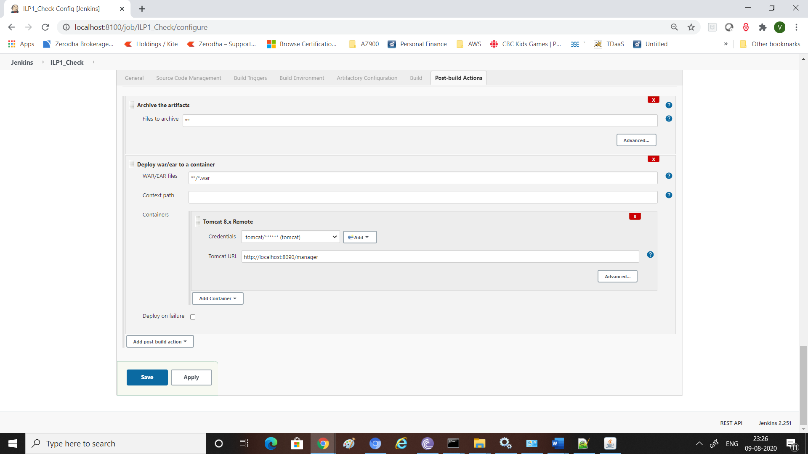

## Git / Gitlab History

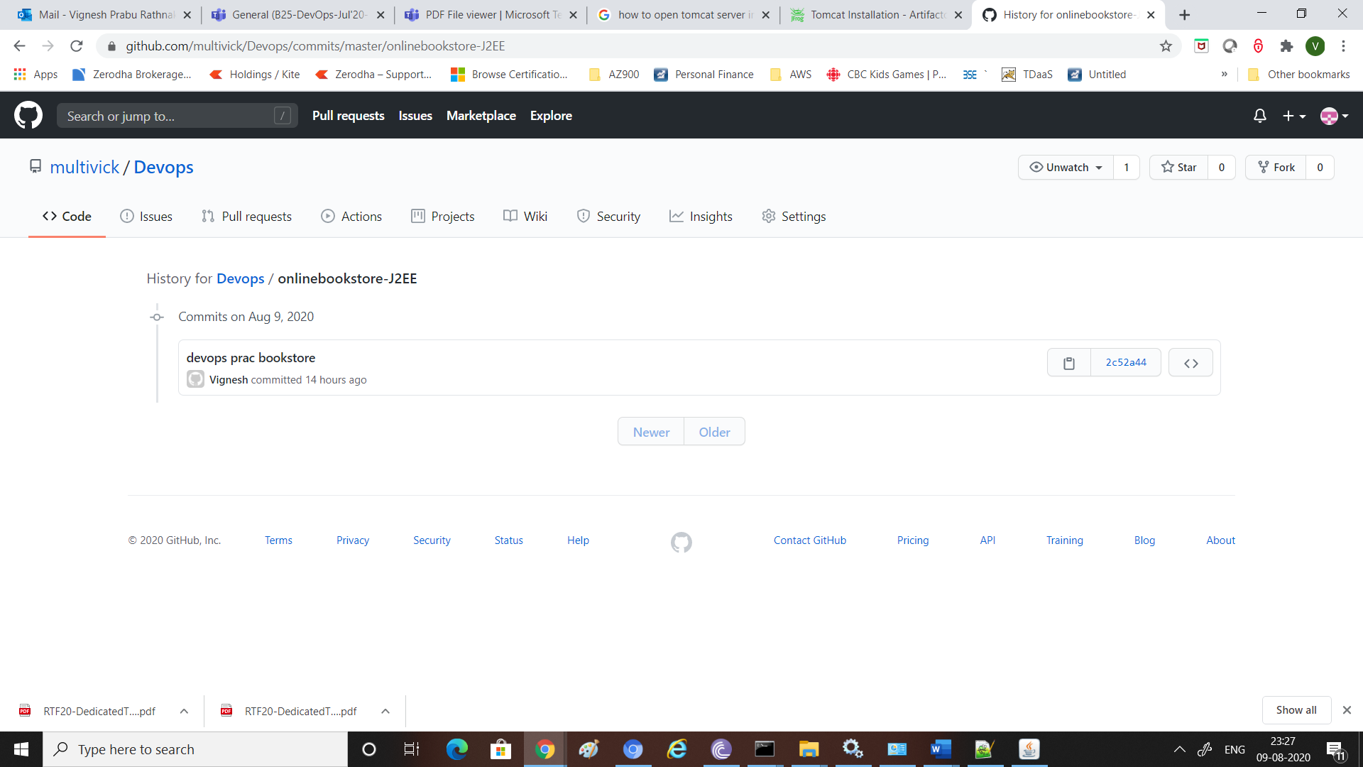

## JFrog Deployment History / Copy

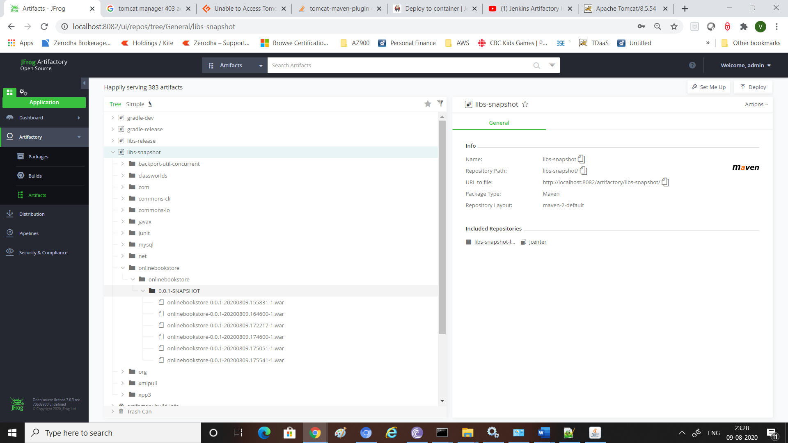

## Application output – Execution of Application Home Page from Browser

