# GIS tool for vulnerability assessment of electric infrastructure to extreme weather events

Commentary on final project and results

## Background and Objective

The aim of our final course project was to develop a tool that would enable a user to assess the vulnerability of electrical infrastructure to extreme weather events using spatial analysis. Specifically, we sought to enable users to identify generation, transmission and electric vehicle (EV) charging assets that may be affected by extreme weather events such as sea level rise, flooding, or wildfires in the State of California. Additionally, we sought to evaluate how road accessibility to critical infrastructure such as transmission lines and EV charging stations might be impacted by these events leveraging a simplified analysis adapted from the 2022 paper by Jones et. al titled ‘Geospatial Assessment Methodology to Estimate Power Line Restoration Access Vulnerabilities After a Hurricane in Puerto Rico’. This issue is particularly important since inability to access damaged portions of transmission lines may negatively impact restoration efforts, lengthening restoration time. Additionally, with increasing adoption of EVs and limited availability of charging infrastructure, if few available EV chargers are damaged or inaccessible, drivers of EVs may be disproportionately affected or forced to drive longer, assuming they have enough charge left to get to the next charger via the nearest usable road.

The objective of designing a tool rather than a static analysis was to enable flexibility in reusing the tool with different assets or different climate scenarios. For example, while we focused on solar plants, transmission lines, EV charging stations and power plants more generally, the same tool can be used for other assets such as substations or to evaluate the disaster risk for a set of greenfield sites where spatial data is available. Additionally, the tool is intended to facilitate the assessment of climate scenarios of different levels of severity such as maximum/median/minimum sea level rise and different temporal scales such as 2020 - 2040 or 2080 - 2100. Since all the input data is dynamically loaded on each run via an Application Programmers Interface (API), the analysis can be reproduced with minimal effort and updated with the latest data and climate models.

## Overview of methods

To implement the project, we applied several of the principles covered across the ENV859 course modules. To facilitate collaboration between ourselves, we set up a GitHub repository and collaborated on the same workspace, leveraging relative paths for our analysis. We began by loading data on electrical infrastructure and extreme weather events via their respective APIs, exploring and wrangling the data in a Jupyter notebook. Since our dataset consisted of both feature layers and raster datasets we leveraged different libraries to wrangle the data including ***arcpy*** and ***GDAL***. Since we were dealing with time series data for the wildfire and sea level rise data, we learned and implemented an approach to dynamically select the period for analysis and pulled the relevant data from the API. **Since some of the datasets are relatively large, importing and transforming the data such as the sea level rise data, may take a relatively long time to complete. We did our best to employ the compression algorithms available via GDAL to mitigate this, but some scripts may take as long as 30 minutes to complete.** Upon testing out our initial code in the notebook, we ported the same to a python script that can be loaded to ArcGIS and enables users to run the analysis based on the inputs outlined below, using functions to facilitate the scenario analysis. Finally, we developed a mock dashboard using ArcGIS Insights to demonstrate how some of the results of the analysis may be visualized.

## Key results

Through our analysis, we managed to successfully design and run the scripts in ArcGIS for a range of inputs, exporting the processed datasets as feature layers as follows:

1. The first script enables a user to input a type of electrical infrastructure asset in California, extreme weather event and climate scenario/model. With these inputs, the script dynamically pulls and wrangles the relevant datasets and outputs a feature layer of the assets that are vulnerable to the applicable event or scenario.
2. The second script enables the user to assess how an extreme weather event under a specific climate scenario/model might impact accessibility of transmission lines that might need to be repaired or EV chargers.

The main challenge we encountered was with the relative size and runtime of some of the scripts which is one of the areas of potential improvement for the tool. Using the tools above, we identified several assets including power plants and EV chargers that are vulnerable to extreme weather events, particularly flooding and wildfires. Additionally we found that accessibility to some EV chargers and transmission is hampered when these events occur, which may lengthen the restoration time when these events occur.

## Sample Workflow

### Tool inputs:

* Type of extreme weather event
  + **Flood:**
    - **Scenario:** 100 year / 200 year / 500 year
  + **Sea level rise:**
    - **Model:** CoSMoS
    - **Scenario:** minimum / median / maximum
    - **Period:** 2020 - 2040 / 2080 - 2100
  + **Wildfire:** 
    - **Model:** Average Simulation (CanESM2) / Warmer/drier simulation (HadGEM2-ES) / Cooler/wetter simulation (CNRM-CM5) / Dissimilar simulation (MIROC5)
    - **Scenario:** Medium emissions scenario (rcp45) / High emissions scenario (rcp85)
    - **Period:** Any decade between 1960 and 2099
* Type of infrastructure:
  + Power plants
  + Transmission lines
  + EV chargers
  + Solar plants

### Tool outputs:

* **Script 1:** Feature layer of vulnerable assets under the specified event and scenario
* **Script 2:** Feature layer of the EV chargers or transmission lines that might be inaccessible via primary or secondary roads after an extreme weather event

## Data requirements (accessed via API):

| **Data type** | **Sources** |
| --- | --- |
| Feature class of primary roads, and secondary roads | TIGERweb/Transportation  <https://tigerweb.geo.census.gov/arcgis/rest/services/TIGERweb/Transportation/MapServer> |
| Feature class of electrical infrastructure: power plants, solar plants, transmission lines and EV charging stations | California Transmission Lines:  <https://services3.arcgis.com/bWPjFyq029ChCGur/arcgis/rest/services/Transmission_Line/FeatureServer/2>  California Power Plants:  <https://services3.arcgis.com/bWPjFyq029ChCGur/arcgis/rest/services/Power_Plant/FeatureServer/0>  California Solar Plants:  <https://services3.arcgis.com/bWPjFyq029ChCGur/arcgis/rest/services/Solar_Footprints_V2/FeatureServer/0>  EV charging stations:  <https://services3.arcgis.com/bWPjFyq029ChCGur/arcgis/rest/services/Stations_that_meet_NEVI_requirements_March2024/FeatureServer/0>  <https://services3.arcgis.com/bWPjFyq029ChCGur/arcgis/rest/services/DC_fast_charging_stations_do_not_meet_1mi_requirement_March2024/FeatureServer/0> |
| Feature class of flooding risk areas | Potential Flood Hazard Areas:  <https://gis.water.ca.gov/arcgis/rest/services/Boundaries/BAM/MapServer> |
| Raster dataset of wildfire risk areas and sea level rise | Potential Wildfire Hazard Areas:  <http://api.cal-adapt.org/api/> |

## General workflow - substitute with screenshots

1. User inputs a climate scenario or year, which is used to select the corresponding feature class for flooding or wildfire risk

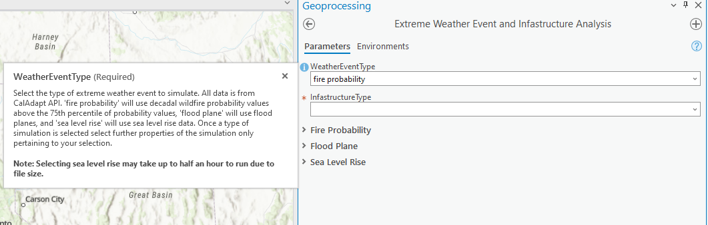

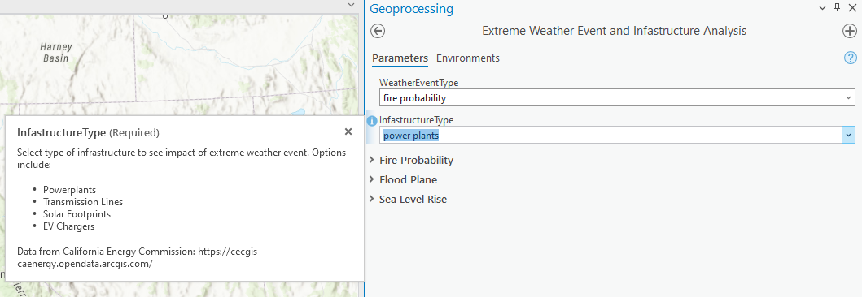

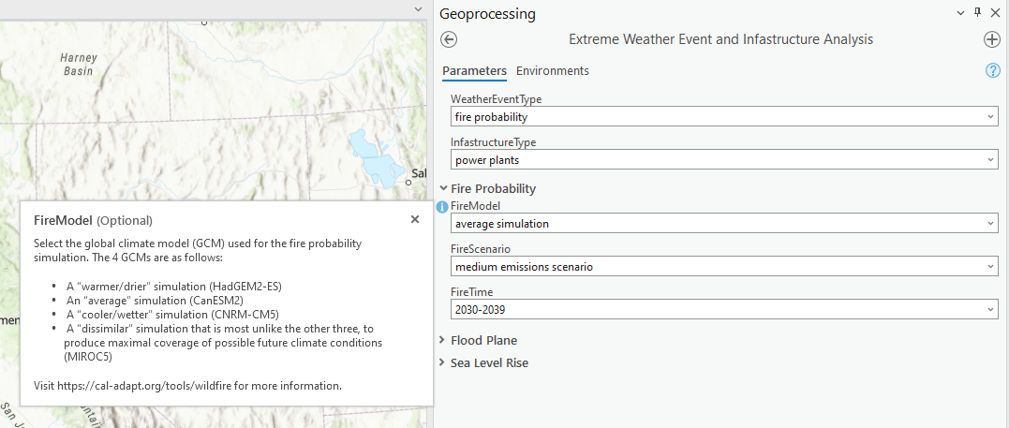

## Sample outputs

<https://insights.arcgis.com/#/view/7f6d60e31ec34c1fbab73c3ab2a791d4>

<https://insights.arcgis.com/#/view/a72c6308724140b9993ba39113a90e5a>

## 