Annual Performance Appraisal 2019 (JG 1 – 9)
Supply Chain 2021

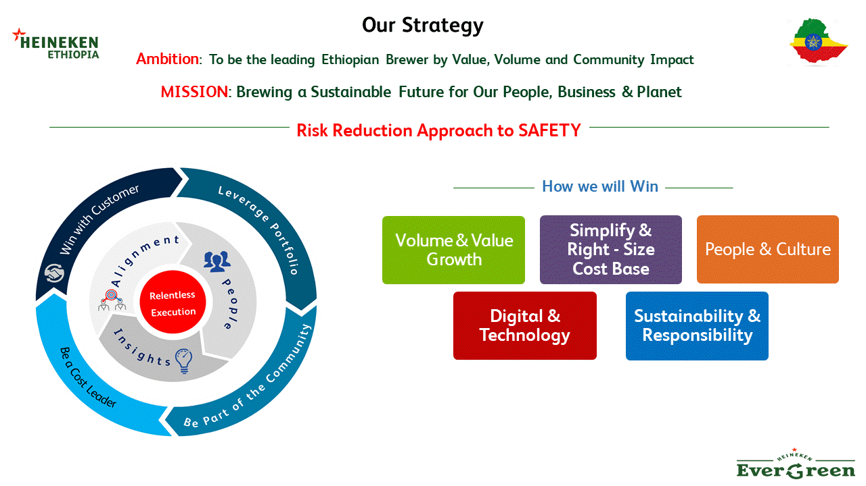

FULL NAME: FANA TESFAY  ID NUMBER: HBSC/706/15 | POSITION: Packaging Operator
JOB GRADE: 05 | EVALUATION PERIOD: Mid-year
MANAGERS NAME: Lesaneselam Kassu | DATE:

INDIVIDUAL BEHAVIORS - HOW | PERFORMANCE COMMENTS | RATING*
1. Put Safety First  Safety goes beyond the brewery gates it is for all of us, all of the time. At the end of every day we want to go home safe and well. Taking care of ourselves and those around us is always our top priority.  - Tag and report unsafe conditions and unsafe acts  - Internalize Lifesaving rules  - Follow the de-tagging or solving of unsafe ,failure and energy tag  - Be conscious about safety  - 2 PI per 2month and 1 Near miss per 2 month. | Self-assessment:
 | Managers comments:
2. Act as an Entrepreneur  We are passionate about our company. We always take responsibility and act as if we are owners. We want to win and we keep looking for opportunities to grow our business, for today and tomorrow.  - Motivate other to collaborate  - As machine owner actively follow the basic operational malfunction  - Should have follow the BBT and utility status  - Control the rejection dump area and Edomias manual workers  - Is he/she report the service driver status.  - IS he/she uses his mill time properly. | Self-assessment:
 | Managers comments:
3. Collaborate through Trust  We always think of ‘we’ before ‘me’. We believe in the power that comes from our relationships and working together for a common goal. All our leadership teams set the example for this alignment  - Ready to collaborate by identifying area which need support.  - Lead the collaboration sprit for better achievement  - Influence others how collaborate for common goal  - Did he/she collaborate | Self-assessment:
 | Managers comments:

INDIVIDUAL BEHAVIORS - HOW | PERFORMANCE COMMENTS | RATING*
4. Keep It Simple  We make things simple internally so that we can focus where it matters – winning in the market place. When things are simple they are easier to explain, operate and more likely to work. Better done than perfect.  - Pull rather than push other simply to bring solution  - Internalize simply any activities as part of the process  - Run the machine without all quality and operational procedures  - Work on agreed standard of packaging. | Self-assessment:
 | Managers comments:
5. Learn, To Improve  We are open-minded and eager to learn. We keep moving forward without forgetting the lessons of the past. We value experience, data and insights as vital business assets. Our individual learning drives business success  - Expend knowledge to other area  - See quality and system related procedures and boost skill and knowledge  - Is he deliver the training and deliver the assignment on time.  - Completion of star OP and level 1 criteria (3E-learning, computer and English) Per 2 months. | Self-assessment:
 | Managers comments:
*Overall Rating for Individual Behaviors - HOW
Rating is Outstanding (A), Exceeds (B), Fully Meets (C), Partially Meets (D), or Unsatisfactory (E)

Please choose 3 – 6 individual WHAT objectives that will help achieving the company objectives
INDIVIDUAL OBJECTIVES - WHAT | PERFORMANCE COMMENTS | RATING*
Objective 1  Bottling line OPI NONA and CILT OTIF for bottling lines operators  Yearly average OPI NONA, Data from BCS  - >70%and CLIT OTIF > 95 %. Exceed Expectations (Maximum)  - 69.6% ≤OPI NONA ≤ 70% and 90 % < CILT OTIF ≤ 95%. Fully Meets Expectations (Target)  - 68% ≤OPI NONA<69 .6% and 80 % < CILT OTIF ≤ 90 %. Partially meets Expectations (Threshold)  - < 68% and CILT OTIF < 80% unsatisfactory (No bonus) | Self-assessment:
 | Managers comments:
Objective 2  Tag raise by operator , De-tag by operators and Reporting of PI,Near miss  - 6 tag & 2 de-tag per month, 3 PI and 1 Near miss per month. Exceed Expectations (Maximum)  - 5 tag & 2 de-tag per month, 2 PI & 1 Near miss per 2 month. Fully meets Expectations (Target)  - 3 tag & 1 de-tag per, 1 PI per month and 1 near miss per Quarter. Partially meets Expectations (Threshold).  - < 2 tag per & < 1 de-tag per month and <1 PI per month with <1 Near miss per Quarter Unsatisfactory (No bonus) | Self-assessment:
 | Managers comments:
Objective 3  Packaging water consumption (Hl/Hl), Packaging thermal consumption (MJ/HL packed) & Packaging extract loss (%).  - H2O ≤ 0.85, TR ≤ 33 and EL ≤ 1.74 Exceeds Expectations (Maximum)  - 0.85 < H2O ≤ 1, 33 <TR ≤ 35 and 1.74 < EL ≤ 1.8. Fully Meets expectations (Target)  - 1 < H2O ≤ 1.1, 35 <TR ≤36 and 1.8 < EL ≤ 1.95 Partially Meets expectations (Threshold)  - > 1.1 H2O , > 36 Thermal and > 1.95 EL Unsatisfactory (No bonus) | Self-assessment:
 | Managers comments:
Objective 4  Shop floor score on packaging lines and People development  - SFE > 85% & Completion of star OP and level 1 criteria (3E-learning, computer and English) less than 2 months Exceed Expectations (Maximum)  - 80 % < SFE ≤ 85 % & Completion of star OP and level 1 criteria (3E-learning, computer and English) Per 2 months. Fully Meets Expectations  - 75 % < SFE ≤ 80 & Completion of star OP and level 1 criteria (3E-learning, computer and English) per 3 months Partially Meets Expectations(Threshold)  - SFE< 75% & Completion of star OP and level 1 criteria (3E-learning, computer and English) Greater than 3 months Unsatisfactory(No bonus) | Self-assessment:
 | Managers comments:
 | Managers comments:
Overall Rating for Individual Objectives - WHAT
Rating is Outstanding (A), Exceeds (B), Fully Meets (C), Partially Meets (D), or Unsatisfactory (E)

Overall Rating PERFORMANCE EVALUATION
** Overall Rating for Functional competencies and INDIVIDUAL Objectives WHAT  Rating is Outstanding (A), Exceeds (B), Fully Meets (C), Partially Meets (D), or Unsatisfactory (E) | End Year Review

*The overall rating for behaviors (How) will be used for salary increase
**The overall rating for individual objectives (WHAT) will be used for bonus calculation (STI)

Manager’s Signature_____________________________

Employee’s Signature____________________________ Date

Rate the employee’s level of performance using the rating scale below. Give an overall rating in the space provided.
Outstanding | Organizational contributions & excellent work are widely recognized. Performance is significantly beyond all expectations, producing important and impactful results through superior planning, execution and creativity and the employee consistently demonstrates behavior whilst delivering results
Exceeds Expectations | Objectives are completed in a manner that expands the scope and impact of the assignment. The employee has made notable contributions to the organization. Consistently demonstrates effective behavior and often demonstrates exceptional behavior
Fully Meets | The employee fully meets performance expectations, performs as a solid contributor and is making valued contributions to the business at the expected level. Employee consistently demonstrates the required behavior whilst delivering results
Partially Meets | Performance that marginally meets but is below performance expectations. The performance results partially meet expectations, but are below target. All planned objectives were accomplished but were either late or delivered whilst not demonstrating appropriate behavior.
Unsatisfactory | Performance is at an unacceptable level. Results are unsatisfactory and clearly below threshold and does not demonstrate appropriate behavior. Rarely achieves expected performance level, requires significant and immediate corrective action).

NB. Please start revising your PDP after submitting your objectives as soon as possible. You can prepare this yourself and discuss it with your manager. You can check the training calendar for 2017 to decide which trainings to subscribe for and include this as a learning action in your PDP.
