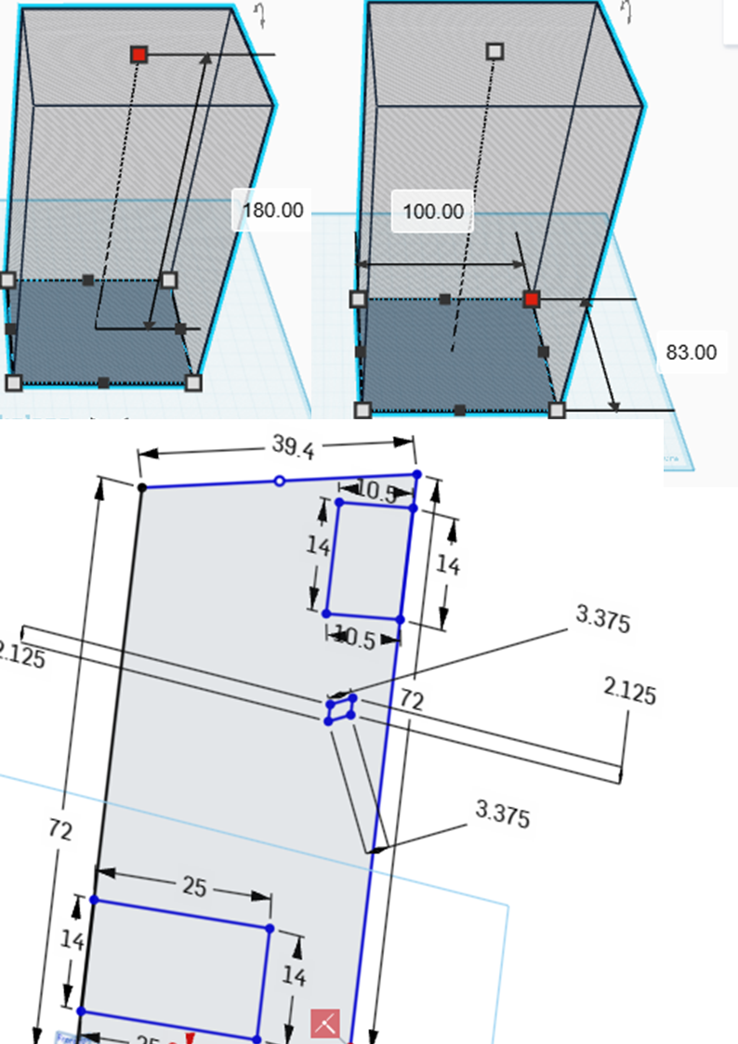

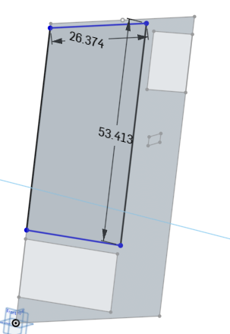
Sheet panels (raw cut sizes):
- 2 × (100 × 180) cm — front & back
- 2 × (80 × 180) cm — sides
- 2 × (100 × 80) cm — top & bottom
RHS pieces:
- 4 × 180 cm
- 4 × 100 cm
- 4 × 80 cm
• Sheet-metal: 4 sheets (safe working quantity)
• RHS: 5 lengths of 6 m

No | Machinery | Usage
1 | Ruler and meter | Measurement
2 | Angular grinder | general cutting, edge clean-up, grind welds.
3 | Hand seamer / mallet & dollies | small flanges and edge forming.
4 | Nibblers / nibbler tool / scissor | cutting sheet without heat distortion
5 | Press brake / sheet metal brake (box & pan or finger brake) | bends and flanges on sheet metal
6 | MIG welder | Fast, easy for structural welds.
7 | Drill press | Straight, repeatable holes in sheet and RHS.
8 | Hand grinder | Smoothness
9 | Mebeyeja | For connecting purpose
