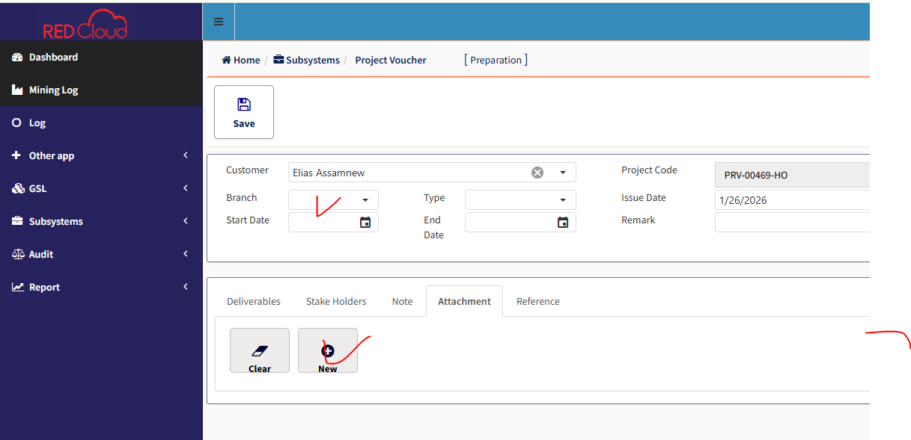
The attachment file chooser and branch selection button are not functioning properly. The file button does not give any response, and the branch selection dropdown is not working correctly.

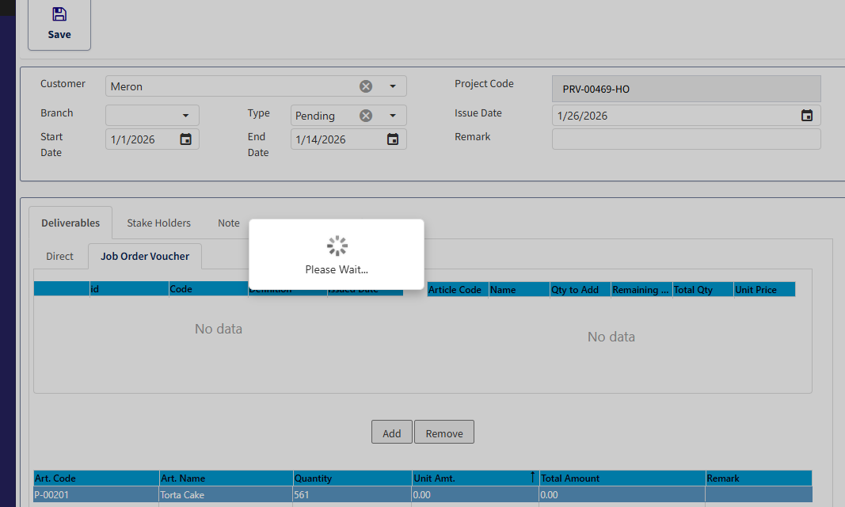
When the Job Order Voucher button is clicked, the loading time is very long and the UI does not appear. It only displays “Please wait” for an extended time and blocks the entire sidebar and UI until the page is refreshed.

