1. Conceptual Diagram (ER Diagram)
Mermaid code for our graph
erDiagram
DEPARTMENT ||--o{ DOCTOR : "employs"
DEPARTMENT ||--o{ STAFF : "employs"
DEPARTMENT ||--o{ APPOINTMENT : "hosts"
DEPARTMENT ||--o{ ROOM : "contains"

PATIENT ||--o{ APPOINTMENT : "books"
PATIENT ||--o{ MEDICAL_RECORDS : "has"
PATIENT ||--o{ BILLING : "receives"
PATIENT ||--o{ ROOM_ASSIGNMENT : "assigned_to"

DOCTOR ||--o{ APPOINTMENT : "handles"
DOCTOR ||--o{ MEDICAL_RECORDS : "creates"

MEDICAL_RECORDS ||--o{ PRESCRIPTION : "includes"
PRESCRIPTION }o--|| MEDICINE : "prescribes"

ROOM ||--o{ ROOM_ASSIGNMENT : "assigned"
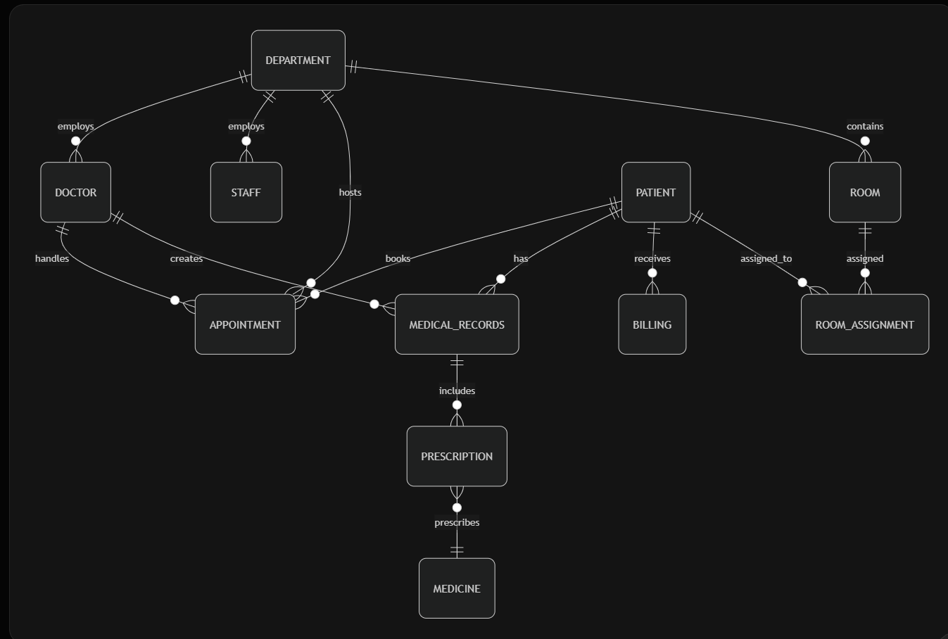

2. Physical Diagram
The physical model is the relational schema defined by the DDL below in section three answer (with data types, constraints, PKs, FKs, NOT NULL, UNIQUE).
3. DDL – Create Tables, Relationships & Constraints
(see the MySQL)
4. Data in the JupytorNotebook

5. 15 Business Questions + SQL Queries (All use JOINs & multiple tables)(See the MySQL)
1. Average appointments per patient in the last 6 months
To
15. Average hospital stay by room type

6. Users & Permissions (See MySQL)
7. PowerBI Visual

2.

