PORTFOLIO PROJECT 1

AN ANALYSIS OF FINANCIAL STABILITY & CREDIT STANDING OF UK SME SECTOR

Group Members
Sadia
Sehrish Irfan
Mariam Irfan

Data Analytics (Cohort -8)
Institute of Emerging Careers - Pakistan

Introduction
In this report we provide a detailed financial analysis of UK Small and Medium Enterprise (SME) using a very extensive synthetic dataset that captures an array of demographic insights, financial indicators, and survival metrics. We aim to provide key insights for the sustainability and growth of business by taking a deep dive into the interplay of financial variables, KPI’s, business creditworthiness and socio-economic factors. We have tried to analyze the broader ecosystem in which these businesses operate to highlight their financial robustness, stability and risk factors if any. We hope that our report will be helpful in providing actionable insights and a strategic foresight for the future development and growth of UK SME ecosystem.

Objectives
- The first objective is to evaluate the financial wellbeing and performance of businesses by analyzing key financial indicators to make informed decisions and predictions about their stability and growth potential.
- The second objective is to assess the creditworthiness and risk profile of businesses by analyzing their credit ratings, helping in making informed decisions about lending, partnerships, and investment opportunities.
- The objective of analyzing the demographics of the UK businesses is to understand the composition, geographical advantage, diversity factor and industry representation to develop targeted strategies for the growth and sustainability of the UK small and medium enterprises.

Key Questions:
- How does different financial metrics like asset turnover, debt to asset, expense ratio and net profit margin depict the health of businesses?
- How can you establish the credit worthiness of SME businesses by looking at their missed and late payments history?
- Which business have good standing items on their credit report?
- Which businesses have bad standing items on their credit report?
- How many businesses have liens and files open against them?
- How does the business risk factor vary across different sectors and which sector has the highest number of high-risk companies?
- Which sector has the highest number of low-risk companies?
- How does women owned businesses compare with men owned businesses in terms of their financial performance?
- How many companies were dissolved and incorporated in each month of the year? Which month saw the highest number of dissolution and incorporation?
- How does the revenue changes across different boroughs and counties?
- How can we categorize entities into different groups based on their size?
- How to sort out entities that have defaulted on their loans?
- How can we analyze the loan payment status of entities in each sector?

Stakeholders
This report provides valuable insights for investors, creditors, business owners as well as policy makers empowering them to make informed decisions.

Dataset
The dataset comprises of a comprehensive set of information pertaining to key financial statistics, credit worthiness and socio-economic factors all summarized in 9 key tables. Each table has a vast array of attributes related to UK businesses. Most of the dataset is time invariant, however, a very few tables show the possibility of time dependent attributes. We are using SQL to analyze our dataset because SQL is known for accurate information retrieval, querying data, and providing useful insights for the policy initiatives for UK SME sector.

ERD Diagram of UK SME Businesses Database

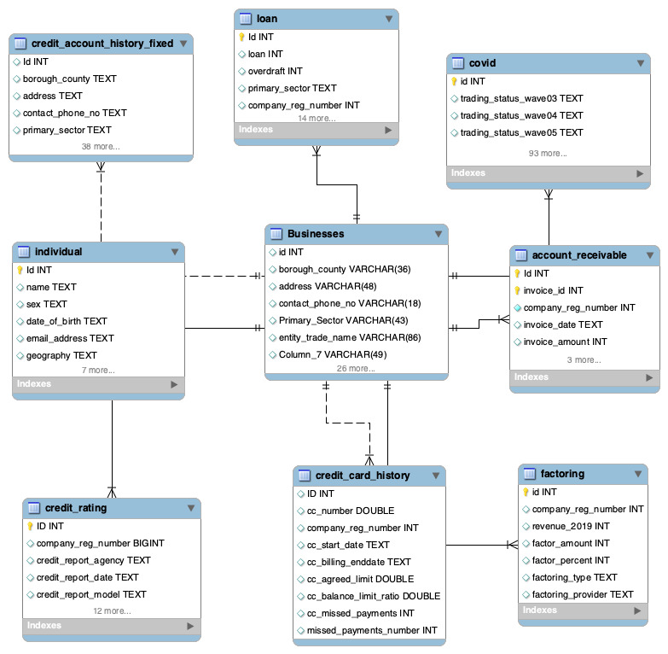

- Financial Key Performance Indicators

Let’s begin our analysis by calculating the most common yet highly desirable financial ratios.

- Average Account Receivable Turnover:

Average account receivable turnover measures how frequently business convert their account receivable into cash in a particular period. It is indeed a metric used to gauge the liquidity of business.

Query Syntax:

SELECT
primary_sector,
AVG(revenue_2019 / accounts_receivable) AS avg_accounts_receivable_turnover
FROM
Businesses
WHERE
accounts_receivable > 0
GROUP BY
primary_sector
ORDER BY
avg_accounts_receivable_turnover DESC;

Query Output

Primary_Sector | avg_accounts_receivable_turnover
Retail | 40.56
Transport & Storage (inc. postal) | 40.56
Motor trades | 36.50
Accommodation & food services | 36.50
Production | 33.18
Information & communication | 30.42
Property | 28.08
Wholesale | 28.08
Construction | 24.33
Arts, entertainment, recreation & other | 21.47
Education | 21.47
Business administration & support services | 21.47
Professional, scientific & technical | 21.47
Health | 21.47
Agriculture, forestry & fishing | 14.04

A higher account receivable ratio indicates the ability of business to quickly convert its account receivable to cash. The higher ratio indicates a better working capital management. The analysis shows that the retail and transportation and storage sectors are two most efficient sectors when it comes to an efficient working capital management. However, the companies in the agricultural sector have the lowest account receivable turnover hinting at a very weak liquidity position.

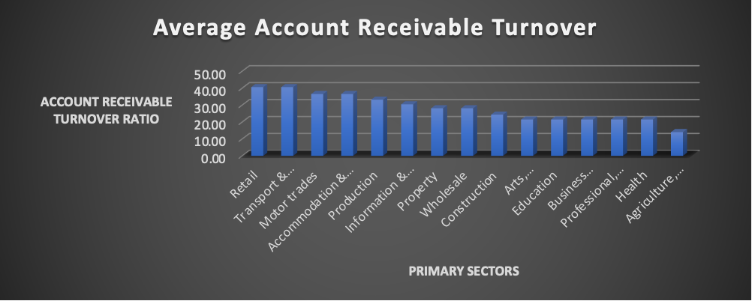

- Debt to Asset ratio:

The debt to asset query analyzes both the short term and the long-term debt in relation to business assets. It provides lenders and investors a useful insight into the extent to which a company is vulnerable to financial risk as heavy debt reliance is an indication of financial distress.

Query Syntax:

SELECT
-- group_concat(distinct(entity_name)),
count(distinct(entity_name)),
Primary_Sector,
AVG(cr.credit_report_total_indebtedness/(b.current_assets + b.fixed_assets)) AS debt_to_assets_ratio
FROM
Businesses b
JOIN
credit_rating cr ON b.company_reg_number = cr.company_reg_number
WHERE
(b.current_assets + b.fixed_assets) > 0
GROUP BY
Primary_Sector
ORDER BY
debt_to_assets_ratio DESC;

Query Output:

Primary_Sector | debt_to_assets_ratio
Retail | 0.79
Wholesale | 0.72
Construction | 0.57
Arts, entertainment, recreation & other | 0.37
Accommodation & food services | 0.35
Business administration & support services | 0.35
Motor trades | 0.31
Professional, scientific & technical | 0.30
Education | 0.28
Health | 0.25
Information & communication | 0.25
Production | 0.22
Transport & Storage (inc. postal) | 0.21
Agriculture, forestry & fishing | 0.07
Property | 0.06

A debt to asset ratio less than 1 shows a business is efficiently using its assets to pay off its financial obligation and is not heavily reliant on financial leverage. The highest debt to asset ratio of 0.79 and 0.72 is in retail and whole sector respectively which is still less than one. Hence, we don’t see any signs of financial distress in UK SME sector. The lowest debt to asset ratio is calculated for the Property sector which shows that Realtors are more focused on organic growth and internal equity financing than an expansion through heavy external debt. Overall, we can say the UK SME sector is prudently managing its capital structure for future growth and stability.

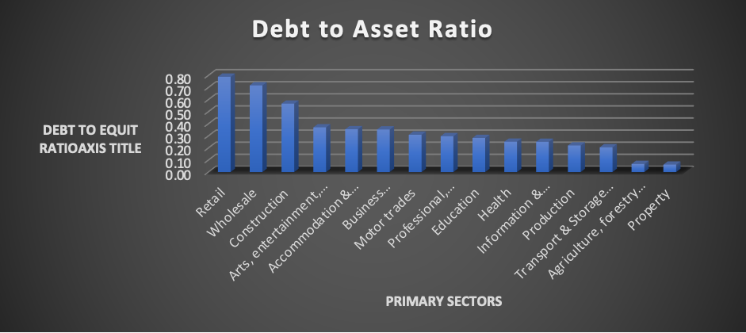

- Net Profit Margin

A net profit margin is a great indication of how efficiently a company converts its revenue into profit. It highlights the effective cost mitigation strategies and stable revenue growth which is adequate for a steady profit generation.

Query Syntax

SELECT
Primary_Sector,
count(distinct(entity_name)),
AVG((revenue_2019 - costs)/(revenue_2019)) AS net_profit_margin
FROM
Businesses
WHERE
revenue_2019 > 0
GROUP BY Primary_Sector
ORDER BY
net_profit_margin DESC;

Query Output

Primary_Sector | net_profit_margin
Education | 0.25
Accommodation & food services | 0.15
Agriculture, forestry & fishing | 0.13
Business administration & support services | 0.09
Information & communication | 0.09
Professional, scientific & technical | 0.09
Wholesale | 0.08
Arts, entertainment, recreation & other | 0.07
Retail | 0.07
Health | 0.06
Transport & Storage (inc. postal) | 0.05
Production | 0.03
Construction | 0.03
Property | -0.02
Motor trades | -0.04

The overall analysis shows that most of the sectors in UK SME ecosystem have a relatively low net profit margin. The ratio of 0.25 being the highest for the UK education sector shows that for every pound generated, only 25 pence is converted to profit. All other sectors follow with a relatively lower net profit margin, thereby, suggesting a review of cost minimization strategies across those SME sectors in UK. The lowest net profit margin being negative 0.04 and negative 0.04 for Motor trade and property industry respectively.

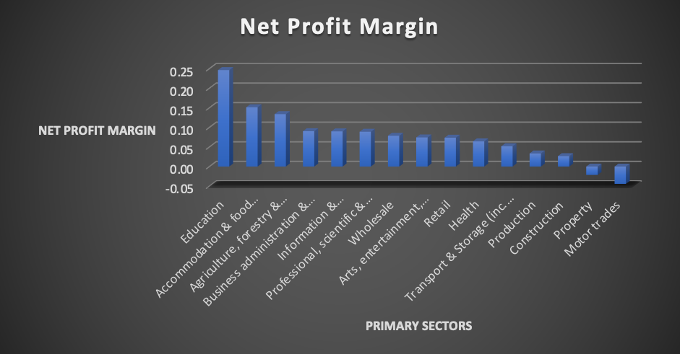

- Cost Efficiency ratio

The cost efficiency metric assesses how efficiently a company is managing its costs relative to its revenue across various industrial sectors in UK.

Query Syntax

SELECT

b.Primary_Sector,
sum(b.costs) / sum(b.revenue_2019) AS cost_efficiency_ratio
FROM
Businesses b
WHERE
b.revenue_2019 > 0
group by b.Primary_Sector
ORDER BY
cost_efficiency_ratio DESC;

Query Output

Primary_Sector | cost_efficiency_ratio
Professional, scientific & technical | 1.01
Property | 1.00
Construction | 0.99
Health | 0.98
Production | 0.97
Retail | 0.95
Motor trades | 0.93
Arts, entertainment, recreation & other | 0.91
Wholesale | 0.89
Agriculture, forestry & fishing | 0.87
Business administration & support services | 0.87
Information & communication | 0.81
Accommodation & food services | 0.80
Transport & Storage (inc. postal) | 0.74
Education | 0.62

The cost efficiency ratio of 1 or greater implies costs are higher than revenue which is not a good sign. The lowest value of cost efficiency is calculated for education sector and such low numbers are evidence of an overall good financial health of companies in this sector and their prudence in achieving operational cost efficiency. However, companies with a higher cost ratio needs to focus on cost mitigation strategies.
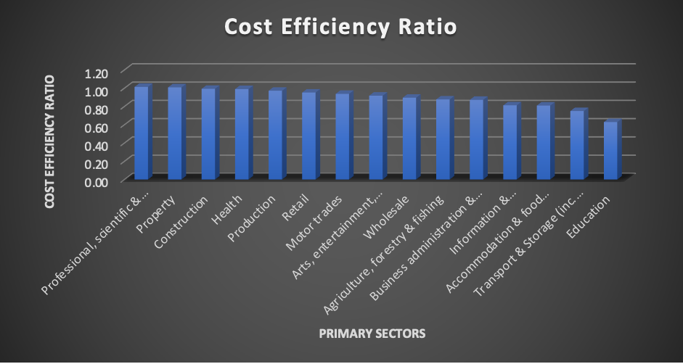

- Revenue Analysis:

Revenue is the primary indicator of a company’s financial performance. It provides useful insights into business’s growth potential and guides the strategy for future success. It is an important figure for investors and stakeholders to gauge financial stability while investing in a company.

Highest Revenue Earning entities:

Query Syntax

SELECT entity_name, revenue_2019
FROM Businesses
ORDER BY revenue_19 DESC
LIMIT 5; -- Highest Revenue

Query Output:

Highest Revenues Earning Entities | Revenue_2019
Hunter/Robinson, Davies, McDonald, Brown, Roberts, Brown Inc | 5173638
Williams, Martin, Harris, Fox, Cole, Taylor, Field, Jackson Ltd | 4034159
Reynolds/Webb, Preston, Wheeler/Green, Coleman, Hill and Saunders | 3816143
Lynch, Pritchard, Brown, O'Donnell/Tyler, West/O'Connor, Robinson Co | 3588865
Fisher/Andrews, Weston/Bishop, Newman, Evans, Pearce, Williams/Smith LLP | 3435392

Lowest Revenue Earning entities:

Query Syntax

SELECT entity_name, revenue_2019
FROM Businesses
ORDER BY revenue_2019 ASC
LIMIT 5; -- Lowest Revenue

Query Output:

Lowest Revenues | Revenue_2019
Bull/Jackson, Hussain/McCarthy, Grant, Singh, Carter and Smith Inc | 0
Hunter, Green, Bryant, King, Tyler, Sullivan/Armstrong Co | 0
Price/Shaw, Clark/Jones, Myers, Nicholls/Owen | 0

- Credit Rating Analysis

Credit ratings are assigned by credit rating agencies to establish the level of risk while lending or extending credit. The analysis of credit rating report is important because it highlights the financial well being and credit worthiness of an entity. We have done a detailed credit analysis by analyzing different aspects of credit ratings and credit history of UK SME companies.

- Entities with good standing items on credit report
Good standing items on a company’s credit report shows a clean credit history and confirms that company has been responsibly managing its financial obligations towards lenders.

Query Syntax:

Use UK_SME_Data;

SELECT entity_name,credit_report_good_standing_items
FROM Businesses
JOIN credit_rating
ON
Businesses.company_reg_number = credit_rating.company_reg_number
WHERE credit_report_good_standing_items >= 8;

Query Output

Entities with good standing items on credit report
Thorpe, Johnson, Cooper, Richardson, Stanley, Whitehouse/Hall Inc
Chambers, Marsh/Parker, Harvey, Harris, Hunt and Edwards Inc
Davies, Barnes/Bates, Ball/Burton, White Inc
Adams/Shepherd, Bishop/Patel, Cox, Francis, Khan, Mann, Dyer and Stone PLC

- Entities with negative standing items on credit report
The negative standing items on the credit report shows troubled financial history. The examples of such items are missed loan payments and other bad practices in credit management. It is important for investors and other stakeholders to be aware of a company’s credit related issues to avoid the risks associated with investments and other dealings with potentially financially distressed companies.

Query Syntax
SELECT entity_name, credit_report_negative_items
FROM Businesses
JOIN credit_rating
ON
Businesses.company_reg_number = credit_rating.company_reg_number
WHERE credit_report_negative_items <= 1
Limit 4;

Query Output:

Entities with poor standing items on credit report
Jennings/Lawson, Williams/Davis, Slater, Collins, Francis, Pearson Inc
King/Akhtar, O'Brien, Poole, Marshall and Sons Co
Wood, Jones, Brooks, Bates, Scott, Farmer/Goddard Co
Bell, O'Brien, Rose, James, Pearce, Kaur, Mistry, Ingram, McLean and Evans Co

- Risk Analysis based on Primary Sector

Query Syntax :

SELECT
Primary_Sector,
CASE WHEN cr.business_failure_score >= 70 THEN 'High Risk'
WHEN cr.business_failure_score >= 50 THEN 'Moderate Risk'
ELSE 'Low Risk'
END AS risk_category,
COUNT (*) AS num_businesses
FROM
Businesses b
JOIN
credit_rating cr
ON
b.company_reg_number = cr.company_reg_number
GROUP BY
Primary_Sector, risk_category
ORDER BY
Primary_Sector, risk_category;

Query Output

Primary Sectors | High Risk | Low risk | Moderate Risk
Accommodation & food services | 16 | 20 | 12
Agriculture, forestry & fishing | 19 | 18 | 15
Arts, entertainment, recreation & other | 24 | 33 | 16
Business administration & support services | 21 | 32 | 15
Construction | 40 | 43 | 28
Education | 8 | 3 | 5
Finance & insurance | 9 | 6 | 6
Health | 6 | 12 | 6
Information & communication | 27 | 22 | 16
Motor trades | 6 | 9 | 4
Production | 15 | 21 | 9
Professional, scientific & technical | 53 | 66 | 41
Property | 7 | 12 | 11
Public administration & defence |  | 1
Retail | 21 | 23 | 17
Transport & Storage (inc. postal) | 10 | 10 | 10
Wholesale | 15 | 13 | 10

This query shows us how various entities in a particular sector can be grouped based on their risk profile. It is important for the investors to understand the business and financial risk associated with a particular company as well as the industry. The visualization below shows the risk profile of companies in each sector.

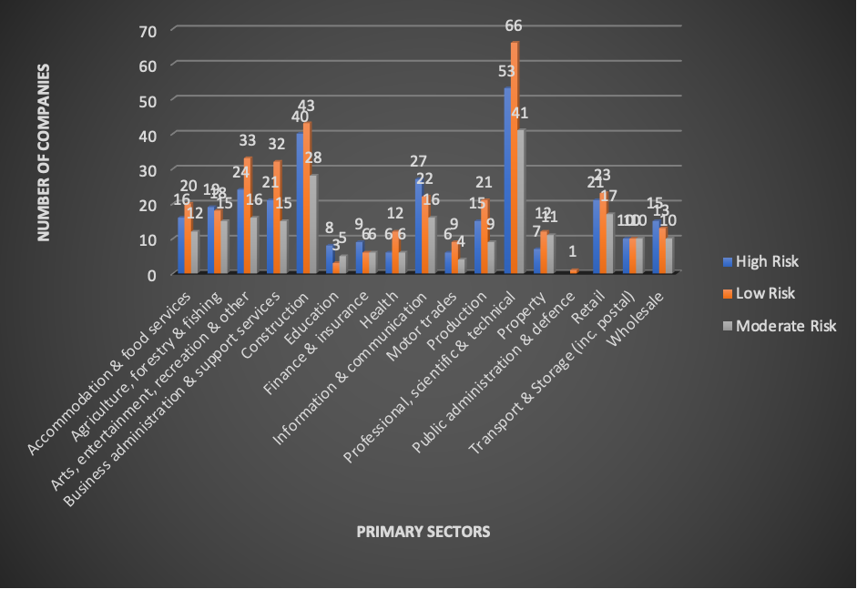

- Extracting the list of Businesses with Liens filed and still open
Liens are legal claims based on business assets placed by creditors to ensure debt security.A creditor has the right to sell the lien in case a borrowing entity fails to pay back it’s obligations towards the creditor. Lien files and still open implies that legal claims have been placed on business assets and properties and are still active and unresolved. Open liens indicate that business is in financial distress and dealing with various challenges related to insolvency. It also highlights potential credit risk and financial risk for an entity.

Query Syntax

SELECT b.entity_name
FROM Businesses b
JOIN credit_rating cr
ON
b.company_reg_number = cr.company_reg_number
WHERE cr.liens_filed_and_open > 0;

Query Output

List of Businesses with Liens filed and still open
entity_name
Johnson, Watson, Cooper, Kent, Gill, Begum, Lee/Black, Phillips/Taylor PLC
Waters, Wood, Allen, James, Jackson, Boyle, Smith and Gray LLC
Holland, Roberts, Fox, Perry, Brown, O'Donnell/Allen
Pratt, Phillips, Storey, Hughes Ltd
Harrison, Jones, Waters, Patel, Carr, Ward, Brown, Davis, Hudson and Wright LLP

Identify businesses with history of missed and late payments.

Businesses with a history late and missed loan payments are highly risky from investment and lending perspective. Usually such a pattern indicates insolvency, financial distress and cashflow disruptions. Investors keep a close eye on the payment behavior to assess cash management and overall efficiency and financial health. Such a behavior results in difficult credit terms and higher interest rates over loan offerings. It damages a business reputation and eventually leads to potential legal disputes. Hence, it is extremely important to assess the payment behaviors of businesses.

Query Syntax

SELECT entity_name
FROM Businesses
JOIN credit_rating
ON
Businesses.company_reg_number = credit_rating.company_reg_number
WHERE missed_and_late_payments_last_five_years > 0
Limit 5;

Query Output

entity_name
Parker, Parker, King, Davies, Martin, Flynn, Dobson/Miller, Hall/Baxter Ltd
Faulkner/Wilson, Wilkinson, Patterson, Hall, Brookes, Patel, Marsh, Barker, Mitchell and Jones LLC
Ahmed/Walsh, Jones, Moss, Marshall, Williams, Bevan PLC
Gough, Taylor, Connor, Jones/Pugh Inc
Taylor, Tucker, Shepherd, Williams, Wilson, Willis, Collins/Hughes, Davis, Marsden and Powell Co

- Average Loan Amount and Survival Rate by Sector

This query will measure if there is a pattern or relationship between the average loan amount and the survival rate across sectors. Such a pattern, if identified, will be crucial in predicting the future growth and survival of UK SME companies. A company with a very high loan amount and lower survival rate indicates huge financial risk.

Query Syntax

SELECT
Businesses.primary_sector,
sum(entity_status)/count(entity_name) as Survival_Rate,
AVG(loan.loan_original_amount) AS avg_loan_amount
FROM
Businesses
left JOIN
loan
ON
loan.company_reg_number = Businesses.company_reg_number
GROUP BY
Businesses.primary_sector;

Query Output

primary_sector | Survival_Rate | avg_loan_amount
 | 0 | 0.00
Accommodation & food services | 0.82 | 109337.50
Agriculture, forestry & fishing | 0.93 | 36683.33
Arts, entertainment, recreation & other | 0.87 | 21450.00
Business administration & support services | 0.97 | 37225.00
Construction | 0.89 | 115312.50
Education | 0.90 | 69200.00
Finance & insurance | 0.96 | 0.00
Health | 0.90 | 79012.50
Information & communication | 0.87 | 81340.91
Motor trades | 0.91 | 36600.00
Production | 0.87 | 0.00
Professional, scientific & technical | 0.95 | 42109.38
Property | 0.86 | 0.00
Public administration & defense | 0.50 | 0.00
Retail | 0.90 | 86078.57
Transport & Storage (inc. postal) | 0.86 | 30641.67
Wholesale | 0.91 | 234641.67

Contrary to our assumption, the survival rate, in many industries, seems independent of the average loan amount. For example, in the above table four sectors including, production, property and finance & insurance, despite having zero loan amount they exhibit notably survival rate of 0.87,0.86 and 0.96. Even the sectors that have a considerable loan amount are showing a very favorable survival rate. Hence, we can say that responsible borrowing within limits fosters growth and sustainability. Interestingly, our findings shows that loan amount in isolation may not significantly impact the overall survival rate.

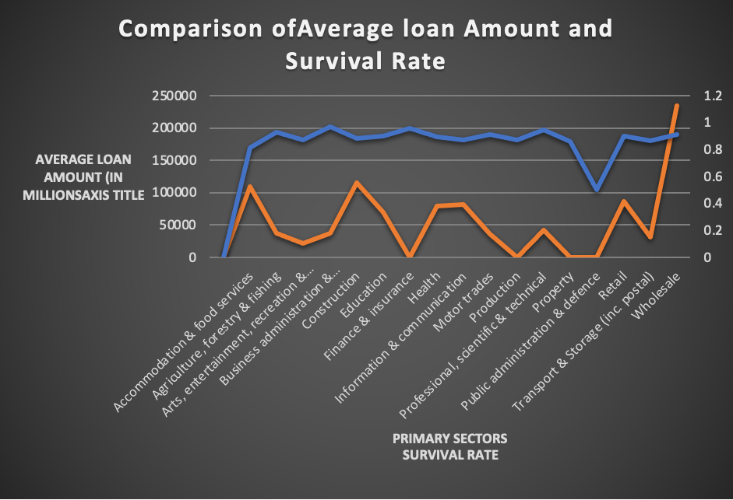

6. Loan Default Analysis
This query will help us analyze and sort the entities which have defaulted on their loan payments.

Query Syntax:
SELECT
b.company_reg_number,
b.primary_sector,
b.entity_name,
FROM
loan l
left join Businesses b ON
b.company_reg_number=l.company_reg_number
where loan_status = "Defaulted"

Query Output
company_reg_number | primary_sector | entity_name
20000017 | Business administration & support services | Taylor, Tucker, Shepherd & Co
20000150 | Education | Webb, Wheeler/Freeman, Fisher/Thompson, Gibbs
20000300 | Accommodation & food services | Jones, Booth, Hawkins, Barnett, Webb and Fry
20000478 | Retail | Moran/Parker, Payne/Scott, Williams/Shah, Edwards Co
20000543 | Information & communication | Harrison, Sullivan, Gray, Holt, Thomas/James, Ryan LLC
20000548 | Professional, scientific & technical | McDonald, Hughes, Alexander, Ross/Hunt, Morris/Harrison, O'Brien, Baxter and White Ltd
20000559 | Business administration & support services | King/Adams, Collins, Wilkinson, Clarke, White, Roberts, Smith, Baker/Ali Inc
20000675 | Information & communication | Hunt/Perry, Ward/Ross, Dale/Graham, Walton/Chan Inc
20000702 | Professional, scientific & technical | Mills/Doyle, Jarvis, Lowe, Wright, Edwards, Evans, Richards and Mitchell Inc
20000720 | Professional, scientific & technical | Norman, Parker, Fletcher, Thomson/Smith, Foster/Ross, Richardson/Richards Ltd
20000837 | Arts, entertainment, recreation & other | Patel, Thomas, Smith, Fleming, Bird/Pickering, Stevenson/Sharpe Ltd
20000984 | Transport & Storage (inc. postal) | Roberts/Iqbal, Pearce, Wilson, Green, Sims, Hunt/Marshall Ltd

3.General Data Exploration

In this section we will explore the demographics and socio-economic landscape in which these businesses operate. It is a general overview of diversity profile, business sectors, composition to develop targeted business strategies.
- Total Number of entities

Query Syntax
SELECT
primary_sector,
COUNT(*) AS firm_count
FROM
credit_account_history
GROUP BY
primary_sector
ORDER BY
firm_count DESC;

Query Output
Primary Sector | Total Firms
Professional, scientific & technical | 236
Construction | 218
Wholesale | 142
Arts | 105
Business administration | 103
Information & communication | 99
Retail | 98
Production | 86
Accommodation & food services | 83
Agriculture, forestry & fishing | 68
Transport & Storage | 44
Property | 43
Motor trades | 42
Health | 34
Education | 20

The above query shows that the largest sector turns out to be the Professional, scientific & technical sector with 236 companies in total whereas the smallest sector is education which comprises of only 20 companies.

Total Number of Enterprises categorized by their size
Let’s categorize each entity by its size and sector to get a bird’s eye view of UK SME sector.
Query Syntax

SELECT
(CASE
WHEN number_of_employees BETWEEN 0 AND 4 THEN 'Micro-enterprise'
WHEN number_of_employees BETWEEN 5 AND 19 THEN 'Small'
WHEN number_of_employees BETWEEN 20 AND 49 THEN 'Medium'
ELSE 'Large'
END) AS enterprise_size,
COUNT(*) AS enterprise_count,
avg(revenue_2019)
FROM
credit_account_history_fixed
GROUP BY
enterprise_size
ORDER BY
enterprise_size
Query Output

Enterprise Type | Count | Revenue
Micro | 831 | 386979.08
Small | 548 | 1230399.96
Medium | 42 | 1940617.92

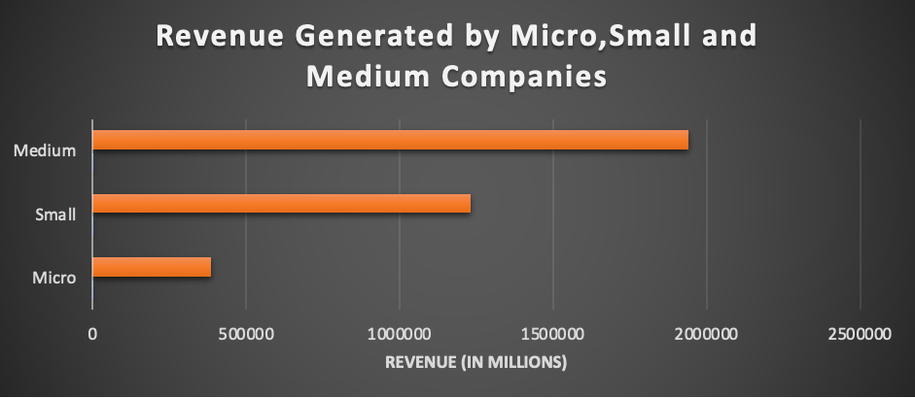

- Analysis of women owned businesses
Query Syntax
SELECT
CASE
WHEN women_owned = 1 THEN 'Women-Owned'
ELSE 'Male-Owned'
END AS ownership,
AVG(revenue_2019) AS average_revenue,
AVG(annual_turnover) AS average_annual_turnover,
AVG(capex) AS average_capex,
AVG(cogs_plus_capex) AS average_cogs_plus_capex
FROM
credit_account_history_fixed
GROUP BY
ownership;
Query Output

Variables | Women Owned Enterprise | Men Owned Enterprise
Average Revenue | 842224.4 | 72228.5
Average Turnover | 99.6 | 76.8
Average Copex | 232.4 | 323.4
Average Copex plus Cogs | 68528.2 | 93196.4

The result proves that female-owned businesses are generating more revenue and turnover as compared to males. Conversely, on average, male-owned enterprises are investing more in their physical assets compared to women-owned enterprises.
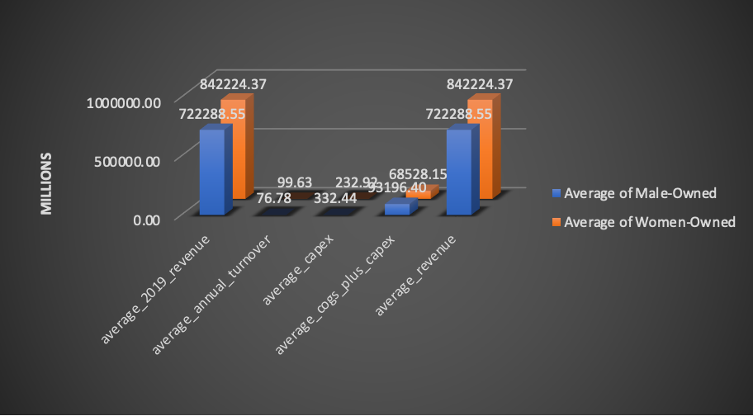

- Analysis of revenue in each county/borough

Query Syntax
SELECT borough_county, AVG(annual_turnover) AS avg_annual_turnover
FROM Businesses
GROUP BY borough_county;

Query Output

borough_county | avg_annual_turnover
Haringey | 0
Lambeth | 0
Cheshire East | 0
Dudley | 0
Cheltenham | 0
South Lanarkshire | 90.28571429
Richmond upon Thames | 126.4
Shropshire | 0
Islington | 57.45454545
Enfield | 0
Buckinghamshire | 79
Bedford | 0
South Cambridgeshire | 0
Merton | 158
Wychavon | 0
Newcastle upon Tyne | 0
King's Lynn and West Norfolk | 0
Camden | 52.66666667
Central Bedfordshire | 0
Fife | 0
Croydon | 158
Leeds | 194.4615385
Woking | 0
Fermanagh and Omagh | 0
Walsall | 0
Plymouth | 158
Westminster | 57.45454545
City of London | 0
East Hertfordshire | 0
Ipswich | 0
Calderdale | 126.4
Lewisham | 210.6666667
County Durham | 0
Bury | 252.8
Gwynedd | 158
Huntingdonshire | 0
Newham | 158
Wiltshire | 210.6666667
Bristol, City of | 0
Rhondda Cynon Taf | 0
Bradford | 180.5714286
Scarborough | 0
Redbridge | 158
Havant | 632
Basildon | 0
Swale | 0
Barnet | 52.66666667
Ealing | 0
East Lindsey | 632
Epsom and Ewell | 316
Pendle | 0
East Devon | 421.3333333
North Lanarkshire | 0
Preston | 0
South Tyneside | 0
Bromley | 0
South Norfolk | 0
Hyndburn | 0
Northampton | 0
Bolton | 105.3333333
Worthing | 316
Stirling | 0
West Devon | 0
Manchester | 114.9090909
Stratford/on/Avon | 126.4
Wokingham | 0
Dartford | 0
South Derbyshire | 0
Torridge | 0
Tamworth | 421.3333333
Dumfries and Galloway | 0
Sandwell | 0
Erewash | 126.4
Rushmoor | 0
Surrey Heath | 0
West Lancashire | 316
Aberdeenshire | 105.3333333
Worcester | 316
Portsmouth | 0
Stockport | 0
Redcar and Cleveland | 0
Stoke/on/Trent | 0
Mid Suffolk | 0
South Hams | 0
Forest of Dean | 0
City of Edinburgh | 105.3333333
Guildford | 0
Sefton | 0
Harrow | 0
North East Derbyshire | 0
East Riding of Yorkshire | 126.4
Glasgow City | 126.4
Birmingham | 0
East Suffolk | 0
Adur | 0
Mid and East Antrim | 0
Mole Valley | 632
South Somerset | 0
Wealden | 0
Perth and Kinross | 0
Denbighshire | 0
Sutton | 158
Neath Port Talbot | 316
Norwich | 0
Elmbridge | 0
Solihull | 158
Hart | 0
Middlesbrough | 421.3333333
Cornwall | 105.3333333
Bournemouth, Christchurch and Poole | 126.4
Hambleton | 0
Brent | 105.3333333
Highland | 210.6666667
Coventry | 0
Mendip | 0
North Hertfordshire | 0
Sevenoaks | 158
Flintshire | 0
York | 0
Bexley | 126.4
Swindon | 0
Runnymede | 0
North Tyneside | 0
South Staffordshire | 0
Conwy | 0
Dorset | 252.8
Charnwood | 0
Tower Hamlets | 0
West Lindsey | 0
Eden | 0
Cherwell | 210.6666667
North Somerset | 0
Horsham | 0
Three Rivers | 0
Gateshead | 0
Belfast | 632
Causeway Coast and Glens | 0
East Ayrshire | 0
Cotswold | 0
Brighton and Hove | 158
Cambridge | 158
Wolverhampton | 0
Boston | 0
Teignbridge | 0
Maidstone | 0
Dundee City | 0
Medway | 0
Angus | 316
Hounslow | 126.4
Reading | 0
Hastings | 0
Thanet | 0
Kirklees | 126.4
Midlothian | 0
Daventry | 0
Wyre | 0
Hertsmere | 0
Hammersmith and Fulham | 0
Selby | 210.6666667
Armagh City, Banbridge and Craigavon | 0
Darlington | 126.4
Dacorum | 0
Carlisle | 0
Milton Keynes | 0
Northumberland | 126.4
Rochdale | 158
Greenwich | 0
Sheffield | 0
Richmondshire | 316
Tewkesbury | 0
Rother | 0
Waltham Forest | 0
South Gloucestershire | 0
Wirral | 158
Lichfield | 0
Doncaster | 0
Caerphilly | 316
Hillingdon | 0
Stroud | 0
Derbyshire Dales | 210.6666667
West Berkshire | 0
Folkestone and Hythe | 0
West Lothian | 0
Chelmsford | 0
Crawley | 0
Kensington and Chelsea | 0
Ashfield | 0
Blackburn with Darwen | 0
Ryedale | 316
Bromsgrove | 316
Oldham | 0
Thurrock | 0
Dover | 632
Staffordshire Moorlands | 0
Newport | 0
Lisburn and Castlereagh | 632
Kingston upon Hull, City of | 0
East Staffordshire | 0
Antrim and Newtownabbey | 316
St Albans | 0
Mid Ulster | 0
Scottish Borders | 0
Winchester | 0
Herefordshire, County of | 126.4
Derby | 316
Barnsley | 0
East Lothian | 316
Chorley | 0
West Suffolk | 0
Fareham | 0
Isle of Anglesey | 0
Bassetlaw | 0
Brentwood | 0
Wakefield | 0
Stockton/on/Tees | 0
Salford | 0
Wrexham | 0
Basingstoke and Deane | 0
Nottingham | 0
Peterborough | 0
Ceredigion | 0
Tunbridge Wells | 0
Tameside | 0
Pembrokeshire | 0
Moray | 0
Slough | 421.3333333
Somerset West and Taunton | 0
North West Leicestershire | 0
New Forest | 0
Melton | 0
Hackney | 158
Cheshire West and Chester | 0
Exeter | 0
Colchester | 0
Watford | 0
Carmarthenshire | 0
Kingston upon Thames | 210.6666667
Waverley | 0
Test Valley | 0
Monmouthshire | 0
Newark and Sherwood | 0
Reigate and Banstead | 0
Southwark | 0
Aberdeen City | 0
Warwick | 0
Cardiff | 0
Sedgemoor | 0
Renfrewshire | 0
Halton | 210.6666667
North Kesteven | 0
Epping Forest | 0
Welwyn Hatfield | 0
Telford and Wrekin | 0
Sunderland | 0
Bolsover | 0
Oadby and Wigston | 0
Liverpool | 0
Barking and Dagenham | 316
Southampton | 0
North Lincolnshire | 0
Fenland | 0
South Ayrshire | 0
North Warwickshire | 0
High Peak | 0
Allerdale | 0
North East Lincolnshire | 632
Eastleigh | 0
Lancaster | 316
Warrington | 0
Stevenage | 0
Powys | 0
Newry, Mourne and Down | 0
Rushcliffe | 0
Fylde | 0
Luton | 0
South Lakeland | 0
Bath and North East Somerset | 316
Braintree | 0
Redditch | 0
South Ribble | 0
Harborough | 0
Burnley | 0
Southend/on/Sea | 0
Uttlesford | 0
Bracknell Forest | 0
Trafford | 0
South Kesteven | 0
Vale of White Horse | 0
East Hampshire | 0
South Northamptonshire | 0
Wandsworth | 0
Great Yarmouth | 0
Chesterfield | 0
Torbay | 0
Babergh | 632
South Holland | 0
Ribble Valley | 0
Oxford | 0
Rugby | 0
Copeland | 0
East Cambridgeshire | 0
Harrogate | 210.6666667
Blackpool | 0
Cannock Chase | 0
Mid Sussex | 0
Maldon | 0
Leicester | 0
Wigan | 0
South Oxfordshire | 632
Gloucester | 0
Kettering | 0
Hinckley and Bosworth | 0
Rochford | 0
Derry City and Strabane | 0
Hartlepool | 0
Harlow | 0
North Norfolk | 632
Chichester | 0

- Total number of companies incorporated in each month of the year
This query will show us the total number of companies incorporated each month of the year.

Query Syntax
select
incorporation_month, count(company_reg_number) from (Select
company_reg_number,
(case when MONTH(incorporation_date) is NULL then month(STR_TO_DATE(incorporation_date, "%d/%m/%Y")) else MONTH(incorporation_date) end) as incorporation_month
FROM Businesses) as tbl join Businesses using (company_reg_number)
group by incorporation_month
order by incorporation_month;

Query Output

incorporation_month | count(company_reg_number)
1 | 110
2 | 87
3 | 101
4 | 92
5 | 68
6 | 107
7 | 79
8 | 83
9 | 68
10 | 84
11 | 70
12 | 51

As we can see here the highest number of companies were incorporated in the month of June.
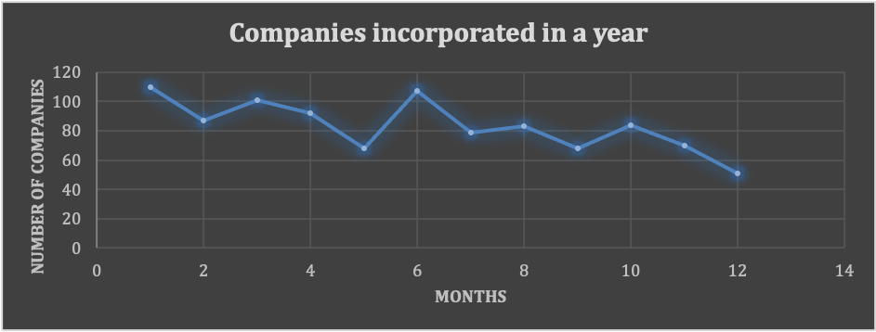

- Total number of companies dissolved in each month of the year
This query will show us the total number of companies dissolved in each month of the year.

Query

select dissolution_month, count(company_reg_number) from (Select
company_reg_number,
(case when MONTH(b.dissolved_on) is NULL then month(STR_TO_DATE(dissolved_on, "%d/%m/%Y")) else MONTH(dissolved_on) end) as dissolution_month
FROM Businesses b) as tbl join Businesses b using (company_reg_number)
group by dissolution_month
order by dissolution_month;

Query Output

dissolution_month | count(company_reg_number)
1 | 75
2 | 74
3 | 65
4 | 80
5 | 80
6 | 75
7 | 100
8 | 117
9 | 81
10 | 93
11 | 85
12 | 75

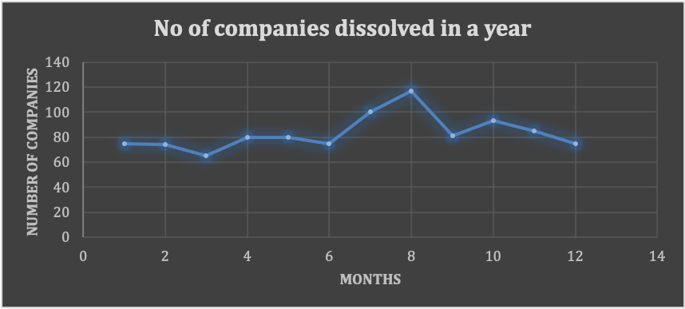

The query output shows that the highest number of companies got dissolved in the month of August.

4. Key Insights

Our Analysis offer an overall positive outlook on UK SME sector. We delved into various financial indicators and credit rating measures and analysis shows that UK SMEs are financially stable. Retail & transportation and storage sectors showed a high account receivable turnover but some other sectors like agriculture are struggling with liquidity issues. Debt to asset ratio is below 1 for almost all the sectors which shows reduced reliance on external financing. These SMEs have relatively low profit margins and high cost ratio, hence they need to focus more on cost minimization strategies.
Our analysis of average loan versus survival rate shows that responsible borrowing within limits can contribute to growth and stability and without effecting the business survival. While their financial stability is commendable, it is noteworthy that many SMEs are struggling with cashflow management as depicted by late and missed payment data. Inherent complexities in small and medium sized businesses hinder their ability to maintain a consistent and timely payment schedule. These factors along with opened liens against these companies can caste a shady impact on the overall credit worthiness of these entities.

- Recommendations

Businesses can tailor their operational strategies based on sector insights. They can proactively address challenges, optimize resources, and plan for growth. We recommend following actionable strategies based on our analysis:

    - Business have shown a varying profile across different regions and sectors in UK. Investors can capitalize on strengths like they can invest in localities where profit margin is higher and look forward to high liquidity regions for further expansion and scaling.
    - A good inventory management system in place and the ability to negotiate favorable payment terms can resolve the cashflow problems and provide a clear cost advantage to UK SME businesses.
    - Lenders should convince businesses with higher debt to asset ratios to focus on debt reduction strategies like refinancing their debt or looking at lower interest rate alternatives.
    - Although education sector has depicted the highest profit margins, but other sectors can benchmark its strategies of right price setting, effective cost control and multiple revenue streams.
    - The overall analysis shows that many sectors in UK SME ecosystem have relatively modest net profit margin and high cost ratio so they need to focus on cost minimization strategies.
    - Lenders should push businesses to control the negative factors which can obstruct a good credit rating profile such as timely payment issues.
    - Women owned businesses have shown a clear win over the men owned businesses in terms of revenue so policy makers should support women founded initiatives and make resources and capital more accessible to them.

