Subhash Chand Rayana
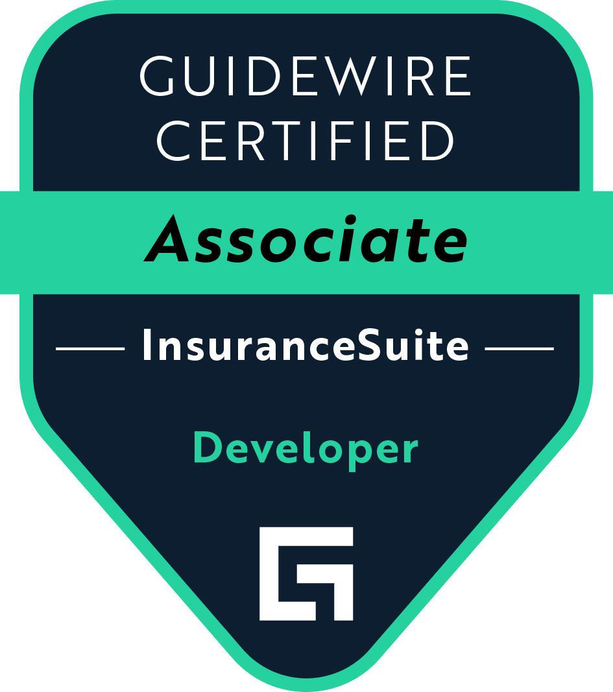
7326453839
subh.rycn256@gmail.com

Summary:

- Around 10+ years of IT Experience involved in developing Property & Casualty insurance applications using Guidewire PolicyCenter and ClaimCenter and web applications using J2EE.
- Experience in guidewire cloud upgrades and integrations.
- Experience in Gosu Testing framework using GT-UI and GT-API in the ClaimCenter cloud project.
- Have worked on Property & Casualty and Supply Chain Management domains.
- Have good experience in Swagger APIs.
- Handled configuration and integration tasks based on project needs.
- Experience in writing Edge APIs.
- Experience in Angular 4.
- Proficient in utilizing integration patterns, plugins, and modules to develop user-friendly solutions.
- Skilled in configuring Policycenter and implementing batch processing techniques to streamline policy life cycle management.
- Experience in Web and Client/Server Application development using Java and Java EE, including JDBC, Prime Faces (JSF), Hibernate, Spring JDBC, Spring ORM, Spring MVC, Spring IOC, XML, XSD.
- Good Working knowledge of Spring Boot, Spring Core, and Spring TX.
- Experience in developing ORM using Hibernate.
- Experience in applying core Java/JEE Design Patterns like Singleton, Strategy, Factory, VO, Command, BO, DAO, Business Delegate, and Entity in web applications.
- Working on Guidewire Policycenter/ClaimCenter with hands on all four layers including Data Model, User Interface, Business logic, and Integration layers in P&C Insurance and Commercial lines.
- Developed robust integrations, adhering to Guidewire Cloud coding standards, and driving system stability through proactive monitoring and audits.
- Proven ability to work with cross-functional teams to design, develop, and deliver high-quality software applications.
- Expertise in testing methodologies, including test automation, to ensure optimal performance and functionality.
- Expertise in Middleware technologies and experience in testing
- Expertise in writing Rules, PCF configuration, GScript, Gosu, Admin Data configuration, Contact Center Management, and Database Report Generation for Guidewire ClaimCenter, and PolicyCenter.
- Experience with Version Control like SVN and GIT Lab.
- Experience with Database Servers using MongoDB, MarkLogic, and Oracle.
- Experienced GuideWire Developer with a strong background in software development and integration.
- Ability to learn and adapt quickly and to correctly apply new tools and technology.
- Multiple appreciations from the client for demonstrating the removal of Edge Dependency.
- Worked in designing, developing, and implementing software solutions with experience in designing, developing, and implementing software solutions using Java and JUnit.
- Strong expertise in software testing, unit testing, and test-driven development (TDD).
- Adept at collaborating with cross-functional teams, and committed to delivering high-quality code and customer satisfaction for various industries.
- Strong expertise in Java, Spring Framework, and RESTful APIs.

Technical Skills:

Languages | Java, GraphQL, and SQL.
Guidewire Products | ClaimCenter and PolicyCenter (V.8, V.9.x, V.10.x)
Java Technologies | Java, J2EE, JDBC, Servlet, JSP, JPA, JUnit, TestNG.
Application FrameWorks | Spring Boot, Spring (Spring JDBC, Spring ORM, Spring MVC, Spring AOP, Spring TX), Struts 1. x, JSF, PrimeFaces, Hadoop (MapReduce), log4j, Angular 4.
Testing Frameworks | GUNIT and JUnit, Selenium, and Cucumber.
ORM Frameworks | Hibernate and Spring Framework.
Integrated Technologies | JMS messaging, XML, DTD, XSD, JAX-P, JAX-B, Web Services (JAX-RPC, JAX-WS, JAX-RS 2.0(Restful)), Micro Services & WS Security Policy, Kubernetes, Docker, Apache Camel, Apache ActiveMQ, Apache Kafka, IBM MQ, and Mule ESB.
Development Tools | Eclipse, STS and IntelliJ idea Eclipse, Git, Maven, Jenkins, JIRA
Application Servers | Apache Tomcat, JBoss Git, SVN, Jenkins, JIRA, and Confluence.
Databases | Mongo DB, Mark Logic, Oracle, H2, Relational databases, SQL, NoSQL databases, MySQL, Oracle, and PostgreSQL.
System Maintenance | Incident Management, Performance Tuning, Stability Monitoring, Root Cause Analysis.

PROFESSIONAL EXPERIENCE

Client: Church Mutual Insurance Company, WI Aug 2023 - Present
Role: Guidewire Arch/Tech Lead

Roles and Responsibilities:

- Design, develop, and debug Center, and Contact Manager i.e., Integration and Configuration in Policy & Claim Center.
- Worked closely with stakeholders to implement valuable system enhancements, tailoring ClaimCenter’s data models, business rules, and user interfaces to meet specific business needs improving claims processing efficiency.
- Developed technical design documents for Policy Center integrations, detailing configuration strategies and integration touchpoints.
- Led root cause analysis on production issues, collaborating with teams across the business to prioritize and resolve urgent defects.
- Resolved complex production issues in Guidewire PolicyCenter and ClaimCenter, focusing on incident resolution and long-term stability.
- Participated in code reviews, ensuring compliance with Guidewire Cloud standards.
- Develop, Analyze, and fix Integration issues and update the test cases using Gosu Testing framework.
- Designed and implemented custom policy lifecycle workflows aligned with business rules, integrating seamlessly with external systems via RESTful APIs.
- Enhanced cloud compatibility by implementing OAuth2-based authentication for external integrations, ensuring secure data exchange between PolicyCenter and third-party systems.
- Conducted performance tuning and audits to identify and mitigate system bottlenecks.
- Led technical design sessions and developed solutions for PolicyCenter, improving claims processing and policy lifecycle efficiency.
- Played a key role in enhancing integrations between ClaimCenter and external systems, such as payment processors and document management platforms, using SOAP/REST APIs.
- Conduct triage meetings to conclude the scope of release and work with the business team for clarifications.
- Analyzed and interpreted business requirements for Guidewire Policy Center, ensuring alignment with business objectives and technical feasibility.
- Reviewed and ensured developer code complied with cloud standards, focusing on best practices specific to Policy Center environments.
- Creating Architectural Design for Integration Features.
- Worked on complex Integration Features in Policy Center.
- Worked on both production level and development support.
- Participated in testing activities, including unit testing using GT-UI, and integration testing using GT-API.
- Provided technical guidance and support to fellow team members.
- Developed various business rules including Assignments, Validation, and Event fired rules.
- Involved in spring planning, retrospective, backlog, and refinements part of agile development.
- Involved in sprint Planning and resource Managing.

Client: Federated Mutual Insurance Company, MN Jun 2021 – Aug 2023
Role: Guidewire Dev/Tech Lead

Roles and Responsibilities:

- Analyze & understand the objectives of configuration and integration requirements of the client
- Involving in Product Refinement sessions for the feature
- Mentoring the team members
- Creating Architectural Design for Integration Features
- Worked on complex Integration Features.
- Conducted integration testing and debugged end-to-end data flows to ensure seamless interoperability between PolicyCenter and external systems.
- Worked on both production level and development support.
- Successfully led multiple implementation projects for various clients, including requirements gathering, configuration, testing, and deployment.
- Configured auto-scaling policies for PolicyCenter services using cloud-native features to handle fluctuating workloads, reducing downtime during peak usage.
- Developed and implemented code optimization practices, aligned with Guidewire Cloud coding standards, leading to improved system performance and maintainability.
- Collaborated with business analysts, developers, and testers to ensure the delivery of high-quality solutions.
- Enhanced the throughput of REST APIs by leveraging cloud-native load balancing and optimizing database queries
- Helped automate the defect management process by integrating JIRA with our Guidewire environments, which improved communication between teams and reduced the time it took to resolve issues.
- Led the creation of dynamic integration solutions between Guidewire systems and third-party applications, reducing manual intervention.
- Collaborated in Agile sprints to deliver high-quality code, leveraging GT-API and JUnit frameworks for automated testing.
- Developed custom integration solutions to integrate Policy Center & Claim Center with external systems, including policy management and financial systems.
- Worked on optimizing ClaimCenter’s performance, improving system response times during high-traffic periods by adjusting database settings and implementing load balancing techniques.
- Supported the team post-implementation, gathering feedback and making continuous improvements to ensure the enhancements were well received and aligned with evolving business goals.
- Ensured high-quality defect fixes and enhancements by leading comprehensive unit and integration testing, making sure that changes were fully tested before going live.
- Participated in testing activities, including unit testing, system testing, and integration testing.
- Provided support to end-users and resolved issues related to PolicyCenter and ClaimCenter.
- Conducted knowledge transfer sessions for client teams to ensure smooth handover of the system.
- Provided technical guidance and support to junior team members.
- Developed and maintained project plans, status reports, and other project-related documentation.
- Conducted training sessions for end-users to ensure the successful adoption of the new system.
- Actively participated in pre-sales activities, including demos and client presentations.
- Fixed critical issues for inbound and outbound integration of the ClaimCenter with downstream systems.
- Designed and developed inbound integration of the ClaimCenter to accept glass invoices and create EFT payments and bulk payments.
- Designed and implemented outbound integration to send emails to external vendors based on claim center-generated events.
- Worked with Portal development for customers to view and track policy and claims information.
- Design and develop Inbound and Outbound Interfaces in PolicyCenter.
- Customized Policy Search and Retrieval services to integrate PolicyCenter with ClaimCenter.
- Developed various business rules including Assignments, Validation, Evaluation rules, and Event fired rules in PolicyCenter.
- Design, develop, and debug PolicyCenter, and ClaimCenter i.e., Integration and configuration
- Involved in spring planning, retrospective, backlog, and refinements part of agile development.
- Involved in sprint Planning and resource Managing

Client: Safe Auto, OH Jan 2020– Jun 2021
Role: Tech Lead

Roles and Responsibilities:

- Handled multiple DBCC Issues and gave code fixes and data fixes for most of the DBCC Issues.
- Solving production issues.
- Triaging the existing application.
- worked on SLA Jira.
- Working with Agile Scrum methodology for frequent software delivery.
- Mentoring the team members
- Worked on Guidewire ClaimCenter kela Batch process, which is used to create the report for the handler and store it in a shared folder.
- Worked on creating history Events and activities using Guidewire ClaimCenter rules.
- Involved in writing enhancements and business rule validation for the project.
- Following the Agile-scrum methodology and actively participating in all scrum ceremonies.
- Analyzing and implementing both configuration and integration-related stories.
- Involved in Design reviews and code reviews
- Performed extensive testing as well as integration testing.
- Involved in YkY-Alli implementation, which creates a claim with the data sent from Portal in XML format.

Client: Germania Insurance, TX Nov 2018– Dec 2019
Project: ECC Support
Role: Sr. Guidewire Developer

Roles and Responsibilities:

- Handled multiple DBCC Issues and Given Code fixes and data fixes for most of the DBCC Issues.
- Developed and implemented plugins to enhance the functionality of the Guidewire PolicyCenter.
- Utilized integration patterns to streamline the integration of Guidewire with external systems.
- Implemented batch processing techniques to automate the policy life cycle management process.
- Design and develop Guidewire solutions, including PolicyCenter and ClaimCenter.
- Develop and maintain Guidewire-based web applications using Java and Gosu programming languages.
- Collaborate with cross-functional teams to understand project requirements and deliver high-quality software applications.
- Develop automated unit tests using JUnit and TestNG, and integration tests using Selenium.
- Conduct testing of Guidewire solutions to ensure optimal performance and functionality.
- Participate in code reviews to ensure compliance with established coding standards and methodologies.
- Guidewire Developer
- Worked on the development of Guidewire solutions, including PolicyCenter and ClaimCenter.
- Developed and maintained Guidewire-based web applications using Java and Gosu programming languages.
- Conducted testing of Guidewire solutions to ensure optimal performance and functionality.
- Collaborated with cross-functional teams to understand project requirements and deliver high-quality software applications.
- Participated in code reviews to ensure compliance with established coding standards and methodologies.
- Solving production issues.
- Triaging the existing application.
- worked on SLA Jiras.
- Working with Agile Scrum methodology for frequent software delivery.

Client: CNA Financial, IL Mar 2016 - Oct 2018
Project: OP HALTI
Role: Sr. Guidewire Developer

Roles and Responsibilities:

- Involved in various workshops and requirement-gathering sessions for ClaimCenter.
- Analyze & understand the objectives of configuration and integration requirements of the client
- Have been involved in Architectural Design Discussion
- Have been involved in upgrades from version 9 to 10 using Upgrade Tool.
- Exposed REST API services from ClaimCenter V.10.
- Prepare schemas for Guidewire API.
- Worked on various integration services from ClaimCenter like Document Archiving in the AS360 system, notifying claim creation and modification to an external system and etc.
- Worked with Agile Scrum methodology for frequent software delivery.

Client: Jewelers Mutual Insurance Company, Neenah, WI Sep 2015 - Feb 2016
Project: OP AUTO
Role: Sr. Guidewire Developer

Roles and Responsibilities:

- Involved in various workshops and requirement-gathering sessions for ClaimCenter.
- Analyze & understand the objectives of configuration and integration requirements of the client
- Prepare schemas for Guidewire API.
- Worked on Document integration services from ClaimCenter.
- Worked with Agile Scrum methodology for frequent software delivery.
- Configured PolicyCenter to meet the specific requirements of clients.
- Developed user-friendly solutions for various Guidewire use cases, such as underwriting and claims management.
- Collaborated with the development team to implement modular solutions that improved the overall performance of the system.

Client: Sentry Insurance, Stevens Point, WI Dec 2012 – Aug 2015
Project: Cloud-Based Order Management API
Role: Java Developer

Roles and Responsibilities:

- Developed and maintained a RESTful API for a cloud-based enterprise application using Java, Spring Boot, and Hibernate
- Collaborated with cross-functional teams to gather requirements and define technical specifications
- Led the design and implementation of a microservices architecture using Kubernetes and Docker
- Implemented test-driven development (TDD) practices, resulting in a 50% reduction in the defect rate
- Mentored junior developers on best practices and coding standards
- Developed and maintained a SOAP-based web service for a financial services company using Java and Spring Framework
- Designed and implemented a NoSQL database for storing customer data, resulting in a 30% improvement in application performance
- Worked with cross-functional teams to define technical specifications and project scope
- Participated in code reviews, ensuring code quality and adherence to coding standards
- Contributed to the development of unit and integration tests, improving application stability and reliability
- Develop and maintain Java-based applications using Apache Camel and Mule ESB for middleware integration with various systems.
- Design and develop software applications in compliance with established coding standards and methodologies.
- Collaborate with cross-functional teams to meet project requirements and ensure the timely delivery of quality results.
- Develop automated unit tests using JUnit and integration tests using Selenium and Cucumber to ensure high code coverage and functionality.
- Optimize existing code to improve performance and scalability.
- Monitor application performance using tools like AppDynamics and Splunk.
- Designed and developed middleware integrations using Apache ActiveMQ and IBM MQ.
- Developed and maintained Java-based web applications using Spring MVC and Hibernate frameworks.
- Worked with cross-functional teams to understand project requirements and deliver quality results.
- Developed automated unit tests using JUnit and integration tests using Selenium.
- Maintained code in version control using Git.

EDUCATION:

- Bachelor of Computer Science, Osmania University, India 2001.

