Integration Specification Creation — Architecture & Workflow
This document describes how MES-to-CMdS Integration Specifications are produced in Cursor using a two-phase, gated design: structured research first, prose spec second, with Python validators and human review between phases.

1. System architecture (logical view)
The system splits into three layers: Cursor orchestration (prompts, rules, agent), per-integration project and shared rule library
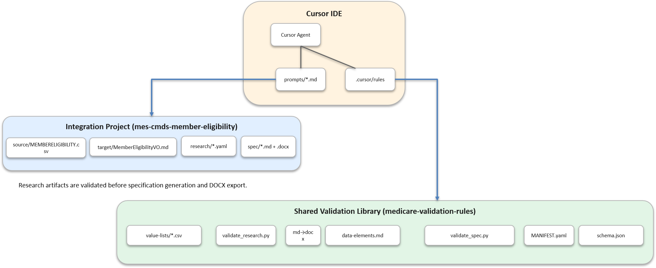

Repository roles
Component | Location | Responsibility
Rule library | medicare-validation-rules/ | T-MSIS data elements, VVL CSVs, prompts, schema, validators, conventions
Integration project | integrations/mes-cmds-member-eligibility/ | Flow-specific source layout, target VO, research YAML, generated spec
Multi-root workspace | mes-cmds-member-eligibility.code-workspace | Opens both folders so @rules/, @prompts/, and @source/ resolve in one chat
The library is read-only for BAs (rules + tooling). Each integration flow owns its inputs and outputs only.

2. Why two phases?
A single prompt that researches and writes at once increases risk across many fields (e.g. 113 mappings), multiple VVL files, and dozens of gap categories.
Single-phase (deprecated) | Two-phase (current)
Agent reads CSV, VO, rules, writes 800+ line spec | Turn 1: cite-only YAML; Turn 2: prose from YAML only
Hallucination surface = all artifacts + full spec | Writer never sees raw CSV/VO/rules
Hard to review | Human reviews compact research/*.yaml before Write
Context isolation: Turn 2 runs in a new chat with only @research/Integration_Research_*.yaml and the writer prompt so the model cannot rely on invented mappings from Turn 1 file reads.

3. Workflow stages (end-to-end)

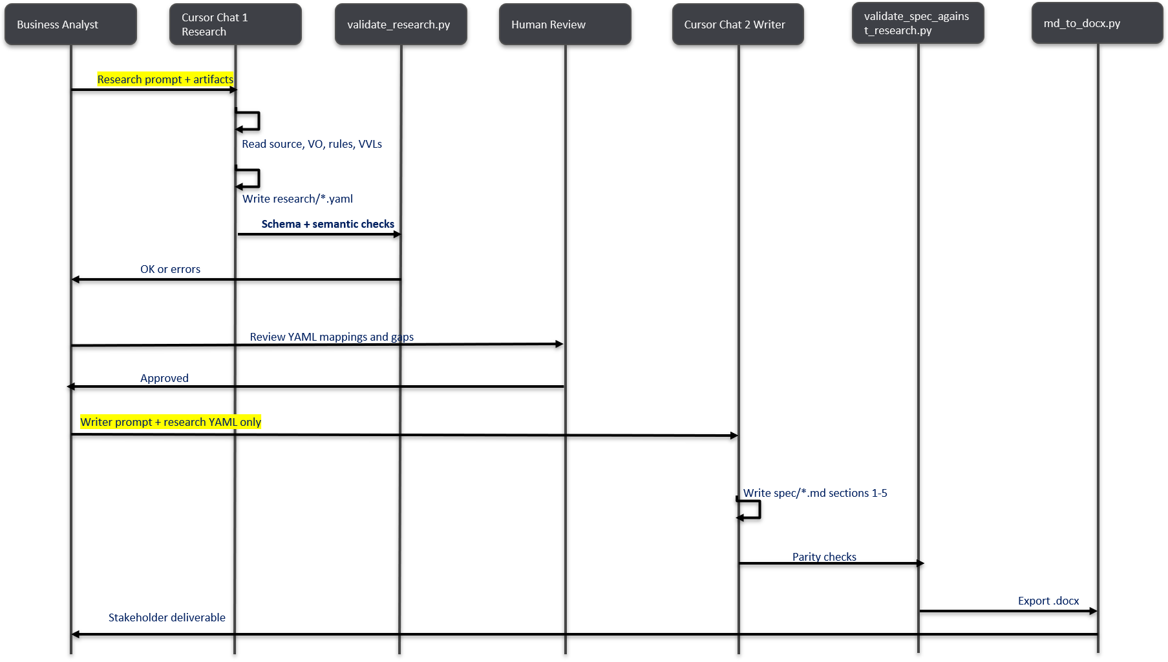

Stage 0 — Workspace setup
- Open both roots (workspace file or Add Folder to Workspace):
  - integrations/mes-cmds-member-eligibility
  - medicare-validation-rules (sibling: ../../medicare-validation-rules)
- Install Python deps (from integration folder):
- pip install -r ..\..\medicare-validation-rules\requirements.txt
- Optional: install Pandoc for Word export.
Always-on rule: medicaid-spec-conventions.mdc (cite-never-invent, provenance). Phase rules are invoked via @ in each turn’s prompt.

Stage 1 — Research (Turn 1)
Goal: Produce a structured, version-controlled research artifact — not spec prose.
Mechanism | Path / behavior
Procedure | prompts/integration-spec-research.md
Phase rule | @.cursor/rules/integration-spec-research.mdc (alwaysApply: false)
Inputs | source/*.csv, target/*VO.md, rules/eligibility/data-elements.md, value-lists/*.csv
Output | research/Integration_Research_MemberEligibility.yaml
Contract | schemas/integration-research.schema.json
Research agent constraints:
- Read-only on inputs; every fact has source_ref (file:Lnn).
- gaps[] only — assumptions: [] (no ASM at research time).
- field_mappings[]: one row per source field; derivation = DIRECT | INFERRED | UNMAPPED.
- vvl_members[]: verbatim CONFIRMED CSV rows with per-row source_ref.
- meta.sources[]: paths + SHA-256 checksums for provenance.
Gate:
python ..\..\medicare-validation-rules\tools\validate_research.py research\Integration_Research_MemberEligibility.yaml
Checks: JSON Schema, dictionary version vs MANIFEST.yaml, empty assumptions, DE ids in data-elements.csv, VVL row parity, optional SHA-256 match.

Stage 2 — Human review (HITL gate)
The BA/SME reviews the YAML (mappings, gaps, VVL members) — typically far smaller than a full spec. This is the intended checkpoint before any narrative or placeholder behavior is written.
No Cursor automation here; approval is procedural.

Stage 3 — Writer (Turn 2, new chat)
Goal: Transcribe approved research into the Integration Specification (§1–§5).
Mechanism | Path / behavior
Procedure | prompts/integration-spec-write.md
Phase rule | @.cursor/rules/integration-spec-writer.mdc
Only input | @research/Integration_Research_MemberEligibility.yaml
Outputs | spec/Integration_Spec_....md (canonical), then .docx
Writer constraints:
- No new field mappings, VVL codes, or GAP IDs beyond research.
- No ASM-NN unless present in research assumptions (empty on first pass).
- §3 echoes research source_ref / target_ref; §2.2 lists research gaps.
Gates (order matters):
python ..\..\medicare-validation-rules\tools\validate_spec_against_research.py research\Integration_Research_MemberEligibility.yaml spec\Integration_Spec_MES_to_CMdS_MemberEligibility.md
python ..\..\medicare-validation-rules\tools\md_to_docx.py spec\Integration_Spec_MES_to_CMdS_MemberEligibility.md
validate_spec_against_research.py checks §3 field parity, §4.D VVL codes ⊆ research, §2.2 GAP ids, and ASM gate when assumptions are empty.

4. Cursor control plane
Cursor does not ship separate “Research Agent” and “Writer Agent” products. Behavior is enforced by:
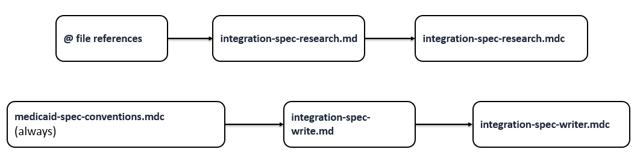

Mechanism | Research | Writer
Prompt file | integration-spec-research.md | integration-spec-write.md
Cursor rule | integration-spec-research.mdc | integration-spec-writer.mdc
Agent input scope | All flow artifacts | Research YAML only
Deliverable | research/*.yaml | spec/*.md + .docx
Validator | validate_research.py | validate_spec_against_research.py
Deprecated entry point: integration-spec-generation.md redirects to the two-phase flow.

5. Research artifact model (contract)
The research YAML is the structured source of truth between phases:
Section | Purpose
meta | Flow name, T-MSIS dictionary_version, input file paths + SHA-256
field_mappings[] | Source ↔ target mapping with citations and optional t_msis_rule / vvl_file
gaps[] | Missing facts (GAP-NN, evidence, owner, priority)
assumptions[] | Empty at research; BAs may fill later
vvl_members[] | Confirmed enum rows copied from VVL CSVs
The Writer transcribes this into normative spec sections:
Spec section | Source in research
§1 Executive summary | meta + pipeline narrative from writer prompt
§2 Gaps & assumptions | gaps[], assumptions[]
§3 Mapping matrix | field_mappings[]
§4.D/E VVL tables | vvl_members[]
§4.F Rule index | field_mappings[].t_msis_rule

6. Deterministic tooling (non-LLM gates)
LLM rules reduce drift; validators fail the pipeline on structural violations:
Tool | When | What it enforces
validate_research.py | After Turn 1 | Schema, refs, empty assumptions, DE/VVL integrity, checksums
validate_spec_against_research.py | Before Word export | Spec does not exceed research (fields, VVL codes, GAPs)
md_to_docx.py | After validation | Markdown → Word via Pandoc
xlsx_to_text.py | Rule maintenance | Regenerate data-elements.md/csv from source.xlsx
Provenance registry: MANIFEST.yaml pins dictionary v4.0.33 and paths to prompts, schema, and validators.

7. Data flow summary
INPUTS (integration + library)
MEMBERELIGIBILITY.csv + .CPY
MemberEligibilityVO.md
data-elements.md + value-lists/*.csv
|
v Turn 1: Research Agent + validate_research.py
research/Integration_Research_MemberEligibility.yaml
|
v Human review
|
v Turn 2: Writer Agent + validate_spec_against_research.py
spec/Integration_Spec_....md
|
v md_to_docx.py
spec/Integration_Spec_....docx

8. Operational limits
- Research quality still depends on the model; validators catch schema and many consistency errors, not semantic mapping mistakes — that is what the YAML review gate is for.
- Spec validator uses pragmatic Markdown parsing (regex/tables); edge-case formatting may need validator tweaks.
- Always-on rules apply in both chats; phase rules are narrower and must be @-referenced in prompts to steer behavior strongly.
- Headless/CI: The same two prompts can map to Cursor SDK (Agent.prompt twice) later; validators are already scriptable.

9. Quick reference — BA prompts
Turn 1 — Research
Run Integration Spec Research per @prompts/integration-spec-research.md.
- Flow: Member Eligibility
- Source layout: @source/MEMBERELIGIBILITY.csv
- Target VO: @target/MemberEligibilityVO.md
- Validation rules: @rules/eligibility/data-elements.md
- Value lists: @rules/eligibility/value-lists/
Write research/Integration_Research_MemberEligibility.yaml only. Do not write the spec.
Turn 2 — Writer (new chat)
Write Integration Specification per @prompts/integration-spec-write.md from
@research/Integration_Research_MemberEligibility.yaml only.
Deliver spec/*.md and run tools/md_to_docx.py for .docx.

Generated from the MES-to-CMdS Member Eligibility integration project. Canonical Markdown: docs/Integration_Spec_Creation_Architecture.md.

