Geometria Ackermann
For a given turn radius R, wheelbase L, and track width T, engineers calculate the required front steering angles (δ_(f,in) and δ_(f,out)) with the following expressions:
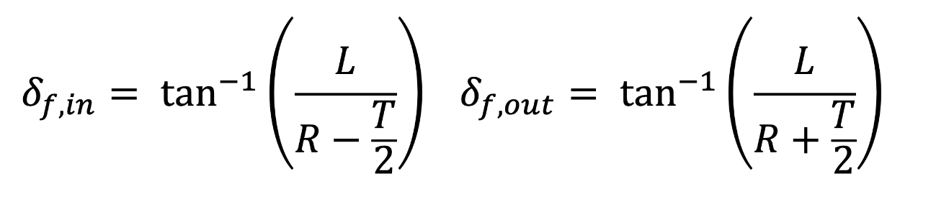
A menor curva executada durante a competição é nas provas de autocross e Endurance que pode ter 9m de raio externo e largura mínima de pista de 4,5m.
Com isso em mente calcula-se a trajetória do carro com a roda interna na parte interna da pista em uma curva com raio externo de 9m e largura de pista de 6m:
L = 1,525m
T = 1,145m
R = 2.8m
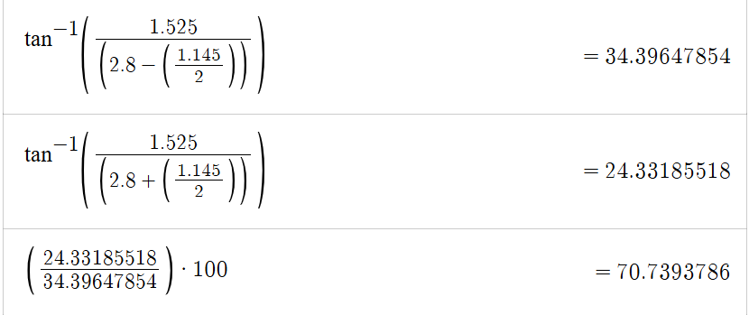

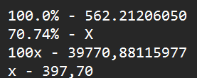

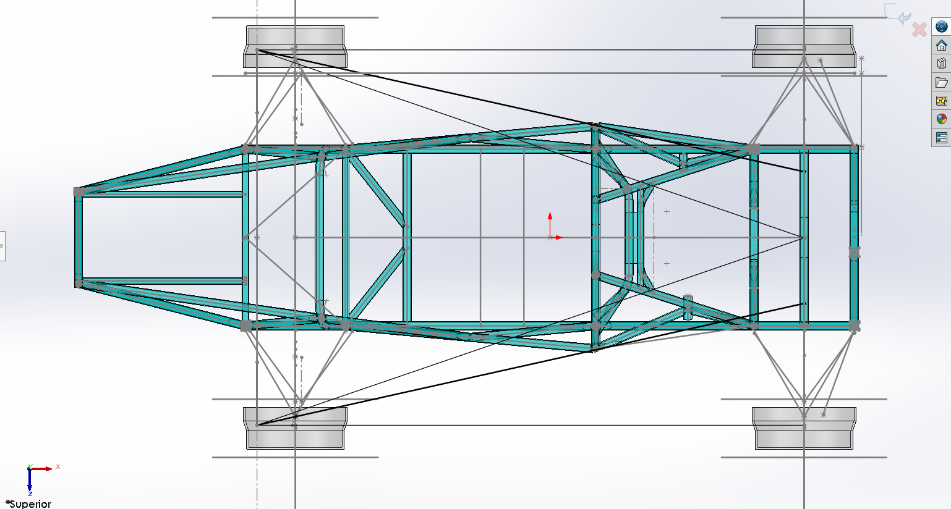

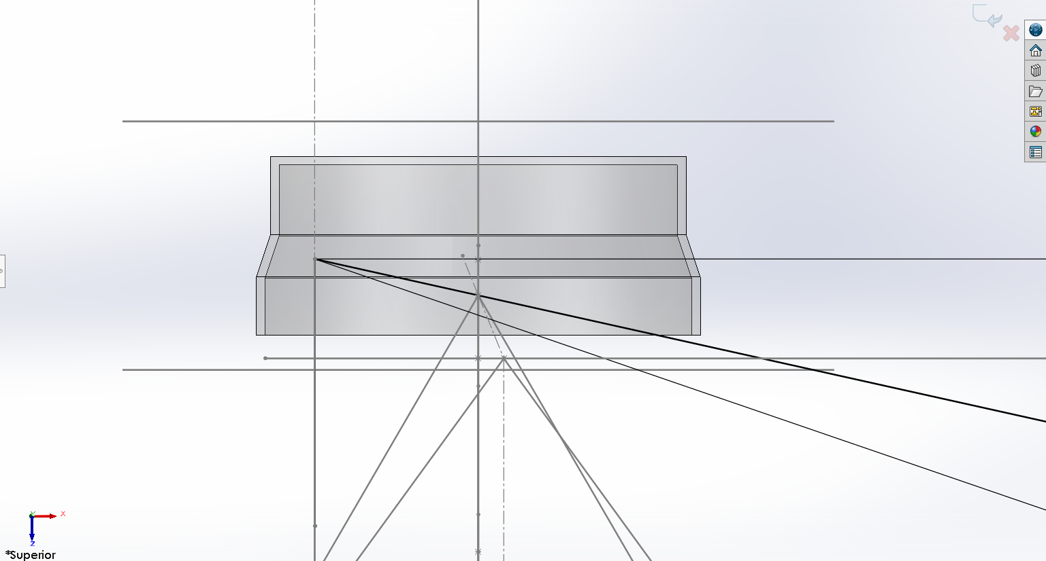

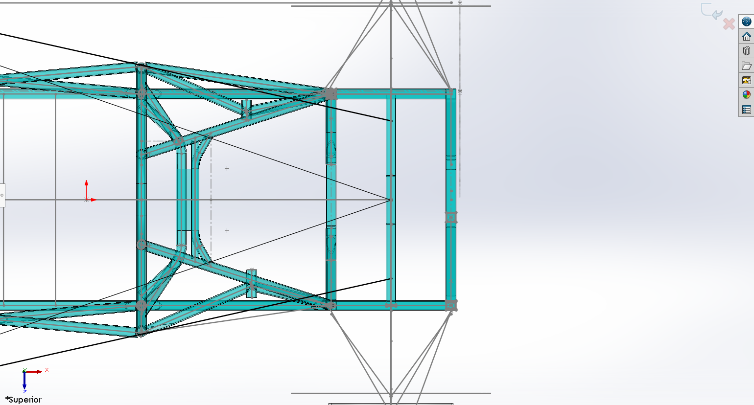
CÁLCULO STEERING EFFORT
Variáveis:
Wheelbase: 1525mm
TrackF: 1145mm
TrackR: 1145mm
Turning Radius: 2800mm
Scrub Radius:10mm
g: 9,81m/s²
Tierod Length: 170mm
TFF = TLP
Pinion radius: 80mm
SteeringWheel diameter: 250mm

- Steering force calculation:

Friction force at the tire is = u * Reaction at each tire
FF = u*g*peso
FF = 0,8 * 9,81 * 180Kg
FF = 1412.64N

Torque due to frictional force = Scrub Radius * FF
TFF = 0,01m * 1412,64N
TFF = 14.1264N/m

Torque due to lateral push = force on tierod / tierod length
Force on tierod = 14,1264 / 0,170
Force on tierod = 83.09647059N

Total force on rack = 2*Force on tierod
Total force on rack = 166,19N

Torque on pinion = piniun radius * total force on rack
Torque on pinion = 0,08 * 166,19
Torque on pinion = 13.2954353N/m

Force Applied by the driver to steer the wheels = torque on the steeringwheel / steeringwheel radius
Force Applied by the driver to steer the wheels = 13,29 / 0,125
Force Applied by the driver to steer the wheels = 106.3634824N

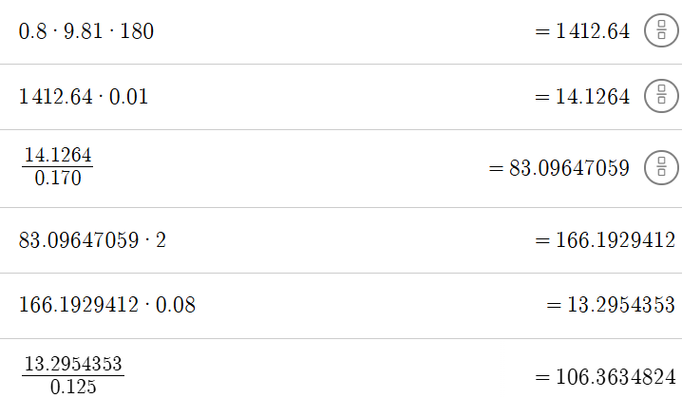

Mudando o diâmetro do pinhão para 50mm de diâmetro:
Torque on pinion = piniun radius * total force on rack
Torque on pinion = 0,05 * 166,19
Torque on pinion = 8.30964706N/m

Force Applied by the driver to steer the wheels = torque on the steeringwheel / steeringwheel radius
Force Applied by the driver to steer the wheels = 8,309 / 0,125
Force Applied by the driver to steer the wheels = 66.47N

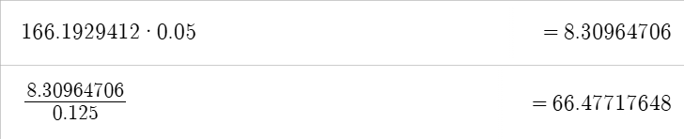

Mudando o diâmetro do pinhão para 40mm de diâmetro:
Torque on pinion = piniun radius * total force on rack
Torque on pinion = 0,04 * 166,19
Torque on pinion = 6.647717648N/m

Force Applied by the driver to steer the wheels = torque on the steeringwheel / steeringwheel radius
Force Applied by the driver to steer the wheels = 6,647/ 0,125
Force Applied by the driver to steer the wheels = 53.18N

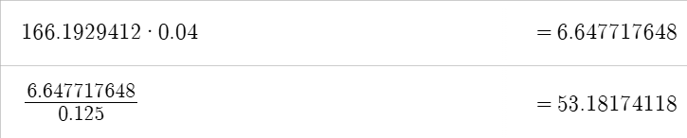

Carro parado com mi do pneu = 1

- Steering force calculation:

Friction force at the tire is = u * Reaction at each tire
FF = u*g*peso
FF = 1 * 9,81 * 93.1Kg
FF = 913.311 N

Torque due to frictional force = Scrub Radius * FF
TFF = 0,03m * 913.311 N
TFF = 27.39933 N/m

Torque due to lateral push = force on tierod / tierod length
Force on tierod = 27.39933 / 0,170
Force on tierod = 161.1725294N

Total force on rack = 2*Force on tierod
Total force on rack = 322.3450588N

Torque on pinion = piniun radius * total force on rack
Torque on pinion = 0,08 * 322.3450588
Torque on pinion = 25.7876047 N/m

Force Applied by the driver to steer the wheels = torque on the steeringwheel / steeringwheel radius
Force Applied by the driver to steer the wheels = 25,78 / 0,125
Force Applied by the driver to steer the wheels = 206.3008376N

Carro parado com scrub 10mm e pinhão 50mm e mi 1

Friction force at the tire is = u * Reaction at each tire
FF = u*g*peso
FF = 1 * 9,81 * 93,1Kg
FF = 913.311 N

Torque due to frictional force = Scrub Radius * FF
TFF = 0,01m * 913.311 N
TFF = 9.13311N/m

Torque due to lateral push = force on tierod / tierod length
Force on tierod = 9.13311 / 0,170
Force on tierod = 53.72417647N

Total force on rack = 2*Force on tierod
Total force on rack = 107.4483529N

Torque on pinion = piniun radius * total force on rack
Torque on pinion = 0,08 * 107.4483529
Torque on pinion = 8.595868232N/m

Force Applied by the driver to steer the wheels = torque on the steeringwheel / steeringwheel radius
Force Applied by the driver to steer the wheels = 8.595868232 / 0,125
Force Applied by the driver to steer the wheels = 68.76694586N

