IVF Audit

M.Mohamed,F.Binti Zahri

Table of Contents

## Are We Compliant with NICE Clinical Guidance No. 174?

### Table 1.1 Overall Compliance Shown Over Weekdays vs Weekends

#### It seems we have slightly worse performance over the weekend- Not statistically tested

|  |  |  |  |
| --- | --- | --- | --- |
|  | level | Week Day | Week End |
| n |  | 22 | 10 |
| Specialty (%) | General Surgery | 21 ( 95.5) | 10 (100.0) |
|  | Vascular Surgery | 1 ( 4.5) | 0 ( 0.0) |
| Ward (%) | 5A | 19 ( 86.4) | 10 (100.0) |
|  | 5B | 2 ( 9.1) | 0 ( 0.0) |
|  | 1B | 1 ( 4.5) | 0 ( 0.0) |
| Documentation in Patient notes to prescribe IVF (%) | Yes | 12 ( 54.5) | 2 ( 20.0) |
|  | No but prescribed in Drug Chart | 10 ( 45.5) | 5 ( 50.0) |
|  | No | 0 ( 0.0) | 3 ( 30.0) |
| Fluid Status Documented on Notes (%) | Not Documented | 17 ( 77.3) | 7 ( 70.0) |
|  | Euovolemia | 5 ( 22.7) | 2 ( 20.0) |
|  | Hypovolemia | 0 ( 0.0) | 1 ( 10.0) |
| Weight Recorded in Last 7 days (%) | Yes | 21 ( 95.5) | 10 (100.0) |
|  | No | 1 ( 4.5) | 0 ( 0.0) |
| Fluids Balance Recorded for last 24 H (%) | Partial | 9 ( 40.9) | 1 ( 10.0) |
|  | Yes | 11 ( 50.0) | 8 ( 80.0) |
|  | No | 2 ( 9.1) | 1 ( 10.0) |
| U&E for last 24 Hours (%) | Yes | 22 (100.0) | 8 ( 80.0) |
|  | No | 0 ( 0.0) | 2 ( 20.0) |
| Indication for IVF noted in the Plan? (%) | No | 20 ( 90.9) | 7 ( 70.0) |
|  | Yes | 2 ( 9.1) | 3 ( 30.0) |
| IVF prescribed for 24H or Fluid Plan noted (%) | Yes | 10 ( 45.5) | 3 ( 30.0) |
|  | No | 12 ( 54.5) | 7 ( 70.0) |
| Composition (%) | 0.18%NaCl 4%Dextrose | 9 ( 40.9) | 6 ( 66.7) |
|  | 5D + .9NaCl | 1 ( 4.5) | 0 ( 0.0) |
|  | Hartmann’s | 6 ( 27.3) | 2 ( 22.2) |
|  | 0.45%NaCl 5%Dextrose | 6 ( 27.3) | 0 ( 0.0) |
|  | 0.9% NaCl | 0 ( 0.0) | 1 ( 11.1) |
| IVF Volume Noted in Prescription (%) | Yes | 22 (100.0) | 9 ( 90.0) |
|  | No | 0 ( 0.0) | 1 ( 10.0) |
| IVF Duration Noted (%) | Yes | 22 (100.0) | 9 ( 90.0) |
|  | No | 0 ( 0.0) | 1 ( 10.0) |
| IV Potassium Prescribed? (%) | No | 9 ( 40.9) | 5 ( 50.0) |
|  | Yes | 13 ( 59.1) | 5 ( 50.0) |
| Appropriate Fluids Prescribed? [Maintenance] (%) | Yes | 7 ( 31.8) | 3 ( 30.0) |
|  | No | 12 ( 54.5) | 5 ( 50.0) |
|  | Not Required | 3 ( 13.6) | 2 ( 20.0) |
| Appropriate Fluids Prescribed? [Replacement] (%) | Yes | 2 ( 9.1) | 2 ( 20.0) |
|  | No | 1 ( 4.5) | 0 ( 0.0) |
|  | Not Required | 19 ( 86.4) | 8 ( 80.0) |
| Appropriate Fluids Prescribed? [Resuscitation] (%) | Yes | 0 ( 0.0) | 0 ( 0.0) |
|  | No | 0 ( 0.0) | 0 ( 0.0) |
|  | Not Required | 22 (100.0) | 10 (100.0) |

### Plot 1 IVF Requirment Documentation

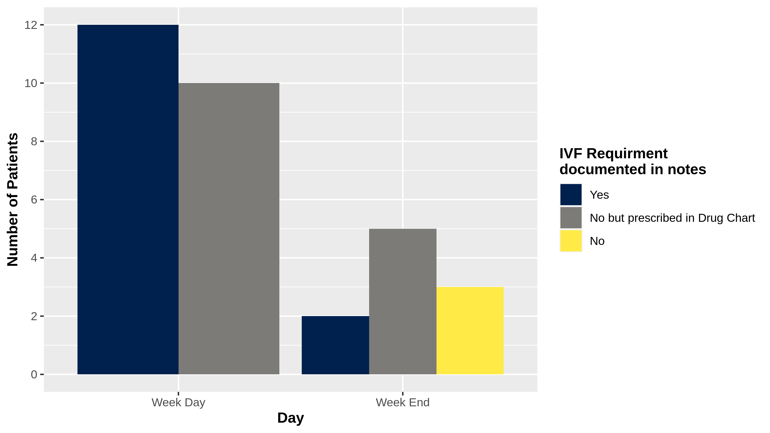

### Plot 2 Compliance to Appropriate Fluids Prescription

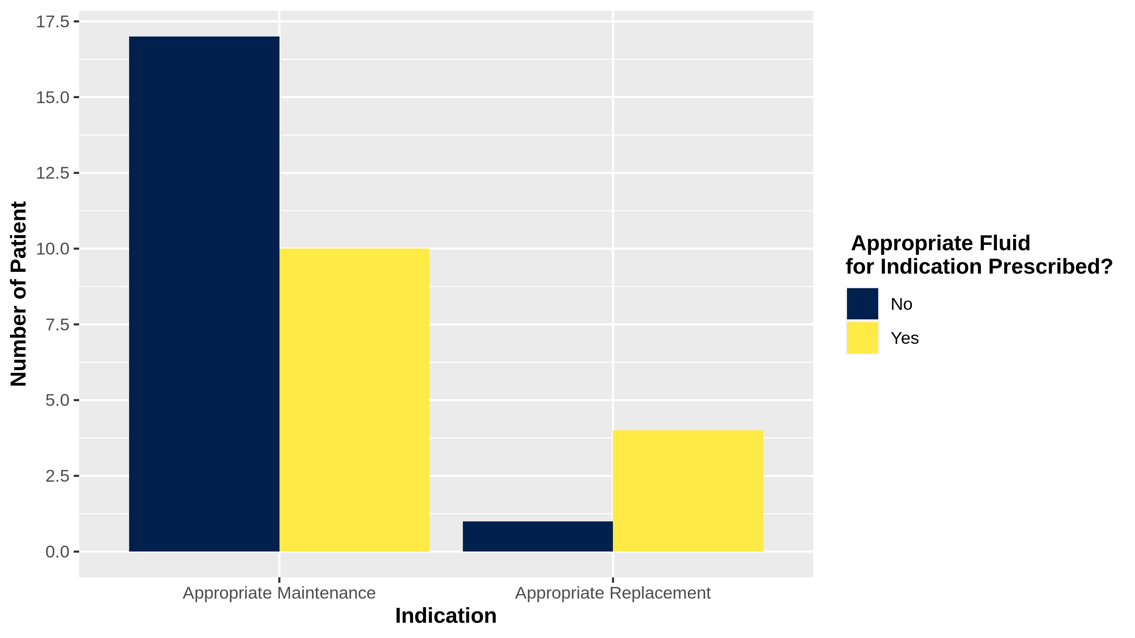

### Plot 3 Compliance to Daily Reviews and Proper Documentation

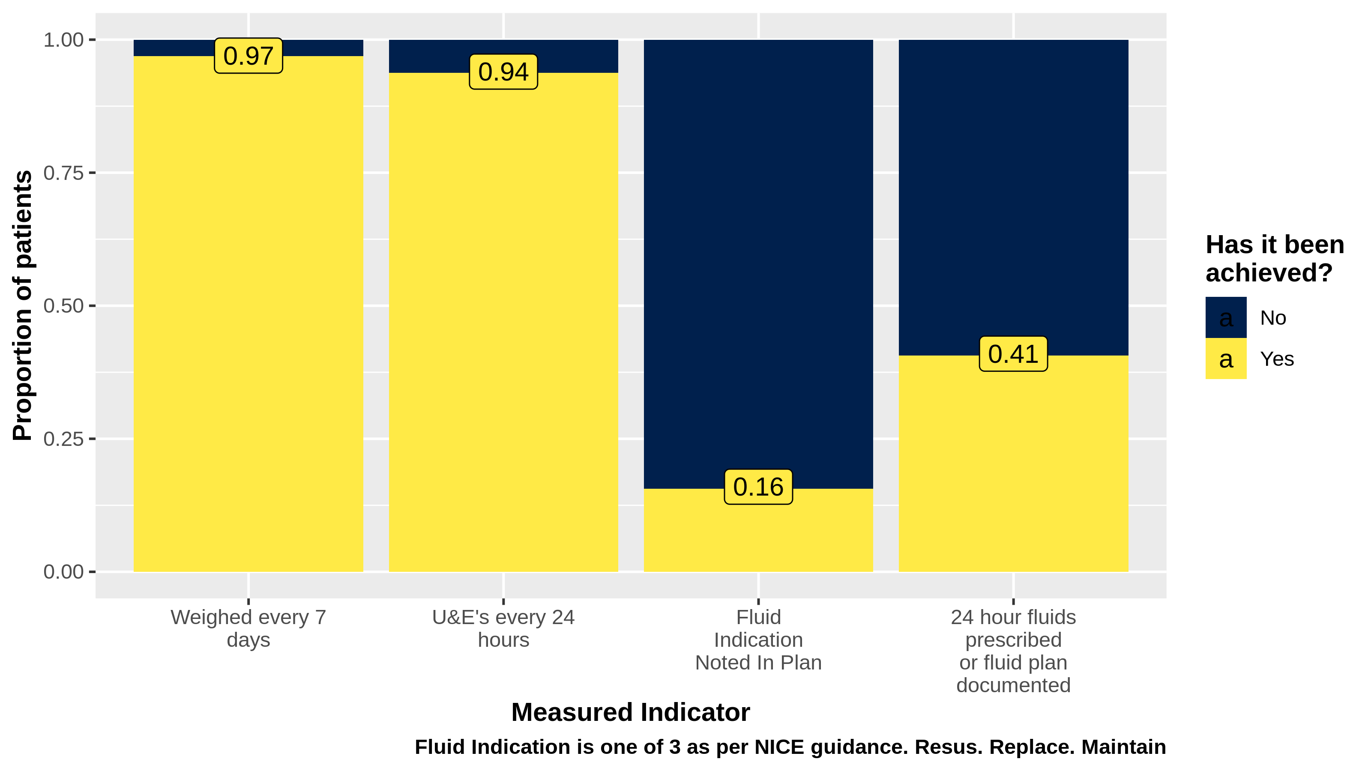

### Plot 4.1 Compliance to IVF Specifications

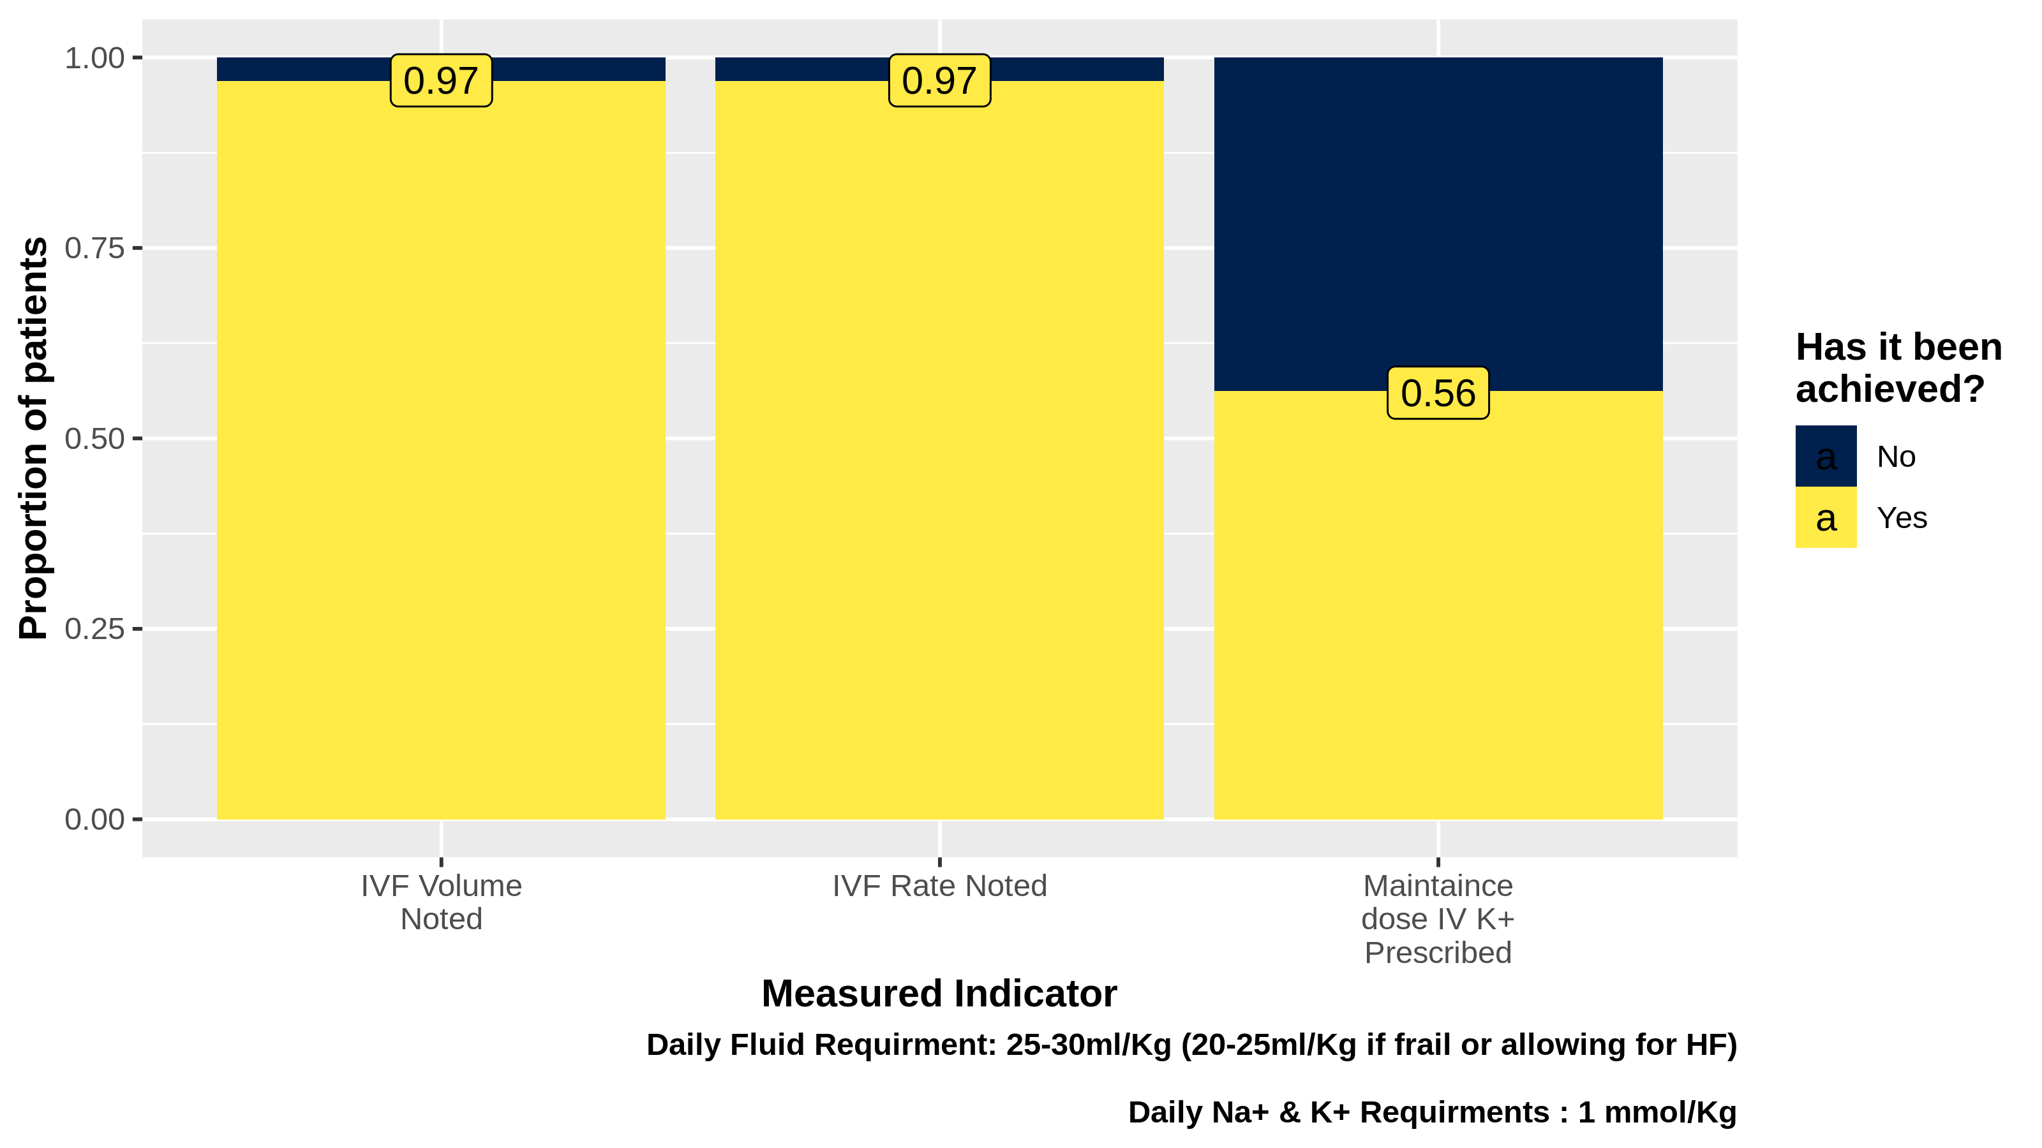

### Plot 4.2

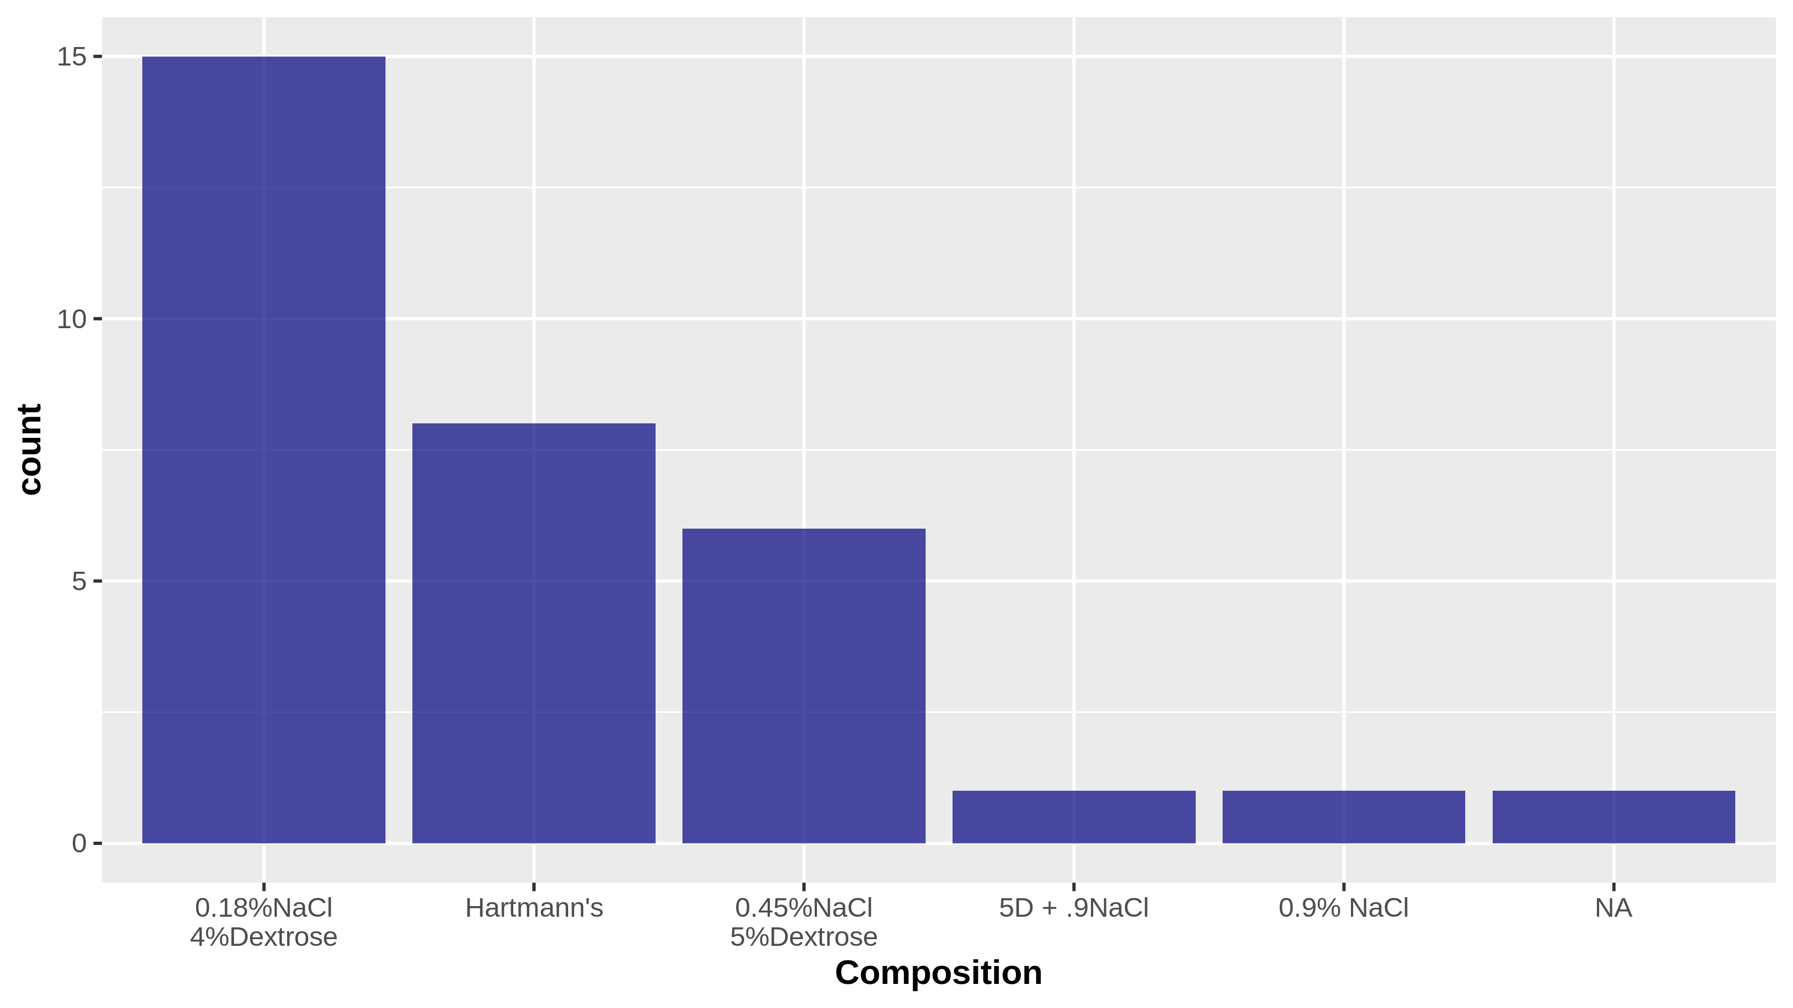

Over 20 instances of IVF prescription recorded on overnight shift on nerver centre for period of assesment.