GIT&GITHUB-01

1. Set up MFA (Multi-Factor Authentication) for the GitHub account using a mobile app.

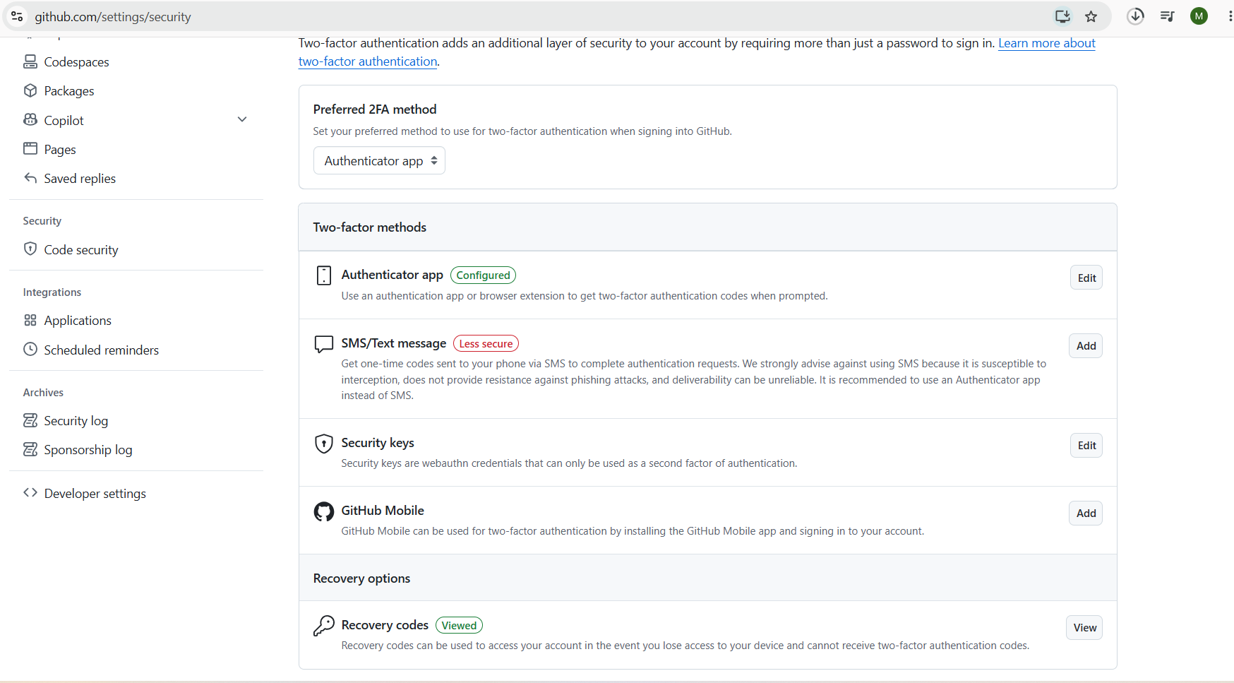

2. Execute all commands shown in the video.

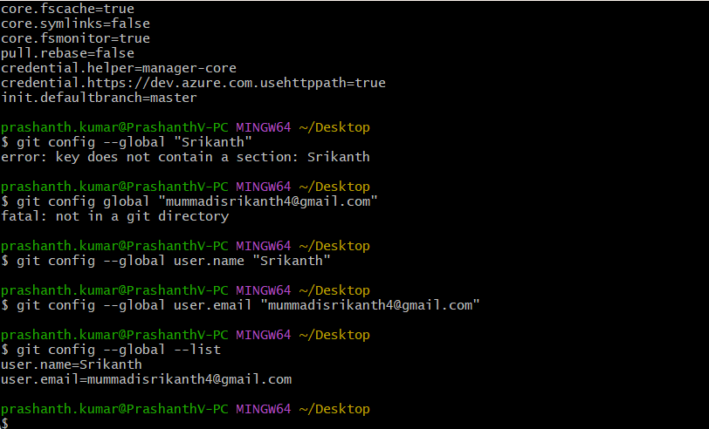

Create a files
Touch A B C
Git status
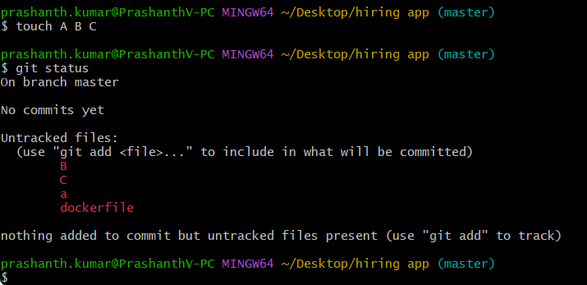

Add files
git add A
git add A B C
git add .
git status
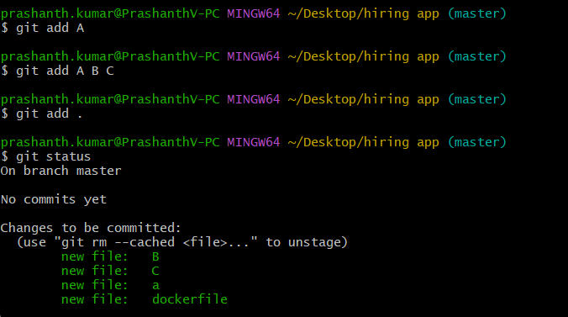

Commit changes
git commit -m "Initial commit"
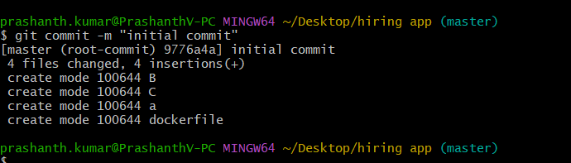

Commit history
Git log
Git log -4
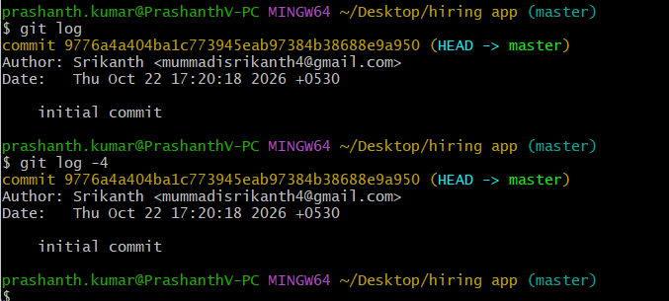

Create GitHub repository and connect it
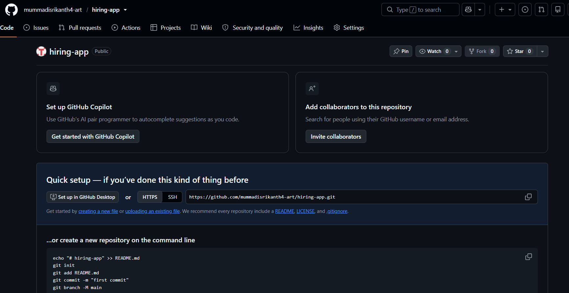
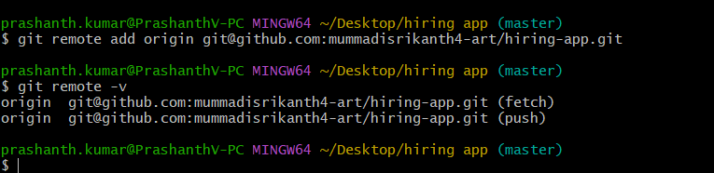

Rename branch to main:-
I used git branch -M main to rename my branch
to main
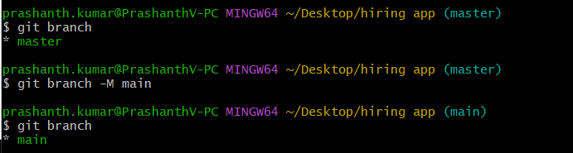

Push code to Github

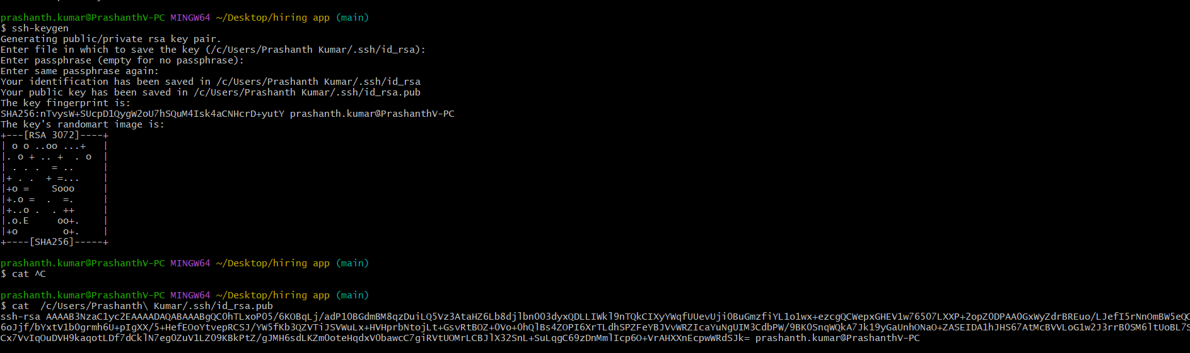
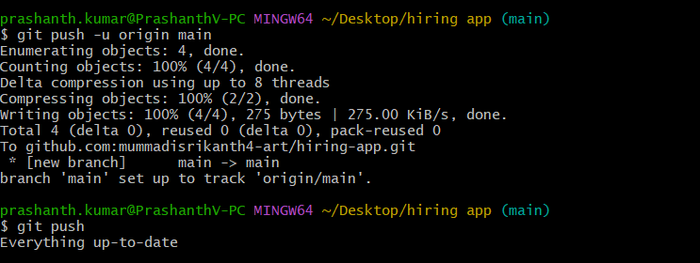
I used git push -u origin main to upload my local commits to the GitHub repository.
The origin represents my remote GitHub repository, and main represents the branch I want to push.
I used git push to upload my local commits to GitHub.

Make another change
touch D
git status
git add D
git commit -m "Added D file"
git push
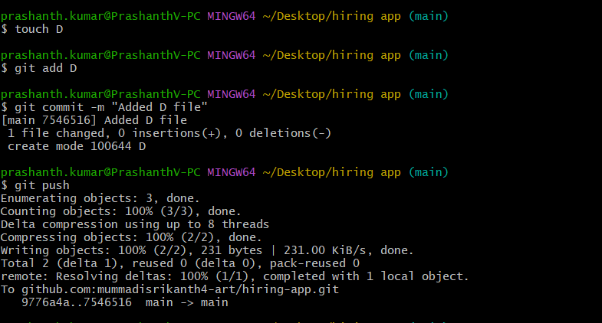

Fetch changes

