1. Install git.

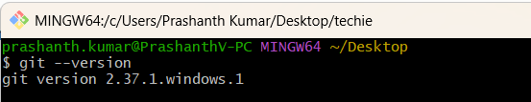

2. Create a repo in github with README.md and .ignore file.
• Open GitHub and sign in to your account.
• Click the + icon in the top-right corner.
• Select New repository.
• Enter the repository name, for example, devops-practice.
• Add a description if required.
• Select Public or Private visibility.
• Select Add a README file.
• Select a suitable template under Add .gitignore, or leave it as None to create the file later.
• Click Create repository.
• If .gitignore was not created automatically, click Add file → Create new file.
• Enter .gitignore as the filename and add the required ignore rules.
• Click Commit changes to save the file.
• Verify that both README.md and .gitignore are available in your repository.

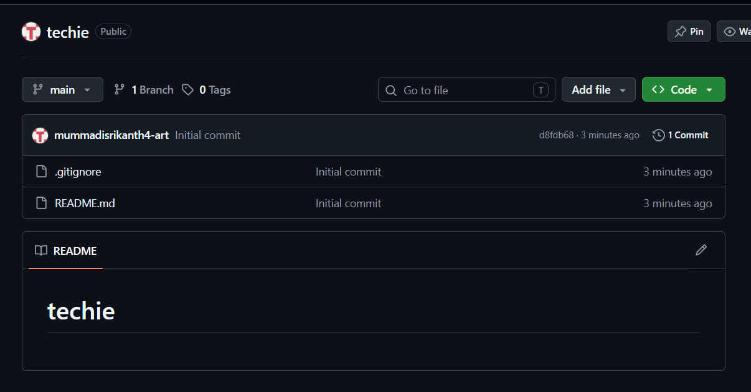

3. Clone the created repo to local.
• Open GitHub and navigate to your created repository.
• Click the green Code button.
• Select the HTTPS option.
• Copy the repository URL.
• Open Git Bash on your local Windows computer.
• Navigate to the folder where you want to store the repository.
• Clone the repository using the copied URL.
• Wait for Git to download the repository files.
• Open the cloned repository folder on your computer.
• Verify that the README.md and .gitignore files are present.
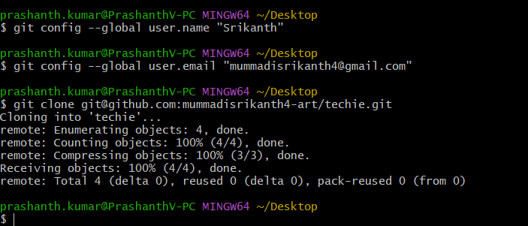

4. Create two files in local repo.

• Open Git Bash on your computer.
• Navigate to the folder where you cloned your GitHub repository.
• Open the local repository folder.
• Create two new files with suitable names, for example, file1.txt and file2.txt.
• Add some sample content to both files.
• Save the files.
• Verify that both files are present inside your local repository folder.

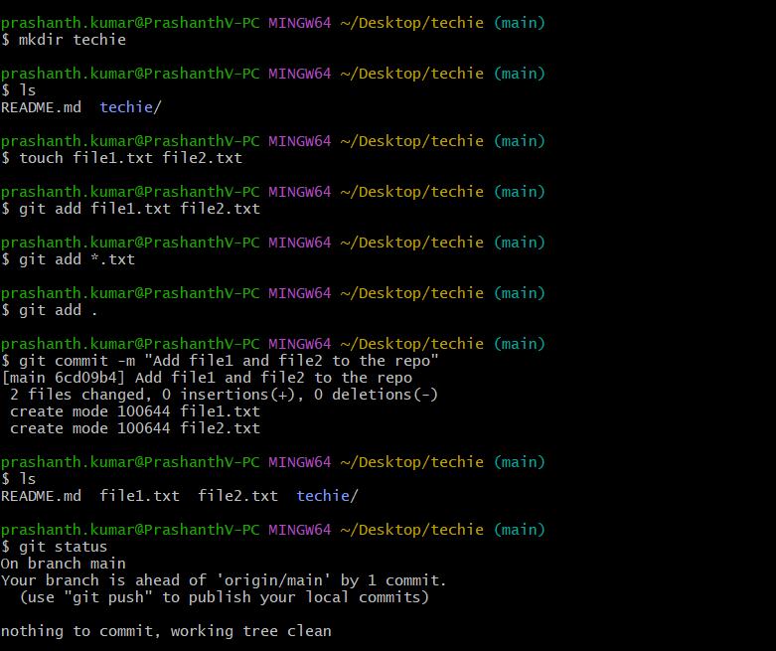

5. Commit two files and push to central Repository.

• Open Git Bash on your computer.
• Navigate to your local Git repository.
• Check the repository status to identify the two files.
• Add both files to the staging area.
• Commit both files with a suitable commit message.
• Push the committed files to the central repository (GitHub).
• Open GitHub and refresh the repository page.
• Verify that both files are successfully uploaded and visible.

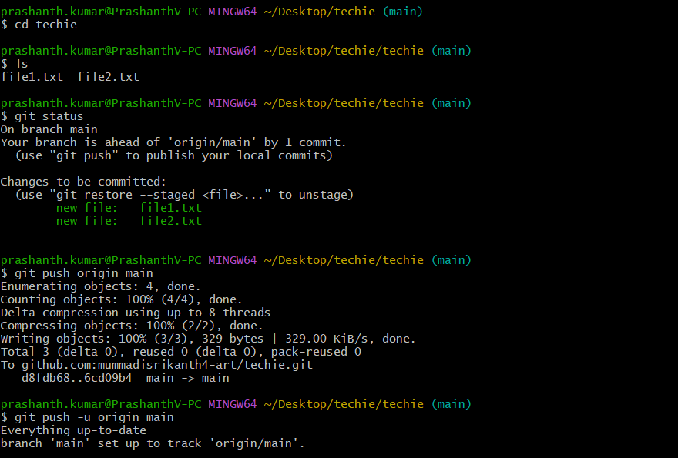

6. Create a branch in local and create a sample file and push to central.

- Open Git Bash and navigate to your local repository.
- Check the current branch and repository status.
- Create a new branch in the local repository.
- Switch to the newly created branch.
- Create a sample file inside the repository.
- Add the sample file to the staging area.
- Commit the file with a suitable commit message.
- Push the new branch and its file to the central repository (GitHub).
- Open GitHub and verify that the new branch and sample file are available.

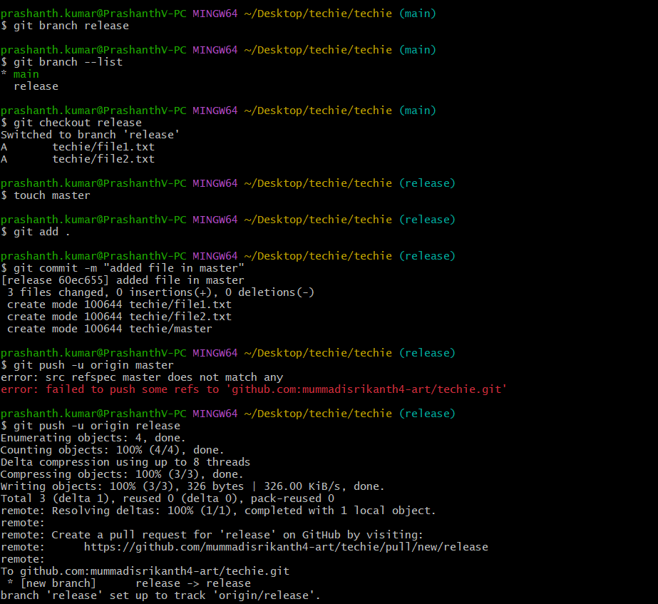

7. Create a branch in github and clone that to local.

• Open your repository on GitHub.
• Click the branch dropdown near the top-left of the repository.
• Enter a new branch name in the search box.
• Click Create branch to create the new branch from the selected base branch.
• Copy the repository's HTTPS URL from the Code button.
• Open Git Bash on your local computer.
• Clone the repository using the copied URL.
• Navigate into the cloned repository folder.
• Switch to the newly created branch.
• Verify that the local repository is on the correct branch.

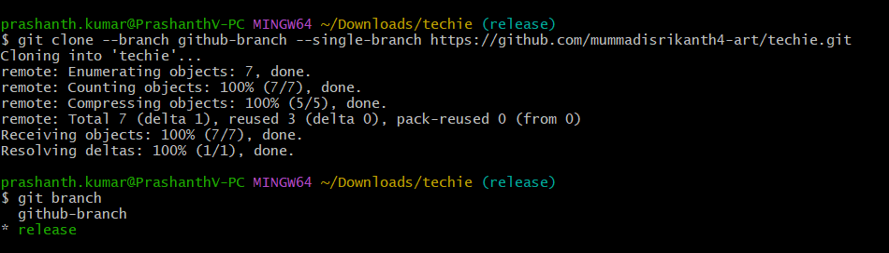

8. Merge the created branch with master in git local.

• Open Git Bash and navigate to your local repository.
• Check the available branches.
• Switch to the master branch.
• Update the local master branch if required.
• Merge the created branch into the master branch.
• Check the repository status to verify the merge.
• Resolve any merge conflicts if they occur.
• Commit the resolved changes if required.
• Verify that the changes from the created branch are available in master

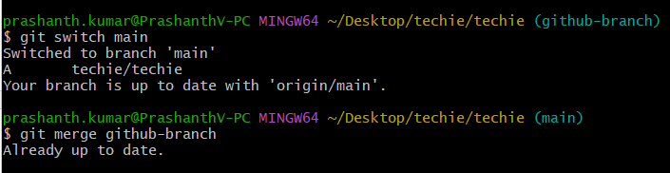

9. Merge the created branch with master in github by sending a pull request.

• Open your repository on GitHub.
• Select the created branch from the branch dropdown.
• Ensure all required changes are committed and pushed to GitHub.
• Click Pull requests.
• Click New pull request.
• Select master as the base branch and your created branch as the compare branch.
• Review the changes and click Create pull request.
• Enter a suitable title and description for the pull request.
• Click Create pull request to submit it.
• After reviewing the changes, click Merge pull request.
• Click Confirm merge.
• Verify that the changes from your created branch are available in master.

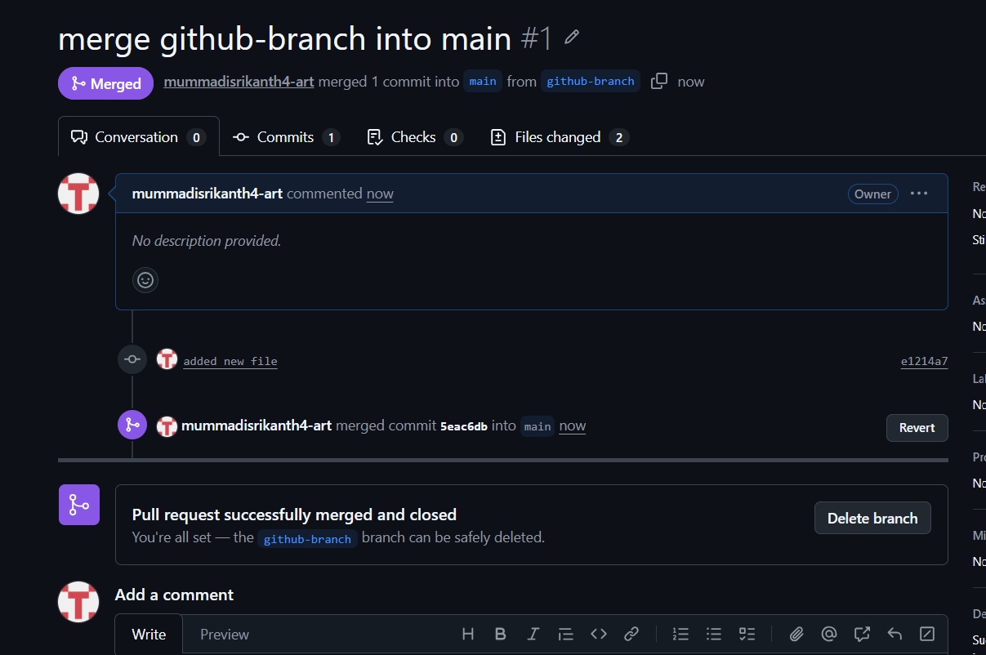

10. Create a file in local and send that to branch in github.

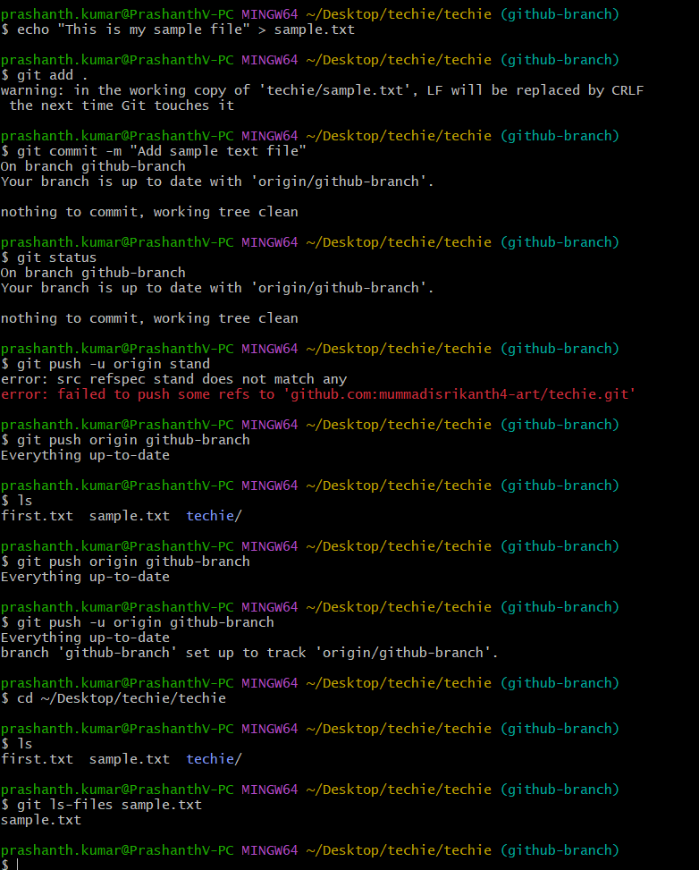

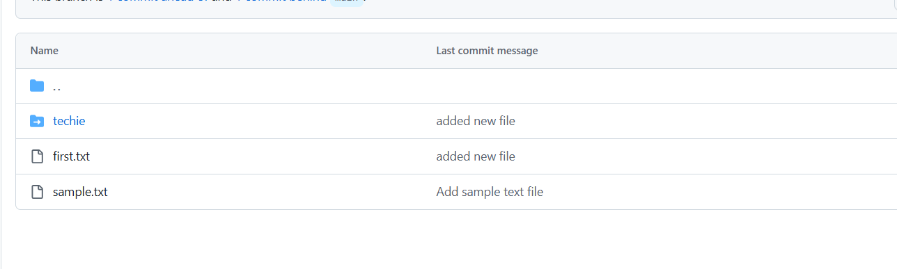

11. Clone only a branch from github to local.

12. Create a file with all passwords and make that untrackable with git.

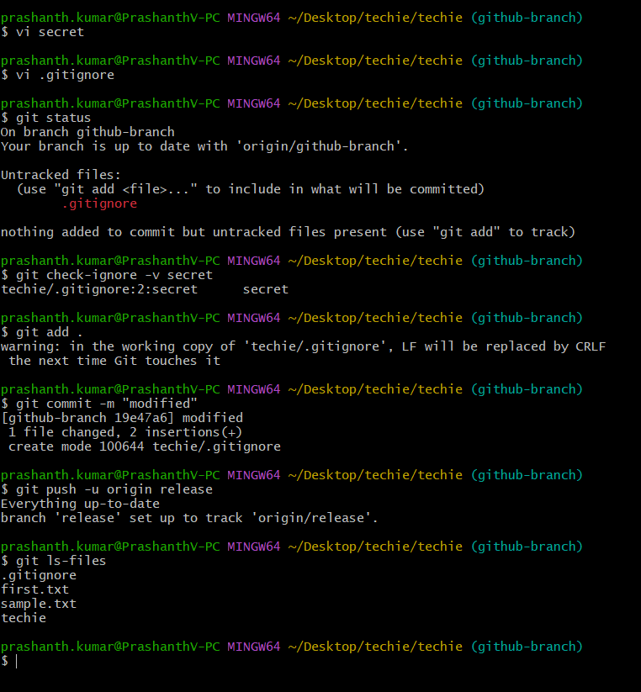

13. Make a commit and make that commit reset without savings changes.

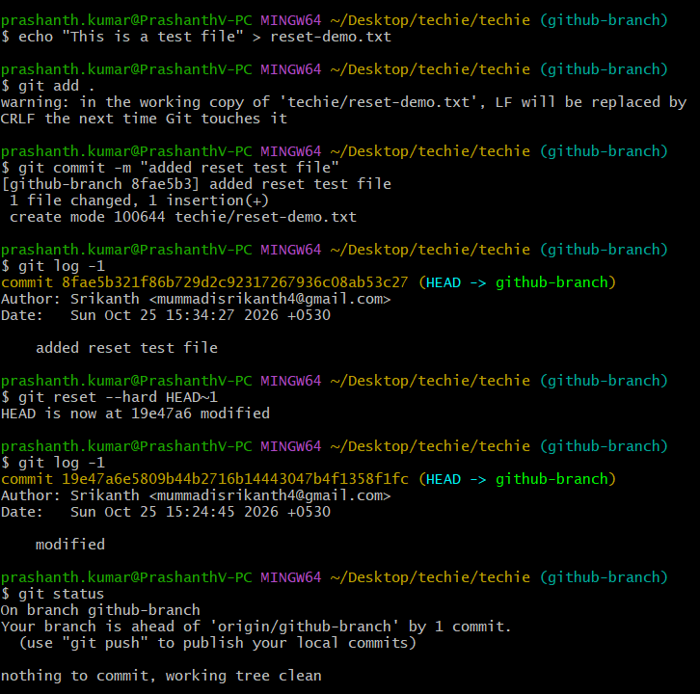

14. Revert a commited commit to the older version.

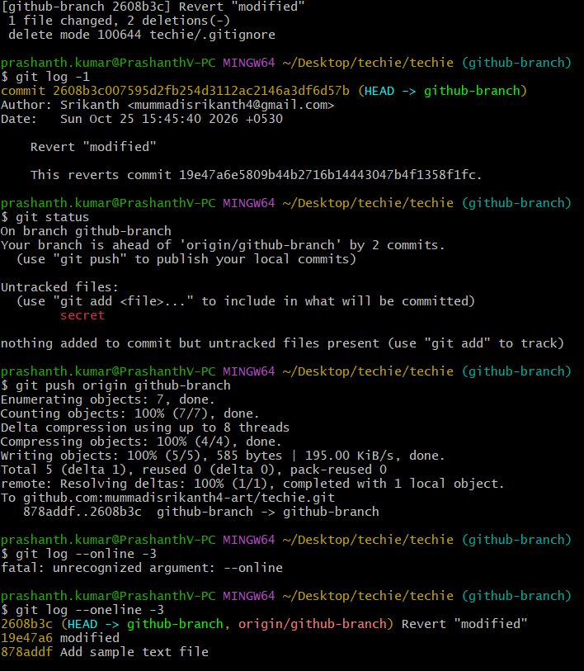

15. Push a file to stash without savings the changes and work on another file.

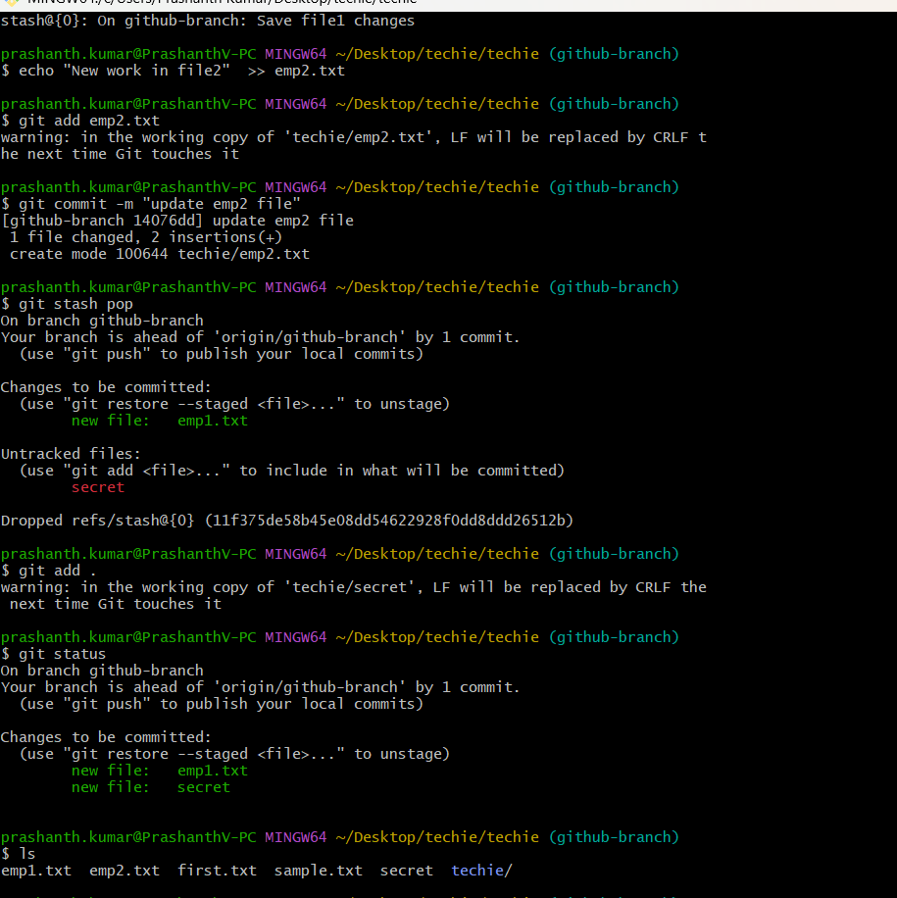

16. Undo the stash file and start working on that again.

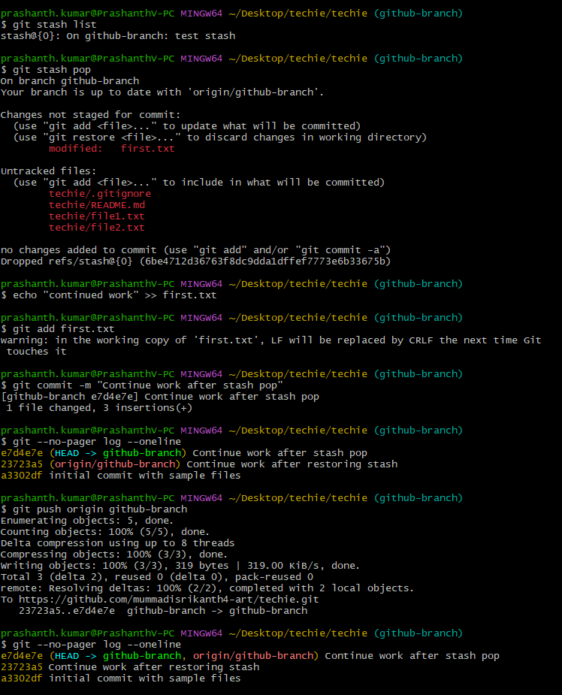

17. Generate a ssh-keygen and configure into github.

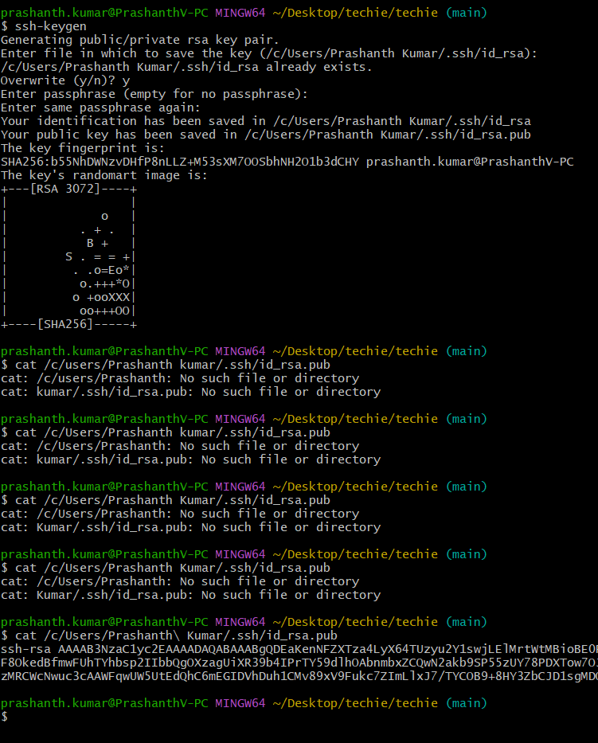
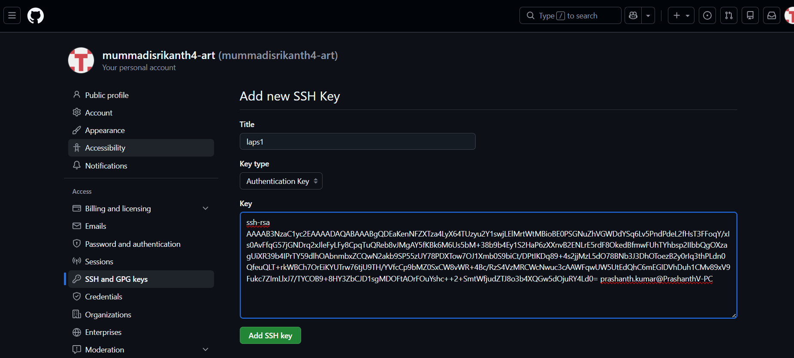

18. Configure webhooks to github.

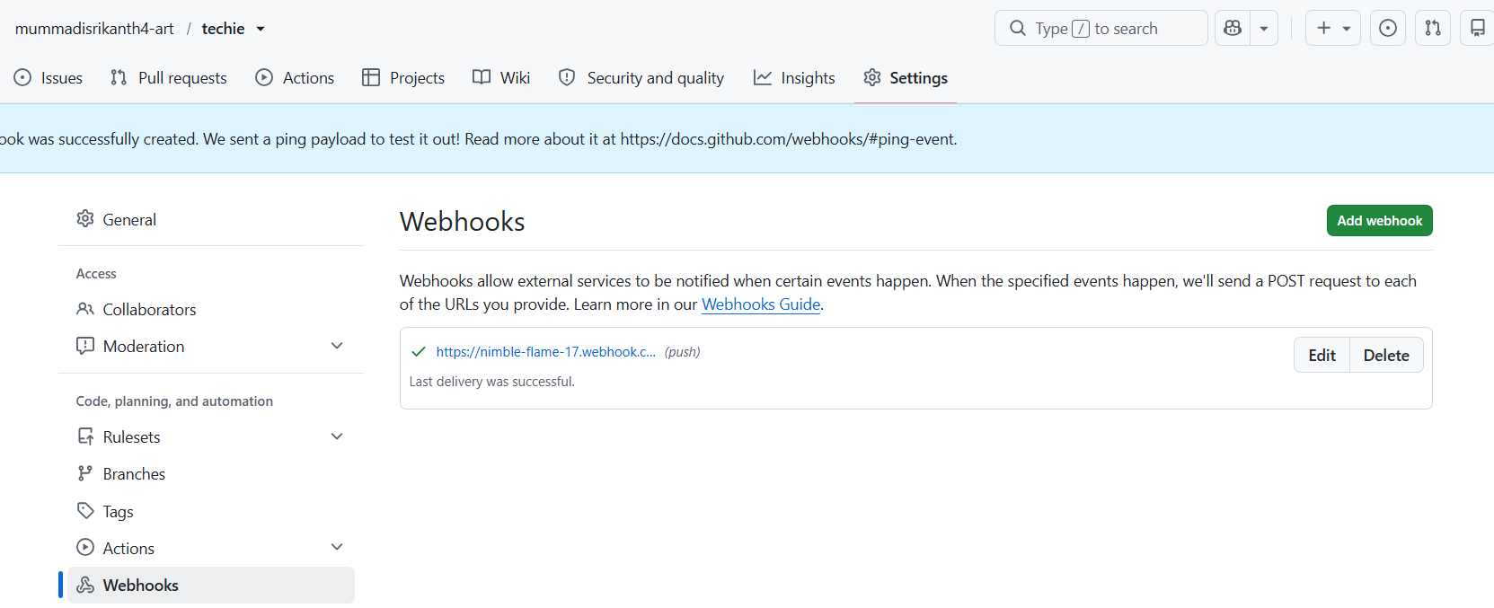

19. Basic understanding of .git file.

The .git folder is a hidden directory that Git creates in your project when you run git init or git clone. It holds the entire repository: all commits, branches, tags, configuration and the staging area. Your project files are just a checkout of one snapshot from it. If you delete .git, the folder becomes a plain folder with no history.
Main contents
Item | Purpose
HEAD | Points to the current branch (e.g. ref: refs/heads/github-branch)
config | Repo settings: remote URL (origin), branch tracking, local user name/email
index | The staging area, which records what git add has staged for the next commit
objects/ | The database of all commits, files (blobs) and directory trees, stored by SHA-1 hash
refs/ | Pointers to commits: heads/ (branches), tags/, remotes/
logs/ | The reflog, a history of where HEAD and branches have moved
hooks/ | Sample scripts that run on events like pre-commit or pre-push
info/exclude | Local-only ignore rules (like .gitignore, but not shared)

20. Check all the logs of git.

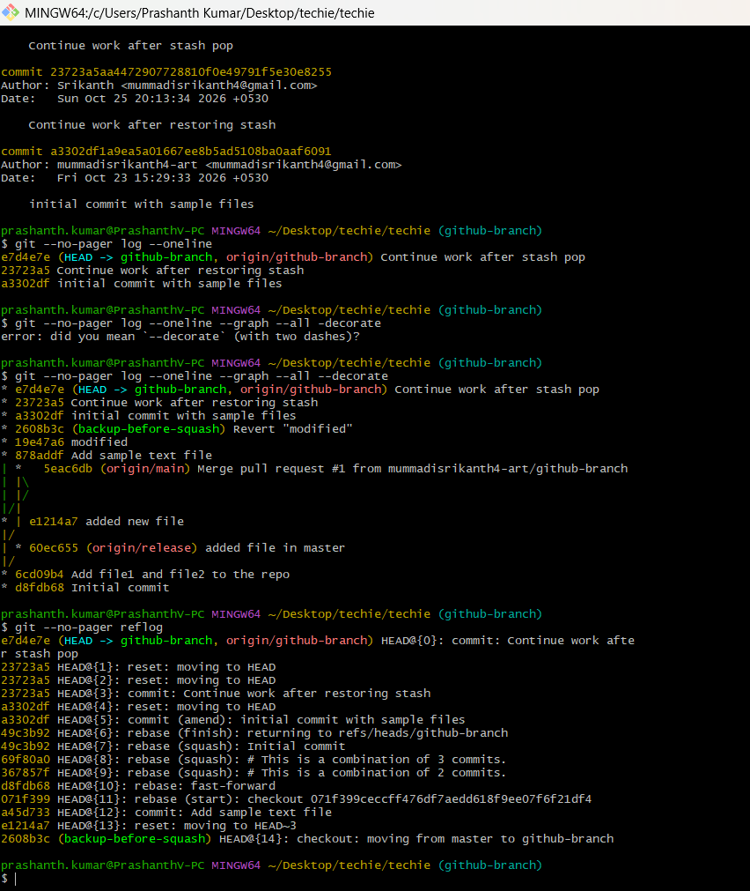

21. Rename the commit message.

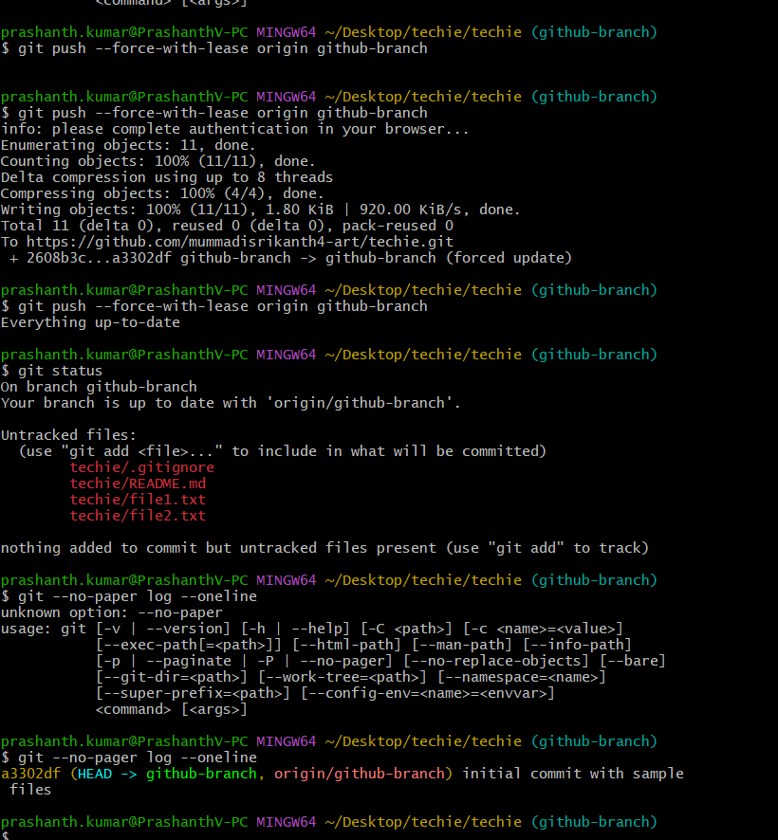

22. Merge multiple commits into single commit.
