Use Case: Setting up Transit Gateway and VPC Endpoints for a Multi-VPC Architecture
Scenario:
A large organization is migrating its on-premises infrastructure to the AWS cloud.
The organization's architecture involves multiple VPCs for different departments and applications, each requiring secure communication with centralized services and external resources.
The IT team needs to design and implement a scalable and efficient network architecture to accommodate the organization's growth and ensure robust connectivity between VPCs and external services.
Objectives:
- Design and deploy a scalable network architecture using AWS Transit Gateway to simplify network connectivity between multiple VPCs.
- Configure VPC endpoints to securely access AWS services without internet gateways or NAT gateways, ensuring data privacy and minimizing exposure to external threats.

Created VPCs
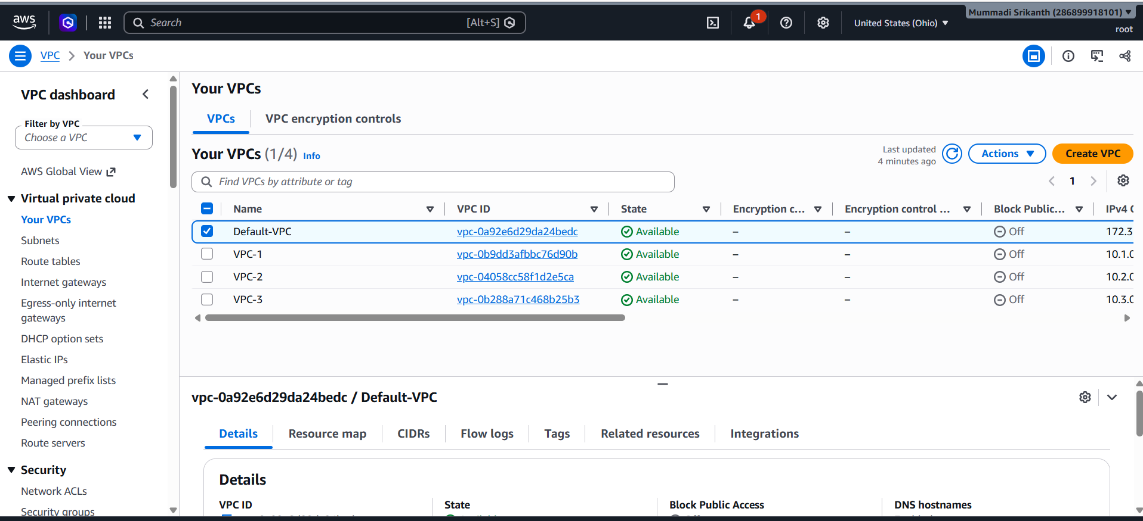

Created Subnets
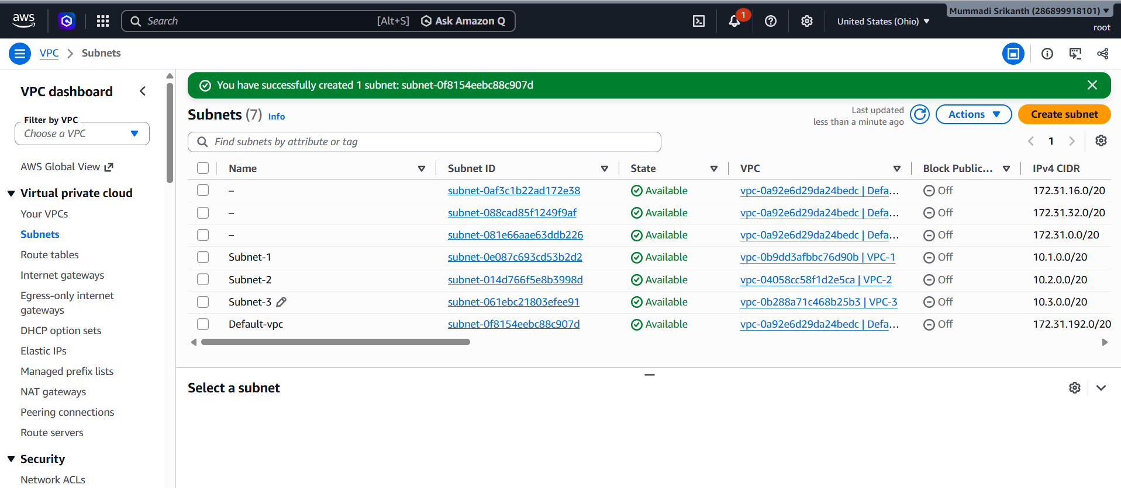

Created Route Tables
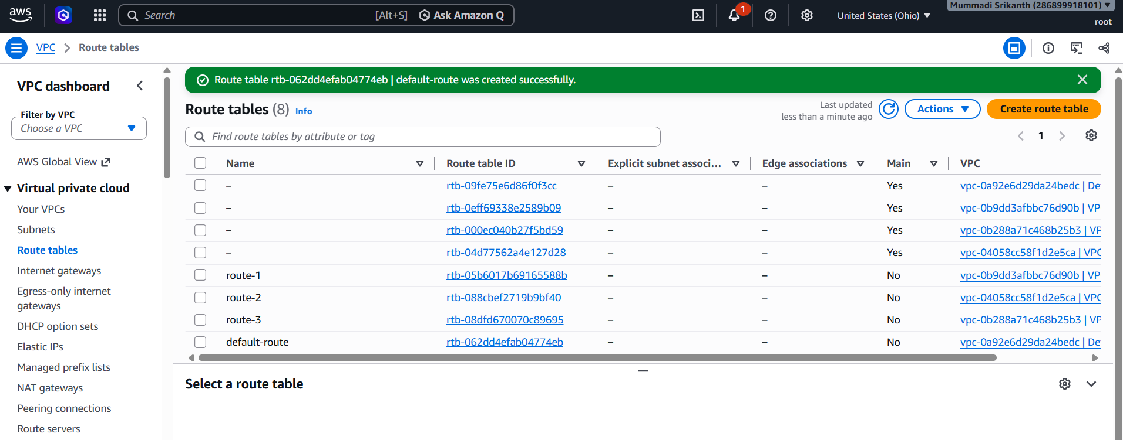

Created Transit gateway attachments
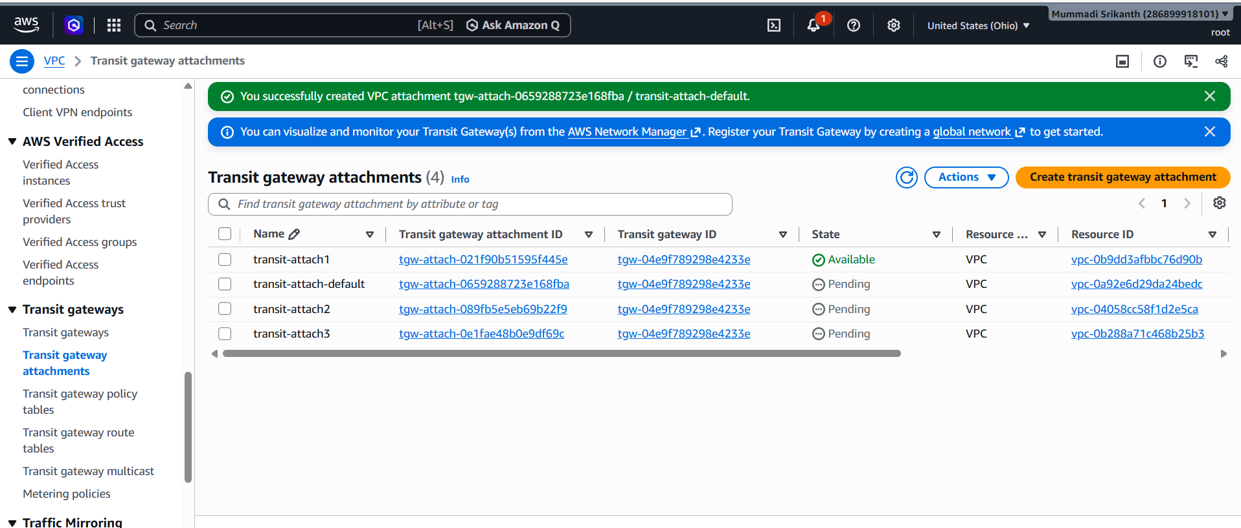

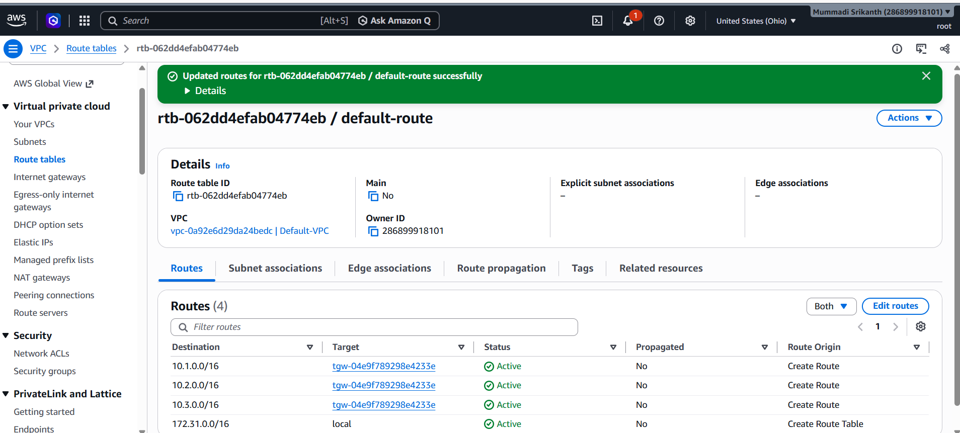

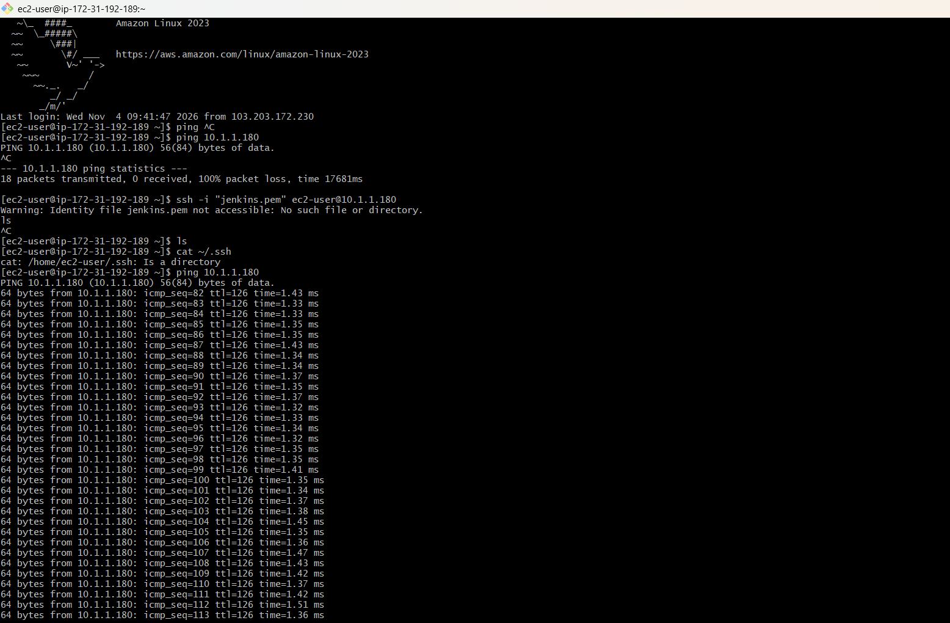

1:- First create a IAM user with s3 full access policy. Then take access key and
secret key from the user.
2:- Now create a S3 bucket.
3:- Go to VPC service and select Endpoint then create new endpoint disable the
DNS configurations, We need new security group for this Endpoint.
4:- In this security configure all VPC ip into HTTPS port.
5:- Now select ssm service in the Services while creating the Endpoint. Then add
the VPC where we want to attach the Endpoint.
6:- Connect with instance, then connect to private instance.
7:- Use aws configure. Add the credentials there.
8:- Then use aws s3 ls to see S3 bucket name.



