CDI 12v
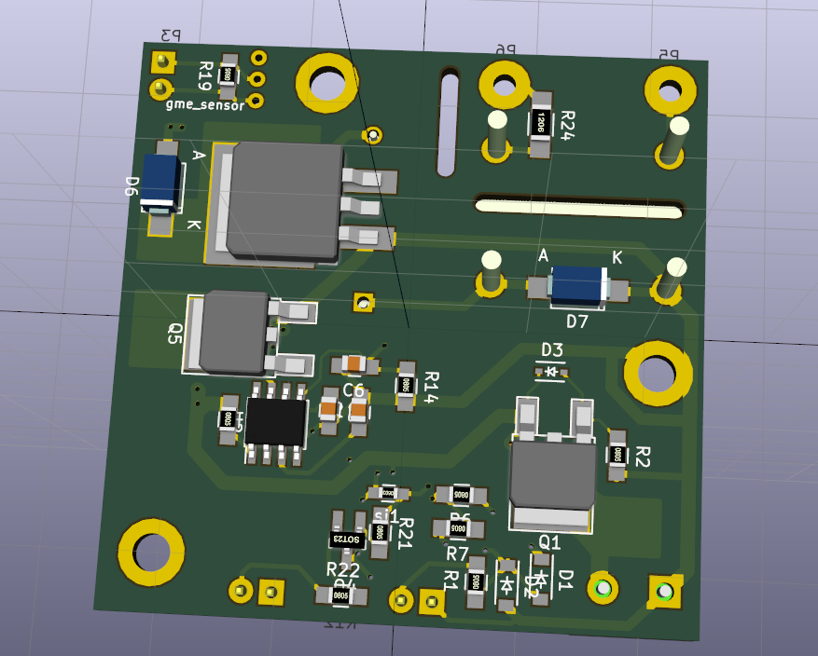
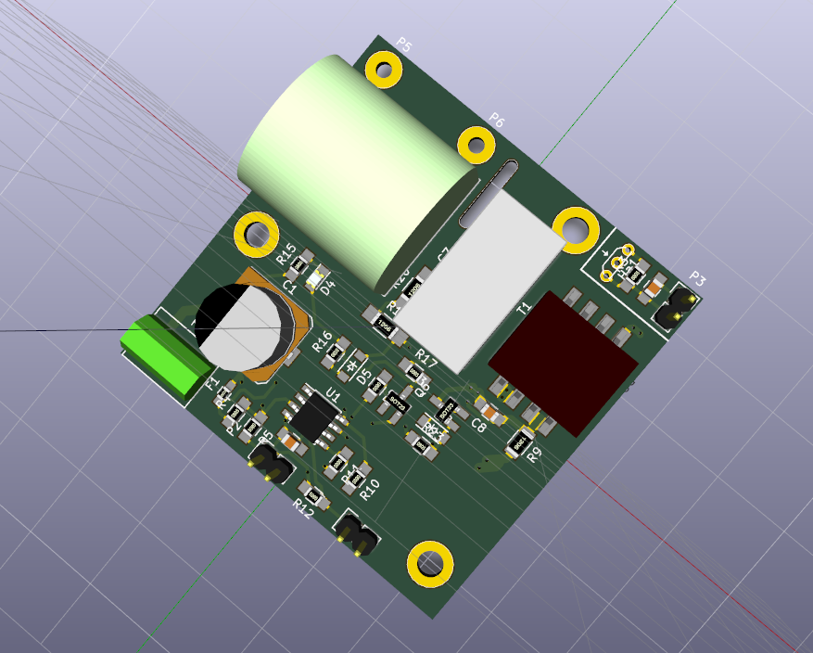

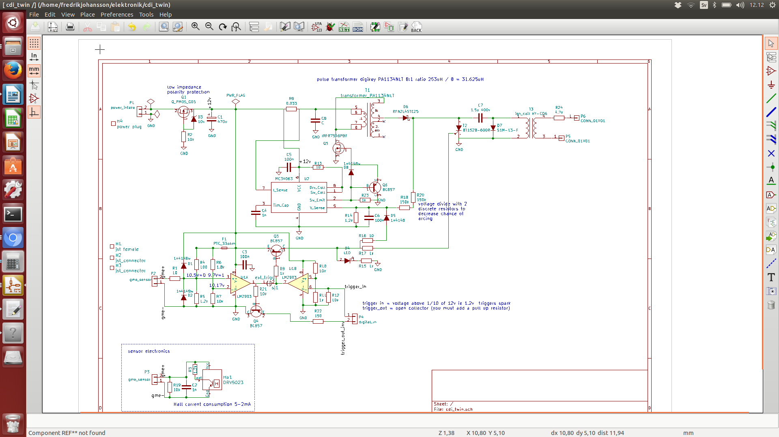

All prices are in SEK.
Index | Quantity | Image | Part Number | Description | Customer Reference | Available Quantity | Backorder Quantity | Unit Price | Extended Price
1 |  | 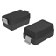 | 1N4148W-FDICT-ND | DIODE GEN PURP 100V 300MA SOD123 |  | 4  Immediate | 0 | 1,37000 | 5,48 kr
2 |  | 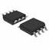 | 296-1012-1-ND | IC DUAL DIFF COMP 8-SOIC |  | 1  Immediate | 0 | 3,17000 | 3,17 kr
3 |  | 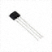 | 296-38520-ND | IC HALL SENSOR DGTL SW TO-92 |  | 1  Immediate | 0 | 9,60000 | 9,60 kr
4 |  | 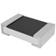 | 311-1.00KCRCT-ND | RES SMD 1K OHM 1% 1/8W 0805 |  | 5  Immediate | 0 | 0,86000 | 4,30 kr
5 |  |  | 311-1.20KCRCT-ND | RES SMD 1.2K OHM 1% 1/8W 0805 |  | 3  Immediate | 0 | 0,86000 | 2,58 kr
6 |  |  | 311-1.80KCRCT-ND | RES SMD 1.8K OHM 1% 1/8W 0805 |  | 1  Immediate | 0 | 0,86000 | 0,86 kr
7 |  |  | 311-10.0CRCT-ND | RES SMD 10 OHM 1% 1/8W 0805 |  | 3  Immediate | 0 | 0,86000 | 2,58 kr
8 |  |  | 311-10.0KCRCT-ND | RES SMD 10K OHM 1% 1/8W 0805 |  | 6  Immediate | 0 | 0,86000 | 5,16 kr
9 |  |  | 311-100CRCT-ND | RES SMD 100 OHM 1% 1/8W 0805 |  | 1  Immediate | 0 | 0,86000 | 0,86 kr
10 |  |  | 311-150CRCT-ND | RES SMD 150 OHM 1% 1/8W 0805 |  | 1  Immediate | 0 | 0,86000 | 0,86 kr
11 |  | 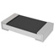 | 311-150KERCT-ND | RES SMD 150K OHM 5% 1/4W 1206 |  | 2  Immediate | 0 | 0,86000 | 1,72 kr
12 |  |  | 311-4.7ERCT-ND | RES SMD 4.7 OHM 5% 1/4W 1206 |  | 1  Immediate | 0 | 0,86000 | 0,86 kr
13 |  | 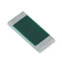 | 408-1576-1-ND | RES SMD 0.033 OHM 1% 3/4W 1206 |  | 1  Immediate | 0 | 4,63000 | 4,63 kr
14 |  | 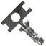 | 455-1135-1-ND | CONN TERM CRIMP XH 22-28AWG |  | 2  Immediate | 0 | 0,86000 | 1,72 kr
15 |  | 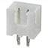 | 455-2247-ND | CONN HEADER XH TOP 2POS 2.5MM |  | 2  Immediate | 0 | 1,29000 | 2,58 kr
16 |  | 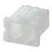 | 455-2266-ND | CONN HOUSING 2.5MM 2POS |  | 1  Immediate | 0 | 0,86000 | 0,86 kr
17 |  | 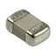 | 478-1328-1-ND | CAP CER 1000PF 50V NP0 0805 |  | 3  Immediate | 0 | 0,86000 | 2,58 kr
18 |  | 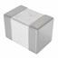 | 478-3352-1-ND | CAP CER 0.1UF 50V X7R 0805 |  | 3  Immediate | 0 | 0,86000 | 2,58 kr
19 |  | 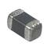 | 490-2471-1-ND | THERMISTOR PTC 33 OHM SMD |  | 1  Immediate | 0 | 4,63000 | 4,63 kr
20 |  | 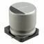 | 493-6225-1-ND | CAP ALUM 470UF 20% 25V SMD |  | 1  Immediate | 0 | 5,83000 | 5,83 kr
21 |  | 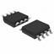 | 497-7851-1-ND | IC REG BUCK BOOST INV ADJ 8SOIC |  | 1  Immediate | 0 | 4,80000 | 4,80 kr
22 |  | 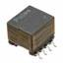 | 553-1982-1-ND | XFRMR 5V 7W 253UH POE EP10 SMD |  | 1  Immediate | 0 | 31,97000 | 31,97 kr
23 |  | 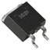 | 568-9619-1-ND | THYRISTOR 650V 20A D2PAK |  | 1  Immediate | 0 | 10,20000 | 10,20 kr
24 |  | 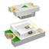 | 732-4986-1-ND | LED GREEN CLEAR 0805 SMD |  | 1  Immediate | 0 | 2,83000 | 2,83 kr
25 |  | 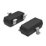 | BC857ALT1GOSCT-ND | TRANS PNP 45V 0.1A SOT-23 |  | 3  Immediate | 0 | 1,03000 | 3,09 kr
26 |  | 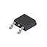 | DMP3010LK3Q-13DICT-ND | MOSFET P-CH 30V 17A TO252 |  | 1  Immediate | 0 | 5,31000 | 5,31 kr
27 |  | 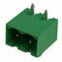 | ED2828-ND | TERM BLOCK HDR 2POS R/A 5.08MM |  | 1  Immediate | 0 | 2,31000 | 2,31 kr
28 |  | 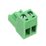 | ED2908-ND | TERM BLOCK PLUG 2POS STR 5.08MM |  | 1  Immediate | 0 | 7,54000 | 7,54 kr
29 |  | 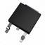 | IRFR7546PBF-ND | MOSFET N-CH 60V 56A DPAK |  | 1  Immediate | 0 | 7,03000 | 7,03 kr
30 |  | 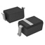 | MM3Z10VT1GOSCT-ND | DIODE ZENER 10V 300MW SOD323 |  | 1  Immediate | 0 | 1,20000 | 1,20 kr
31 |  | 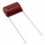 | PCF1613-ND | CAP FILM 1.5UF 5% 450VDC RADIAL |  | 1  Immediate | 0 | 6,86000 | 6,86 kr
32 |  | 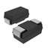 | RFN2L4STE25CT-ND | DIODE SCHOTTKY 400V 1.5A PMDS |  | 1  Immediate | 0 | 4,63000 | 4,63 kr
33 |  | 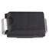 | S1M-FDICT-ND | DIODE GEN PURP 1KV 1A SMA |  | 1  Immediate | 0 | 2,06000 | 2,06 kr
 |  |  |  |  |  |  |  | Subtotal | 153,27 kr
 |  |  |  |  |  |  |  | Shipping | 170,00 kr
 |  |  |  |  |  |  |  | Total | unknown

