**Novel Transfer Learning Based Deep Features for**

**Diagnosis of Down syndrome in Children**

**Using Facial Images**

# **ABSTRACT**

The early and accurate diagnosis of Down syndrome in children is critical for effective intervention and support. This study presents a novel approach to Down syndrome diagnosis using facial images through advanced transfer learning techniques and deep feature extraction methods. We propose a multi-faceted approach that integrates VNL-Net and a MobileNet + SVM hybrid model to enhance diagnostic accuracy and computational efficiency.

Our primary methodology involves VNL-Net, which combines the VGG16 model for initial spatial feature extraction with Non-Negative Matrix Factorization (NMF) for dimensionality reduction and refined feature extraction. The extracted features are then further enhanced using the Light Gradient Boosting Machine (LGBM). This robust feature generation method is followed by classification using Logistic Regression, with the model's performance rigorously evaluated through k-fold cross-validation.

To extend our approach for practical deployment, especially on mobile and edge devices, we introduce a MobileNet + SVM hybrid model. MobileNet's efficient feature extraction capabilities are leveraged to process facial images, producing lightweight yet high-performance features. These features are then classified using a Support Vector Machine (SVM), aimed at distinguishing between Down syndrome and healthy children effectively.

Our proposed methods demonstrate improved accuracy in Down syndrome detection, leveraging the strengths of advanced transfer learning models and hybrid classification approaches. This research not only contributes to the field of automated medical diagnosis but also addresses the need for efficient, real-time solutions suitable for mobile and edge computing environments.

**Keywords:** Down syndrome, facial images, transfer learning, VNL-Net, VGG16, Non-Negative Matrix Factorization, Light Gradient Boosting Machine, MobileNet, Support Vector Machine, classification, logistic regression, feature extraction, deep learning.

**STATEMENT ABOUT THE PROBLEM**

The early and accurate diagnosis of Down syndrome in children is essential for effective intervention and support. Traditional diagnostic methods are often invasive, time-consuming, and costly. This study addresses the need for a non-invasive, efficient, and accurate diagnostic tool by proposing a novel approach using facial images and advanced transfer learning techniques. By integrating VNL-Net and a MobileNet + SVM hybrid model, we aim to enhance diagnostic accuracy and computational efficiency, making the solution viable for mobile and edge devices. This approach leverages deep feature extraction and hybrid classification methods to distinguish between Down syndrome and healthy children effectively.

**WHY IS THE PARTICULAR TOPIC CHOSEN?**

The choice to focus on the diagnosis of Down syndrome using facial images through advanced transfer learning techniques stems from several compelling factors. Down syndrome, a genetic disorder caused by the presence of an extra chromosome 21, is characterized by distinct facial features and developmental delays. Early and accurate diagnosis is essential for timely intervention and support, which can significantly improve the quality of life for affected children and their families. Traditional diagnostic methods, which often rely on clinical expertise and genetic testing, can be resource-intensive and may not be accessible in all regions.

Facial recognition technology, combined with deep learning, offers a promising alternative by providing a non-invasive, cost-effective, and scalable solution for early diagnosis. The use of facial images as a diagnostic tool capitalizes on the observable phenotypic markers of Down syndrome, enabling rapid and efficient screening. Advanced transfer learning techniques, such as VNL-Net and MobileNet, further enhance the accuracy and efficiency of this approach. VNL-Net leverages pre-trained models like VGG16 to extract meaningful features from facial images and refines them through Non-Negative Matrix Factorization and Light Gradient Boosting Machine, improving diagnostic precision.

**SCOPE**

The scope of this study encompasses the development and evaluation of advanced diagnostic models for early detection of Down syndrome in children using facial images. It includes the integration of VNL-Net for robust feature extraction and dimensionality reduction, as well as a MobileNet + SVM hybrid model optimized for mobile and edge device deployment. The research focuses on enhancing diagnostic accuracy and computational efficiency through the use of transfer learning, deep learning, and hybrid classification methods. Additionally, the study involves rigorous performance evaluation using k-fold cross-validation to ensure the reliability and effectiveness of the proposed diagnostic tools in real-world scenarios.

**OBJECTIVE OF THE PROJECT**

The objective of this study is to develop a non-invasive, efficient, and accurate diagnostic tool for early detection of Down syndrome in children using facial images. By employing advanced transfer learning techniques, we aim to enhance diagnostic accuracy and computational efficiency. The study integrates VNL-Net, which combines VGG16 for spatial feature extraction and Non-Negative Matrix Factorization for dimensionality reduction, with a MobileNet + SVM hybrid model for practical deployment on mobile and edge devices. This research seeks to provide a robust, real-time diagnostic solution, leveraging deep feature extraction and hybrid classification methods to distinguish between Down syndrome and healthy children effectively.

# **EXISTING METHOD**

Current methods for diagnosing Down syndrome primarily involve invasive procedures such as amniocentesis and chorionic villus sampling, which carry risks for both mother and child. Non-invasive prenatal testing (NIPT) using cell-free fetal DNA from maternal blood is also available, but it is expensive and not universally accessible. Traditional facial recognition methods rely on manual assessment by trained clinicians, which can be subjective and inconsistent. Additionally, existing automated diagnostic tools often lack the necessary accuracy and computational efficiency for practical deployment, particularly on mobile and edge devices. These limitations highlight the need for improved, non-invasive, and accessible diagnostic solutions.

# **DISADVANTAGES**

Existing diagnostic methods for Down syndrome have several disadvantages:

**1. Invasive Procedures:** Techniques like amniocentesis and chorionic villus sampling are invasive, posing risks to both mother and fetus, including miscarriage and infection.

**2. High Costs:** Non-invasive prenatal testing (NIPT) using cell-free fetal DNA is expensive, limiting its accessibility to many patients, especially in low-resource settings.

**3. Subjectivity:** Manual facial assessments by clinicians are subjective and can vary in accuracy, leading to inconsistent diagnoses.

**4. Limited Accuracy:** Current automated diagnostic tools often fall short in accuracy, resulting in false positives or negatives.

**5. Computational Inefficiency:** Many existing methods are not optimized for mobile or edge devices, limiting their practical deployment in real-time applications.

**6. Accessibility:** High costs and limited availability of advanced diagnostic tools restrict access for many populations, particularly in remote or underserved areas.

# **PROPOSED SYSTEM:**

The proposed system aims to develop a non-invasive, efficient, and accurate diagnostic tool for Down syndrome detection using facial images. It integrates VNL-Net, combining VGG16 for initial spatial feature extraction with Non-Negative Matrix Factorization (NMF) for dimensionality reduction and Light Gradient Boosting Machine (LGBM) for robust feature generation. Classification is performed using Logistic Regression with k-fold cross-validation. Additionally, a MobileNet + SVM hybrid model is introduced for efficient feature extraction and classification, optimized for deployment on mobile and edge devices. This system leverages advanced transfer learning and hybrid classification methods to enhance diagnostic accuracy and computational efficiency.

# **ADVANTAGES:**

The proposed system for Down syndrome detection offers several advantages:

**1. Non-Invasive:** Uses facial images, eliminating the risks associated with invasive diagnostic procedures.

**2. High Accuracy:** Integrates advanced transfer learning models (VNL-Net and MobileNet) and robust classification techniques to improve diagnostic precision.

**3. Computational Efficiency:** Employs efficient feature extraction and classification methods, making it suitable for real-time deployment on mobile and edge devices.

**4. Cost-Effective:** Provides a more affordable alternative to expensive prenatal testing methods like NIPT.

**5. Scalable and Accessible:** Designed for broad accessibility, particularly in remote and underserved areas, enhancing the reach of early diagnosis.

**6. Consistent and Objective:** Reduces subjectivity and variability associated with manual assessments by clinicians.

# **BLOCK DIAGRAM**

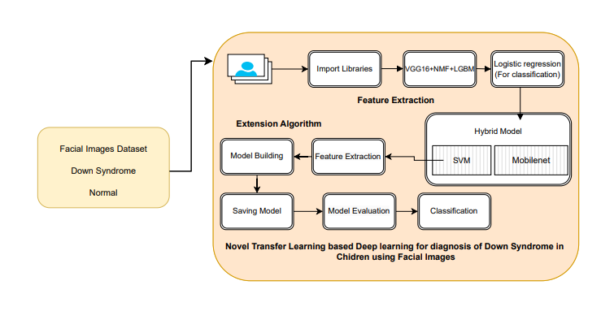

**APPLICATIONS**

Here are simple applications of project on diagnosing Down syndrome using facial images:

1. Early Screening Tools for Clinics: Develop a software application for pediatric clinics that uses facial image analysis to screen children for Down syndrome. This tool can assist doctors in identifying at-risk children early, prompting further diagnostic testing and intervention.

2. Educational Tools for Medical Training:Integrate the diagnostic model into educational platforms for medical students and professionals. This can be used as a teaching aid to help trainees recognize Down syndrome features and understand advanced diagnostic techniques.

3. Telemedicine Services: Implement the technology in telemedicine platforms to enable remote consultations. Specialists can analyze facial images submitted by patients or local practitioners, making it easier to diagnose Down syndrome without the need for physical visits.

4. Public Health Screening Programs: Use the technology in community health initiatives to conduct large-scale screenings. This could be particularly beneficial in underserved regions where access to genetic testing and specialist care is limited, allowing for wider identification and early intervention.

**FLOW DIAGRAM**

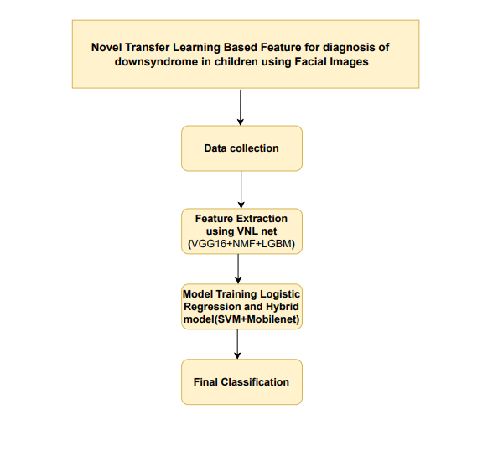

**SOFTWARE HARDWARE REQUIREMENTS**

**H/W CONFIGURATION:**

Processor - I3/Intel Processor

Hard Disk - 160GB

Key Board - Standard Windows Keyboard

Mouse - Two or Three Button Mouse

Monitor - SVGA

RAM - 8GB

**S/W CONFIGURATION:**

* Operating System : Windows 7/8/10
* Server side Script : HTML, CSS, Bootstrap & JS
* Programming Language : Python
* Libraries : Flask, Pandas, MySQL. Connector, Scikit-Learn
* IDE/Workbench : VS Code
* Technology : Python 3.8+
* Server Deployment : Xampp Server

**MODULES**

**System**

**1. Data Collection:**

* Objective: Gather and preprocess facial image data.
* Description: Collect high-quality facial images of children, ensuring a balanced dataset with both Down syndrome and healthy children. Preprocess images by normalizing, resizing, and augmenting to maintain consistency and enhance model performance.

**2. Feature Engineering:**

* Objective: Enhance input data quality.
* Description: Apply image preprocessing techniques such as normalization, augmentation, and segmentation. Use Non-Negative Matrix Factorization (NMF) for dimensionality reduction and refined feature extraction.

**3. Model Integration:**

* Objective: Utilize and compare deep learning models.
* Description: Integrate VNL-Net (combining VGG16 and NMF) and a MobileNet + SVM hybrid model. Compare their performances using an ensemble approach to determine the most effective model for diagnosis.

**4. Dynamic Selection Mechanism:**

* Objective: Optimize model selection.
* Description: Implement a dynamic selection framework that evaluates accurate results for data inputs to choose the most effective model for accurate diagnosis, enhancing computational efficiency.

**5. Adaptive Learning:**

* Objective: Ensure model relevance over time.
* Description: Employ advanced transfer learning techniques to continuously adapt and fine-tune the models with new data, ensuring they remain accurate and up-to-date.

**6. Evaluation and Validation:**

* Objective: Confirm model reliability and effectiveness.
* Description: Assess model performance using metrics such as accuracy, precision, recall, and F1-score. Validate the models on test datasets to ensure robustness and reliability.

**User**

**1. Register:**

* Objective: User account creation.
* Description: Users, such as healthcare professionals, register with their credentials to create an account within the system.

**2. Login:**

* Objective: Secure system access.
* Description: Registered users log in with their credentials to access the system's diagnostic features.

**3. Input Data:**

* Objective: Upload facial images for diagnosis.
* Description: Users upload facial images into the system for Down syndrome diagnosis. The system preprocesses and prepares the images for model analysis.

**4. Viewing Results:**

* Objective: Access and analyze diagnostic outcomes.
* Description: The system processes the input images through the integrated models and provides diagnostic results. Users can view detailed information on the diagnosis and any relevant image uploaded.

**5. Logout:**

* Objective: Secure user session.
* Description: Users log out to secure their session and protect personal and operational data.

# **LEARNING OUTCOMES**

**Understanding Advanced Transfer Learning Techniques:** Gain a comprehensive understanding of how advanced transfer learning methods, such as VNL-Net and MobileNet, can be applied to medical image analysis for accurate disease diagnosis.

**Application of Facial Image Analysis in Diagnostics:** Learn how to leverage facial image analysis to identify specific medical conditions, such as Down syndrome, using deep learning models and feature extraction techniques.

**Integration of Hybrid Models for Enhanced Accuracy:** Develop skills in integrating hybrid models, such as combining MobileNet with Support Vector Machine (SVM), to improve diagnostic accuracy and computational efficiency.

**Implementation of Dimensionality Reduction Methods:** Understand and apply dimensionality reduction techniques, such as Non-Negative Matrix Factorization (NMF), to refine and enhance feature extraction processes in medical image analysis.

**Evaluation and Validation of Diagnostic Models:** Learn how to rigorously evaluate and validate diagnostic models using methods like k-fold cross-validation to ensure their reliability and performance in real-world applications.