CFC转中间元件方案概述

# 方案概述

语法检查通过后，按元件执行序号逐个元件生成中间语言

# 转中间语言头文件

## 文件名生成

获取POU名称，若不以数字起始，则文件名使用POU名称；若以数字起始，则命名规则为：

POU类型（PRG|FB|FUN）_POU名称_POU名称MD5值

注：函数名称与文件名称相同

## PRG头文件生成

1. 生成中间语言函数声明

例：

#ifndef __CFCPRG_H_

#define __CFCPRG_H_

#include <stdbool.h>

#include <stdint.h>

#include <math.h>

// Prg

#ifdef __cplusplus

extern "C"

{

#endif

void CFCPRG();

#ifdef __cplusplus

}

#endif

#endif

## FB头文件生成

1. 生成中间语言函数声明
2. 生成结构体定义（全部变量）
3. 生成Copy函数定义

例：

#ifndef __CFCFB_H_

#define __CFCFB_H_

#include <stdbool.h>

#include <stdint.h>

#include <math.h>

// FB

struct CFCFB

{

// IN

int16_t* p1;

bool* p1Force;

// OUT

bool* p2;

bool* p2Force;

// INOUT

float* p3;

bool* p3Force;

// TEMP

uint16_t* p4;

bool* p4Force;

};

#ifdef __cplusplus

extern "C"

{

#endif

void CFCFB(void* _pHead);

#ifdef __cplusplus

}

#endif

// Struct Copy

void CFCFB_Copy(struct CFCFB* pSrc, struct CFCFB* pDesc);

#endif

## FUN头文件生成

1. 生成中间语言函数声明
2. 生成结构体定义（无局部变量，包含返回值变量）
3. 生成Copy函数定义

例：

#ifndef __CFCFUN_H_

#define __CFCFUN_H_

#include <stdbool.h>

#include <stdint.h>

#include <math.h>

// Fun

struct CFCFUN

{

// IN

bool* p1;

// INOUT

int16_t* p2;

// RETURN

bool* CFCFUN;

};

#ifdef __cplusplus

extern "C"

{

#endif

bool CFCFUN(void* _pHead);

#ifdef __cplusplus

}

#endif

// Struct Copy

void CFCFUN_Copy(struct CFCFUN* pSrc, struct CFCFUN* pDesc);

#endif

# 转中间语言源文件

## FB_Copy函数生成

判断是否强制，若未强制，则值赋值

例：

void CFCFB_Copy(struct CFCFB* pSrc, struct CFCFB* pDesc)

{

if (!(bool)(*(pDesc->p1Force))) {

*(pDesc->p1) = *(pSrc->p1);

}

if (!(bool)(*(pDesc->p2Force))) {

*(pDesc->p2) = *(pSrc->p2);

}

if (!(bool)(*(pDesc->p3Force))) {

*(pDesc->p3) = *(pSrc->p3);

}

if (!(bool)(*(pDesc->p4Force))) {

*(pDesc->p4) = *(pSrc->p4);

}

}

## FUN_Copy函数生成

直接值赋值

例：

void CFCFUN_Copy(struct CFCFUN* pSrc, struct CFCFUN* pDesc)

{

*(pDesc->p1) = *(pSrc->p1);

*(pDesc->p2) = *(pSrc->p2);

}

## PRG源文件生成

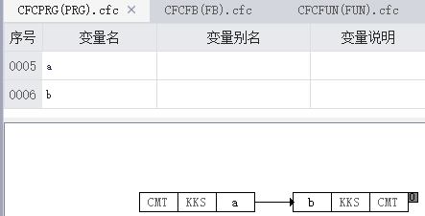

按元件执行次序生成各自中间语言

例：

#include "CFCPRG.h"

#include "HOLLYSYS-M7-AT-TASK-DEFINE.h"

void CFCPRG() {

// 0: Implementation of element b

if(!(bool)((*(((bool*)(gl_ulDatRangeHeadAdress + H_LrVarHAdr + H_CFCPRG_B + H_FrVarHAdr - HD_EDITABLE_DATA_OFFSET )))))){

(*(((bool*)(gl_ulDatRangeHeadAdress + H_LrVarHAdr + H_CFCPRG_B)))) = (*(((bool*)(gl_ulDatRangeHeadAdress + H_LrVarHAdr + H_CFCPRG_A))));

}

}

## FB源文件生成

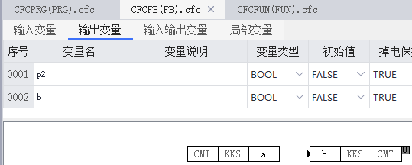

按元件执行次序生成各自中间语言

例：

void CFCFB(void* _pHead) {

// Parameter assignment

struct CFCFB* pHead = (struct CFCFB*)_pHead;

// 0: Implementation of element b

if(!(bool)((*(((bool*)(pHead->bForce)))))){

(*(((bool*)(pHead->b)))) = (*(((bool*)(pHead->a))));

}

}

## FUN源文件生成

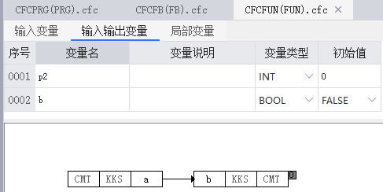

按元件执行次序生成各自中间语言

例：

#include "CFCFUN.h"

#include "HOLLYSYS-M7-AT-TASK-DEFINE.h"

bool CFCFUN(void* _pHead) {

// Temp variable definition

int16_t p3 = 0;

// Parameter assignment

struct CFCFUN* pHead = (struct CFCFUN*)_pHead;

// Return variable assignment

(*((bool*)(pHead->CFCFUN))) = false;

// 0: Implementation of element b

(*(((bool*)(pHead->b)))) = (*(((bool*)(pHead->a))));

// Function return

return (*((bool*)(pHead->CFCFUN)));

}

# 结构体变量转中间语言

收集转C过程中用到的结构体变量，在IEC整体预编译完成后，生成结构体变量声明类，文件名命名格式：结构体名称_Struct.h 结构体名称_Struct.c，结构体名称同变量类名

例：

#ifndef __TASK_INFO_H_

#define __TASK_INFO_H_

struct TASK_INFO

{

int32_t* dwCount;

bool* dwCountForce;

int32_t* dwCycleTime;

bool* dwCycleTimeForce;

int32_t* dwCycleTimeMin;

bool* dwCycleTimeMinForce;

int32_t* dwCycleTimeMax;

bool* dwCycleTimeMaxForce;

int32_t* dwCycleTimeAvg;

bool* dwCycleTimeAvgForce;

uint16_t* wStatus;

bool* wStatusForce;

uint16_t* wMode;

bool* wModeForce;

};

struct TASK_INFO_TEMP

{

int32_t dwCount;

int32_t dwCycleTime;

int32_t dwCycleTimeMin;

int32_t dwCycleTimeMax;

int32_t dwCycleTimeAvg;

uint16_t wStatus;

uint16_t wMode;

};

#endif

#include "TASK_INFO_STRUCT.h"

void TASK_INFO_Copy(struct TASK_INFO* pSrc, struct TASK_INFO* pDesc) {

if (!(*((bool*)pDesc->dwCountForce))) {

pDesc->dwCount = pSrc->dwCount;

}

if (!(*((bool*)pDesc->dwCycleTimeForce))) {

pDesc->dwCycleTime = pSrc->dwCycleTime;

}

if (!(*((bool*)pDesc->dwCycleTimeMinForce))) {

pDesc->dwCycleTimeMin = pSrc->dwCycleTimeMin;

}

if (!(*((bool*)pDesc->dwCycleTimeMaxForce))) {

pDesc->dwCycleTimeMax = pSrc->dwCycleTimeMax;

}

if (!(*((bool*)pDesc->dwCycleTimeAvgForce))) {

pDesc->dwCycleTimeAvg = pSrc->dwCycleTimeAvg;

}

if (!(*((bool*)pDesc->wStatusForce))) {

pDesc->wStatus = pSrc->wStatus;

}

if (!(*((bool*)pDesc->wModeForce))) {

pDesc->wMode = pSrc->wMode;

}

}

void TASK_INFO_TEMP_Copy(struct TASK_INFO_TEMP* pSrc, struct TASK_INFO_TEMP* pDesc) {

pDesc->dwCount = pSrc->dwCount;

pDesc->dwCycleTime = pSrc->dwCycleTime;

pDesc->dwCycleTimeMin = pSrc->dwCycleTimeMin;

pDesc->dwCycleTimeMax = pSrc->dwCycleTimeMax;

pDesc->dwCycleTimeAvg = pSrc->dwCycleTimeAvg;

pDesc->wStatus = pSrc->wStatus;

pDesc->wMode = pSrc->wMode;

}

# AT变量类型与中间语言类型对应表

(DT_BOOL "BOOL" "bool" "false")

(DT_STRUCT "STRUCT" "struct" "0")

(DT_ARRAY "ARRAY" "" "")

(DT_STRING "STRING" "char" "0")

(DT_FB "FB" "struct" "")

(DT_POINTER "POINTER" "" "0")

(DT_REF "REF" "" "")

(DT_LREAL "LREAL" "double" "0.00")

(DT_REAL "REAL" "float" "0.0")

(DT_DT "DT" "uint32_t" "0")

(DT_TOD "TOD" "uint32_t" "0")

(DT_DATE "DATE" "uint32_t" "0")

(DT_TIME "TIME" "uint32_t" "0")

(DT_UDINT "UDINT" "uint32_t" "0")

(DT_UINT "UINT" "uint16_t" "0")

(DT_USINT "USINT" "uint8_t" "0")

(DT_SINT "SINT" "int8_t" "0")

(DT_DWORD "DWORD" "uint32_t" "0")

(DT_DINT "DINT" "int32_t" "0")

(DT_WORD "WORD" "uint16_t" "0")

(DT_BYTE "BYTE" "uint8_t" "0")

(DT_ENUM "ENUM" "int16_t" "0")

(DT_INT "INT" "int16_t" "0")

(DT_BIT "BIT" "bool" "0")

(DT_ZO "ZO" "int8_t" "0")

# 元件转中间语言

无执行次序的元件，不参与转中间语言，涉及的元件有：输入元件、网络输入元件、注释元件

## Jump元件

## Label元件

## Return元件

## Output元件

## PRG块元件

1. 添加PRG引用头文件
2. 转C直接调用被调PRG函数名称
3. 记录POU引用关系

例：

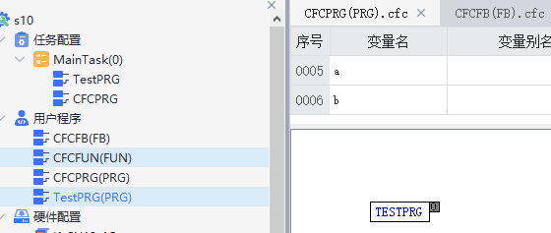

#include "CFCPRG.h"

#include "HOLLYSYS-M7-AT-TASK-DEFINE.h"

#include "TESTPRG.h"

void CFCPRG() {

// 0: Implementation of element TESTPRG

TESTPRG();

}

## FB块元件

### PT_PRG中调用FB块元件

#### 全局变量

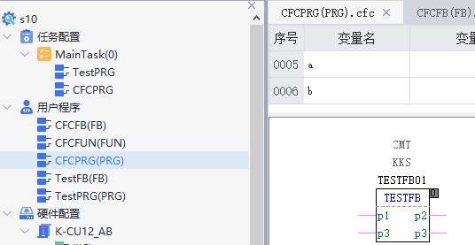

#include "CFCPRG.h"

#include "HOLLYSYS-M7-AT-TASK-DEFINE.h"

#include "TESTFB.h"

void CFCPRG() {

// 0: Implementation of element TESTFB

struct TESTFB* TESTFB01 = (struct TESTFB*)(gl_ulStactAddress+0);

// Assign address to input variable

TESTFB01->p1 = ((bool*)(gl_ulDatRangeHeadAdress + H_LrVarHAdr + H__TESTFB01_P1));

TESTFB01->p1Force = ((bool *)(gl_ulDatRangeHeadAdress + H_LrVarHAdr + H__TESTFB01_P1+ H_FrVarHAdr - HD_EDITABLE_DATA_OFFSET ));

// Assign address to output variable

TESTFB01->p2 = ((bool*)(gl_ulDatRangeHeadAdress + H_LrVarHAdr + H__TESTFB01_P2));

TESTFB01->p2Force = ((bool *)(gl_ulDatRangeHeadAdress + H_LrVarHAdr + H__TESTFB01_P2+ H_FrVarHAdr - HD_EDITABLE_DATA_OFFSET ));

// Assign address to inout variable

TESTFB01->p3 = ((bool*)(gl_ulDatRangeHeadAdress + H_LrVarHAdr + H__TESTFB01_P3));

TESTFB01->p3Force = ((bool *)(gl_ulDatRangeHeadAdress + H_LrVarHAdr + H__TESTFB01_P3+ H_FrVarHAdr - HD_EDITABLE_DATA_OFFSET ));

// Assign address to temp variable

TESTFB01->p4 = ((bool*)(gl_ulDatRangeHeadAdress + H_LrVarHAdr + H__TESTFB01_P4));

TESTFB01->p4Force = ((bool *)(gl_ulDatRangeHeadAdress + H_LrVarHAdr + H__TESTFB01_P4+ H_FrVarHAdr - HD_EDITABLE_DATA_OFFSET ));

bool __AT__CFCPRG_EN_1 = true;

if((bool)__AT__CFCPRG_EN_1){

// Assign value to input pin variable

TESTFB(TESTFB01);

}

}

#### 局部变量

#include "CFCPRG.h"

#include "HOLLYSYS-M7-AT-TASK-DEFINE.h"

#include "TESTFB.h"

void CFCPRG() {

// 0: Implementation of element TESTFB

struct TESTFB* TESTFB02 = (struct TESTFB*)(gl_ulStactAddress+0);

// Assign address to input variable

TESTFB02->p1 = ((bool*)(gl_ulDatRangeHeadAdress + H_LrVarHAdr + H_CFCPRG_TESTFB02_P1));

TESTFB02->p1Force = ((bool *)(gl_ulDatRangeHeadAdress + H_LrVarHAdr + H_CFCPRG_TESTFB02_P1+ H_FrVarHAdr - HD_EDITABLE_DATA_OFFSET ));

// Assign address to output variable

TESTFB02->p2 = ((bool*)(gl_ulDatRangeHeadAdress + H_LrVarHAdr + H_CFCPRG_TESTFB02_P2));

TESTFB02->p2Force = ((bool *)(gl_ulDatRangeHeadAdress + H_LrVarHAdr + H_CFCPRG_TESTFB02_P2+ H_FrVarHAdr - HD_EDITABLE_DATA_OFFSET ));

// Assign address to inout variable

TESTFB02->p3 = ((bool*)(gl_ulDatRangeHeadAdress + H_LrVarHAdr + H_CFCPRG_TESTFB02_P3));

TESTFB02->p3Force = ((bool *)(gl_ulDatRangeHeadAdress + H_LrVarHAdr + H_CFCPRG_TESTFB02_P3+ H_FrVarHAdr - HD_EDITABLE_DATA_OFFSET ));

// Assign address to temp variable

TESTFB02->p4 = ((bool*)(gl_ulDatRangeHeadAdress + H_LrVarHAdr + H_CFCPRG_TESTFB02_P4));

TESTFB02->p4Force = ((bool *)(gl_ulDatRangeHeadAdress + H_LrVarHAdr + H_CFCPRG_TESTFB02_P4+ H_FrVarHAdr - HD_EDITABLE_DATA_OFFSET ));

bool __AT__CFCPRG_EN_1 = true;

if((bool)__AT__CFCPRG_EN_1){

// Assign value to input pin variable

TESTFB(TESTFB02);

}

}

### PT_FB中调用FB块元件

#### 全局变量

通过任务获取全局变量地址，并赋值变量，之后调FB函数

例：

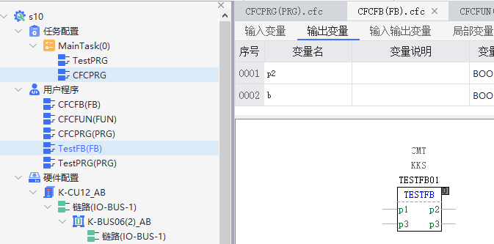

#include "CFCFB.h"

#include "HOLLYSYS-M7-AT-TASK-DEFINE.h"

#include "TESTFB.h"

void CFCFB(void* _pHead) {

// Parameter assignment

struct CFCFB* pHead = (struct CFCFB*)_pHead;

// 0: Implementation of element TESTFB

bool __AT__CFCFB_EN_1 = true;

if((bool)__AT__CFCFB_EN_1){

struct TESTFB* TESTFB01 = (struct TESTFB*)(gl_ulStactAddress+0);

// Assign address to input variable

TESTFB01->p1 = ((bool*)(gl_ulDatRangeHeadAdress + H_LrVarHAdr + H__TESTFB01_P1));

TESTFB01->p1Force = ((bool *)(gl_ulDatRangeHeadAdress + H_LrVarHAdr + H__TESTFB01_P1+ H_FrVarHAdr - HD_EDITABLE_DATA_OFFSET ));

// Assign address to output variable

TESTFB01->p2 = ((bool*)(gl_ulDatRangeHeadAdress + H_LrVarHAdr + H__TESTFB01_P2));

TESTFB01->p2Force = ((bool *)(gl_ulDatRangeHeadAdress + H_LrVarHAdr + H__TESTFB01_P2+ H_FrVarHAdr - HD_EDITABLE_DATA_OFFSET ));

// Assign address to inout variable

TESTFB01->p3 = ((bool*)(gl_ulDatRangeHeadAdress + H_LrVarHAdr + H__TESTFB01_P3));

TESTFB01->p3Force = ((bool *)(gl_ulDatRangeHeadAdress + H_LrVarHAdr + H__TESTFB01_P3+ H_FrVarHAdr - HD_EDITABLE_DATA_OFFSET ));

// Assign address to temp variable

TESTFB01->p4 = ((bool*)(gl_ulDatRangeHeadAdress + H_LrVarHAdr + H__TESTFB01_P4));

TESTFB01->p4Force = ((bool *)(gl_ulDatRangeHeadAdress + H_LrVarHAdr + H__TESTFB01_P4+ H_FrVarHAdr - HD_EDITABLE_DATA_OFFSET ));

// Assign value to input pin variable

TESTFB(TESTFB01);

}

}

#### 局部变量

void CFCFB(void* _pHead) {

// Parameter assignment

struct CFCFB* pHead = (struct CFCFB*)_pHead;

// 0: Implementation of element TESTFB

bool __AT__CFCFB_EN_1 = true;

if((bool)__AT__CFCFB_EN_1){

TESTFB(&(pHead->TESTFB02));

}

}

### PT_FUN中调用FB块元件

同PT_FB中调用FB块元件

## FUN块元件

## Operator块元件

# 其它

## FB或FUN中包含复杂变量，转C结构体原则

除了FB和Struct变量外，其它都用指针

例：

struct PRGSTEP

{

// IN

bool* IN;

bool* INForce;

bool* FBK;

bool* FBKForce;

bool* JUMP;

bool* JUMPForce;

bool* STRFAIL;

bool* STRFAILForce;

bool* RUN;

bool* RUNForce;

bool* NRST;

bool* NRSTForce;

bool* INJUMP1;

bool* INJUMP1Force;

bool* WT;

bool* WTForce;

// OUT

bool* LRST;

bool* LRSTForce;

bool* RUNOUT;

bool* RUNOUTForce;

bool* FALOUT;

bool* FALOUTForce;

uint8_t* STEPOUT;

bool* STEPOUTForce;

bool* ENDOUT;

bool* ENDOUTForce;

bool* JMPOUT;

bool* JMPOUTForce;

// INOUT

// TEMP

bool* INJUMP2;

bool* INJUMP2Force;

uint32_t* CYC;

bool* CYCForce;

uint8_t* BB;

bool* BBForce;

struct RS RS1;

struct RS RS2;

struct RS RS3;

struct RS RS4;

struct HSTON TON1;

};

// FB

struct PRGSTART

{

// IN

bool* FBK;

bool* FBKForce;

bool* PEN;

bool* PENForce;

bool* MAN;

bool* MANForce;

bool* AUT;

bool* AUTForce;

bool* MOFFRST;

bool* MOFFRSTForce;

bool* AOFFRST;

bool* AOFFRSTForce;

bool* FALIN;

bool* FALINForce;

uint8_t* OUTAD;

bool* OUTADForce;

bool* INJUMP;

bool* INJUMPForce;

// OUT

bool* POUT;

bool* POUTForce;

bool* OUT;

bool* OUTForce;

bool* FALOUT;

bool* FALOUTForce;

bool* OUTJMP;

bool* OUTJMPForce;

// INOUT

// TEMP

struct RS RS1;

struct RS RS2;

struct RS RS3;

struct HSTP VOPTP;

struct HSTON OTTON;

struct HSTP TP1;

struct HSTP TP2;

};

struct NWRITERAWDIAG_NM

{

uint8_t *DiagAdd;

bool* DiagAddForce ;

struct STCSLDIAGNOR SlDiag;

bool* SlDiagForce ;

uint8_t* devDiag;

bool* devDiagForce ;

uint8_t* modDiag;

bool* modDiagForce ;

uint16_t* bModeNo;

bool* bModeNoForce ;

uint8_t* bChErr;

bool* bChErrForce ;

uint8_t* bErr;

bool* bErrForce ;

uint8_t* NWRITERAWDIAG_NM;

};