CSc4351 Capstone 1
Software Design Document
Fall 2025

Team Name: Senioritis

RespoSphere

Team Members:
- Faith Nnakwe
- Mumo Musyoka
- Chioma Nwokedi
- Khue Nguyen

Date: (12/09/2025)

Table of Contents
1. Introduction 4
1.1 Purpose 4
1.2 Scope 4
1.3 Definitions, Acronyms, and Abbreviations 4
1.4 References 4
1.5 Overview 4
2. System Overview 5
2.1 System Architecture 5
∙ Presentation Layer: 5
∙ Business Logic Layer: 5
∙ Data Access Layer: 5
2.2 System Context 5
3. Functional Requirements 6
3.1 Use Case Diagram 6
3.2 Use Cases 6
1. View Grades 6
2. Enroll in Course 6
3. Enter Grades 6
4. Manage Users 7
4. Non-Functional Requirements 7
4.1 Performance Requirements 7
4.2 Security Requirements 7
4.3 Usability Requirements 7
5. System Design 8
5.1 High-Level Design 8
5.2 Detailed Design 8
1. User Interface Components: 8
2. Business Logic Components: 8
5.3 Database Design 8
6. Implementation Plan 9
6.1 Development Environment 9
6.2 Tools and Technologies 9
6.3 Coding Standards 9
7. Testing Plan 13
7.1 Testing Strategy 13
7.2 Test Cases 14
8. Deployment Plan 15
8.1 Deployment Strategy 15
8.2 User Training 15
9. Future Enhancements 16
10. Appendices 17

1. Introduction

1.1 Purpose
The purpose of this Software Design Document (SDD) is to describe the design and functionality of RepoSphere, a web application developed to analyze and visualize GitHub contribution activity. This document provides a detailed overview of the system architecture, design decisions, and operational features, ensuring that all stakeholders have a clear understanding of the application’s goals and capabilities. The system is designed to make GitHub contribution data more accessible, interpretable, and meaningful for users seeking insights into project activity and collaboration patterns.

1.2 Scope
RepoSphere enables users to visualize, analyze, and interpret contribution activity within GitHub repositories. The system offers dashboards, summaries, and time-based statistics to provide insights into individual and team participation.
Target users include software development teams monitoring project progress, open-source contributors tracking their involvement, and educators or students engaged in collaborative projects.
The scope of this project includes the design, development, testing, and deployment of RepoSphere as a fully functional application capable of retrieving GitHub data, generating visual reports, and presenting metrics such as commits, pull requests, issues, and lines of code added/removed.

1.3 Definitions, Acronyms, and Abbreviations
- API: Application Programming Interface.
- UI: User Interface.
- GitHub Metrics: Contribution-related data such as commits, pull requests, issues, and lines of code added/removed.
- Visualization Dashboard: A graphical interface displaying contribution summaries.
- Contribution Analytics: The process of analyzing user or team activity within a GitHub repository.
- RepoSphere: The GitHub contribution analytics web application described in this document.
- AWS: Amazon Web Services
- CRUD: Create, Read, Update, Delete

1.4 References
- GitHub REST API v3 Documentation.
- RepoSense – Architecture. (n.d.). Retrieved from https://reposense.org/RepoSense/dg/architecture.html

1.5 Overview
This document provides an in-depth description of RepoSphere, including its functional requirements, non-functional requirements, system architecture, design models, testing strategy, implementation plan, and maintenance plan. It highlights major system features, including visual dashboards, contribution summaries, time-based analytics, and formatted reports. Additionally, the document outlines future enhancements, including advanced comparison analytics and milestone-based activity tracking. Each section is structured to help stakeholders clearly understand the system’s intended functionality, design considerations, and long-term vision.

2. System Overview

2.1 System Architecture
The RepoShere web application will be developed using a three-tier architecture consisting of:
- Presentation Layer: The user interface where users sign in via inputting their GitHub username to view their GitHub repositories' insights, collaboration, and achievements.
- Business Logic Layer: The backend functionality that contains the application’s logic, processing data, and creating a connection flow between the Presentation Layer and the Data Access Layers. Handling the GitHub API routes for the presentation layer.
- Data Access Layer: This layer is responsible for querying data and interacting with the database to perform CRUD operations.

2.2 System Context
The RepoShere will deploy and operate on a web application and can be accessed through modern web browsers such as Chrome, Firefox, etc. The RepoShere system will interact with MySQL, a relational database, to be able to query users’ GitHub repositories data. The following diagram below showcases how the RepoSphere web application system interacts with each other:

+-------------------+
| Web Browser |
| (User Interface) |
+-------------------+
|
v
+-------------------+
| Presentation |
| Layer |
+-------------------+
|
v
+-------------------+
| Business Logic |
| Layer |
+-------------------+
|
v
+-------------------+
| Data Access |
| Layer |
+-------------------+
|
v
+-------------------+
| Relational DB |
| (MySQL) |
+-------------------+

3. Functional Requirements

3.1 Use Case Diagram

Welcome Page: Use Case Diagram
The following use case diagram illustrates the welcome page (Home) showing the interactions between users and the web application management system.
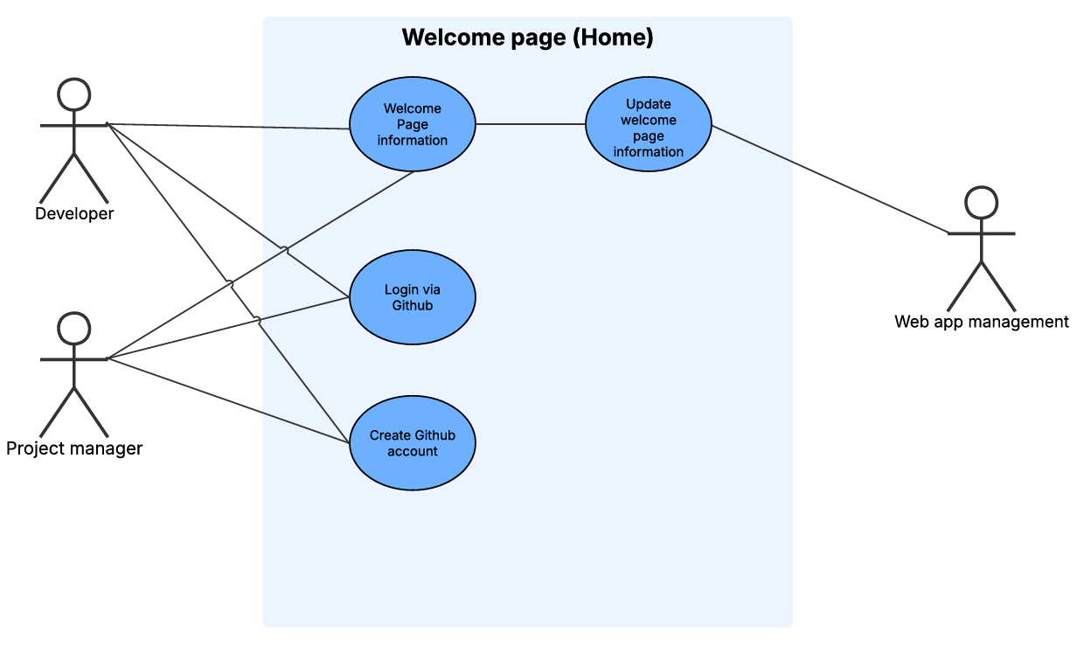

RepoSphere Registration System: Use Case Diagram
The following use case diagram illustrates the user and the GitHub contribution database for the registration system. How the user’s GitHub authentication will be verified to ensure they’re the authorized users.
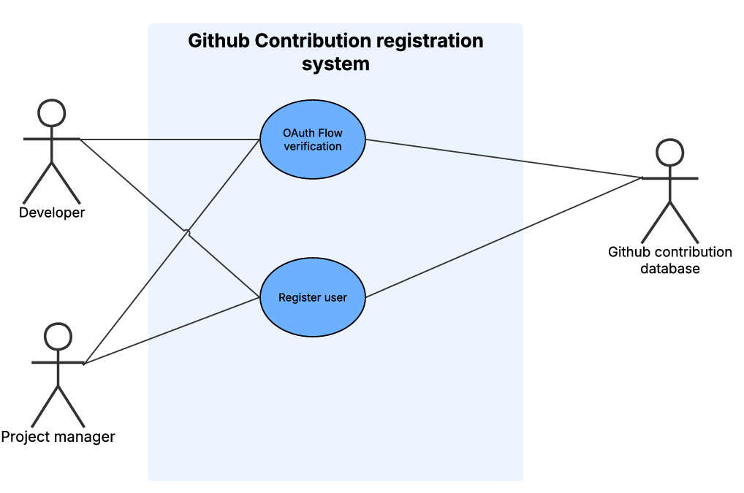

RepoSphere Contribution System: Use Case Diagram
The following use case diagram illustrates the user and the GitHub API to be able to retrieve the GitHub contribution metric system for the RepoSphere web application.
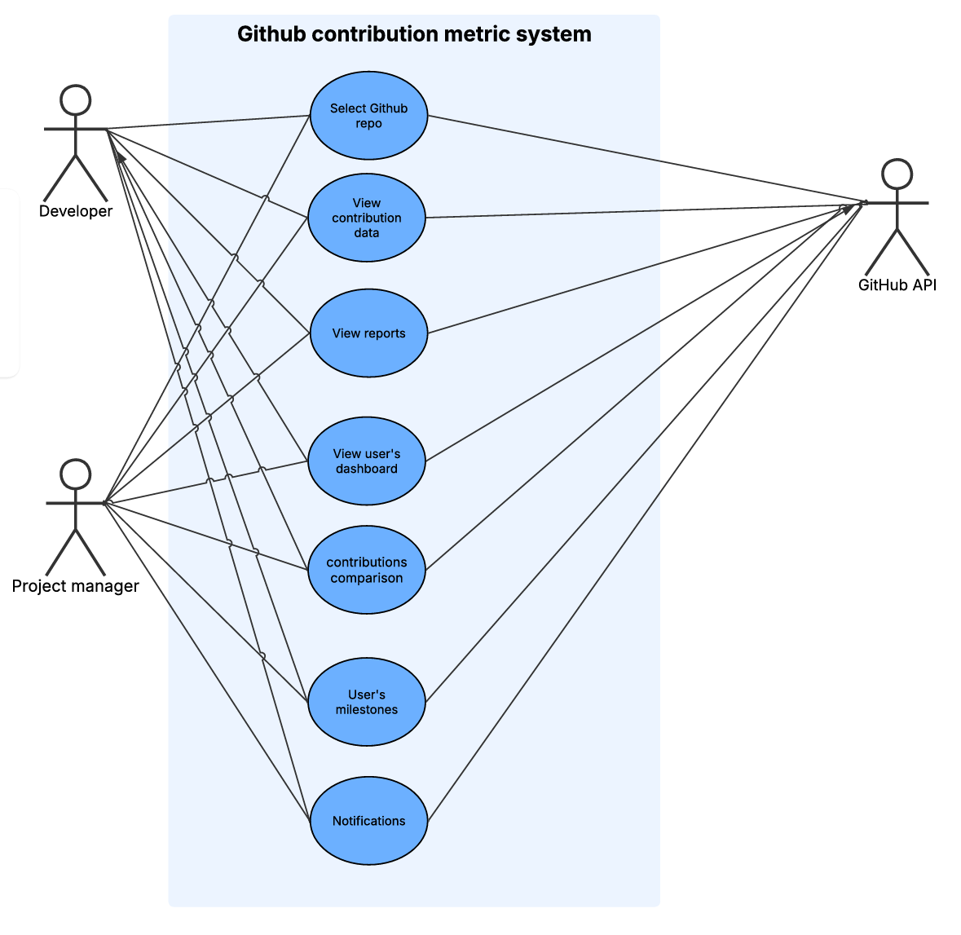

3.2 Use Cases

Welcome Page
  - Actors: Developer and Project Manager
  - Description: The Developer and project manager can view the welcome page and information about the RepoSphere web application.
  - Preconditions: The users must have a GitHub account to log in to RepoSphere.
  - Post Conditions: The RepoSphere web application is displayed on the screen, ready to use once users are signed in.

GitHub Contribution System
  - Actors: Developer and Project Manager
  - Description: RepoSphere uses OAuth for secure user authentication. If the user already has an account, they are authenticated. If a user does not have an account, they are redirected to a GitHub registration page. Once they have created a GitHub account, they can return to RepoSphere for verification and data linking.
  - Preconditions: RepoSphere developer and project manager users must meet the GitHub OAuth verification process. OAuth must become available and properly configured for authentication.
  - Post Conditions: The user’s GitHub account is either successfully verified and linked to RepoSphere web application. If authentication fails, users are not able to access their GitHub contribution metric data on RepoSphere.

GitHub Contribution Metric system:
  - Actors: Developer and Project Manager
  - Descriptions: Developer and project manager users are able to select the repository to view their own or other GitHub contribution data, get reports, and receive notifications.
  - Preconditions: The users are authenticated and are authorized to use RepoSphere, with an active session. The user's repository must contain contribution activity for RepoSphere to retrieve and analyze.
  - Postconditions: RepoSphere successfully displays the GitHub repository metrics for users to see the contributions, insights, and achievements.

4. Non-Functional Requirements

4.1 Performance Requirements
- The system shall load the dashboard within 2 seconds after user login
- User-selected reports shall display within 3 seconds for typical report sizes.
- The backend shall support simultaneous analyses for multiple users without significant performance degradation.
- The database shall support growth in stored reports without impacting query time.

4.2 Security Requirements
- The system shall require users to create an account with unique credentials.
- All communication between frontend, backend, and database shall use HTTPS/TLS encryption.
- User passwords shall be hashed and salted before storage.
- All user inputs (file uploads, text fields, form data) shall be validated to prevent injection attacks.
- GitHub API access tokens shall be securely stored and never exposed on the client side.
- Only authorized backend services shall make requests to external APIs.

4.3 Usability Requirements
- The user interface shall provide a clean, intuitive dashboard with clearly labeled actions.
- All primary actions (Run Analysis, View Reports, Dashboard) should be accessible within two clicks.
- Visualizations (charts, calendars, summary panels) must be legible and easy to interpret.
- The UI shall follow accessibility best practices (sufficient contrast, readable fonts, keyboard navigation support).
- The user flow (login → dashboard → action → results) shall remain predictable and logical.

5. System Design

5.1 High-Level Design
The high-level design of the RepoSphere includes the following components:
- User Interface: Developed using ReactJS.
- Business Logic: Implemented using a server-side language such as Node.js with Express.
- Database: A relational database, such as MySQL, that will handle the storing and receiving of users’ GitHub metrics.

5.2 Detailed Design

User Interface Components:
  - Log inputs via the user’s GitHub accounts
  - Selecting a Repository option
  - RepoSphere’s Repository Dashboard
  - GitHub Repository Metrics
  - Reports feature (Generating reports)
  - User’s information
  - Search bar feature
  - Settings

Business Logic Components:
  - User Authentication Module
  - GitHub Management Module
  - Database Management Module

5.3 Database Design
The RepoSphere database schema is designed to logically organize the structure of the database, which involves defining the tables, column relationships, and constraints. Showcasing how the RepoSphere web application data is stored or accessed. It focuses on the organization of the GitHub data to reduce redundancy and improve data integrity when users are using the web application. By establishing these relationships, it leads to the elimination of data duplication, inconsistencies, and deletion.

The diagram below showcases the RepoSphere database schema, which will include the following tables that will showcase how the database is going to be designed. The diagrams are designed by the tables with arrows establishing the relationship connection that references one table to another. Each table will contain a primary key and a foreign key to uniquely identify the records in the data.
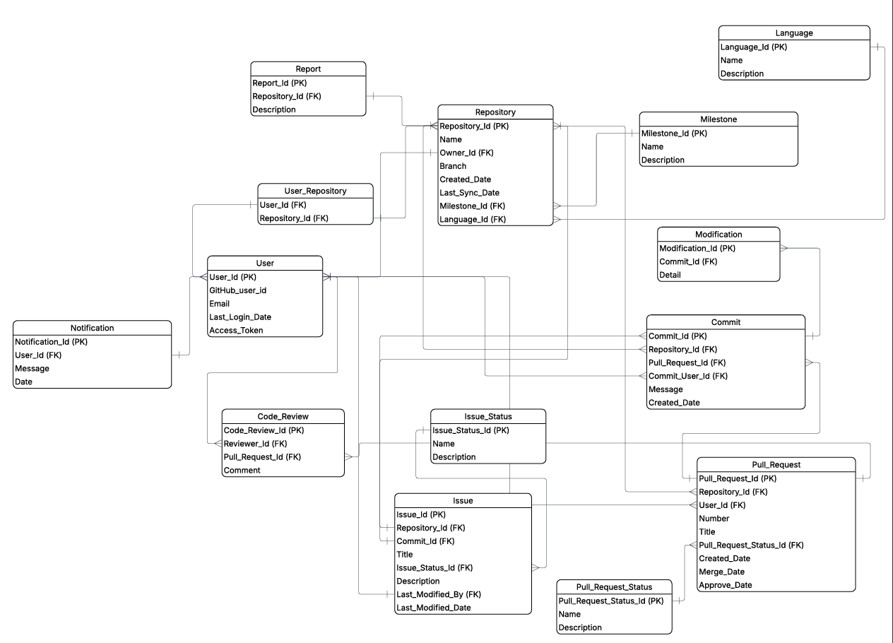

- User Table: (User_id, GitHub_user_id, Email, Last_Login_Date, Access_Tolken)
  - Description: Stores the user’s information
  - Primary Key: User_Id
- Repository Table: (Repository_Id, Name, Owner_Id, Branch, Created_Date, Last_Sync_Date, Milestone_Id, Language_Id)
  - Description: Stores all the repositories via GitHub
  - Primary Key: Repository_Id
  - Foreign Key:
    - Owner_Id → References to User Table
    - Milestone_Id —> References to Milestone Table
    - Language_Id —> References to Language Table
- User Repository Table: (User_Id, Repository_Id)
  - Description: Stores users’ GitHub repositories since each user can have multiple repositories
  - Foreign Key:
    - User_Id —> References to User Table
    - Repository_Id → References to Repository Table
- Language Table: (Language_Id, Name, Description)
  - Description: Store the languages being used in the repository
  - Primary Key: Language_Id
- Milestone Table: (Milestone_Id, Name, Description)
  - Description: Return the user’s achievements milestone
  - Primary Key: Milestone_Id
- Commit Table: (Commit_Id, Repository_Id, Pull_Request_Id, Commit_User_Id, Message, Created_Date)
  - Description: Store the user’s commit data in the repository
  - Primary Key: Commit_Id
  - Foreign Key:
    - Repository_Id → References to Repository Table
    - Pull_Request_Id —> References to Pull Request Table
    - Commit_User_Id —> References to User Table
- Pull Request Table: (Pull_Request_Id, Repository_Id, User_Id, Number, Title, Pull_Request_Status_Id, Created_Date, Merge_Date, Approve_Date)
  - Description: Store the user’s pull request data in the repository
  - Primary Key: Pull_Request_Id
  - Foreign Key:
    - Repository_Id → References to Repository Table
    - User_Id → References to User Table
    - Pull_Request_Status_Id → References to Pull Request Status Table
- Pull Request Status Table: (Pull_Request_Status_Id, Name, Description)
  - Description: Showcases the user’s pull request status in their repository.
  - Primary Key: Pull_Request_Status_Id
- Issue Table: (Issue_Id, Repository_Id, Commit_Id, Title, Issue_Status_Id, Description, Last_Modified_By, Last_Modified_Date)
  - Description: Store the user’s issue data in the repository when it is being committed and the issue status of the project.
  - Primary Key: Issue_Id
  - Foreign Key:
    - Repository_Id → References to Repository Table
    - Commit_Id —> References to Commit Table
    - Issue_Status_Id → References to Issue Status Table
    - Last_Modified_By —> References to User Table
- Issue Status: (Issue_Status_Id, Name, Description)
  - Description: References to the issue table to avoid redundancy or potential data loss since many issues can happen in the repository. This will showcase the issue status and its description.
  - Primary Key: Issue_Status_Id
- Code Review: (Code_Review_Id, Reviewer_Id, Pull_Request_Id,
  - Description: Allow users to be able to perform code review with each other via pull request.
  - Primary Key: Code_Review_Id
  - Foreign Key:
    - Reviewer_Id —> References to User Table
- Modification Table: (Modification_id, Commit_Id, Detail)
  - Description: Allow users to make modifications or any code changes in the code repository. Allow users to submit a commit about the modification and details of the changes.
  - Primary Key: Modification_Id
  - Foreign Key:
    - Commit_Id → References to Commit Table
- Notification Table: (Notification Id, User_Id, Message, Date)
  - Description: A notification will be sent to the user when they’re in a repository, when there are changes in the repository, and when the user reaches their milestone.
  - Primary Key: Notification_Id
  - Foreign Key:
    - User_Id —> References to User Table
- Report Table: (Report_Id, Repository_Id, Description)
  - Description: A report that showcases the log of the GitHub metric events that were happening in the repository.
  - Primary Key: Report_Id
  - Foreign Key:
    - Repository_Id → References to Repository Table

6. Implementation Plan

6.1 Development Environment
- IDE: Visual Studio Code
- Version Control: Git and GitHub for source code management
- Database Management: MySQL Workbench for database management

6.2 Tools and Technologies
- Frontend: React.js
- Backend: Node.js with Express
- Database: MySQL
- Infrastructure & DevOps: Docker

6.3 Coding Standards
- Follow the Airbnb JavaScript style guide for JavaScript.
- Use meaningful variable and function names.
- Write comments and documentation for all major functions and classes.
- Run automated lint checks before committing.
- Ensure no hard-coded sensitive information is included in the repository.

7. Testing Plan

7.1 Testing Strategy
Our main testing approach for RepoSphere will guarantee that all the components, from the frontend UI to the backend API integrations and database queries, function reliably, securely, and efficiently. Below are the testing approaches we will be using:
- Unit Testing
  - Will be performed on individual React components, backend controllers, utility functions, and data processing modules.
  - Ensures that all the functions behave as expected when isolated.
    - Example targets:
      - OAuth authentication handler
      - Database CRUD functions
      - GitHub API data retrieval module
      - Repository analytics calculation functions
- Integration Testing
  - This tests the interactions between the system modules:
    - Frontend and Backend communication
    - Backend and GitHub API
    - Backend and MySQL database
  - Ensuring that data correctly flows from GitHub to the API server to the Database to the Frontend dashboard.
- System Testing
  - Verifies that the entire RepoSphere application operates as intended.
  - Includes testing authentication flows, dashboards, analytics, notifications, and reports.
  - Ensures compatibility across browsers (e.g., Chrome, Safari, Firefox)
- User Acceptance Testing (UAT)
  - Conducted with the development team and students(our intended users)
  - The users will validate whether RepoSphere meets usability expectations and functional requirements.
  - There will be a focus on clarity of dashboards, accuracy of metrics, and ease of navigation.
- Performance & Load Testing
  - Ensures the application supports ≥100 concurrent users.
  - Measures:
    - API response time
    - Database query efficiency
    - Page load time for visual dashboards
- Security Testing
  - Validates:
    - OAuth token handling
    - API key protection
    - Role-based access
    - SQL injection defense
    - HTTPS enforcement.

7.2 Test Cases

User Login with GitHub OAuth

Input:

The user selects Sign in with GitHub

Expected Output:
  - User is redirected to the GitHub OAuth screen
  - Upon approval, RepoSphere creates or verifies the user record in the database
  - User is then redirected to the Dashboard page
- Pass Criteria:
  - The user session initializes, and the user-specific data loads successfully.

Retrieve GitHub Repositories

Input:

A pre-authenticated user selects "Fetch My Repositories."

Expected Output:
  - GitHub API returns a list of repositories
  - System stores the metadata in the Repository table
  - User sees the repository list populated on the screen
- Pass Criteria:
  - All the repositories display with correct names, languages, and updated information

View Contribution Metrics for Repository
- Input:
  - The user selects a repository from the dashboard
- Expected Output:
  - Commits, pull requests, issues, and code modifications are retrieved
  - Analytics visualizations update accordingly
  - Summary statistics appear without errors
- Pass Criteria:
  - Charts, tables, and totals match GitHub’s live data.

Generate Report
- Input:
  - User clicks “Generate Report.”
- Expected Output:
  - RepoSphere compiles repository metrics
  - The report record is created in the Report Table
  - User receives downloadable PDF/CSV description (future enhancement)
- Pass Criteria:
  - The report includes accurate and complete data with correct timestamps.

8. Deployment Plan

8.1 Deployment Strategy
- The application will be deployed on Amazon Web Services (AWS), which will host both the frontend (React.js) and backend (Node.js with Express).
- All components of the system will be packaged using Docker to ensure consistent environments across development, testing, and production.
- The backend and frontend will each have their own Docker containers, allowing them to be deployed, updated, and scaled independently.
- OAuth credentials, API keys, and environment secrets will not be stored in source code.
  - Sensitive data will be stored and accessed via:
    - AWS Secrets Manager, or
    - Encrypted environment variables are defined in the deployment pipeline.
  - The system will utilize HTTPS with TLS encryption for secure API communication.
- A CI/CD pipeline will be implemented using Docker-based workflows. When changes are pushed to the main branch, the pipeline will:
  - Run basic build and test steps
  - Build updated Docker images for the frontend and backend.
  - Push these images to an AWS container registry.
  - Deploy the updated containers automatically to minimize downtime using AWS.
- Deployment will support:
  - On-demand deployments requiring manual approval.
  - Continuous delivery for minor updates and UI changes.
  - Scheduled major releases to avoid service interruptions and allow coordinated testing.

8.2 User Training
- Hands-on training workshops for new users demonstrating system navigation.
- Walkthroughs covering authentication, selecting repositories, viewing contribution analytics, and exporting reports.
- User Documentation
  - User Manual: Step-by-step instructions for all major features, written for non-technical users.
  - Online Help Center: Integrated into the UI, including:
    - Searchable FAQs.
    - Troubleshooting guides.
    - Short video walkthroughs.
    - Common error explanations.
- Developer Documentation
  - Instructions for system setup, environment configuration, and local development.
  - API documentation for backend endpoints.
  - Guidelines for contributing, branching workflows, and CI/CD expectations.

9. Future Enhancements

Mobile Application Support
  - Development of a mobile application using React Native or Flutter.
  - Mobile-friendly dashboards for viewing contribution insights easily.
  - Push notifications for milestone achievements or repository changes.
  - Include In-app messaging or team annotation for repository insights.

Advanced Reporting & Analytics

Enhance reporting features, including multi-repository comparison reports, historical trend timelines, and interactive visualization layers.

Support customisable report templates for exporting data in multiple formats, such as CSV, XLSX other than PDFs.

Extended Integration Support
  - Option to integrate with other applications, such as:
    - GitLab for organizations using self-hosted or cloud-based pipelines.
    - Project management tools such as Jira, to link repository activity with task progress.
    - Communication tools (e.g., Slack, Microsoft Teams) to deliver automated repository insight notifications.

10. Appendices

Appendix A: Glossary of Terms
Access Token
A secure credential issued by GitHub during OAuth authentication that grants the application permission to access the user’s data.
API (Application Programming Interface)
A set of rules that allows different software components to communicate
Authentication
The process of verifying the identity of a user through GitHub OAuth.
Authorization
Granting a verified user the right permissions to access RepoSphere features and resources.
CRUD
Create, Read, Update, Delete
Commit
A recorded change in a GitHub repository that includes code modifications, messages, timestamps, and metadata.
Contribution Metrics
Quantitative indicators such as commits, pull requests, issues, and code modifications are used to assess activity within a repository.
Dashboard
A visual interface displaying contribution summaries, charts, and statistics within RepoSphere.
Integration Testing
Testing how well different components of RepoSphere interact with each other
Milestone
A progress marker
OAuth
Open Authorization is a widely adopted industry authorization framework that allows RepoSphere to connect with other applications without needing a User’s password
Pull Request
A request to merge code changes from one branch into another in a GitHub repository.
Repository
A project folder that is hosted on GitHub that contains the files, code history, and version control metadata.
UI (User Interface)
The frontend of RepoSphere is where the users interact with dashboards, analytics, and reports.
Visualization
Graphic display of contribution data

Appendix B: User Interface Mockups
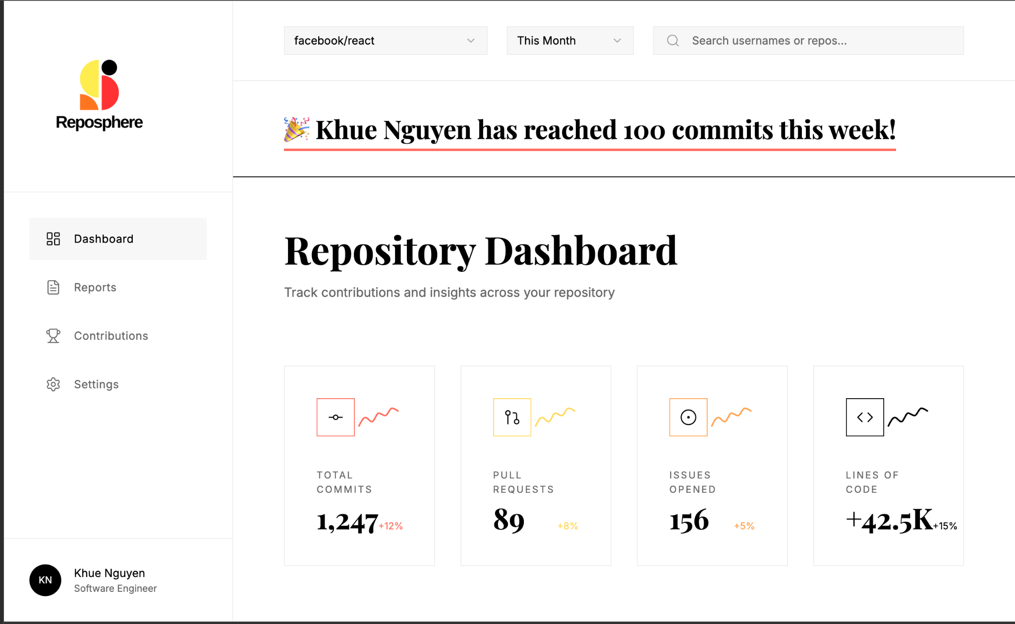
Figure 10.2.1
Repository dashboard:
This is the main repository dashboard, with a celebratory message and personalized contribution metrics
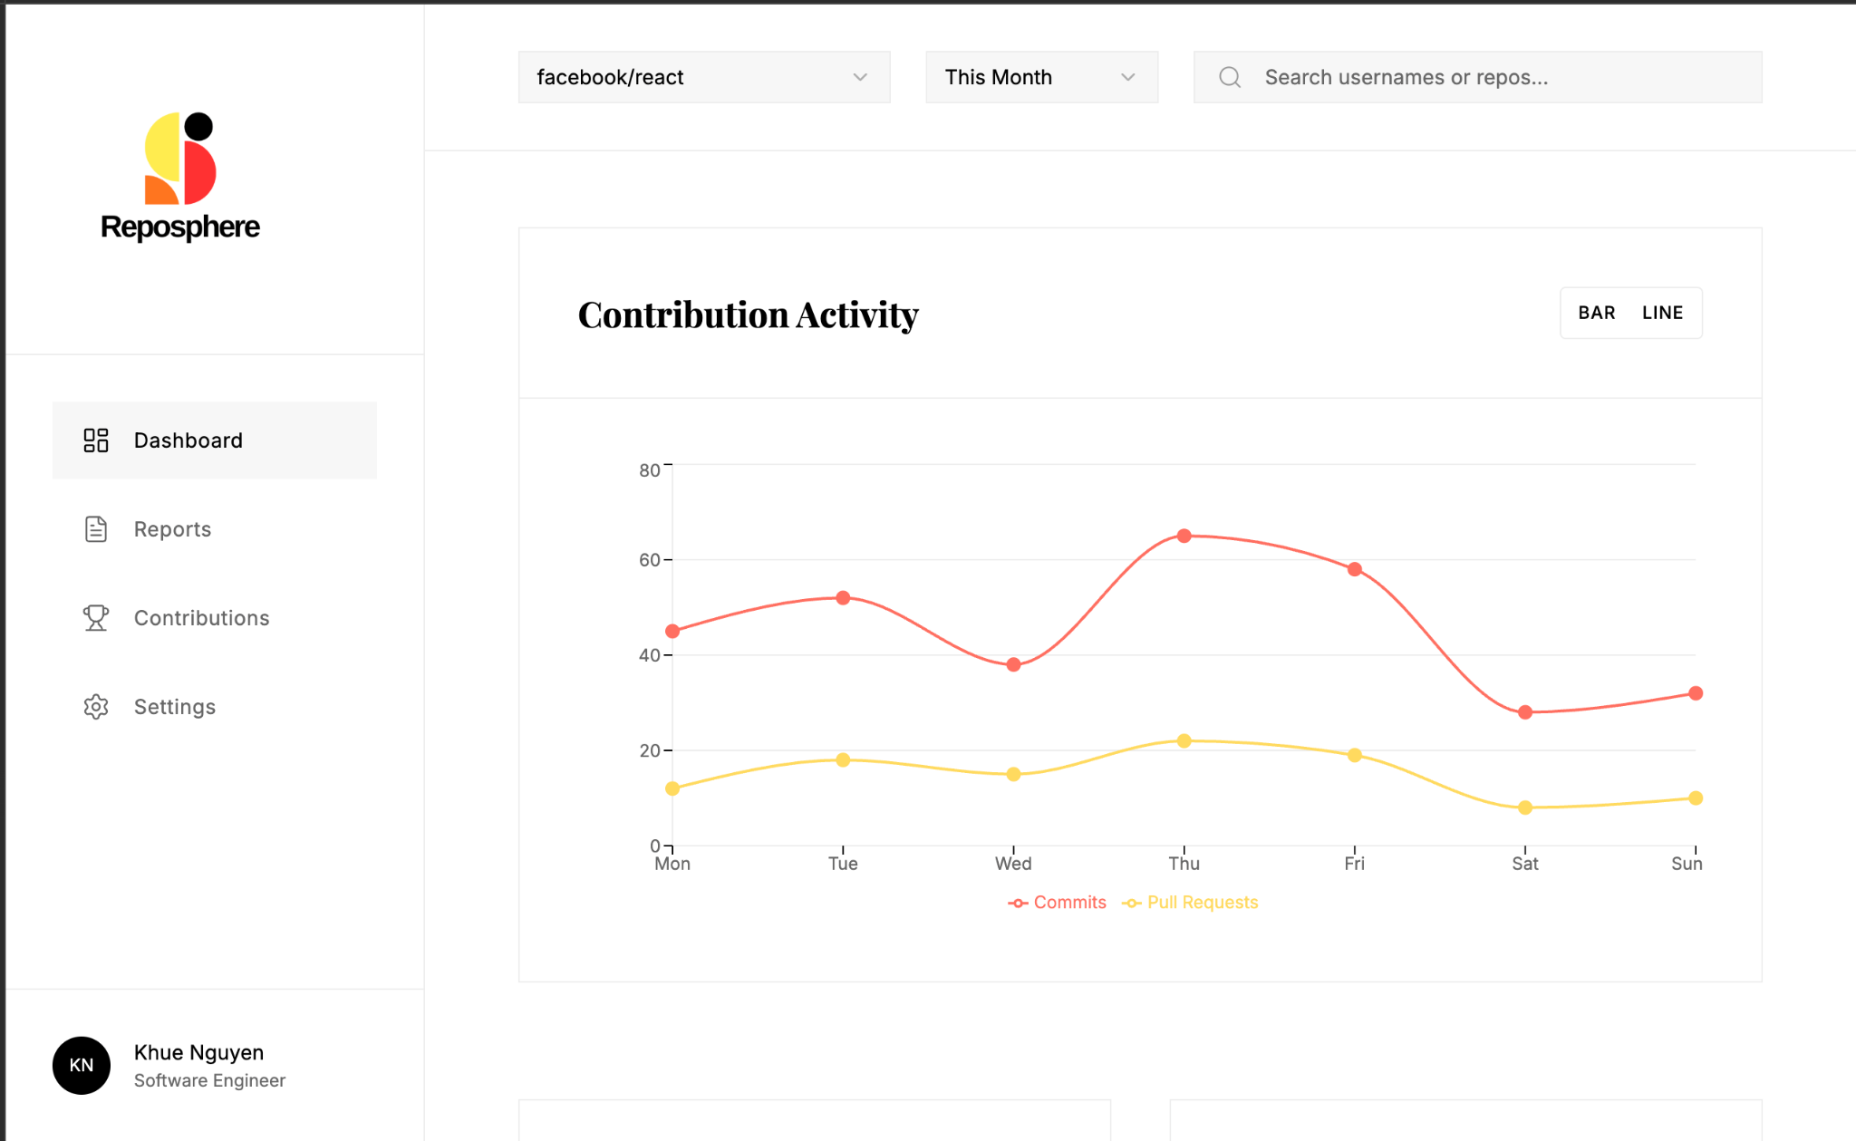
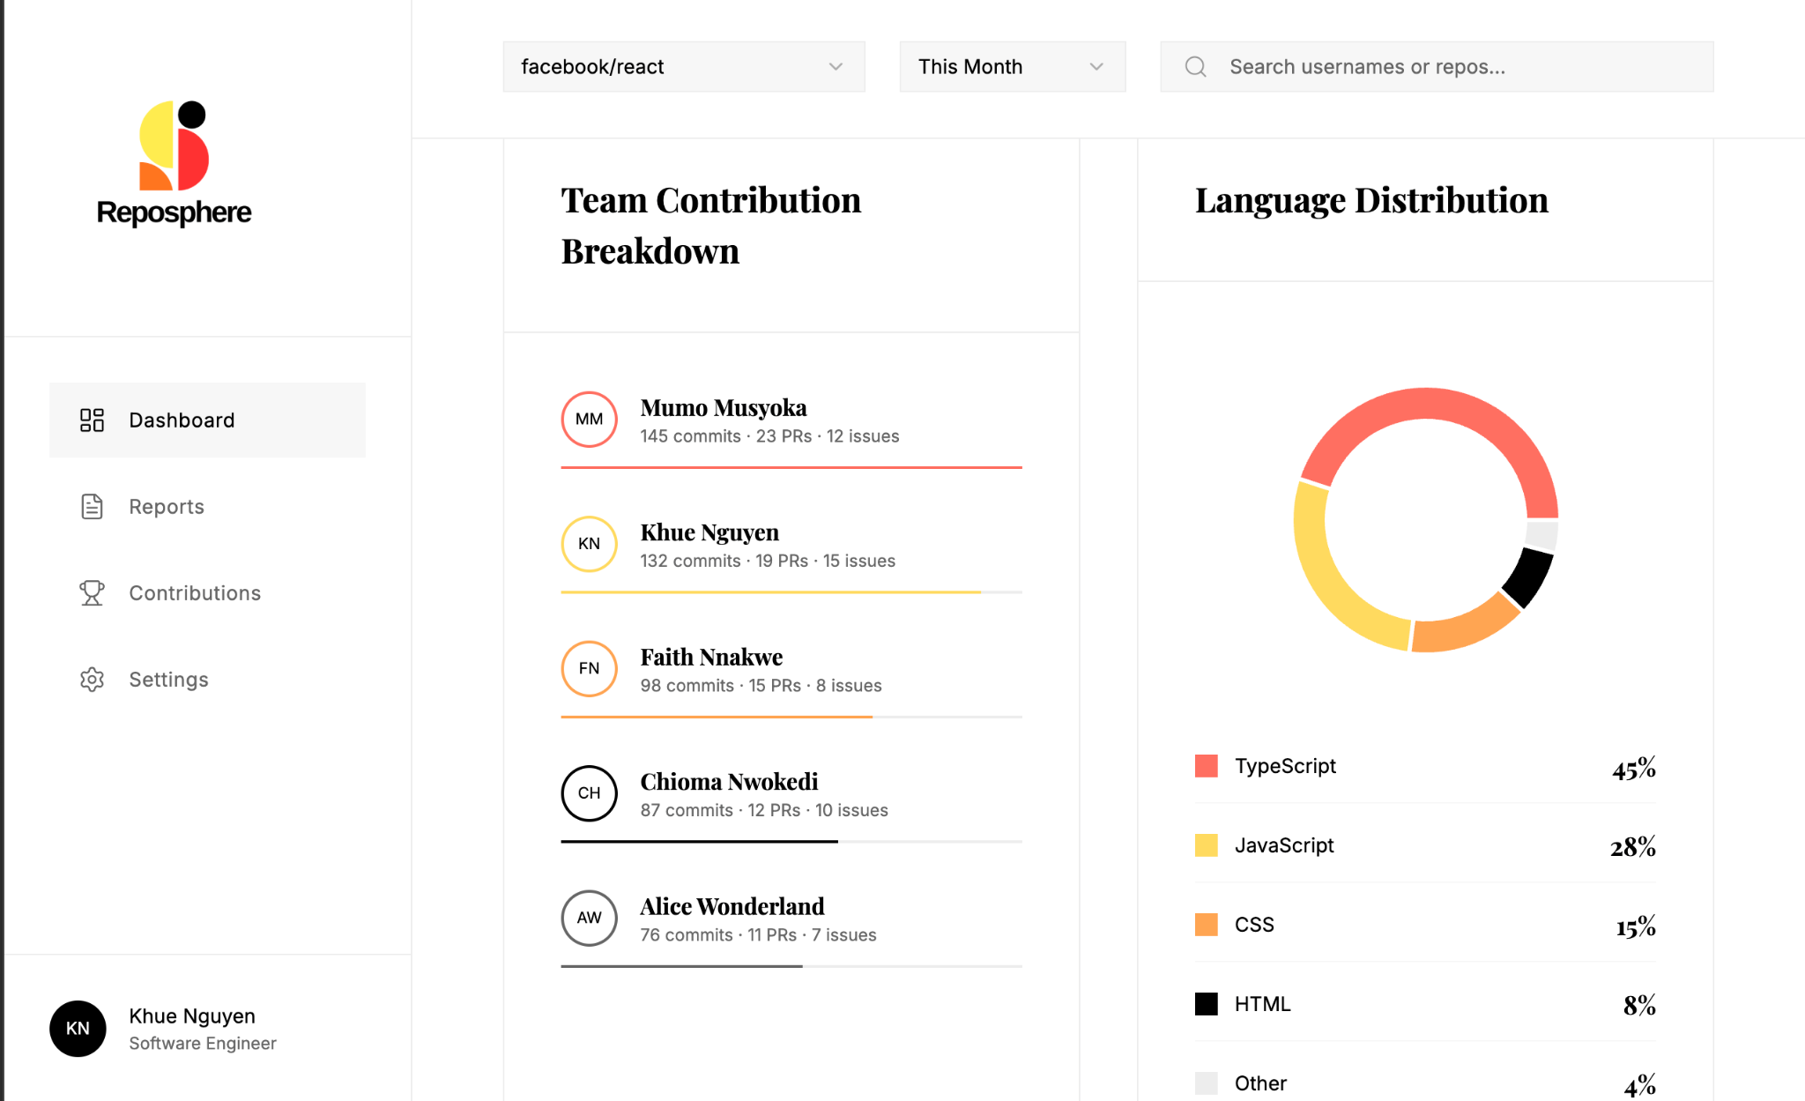
Figure 10.2.2 & 10.2.3
Repository Dashboard
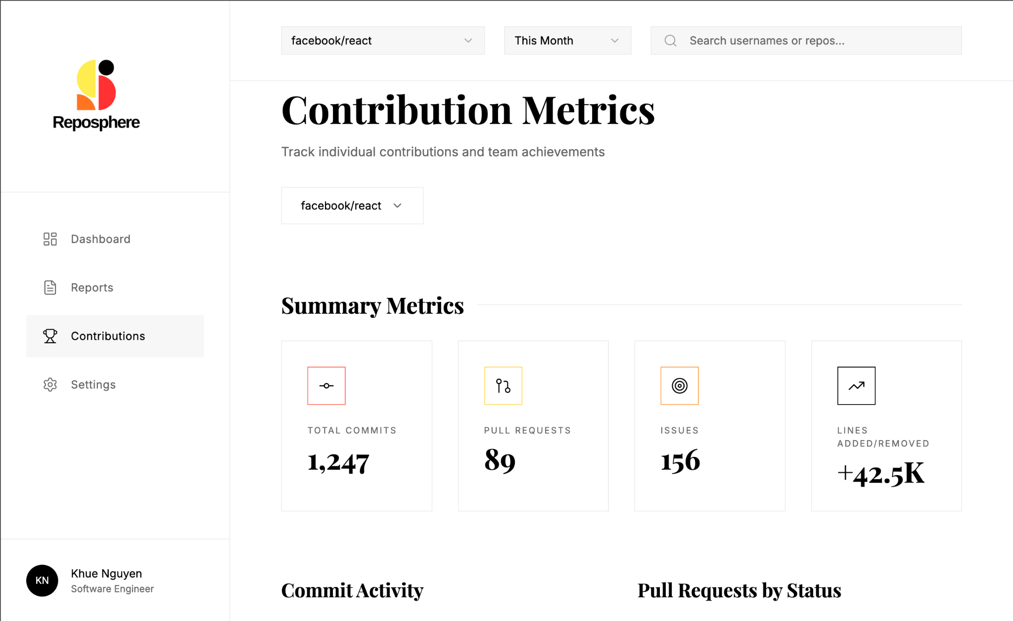
This shows the other contribution metrics, such as team contribution breakdown and language distribution
Figure 10.2.4
Contribution Metrics
This shows commit messages, authors, dates, pull request/issue references, and lines changed
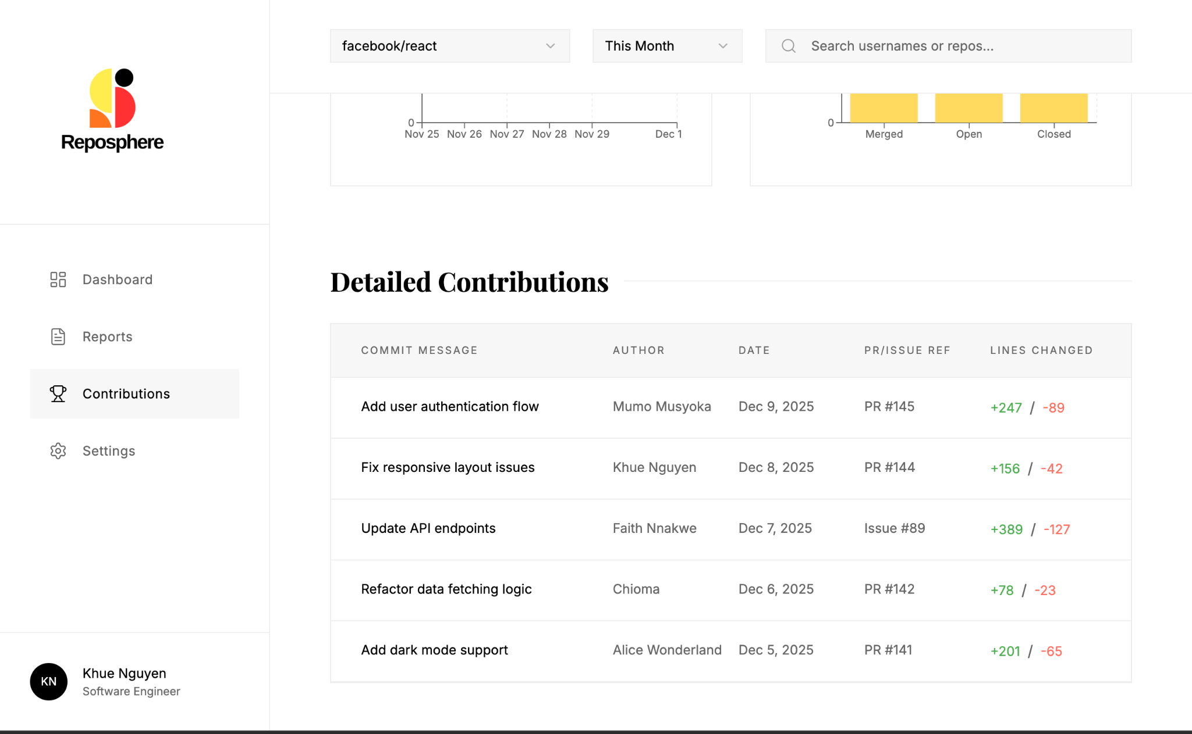
Figure 10.2.5
Contribution Metrics
Detailed contributions for each user
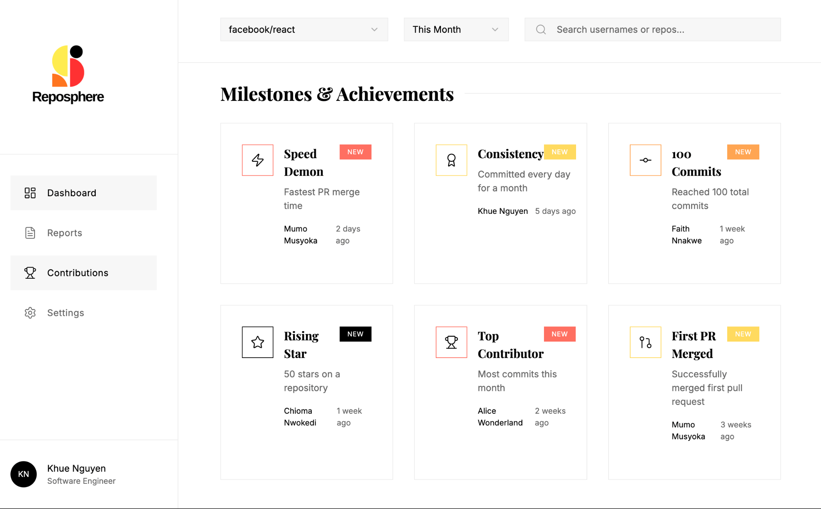
Figure 10.2.6
Contribution Metrics
Milestones and Achievements, gamifying contributions by users

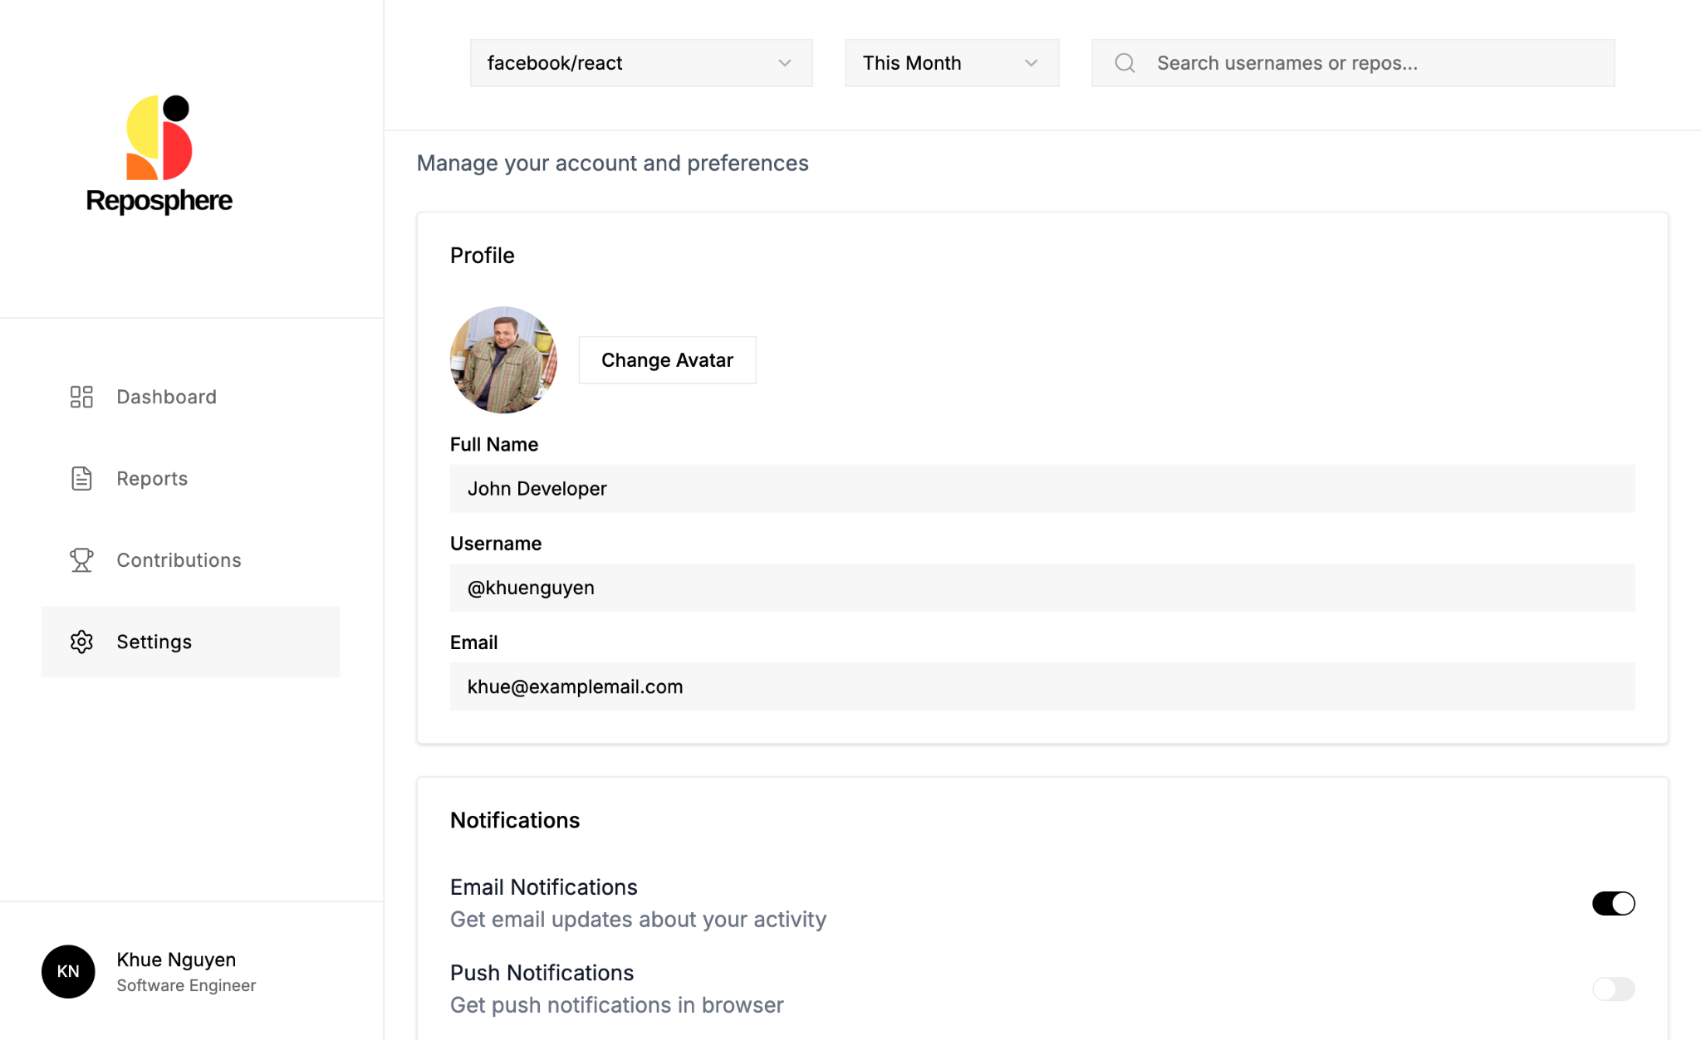
Figure 10.2.7
Settings
Users can select a new profile avatar, name, and email. Additionally, they can choose what notifications they want
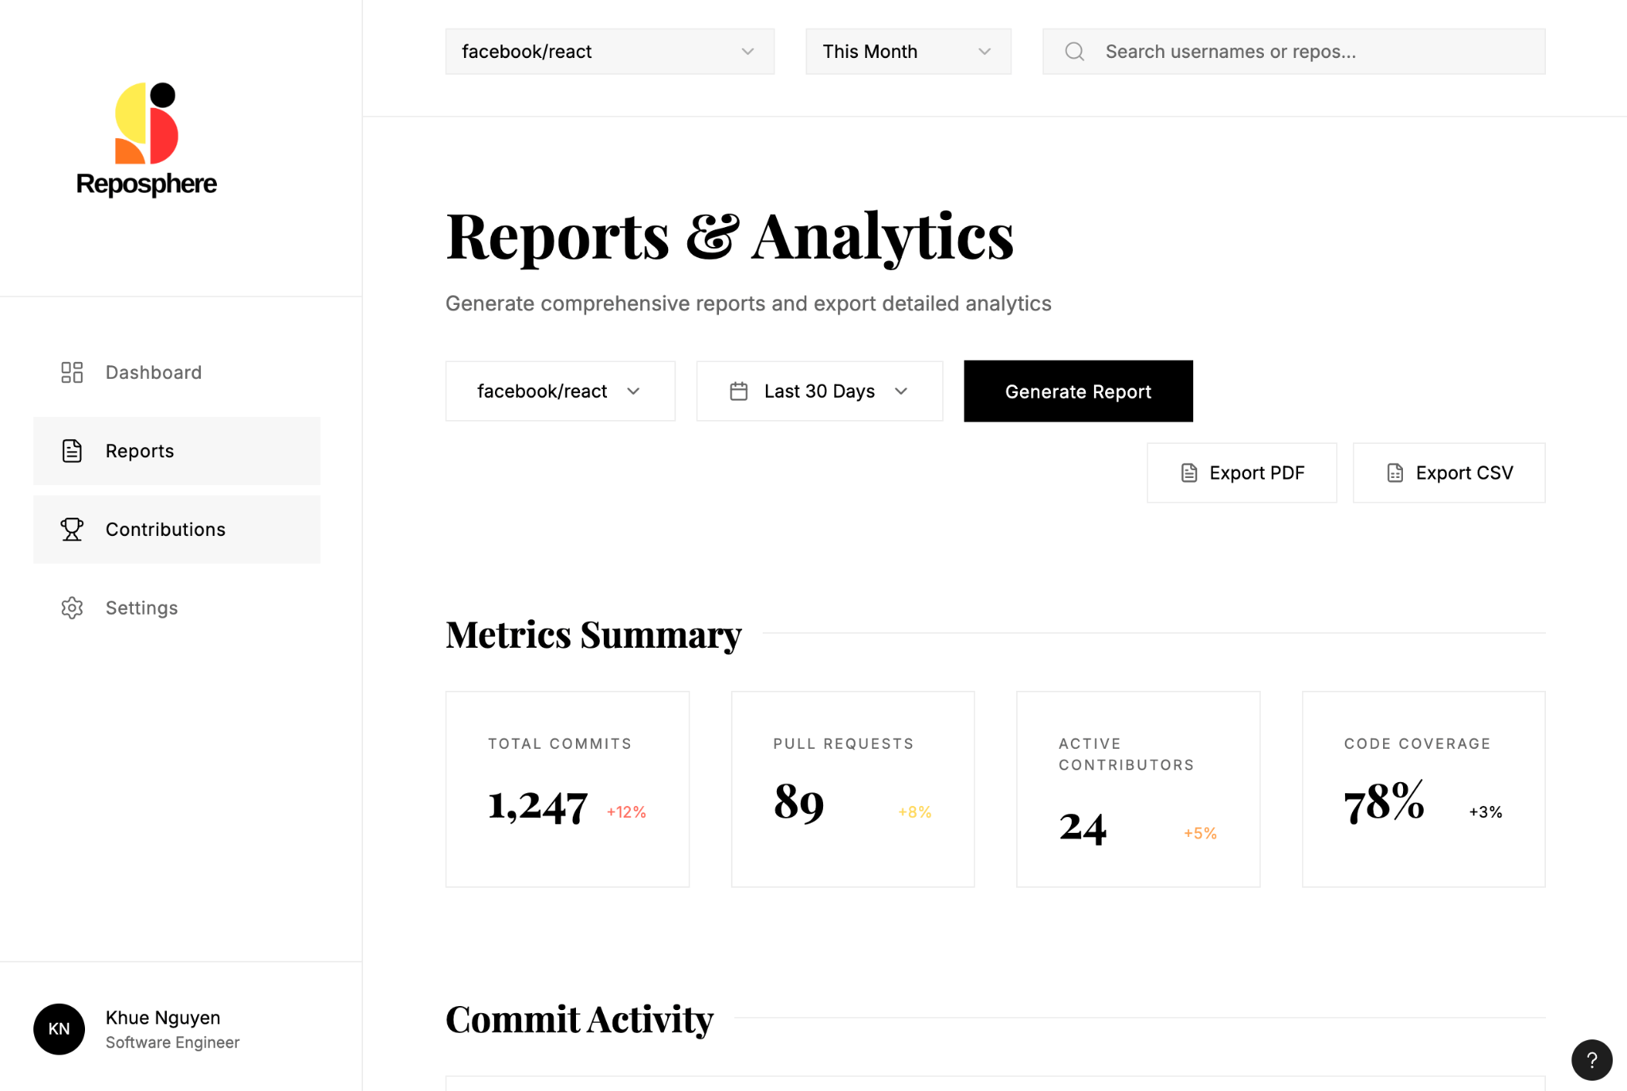
Figure 10.2.8
Reports
Detailed report and analytics, such as metrics summaries and exporting CSVs or PDFs

Appendix C: Database Schema Diagrams
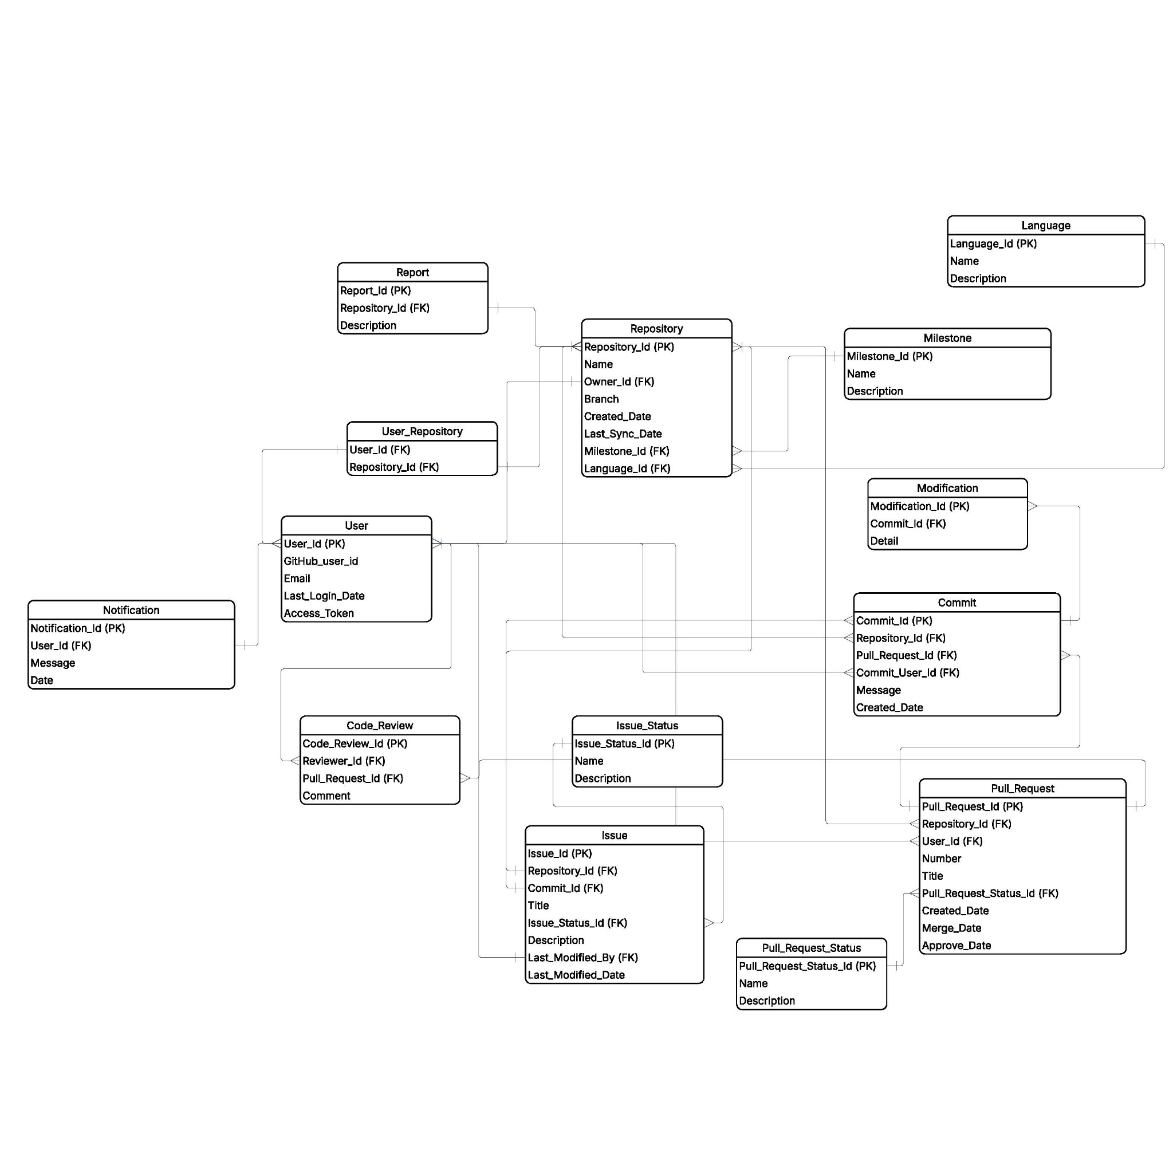
Figure 10.3.1
ERD Diagram
The diagram represents the RepoSphere database schema, outlining the tables and relational structure used to organize the GitHub contribution data. Arrows indicate primary and foreign key relationships between tables, making sure of data integrity and uniquely identifying all the records within the system

This Software Design Document serves as a comprehensive guide for the development of the RepoSphere web application, detailing every aspect from requirements to deployment and maintenance. It is intended to ensure that all stakeholders are aligned and that the development team has a clear roadmap for building the system.

