**ICBP and CCLE Results**

**Green** = Good **Red**  = Bad

**1) Adaptive vs. Non-Adaptive**

**Figure 1.** Correlations between Adaptive and Non-Adaptive ASSIGN pathway predictions for both single and multi-pathway in **IBCP data**

|  |  |  |
| --- | --- | --- |
| ICBP | **Single** | **Multi** |
| AKT(adap)-AKT(nonadap) | 0.99 | 0.99 |
| HER2(adap)--HER2(nonadap) | 0.99 | 0.98 |
| IGFR(adap)--IGFR(nonadap) | 0.72 | 0.99 |
| BAD(adap)--BAD(nonadap) | 0.99 | 0.98 |

**Figure 2.** Correlations between Adaptive and Non-Adaptive ASSIGN pathway predictions for both single and multi-pathway in **CCLE data**

|  |  |  |
| --- | --- | --- |
| CCLE | **Single** | **Multi** |
| AKT(adap)-AKT(nonadap) | 0.99 | 0.99 |
| HER2(adap)--HER2(nonadap) | 0.99 | 0.83 |
| IGFR(adap)--IGFR(nonadap) | 0.99 | 0.97 |
| BAD(adap)--BAD(nonadap) | 0.98 | 0.96 |

**Results:**

* Adaptive and Non-adaptive are pretty much the same for single pathway, except **IGF1R** in ICBP Data.
* Start to see a bigger differences for multi-pathway, especially for HER2 in CCLE data.
* **Should use adaptive for multi-pathway**

**2) Single vs Multi-pathway (still need to complete bootstrap)**

**Figure 3.** **Single vs. Multi ASSIGN pathway predictions in IBCP data.** Spearman correlations between adaptive ASSIGN predictions for each signature

|  |  |  |  |  |
| --- | --- | --- | --- | --- |
| ICBP | **Adaptive** | | **Non-Adaptive** | |
| Single | Multi | Single | Multi |
| AKT-BAD | 0.46 | -0.25 | 0.45 | -0.15 |
| AKT-HER2 | 0.32 | 0.24 | 0.31 | -0.12 |
| AKT-IGFR | 0.03 | 0.21 | 0.02 | 0.23 |
| BAD-HER2 | -0.03 | -0.29 | -0.03 | -0.15 |
| BAD-IGFR | -0.52 | -0.39 | -0.62 | -0.41 |
| IGFR-HER2 | -0.06 | -0.39 | 0.13 | -0.47 |

**Figure 4.** **Single vs. Multi ASSIGN pathway predictions in CCLE data.**

|  |  |  |  |  |
| --- | --- | --- | --- | --- |
| CCLE | **Adaptive** | | **Non-Adaptive** | |
| Single | Multi | Single | Multi |
| AKT-BAD | 0.39 | -0.39 | 0.40 | -0.17 |
| AKT-HER2 | 0.52 | 0.37 | 0.50 | -0.01 |
| AKT-IGFR | -0.03 | 0.41 | -0.07 | 0.51 |
| BAD-HER2 | -0.12 | -0.54 | -0.13 | -0.16 |
| BAD-IGFR | -0.53 | -0.66 | -0.56 | -0.58 |
| IGFR-HER2 | 0.40 | 0.21 | 0.37 | -0.13 |

**Results:**

* **Multi**-**pathway** gives more expected results than single (AKT-BAD, BAD-HER2, IGFR-AKT correlations). No difference for BAD-IGFR or AKT-HER2.
* Not too sure about the IGFR-HER2 negative correlation and fluctuations.
* IGF1R signatures seems to create the biggest differences.
* Adaptive and Non-adaptive **single** pathway predictions are **very** **similar for both ICBP and CCLE,** but adaptive is better for **multi-pathway**
* We should be using **Adaptive Multi-pathway**

**TCGA Data**

**Figure 5. Single vs. Multi ASSIGN pathway predictions in TCGA data.**

|  |  |  |
| --- | --- | --- |
| **TCGA** | **Single** | **Multi** |
| AKT-BAD | 0.58 | 0.16 |
| AKT-HER2 | 0.34 | 0.41 |
| AKT-IGFR | -0.06 | -0.07 |
| BAD-HER2 | 0.06 | -0.31 |
| BAD-IGFR | -0.34 | -0.33 |
| IGFR-HER2 | 0.02 | -0.08 |

**Results.**

* Single and Multi and equally bad, but Multi is a little better. Not seeing the expected neg. AKT-BAD correlation, but see the Seeing the BAD- IGF1R & HER2 negative correlations.
* **How can we make this better?**

**Figure 6. CCLE Cell Lines**

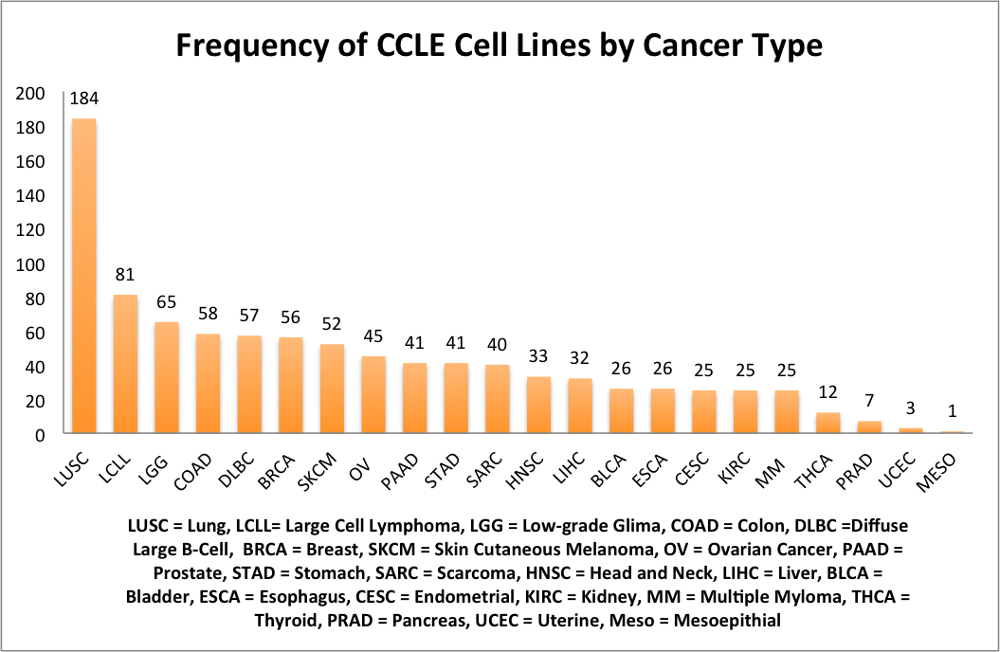

**Figure 7:** List of Common and Unique CCLE and ICBP Cell Lines

|  |  |  |
| --- | --- | --- |
| **Common to ICBP & CCLE (30)** | **Unique to CCLE (26)** | **Unique to ICBP (25)**  Overlap between CCLE & ICBP Breast Cancer Cell Lines |
| AU565 | BT20 | 184A1 |
| BT474 | CAL120 | 184B5 |
| BT483 | CAL148 | 21MT1 |
| BT549 | CAL51 | 21MT2 |
| CAMA1 | CAL851 | 21NT |
| EFM192A | DU4475 | 21PT |
| HCC1143 | EFM19 | 600MPE |
| HCC1395 | HA578T | EFM192B |
| HCC1419 | HCC1187 | EFM192C |
| HCC1428 | HCC1500 | HCC3153 |
| HCC1569 | HCC2157 | HS578T |
| HCC1599 | HDQP1 | LY2 |
| HCC1806 | HMC18 | MB157 |
| HCC1937 | HS281T | MCF10A |
| HCC1954 | HS343T | MCF10F |
| HCC202 | HS606T | MCF12A |
| HCC2218 | HS739T | MDAMB175 |
| HCC38 | HS742T | MX1 |
| HCC70 | KPL1 | SUM1315 |
| JIMT1 | MDAMB157 | SUM149PT |
| MCF7 | MDAMB175VII | SUM225CWN |
| MDAMB134VI | MDAMB415 | SUM229PE |
| MDAMB231 | MDAMB435S | SUM52PE |
| MDAMB361 | MDAMB436 | T47D Kbluc |
| SKBR3 | MDAMB453 | ZR75B |
| T47D | MDAMB468 |  |
| UACC812 |  |  |
| UACC893 |  |  |
| ZR751 |  |  |
| ZR7530 |  |  |