**Paper Outline**

**Multi-pathway modeling of response to AKT inhibitors in breast cancer**

**Modeling AKT inhibitor response in breast cancer using multi-pathway signatures**

Predicting drug response to AKT inhibitors at the multi-pathway level in breast cancer

Mumtahena Rahman1, Shelley MacNeil2, Laurie K Jackson2, David Jenkins, Paula Hoffman, Stephen Piccolo2, 3, Laura M Heiser 4, Joe W. Gray4, Evan W Johnson3, Andrea H Bild2

Journal: Cancer Research

Introduction

* Breast cancer statistics
* History of personalized medicine in breast cancer and why it’s inefficient
  + - (HER2 story)
* The need for personalized drug response predictions
* Why the pathway-based approach is better
* AKT/BAD/IGF1R/HER/ERK in breast cancer
* Goal: Modeling and validating drug response predictions using a pathway based approach to provide individualized treatments.

Methods

1) Overexpression of pathway elements using adenovirus in HMEC cells

- Virus we used, infection time, MOI, all the specifics

*-* Western blot figures for each signatures (supplements)

- Just the phosphorylated proteins and the B-action

2) Data processing and normalization

Sequencing methods, processing (Rsubread), normalization, batch adjusting

- Signatures

- ICBP

- CCLE

- TCGA

3) Generation and validation of genomic signatures that represent pathway activity

- ASSIGN parameters, test data tests, correlation parameters, boot strap method

4) Validating finding in cell lines and patient cells

-Reagents, protocols

Results

1. BAD pathway as a biomarker for chemosensitivity and chemoresistance:
   1. High BAD activity correlated well with chemosensitivity in cell lines for many classes of chemotherapies including taxane derivatives, platinum analogs and topoisomerase inhibitors.

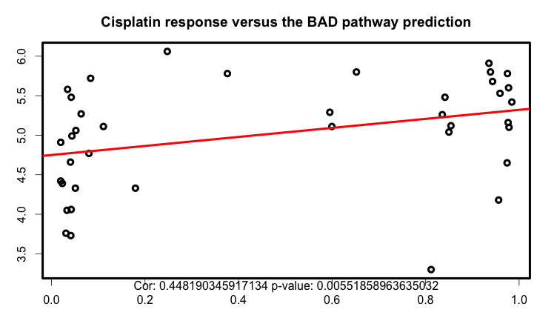

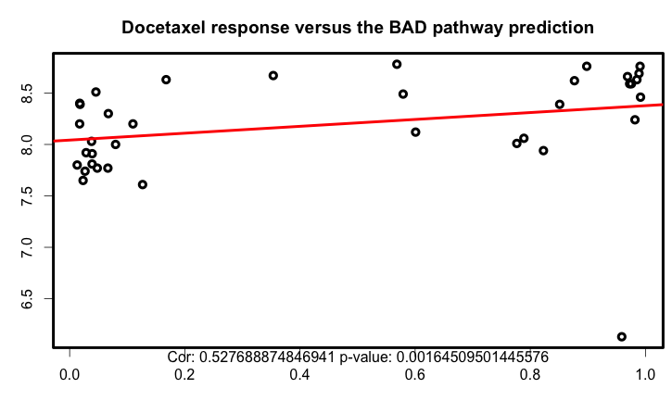

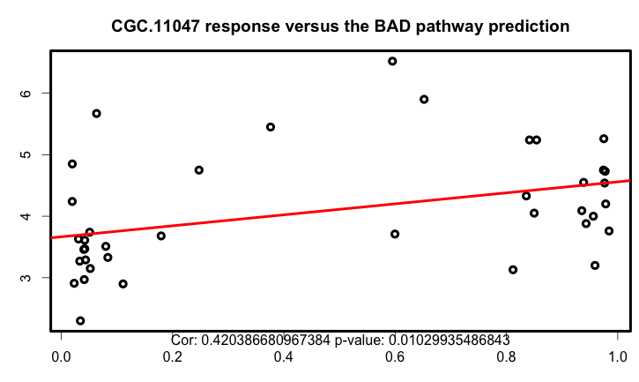

* 1. Within subtypes, triple negative breast cancer has higher BAD activity making this subtype more sensitive to chemotherapies
     1. In ICBP, CCLE breast cancer cell lines

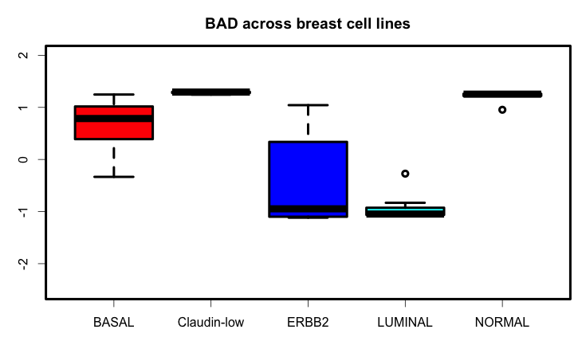

* + 1. In TCGA BRCA, basal-like subtype samples have the highest BAD activity and patients with this subtype of breast cancer are more likely to benefit from chemotherapy.

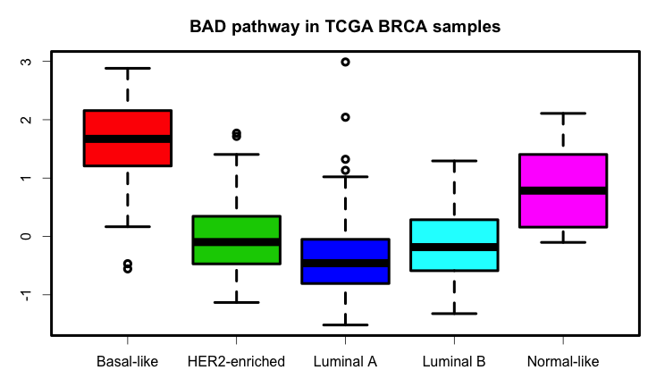

1. BAD pathway provides insights about HER2, AKT, PI3K and mTOR targeted therapy sensitivity. BAD pathway activity is negatively correlated with HER2, AKT, PI3K and mTOR activity and can be used to identify resistance to therapies targeting these nodes.
   1. In ICBP, CCLE and GDSC dataset

*1) Validation of the genomic signatures (in methods, one Figure)*

* AKT, HER2, IGF1R, BAD, ERK predictions correlate with ICBP drug response data (more interesting)
* Show all correlation one heat map
* Boxplot for sensitive and resistance for each signature(mClust)
* Should we add TCGA validation?

*3) BAD/ERK pathway activity correlates with chemotherapy response (tie in with 2)*

* ICBP boxplots of pathway activation in BAD/ERK for multiple chemo drugs
* TCGA hopefully, survival curves from patients that got chemo and had high bad activity vs. those that don’t.

**Balko et al. DUSP4, a negative regulator of ERK1 & 2

DUSP4 loss after chemo correlates with poor patient outcome by activating RAS-ERK pathway

*6) Predictive models for Sigma AKT using gene expression signature’s*

*-*Building the model (method)

- Testing the model

1) Publically available data

- GDSC or CCLE

- Probably can’t do with TCGA

2) Breast cancer cell lines in the lab

3)Patient cells pleural effusions

- Test the EC50 for sigmaAKT

7) *Predictive models for Sigma AKT using multi-omic data*

*-*Building the model (method)

- Testing the model

1) Publically available data

- GDSC or CCLE

- Probably can’t do with TCGA

2) Breast cancer cell lines in the lab

3)Patient cells pleural effusions

- Test the EC50 for sigmaAKT

4) Contribution of adding multi-omic data

*2) Are multi-pathway prediction better predict than single pathway ?*

- Describe which pathways work best together for predictions

- Table with prediction/drug response correlations and p-values.

4) *Other ideas*

*- IGF1R pathway activation and response to AKT inhibitiors*

***- AKT pathway response to AKT inhibitors, Pi3k inhibitors.***

***- HER2 response to AKT and PI3K drugs***

*- ERK pathway response to PI3K, mTOR, and AKT drugs*

*-*

*5) Subtypes specific pathway deregulation in breast cancer cell lines and TCGA data*

What pathways are important in each subtype in breast cancer cell lines.

-ICBP correlation matrix between subtypes and drug predictions

-Validate in CCLE (need to do this)

-TCGA maybe (need to comment on why it is not as good)