Paper Outline

Multi-pathway modeling of response to AKT inhibitors in breast cancer

Modeling AKT inhibitor response in breast cancer using multi-pathway signatures

Predicting drug response to AKT inhibitors at the multi-pathway level in breast cancer

Molecular profiling of breast cancer treatments using multi-pathway HER2/IGF1R/AKT/BAD signatures

Mumtahena Rahman, Shelley MacNeil, Laurie K Jackson, David Jenkins, Paula Hoffman, Stephen Piccolo, Laura M Heiser, Joe W. Gray, Evan W Johnson, Andrea H Bild

Journal: Cancer Research?

Introduction

* Breast cancer statistics
* History of personalized medicine in breast cancer and why it’s inefficient
  + - (HER2 story)
* The need for personalized drug response predictions
* Why the pathway-based approach is better
* AKT/BAD/IGF1R/HER/ERK in breast cancer
* Goal: Modeling and validating drug response predictions using a pathway based approach to provide individualized treatments.

Methods

1) Overexpression of pathway elements using adenovirus in HMEC cells

- Virus we used, infection time, MOI, all the specifics

*-* Western blot figures for each signatures (supplements)

- Just the phosphorylated proteins and the B-action

2) Data processing and normalization

Sequencing methods, processing (Rsubread), normalization, batch adjusting

- Signatures

- ICBP

- CCLE

- TCGA

3) Generation and validation of genomic signatures that represent pathway activity

- ASSIGN parameters, test data tests, correlation parameters, boot strap method

4) Validating finding in cell lines and patient cells

-Reagents, protocols

Results

1. BAD pathway as a biomarker for chemosensitivity:
   1. High BAD activity correlated well with chemosensitivity in cell lines for many classes of chemotherapies including taxane derivatives, platinum analogs and topoisomerase inhibitors.

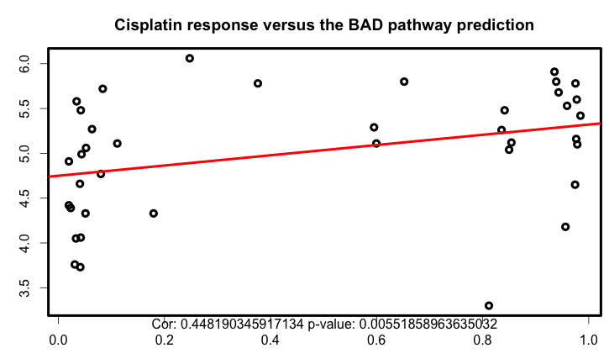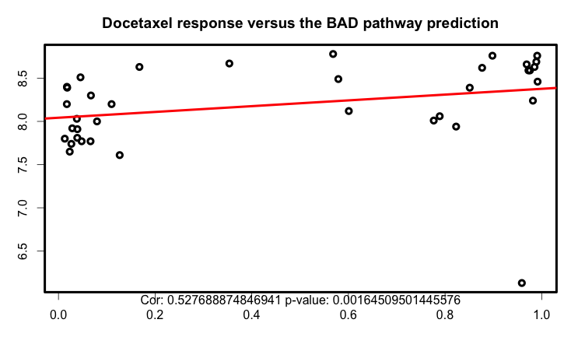

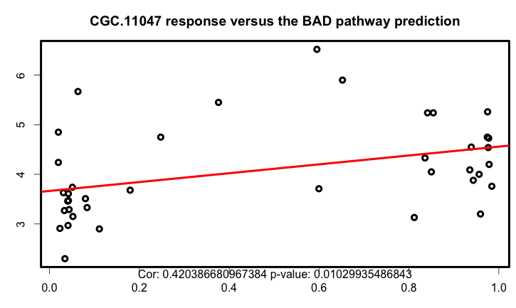

* 1. Within subtypes, triple negative (Basal and Claudin-low) breast cancer has higher BAD activity making this subtype more sensitive to chemotherapies
     1. In ICBP, CCLE breast cancer cell lines

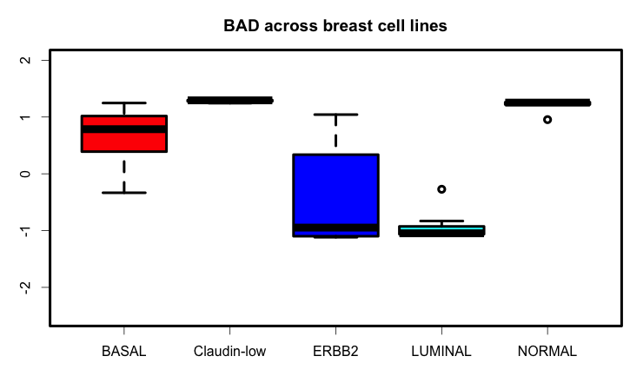

* + 1. In TCGA BRCA, basal-like subtype samples have the highest BAD activity and patients with this subtype of breast cancer are more likely to benefit from chemotherapy.

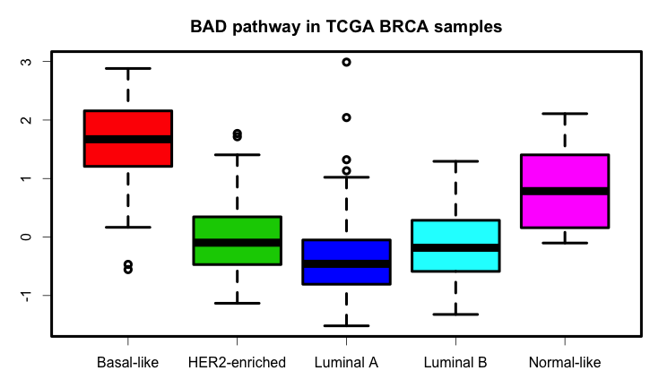

1. In addition to chemosensitivity, BAD pathway provides insights about HER2, AKT, PI3K and mTOR targeted therapy sensitivity. BAD pathway activity is negatively correlated with HER2, AKT, PI3K and mTOR activity and can be used to identify resistance to therapies targeting these nodes.
   1. In ICBP breast cancer cell lines

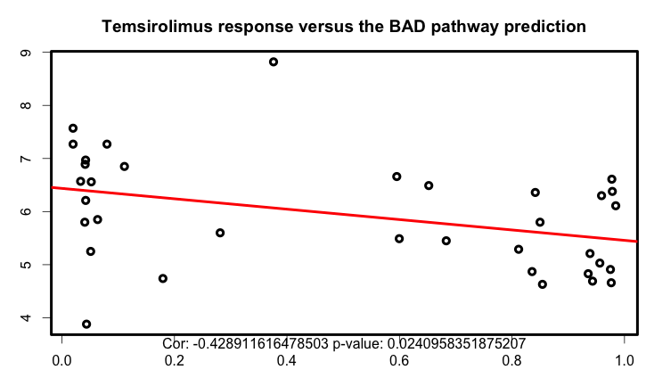

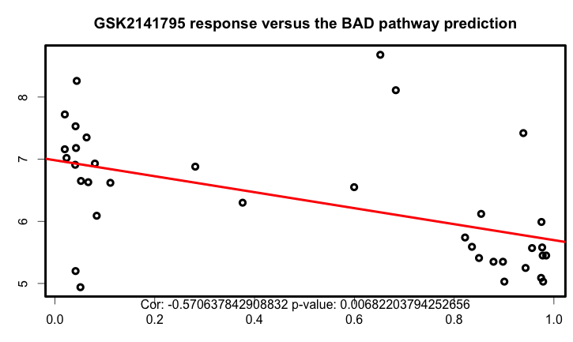

* 1. CCLE and GDSC dataset

1. Modeling AKT targeting drug response
   1. Luminal breast cancers have high AKT activity, therefore, AKT targeting therapies work better in this subtype.

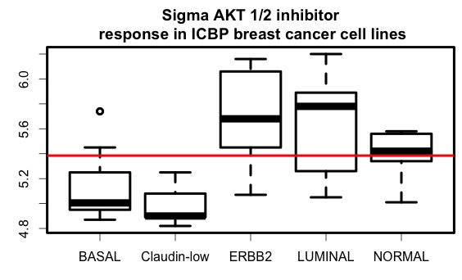

* 1. AKT drug response in Luminal subtype

1. Modeling HER2 targeting drug response
   1. Compare HER2 amplification status and HER2 high pathway activity
   2. Comparing drug response based on the HER2 amplification versus HER2 high pathway activity in breast cancer cell lines. Pathway predictions are more specific to drug response for lapatinib than the HER2 status.

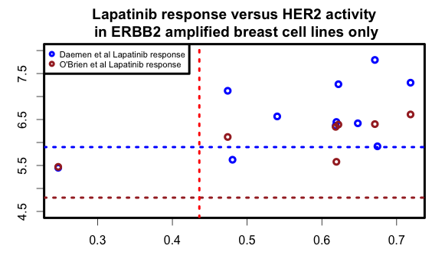

Figure: The blue dashed line divides the cell lines based on the drug response assay done by O’Brien et al and all blue dots are representing ERBB2 amplified cell lines. Cell lines above this line are “sensitive” to Lapatinib and below are “resistance”. The redline shows HER2 pathway prediction above which cell lines are likely to be sensitive to HER2 targeted therapy and below which cell lines are not likely to responsive to HER2 targeted therapy. The brown dots are showing ERBB2 amplified cell lines’ drug response and brown dashed line is showing above which cell lines are Lapatinib sensitive (data from Heiser at al). HER2 pathway predictions are more specific for HER2 targeted therapy response in these ERBB2 amplified cell lines.

1. Building model based on BAD, AKT, HER2 and IGF1R pathway predictions and subtypes.
   1. Chemodrugs

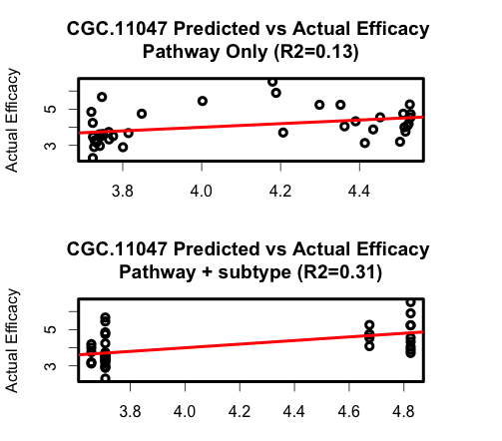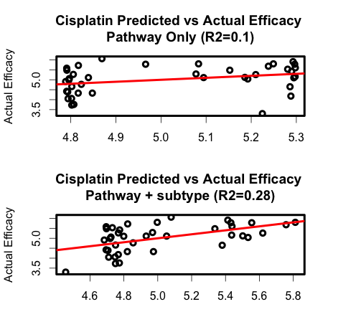

* 1. AKT and mTOR targeting drug: Sigma AKT, GSK2141795, rapamycin, temsirolimus, everlolimus. For targeted therapies, pathway predictions explains significant portion of the drug response variability.

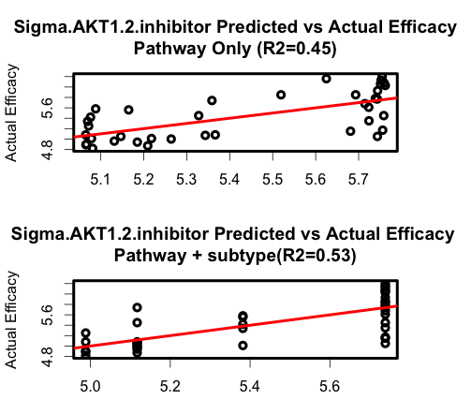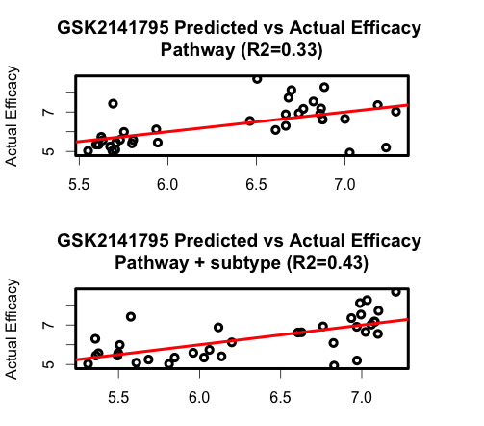

* 1. HER2 targeting drug: Lapatinib, BIBW2992

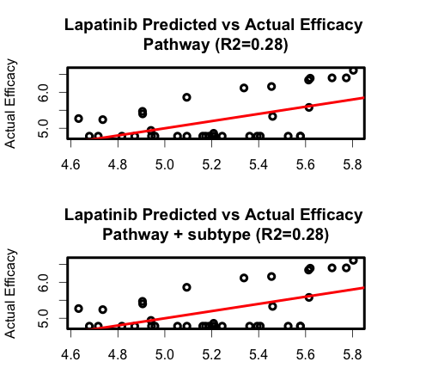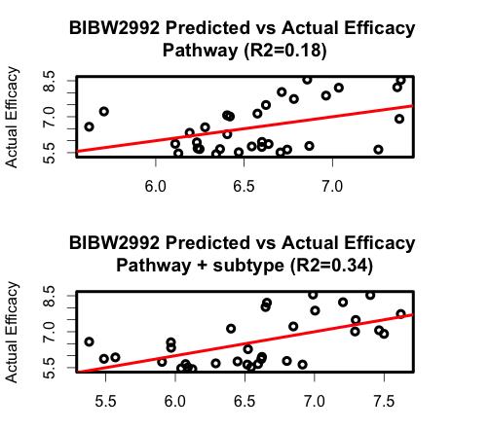

1. Validation of the models in independent cell lines and patient cells
2. *Other ideas*

*- something interesting about IGF1R pathway*

*- something interesting about ERK pathway*