**ICBP and CCLE Results**

**Green** = Good **Red**  = Bad

**1) Adaptive B/Non-Adpative S vs. Non-Adaptive B/Non-Adaptive S**

**Figure 1.** Correlations between Adaptive and Non-Adaptive ASSIGN pathway predictions for both single and multi-pathway in **IBCP data**

* **Boot strap these, but also add the correlations:**

1. Adaptive B/Non-Adpative S vs. Non-Adaptive B/Non-Adaptive S
2. Non-Adaptive B/Non-Adaptive S vs. Adaptive B: Adaptive B Onlytive S <might not do this one
3. Adaptive B/Non-Adpative S vs. Adaptive B: Adaptive B Onlytive S

I could do them, but mine as well wait for the bootstrap code.

|  |  |  |
| --- | --- | --- |
| ICBP | **Single** | **Multi** |
| AKT(adapB)-AKT(nonadapB) | 0.99 | 0.99 |
| HER2(adapB)--HER2(nonadapB) | 0.99 | 0.98 |
| IGFR(adapB)--IGFR(nonadapB) | 0.72 | 0.99 |
| BAD(adapB)--BAD(nonadapB) | 0.99 | 0.98 |

|  |  |  |  |  |
| --- | --- | --- | --- | --- |
| ICBP | **Background** | **Signature** | **Single** | **Multi** |
| AKT-AKT | + | + |  |  |
| AKT-AKT | + | - |  |  |
| AKT-AKT | - | - |  |  |
| BAD-BAD | + | + |  |  |
| BAD-BAD | + | - |  |  |
| BAD-BAD | - | - |  |  |
| IGF1R-IGF1R | + | + |  |  |
| IGF1R-IGF1R | + | - |  |  |
| IGF1R-IGF1R | - | - |  |  |
| HER2-HER2 | + | + |  |  |
| HER2-HER2 | + | - |  |  |
| HER2-HER2 | - | - |  |  |

**Figure 2.** Correlations between Adaptive and Non-Adaptive ASSIGN pathway predictions for both single and multi-pathway in **CCLE data**

|  |  |  |
| --- | --- | --- |
| CCLE | **Single** | **Multi** |
| AKT(adap)-AKT(nonadap) | 0.99 | 0.99 |
| HER2(adap)--HER2(nonadap) | 0.99 | 0.83 |
| IGFR(adap)--IGFR(nonadap) | 0.99 | 0.97 |
| BAD(adap)--BAD(nonadap) | 0.98 | 0.96 |

|  |  |  |  |  |
| --- | --- | --- | --- | --- |
| ICBP | **Background** | **Signature** | **Single** | **Multi** |
| AKT-AKT | + | + |  |  |
| AKT-AKT | + | - |  |  |
| AKT-AKT | - | - |  |  |
| BAD-BAD | + | + |  |  |
| BAD-BAD | + | - |  |  |
| BAD-BAD | - | - |  |  |
| IGF1R-IGF1R | + | + |  |  |
| IGF1R-IGF1R | + | - |  |  |
| IGF1R-IGF1R | - | - |  |  |
| HER2-HER2 | + | + |  |  |
| HER2-HER2 | + | - |  |  |
| HER2-HER2 | - | - |  |  |

**Results:**

* Adaptive and Non-adaptive are pretty much the same for single pathway, except **IGF1R** in ICBP Data.
* Start to see a bigger differences for multi-pathway, especially for HER2 in CCLE data.
* **Should use adaptive for multi-pathway**

**2) Single vs Multi-pathway (still need to complete bootstrap)**

**Figure 3.** **Single vs. Multi ASSIGN pathway predictions in IBCP data.** Spearman correlations between adaptive ASSIGN predictions for each signature

*** Add Adaptive Adaptive

*** Add the bootstrap, waiting on Evan

*** Don’t bother adding the new results because you need to boot strap the others.

|  |  |  |  |  |  |  |
| --- | --- | --- | --- | --- | --- | --- |
| ICBP | **Adap B/N-Adap S** | | **N-Adap B/N-Adap S** | | **Adap B: Adaptive B Only S** | |
| Single | Multi | Single | Multi | Single | Multi |
| AKT-BAD | 0.46 | -0.25 | 0.45 | -0.15 |  |  |
| AKT-HER2 | 0.32 | 0.24 | 0.31 | -0.12 |  |  |
| AKT-IGFR | 0.03 | 0.21 | 0.02 | 0.23 |  |  |
| BAD-HER2 | -0.03 | -0.29 | -0.03 | -0.15 |  |  |
| BAD-IGFR | -0.52 | -0.39 | -0.62 | -0.41 |  |  |
| IGFR-HER2 | -0.06 | -0.39 | 0.13 | -0.47 |  |  |

**Figure 4.** **Single vs. Multi ASSIGN pathway predictions in CCLE data.**

|  |  |  |  |  |  |  |
| --- | --- | --- | --- | --- | --- | --- |
| CCLE | **Adap B/N-Adap S** | | **N-Adap B/N-Adap S** | | **Adap B: Adaptive B Only S** | |
| Single | Multi | Single | Single | Single | Multi |
| AKT-BAD | 0.39 | -0.39 | 0.40 | -0.17 |  |  |
| AKT-HER2 | 0.52 | 0.37 | 0.50 | -0.01 |  |  |
| AKT-IGFR | -0.03 | 0.41 | -0.07 | 0.51 |  |  |
| BAD-HER2 | -0.12 | -0.54 | -0.13 | -0.16 |  |  |
| BAD-IGFR | -0.53 | -0.66 | -0.56 | -0.58 |  |  |
| IGFR-HER2 | 0.40 | 0.21 | 0.37 | -0.13 |  |  |

**Results:**

* **Multi**-**pathway** gives more expected results than single (AKT-BAD, BAD-HER2, IGFR-AKT correlations). No difference for BAD-IGFR or AKT-HER2.
* Not too sure about the IGFR-HER2 negative correlation and fluctuations.
* IGF1R signatures seems to create the biggest differences.
* Adaptive and Non-adaptive **single** pathway predictions are **very** **similar for both ICBP and CCLE,** but adaptive is better for **multi-pathway**
* We should be using **Adaptive Multi-pathway**

**TCGA Data**

**Figure 5. Single vs. Multi ASSIGN pathway predictions in TCGA data.**

|  |  |  |
| --- | --- | --- |
| **TCGA** | **Single** | **Multi** |
| AKT-BAD | 0.58 | 0.16 |
| AKT-HER2 | 0.34 | 0.41 |
| AKT-IGFR | -0.06 | -0.07 |
| BAD-HER2 | 0.06 | -0.31 |
| BAD-IGFR | -0.34 | -0.33 |
| IGFR-HER2 | 0.02 | -0.08 |

**Results.**

* Single and Multi and equally bad, but Multi is a little better. Not seeing the expected neg. AKT-BAD correlation, but see the Seeing the BAD- IGF1R & HER2 negative correlations.
* **How can we make this better?**

**Figure 6. CCLE Cell Lines**

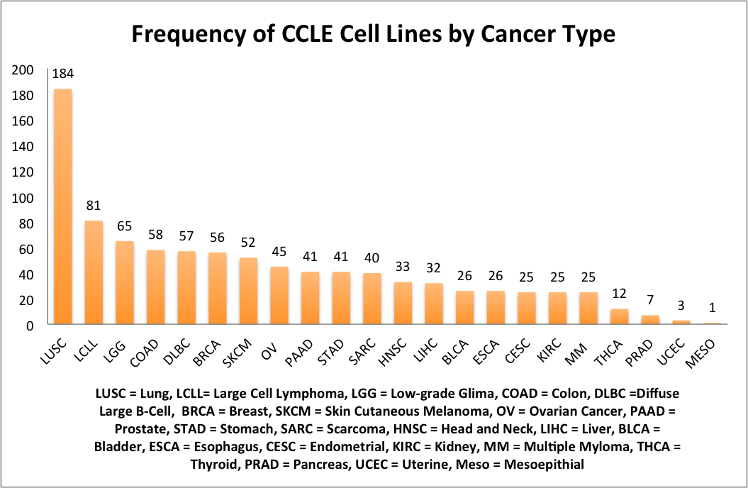

**Figure 7:** List of Common and Unique CCLE and ICBP Cell Lines

|  |  |  |
| --- | --- | --- |
| **Common to ICBP & CCLE (30)** | **Unique to CCLE (26)** | **Unique to ICBP (25)**  Overlap between CCLE & ICBP Breast Cancer Cell Lines |
| AU565 | BT20 | 184A1 |
| BT474 | CAL120 | 184B5 |
| BT483 | CAL148 | 21MT1 |
| BT549 | CAL51 | 21MT2 |
| CAMA1 | CAL851 | 21NT |
| EFM192A | DU4475 | 21PT |
| HCC1143 | EFM19 | 600MPE |
| HCC1395 | HA578T | EFM192B |
| HCC1419 | HCC1187 | EFM192C |
| HCC1428 | HCC1500 | HCC3153 |
| HCC1569 | HCC2157 | HS578T |
| HCC1599 | HDQP1 | LY2 |
| HCC1806 | HMC18 | MB157 |
| HCC1937 | HS281T | MCF10A |
| HCC1954 | HS343T | MCF10F |
| HCC202 | HS606T | MCF12A |
| HCC2218 | HS739T | MDAMB175 |
| HCC38 | HS742T | MX1 |
| HCC70 | KPL1 | SUM1315 |
| JIMT1 | MDAMB157 | SUM149PT |
| MCF7 | MDAMB175VII | SUM225CWN |
| MDAMB134VI | MDAMB415 | SUM229PE |
| MDAMB231 | MDAMB435S | SUM52PE |
| MDAMB361 | MDAMB436 | T47D Kbluc |
| SKBR3 | MDAMB453 | ZR75B |
| T47D | MDAMB468 |  |
| UACC812 |  |  |
| UACC893 |  |  |
| ZR751 |  |  |
| ZR7530 |  |  |

**ERK Validation**

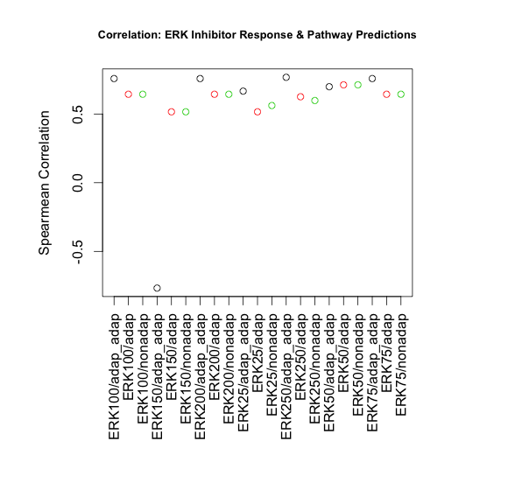

|  |  |
| --- | --- |
| ERK Predictions | ERKi.II..FR180304. |
| **ERK100: Adaptive B+S** | **0.75799877** |
| ERK100: Adaptive B Only | 0.643842329 |
| ERK100: Non-Adpative | 0.643842329 |
| ERK150: Adaptive B+S | -0.767131285 |
| ERK150: Adaptive B Only | 0.515987114 |
| ERK150: Non-Adpative | 0.515987114 |
| **ERK200: Adaptive B+S** | **0.75799877** |
| ERK200: Adaptive B Only | 0.643842329 |
| ERK200: Non-Adpative | 0.643842329 |
| ERK25: Adaptive B+S | 0.666673617 |
| ERK25: Adaptive B Only | 0.515987114 |
| ERK25: Non-Adpative | 0.561649691 |
| **ERK250: Adaptive B+S** | **0.767131285** |
| ERK250: Adaptive B Only | 0.625577298 |
| ERK250: Non-Adpative | 0.598179752 |
| ERK50: Adaptive B+S | 0.69863742 |
| ERK50: Adaptive B Only | 0.712336193 |
| ERK50: Non-Adpative | 0.712336193 |
| **ERK75: Adaptive B+S** | **0.75799877** |
| ERK75: Adaptive B Only | 0.643842329 |
| ERK75: Non-Adpative | 0.643842329 |

- Looks like for 50 if you use less genes its better with Non-adpative

**Results:**

1. Gene lists all contain the same genes and coefficients for all three (adaptive B + S, adaptive B only, and Non-adaptive B or S) <- have Moom double check this.
2. If they have the same gene lists why do they lead to different pathway predictions

100 genes and 200 genes seems to be the best because it’s more stable.

This is probably because all of the gene lists are the same. If the gene lists and coefficients are the same for adaptive and non-adaptive, why are the predictions different? Does adaptive signature do something different?

See excel document for correlations of predictions.

