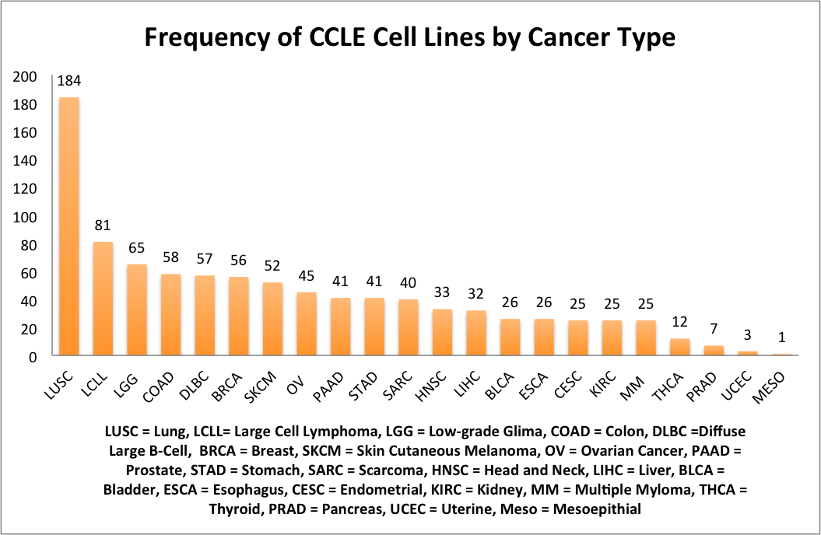

List of Common and Unique CCLE and ICBP Cell Lines

|  |  |  |
| --- | --- | --- |
| **Common to ICBP & CCLE (30)** | **Unique to CCLE (26)** | **Unique to ICBP (25)**  Overlap between CCLE & ICBP Breast Cancer Cell Lines |
| AU565 | BT20 | 184A1 |
| BT474 | CAL120 | 184B5 |
| BT483 | CAL148 | 21MT1 |
| BT549 | CAL51 | 21MT2 |
| CAMA1 | CAL851 | 21NT |
| EFM192A | DU4475 | 21PT |
| HCC1143 | EFM19 | 600MPE |
| HCC1395 | HA578T | EFM192B |
| HCC1419 | HCC1187 | EFM192C |
| HCC1428 | HCC1500 | HCC3153 |
| HCC1569 | HCC2157 | HS578T |
| HCC1599 | HDQP1 | LY2 |
| HCC1806 | HMC18 | MB157 |
| HCC1937 | HS281T | MCF10A |
| HCC1954 | HS343T | MCF10F |
| HCC202 | HS606T | MCF12A |
| HCC2218 | HS739T | MDAMB175 |
| HCC38 | HS742T | MX1 |
| HCC70 | KPL1 | SUM1315 |
| JIMT1 | MDAMB157 | SUM149PT |
| MCF7 | MDAMB175VII | SUM225CWN |
| MDAMB134VI | MDAMB415 | SUM229PE |
| MDAMB231 | MDAMB435S | SUM52PE |
| MDAMB361 | MDAMB436 | T47D Kbluc |
| SKBR3 | MDAMB453 | ZR75B |
| T47D | MDAMB468 |  |
| UACC812 |  |  |
| UACC893 |  |  |
| ZR751 |  |  |
| ZR7530 |  |  |

ICBP Correlations between individual pathway predictions for single and multi (adaptive)

|  |  |  |
| --- | --- | --- |
|  | **Single** | **Multi** |
| AKT-BAD | 0.45 | -0.43 |
| AKT-HER2 | 0.33 | 0.26 |
| AKT-IGFR | 0.01 | 0.18 |
| BAD-HER2 | 0.03 | -0.34 |
| BAD-IGFR | -0.51 | -0.46 |
| IGFR-HER2 | 0.01 | -0.41 |

CCLE Correlations between adaptive and non-adaptive ASSIGN predictions

- Do with adap and adap.

Multi-Pathway (all four)

|  |  |  |  |  |
| --- | --- | --- | --- | --- |
| Multi | AKT-adap | BAD-adap | HER2-adap | IGF1R-adap |
| AKT-nonadap | 0.990088859 | -0.343745728 | 0.338892686 | 0.372863978 |
| BAD-nonadap | -0.224333561 | 0.967737526 | -0.491524265 | -0.60430622 |
| HER2-nonadap | 0.000683527 | -0.141490089 | 0.832946001 | -0.149213944 |
| IGF1R-nonadap | 0.549829118 | -0.673547505 | 0.260902256 | 0.977033493 |

Single

|  |  |  |  |  |
| --- | --- | --- | --- | --- |
| Single | AKT-adap | BAD-adap | HER2-adap | IGF1R-adap |
| AKT-nonadap | 0.999384826 | 0.398564593 | 0.5215311 | -0.041900205 |
| BAD-nonadap | 0.406630212 | 0.987696514 | -0.155775803 | -0.546821599 |
| HER2-nonadap | 0.511278195 | -0.10683527 | 0.99241285 | 0.395557075 |
| IGF1R-nonadap | -0.069514696 | -0.55509227 | 0.385099111 | 0.997607656 |

* Adap and Non-apad correlate with each other in terms of the individual signatures for both single and multi.
* But very different when the signatures correlate with each other. It could just be due to that the signatures look very different with single and multi.
* With single we don’t get as many expected results.

TCGA Breast Cancer ASSIGN multi-pathway adaptive predictions

|  |  |  |  |  |
| --- | --- | --- | --- | --- |
| Multi | AKT | BAD | HER2 | IGF1R |
| AKT | 1 | 0.16 | 0.41 | -0.07 |
| BAD | 0.16 | 1 | -0.31 | -0.33 |
| HER2 | 0.41 | -0.31 | 1 | -0.08 |
| IGF1R | -0.07 | -0.33 | -0.08 | 1 |

* We aren’t seeing a Neg. correlation between AKT and BAD
* Seeing a neg. correlation between BAD and IGF1R & HER2

TCGA Breast Cancer ASSIGN single pathway adaptive predictions

|  |  |  |  |  |
| --- | --- | --- | --- | --- |
| Single Adaptive | AKT | BAD | Her2 | IGF1R |
| AKT | 1 | 0.58 | 0.34 | -0.06 |
| BAD | 0.58 | 1 | 0.06 | -0.34 |
| HER2 | 0.34 | 0.06 | 1 | 0.02 |
| IGF1R | -0.06 | -0.34 | 0.02 | 1 |

* TCGA with single pathway is not very good.
* Prob. Going to have to use multi in patient data

Green = GOOD

Red = BAD