**Creating Cloud9 environment.**

1. Click on ORANGE **Create environment** button.

1. Write **Name** and **Description** and click **Next step**.

1. Choose default settings in **Step 2 Configuration settings** and click **Next.**

1. Step 3 **Review** click on **Create environment.**

**To log in to your server you have to upload your key which you created while creating ec2 instance.**

Click on **File** and then **Upload Local Files**

After uploading key file successfully it will appear on sidebar.

Now we need EC2 instance address so we will go back to dashboard.

Right click on mouse and select **Connect.**

Click on orange button **Connect.**

This screen will appear. We will close this screen.

Choose **SSH client** from menu.

Gå back to **Cloud9** terminal and type ls -l

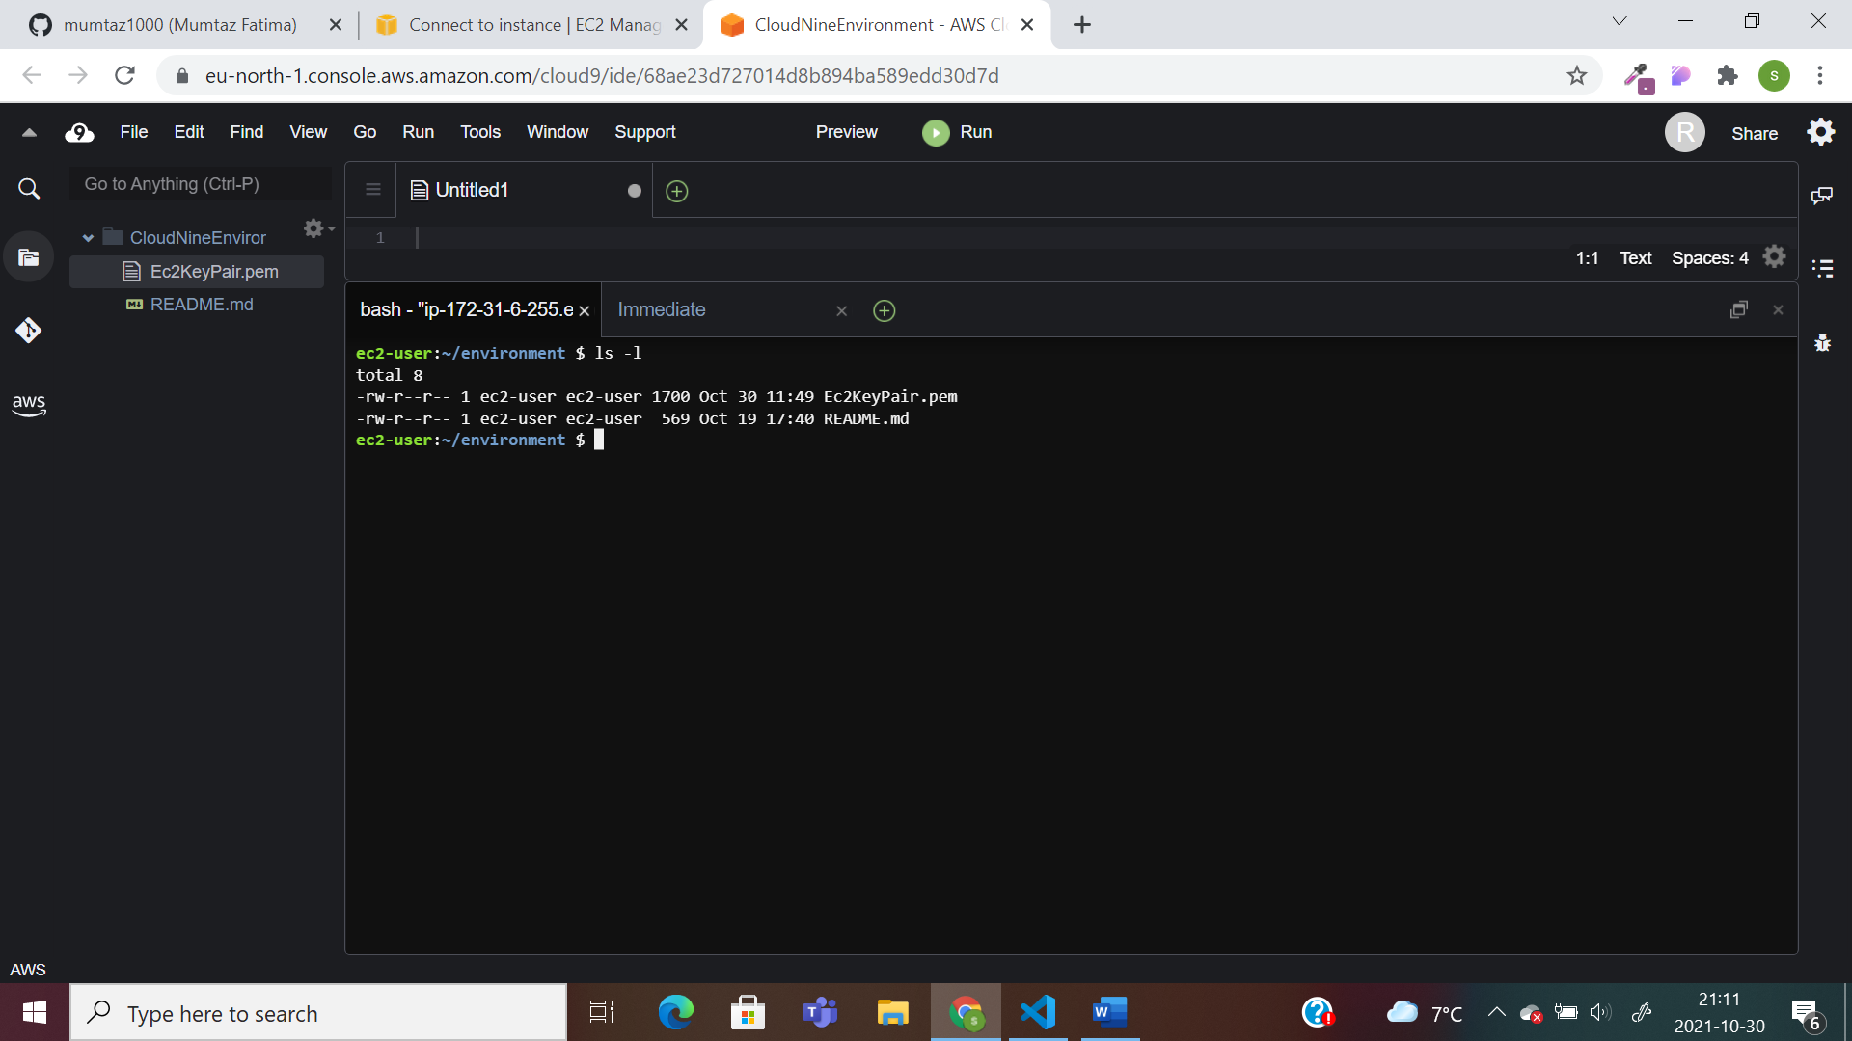

Here we have problem with access to instance key pair.

To edit it type **chmod 400 Ec2KeyPair.pem** to disable all other access and to make it read only.

Copy the last command

Paste the copied command in cloud9 terminal, enter and type **Y.**

Now we have to create termination protection.

Right click on **Cloud9 instance.**

In **Instance setting** click on **change termination protection.** Click on **Enable.**

And then click on **Save.**