Project
- Please attach the photo of the essay you wrote in class here.
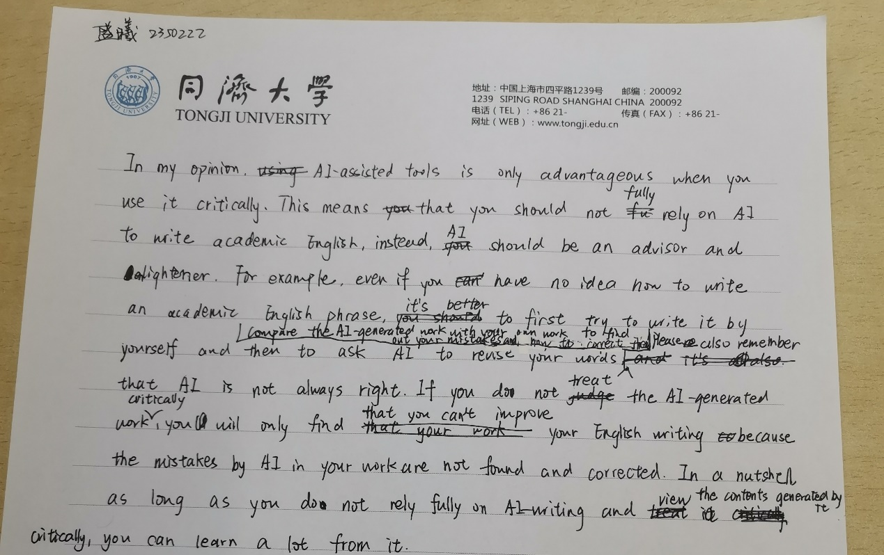
- Please attach the photo of the revised essay you completed in class.
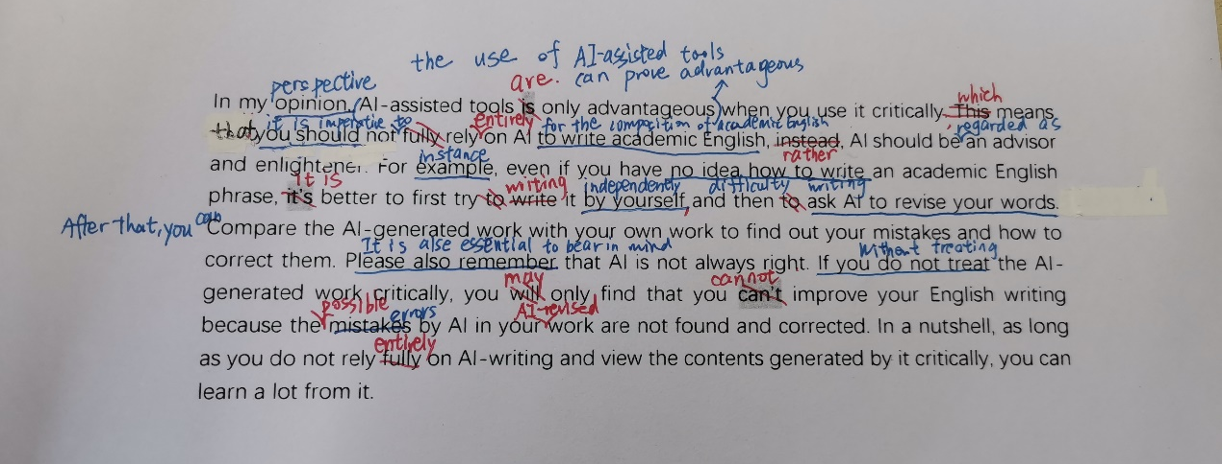
3. Please transcribe the text from photo 2, and apply the modifications shown in photo 2 using track changes mode.
Please include reflections on each modification made using track changes mode. Your reflections should encompass the rationale behind each modification and an evaluation of each of the modification.

In my opinion perspective, AI-assisted tools is only advantageous The use of AI-assisted tools can prove advantageous when you use it critically. This , which means that you should not fully rely it is imperative not to rely entirely on AI to write academic English for the composition of academic English, instead, AI should be an advisor and enlightener ; instead, use AI as an advisor and a source of insight. For example instance, even if you have no idea how to write have difficulty writing an academic English phrase, it’s it is better to first try to write try writing it by yourself independently, and then to ask AI to revise your words. After that, you can Ccompare the AI-generated work with your own work to find out your mistakes and how to correct them. Please also remember It is also essential to bear in mind that AI is not always right. If you do not treat Without treating the AI-generated work critically, you will may only find that you can’t cannot improve your English writing because the mistakes possible errors by AI in your AI-revised work are not found and corrected. In a nutshell, as long as you do not rely fully entirely on AI-writing and view the contents generated by it critically, you can learn a lot from it.

4. Two open questions:
Could you please provide your perceptions of making revisions on improving your writing? (200 words or so; in Chinese)
我认为不断的修改是非常必要的。通过这次的修改，我找到了一些我常见的错误（比如使用缩写，不够正式，一些小的语法错误等），以及一些相对应的修改方式（比如使用名词而非形容词常常显得更正式，更简洁，e.g. If you do not treat Without treating）。可见，不断的修改有助于我们找到自己的常见的错误写作习惯，并对症下药地进行修正。同时，修改也可以锻炼我们的思辨能力和逻辑思维，因为我们需要不断地质疑我们自己写下的东西，并尽可能地跳出自身的思维定势，从别的角度去思考自己写的东西有何不足。此外，修改还有助于拓宽我们的词汇量和短语库等，因为在修改的过程中我们需要查阅词典，参考别人的写作。
Could you please provide your reflections on how you are going to revise your writing in the future? (200 words or so; in Chinese)
首先，我要提高我修改的次数。每一次的修改，都可以在前一次的基础上找到新的东西，获得新的知识。第二，我要多多参考别人的作品，借助工具，如字典、词典，查阅资料，甚至询问老师，因为自己一个人埋头修改可能会走弯路，陷入自身的思维定势，甚至越改越错，只有外界的反馈、评估、指导才可以帮助我们找对修改的方向。第三，我会在写作的同时有意识地回顾自己刚刚写下的句子，边写边改，以免犯下一些低级错误，比如语法错误等。
具体到每一次修改，我计划以后更注重于语句的精简性、准确性、专业性，在确保意思表达争取的基础上，我会避免过度复杂或冗长的表达，使文章更加清晰易懂。同时，我将努力使用更精确的词汇和短语，以提高论述的准确性和专业性。

Sample:

1. Photo 1
2. Photo 2
3. Revised essay in track changing mode
Language is the main means of interactionbetween people. But sometimes language has often been a barrier rather that an aid to understand among people. …

4. Open questions
4.1 …
4.2 …

