1,下载nifi,minifi,minifi-toolkit

Nifi配置 : Vim nifi.properties

Hadoop-7配置

# Site to Site properties配置site-to-site用于实例间传输数据

nifi.remote.input.host=

nifi.remote.input.secure=false

nifi.remote.input.socket.port=1026

nifi.remote.input.http.enabled=true

nifi.remote.input.http.transaction.ttl=30 sec

# web properties #

nifi.web.war.directory=./lib

nifi.web.http.host=hadoop-6

nifi.web.http.port=12321

nifi.web.http.network.interface.default=

nifi.web.https.host=

nifi.web.https.port=

nifi.web.https.network.interface.default=

nifi.web.jetty.working.directory=./work/jetty

nifi.web.jetty.threads=200

**Test-1 site-to-site**

Hadoop-6 nifi-web页面配置 remote process group

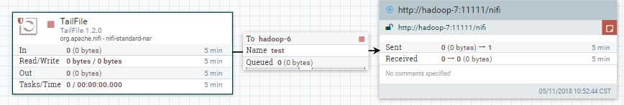

Hadoop-7 nifi-web配置 input-port

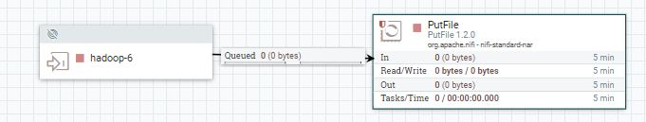

Test-2 minifi-nifi use site-to-site

Nifi-web配置

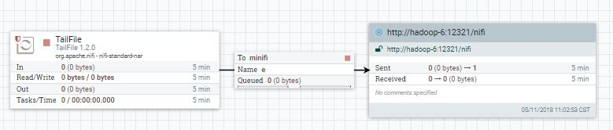

hadoop-7 Minifi配置

Remote Process Groups:

- id: a7f67ffb-b9d3-307f-0000-000000000000

name: ''

url: http://hadoop-6:12321/nifi

comment: ''

timeout: 30 sec

yield period: 10 sec

transport protocol: RAW

proxy host: ''

proxy port: ''

proxy user: ''

proxy password: ''

local network interface: ''

Input Ports:

- id: 497d4dea-0163-1000-7f1b-390719e20a66

name: minifi

comment: ''

max concurrent tasks: 1

use compression: false

Properties:

Port: 1026

Host Name: hadoop-6

Hadoop-6 nifi-web配置

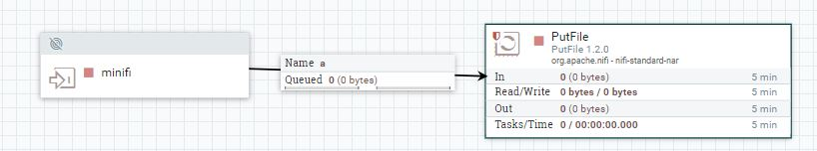

Test-3 tcp传输配置

Hadoop-7监听一个端口22232作为tcp server

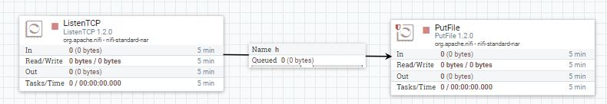

Hadoop-6连接hadoop-7对应端口传输数据

