Sprint 1 | Database Design and ERD Improvements
  - Film Equipment Rental Database • Database Design and Normalization

1. Overview
Our project is a film equipment rental database designed to manage customers, equipment, equipment categories, and rental transactions. For this sprint, I reviewed the current database schema and created an updated relational diagram showing tables, attributes, keys, and relationships. I also proposed improvements to data integrity and reviewed functional dependencies and Boyce-Codd Normal Form (BCNF).

2. Database Structure
The database contains five tables: Customer (customer information), Category (equipment types), Equipment (individual items and rates), Rental (transactions and dates), and RentalItem (the equipment associated with each rental and its charged rate). Customer–Rental, Category–Equipment, Rental–RentalItem, and Equipment–RentalItem are one-to-many relationships. The composite primary key (rental_id, equipment_id) in RentalItem prevents a particular equipment item from appearing twice within the same rental.

3. Proposed Design Improvements

Rental date validation
Proposed CHECK rules require expected_return_date >= rental_date and actual_return_date IS NULL OR actual_return_date >= rental_date. These prevent impossible return dates while allowing an item to remain unreturned.

Equipment status validation
Proposed CHECK (status IN ('available', 'rented', 'maintenance')) restricts the status field to valid labels. This does not guarantee that the status agrees with the rental records.

Rental price validation
Proposed CHECK (daily_rate >= 0) in Equipment and CHECK (rental_rate >= 0) in RentalItem prevent negative prices. Keeping both fields is intentional: daily_rate is the current listed price, whereas rental_rate records the amount charged for a particular rental, preserving historical rates.

4. Functional Dependencies and BCNF
Primary keys determine their tables’ other attributes. For example, customer_id determines name, email, and phone; (rental_id, equipment_id) determines rental_rate. In Equipment, the NOT NULL UNIQUE serial_number is also a candidate key. BCNF requires every non-trivial functional dependency to have a superkey on its left side. Based on these identified dependencies, the five tables satisfy BCNF, assuming no further dependencies arise from business rules. Therefore, no BCNF decomposition was identified as necessary under those assumptions.

5. Remaining Limitations
The schema does not prevent an equipment item from being assigned to overlapping rental periods. Status may also become inconsistent with actual rental records. Addressing these limitations requires further business logic or database-level enforcement beyond the proposed simple CHECK constraints.

6. Conclusion
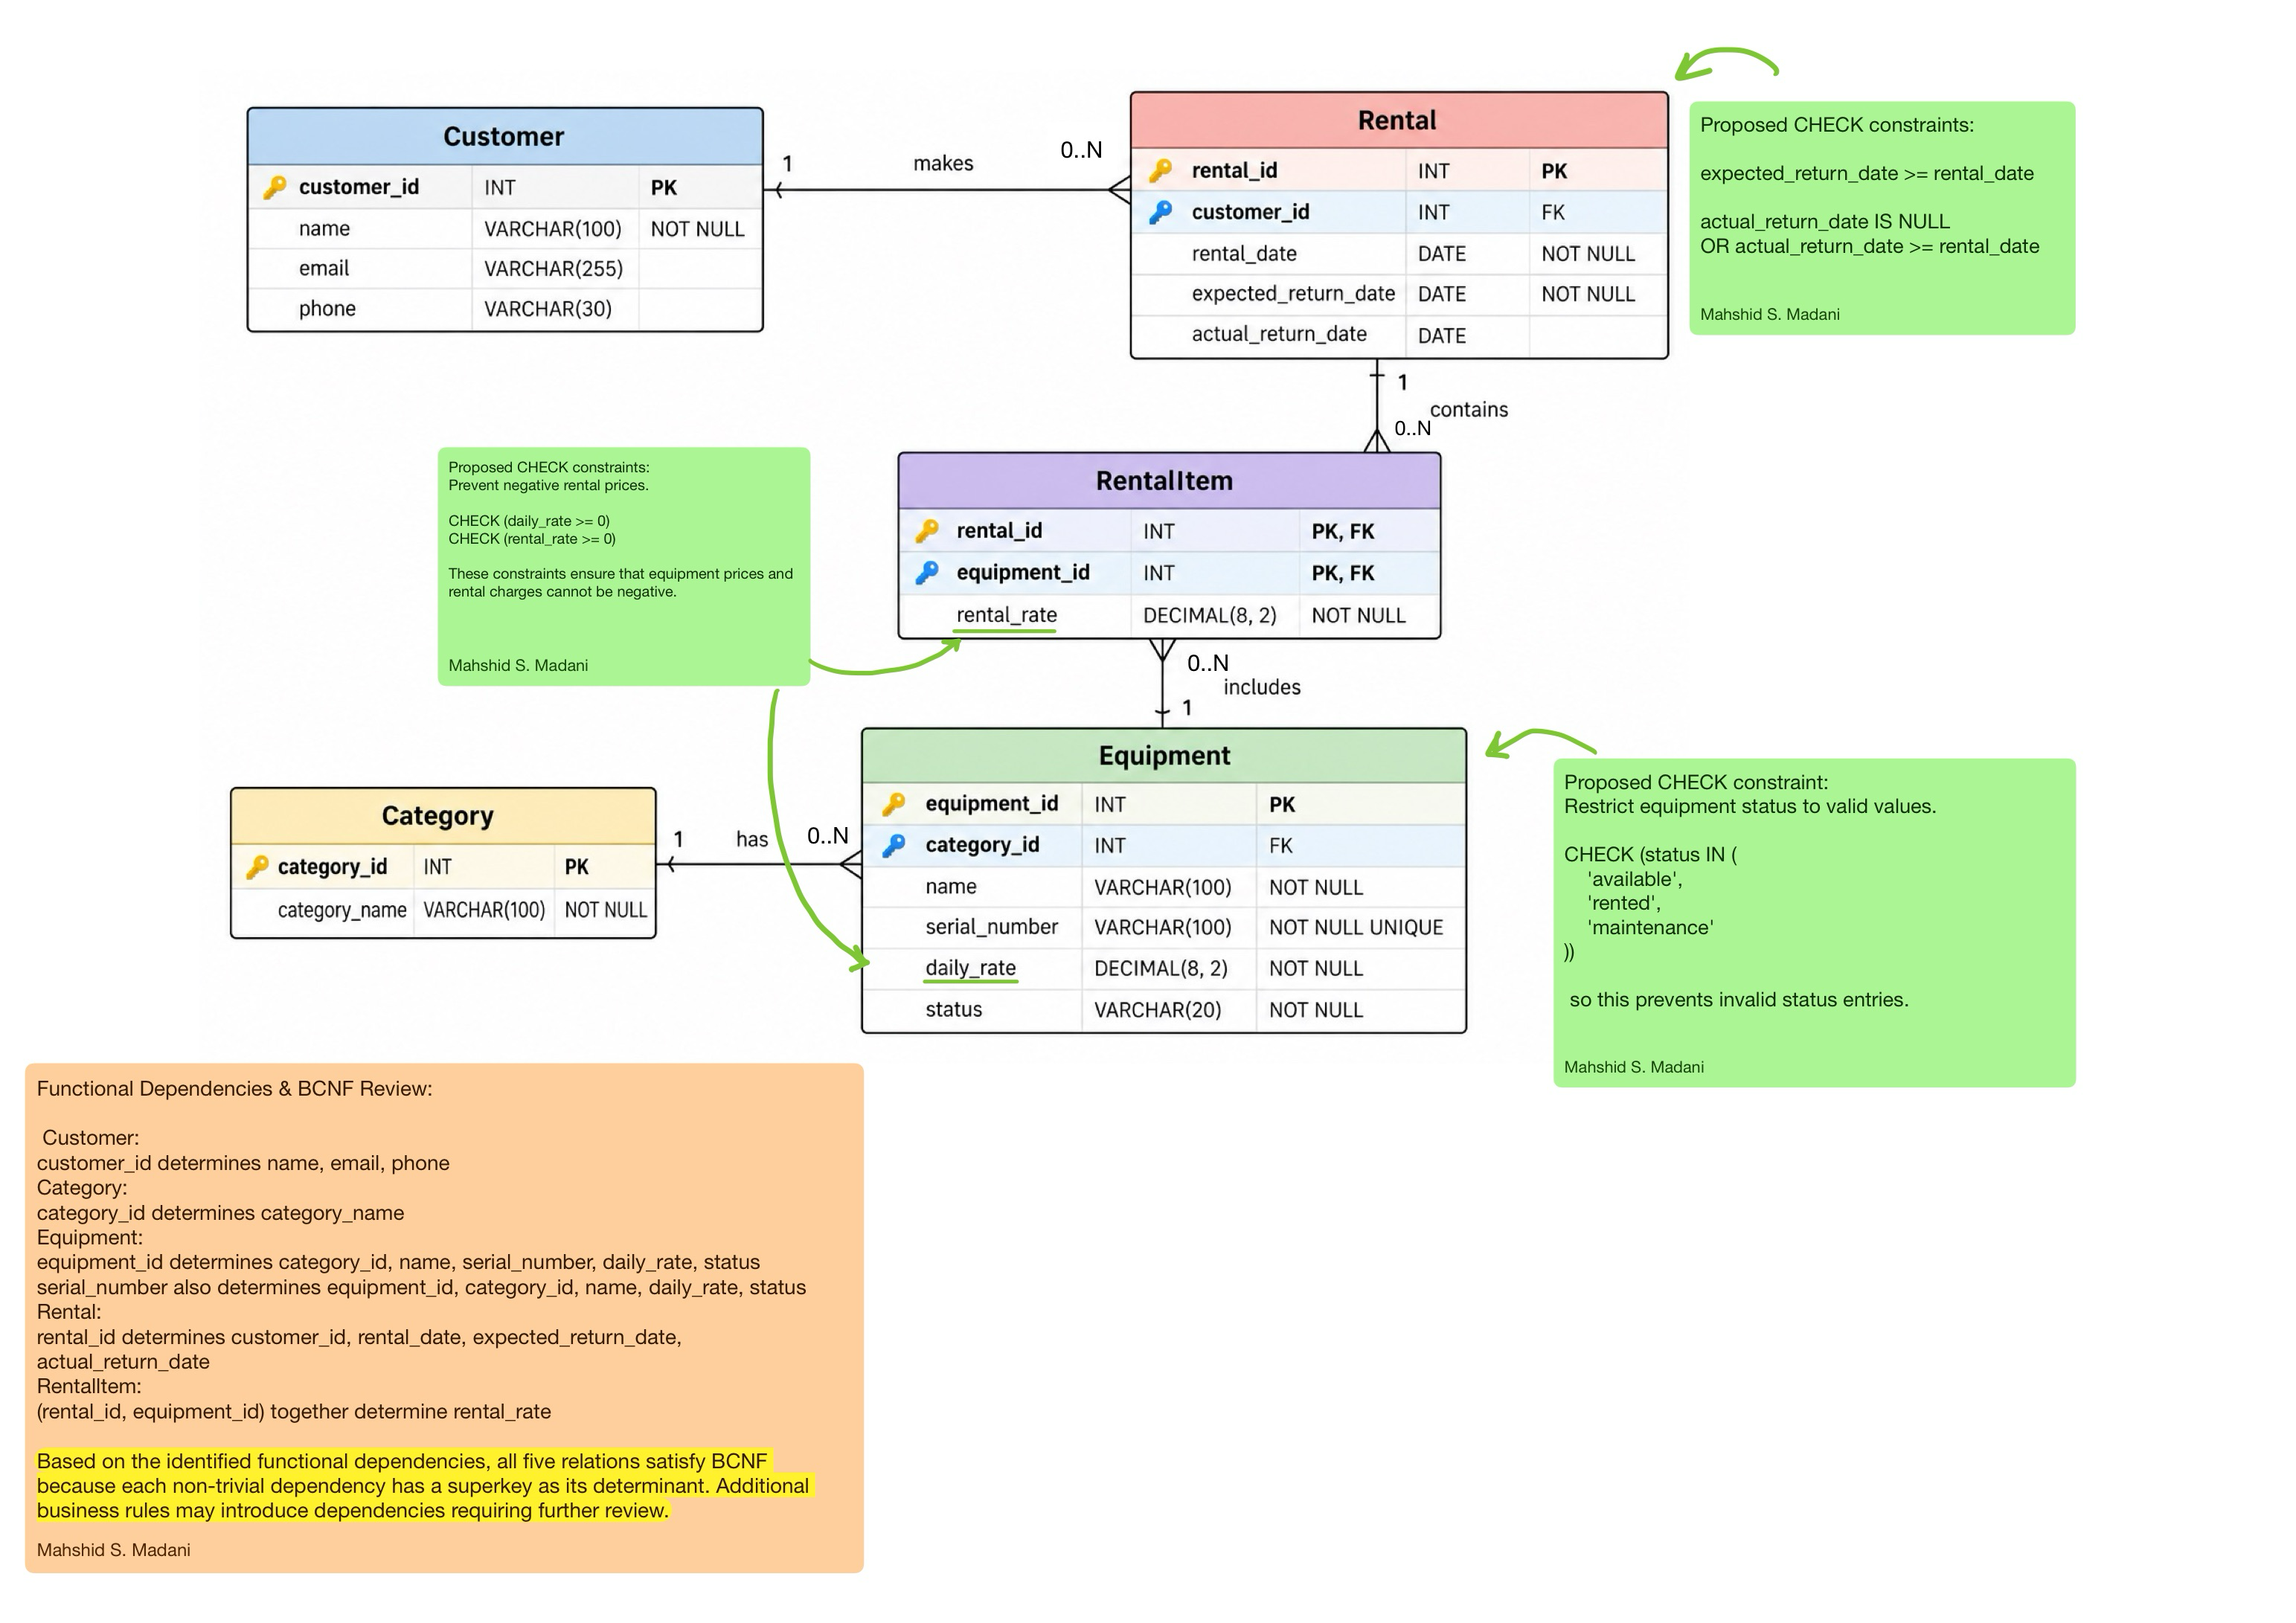
I documented the existing relational structure, clarified relationships and multiplicities, reviewed functional dependencies and BCNF, and proposed targeted integrity constraints. These are design proposals rather than implemented functionality; the SQL implementation must add and test them. The changes preserve the existing table structure to minimize disruption to the team's other work.

