**L.J. INSTITUTE OF COMPUTER APPLICATIONS**

**Master of Computer Application**



Project Title

Analysis of Crime Ratio in Different states

of India using Chi-Square Test.

Name Enrollment number

Undhad Archana 185173693121

Soni Pooja 185173693113

Saiyed Muhammed Munaf 185173693098

**Under the guidance of**

Prof. Shanti Varma

Project submitted in partial fulfilment of MCA II, Semester 4

Software Project 2 - Data Science (4649304)

Master of Computer Application

Gujarat Technological University

**L.J. INSTITUTE OF COMPUTER APPLICATIONS**

Near Nagdev Kalyan Mandir, Near Sanand Cross Roads,

Serkhej-Gandhinagr Highway  Ahmedabad - 382481  
Ph. No. : 079 29296364



***CERTIFICATE***

**Enrollment No**: **185173693121** **Seat No:** ___M400755___

This is to certify that ~~Mr~~. / Ms._______Undhad Archana______________ of Master in Computer Applications, Semester IV, Roll No___59___ has satisfactorily completed his/her Project titled Analysis of Crime Ratio in Different states of India using Chi-Square Test under the supervision of

**Internal Guide Names** **Signature**

Prof. Shanti Varma

**Date of Submission:**

**Director**

**L.J. INSTITUTE OF COMPUTER APPLICATIONS**

Near Nagdev Kalyan Mandir, Near Sanand Cross Roads,

Serkhej-Gandhinagr Highway  Ahmedabad - 382481  
Ph. No. : 079 29296364



***CERTIFICATE***

**Enrollment No: 185173693113__ Seat No:** ___M400754____

This is to certify that ~~Mr~~. / Ms.  **Soni Pooja**  of Master in Computer Applications, Semester IV, Roll No **57** has satisfactorily completed his/her Project titled **Analysis of Crime Ratio in Different states of India using Chi-Square** under the supervision of

**Internal Guide Names** **Signature**

Prof. Shanti Varma

**Date of Submission:**

**Director**

**L.J. INSTITUTE OF COMPUTER APPLICATIONS**

Near Nagdev Kalyan Mandir, Near Sanand Cross Roads,

Serkhej-Gandhinagr Highway  Ahmedabad - 382481  
Ph. No. : 079 29296364



***CERTIFICATE***

**Enrollment No**: **185173693098** **Seat No:** ___M400606____

This is to certify that Mr. / ~~Ms~~.  **Saiyed Muhammed Munaf** of Master in Computer Applications, Semester IV, Roll No **49** has satisfactorily completed his/her Project titled **Analysis of Crime Ratio in Different states of India using Chi-Square** under the supervision of

**Internal Guide Names** **Signature**

Prof. Shanti Varma

**Date of Submission:**

**Director**

**Components**

|  |  |  |
| --- | --- | --- |
| **Certificate** | | |
| **Sr. No.** | **Particulars** | **Page No.** |
| **1** | **Introduction** | **6** |
| **2** | **Problem Statement** | **6** |
| **3** | **Organisation of Data** | **7** |
| **4** | **Cleaning Data** | **8** |
| **5** | **Method/ Techniques** | **9** |
| **6** | **Data Visualizations through summary / tables** | **10** |
| **7** | **Crime Ratio Analysis Model**   1. **Chi Square Test** 2. **Decision Tree Algorithm** | **19**  **22** |
| **8** | **Conclusion** | **28** |
| **9** | **Appendix**   1. **Bibliography** | **29** |

**Introduction**

This study presents the trend analyses of police crime recorded data in India. The data for our study is drawn from Crime in India, an annually publication by the National Crime Record of India.

Crime exists in India in various forms such as murder, drug trafficking, money laundering, fraud, human trafficking, robbery and prostitution etc.

It results suggest that rates of murder, robbery, theft, and rioting follow declining trends, while rates of rape show an increasing trend between 2001 and 2012.

Accordingly, this paper will attempt an overview of the trends and characteristics of crime and crime control in India and in doing so will provide a general understanding of crime in Indian society.

**Problem Statement**

By examining the crime data, we can get a better picture of how we can make safe our country. And through this analysis we can predict that which crime happened in large amount during 2000 to 2012 and how we can control that.

**Organization of Data**

[National Crime Records Bureau (NCRB)](http://ncrb.nic.in/)

Government of India has published this [dataset](http://ncrb.nic.in/StatPublications/CII/PrevPublications.htm) on their website and also has shared on [Open Government Data Platform India portal](https://goo.gl/yVdXyd) under [Govt. Open Data License - India](https://data.gov.in/government-open-data-license-india).

**List of Attributes**

|  |  |  |
| --- | --- | --- |
| Sr. No | Attribute Name | Meaning of Attributes |
| 1 | state_ut | State value of India state |
| 2 | District | State wise District value of India |
| 3 | Year | Year value between 2001 to 2012 |
| 4 | Murder | Number of Murder to state in district wise |
| 5 | Rape | Number of Rape to state in district wise |
| 6 | Robbery | Number of Robbery to state in district wise |
| 7 | Theft | Number of Theft to state in district wise |
| 8 | Riots | Number of Riots to state in district wise |
| 9 | Cheating | Number of Cheating to state in district wise |
| 10 | dowry_deaths | Number of Dowry deaths to state in district wise |

**Cleaning Data**

For creating a predictive model, firstly the data must be clean and accurate and null values should not be there.

Data cleansing, data cleaning, data-wash or data scrubbing is the process of detecting and correcting (or removing) corrupt or inaccurate records from a record set, table or database

In This dataset we have checked null values. And we clear all the null or Nan values by different techniques.

any (is.na(murder))

After cleaning Data, the data shown in below figure 1.

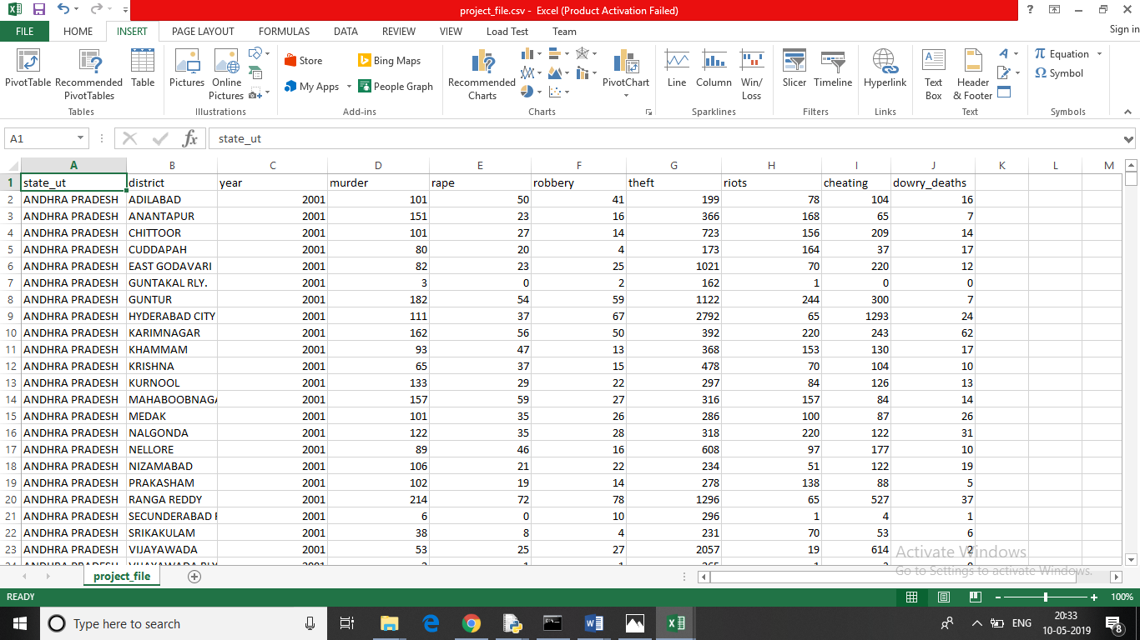

*Figure 1: data after cleaning.*

# The several types of techniques used for cleaning data are firstly Excel’s inbuild filtering method is used for cleaning the data. And python dropna( ) is used for dropping and deleting the null value rows from the datasets.

“data = data.dropna( )”

**Methods / Techniques**

Application and Identification of technique and tool used:

Matplot Library:

Matplot is a python library used to create 2D plot graph and plots by using python scripts.

Pyplot Library:

It has a module named pyplot which makes things easy for plotting by providing feature to control line styles, font properties, formatting axes etc. It supports a very wide variety of graph and plots namely-histogram, bar charts, power spectra, error charts etc.

Pandas Library:

Pandas is an open –source python library used for high-performance data manipulation and data analysis using its powerful data structures.

Numpy Library:

It is used along with NumPy to provide an environment that is an effective open source alternative for MatLab.

Numpy is a Python package which stands for ‘Numerical python’. It is a library consisting of multidimensional array objects and a collection of routines for processing of array.

Seaborn Library:

The main idea of Seaborn is that it provides high-level commands to create a variety of plot types useful for statistical data exploration, and even some statistical model fitting.

Scipy Library:

SciPy is an Open Source Python-based library, which is used in mathematics, scientific computing, Engineering, and technical computing.

SciPy contains varieties of sub packages which help to solve the most common issue related to Scientific Computation.

Sklearn Library:

[Scikit-learn](http://scikit-learn.org/stable/) is a library in Python that provides many unsupervised and supervised learning algorithms.

The functionality that scikit-learn provides include:

Regression, Classification, Clustering, Model selection, Pre-processing

**Data Visualization**

Preliminary Analysis:

In this project statistical analysis done using inbuild describe() function.

“ murder_summary=[ ]

murder_summary=data[‘murder’].describe( )

print(murder_summary)”

**Crime Summery Table**

|  |  |  |  |  |  |  |  |  |  |
| --- | --- | --- | --- | --- | --- | --- | --- | --- | --- |
| **Crime Name** | **Mean** | **standard Deviation** | **Quantile Value**   |  |  |  | | --- | --- | --- | | **Q1** | **Q2** | **Q3** | | | | **Maximum** |
| **Murder** | 46.823659 | 42.755817 | 18.00000 | 37.00000 | 63.00000 | 542.000000 |
| **Rape** | 27.816331 | 30.897866 | 8.000000 | 19.000000 | 39.000000 | 568.000000 |
| **Robbery** | 28.878330 | 50.937364 | 6.000000 | 16.000000 | 34.000000 | 1131.000000 |
| **Theft** | 407.180412 | 778.770851 | 86.000000 | 206.000000 | 430.000000 | 13195.000000 |
| **Riots** | 90.139235 | 137.592242 | 10.000000 | 44.000000 | 116.000000 | 3181.000000 |
| **Cheating** | 89.286612 | 183.973214 | 12.000000 | 35.000000 | 93.000000 | 3155.000000 |
| **Dowry Deaths** | 10.608584 | 14.186601 | 1.000000 | 5.000000 | 15.000000 | 168.000000 |

In this we have calculated mean, median, standard deviation, Q1, Q2, Q3, Max value.

This all is calculated for all columns like for murder, rape, robbery, theft, riots, cheating, dowry deaths.

Through this we understand that from these seven crimes the highest crime rate of crime is theft and second highest crime is Riots in India.

Graphical Representation with Line Graph:

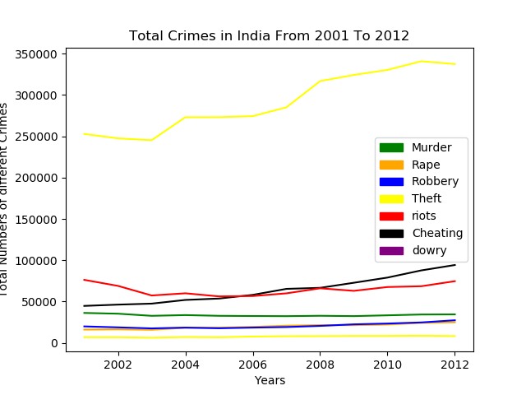

*Figure 2: line graph for all crimes.*

Through this Line graph we can read statistics of Indian IPC Crimes and through this graph we can understand that Theft Crime is very High in India Among All Other Crimes and this crime is Continue Rising from 2001 to 2012 no changes are there in crimes.

Its show that every year theft crime keeps increasing. And this crime is very higher from all other crimes.

We can say that theft crime is increasing because of unemployment in our country.

**Crime Data Visualization by Murder Wise:**

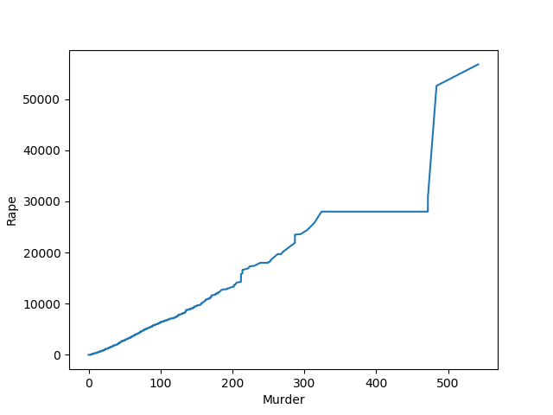

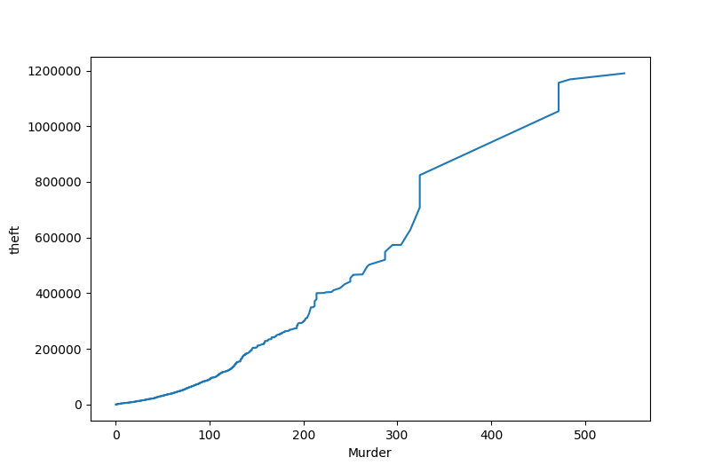

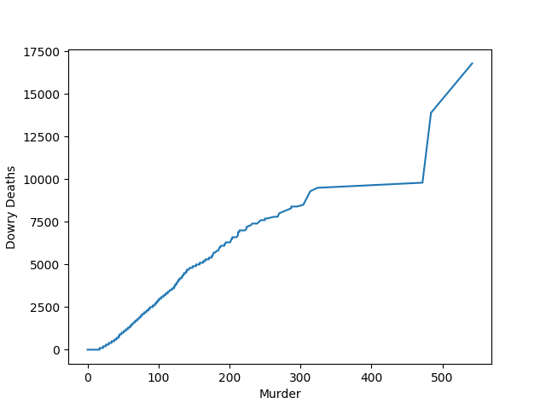 Figure 4: Murder wise Theft graph

Figure 3: Murder wise Rape crime graph

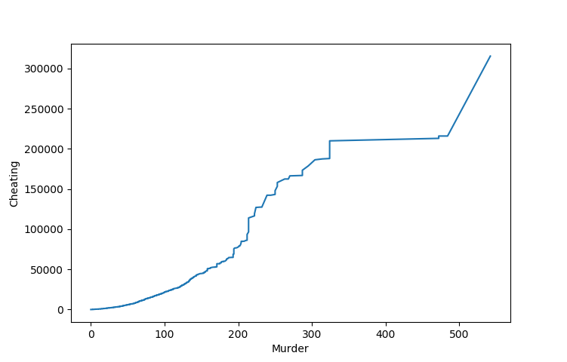

Figure 5: Murder wise Cheating graph Figure 6: Murder wise Dowry death graph

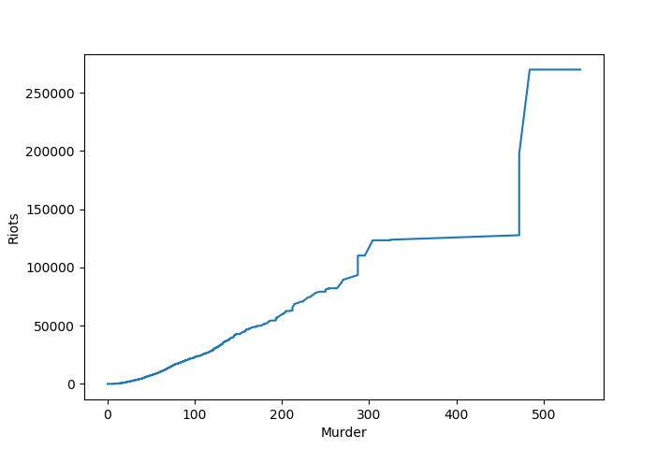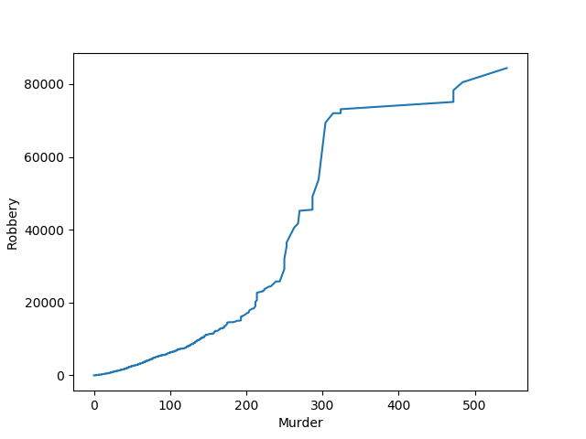

Figure 8: Murder wise Riots graph

Figure 7: Murder wise Robbery graph

* So, this graph Show Relation between Murder and the different crimes like robbery, rape, theft, riots.
* Which means for example it checks like if rape is increasing then it affects to murder crime or not. Murder is increasing because of rape increasing.

**Crime Data Visualization by Using Bar Chart**

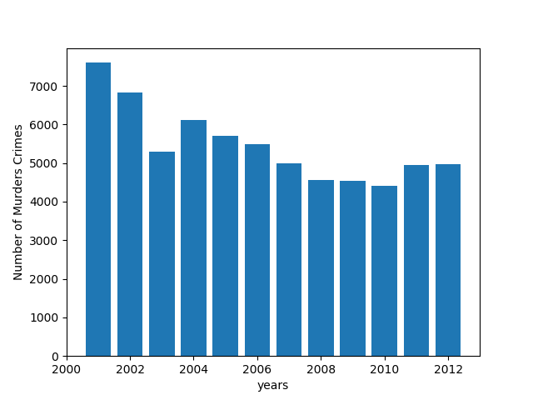*Figure 9: Bar graph for Murder crime from 2000 to 2012*

This Bar Chart Show Years Wise Murder Crime Records, and Year 2010 has a smaller Number of Murder. So, we identify that years wise Murder crime is decreasing

**Crime Data Visualization by Using Bar Chart**

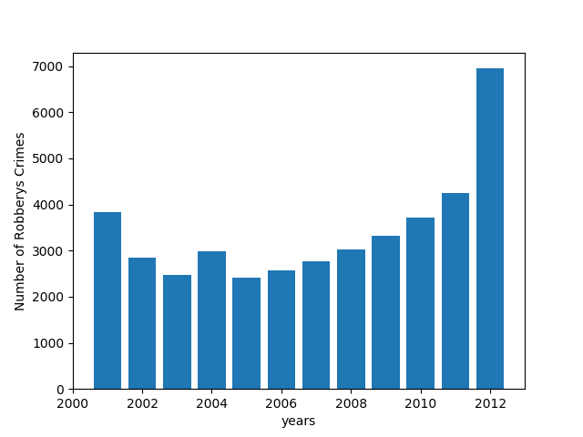

*Figure 10: Bar graph for Robbery crime from 2000 to 2012*.

By reading this bar graph we identify that every year from 2005 to 2012 Robbery crime is keep increasing. And in 2012 robbery crime is more frequently increasing from 2011.

The robbery crime increases in India very speedy from 2011 to 2012. This period has more robbery crime.

**Visualizing Data with Pairs Plots**

Plot pairwise relationships in a dataset.

By default, this function will create a grid of Axes such that each variable in data will by shared in the y-axis across a single row and in the x-axis across a single column. The diagonal Axes are treated differently, drawing a plot to show the univariate distribution of the data for the variable in that column.

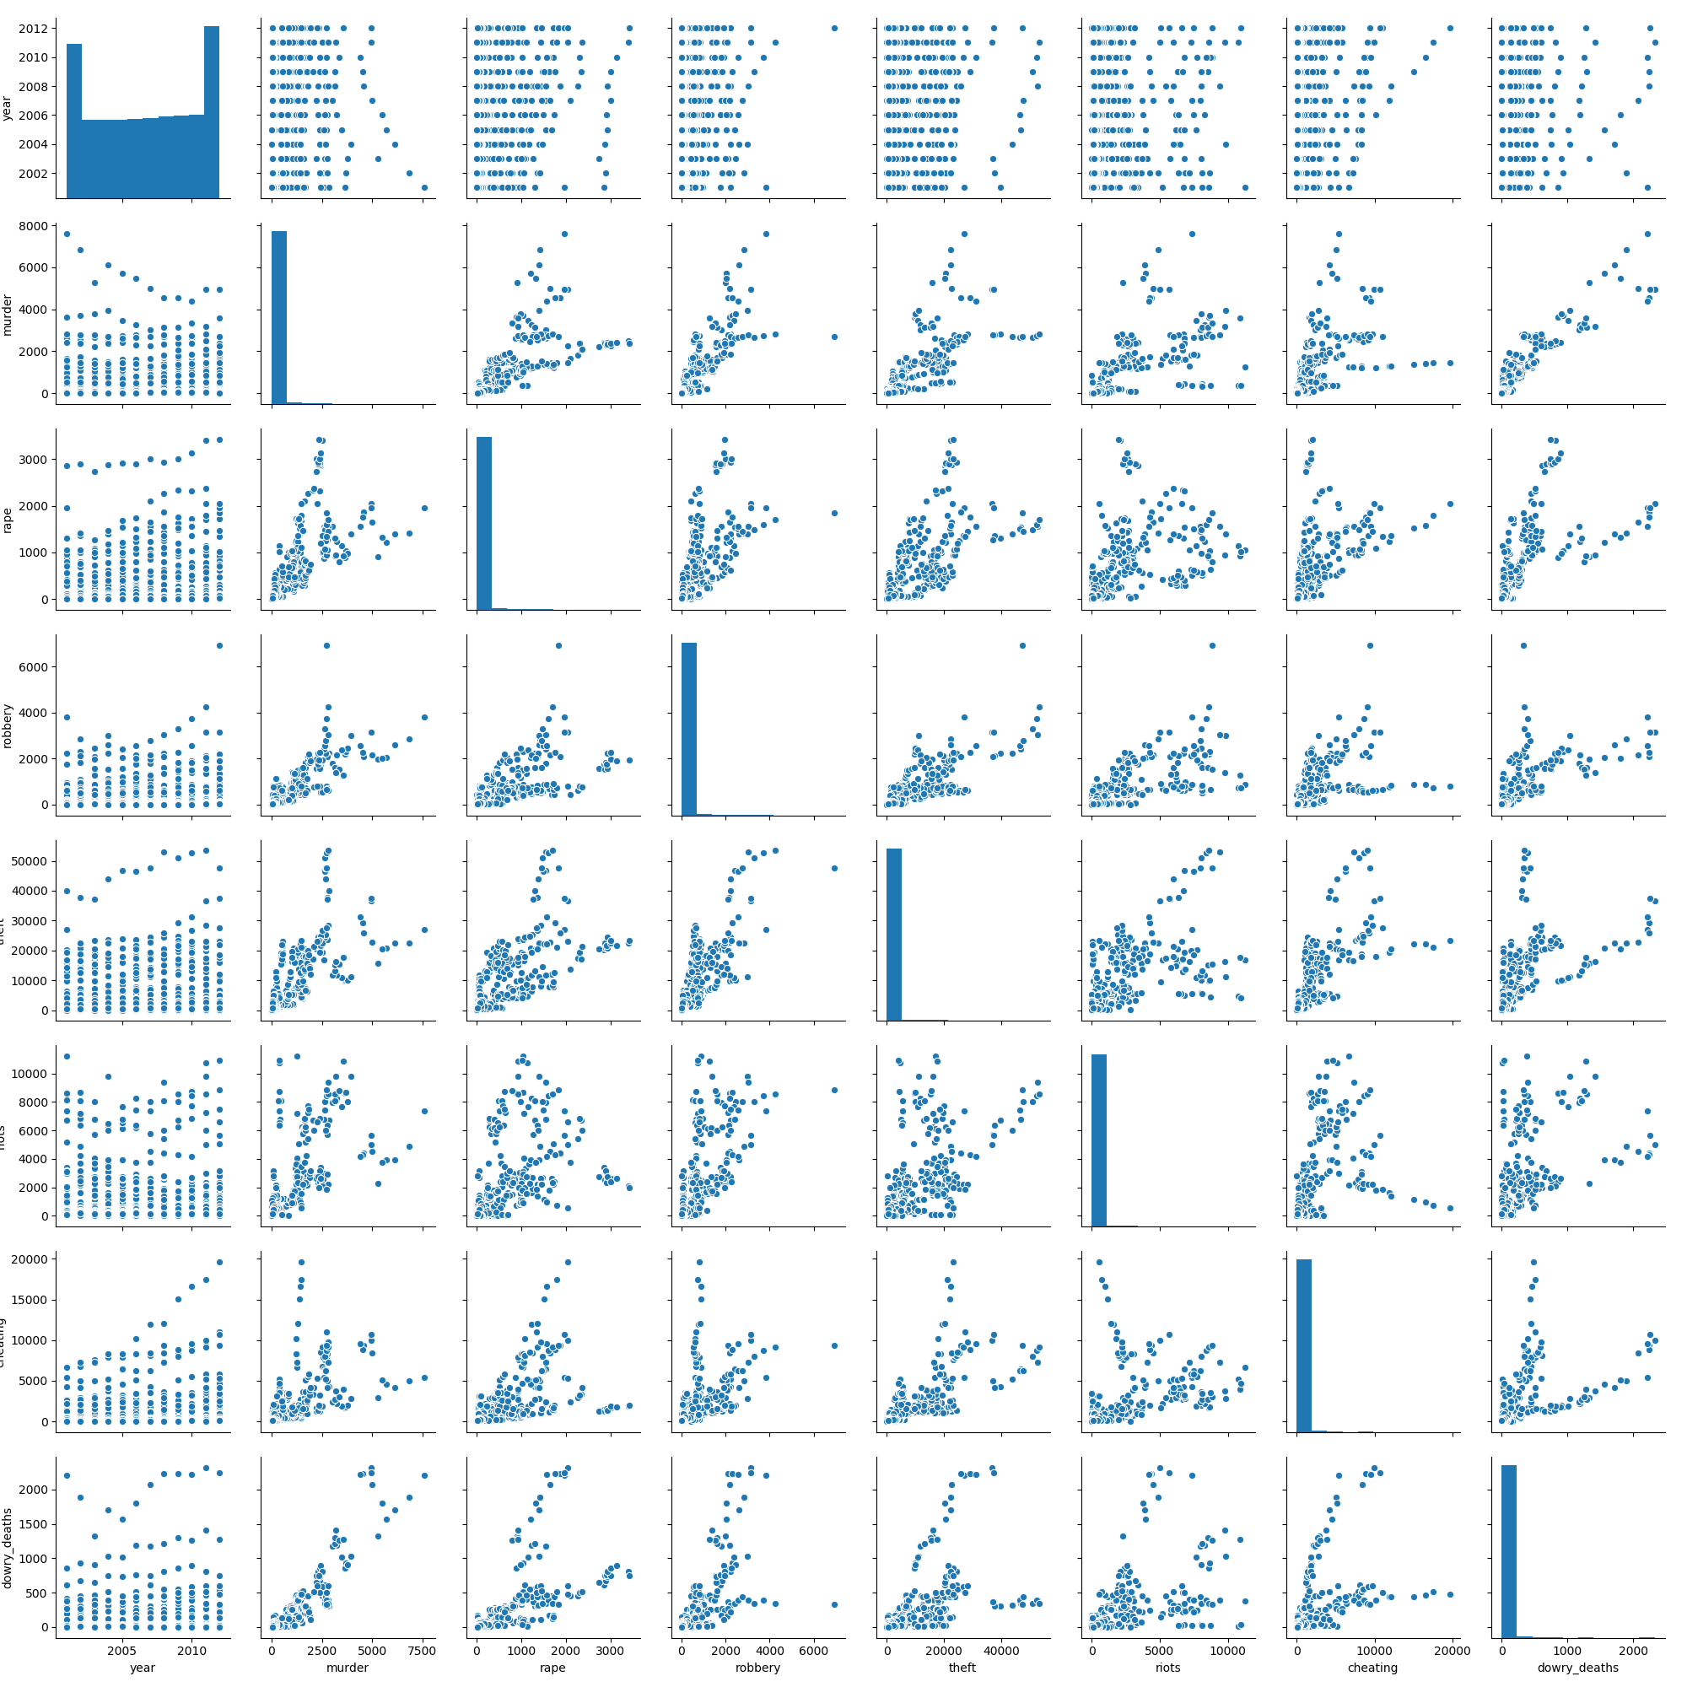

Figure 11: Pari plot graph for whole dataset

**Visualizing Data with Heatmap Graph**

A heatmap contains values representing various shades of the same colour for each value to be plotted. Usually the darker shades of the chart represent lower values than the lighter shade. For a very different value a completely different colour can also be used.

The below figure is a two-dimensional plot of values which are mapped to the indices and columns of the chart.

Also note that it’s now easier to compare magnitudes of negative vs positive values

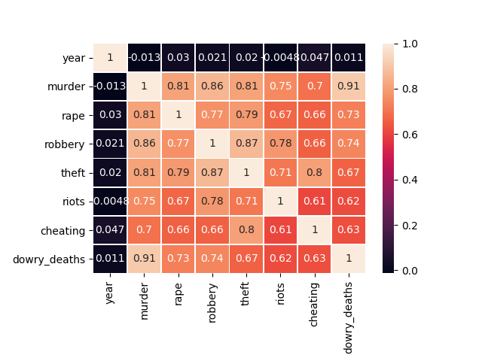

Figure 12: Heatmap to check dependency

So we identify the relation between all variables this shows relations variable to variable with the help of heatmap.

In this heatmap we can identify that dowry deaths and murder has highly dependency with each other and murder and year has negative dependency.

**Visualizing Data with Distplot Graph**

Histograms and KDE can be combined using dispolt **Distplot()**. This function combines the matplotlib hist function (with automatic calculation of a good default bin size) with the seaborn **kdeplot()** and **rugplot()** functions. It can also fit scipy.stats distributions and plot the estimated PDF over the data.

Given below Graph shown Murder to correspond with rape and robbery Crime.

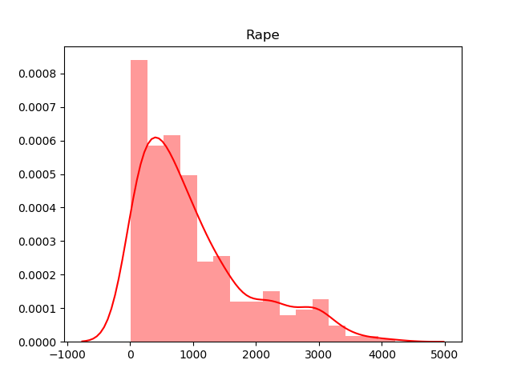

Figure 13: Rape corresponds with murder

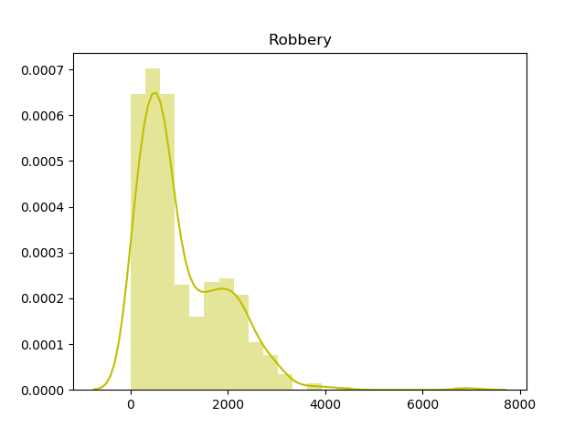

Figure 14: Robbery corresponds with murder

This dist. plot graph shows us the corresponds of one variable with another variable.

It helps us to plot the estimated PDF over the data.

**Visualizing Data with** **Boxplot**

We can detect Outliers and handle it in data. It can distort predictions and affect the accuracy, if you don’t detect and handle them appropriately especially in regression models then our whole analysis became wrong.

Data point that falls outside of 1.5 times of an interquartile range above the 3rd quartile and below the 1st quartile then it identify an outlier.

Data point that falls outside of 3 standard deviations. we can use a z score and if the z score falls outside of 2 standard deviation

**The impact of an outlier:**

Causes serious issues for statistical analysis

Skew the data.

Significant impact on mean

Significant impact on standard deviation.

we can identify an outlier by plotting

using box plots

using scatter plots

using Z score

using the IQR interquartile range

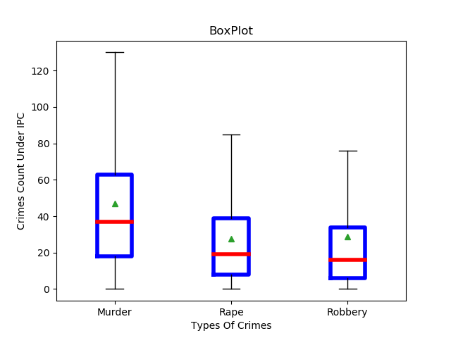

*Figure 15: Box plot for murder, rape and robbery.*

**Result:**

Box Plot of murder, rape and robbery crimes by state.

Based on this box plot we can identify that have maximum number crime among these three crimes is Murder.

Through this plot we can check the wrong data inserted. The wrong data of fake we can see the value which is Outlier.

**Chi square Test**

A chi-square test is a technique to compares the observed distribution of data to an expected distribution of data.

There are two types of chi-square tests: Chi-square test for goodness-of-fit and Chi-square tests of association and independence.

In this study we use test of independence. Test of independence is used to determine whether the crime and state has independence or not.

So, we have taken three crimes and four states from datasets to predict chi-square. States are Rajasthan, Gujarat, Bihar and Uttar Pradesh. And three crimes taken are rape, robbery and murder.

DISCUSSION OF P AND CHI-SQUARE VALUE

Step 1:

Prepare final data table to put values in chi-square to predict independence.

|  |  |  |  |
| --- | --- | --- | --- |
| **State** | **Rape** | **Robbery** | **Murder** |
| **Gujarat** | 4249 | 14383 | 13775 |
| **Rajasthan** | 15798 | 9071 | 15844 |
| **Bihar** | 13124 | 23666 | 41245 |
| **Uttar Pradesh** | 19058 | 30767 | 65443 |

*Table 1: table format created before running chi-square test*

Hypothesis:

H0: There is no statistically significant relationship between States and Crimes.

Ha: There is a statistically significant relationship between States and Crimes.

Step 2:

Run Chi-square test and calculate expected percentage frequency for each cell

**Run Output:**

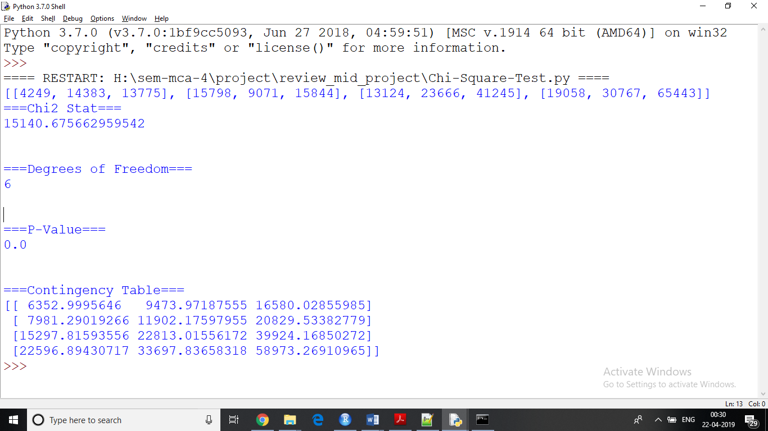

*Figure 16: output of chi-square test.*

Step 3:

Creating observed and expected values table

|  |  |  |  |
| --- | --- | --- | --- |
| **State** | **Crime** | **Observed** | **Expected** |
| **Gujarat** | Rape | 4249 | 6352.9995646 |
|  | Robbery | 14383 | 9473.97187555 |
|  | Murder | 13775 | 16580.02855985 |
| **Rajasthan** | Rape | 15798 | 7981.29019266 |
|  | Robbery | 9071 | 11902.17597955 |
|  | Murder | 15844 | 20829.53382779 |
| **Bihar** | Rape | 13124 | 15297.81593556 |
|  | Robbery | 23666 | 22813.01556172 |
|  | Murder | 41245 | 39924.16850272 |
| **Uttar Pradesh** | Rape | 19058 | 22596.89430717 |
|  | Robbery | 30767 | 33697.83658318 |
|  | Murder | 65443 | 58973.26910965 |

*Table 2: Chi-square Observed and Expected Table*

**Result**

The results show that probability of awarding crime in India.

Here p value is less than (0.5) α alpha, hence can reject H0.

This analysis is done by the help of chi-square to check independence.

Calculating degree of freedom using following the Rule

DOF = (Number of rows−1) ∗ (Number of columns−1)

Degree of freedom df = (4-1) * (3-1) = 6 the following outcomes are drawn

Formula for calculating or prediction chi-square test.

X2=(observed−expected)2

(expected)

Now we are ready to look into the Chi-squared distribution table. The cut off for a p-value of 0.06 was 12.592. Our **X**2 statistic was so large that the p-value is approximately zero. So, we have evidence against the null hypothesis.

With a p-value < 0.05, we can reject the null hypothesis. There is definitely some sort of relationship between 'states' and the ‘crimes' column. We don't know what this relationship is, but we do know that these two variables are not independent of each other

**Decision Tree Algorithm**

Decision tree implementation using python:

Decision tree is one of the most powerful and popular algorithms. Decision-tree algorithm falls under the category of supervised learning algorithms. It works for both continuous as well as categorical output variables

**Data Slicing:**

Before training the model, we have to split the dataset into the training and testing dataset.

To split the dataset for training and testing we are using the sklearn module *train_test_split.*

First of all, we have to separate the target variable from the attributes in the dataset.

X = balance_data.values[:, 2:6]

Y = balance_data.values[:, 0]

Above are the lines from the code which separate the dataset. The variable X contains the attributes while the variable Y contains the target variable of the dataset.

Next step is to split the dataset for training and testing purpose.

X_train, X_test, y_train, y_test = train_test_split(X, Y, test_size = 0.3, random_state = 100)

Above line split the dataset for training and testing. As we are splitting the dataset in a ratio of 70:30 between training and testing so we are pass *test_size* parameter’s value as 0.3.

*random_state* variable is a pseudo-random number generator state used for random sampling.

**Terms used in code:**

Gini index and information gain both of these methods are used to select from the *n* attributes of the dataset which attribute would be placed at the root node or the internal node.

Gini index:

Gini Index = 1 -∑j Pj2

Gini Index is a metric to measure how often a randomly chosen element would be incorrectly identified.

It means an attribute with lower Gini index should be preferred.

Sklearn supports “Gini” criteria for Gini Index and by default, it takes “Gini” value.

Entropy:

If a random variable x can take N different value, the ith value x, with probability p(xi), we can associate the following entropy with x:

(xi)log2 p(xi)

Entropy is the measure of uncertainty of a random variable, it characterizes the impurity of an arbitrary collection of examples. The higher the entropy the more the information content.

Accuracy score:

Accuracy score is used to calculate the accuracy of the trained classifier.

Confusion Matrix:

Confusion matrix is used to understand the trained classifier behaviour over the test dataset or validate dataset.

Data Information:

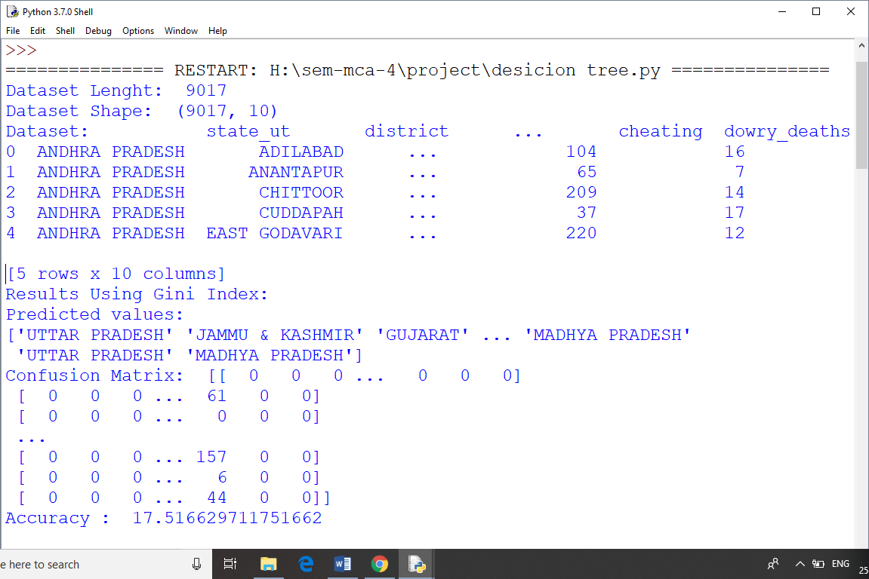

*Figure 17: Information of data loaded*

Result using Gini Index:

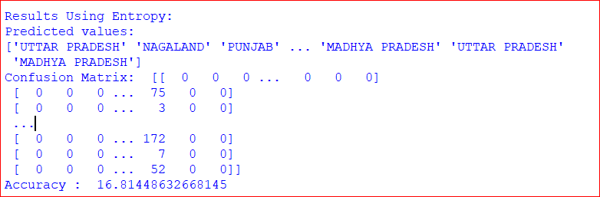

*Figure 18: Result using Gini Index.*

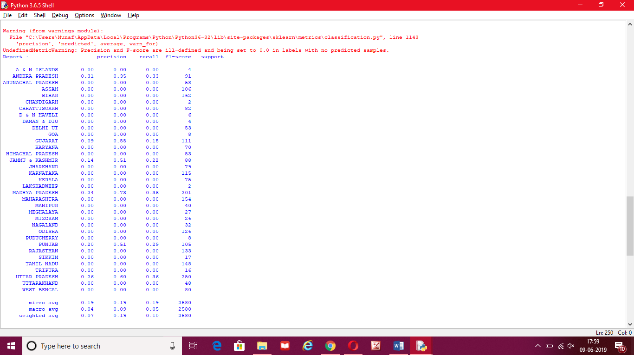

*Figure 18.2: Result using Gini Index*

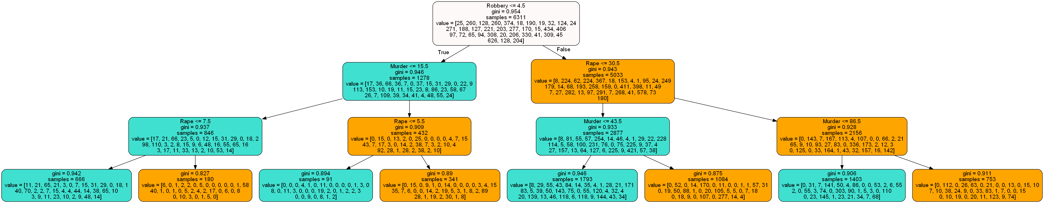

Figure 19: Gini Index Tree graph

**Results Using Entropy:**

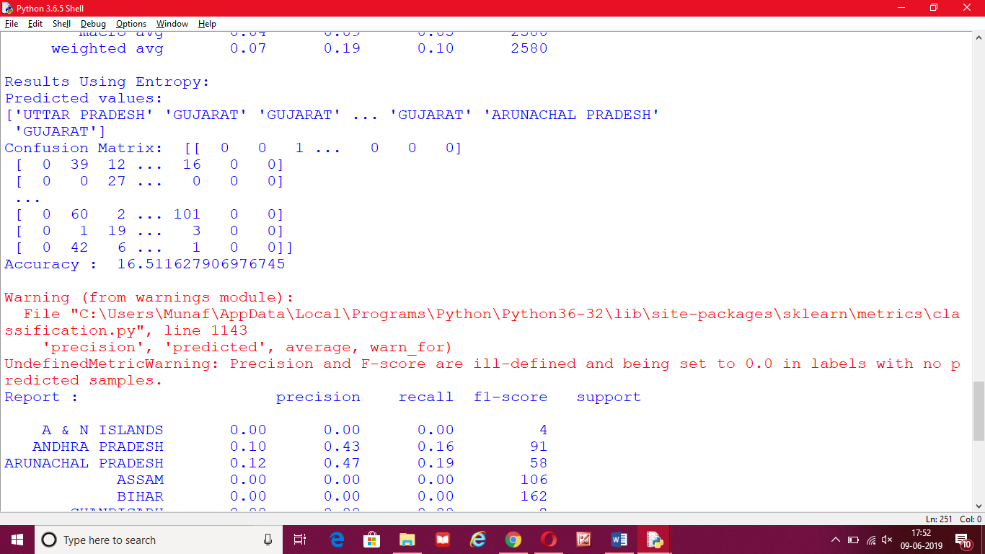

Figure 20: Result using Entropy

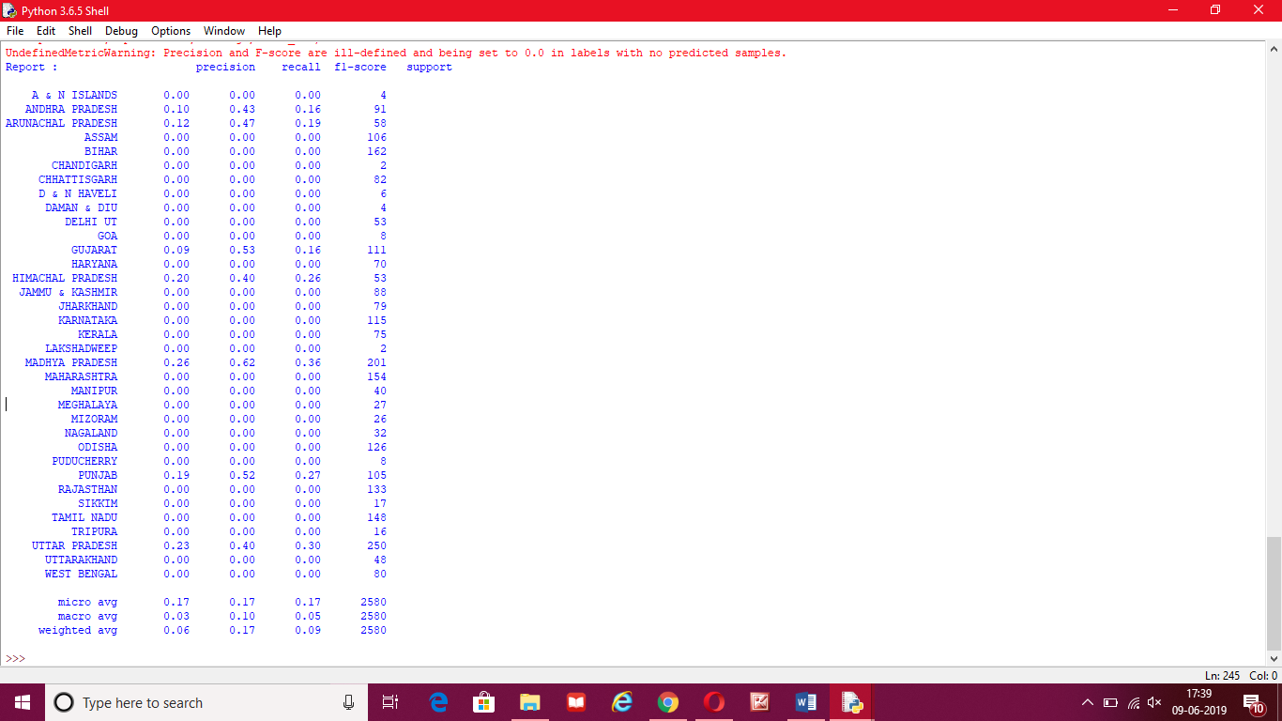

Figure 20.2: Result using Entropy

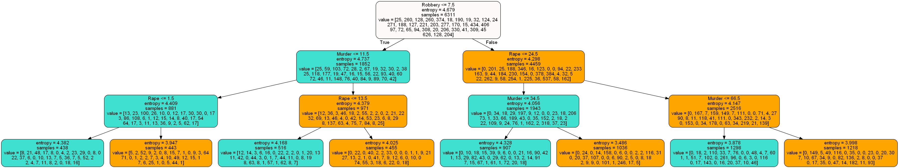

Figure 21: Entropy Tree graph

**CONCLUSION**

We generated many graphs and found interesting statistics that helped in understanding India crimes datasets that can help in capturing the factors that can help in keeping society safe.

The graphs include Bar, Line, Heatmap, Pari plot, Dist plot, Decision tree and scatter graphs each having its own characteristics.

The objective to test chi-square value at 95% confidence is achieved.

The results of test clearly show that combination of crime according to state.

Through Line graph we can read statistics of Indian IPC Crimes and through this graph we can understand that Theft Crime is very High in India Among All Other Crimes and this crime is Continue Rising from 2001 to 2012 no changes are there in crimes.

Its show that every year theft crime keeps increasing. And this crime is very higher from all other crimes.

We can say that theft crime is increasing because of unemployment in our country.

In Chi Square with a p-value < 0.05, we can reject the null hypothesis. There is definitely some sort of relationship between 'states' and the ‘crimes' column. We don't know what this relationship is, but we do know that these two variables are not independent of each other

Now we are ready to look into the Chi-squared distribution table. The cut off for a p-value of 0.06 was 12.592. Our **X**2 statistic was so large that the p-value is approximately zero. So, we have evidence against the null hypothesis.

Using a Decision algorithm, it divides the value and split in small parts and through this we get help for making decision.

Our decision is for control theft and robbery crimes by creating more and more recruitment for jobs. Our thought is that the reason of theft and robbery is because of unemployment in our country.

And by this crimes murder is dependent on all of them.

*

**BIBLIOGRAPHY**

**Dataset:** <https://www.kaggle.com/rajanand/crime-in-india>

**Graph :-** https://plot.ly/python/ , https://matplotlib.org/3.1.0/tutorials/introductory/pyplot.html#sphx-glr-tutorials- introductory-pyplot-py , https://[www.programcreek.com/python/example/96215/seaborn.set](http://www.programcreek.com/python/example/96215/seaborn.set)

**Pandas :** <http://pandas.pydata.org/pandas-docs/stable/>

**NumPy:-** <https://www.numpy.org/devdocs/>

**Data Modelling (sklearn):** <https://scikit-learn.org/stable/documentation.html>

**Decision Tree Algorithm:** <https://scikit-learn.org/stable/modules/tree.html>